Comparison and Contrasts between SOAP, REST and GraphQL Web Services their Principle Benefits and Drawbacks

Your name

Course

University
Date

Contents
1. Introduction 2
1.1. Overview 3
1.2. SOAP 3
1.3. Representational state transfer (REST) 5
1.4. GraphQL 5
2. Comparison and Contrast between these Web Services 6
2.1. Comparison 6
2.2. Contrast 7
3. Principle Benefit and Drawbacks 9
3.1. SOAP Benefits and Drawbacks 9
3.2. REST Benefits and Drawbacks 9
3.3. GraphQL Benefits and Drawbacks 10
4. Bibliography 13

Introduction

Overview

The basic concept of a web service entails a network accessible interface to systems and application functionality. The interface is developed using standard internet programming technologies as illustrated in Figure 1 below [1]. In other words, if a web or software application can be accessed through a chain of network connection protocols such as HTTP, XML, and SMTP or perhaps Jabber, then it qualifies to be referred as a web service [1].
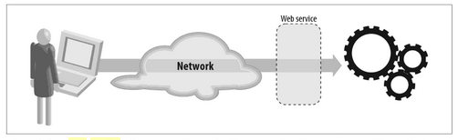
Fig 1: Sample process of a typical Web Service

Based on Figure 1 and figure 2, web service is typically an abstraction layer that is positioned between the application code and the user of that code. The position separates the platform and the programming script being used in the application [2]. The layer implies that any programming script that supports the web service can access the application's functions. For instance, HTML website would offer service to publish, manage, search and retrieve contents through exertion of standard protocols and data formats of HTTP [1]. On the other hand, client application services also referred to as web browsers do understand these standards in a bid to offer interactions that support services such as online ordering, sending and viewing contents [1].
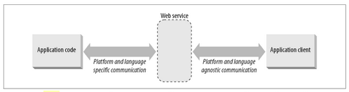
Fig 2: Web service Abstraction Layer

SOAP, REST and GraphQL Web are some of the numerous techniques that offer modern web services. This research paper analyses, compares and contrasts the three web services as well as examining their principle benefits and drawbacks.

SOAP

Simple Object Access Protocol (SOAP) provides easily formatted protocols for sending and receiving message contents via web services and the client application interface. The SOAP service specifications integrate a simple XML-based envelope for the message to be exchanged using a collection of procedures for interpreting an application and platform-specific data types into XML representations [2]. The presentation literally implies that there is a strong connection between XML and SOAP given the underlying aspects of SOAP using XML standards such as Schema, Namespace for its definition and functions. The SOAP envelope element defines XML document structure header, header block, SOAP body and message block [3].

The Header element contains header information and other authentication credentials that can be utilised by the calling application. By default SOAP messages include variables that can store simple types of data such as strings and numbers and in some cases be a complex object type [4].

<xsd:complexType>
<xsd:sequence>
<xsd:element name="Hello World" type="string"/>
<xsd:element name=" World Description" type="string"/>
</xsd:sequence>
</xsd:complexType>

For example, when sending a structured data type that is collaged with 'Hello Word' and ‘World Description', then we can define the complex as defined in the snippet above. The complex object type defined by tag <xsd:complexType> element which also suggests that all required elements of the structure together with their respective data types hence defined in the complex type set. Conversely, the Body structure comprises call and response information, which is actual data sent between web service and the client application, as shown in the snippet below [4].

<soap:Body>
<GetWorldInfo>
<WorldName>Web Services</WorldName>
<WorldDescription>This is SOAP</WorldDescription>
</GetWorldInfo>
</soap:Body>

Representational state transfer (REST)

REST entails a web service with provision of standards between applications and its connection to web services such as the HTPP, thus allowing seamless communication with each other [5]. The service suggests a sequence of constrictions on the ways a server and client application ought to interact. RESTful systems are attributable to stateless and distinct aspects of client and server. The separation implies that the scripts from the client side can be modified whenever without affecting the operation of the server, whereas the script on the server side can also be altered without affecting the operation of the client [5].

POST http:///rest-book-rent.org/order HTTP/2.0
From: abc@yahoo.com
Title: Web Services
The client will get back a URI:
http:///rest-book-rent.org/order/002

REST has procedures that define the way web standards such as URLs and HTTP are supposed to be utilised. The procedure allows REST applications to assign every web service element to a unique global ID, communicate stateless, exert standard techniques, connect processes together and offer applications with various representations. REST provides standard methods such as GET, PUT, POST, DELETE to the HTTP operations while offering CRUD services directly. For example, RESTful URLs specify a location where the resource can be found and accessed using a unique ID that is included in the URL metadata for the URN; the URL can be modified, but the URN remains unchanged and accurate as shown in the snippet above. The payment aspect of the URI specifies the way to send that payment in the next client post [6].

GraphQL

GraphQL is a query language that offers server and client side query scripts for APIs and runtime into an application programming interface by loading data from a server to a client [7]. This web service has a specification that communicates with an API over HTTP in order to post a query to an HTTP endpoint other than calling a different HTTP endpoint for different resources. The web service is specifically designed for web and mobile applications using HTTP clients that allow them to make API calls to fetch exactly the information that they require from their backend APIs [8]. Ideally, the GraphQL client requests can be created from user HTTP clients using JSON request/response format. On the other hand, the GraphQL query functions effectively via a common interface between the client and the server by fetching data and manipulating them using a response format that is described in the query and defined by the client rather than the server; also referred to as client-specified queries as shown in Figure 3 [9].
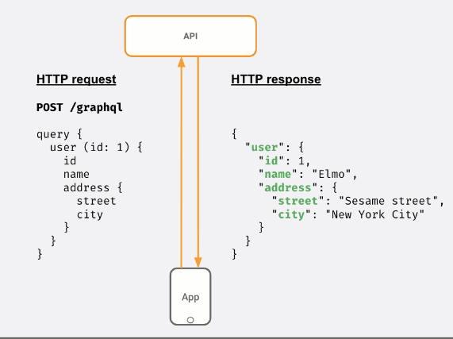
Figure 3: GraphQL API Call

Comparison and Contrast between these Web Services

Comparison

The most apparent comparable attribute between the three web services is that all offer scripts that connect the server and client-side application interface. Perhaps, SOAP and REST link to two applications through server-side data that are computer and human-understandable. All the three web services also use HTTP protocols and data exchange methods such as GET, POST, and DELETE as well as use other protocols such as the Simple Mail Transfer Protocol (SMTP). As such any of the three web service approaches can be applied to design and develop API architecture and communication protocol application for electronic mail transmission that uses SMTP [10]. Both SOAP and GraphQL not only use single endpoint URLs to get and alter the data, but also have strong data typing capabilities, GraphQL and SOAP protocol can declare data types explicitly; thus ensuring better communication between applications [10, 11].

Endpoints in the REST technique as well as files in the GraphQL are similar in regard to calling functions on the server. Besides, both REST and GraphQL normally depend on framework and libraries to manage the reality of networking boilerplate and have an idea of a resource, specifying IDs for those resources as well. REST, SOAP, and GraphQL can return JSON data in the request [12]. Both GraphQL and REST are specifications for building and using APIs thus both retrieve resources by pushing queries, and returning JSON data in the request. Also, REST endpoints are the same as those of GraphQL fields since they are entry points into the data that call functions on the application server [14].

With several similarities in place, these web services can perhaps be collaged to create a robust web service framework. For instance, SOAPREST framework can be used to design web service endpoints that are compatible with SOAP and REST invocations. In this case, a SOAPREST endpoint is specified as a SOAP web service utilising the WSDL, though will accept REST invocations and thereafter respond based on the way a request is invoked [13]. Besides, implementing or layering GraphQL with REST API creates a new dimension to backend capabilities. The merger can help the web application to benefit from GraphQL internally whereas subjecting the REST process outwardly as a public API for user interface. Further, the GraphQL2REST combines the similarities using Node.js to read GraphQL schema and a manifest file to spontaneously generate an express router with fully RESTful HTTP routes. The technique can be installed on a GraphQL server and create a REST endpoint dynamically at runtime while effectively designing and customising the REST API, which also is hosted on the top of an exceptionally existing GraphQL layer. This hybrid web service would filter parameters in entire REST endpoints and let the client to filter entire fields of response [14]. Additionally, incorporating GraphQL API on an existing REST APIs and server-side allows the application and web service to have robust architecture without writing different endpoints or possibly waiting on server-side modifications [15].

Contrast

Differences between the three web services are diverse; however, the differences can be identified and determined based on their script structure and style, security, functions, as well as performance. In terms of performance, through a systematic mapping, Heredia established that the performance of the three web services differed based on several conditions such as speed of message exchange and better performance. GraphQL has a faster response rate and enhanced performance than SOAP and REST [10]. REST is not only fully compatible with JavaScript-based applications, but also faster than SOAP. As such, if an application is load-intensive, REST and GraphQL can be preferred to SOAP. GraphQL can exhibit enhanced performance when the amount of queries required to be lessened to the absolute minimum. Literally, GraphQL single query can address several resources and considering that in GraphQL, data is defined on the client-side, which places the approach in a better position to reduce cases where dependency between the client system and the server do not exist [16].
Generally, with GraphQL and REST being the newest web services, it is evident that GraphQL contains improved efficiency given the approach's ability to reduce the number of endpoints and obtain all the required data with one call and format the information in JSON for fast retrieval. GraphQL also includes transport-layer aspects that allow its services to exchange data across platforms and protocols such as HTTP. Web-Sockets, and HTTPS as well as TCP [17]. Besides, as compared to numerous endpoints in REST, GraphQL sends entire queries to one endpoint such as HTTP POST with static schemas. By contrast, GraphQL lets its users to define schemas for inspection and verification; when REST services often return several unusable data collaged with relevant information, typically as an outcome of various server queries. The inefficiencies perhaps increases the duration the client takes to return all the required data [17].

In regard to script style, structure, and security, SOAP web services exert XML to communicate whereas REST and GraphQL use JSON format. Also, there is no requirement for an extra library for REST API, web service. SOAP with SSL, additional configurations are needed in the application server. The XML SOAP envelope are embedded with null values; however, when using REST or rather GraphQL JSON, these values are not necessary SOAP receives security authentication only in the request body; in REST API, its permissible to authorise authentication to the web URL [10]. Further, each GraphQL server consists of two key sections, which regulate the way it functions; for example, a schema and resolution functionalities. Ideally, such a schema is fairly easy given its ability to classify the application into three forms, which comprise; the Author, Post and Query. The query essential plays the role of marking the entry point into the schema [18].

In terms of data fetching, SOAP functions with the two typical functions that are GET and POST, whereas GraphQL leverages requests data by querying from the server and mutations changing the data and on the other hand, REST requests data from the server using GET, PUT, POST, DELETE. Security aspects for SOAP efficiently support WS-security and SSL and on the other hand REST and GraphQL supports SSL and HTTPS but not WS-security. SOAP is only a protocol and thus cannot be cached in contrast with REST and GraphQL, which are architectural style and query language respectively; they can also be cached. In regard to payload handling, GraphQL and REST require no knowledge about the API, by contrast, SOAP uses a strict communication contrast and requires knowledge of everything prior to performing any interaction. Last but not least, SOAP contains an in-built ACID compliance to mitigate anomalies. However, GraphQL and REST have integration issues with ACID compliance [16]. Generally, SOAP handles the entire application logic using multiple collections of interfaces and is best for performing operations. In contrast REST is frequently exerted by the developer to expose public or partner APIs across the internet. Graph is not limited by any particular protocol [19]. While REST is designed using files, GraphQL on the other hand, is created using graphs. Besides, REST is different from GraphQL based on how it changes the application developer’s experience of creating and consuming an API [13].

Principle Benefit and Drawbacks

SOAP Benefits and Drawbacks

SOAP has several benefits among them the ability to isolate the encoding and communications protocol from the runtime environment. SOAP is easy to implement and use and can be exerted to synchronise multiple protocols in web service application. Besides, SOAP runs above HTTP and mitigates firewall issues. For instance, if protocol HTTP is utilised as the protocol binding, an RPC call is automatically assigned to an HTTP request thus, the RPC response is assigned to an HTTP reply [20]. In terms of drawback, SOAP does not offer modern features that supports developers to upgrade to SOAP API platform. Besides, it provides only a single profile data retrieval given bundles of order data are only present in a particular request type. As such, orders retrieval might need two requests based on integration architecture. Only offer XML strict formatting. SOAP has been cited to be slower than other types of web services because of its exertion of a detailed XML format. Further, SOAP is limited to pooling thus cannot allow concurrent client use of the services of one server. SOAP does not have service and event alerts in case HTTP is utilised for the transport. SOAP has weak cross-platform support, which is usually limited with the programming language of the application. For instance, SOAP can fully support python and PHP, however, is weak for Java and .NET applications [20].

REST Benefits and Drawbacks

REST is rich in benefits such as integrated with aspects that seem to solve challenges that perhaps SOAP could not manage. For instance, in cases where bandwidths are limited and embedded with exploding endpoints challenges, REST is incorporated with every resource beneath a specific endpoint to eradicate this problem [16]. REST is extremely scalable, flexible and portable in regard to protocol given the web service ability to separate between client and server. The flexibility and portability offered by REST allows developers to easily migrate data from one server and platform to another. Another specific advantage includes the capability for the REST to process instances explicitly and with the first URI, the client does not need routing data. Further, REST has low resource utilisation, simple to design, build, and adapt, clients can possess a generic listener interface for application alerts [21]. In terms of drawbacks, REST protocol does not inherently support server-initiated notifications (peer-to-peer), which are frequently needed for an efficient web service provider. This deficiency makes REST application call-backs to need an external support of application-level design patterns such as Web-hooks [22]. REST request is latent for request processing time and bandwidth usage, particularly GET, which does not appropriately application that stores and exchanges huge amounts of data. Last but not least, REST APIs largely rely on headers for state; for instance, to route incoming requests to the same backend server, which manages the preceding update, or perhaps for verification [23]. The situation lets the header use to be difficult and only joins the API to HTTP as a transport [23].

GraphQL Benefits and Drawbacks

In regard to advantages, GraphQL contains syntax, which defines the way of querying the data, and it’s normally exerted to load data from an application server to a client-side in a Graph way. This framework allows clients to specify precisely the type of data it wants. GraphQL creates simplicity in regard to aggregating data from various sources. Further, it helps developers to create complex applications that specifically utilise a type of web systems to describe data. GraphQL effectively helps developers to migrate from a monolithic backend system to a microservice structure system by handling communication between multiple microservices and merges them into one GraphQL schema [24]. Also, each microservice describes its own GraphQL schema and its own endpoint. One GraphQL API gateway can effectively consolidate entire schemas into a single global scheme as illustrated in Figure 3 [25].

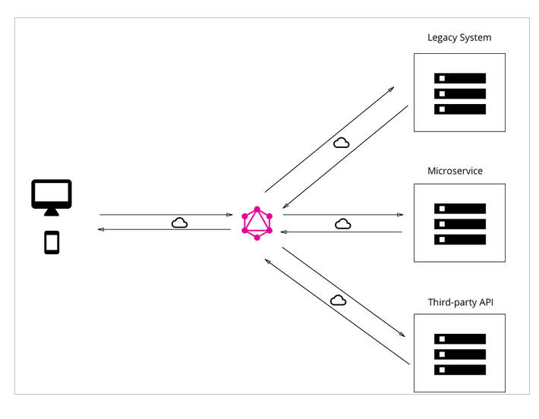
Fig 3: GraphQL combining data from various sources into a single API

Besides, specific benefits contained in GraphQL such as detailed error messages, the web service offers additional operations in APIs to perform CRUD, provides rapid system prototyping so that s single API endpoint can serve as a data proxy between the user interface and the server as well as simpler coding with the data right next to interface. Developers can share scripts while worrying less about error handling; and to enhance security, REST architecture does not disclose the public part of the requested data [25]. Last but not least, GraphQL attributes such as introspection permits for navigation into exploring schema in a bid to guarantee the application being supported only queries for what is realistic in an appropriate format. Then again, developers can view what the schema can ask and the way the data is configured. As such, developers can effortlessly add new fields to the existing queries. It’s not necessary to validate the data format, given the ability of Graph to automatically perform the tasks for developers; developers would only write resolvers in the way the data will be received [24].

Despite GraphQL being a decent alternative to REST, it poses some drawbacks such as performance problems with complicated server and client-side queries. For instance, when allowing the client to request exactly what they wanted, the web service can encounter performance problems in case the client queries for myriad fields at once [25]. Also, GraphQL has web caching complexity on databases or client level since the approach does not depend on the HTTP caching techniques that perhaps allows storing data of a request. It is essential to note that caching assists to eliminate the quantity of traffic to a server by storing often accessed data close to the client interface [24]. Given that GraphQL only has one endpoint, with multiple queries, it’s difficult to exert such type of caching with a GraphQL API. In terms of file uploading, GraphQL does not comprehend well with files uploading features in its specification [25].

Bibliography

[1] D. T. P. K. James Snell, “Web Service Fundamentals,” in Programming Web Services with SOAP: Building Distributed Applications, Carlifornia, O'Reilly, 2002, pp. 1-3.

[2] C. J. Petrie, “Informal Defination of Services and Web Services,” in Web Service Composition, Bastrop, Springer, 2016, pp. 1-7.

[3] F. Marchioni, “Developing SOAP-based web services,” in Practical Java EE Development on WildFly: Quickstart guide for developing, Rome, ITBuzzPress, 2018, p. 205.

[4] Paik HY, “Web services–soap and WSDL,” in Web Service Implementation and Composition Techniques, Cham, Springer, 2017, pp. 25-66.

[5] C. J. Petrie, “REST Services,” in Web Service Composition, Bastrop, Springer, 2016, p. 25.

[6] O. Eyuphan, “A General Overview of RESTful Web Services,” in In Applications and Approaches to Object-Oriented Software Design: Emerging Research and Opportunities, Pennsylvania, IGI Global, 2020, pp. 133-165.

[7] B. Samer, Learning GraphQL and relay, Birmingham: Packt Publishing, 2016.

[8] P. Márton, “GraphQL Overview - Getting Started with GraphQL and Node.js,” Rising Stack, 09 July 2015. [Online]. Available: https://blog.risingstack.com/graphql- overview-getting-started-with-graphql-and-nodejs/. [Accessed 23 December 2020].

[9] L. Byron, “GraphQL is changing the way modern apps are built,” Hasura, 12 January 2020. [Online]. Available: https://hasura.io/graphql/. [Accessed 23 December 2020].

[10] S. Heredia, “Comparative Analysis between Standards Oriented to Web Services: SOAP, REST and GRAPHQL,” in International Conference on Applied Technologies, Cham, Springer, 2019, pp. 286-300.

[11] Da14, “The Ultimate Guide to API Architecture: REST, SOAP or GraphQL?,” Da14, 02 July 2018. [Online]. Available: https://da-14.com/blog/ultimate-guide-api-architecture- rest-soap-or-graphql. [Accessed 12 December 23].

[12] S. Stubailo, “GraphQL vs. REST,” Apollo Blog, 27 June 2017. [Online]. Available: https://www.apollographql.com/blog/graphql-vs-rest-5d425123e34b/. [Accessed 23 December 2020].

[13] NEU, “Combined SOAP and REST Web Service,” Northeastern University, 1 January 2020. [Online]. Available: https://www.ccs.neu.edu/home/kenb/soaprest/. [Accessed 23 December 2020].

[14] R. Mor, “GraphQL API or REST API? Why not have BOTH?,” Medium, 30 April 2020. [Online]. Available: https://medium.com/swlh/graphql-api-or-rest-api-why-not-have- both-c4171e68900a. [Accessed 23 December 2020].

[15] P. Otemuyiwa, “Layering GraphQL on top of REST,” Apollo Blog, 18 September 2018. [Online]. Available: https://www.apollographql.com/blog/layering-graphql-on-top-of- rest-569c915083ad/. [Accessed 23 December 2020].
[16] C. Oggier, “How fast GraphQL is compared to REST APIs,” 21 May 2020. [Online]. Available: https://core.ac.uk/download/pdf/323461807.pdf. [Accessed 21 May 2020].

[17] K. Doyle, “A head-to-head GraphQL vs. REST performance faceoff,” TechTarget, 20 November 2020. [Online]. Available: https://searchapparchitecture.techtarget.com/tip/When-GraphQL-wins-in-a-GraphQL- vs-REST-performance-comparison. [Accessed 24 December 2020].

[18] G. a. M. T. V. Brito, “REST vs GraphQL: A Controlled Experiment,” in IEEE International Conference on Software Architecture (ICSA), Brasil, 2020.

[19] P. Logan, “REST, SOAP, GraphQL — Gesundheit!,” Medium, 22 September 2018. [Online]. Available: https://medium.com/better-practices/rest-soap-graphql- gesundheit-6544053f65cf. [Accessed 24 December 2020].

[20] J. D. I. Chwan-Hwa (John) Wu, “XML-based Web Services,” in Introduction to Computer Networks and Cybersecurity, New York , CRC Press, 2016, pp. 131-139.

[21] M. Little, “What Are The Drawbacks Of REST?,” InfoQ, 2013 MAy 13. [Online]. Available: https://www.infoq.com/news/2013/05/rest-drawbacks/. [Accessed 24 December 2020].

[22] V. Kumari, “Web Services Protocol: SOAP vs REST,” International Journal of Advanced Research in, vol. 4, no. 5, 2015.

[23] F. H. a. E. Ramadani, “Web Services: A Comparison of Soap and Rest Services,” Modern Applied Science, vol. 12, no. 3, pp. 175-183, 2013.

[24] Altexsoft, “GraphQL: Core Features, Architecture, Pros and Cons,” Altexsoft, 23 March 2019. [Online]. Available: https://www.altexsoft.com/blog/engineering/graphql-core-features-architecture-pros-and-cons/. [Accessed 24 December 2020].

[25] How to GraphQL, “GraphQL server with a connected database,” How to GraphQL, 15 January 2020. [Online]. Available: https://www.howtographql.com/basics/3-big- picture/. [Accessed 24 December 2020].

