The comparative analysis of the representation of cultural or national identities in two film or television texts from Scotland, Ireland and/or Wales.
The two film texts chosen are; 71 (Demange, 2014) and Angel (Jordan, 1982). Both films reflect the unrest and uncertainty brought to both sides of the troubles in Ireland during the latter part of the twentieth century. Firstly we need to understand what the troubles meant to us this side of the Irish Sea here in Wales.
Macnab (2008) says ‘The predominant feeling you had if you were my age was that you [as a Brit] knew about the conflict – it was a dark shadow, but it didn't really impact you, .... Paul Greengrass (director of Bloody Sunday [2002] and screenwriter of Omagh [2004]) recalls of the indifference that many of his generation in the UK felt toward events across the water.’
We were isolated here in Wales, we only knew what we were being told by a very bias media, which in effect was and still is today controlled by the British government. So there was no way of knowing the facts about what was happening in Northern Ireland and what the UK government in the name of justice and the British people were up to, or for that matter what the ordinary solider was going through and the things they were being asked to do. The Irish republicans saw it as a struggle against the ongoing oppression by the British.
Both 71 (2014) and Angel (1982) are very different films, but both deal with the same subjects. They both deal with people being oppressed, the Irish on one hand by the British invaders and on the other hand Irish against Irish. Also you had the Catholics (Republicans) and Protestants (Loyalists) fighting each other with the British soldiers stuck in the middle.
Smith (2015) says’ The logic of sectarian violence, which makes Boolean algebra look like tick-tack-toe, is the vertigo-inducing force behind a gripping first film about Northern Ireland’s 30-year war between rival factions of pasty-faced Christians.’
The soldiers on all sides were expendable, they were cannon fodder, a means to an end for leaders on all sides. As in all wars and conflicts it’s not the leaders, or the politicians that fight, but the ordinary people. People are just people when you take away the uniforms and politics, and we see an example of this in 71 (2014).
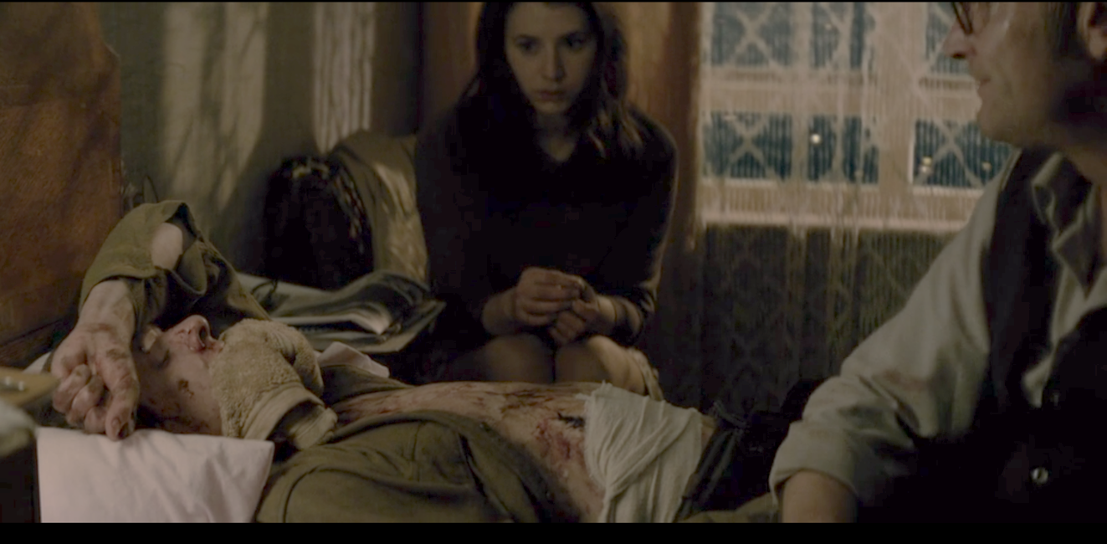
Fig 1. (Demange, 2014)
The above scene is an example of what happens when you take away the politics and uniforms, people are just people. The character Eamon played by Richard Dormer shows compassion towards the rooky solider Gary Hook played by Jack O’Connell. Eamon identifies with Hook because he once served in the army.
Smith (2015) explains, ‘ “Whose side are you on?”.... The question is being asked of a Catholic who has been aiding a Protestant soldier recovering from the effects of a Protestant bomb originally stolen from Catholics.... The question is being posed by a Catholic who wants to kill another Catholic for not letting him kill enough Protestants’
But Eamon doesn’t forget his beliefs and goes on to tell Hook how it really is. He tells Hook that he’s just seen as a piece of meat by his superiors that he’s expendable.
It’s as straight forward as snobbish upper class people, ordering subservient people, to kill the underprivileged, what Hook has been ordered to do is just another lie.
After seeing this film for myself, I might have to agree somewhat. The troubles or struggle for the Irish people, was not just against the British wanting to hang on to power in Northern Ireland by any means, but against themselves.
According to Dorney (2015), ‘The conflict in Northern Ireland was generally referred to in Ireland during its course as ‘The Troubles’ – a euphemistic folk name that had also been applied to earlier bouts of political violence....This name had the advantage that it did not attach blame to any of the participants and thus could be used neutrally...Republicans, particularly supporters of the Provisional IRA referred to the conflict as ‘the war’, and portrayed it as a guerrilla war of national liberation.... Unionists and the British government referred to the long running political violence as a law and order problem of ‘terrorism’.’
Both sides were being deliberately manipulated by the British, being turned against one another, so that they the establishment, could hang on to the diminishing and outdated last remains of the British Empire. And even though they have relinquished some power to the six counties that make up Northern Ireland, they still see it as part of the old Empire.
Army intelligence in 71 (2014) are playing both sides against each other, while the high-ranking officers keep a safe distance and get the lower ranks to do the dirty work for them.
It’s all about deniability, the officers tell the army intelligence sergeant, that Hook is his problem and to deal with it. Without actually saying it, he implies that Hook should be got rid of, killed.
The struggle is not only just against the occupying forces (the British) but also within the rank and file of the IRA themselves.
The younger generation see the older leaders as being irrelevant and start to go it alone, fracturing the cause, splintering the IRA. There’s also the struggle between the Northern Irish people, the religious and political divide between the republicans and nationalists, which suites the British because it’s all about dived and conquer.
71 (2014) shows the vulnerability and inexperience of the young soldiers on both sides. They are willing to follow orders no matter what the consequences.
But this leads to their own down fall and ultimately puts Hook in the position he now finds himself, which is effectively behind enemy lines.
According to Smith (2015), ‘Separated from other troops during a routine police ass-kicking session in a Catholic neighbourhood, he finds himself an Odysseus trying to sail home through a sea of cement and Naugahyde.’
Maybe it could be seen as a false sense of loyalty on their behalf, because they are just pawns being manipulated. Men and Women are being use by the faceless political leaders on both sides.
It becomes quite clear that all sides are just as unscrupulous and unethical as each other and are willing to do anything to achieve their agenda in Northern Ireland and the people on the ground are expendable no matter what.

Day to day life during the troubles carries on, people are unwilling to be affected by it, but unfortunately, the troubles does rear its ugly head, especially in the case of musician Danny played by Stephen Rea in Angle (1982). Where he witnesses firstly the murder of his band’s manager Ray, played by Peter Caffrey and secondly the gunning down of a young deaf mute girl Annie, played by Veronica Quilligan.
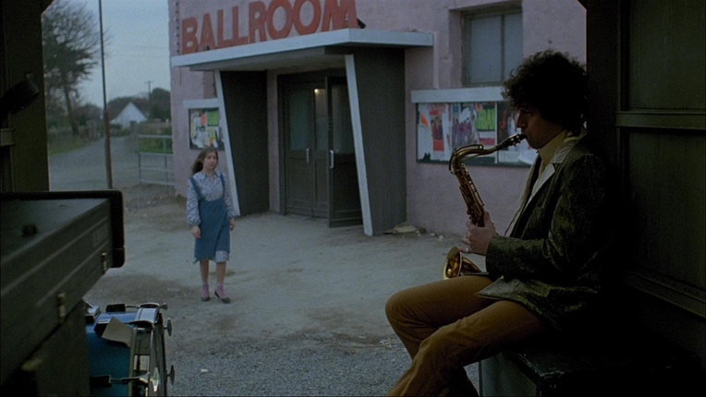
Fig 2. (Jordan 1982)
Chambers (2016) says ‘....it is implied that the extortionists/murderers are loyalist paramilitaries.’
According to Hill (2006) ‘Drawing loosely on the murders of the Miami Showband by the Ulster Volunteer Force (UVF) in 1975, Neil Jordan’s Angle also shows loyalist paramilitaries, even though the film’s vagueness about social and political detail means that it is commonly regarded as referring to IRA violence’
The troubles however do have an affect on the lives of ordinary people, people that you wouldn’t normally think it would. But Danny has a baptism of fire, firstly by seeing his manger Ray killed and then this young girl he’s befriended.
His world is in turmoil he’s only a musician and up until now kept his distance for this sort of thing, but he’s so enraged by this event, he sets out to avenge the death of the innocent Annie, shot dead by the paramilitaries.
After committing such an act can these paramilitaries continue to claim to be fighting for and protecting the innocent, people like the young girl they just killed in cold blood. Or are they just thugs, gagsters or even common criminals.
Danny begins to see them for what they are; he becomes the avenging angel of this young innocent girl, even though he’s only had a brief encounter with her. Maybe he feels responsible for her, maybe it’s about the ordinary person not just standing by anymore, but taking some control back. He wants justice for her and Ray and maybe some redemption for himself, because he feels he’s let both of them down, by not being able to stop the paramilitaries.
He’s about to enter a very unfamiliar world, a world which up until now he’s not really wanted to get involved in, or even acknowledge. Maybe its time for him to face up to the reality of his surrounds, instead of hiding away behind his music.
Barton (2004) states that, ‘Danny goes on his quest, the more it seems that he is leaving his previous quotidian existence behind him and entering a metaphysical dream world,...’
The more he gets involved the more he becomes like the very people he despises. Hill (2006) explains that, ‘However, in substituting the sax for the gun, Danny also becomes a figure of moral ambiguity, succumbing to the very violence he wishes to oppose.’
Danny eventually gets his revenge but at what cost, because now he’s no better that the very person that gunned down and killed his manager Ray and the young girl Annie. Has he become just like them and if so at what cost to himself and the people around him. It did affect his relationship with his girlfriend Deirdre played by Honor Heffernan.

Both 71 (2014) and Angle (1982) have definitely opened my eyes to this very complexed subject. The question still stands today who’s right or wrong are the republicans and loyalists as bad as each other.
Wikan (2018) says ‘Is One Man's Terrorist Another Man's Freedom Fighter,’ or, are they all including the squaddie just pawns in a very sophisticated political game. Both Hook and Danny seemed to have found themselves in a situation neither of them wanted to be in, but one they were forced into by unfortunate circumstances. Just like the people of Northern Ireland.
Word Count 1698

Reference List

Barton, R. (2004) Irish National Cinema. New York: Routledge.

Chambers, J. (2016) 60 Films about the Troubles/Northern Ireland. Available at:
https://belfastchildis.com/2016/07/31/60-films-about-the-troublesnorthern-ireland/
(Accessed: 8 January 2019)

Dorney, J. (2015) The Northern Ireland Conflict 1968-1998 – An Overview. Available at: http://www.theirishstory.com/2015/02/09/the-northern-ireland-conflict-1968-1998-an-overview/#.XDR8D8_7RBw (Accessed: 8 January 2019)

Hill, J. (2006) Cinema and Northern Ireland. London: BFI.

Macnab, G. (2008) Classic films with the Troubles in mind. Available at: https://www.independent.co.uk/arts-entertainment/films/features/classic-films-with-the-troubles-in-mind-795354.html (Accessed: 2 January 2019)

Robey, T. (2014) '71, review: 'Blindingly Strong'. Available at: https://www.telegraph.co.uk/culture/film/filmreviews/11151420/71-review-blindingly-strong.html (Accessed: 4 January 2019)

Smith, K. (2015) Why the IRA film ‘’71’ is a cut above so many others. Available at:
https://nypost.com/2015/02/25/why-the-ira-film-71-is-a-cut-above-so-many-others/ (Accessed: 8 January 2019)

Wikan, VS. (2018) Is “One Man’s Terrorist Another Man’s Freedom Fighter”? Available at: https://www.e-ir.info/2018/11/29/is-one-mans-terrorist-another-mans-freedom-fighter/ (Accessed: 8 January 2019)

Image List

Fig 1. Screen Grab, 71 (Demange, 2014)

Fig 2. Screen Grab, Angel (Jordan, 1982)

