The 5 Key Principles

Introduction

Enquiring and learning have become two very different things. Enquiring to me, is a child’s desire and want to be creative and to achieve. Where learning is a lot more rote with a more robotic feeling that’s forced. Now, whether I’m looking at this in just a school context is beside the point as that’s how myself and a lot of other people see learning. Yet this shouldn’t be the case. The enquiring mind is so beautiful and interesting that learning needs to make use of it, rather than it being the other way around. As someone who has had the highs and the lows of education it’s something not only interesting but very important to me. I believe I have an enquiring mind yet when it comes to learning I fall apart. I enjoy “learning” when learning is interesting and when I engage with the topic, in effect using my enquiring mind which brings me onto what this e portfolio is all about. Creativity is killed by schools as shown by this reference (YouTube, 2011). Children need to be excited by education and look forward to learning, with these 5 key concepts imputed correctly they will take 21st century learning to the next step.

There are 5 key concepts of learning. These are the Leonardo effect, the mantle of the expert, scientific enquiry, the taxonomy of play and the outdoor classroom.

The Leonardo effect puts the child at the centre of the learning, there is a huge emphasis on play. Instead of the child being taught by a teacher, the teacher is more there to support the child where needed. The Leonardo effect links the arts and sciences instead of seeing them as separate, almost like one powerful tool together to perform the best possible outcome (Griffiths, 2021)

There are 4 stages. Firstly, the research or observation of a new area of study. Secondly, experimentation of the new topic through images, visual or even experiments Thirdly, applying previous skills and knowledge as a base to apply to the new topic to express their thoughts feelings and understanding differently. Finally, an analysis of what the pupils have archived and how it can be used as a new skill. (Griffiths, 2021)

Mantle of the expert –

A dramatic style of teaching, where all the pupils imagine themselves as ‘experts’. The mantle of the expert once again puts the child at the centre of the learning that in practice could use the hole school curriculum. The children are in charge of their own learning and has a massive increase on a child’s attainment. (Griffiths, 2021)

4 stages
- Pre-planning- the main ideas are pit together to make sure the mental of the expert facilitates learning
- Mapping – plan a general sense of where the idea could go, for example will there be different stages, like the different stages in a factory where clothing is made.
- Micro planning – A drama feel different strategies and questions that could be asked are selected
- Storying – so pupils can understand the unveiling of what’s happening more. (Griffiths, 2021)

Scientific enquiry –

Scientific enquiry is more about observation and investigation, these are such things as exploring, testing, looking at patterns, using models, and making things. In this instinct pupils take more control in their own learning by using real life scenario’s and investigations so its purposeful and has meaning to the child (Griffiths, 2021)

The cycle
- Orientation – a hook to create a question or idea
- Prediction – look in depth at the question how can it be solved.
- Preparation – create and experiment or investigation to reach a successful answer
- Investigation – carry out the experiment and show observations
- Evaluation – look into results and discuss a conclusion and further questions that may be raised (Griffiths, 2021)

Taxonomy of play –

- Epistwmic play – when children explore the basic properties of the world
- Ludic play – using their own imagination to come up with their understanding
- Games with rules – more structed play where looking for specific outcomes or results (Griffiths, 2021)

The outdoor classroom –

A very sensory and different approach that involves so many different aspects. The outdoors is a lot more creative then inside. Children are more at ease outside and are more co-operative. (Griffiths, 2021)

Activates can involve more understanding of the world
- Their local area
- Classifying different objects
- Core earth sciences
- Different weathers first hand
- Animals

Theorists

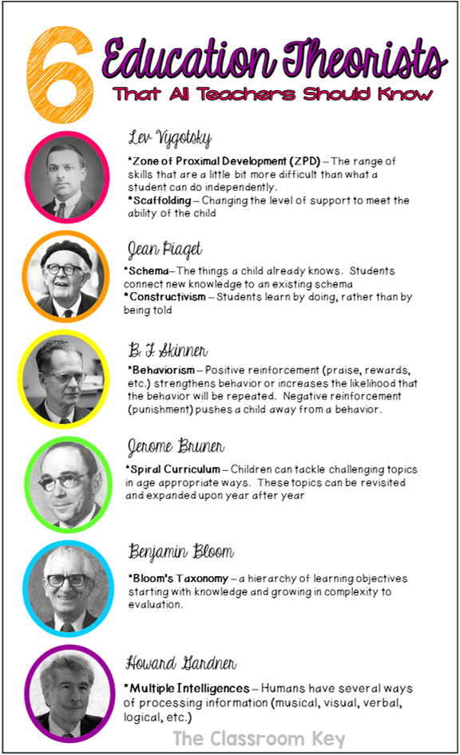

Picture sourced from (elearning infographics, 2015)

“Montessori is a method of education that is based on self-directed activity, hands-on learning and collaborative play. In Montessori classrooms children make creative choices in their learning, while the classroom and the highly trained teacher offer age-appropriate activities to guide the process” (montessori, 2021)

- The Leonardo effect links highly to Montessori’s approach of leaving the child to learn from themselves the teacher steps back and supports. With also links to Piaget with children using what they already knew
- Mantel of the expert is a very hand on approach that supports Piaget through children doing rather than being told, also slightly in blooms higher achy where children can see all steps of a process
- Scientific enquiry looks more at Vygotski challenging the child slightly more
- Taxonmi of play links to Vygotski and his clear support of playful learning.
- The outdoor classroom links to Hardnen in children having different ways of processing information like the different tools there are in an outdoor classroom also to Bruner saying children can tackle topics in age appropriate ways like letting them use knives etc

There are many more such as John Dewey (1858-1952). Dewey had many educational and social theories. One of which believed that people learnt best from a hands-on approach. Dewey was regarded as a 20-century educational reformer, progressive education and liberalism.

For the purpose of demonstrating how these Theories can be demonstrated in a practical context a look at the New Curriculum will demonstrate how the 5 key concepts can be put into policy and practice.

In 2014 the Welsh Government asked Professor Graham Donaldson to review the curriculum and assessment arrangements in schools in Wales.
From this came Successful Futures with the outcome being the
New Curriculum For Wales.

Professor Donaldson talks Successful Futures at UWTSDs Aiming for Excellence’ education conference (University of Wales Trinity Saint David, 2019).

The Minister for Education in Wales, at the time, was Kirsty Williams who stated that Education is changing.
“Our national mission in Wales is to raise standards, raise the attainment of all our children and ensure we have an education system that is a source of national pride and public confidence.” (YouTube, 2021)
What was key to this initiative was the realisation that the current curriculum had become too restrictive, narrow inflexible. Restricting creativity both in teaching and learning.
What is interesting is how some of the educational theories of the last century have been revisited and helped mould a 21 century curriculum.

Donaldson report evidence gathering process.

Picture sourced from (gov.wales, 2018)

Finding of Evidence Gathering

Picture sourced from (gov.wales, 2018)

Below is the Welsh Government website information (gov.wales, 2015).
This sets out the four purposes of the curriculum for Wales.
Directly below is another example of this information (Oxford Education Blog, 2018).
What is interesting is even here there is evidence of how information is displayed.
How information is displayed is crucial to how it is understood.
Educational Theorist John Dewey believed that art and visual cues helped the learner understand the meaning.
The examples below are an excellent example of this.

Picture sourced from (gov.wales, 2015).
Picture sourced form (Oxford Education Blog, 2018).
Picture sourced form (Oxford Education Blog, 2018).

Picture sourced form (Oxford Education Blog, 2018).

There are many different teaching and educational theories which are informed by a vast diversity of learning experiences.
What is interesting is that there are clear links to both old and new educational concepts including the 5 key concepts. These are now evident throughout the New curriculum for Wales.
The emphasis of the teacher being responsible for making the learning accessible to the pupil. Not the pupil having to point out they don’t understand!
The learner is not passive they are at the heart of the learning experience.
The teacher needs to be the EXPERT in how to enable the child to become an independent learner.
This can be achieved by using the 5 Key Concepts.
Evidence of how each of the 5 Key Concepts are linked into the practical application of the new curriculum.

The Leonardo Effect where the emphasis is a Child centred learning approach.
The New curriculum emphasises a child centred learning experience.

The Mantle of Experts where the teaching and learning is a developed through the collaboration of pupil and teacher working together allowing the pupil to evaluate their own learning, aims and objectives.
]
Scientific Enquiry where pupils are allowed to have hands on experience of real world and imaginary concepts which they can question, test and reflect on.

Taxonomy of Play where using their own experiences of life to help inform

Outdoor Play where pupils are able to engage with the real world and relate it to learning skills and knowledge.

In addition to this Wales has introduced a new ALN reform Bill where every pupil has the legal right to access learning (gov.wales, 2016).
Again, it is putting the child/learner at the centre of the educational ethos.
In essence this new bill requires all teaching and learning institution produce teachers who are able to practice the 5 key concepts.
The expectations that teachers are Experts in best practice for ALL.

Conclusion

From my own personal experiences, I found school very hard, and it extremely hard to concentrate. I didn’t find it engaging at all, which if the use of these 5 concepts were in place would be a different story. Teaching needs to be fun for all even the teacher. Teachers need to be given training in order to implement them and the future will look promising.

Bibliography
elearning infographics, 2015. 6 education theorists all teachers should know infographic. [Online]
Available at: https://elearninginfographics.com/6-education-theorists-teachers-know-infographic/
[Accessed 19 07 2021].
gov.wales, 2015. The four purposes of the curriculum for Wales. [Online]
Available at: https://gov.wales/sites/default/files/publications/2018-03/the-four-purposes-of-the-curriculum-for-wales.pdf
[Accessed 19 07 2021].
gov.wales, 2016. New law to transform ALN experience in Wales. [Online]
Available at: https://gov.wales/new-law-transform-aln-experience-wales
[Accessed 19 07 2021].
gov.wales, 2018. Successful Futures. [Online]
Available at: https://gov.wales/sites/default/files/publications/2018-03/succesful-futures-a-summary-of-professor-graham-donaldsons-report.pdf
[Accessed 19 07 2021].
montessori, 2021. [Online]
Available at: https://montessori-nw.org/about-montessori-education
[Accessed 19 07 2021].
Oxford Education Blog, 2018. 4 Things you need to do to prepare for Curriculum Change in Wales. [Online]
Available at: https://educationblog.oup.com/primary/4-things-you-need-to-do-to-prepare-for-curriculum-change-in-wales
[Accessed 19 07 2021].
University of Wales Trinity Saint David, 2019. Professor Donaldson talks ‘Successful Futures’ at UWTSD’s ‘Aiming for Excellence’ education conference. [Online]
Available at: https://www.uwtsd.ac.uk/news/press-releases/press-2019/professor-donaldson-talks-successful-futures-at-uwtsds-aiming-for-excellence-education-conference.html
[Accessed 19 07 2021].
YouTube, 2011. school kills creativity ken robinson. [Online]
Available at: https://www.youtube.com/watch?v=Z1yl0MFYzXc
[Accessed 14 07 2021].
YouTube, 2021. Y Gweinidog Addysg a'r Cwricwlwm i Gymru // Education Minister and Curriculum for Wales. [Online]
Available at: https://www.youtube.com/watch?v=L_sqRCl3Tm0&list=PLTZvaU9CIF5tfIXnHAp-RQnbqSMAEF4wW
[Accessed 19 07 2021].

Griffiths, H. Hutchings, L. (2021) The Enquiring Mind: Creative Approaches. [Lecture] University of Wales Trinity St Davids. Carmarthen Campus. 19th July 2021

Griffiths, H. Hutchings, L. (2021) The Enquiring Mind. [Lecture] University of Wales Trinity St Davids. Carmarthen Campus. 19th July 2021

Griffiths, H. Hutchings, L. (2021) The Enquiring Mind (the outdoor classroom) [Lecture] University of Wales Trinity St Davids. Carmarthen Campus. 19th July 2021

