three Cliff bay

Susan Beer (2007542)
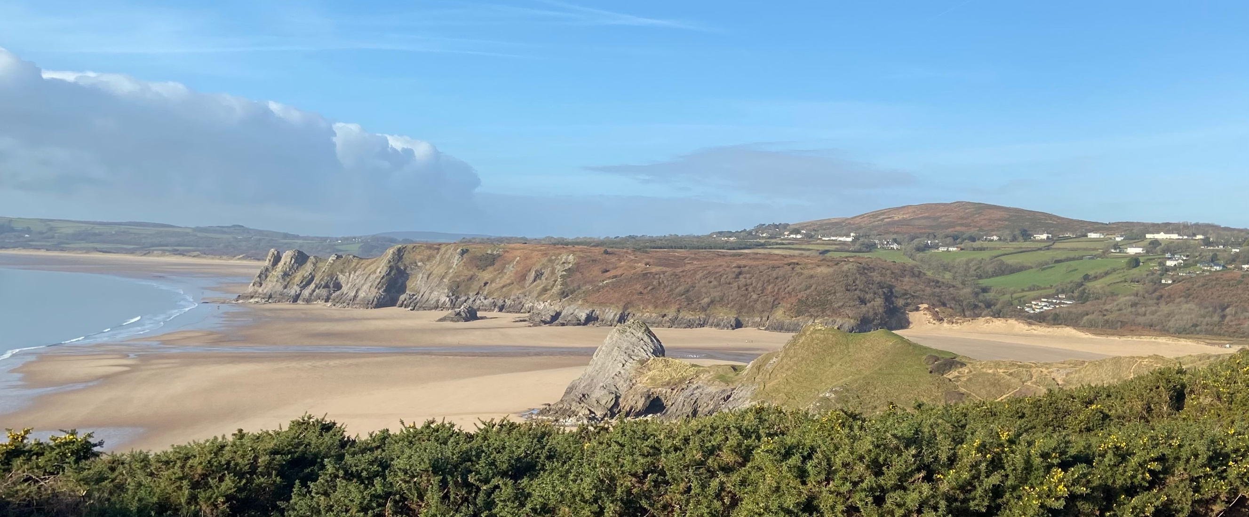

Table of Contents
2 Introduction 2
3 Investigation 4
3.1 Geology 4
3.1.1 The Pennard Pill (the river) 9
3.2 Conservation 10
3.2.1 Plants 10
3.2.2 Animals 12
3.3 Tourism and recreation 14
3.4 Sand dunes 15
3.5 Aeolian transport 16
3.5.1 Sand 16
3.6 Rock pool 17
3.7 Cave 17
3.8 Coastal Processes 18
3.9 Salt Marsh 18
4 Conclusion 19
5 Bibliography 20

Introduction
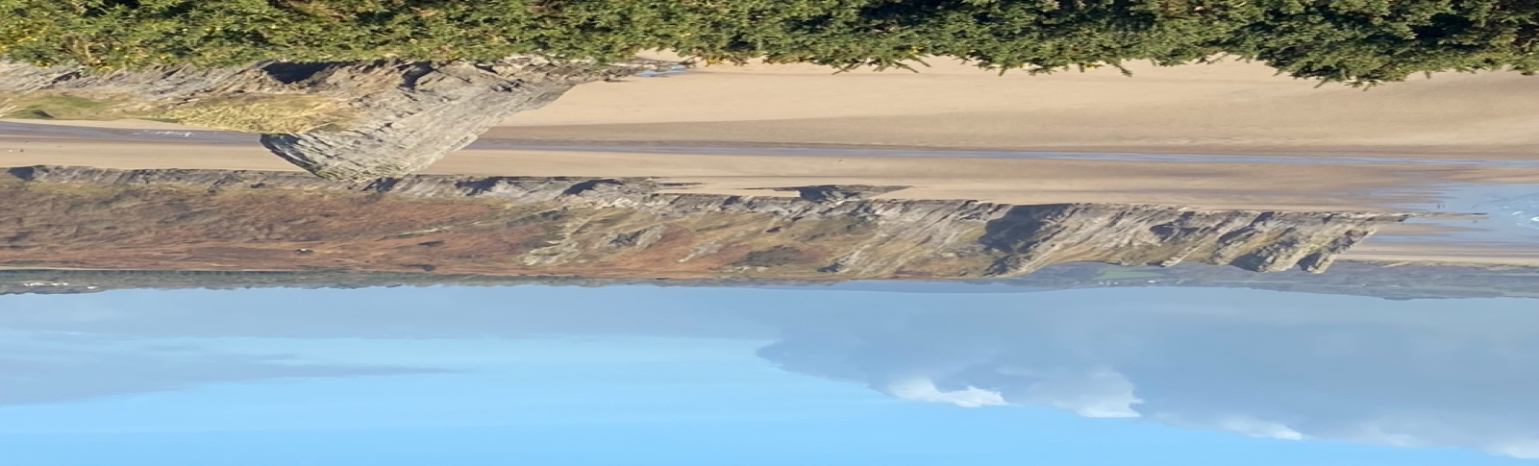
Beer S 1/2/2022
fig 1.1 area of study @Three Cliff Bay 2022
grid ref: ss 5361 8797 postcode SA3 2HD

Three cliff bay is a bay on the south coast of the Gower Peninsula consisting of three cliffs that protrude into the Bay. A large stream called Pennard Pill flows into the sea in the middle of the Bay. There are three beaches that make up this Bay which are Pobbles Bay to the east of three cliffs and Tor Bay to the West. The beaches all separated at high tide but are accessible two each other at low tide on foot over the sands the sea has a dangerous current, so swimming is not recommended unless a lifeguard is present. The RNLI lifeguard is present from July to the begin of September and patrol from 10am till 6pm(visitwales.com14/02/2022) There are sand dunes and salt marsh to the West.

The Three Cliff Bay is effectively part of the inlet of Oxwich bay and has been shaped over millions of years with the sandy beach’s demonstrative of the effects of the sea current. The rock's undercliffs sites make up this rocky landscape.
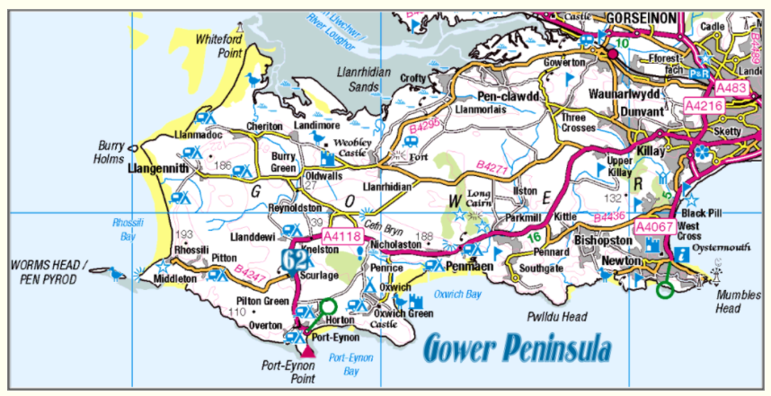
Gower map – OS28/01/2022
The map above is an Ordinance Survey map that shows where Three Cliffs Bay sits in relation to other sites and landmarks on the Gower Peninsular
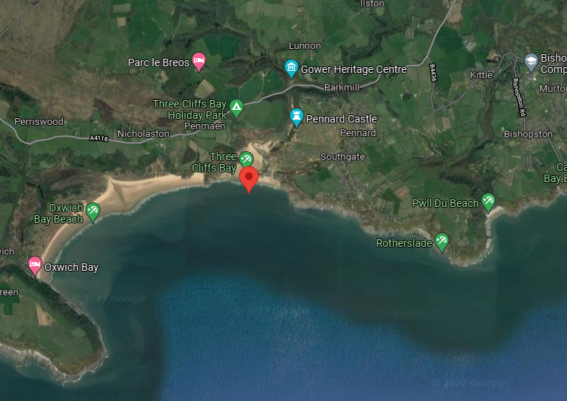
Google maps Satellite view21/01/22

The map above shows a satellite view of the Bay (Rotherslade, Three Cliffs, and Oxwitch) provided by Google maps29/01/2022

The Cliff faces the waves, with the ways approaching at a 90-degree angle making Three Cliffs Bay a swash aligned beach. The sand should be evenly deposited from West to East as there is no net short drift due to the directional impact of the waves. The situation of the Pennard Pill River however impact on the eastern side causes increased erosion meaning the beach may be higher in the West then the East.

Investigation

Geology

The dominant rock type within Three Cliff's Bay is limestone standing at approximately 20 metres high. The creation off the bay is dependent on a fault line that runs through the bay not its geology makes it unique to other bay creation. The fault line exposed weaker sandstone at the back of the bay and this was exploited by the Pennard river and the sea.
(Untitled(weebly.com)29/01/2022)

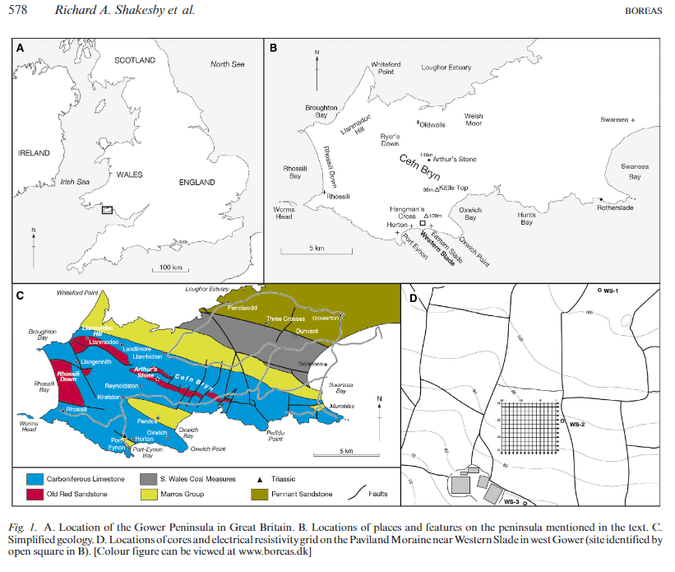
(Shakesby, R)29/01/2022
The series of maps above shows the composition the rock types in the Gower peninsular. The geological map indicates that the area surrounding Three Cliffs if composed of Carboniferous Limestone, Old Red Sandstone and Rocks from the Marros Group.

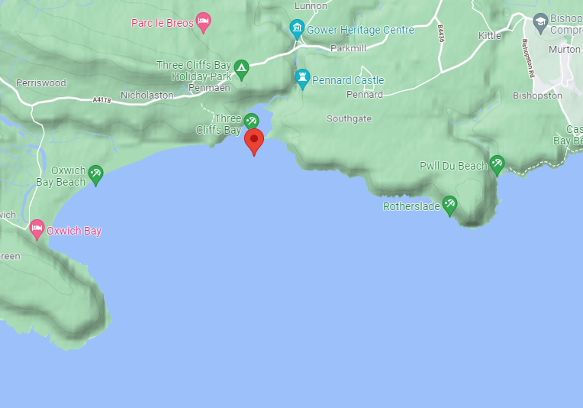
Google maps Terrain view 01/02/2022

The map above shows the relative heights of the terrain, rivers, and inlets of the Bay (Rotherslade, Three Cliffs, and Oxwitch) provided by Google maps

Most people are unaware that such creatures as brachiopods or lampshells an obscure reference to Roman oil-lamp. These are superficially like cockles and mussels, and confined to their having two opposed, hinged shell(valves) these are so entirely different phylum of the animal kingdom
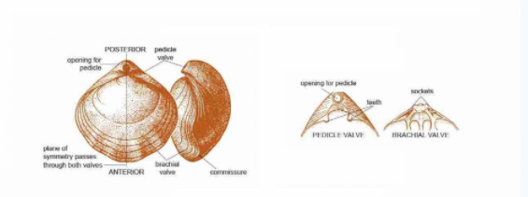
www.bgs.ac.uk

The diagram above was obtained from the British Geological Survey and illustrates the form of a typical Brachiopod (as mentioned in the previous section). These can only be seemed at three cliff bay and should be protected so future generations will be able to see them also.

Subcarboniferous limestone

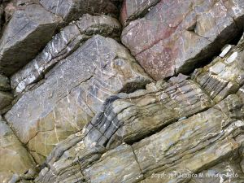
Three Cliffs Rocks - https://natureinfocus.blog10/02/2022

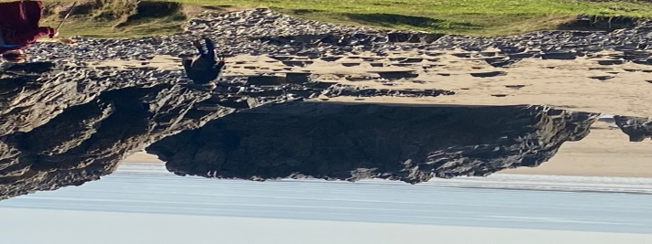
Three Cliff bay (Beer S19/01/2022)

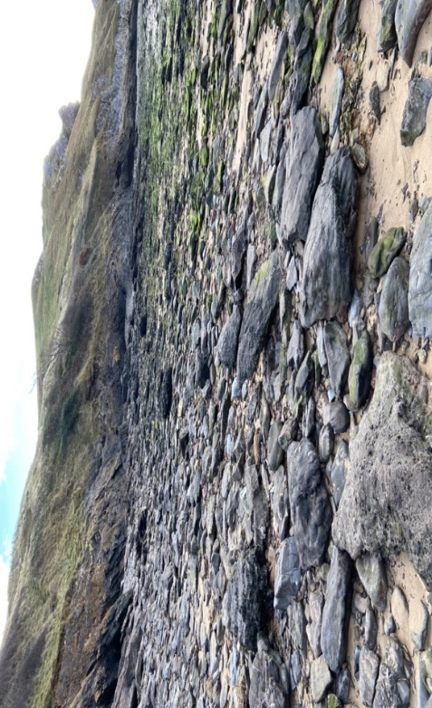
Rock and pebbles at Three Cliff Bay (Beer S 19/01/2022)

Three Cliff Bay Cliffs are constructed mainly from lower Carboniferous Limestone which is a hard rock and shouldn't not be eroded however there lies a fault line or weakness in the rock that is responsible for the erosion, this makes limestone susceptible to freeze-thaw weathering (this is where expansion caused by freezing water in the fissures, causes the gaps to enlarge and the rock to further crack).Limestone is also susceptible to acid erosion owing to the calcium carbonate in its composition. This has resulted in one side of the bay being higher due to the other being pushed down.

A prominent, late Tournai Sian to basal Viséan, transgressive-to-regressive (T-R) cycle spanning the Broﬁscin Oolite, Tears Point Limestone and Caswell Bay Oolite can be seen at the Three Cliffs Bay section both in the facies stacking patterns” (cf. Wright, 1986, 1987)

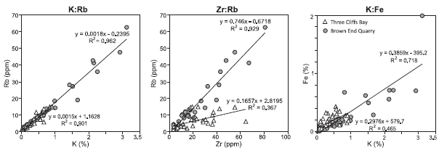
Concentrations of K, Zr, and Fe at three cliffs (Triangles) and Brown End(circles)

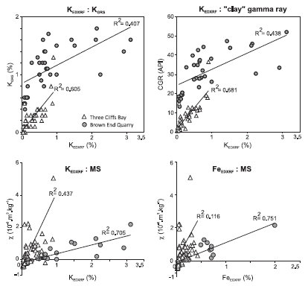

Sandstone has been revealed due to this process and as a softer rock this has resulted in erosion and the bays creation. The condition of the rocks presently all the results of the conditions in which they laid and impact of ongoing pressure causing fracturing
The sea at Three Cliff Bay retreated, withdrawing the oolite sands reveal as new land. Vegetation grew and this, together with rainwater, created the karst. Beneath this new area of land fresh water elaborate leaving the marine groundwaters which give rise to dolomitization in the mixed zone- hence the Laminose Dolomite which exposed more coastal limestone sediments to the air. This has an influence of rainwater.
Laminose being another characteristic fossil, and dolomite being the principal mineral composing the lithology. In dolomite magnesium is present as a regular and necessary part of the crystal lattice.

The Pennard Pill (the river)

The Pennard Pill (the river) curves around the bay which lead down to the beach. The Pennard Pill has karstic features which enter the sea at Three Cliff Bay after following a deeply incised course across the limestone outcrop.
“Unpublished seismic evidence from the valley south of park mill village suggests it was occupied by glacier ice and over deepened by glacial scouring” (Gower Coast book19/01/2022) The Pennard Pill valley surround by a low beach shingle ridge constructed of partly rounded platy limestone fragments, reaching out from the eastern side of the valley.
In August it can been seem on the right-side bank bright patch of yellow and black lichens. There also on ground hugging clumps of red -stemmed plants with small pink flowers.
(jessicanatureblog 13/02/2022)
As rivers cut into the earth and water flow grind up rocks and pick up small rocks and soil. Over time the rocks and soil the river deposits to create up new land areas. Over time river can reshape land they flow over and creating new directions of flow for the river. (River and streams-netureworks-newhampshire pbs12/02/2022) You can see how this has happen at The Pennard Pill River by the formation the river has taking.

Conservation

Three Cliffs is a site of special scientific interest (SSSI), and an area of outstanding natural beauty (AONB)

The cliffs in the bay and the surrounding area are effectual for wildlife including (https://www.swansea.gov.uk/pennardcliffs)-20/1/2022)

Plants

  - Yellow Whitlow grass
A delicate yellow wildflower that can only be found in Wales on the Gower peninsula in rocks and flowers between March and May

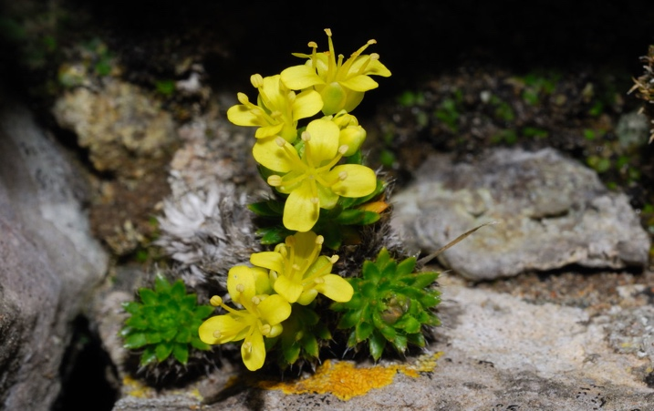
This Photo by Unknown Author is licensed under CC BY-NC-1212/ND 13/02/22

  - Primroses
It’s a small perennial woodland plant that grow around 10cn high and flower between December through to say the primrose has a deep yellow with dark and yellow own centre the single flower has five notch petals its leaves are winkled with hairy undersides (woodlandtrust.org.uk12/02/2022)

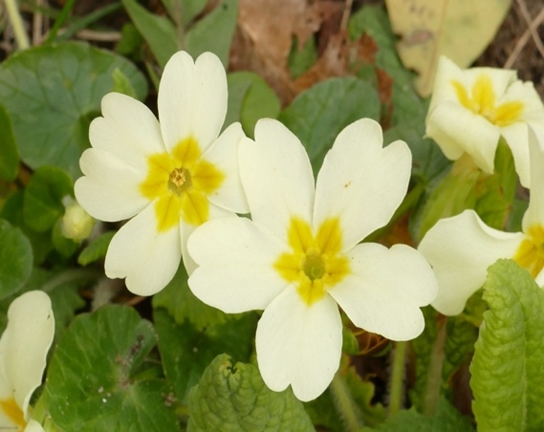

Beer 2021 primrose

  - Gorse bushes
It’s an evergreen plant with conifer needle and brilliant yellow flower and give shelter and food for many insects and birds. Its flower between January and June
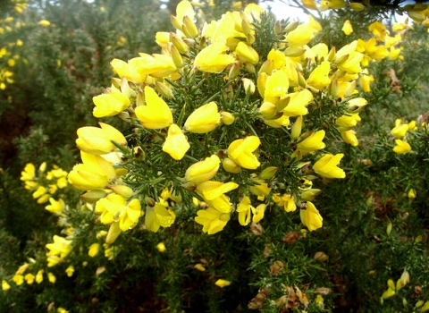

Beer2022 three cliff bay
  - Sea Purslane
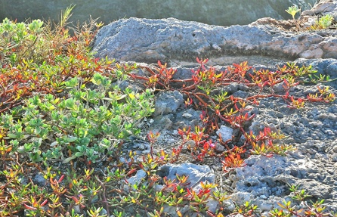
This Photo by Unknown Author is licensed under CC BY-SA-NC
Beer 2020 three cliff bay
This plant is a perennial and available all year round and can be found in salt
Marshes. This plant can also edible and grow in huge number.
(Wildplantguildes.com 12/02/2022)

  - Wild Garlic
This is found are the pathway down to the cliff I the shade part, it’s given off a very distinctive smell in spring and it has very white flower. The leaf can be eaten but must be careful it’s not lily of the valley which is poisonous.
(nationaltrust.org.uk10/2/2022)

  - Blackthorn
The blackthorn is great for the threatened Black Hairstreak (Satyrium Pruni) butterfly “which lays its eggs in thickets” over winter and caterpillars emerge in spring. Birds also builds their nest in the branches. Blackthorn grows on rock and protects the soil from erosion as it used the blackthorn “as a barrier against the wind”.
(treegrowing.tcv.org.uk 2/02/2021)
  - Hawthorn
  - Sea Beet
  - Golden Samphire
  - Rock Samphire
- Birds that can been seem at Three Cliff Bay are as follow

  - Chough is a member of the crow family and has a red bill and legs and is restricts to the west British lsles
  - Blue Tits can be found on the walk down to the bay just listen to them singing in the bud burst of trees. (woodlandtrust.org.uk13/02/2022)
  - Ravens
    - Skylarks
    - Black birds
    - Larks

Animals
- Caterpillar
- Moths
- Horse can be seen on the beach having a good gallop or on the bridlepaths that goes along the cliffs
(swansea.gov.uk13/02/2022)
- Cows can be appearing at Southgate on the National Trust Land
- Voles
- Limpets
All the above can be seen at Three Cliff Bay on the way down to the bay at certain times of the years but with the quantity of visitors the foot path is eroding some of these will be hard to find because of this.
Three Cliff Bay is one off five project that been awards two Welsh Government worth £325,000 for improvement to physical condition, new interpretation signs, and upgrades to footpaths around it.
This can only encourage more visitors to the area it has been recognised by the council in a report that in 2020 more images of the Three Cliff Bay and other parts of the Gower. (walesonline.co.uk8/2/2022)

Tourism and recreation

Three cliff bay is one most “photographed area in the Gower” (visitwales.com12/02/2022) with the Pennarn Pill stream running down to the beach, the spectacular shoreline, the rock pools sand dunes, and comprehensive view from the limestone cliff.

At Three Cliff Bay you can offer see rock climbs as there are “easy slabby and pleasant routes” (Gower Rock10/2/2022)
The camp site on the top off Three Cliff Bay is located on North Hill Farm, the same family has been running it since 1948 which goes back five generations. It sits on one of three paths that goes down to the Three cliffs Bay (three cliff bay 15/2/2022)
Car parking can also be found here at the holiday park and at Parkmill, Penmaen and Pennard which give different routes which give different routes to get down to the bay and different things to see.

The bay has suffered from pollution in the form of plastics washing up, and the latest news report of 2019 describes how a voluntary team collected 14lb of debris in just a 100-meter area. Having a clean beach is more inviting to visitors.

(https://www.walesonline.co.uk/news/local-news/three-cliffs-bay-plastic-litter-16877930 01/02/2022)

Sand dunes
The weathering of the sand along the shoreline is due to the wind aeolian transportation sediment which are made up three separate ways, suspension, saltation, creep,
Wind flowing over the beach will transfer particles such as sand with will come to a halt against obstructing elements to form a ridge. Smaller sediments will come to rest on the other side. This wind-facing side will become steeper as more material is deposited and will eventually become unstable. When instability is reached, the smaller sediments will fall over the crest and a more stable angle is created (in a range of 30-34 degrees); At this point slipping of the sand ceases and the entire process repeats in a cycle.

As this dune now becomes an obstacle, more dunes may be formed in the front of it. The higher the strength of the wind will result a taller set of dunes. (internetgeography.net)

- 1% of sand movement is caused by suspension. This is where sand is picked up and carried because of wind movement.

- 95% of sand movement is caused by saltation; in this case particles of sand bounce along the beach because of being picked up and dropped by the wind flow.

- The remaining 4% of movement is caused by creep; in this case sand particles push each other along due to collision.
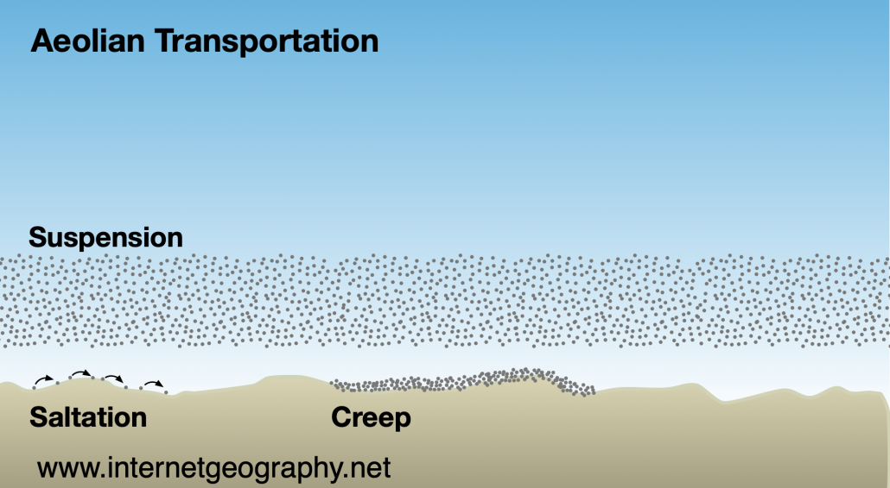

Aeolian transport
For sand dunes to form there are several conditions which must be met including-
- A plentiful supply of sand
- Large and relatively flat beaches
- Time for drying of the sand between tidal movements
- flow of wind from the sea towards the land
- Some debris to act as an obstacle for the dune to form against (e.g., rocks or driftwood)
All off this can seem at Three Cliff Bay at it’s a flat beach with the sand dunes and rocks from the cliff also being present.

Sand

Sand at Three Cliff Bay is made from the surroundings limestone rock which is like fingerprint off the beach. Overtime thousand if not millions of years the weathering begins with large rocks, then break into small rocks. The water penetrates through the cracks erodes the rocks which in times gaps widen bits break. Persistent waves and the tides also made the sand.
You can see ripper in the sand which is formed by the tide raising and falling as sandstone is influenced the waves leaving the ripper behind.
(www.whoi.edu<how-is-beac...14/2/2022)

Rock pool

At Three Cliff Bay there are many rocks pool that have been left went the tide goes out and leaves behind some creatures such as limpet, barnacles, seaweed, and sponges. ( www.discoverwild.com 12/02/2022)
Looking at the rock pool you can sometime be surprised what creatures is hide their benweed the rocks and pebbles. Rock pools are made up of non-porous rock which fill up with the sea water and retain water when the tides go out to create the pool. Some of the rock pool appear to be cover in sand and are always from the main rock formation.

Cave

The sandy Penmaen Burrows have trace of artwork that goes back to the Norman as earthworks of this time has been found and a prehistoric burial chamber. In the wooded valley north is Neolithic Parc le Breos chamber also known as Giant’s Grave dating back from 4000 BC.
The Cathole Cave where in 1968 flint tools were found that suggest human occupation in around 12000 BC (enjoy Gower.com)
At Penmaen Burrows which is a 60m high cliffs is a tomb, Pen-y-Crug fought to be 5000 years old and suggest this was one of the first communities on the Gowers.
The Pannard Burrows cave is below the footpath in the way down to the beach from Southgate café. Bones of elephants, rhinoceros, reindeer, wolfs,and bear have been found there.(walking :three cliff bay,Swansea-countryfile.com 13/02/2022)

Coastal Processes

The tides around Three cliff Bay can be dangerous at high tide as there is a rip current. This is particularly dangerous for swimmers and other sports.
The rip currents are caused by water coming from the beach or river after a big wave or after the tide has pull water up the sand bank. The water is trying to get back to the sea down the sands as quickly as possible. Rip current can be present permanently or for medium, short times. ‘A river mouth is an example of a permanent rip current. Rock projections can have escape route for water off the beach which can also cause a rip current see picture below as example.

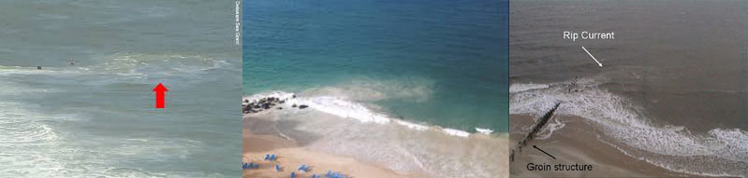
(ripnrock.co.uk01/01/2020)

Salt Marsh

The salt marsh is the coastal wet land at Three Cliff Bay where the sea flooded the soil which can composed of deep mud and peat. The peat can be very spongy, root filled and can be made of decomposing plant matter which can be several feet thick.
The location of the salt march is on the right hand or west bank is composed of rough stone and then transitions into a salt marsh.
(The story of west bank of Pennard Hill – Jessica-s nature blog)19/01/2022

Conclusion
This study has found that three cliffs bay is composed primarily of limestone with a river that provides a rip-current that contributes towards erosion of the soft rock. The location also presents salt marshes to the west of the site.

The study found this site to be rich in palaeontology, particularly in samples of brachiopods. And fossils of plants within the shale levels.

It is possible to see the dune-building process active at the three cliffs site (as discussed in section 3.4).

Significant environmental issues have been isolated throughout the Gower peninsular, not only natural erosion, but also human impact as discussed in section 3.3

Three cliffs bay is considered a site of special scientific interest (SSSI), and an area of outstanding natural beauty (AONB) and as such should be protected and maintained in the future.

Bibliography
Bábek, O., 2013. Facies and petrophysical signature of the Tournai Sian/Viséan (Lower Carboniferous)sea-level cycle in carbonate ramp to basinal settings of the Wales-Brabant massif,. Sedimentary Geology 284–285, pp. 197-213.
C.Geogerty, 2021. Gower peninsula national trus. [Online]
Available at: https://www.nationaltrust.org.uk/features/place-where-wild-garlic-grows
[Accessed 12 1 2022].
countryfile, 2020. www.countryfile.com<walks:three cliff bay Swansea<countryfile.com. [Online]
Available at: www.countryfile.com
[Accessed 22 01 2022].
Discover wildlife, 2021. How to identify rockpool wildlife. [Online]
Available at: https://www.discoverwildlife.com/how-to/identify-wildlife/how-to-identify-rockpool-wildlife/
[Accessed 19 01 2022].
gogerty, c., 2017. Gower Peninsular. s.l.:national trust.
lewis, a., 2019. when do bluetits nest. [Online]
Available at: https://www.woodlandtrust.org.uk/blog/2019/02/when-do-blue-tits-nest/
[Accessed 2022 01 23].
ripnrock, 2022. THE DANGERS OF RIP CURRENTS. [Online]
Available at: https://www.ripnrock.co.uk/blog/the-dangers-of-rip-currents/
[Accessed 01 02 2022].
swansea council, 2022. Pennard Cliffs and Burrows (Three Cliffs Bay). [Online]
Available at: https://www.swansea.gov.uk/pennardcliffs
[Accessed 12 02 2022].
swansea council, 2022. three cliffs beach. [Online]
Available at: https://www.visitswanseabay.com/listing/three-cliffs-bay-beach
[Accessed 22 01 2022].
treegrowing.org, 2019. blackthorn. [Online]
Available at: https://treegrowing.tcv.org.uk/?s=blackthorn&swpmfe=5916110af2bd3b2b4d5992f3b0f8059a
[Accessed 29 12 2021].
Wales online, 2021. three-cliffs-bay-castle-swansea. [Online]
Available at: https ://www.walesonline.co.uk/news/ wales-news/three-cliffs-bay-castle-swansea-20809134
[Accessed 10 01 2022].
woodfield, l., n.d. an overview of valley formation and development-though gower rock. selected Rock Climbs, Volume 2.
woods hole oceanographic institution, n.d. How beach sand is created?. [Online]
Available at: https://www.whoi.edu/know-your-ocean/did-you-know/how-is-beach-sand-created/
[Accessed 10 01 2022].

