

Student Name: HIRALBEN YUVRAJSINH DABHI

Student ID: 2539211

Module Name: Marketing Management

Assesment 2

Module Code: LCMB7024

Lecturer’s Name: Laila Maazouz

Term 1

Contents
Element 2: Segmentation, Targeting, Differentiation, and Positioning (STDP) Analysis 3
Segmentation 3
Targeting 4
Differentiation 4
Positioning 5
Element 3: Sustainable Marketing Mix (4Ps) 6
Product 6
Price 7
Place 7
Promotion 8
Element 4: Critical Personal and Professional Reflection 9
Strategic Marketing Appraisals 9
Presentation Evaluation 9
Development Outcomes 9
Future Performance Plans 10
Conclusion 11

Element 2: Segmentation, Targeting, Differentiation, and Positioning (STDP) Analysis

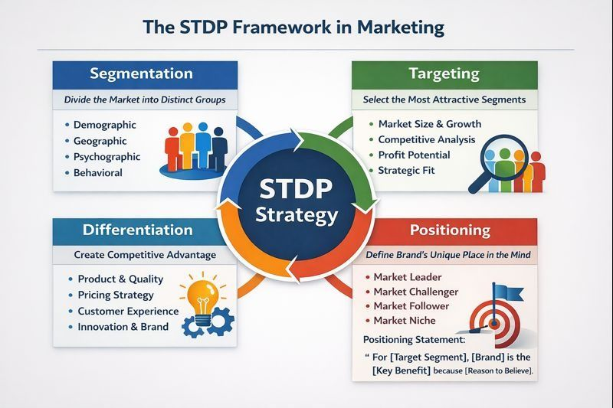

Segmentation
The market needs to be divided on the basis of geographical, demographic, psychographic and behavioural factors to ensure the successful implementation of the Refillable Smart Bottle System of Coca-Cola. The structured approach allows the company to prioritise the most pertinent consumer groups and the offering can be shaped to meet their needs and lifestyle (Kotler and Keller, 2016).
Geographically, the first deployment should be in high-density cities, such as smart city centers, metropolitan areas, and universities. They are places where there is high levels of foot traffic, sophisticated infrastructure and lots of digitally-enabled consumers. In addition, this type of environment can be ideal for the placement of automated “Refill Here” kiosks, which provides accessibility and efficiency.
Demographically, the main focus group are Generation Z and Millennials (18-35 years old). This cohort are more inclined to embrace solutions that support the circular economy (CE) and mobile app-based retail systems (Dibb and Simkin, 2008). Also, many of these individuals are in the middle to low income range, and affordability is a key consideration, such as students and early career professionals. The pricing strategy that is proposed, therefore, will focus on value and cost savings in order to improve uptake.
Target segment is extremely close to the LOHAS (Lifestyles of Health and Sustainability) target segment from a psychographic point of view. These individuals care about the environment and would like to buy from brands that are not only committed to sustainability, but truly living by it. They have an ethics-centered approach to consuming and feel that decreasing plastic waste is their responsibility (Polonsky, 2011). This is to strengthen the consumer feeling and value of the brand.
Finally, behavioural segmentation targets customers who are active digital consumers and often drink soft drinks. They are regular users of the mobile application, positive about gamification and are active in loyalty programmes. Importantly, they are willing to change their eating habits when it's easy, technologically advanced, and has a clear benefit. This means they are a good fit for an “easy, no-fuss” packaging model that centers on refill.

Targeting
The Refillable Smart Bottle System focuses on niche targeting, specifically targeting urban, tech-savvy and environmental conscious consumers (Hooley et al., 2020). This segment is not large, but it has high value because of the high engagement and the potential of the long-term market in the context of a circular consumption model.
The consumers are particularly attractive from customer life value (CLV) point of view since they are customers who buy soft drinks regularly and are highly receptive towards digital marketing campaigns. This group is the focus because resistance to behaviour change (such as using reusable bottles, joining refill schemes) is minimised.
Furthermore, capturing the early adopters makes it easier to build brand advocates who can grow consumer adoption. The positive experiences and social sharing behaviours they have created fast-track the diffusion of innovation and get the refill infrastructure into the mainstream. It is a staged rollout approach that minimizes risk, and at the same time increases credibility and trust in the system.

Differentiation
Coca-Cola sets it apart from conventional packaging and reusable bottles by incorporating three elements to the Refillable Smart Bottle System.
Firstly, the smart bottle with its own private Internet-of-Things (IoT) ecosystem is an innovation of its own. The smart bottle is equipped with a QR code tracking system, unlike the conventional reusable bottles like thermos flask or aluminium bottle. This technology allows for complete integration with a mobile app, enabling physical use to connect with digital data, and providing a personalised consumption experience.
Secondly, the system includes rewards and closed-loop incentives, boosting user engagement. Tangible financial benefits are offered to consumers, as well as measurable environmental impact information, including carbon footprint reduction and plastic bottle savings. The system is able to measure sustainability outcomes, making what benefits the environment more tangible and recognisable and in turn more rewarding, encouraging positive behaviour.
Thirdly, Coca-Cola has an unmatched global distribution system which makes it very convenient. The Coca-Cola Company (2026a) states that this infrastructure provides the potential for dispensing kiosks to be widely available in various locations. This is more convenient than boutique sustainable brands, which may only offer a handful of refill options, which gives Coca-Cola a head, giving Coca-Cola a head up in terms of scalability and reach.

Positioning
Overall, the Refillable Smart Bottle System represents a blend of cutting-edge technology and eco-conscious initiative. This is an “inconvenient” way to have sustainable consumption without compromising. Rather, it is based on the principles of the “Green Marketing Value Matrix”, which focuses on providing environmental and consumer value at the same time (Ansar, 2013).
The strategy will focus on sustainability without making sacrifices in terms of convenience, lifestyle or user experience. Creating a digital innovation that is easy to use and has a positive impact on the environment makes it an attractive option for consumers who value functionality and usefulness.
This positioning is encapsulated in the core brand promise, “Refill, Reuse, Refresh the Future”. It conveys the message of sustainability and guarantees the consumer that they will not have to compromise on the taste, quality or convenience of Coca-Cola products. This is a dual value proposition that enhances brand equity and aids to reinforcing long-term behavioural change with consumers.

Element 3: Sustainable Marketing Mix (4Ps)
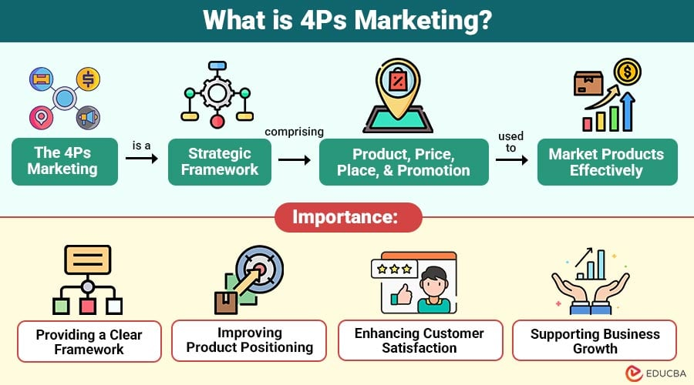

Product
The Refillable Smart Bottle System is a change from the traditional fast moving consumer good (FMCG) model to a product-service system (PSS) from a product strategy perspective. The shift involves a shift towards value creation over the production of physical goods alone; towards integrated products and services instead of isolated physical products (Tukker, 2015).
The physical aspect of the system is the smart bottle itself, which will be made durable, long-lasting and environmentally friendly. Made from 100% safe, food-grade materials which are 100% recyclable, the bottle has a long life cycle and is safe to use. The system extends the lifespan of the container, which decreases the environmental impacts of the repeated production and disposal of single-use plastic bottles, and thus reduces the total carbon footprint.
A distinguishing advantage of the product is the embedded QR code or RFID-enabled collar, serving as the technological link between the material product and the virtual world. This clever option is linked straight to a cell app, which allows people to observe a range of usage metrics, like quantity of beverage consumed, temperature, bottle condition, or “health.” This integration improves user engagement and brings real-time data insights to reinforce sustainable consumption behaviors.
More significantly, the basic beverage formula is not altered, meaning that the experience of the beverage (taste, carbonation, brand recognition etc.) remains the same as the Coca-Cola products. The strategic move serves to safeguard the brand's value, while also removing the negative environmental impact of using single-use plastics. Consequently, the system provides continuity of product and innovation in delivery format.

Price
The pricing strategy is a two-tiered approach to cope with different price sensitivities among the consumers, which is based on the perceived value theory (Zeithaml, 1988). This strategy not only helps to mitigate the upfront investment hurdle but also promotes long-term sustainability in the use of these resources.
The first is a single premium for the purchase of the smart bottle. The extra initial price is due to the cutting edge technology, durability, and environmental sustainability characteristics incorporated into the product. This can be a hurdle at first, but it's seen as an investment in a long-lasting, reusable resource.
The second piece of the puzzle is continuous costs of consumption, in which the cost of the beverages at refill stations is much less expensive than the cost of a traditional single use plastic bottle or aluminium can. This price difference makes it more financially attractive to customers to switch to the refill system, as they should save money over time.
This can be broken down into the following:
- One-Time Purchase: Initial Purchase → Premium Smart Bottle.
- Ongoing Purchases → Discounted beverage refills (discounted from other single-use alternatives)

Place
The distribution strategy is a hyper-local omnichannel approach, which is aimed at maximizing convenience and reducing environmental impact (Christopher, 2016). This will combine both physical and digital platforms, providing a more seamless customer experience and enable sustainable logistics.
Physical “Refill Here” dispensing stations are strategically placed in high traffic, semi-captive, areas where consumers are more likely to engage in the habit of “refilling here”. These locations include:
- Major public transportation hubs and subway stations
- University campuses, student unions and libraries
- High density fitness centres, corporate office complexes
These placements are designed to make the refill system a natural extension of consumers' everyday lives and to make it easier to use, thus making it more frequent.
All kiosks are backed by Coca-Cola's sophisticated logistics and distribution system, which allows the syrup level, carbonation supply and machine operation to be tracked at all times (Leftover Books, 2010). By using this technological integration, the risk of stock-outs is lowered and operations become efficient. Moreover, the optimised urban distribution routes also help reduce transportation emissions, in line with the principles of circular economy set forth by UNEP (2021).

Promotion
The promotional strategy is one that is green marketing focused and is centered on engagement, rather than the traditional persuasive advertising approach (Peattie, 2001). The use of gamification is central to this, as it is a method of promoting ongoing participation while maintaining that it does not involve any of the problems that can arise out of superficial and misleading environmental claims (greenwashing).
The central marketing medium is the mobile application, which is a platform for interactive and personalised communication, replacing passive marketing. By using the app, users get instant insights into their environmental footprint, like the number of plastic bottles saved and the reduction in their carbon footprint. Gamified features like streak tracking, milestone achievements, digital badges and leader boards (e.g. “Top Campus Refillers”) promote a sense of competition and community engagement.
Point-of-purchase displays also help to reinforce the brand's sustainability messaging, focusing on transparency and credibility. Transparency and trust are built through environmental benefits being clearly communicated and backed by third party sustainability certifications. The digital engagement, experiential interaction, and clear communication are all essential elements of this comprehensive promotional approach, which helps foster both awareness and long-term behavioural shifts.

Element 4: Critical Personal and Professional Reflection

Strategic Marketing Appraisals
The process of creating this sustainable brand extension revealed some of the practical distinctions between an academic approach to marketing and implementation. This poster was created as a tool for defining a company's sustainability agenda, which is frequently cast as a secondary corporate social responsibility (CSR) issue, in literature (Polonsky, 2011), but in creating this poster one had to understand that environmental frameworks must be embedded in the core and essential business function.
The shift towards the brand extension to align with UNEP SDG 12 went beyond the superficial marketing 'shout' towards addressing the structural logics of product circularity (Tukker, 2015). The balance between convenience of the FMCG market and behaviour changes needed to achieve the circular model was a perfect example of the need for change in all 4Ps for sustainable design.

Presentation Evaluation
This involved prioritizing the data and communicating in a business-like manner in an academic poster, which was a maximum of 1800 words. The biggest issue was integrating visually with the application mockups and the theoretical backing for an academic defense with the smart kiosk placements.
The separation of the elements of the layout design, between the data regarding the motive of the market and the elements of the technical execution (QR code tracking and refill kiosks) helped to lead the viewers in the evaluation of the project logic.
But ideal iconography could bring the layout density up by better conveying the circular logistics. This would lead to a more balanced look overall, as there would be less heavy text in the introduction and market appeal.

Development Outcomes
This project contributed to the development of basic skills of sustainable product development and digital-physical service integration. The creation of an IoT based product ecosystem has been hands-on experience with contemporary product tracking patterns and gamified loyalty strategies (Kotler and Keller, 2016).
Professionally, the experience sharpened the art of delivering highly nuanced business concepts in a succinct manner, which is essential in today's corporate landscape where sustainability efforts are closely monitored for business viability.

Future Performance Plans

The next steps would be more structured and based in evidence as I would start testing the idea with consumers prior to implementation in future projects. Early UX testing would help to highlight issues that would be problematic, like using refill kiosks, hygiene concerns, app usability, and the perceived value of the smart bottle. In addition, I would conduct pilot testing in select universities and urban settings to test the uptake of the customers, frequency of refilling, and repeat usage.
Last but not least, there would be more focus placed on communicating sustainability claims in a transparent fashion without greenwashing. I would be able to create marketing strategies which are not only creative, but also measurable, realistic and commercially viable by using consumer research, measurable sustainability outcomes and continuous improvement.

Conclusion
Overall, the proposed Coca-Cola Refillable Smart Bottle System demonstrates how sustainability can be integrated into the core of a business strategy rather than treated as a separate CSR activity. Through focused STDP analysis, the concept targets urban, digitally engaged and environmentally conscious consumers, while differentiation is achieved through smart technology, rewards and Coca-Cola’s extensive distribution network.
The sustainable 4Ps further support this strategy by combining a durable smart bottle, value-based pricing, convenient refill locations and interactive green marketing. Together, these elements aim to reduce single-use plastic while maintaining Coca-Cola’s familiar taste, convenience and brand experience.
Ultimately, the success of the system will depend on making sustainable behaviour easy, affordable and rewarding. Early consumer UX testing, effective digital engagement and continuous improvement will be important for reducing user friction and encouraging long-term adoption.

References
- Ansar, N., 2013. Impact of green marketing on consumer purchase intention and buying behavior. Journal of Business and Management, 9(5), pp.87-92.
- Christopher, M., 2016. Logistics & supply chain management. 5th ed. London: Pearson Higher Education.
- Dibb, S. and Simkin, L., 2008. Market segmentation success: Making it happen. New York: Routledge.
- Hooley, G., Nicoulaud, B., Piercy, N.F. and Close, J., 2020. Marketing strategy and competitive positioning. 7th ed. Harlow: Pearson Education.
- Kotler, P. and Keller, K.L., 2016. Marketing management. 15th ed. Boston: Pearson.
- Peattie, K., 2001. Towards sustainability: The third age of green marketing. The Marketing Review, 2(2), pp.129-146.
- Polonsky, M.J., 2011. Transformative green marketing: What we already know and what we still need to learn. Journal of Business Research, 64(12), pp.1311-1319.
- The Coca-Cola Company, 2026a. How The Coca-Cola System Is Scaling Refillable Bottles Around the World. [online] Available at: <coca-cola.com> [Accessed 1 August 2026].
- The Coca-Cola Company, 2026b. Sustainability, coca-colacompany.com. [online] Available at: <coca-cola.com> [Accessed 31 July 2026].
- Tukker, A., 2015. Product services for a resource-efficient and circular economy-a review. Journal of Cleaner Production, 97, pp.76-91.
- UNEP, 2021. Goal 12: Responsible Consumption and Production. UNEP - UN Environment Programme. [online] Available at: <unep.org> [Accessed 1 August 2026].
- Zeithaml, V.A., 1988. Consumer perceptions of price, quality, and value: a means-end model and synthesis of evidence. Journal of Marketing, 52(3), pp.2-22.



