

School of Hospitality and Tourism Management

BA International Hotel Management

Module: Management & Organisational Behaviour

Module code: BMIH5004

Written Report

Topic: Hilton Hotels & Resorts: A Strategic Case Study

Student Name:Radu Diana Elena

Student ID:2240776

Module Leader : Daniel Payne

Executive Summary
Hilton Hotels & Resorts is a global hospitality brand, one of the leading global brands in the worldwide hospitality industry and it is a famous provider of luxury accommodations and strong corporate culture. The objective of this report is to identify Hilton's organizational structure, culture, and strategic goals, particularly its decentralized management, and its innovative operations. Current change initiatives including digital transformation and sustainability efforts have made the organization more efficient and the guest experiences more pleasing. The strategic analysis shows that Hilton is making a global expansion, technological integration, and competitive differentiation. The key recommendations offer further digital advancements, leadership in sustainability, and further employee training and investment. By implementing these strategies, Hilton will have a stronger position in the market and thus will continue its success in the industry of competitive hospitality.

Table of Contents
1. Introduction 4
2. Organisation Structure, Culture, and Goals 500 5
2.1 Organisational Structure 5
2.2 Corporate Culture and Its Influence on Operations 5
2.3 Goals at Corporate and Individual Hotel Levels 6
3. Recent Change Initiatives 6
3.1 Identification of Key Change Initiatives 7
3.2 Impact of These Initiatives 7
3.3 Evaluation of Change Management 8
4. Strategic Direction 9
4.1 Overview of Hilton’s Strategic Direction 9
4.2 Strategies for Achieving Objectives 9
5. Conclusion 10
6. References 12

Introduction
Hilton Hotels & Resorts is the world’s largest hospitality franchise with more than 7,000 hotel properties in 123 countries on 6 continents. Conrad Hilton founded the company in 1919 and since then, it has developed into a global leader in luxury and mid-scale accommodations around the world, with exceptional guest experience under several brands, including Hilton Hotels, Waldorf Astoria, and DoubleTree (Hilton Hotels & Resorts, 2025). The solid reputation of Hilton as one of the most innovative, customer,r and socially responsible hotel chains has been further enhanced by Hilton’s commitment.
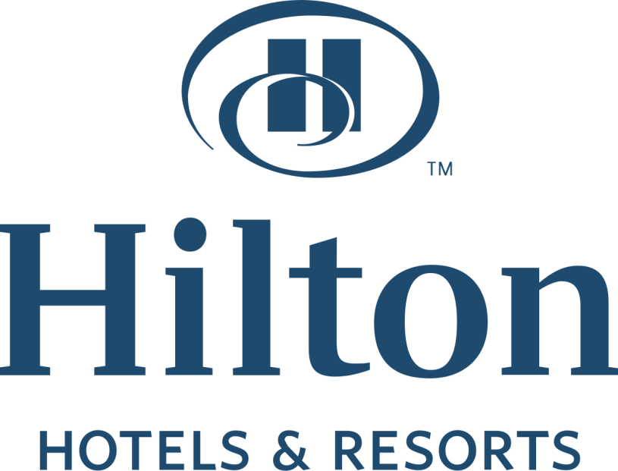
Figure: Logo of the company
Source: Hilton Hotels & Resorts, (2025)
The scope of this report is to critically analyze Hilton Hotels & Resorts at corporate and individual level hotel levels. This report will take a look at Hilton’s organizational structure, corporate culture, and strategic goals to understand how they impact operations and customer service. Furthermore, the report will disclose certain recent change initiatives and analyze their implementation specifically including digital transformation and sustainability, to assess their progress on performance.
At the same time, the study will investigate Hilton’s strategic direction towards long-term objectives as well as competitive strategies. Relevant management and organizational theories will be used to support the analysis to give an overall evaluation. Recommendations to improve Hilton’s competitive advantage and operational efficiency will be made finally. This report examines these key areas to offer insight into Hilton’s evolution and future, as well as ways the company can continue its current success.

Organisation Structure, Culture, and Goals 500

2.1 Organisational Structure
As a hierarchical corporate structure, Hilton Hotels & Resorts manages to provide decision-making smoothly while keeping solid brand exposure in any corner of the world. The corporate leadership team is based at the top of the hierarchy and consists of the CEO, board of directors, and senior executives, responsible for global operations, strategic planning, and financial management at the top of the hierarchy (Lei et al., 2021) . Below this level, regional managers are responsible for overseeing a particular geographic area to ensure that Hilton’s strategic goals bear place with the local market demands.
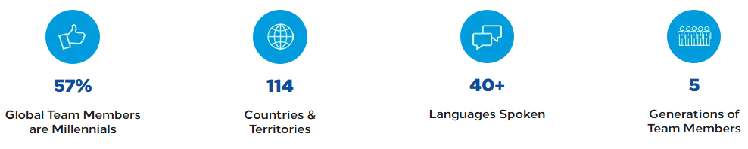
Figure: Organisational achievements of Hilton
Source: Hilton Hotels & Resorts, (2025)
In terms of business model, it is a franchising and management company, which enables it to expand rapidly and with brand consistency. Hilton’s properties include many that are independently owned and operated by franchisees under their respective franchise agreements and some that are directly run by the Hilton’s corporate team (Mullins, 2013). Hilton’s dual structure allows them to take advantage of independent investors’ knowledge and at the same time maintain a high standard of quality through tough quality controls and brand guidelines.
Hilton falls into the divisionalised form in which Mintzberg’s Organisational Structures Theory can be applied (Hlavatý, 2023). The corporate policies hold for each hotel but they are all independent units. It achieves the right balance of autonomy and corporate oversight that enables properties to provide services that are local to their clientele via consistency in customer experience and operational efficiency across the brand (Bloisi, 2007).

2.2 Corporate Culture and Its Influence on Operations
The mission of Hilton is to fill the earth with the light and warmth of hospitality, and its corporate culture has been built around this mission. Values such as hospitality, integrity, leadership, teamwork, and ownership are woven into employee training as well as daily operations at the company (Buchanan, 2007). Hilton’s culture is customer-centric with its Team Member Value Proposition (TMVP) which addresses the well-being, development, and recognition of its associates.
The effectiveness of staff performance and guest satisfaction depends largely on the strength of corporate culture. Valued and empowered employees will provide high-quality service, guest experience, and customer retention (Meyer et al., 2024). Hilton has always been a top employer because of its inclusive work environment and focus on professional growth.
At three levels, Hilton’s culture can be analyzed using Schein’s Organisational Culture Model. Hilton’s culture at the artifact level comes through customer service practices, branding, and workplace design. At the espoused values level, Hilton espouses teamwork, service excellence, and ethical business (Makumbe, 2022). On the basic assumptions level, employees assimilate Hilton’s values and work to provide the same level of continued service quality at every location. Hilton’s continued success and global reputation have been due to this deep-rooted culture.

2.3 Goals at Corporate and Individual Hotel Levels
At the corporate level, Hilton’s main goals are global expansion, technological innovation, sustainability, and guest satisfaction. The company continues to invest in digital transformation like the Hilton Honors mobile app to improve the experience for the customer (Grosbois, 2022). Hilton is also ambitious when it comes to sustainability and has set ambitious targets assigned to its Travel with Purpose initiative to cut environmental impact in half by 2030.

At the corporate level, the goals are aligned with corporate strategy but tailored to local market conditions at the individual hotel level. These are occupancy targets, revenue growth, customer service levels, and employee engagement (Huczynski, 2019). Key performance indicators (KPIs) that each hotel uses include average daily rate (ADR), revenue per available room (RevPAR), etc., and their performance is tracked by each hotel.

Recent Change Initiatives

3.1 Identification of Key Change Initiatives
Recent years have seen many strategic changes at Hilton Hotels & Resorts concerning its operations, customer experience, and the company’s efforts in terms of sustainability. Digital transformation has been one of the most significant initiatives particularly expanding the Hilton Honors mobile app to enable guests to check in, book their rooms, unlock their rooms, and so on (Robbins, 2017). Therefore, it has made the guest experience faster and more convenient.
Hilton moves on another key change initiative by pledging to work towards sustainability through “Travel with Purpose”, to duly reduce the environmental footprint of the company by half in 2030. These efforts include cutting down on their use of energy and water, and the use of renewable energy, as well as the minimization of the use of single-use plastics (Mullins, 2019). Hilton has many properties that have implemented smart energy management systems resulting in the reduction of operational costs as well as the improvement of environmental performance.
With that, Hilton has also worked on employee engagement and service quality improvement. Hilton Thrive, the company’s new employee well-being and development program, was introduced (Boddy, 2017). Providing mental health support, leadership training, and flexible work policies, this initiative ensures that the employer Hilton retains and attracts hospitality’s best talent.

3.2 Impact of These Initiatives
Hilton’s digital transformation has also had a huge financial impact as higher direct bookings stemming from increased customer engagement via the mobile app have reduced reliance on third-party platforms. Thus the improvement in this lowered the commission costs; which increased profit margins (Rollinson, 2008). Hilton's commitment to sustainability has further lowered the company's cost by lowering its use of energy and water.
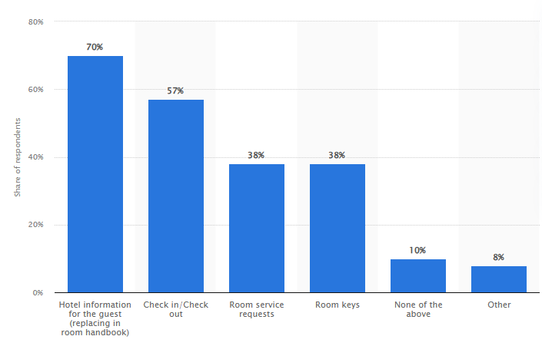
Figure: Key aspects of the guest experience hoteliers want to digitalize worldwide in 2021
Source: Statista Research Department, (2021)

These initiatives have also been operationally efficient. With the help of digital key technology, the front desk is less crowded and the staff is free to dedicate more of their time to direct guest contact (Mullins, 2023). By improving the brand reputation as one of the most eco-friendly hotels, the sustainability initiatives have attracted eco-conscious travelers who tend to stay in hotels with strong environmental commitments.

While these projects succeeded, Hilton had to overcome some obstacles. To adopt digital key technology, however, considerable investment was needed in infrastructure upgrades, and not all guests could be accustomed to the mobile app. Like, coordination was needed across several properties and ownerships for their sustainability initiatives, which was logistically hard.

3.3 Evaluation of Change Management
Hilton’s change management has been quite successful and has generally followed pattern methodologies such as Kotter’s 8-Step Change Model. One such example is that Hilton created urgency first in digital transformation, understanding that there’s a growing demand for mobile as a first experience (Laig, 2021). It then created a technology coalition of hospitality leaders and experts to oversee implementation. Hilton created momentum for further adoption by acquiring short-term wins, i.e. more mobile check-ins.
Moreover, Hilton’s sustainability initiatives can be implemented according to Hilton’s Change Management Model put forward by Lewin. The unfreezing of traditional practices by the company enabled the acceptance of sustainability through the education of stakeholders on the benefits of the idea (Harrison et al., 2021). During this, Hilton changed new systems that included new technologies for energy as well as the reduction folders. Hilton succeeded, finally, by taking sustainability into its corporate mission and refreezing in this manner so that these changes became permanent.

Strategic Direction

4.1 Overview of Hilton’s Strategic Direction
Hilton Hotels & Resorts aims to expand to strengthen its position as one of the world’s leading hospitality businesses through innovation, expansion, and sustainability. Its long-term vision is to become a world-class company and to deliver exceptional guest experiences while proving operational excellence and environmental responsibility (Harrison et al., 2021). Hilton’s high priorities are global expansion of the market, digital transformation, enhancing customer loyalty, and going green for business. The company is still developing smart technology and providing a personal experience for guests, thus it keeps up with the pace of the industry.

4.2 Strategies for Achieving Objectives
The growth strategy adopted by Hilton for its global footprint involves franchising, strategic partnerships, and acquisitions. With its franchising model, the company does not require much capital to expand the business quickly and spread brand consistency across varied markets (Kvestek, 2023).
However, Hilton has used AI-powered customer service, mobile check-ins, and smart room technology to improve and increase conveniences and efficiency regarding digital and technological innovation (Leocádio et al., 2024).
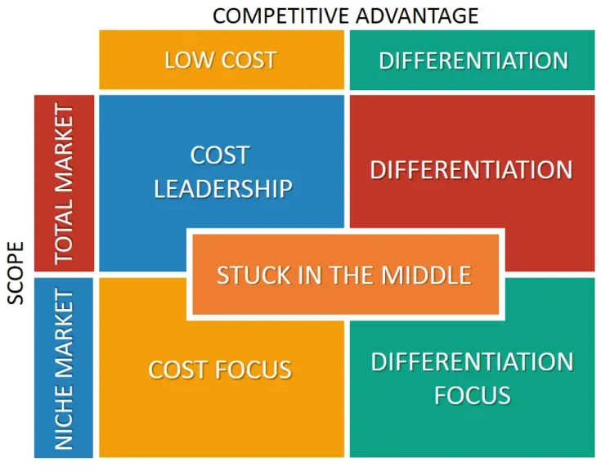
Figure: Porter’s Differentiation Strategy
Source: Ghraizi, (2024)
Hilton follows Porter’s Differentiation Strategy, since in terms of a competitive strategy, Hilton delivers high-quality service, is strongly branded, and offers a personalized guest experience. Moreover, there are elements of cost leadership in its efficiency-based operations and its commitment to Sustainability that make this business remain competitive (keeping services up to par).

Conclusion
Hilton Hotels & Resorts continues to be a global leader in the hospitality industry based upon a strong organizational structure, a customer-facing corporate culture, and balanced strategic goals, focusing on innovation and sustainability. Efficiency improvements and guest satisfaction have been made through its recent change initiatives, in digital transformation and sustainability. Franchising, technological improvement, and differentiation give Hilton a strategic direction for going forward in the fragmented market. The implementation though, has been a challenge to a similar extent, although Hilton has been reasonably effective in adopting change with structured frameworks. Hilton boasts a strong brand rep, innovative strategies, and a pledge to be sustainable, and is well positioned for long-term success in the world of hospitality.

References

Bloisi, W. 2007 Management and Organisational Behaviour, (2nd edition) Maidenhead: McGraw-Hill. Available at: https://books.google.co.in/books/about/Management_and_Organisational_Behaviour.html?id=2TPMAAAACAAJ&redir_esc=y [Accessed 7 February 2025]
Boddy, D. 2017 Management: An Introduction (7th Ed), Harlow, Pearson Available at: https://www.pearson.com/se/Nordics-Higher-Education/subject-catalogue/business-and-management/boddy-management-uk.html [Accessed 7 February 2025]
Buchanan, D. And Huczynski, A. 2007 Organisational Behaviour: An Introductory Text (6th edition), Harlow: Prentice Hall. Available at: https://www.scirp.org/reference/referencespapers?referenceid=1689949 [Accessed 7 February 2025]
de Grosbois, D. and Fennell, D.A., 2022. Determinants of climate change disclosure practices of global hotel companies: Application of institutional and stakeholder theories. Tourism Management, 88, p.104404. Available at: https://doi.org/10.1016/j.tourman.2021.104404 [Accessed 7 February 2025]
Ghraizi, R. 2024. Porter’s Generic Strategies: Differentiation, Cost Leadership & Focus. Available at: https://www.linkedin.com/pulse/porters-generic-strategies-differentiation-cost-focus-ruba-ghraizi-8romf/ (Accessed: [insert date]).
Harrison, R., Fischer, S., Walpola, R.L., Chauhan, A., Babalola, T., Mears, S. and Le-Dao, H., 2021. Where do models for change management, improvement and implementation meet? A systematic review of the applications of change management models in healthcare. Journal of healthcare leadership, pp.85-108. Available at: https://doi.org/10.2147/JHL.S289176 [Accessed 7 February 2025]
Hilton Hotels & Resorts 2025. Hilton hotels in India. Available at: https://www.hilton.com/en/locations/india/ [Accessed 7 February 2025]
Hlavatý, J., Ližbetin, J. and Fázik, J., 2023. Comparison of Organisational Structures of Selected Passenger Railway Transport Companies and their Impact on Strategic Goals of Companies. LOGI–Scientific Journal on Transport and Logistics, 14(1), pp.227-238. Available at: https://intapi.sciendo.com/pdf/10.2478/logi-2023-0021 [Accessed 7 February 2025]
Huczynski, A. & Buchanan, D. 2019 Organisational Behaviour (10th Ed), Harlow: Pearson Available at: https://books.google.co.in/books/about/Organisational_Behaviour.html?id=YwyiDwAAQBAJ&redir_esc=y [Accessed 7 February 2025]
Kvestek, M., Roncevic, A. and Giergia, D., 2023. Acquisition and Franchise as Strategies for External Growth of the Company. Economic and Social Development: Book of Proceedings, pp.328-342. Available at: https://esd-conference.com/upload/book_of_proceedings/Book_of_Proceedings_esdVarazdinII2023_Online.pdf#page=334 [Accessed 7 February 2025]
Laig, R.B.D. and Abocejo, F.T., 2021. Change management process in a mining company: Kotter’s 8-step change model. Journal of Management, Economics, and Industrial Organization, 5(3), pp.31-50. Available at: https://www.researchgate.net/profile/Ferdinand-Abocejo/publication/354614425_Change_Management_Process_in_a_Mining_Company_Kotter's_8-Step_Change_Model/links/615093f2f8c9c51a8af65225/Change-Management-Process-in-a-Mining-Company-Kotters-8-Step-Change-Model.pdf [Accessed 7 February 2025]
Lei, C., Hossain, M.S., Mostafiz, M.I. and Khalifa, G.S., 2021. Factors determining employee career success in the Chinese hotel industry: A perspective of Job-Demand Resources theory. Journal of Hospitality and Tourism Management, 48, pp.301-311. Available at: https://shura.shu.ac.uk/28848/7/Mostafiz-FactorsDeterminingEmployee%28AM%29.pdf [Accessed 7 February 2025]
Leocádio, D., Guedes, L., Oliveira, J., Reis, J. and Melão, N., 2024. Customer service with AI-powered human-robot collaboration (HRC): a literature review. Procedia Computer Science, 232, pp.1222-1232. Available at: https://www.sciencedirect.com/science/article/pii/S1877050924001200/pdf?md5=c7175ea71bedcf707d581f054def7b43&pid=1-s2.0-S1877050924001200-main.pdf [Accessed 7 February 2025]
Makumbe, W. and Washaya, Y.Y., 2022. Organisational culture and innovation: testing the Schein Model at a private university in Zimbabwe. Cogent Business & Management, 9(1), p.2150120. Available at: https://doi.org/10.1080/23311975.2022.2150120 [Accessed 7 February 2025]
Meyer, M., Barnette, L., Mehrani, A., Schandera, L., Stone, S., Cai, B., Vecchiarelli, P. and Lead, J.R., 2024. Quantitative assessment of customer segment, value proposition and appropriateness of minimum viable product features for technology commercialization in the environmental sciences. Environmental Challenges, 15, p.100939. Available at: https://doi.org/10.1016/j.envc.2024.100939 [Accessed 7 February 2025]
Mullins, L & Dosser, P. (2013) Hospitality Management and Organisational Behaviour (5th Ed) Harlow, Pearson. Available at: https://www.pearson.com/en-gb/subject-catalog/p/hospitality-management-and-organisational-behaviour/P200000005088/9780273758419 [Accessed 7 February 2025]
Mullins, L. 2019 Organisational Behaviour in the Workplace (12th edition) Harlow: Pearson Available at: https://www.pearson.com/store/p/organisational-behaviour-in-the-workplace/GPROG_A102000012207_learnernz-availability/9781292245485 [Accessed 7 February 2025]
Mullins, L. 2023 Management and Organisational Behaviour (13th edition) Harlow: Pearson Available at: https://www.pearson.com/en-gb/subject-catalog/p/management-and-organisational-behaviour/P200000010066/9781292422398 [Accessed 7 February 2025]
Robbins, S. & J u d g e 2017 Organizational Behaviour (17th edition) Harlow: Pearson Education Limited. Available at: https://scirp.org/reference/referencespapers?referenceid=2647298 [Accessed 7 February 2025]
Rollinson, D. 2008 Organisational Behaviour and Analysis (4th edition) Harlow: Addison-Wesley Longman. Available at: https://books.google.co.in/books/about/Organisational_Behaviour_and_Analysis.html?id=BzJtQr3Rdp0C&redir_esc=y [Accessed 7 February 2025]
Statista 2021. Guest experiences hoteliers want to digitalize worldwide. Available at: https://www.statista.com/statistics/1250380/guest-experiences-hoteliers-want-to-digitalize-worldwide/ [Accessed 7 February 2025]

