LCLM4002 Digital Skills
Task 2 – Informative Poster

Student Name: Emma Louise

Table of Contents
How to Insert Hyperlinks in PowerPoint 3

How to Insert Hyperlinks in PowerPoint
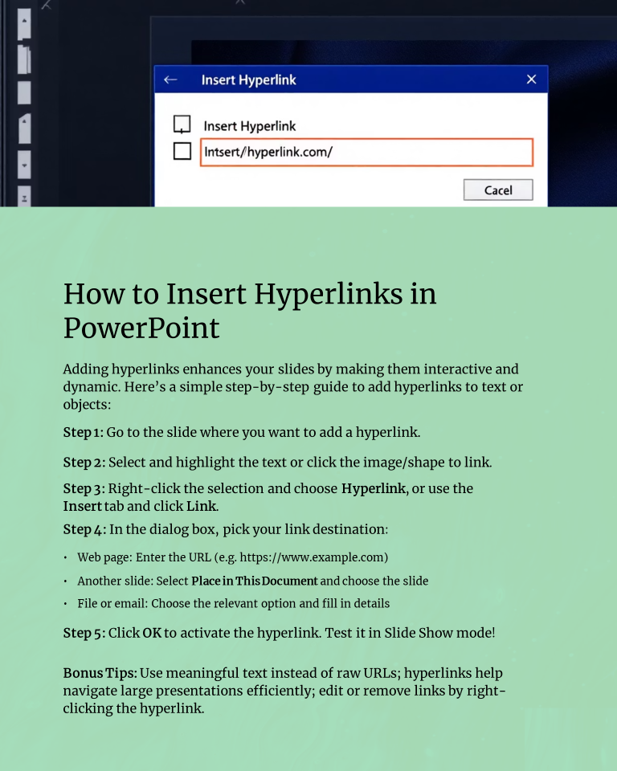

A good and interactive presentation would wonderfully improve the experience of your audience and use of hyperlinks is one of the simplest methods to create the same experience. With hyperlinks, you can refer to outside web pages, move to the other pages on your presentation, or view files and emails with a single mouse click. This guide will take you through the step by step procedures of adding hyperlinks and give you some tips to do so that your presentations become dynamic and professional.
One, open your PowerPoint file and go to the slide which you are going to add a hyperlink. It may be on a given phrase of text, an image, a shape, or any object that you want to be clickable. It is important that you select the correct element since the hyperlink shall be populated on that element you select, whether text or object.
Then, choose a content to be linked. In case it is written text, click and drag to select the words or phrase. With pictures or figures, a quick click on the object selects it. After choosing the hyperlink, you can place your link easily in two different ways. Either right-click on the picked text or item and select the option of Hyperlink in the following menu, or continue to the ribbon of PowerPoint, find the tab of Insert and click on the button of Link or Hyperlink. Both tools lead to the opening of the same dialog box where you will specify where your hyperlink is going.
There are a number of linking options, which will be available in the hyperlink dialog box. To find a web page, all you need to do is to type in the complete web address, e.g., https://www.example.com in the Address field. This enables you to reference your audiences to some online sources or other details. To add a link that does not navigate to a slide but to a place within your presentation click on Place in This Document and use the drop down to select the slide where you want to go. This can be quite handy when making interactive menus or when you want your audience to move not linearly through your slides. You are also able to add links to other files of to organize an email link which will open a new message directed to a user.
Once you have inserted the destination, use the hyperlink by clicking to use the OK button. Note: that you should inspect your hyperlink by clicking on it in Slide Show mode to make sure it do what you want. This is just to prevent your actual presentation with broken-down links or navigation problems.
Hyperlinking Hyperlinks should be as meaningful and text as possible where raw URLs are shown. Like in the example, “Click here to get more info” appears more presentable and understandable to your audience. Hyper links are also useful when handling large presentations as they make it easy to switch between various sections without the need to scroll up and down. Should you want to make changes to the linked text or object or delete it altogether at a later date, right-click on the “Hyperlinked Object”/Text and either click on Edit Hyperlink or Remove Hyperlink.
By including hyperlinks to your presentation, you provide a dynamicity to your presentation. They allow you to branch your slides to valuable resources or further reference rather than putting too much information in too many words on your slides. This ensures that your presentation remains focused and tidy, as well as leaves your audience with the ability to follow up. Hyperlinks added, be it be it websites, documents, or other sliders, provide a professional touch and promote users.

