Dawid Trochim - 1900457
Creating a database University Of Wales Trinity Saint David
Assignment - Information Engineering

Table of Contents
Introduction 1
Screen captures from the relationship diagram 1
Relationship 1 1
Relationship 2 2
Relationship 3 2
Relationship 4 2
Relationship 5 2
Relationship 6 3
Relationship 7 3
Relationship 8 3
Screen captures for each form used 4
Evidence of SQL 10
Output from all reports 12
Appendix 12
Brief user guide 12

Introduction

This report is going to cover all the aspects of the database that has been created for The City Book Store. This report is going to include the features and explanation on how to use it and also the purpose of each function. The screenshots of the SQL, database and the relationship diagram are going to be provided and explained.

Screen captures from the relationship diagram

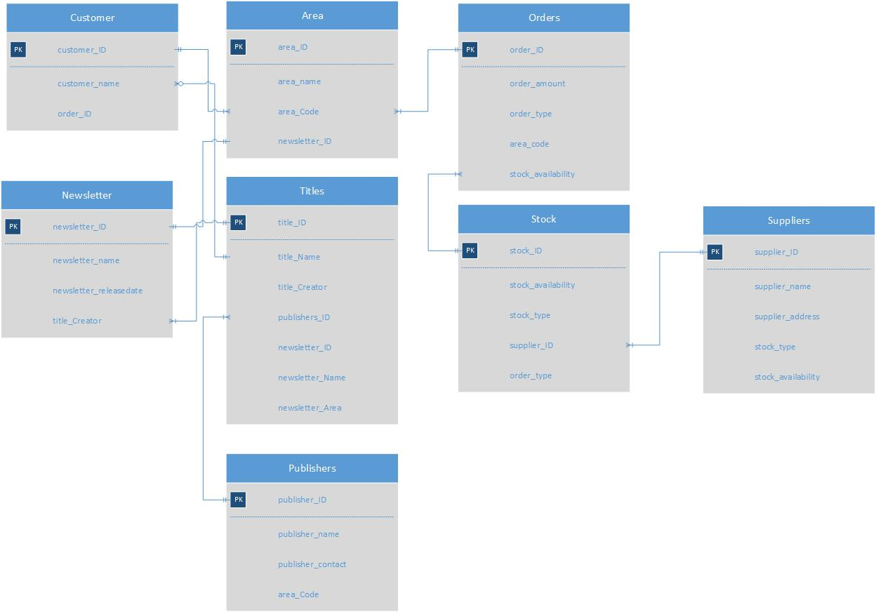
A general overview of the Entity Relationship diagram:
This diagram is showing all the relationships created in order to create a properly functioning database. I decided to carefully plan all the content that needs to be created and I came to the conclusion that fields such as Customer, Area, orders, Newsletter, Titles, Stock, Suppliers and publishers are relevant to what is being asked to create.
Now I am going to explain all the relationships.

Relationship 1

The first relationship goes from Customer_ID to the area_Code. I decided to connect them both because it is good to know where the customer lives. It can be easily identified by the area code for example 1 which could be Mayhill etc. instead of typing long names which can also lead to the mistake. The beginning symbol is “1 and only 1” whereas the end symbol is “1 or more” I decided to put it as 1 and only 1 because it is a customer_ID which is a unique key and cannot be duplicated. The end symbol is set to one or more because there can be more than one area code.

Relationship 2

The second relationship goes from area_Code to the order_ID. I decided to connect them both because it is good to know where each order was placed. It is easy identify the area by using just numbers, for example 1 – Mayhill, 2 – Marina etc. instead of typing long names which can result in making an accidental mistake and can lead to a serious mess and confusion inside the database. So foe example order with a number #234 was placed in area_Code 2 by Customer_ID 10. The beginning symbol is “1 and only 1” whereas the end symbol is “1 or more” I decided to put it as 1 and only 1 because it is a customer_ID which is a unique key and cannot be duplicated. The end symbol is set to one or more because there can be more than one area code.

Relationship 3

The third relationship goes from newsletter_ID to newsletter_ID in an area. The idea behind having it there is to know which newsletter belongs to the certain areas so it is easy to identify what goes where. I decided to put it as 1 and only 1 as the beginning symbol for newsletter_ID inside the newsletter entity which is a unique key and cannot be duplicated whereas for the other one which is the same one I decided to put the end symbol as 1 or more because there can be more than one newsletter_ID. The end symbol is set to one or more because there can be more than one ID for a newsletter.

Relationship 4

The fourth relationship goes from title_Creator to title_ID. I decided to connect them both because it is good to know which creator created the tile, so for example the title creator could be John Wick which and a special and unique title_ID is going to be assigned to his work just to make it really easy to identify which title creators are doing the work. For title_creator, I decided to put the beginning symbol as 1 or more because there can be more than one title creators working on a new book and I decided to connect it to title_ID as I said so the end symbol for title_ID is 1 and only 1 because there cannot be more than 1 unique ID assigned to the title.

Relationship 5

The fifth relationship goes from customer_name to title_Name. I decided to connect them both to make it really easy to understand and recognise which customer bought which title so for example customer_Name Clive Prosser bought a book named title_Name Programming etc. It is just an extra feature which is going to make it really clear and simple. I decided to put the beginning symbol for customer_Name as 1 or more because there can be more than one customer placing an order and for the title_Name I decided to put 1 or more as well because there can be more than one title name.

Relationship 6

The sixth relationship goes from publishers_ID in titles entity to publisher_ID in publishers entity. I decided to connect them both because it is good to know which publisher published the title and it is essential to know that. So for example, publisher_ID 1 which can represent books_Marina can publish the title_ID 1. It is easier to use numbers because it decreases the chance of making a mistake. I decided to put the beginning symbol for publishers_ID in titles entity as 1 or more because there can be more than one publisher_ID in titles, whereas for the same one which is publishers_ID inside the publishers entity I decided to put it as 1 and only 1 because the unique ID needs to created and cannot be assigned to any other title.

Relationship 7

The seventh relationship goes from stock_ID to stock_availability. I decided to connect them both because it is essential to know if a certain stock is available. For example stock_ID 5 could be for journals is connected to stock_availability Yes. So know the employees know that journals are available and ready to sell. For stock_ID I decided to put the beginning symbol as 1 and only 1 because there cannot be more than one stock_ID assigned to all the items, whereas for the stock_availability I decided to put the end symbol as 1 or more because there can be more than one options of availability – Yes, No, Pending, Out of Stock etc.

Relationship 8

The last relationship goes from supplier_ID in suppliers entity to the supplier_ID inside the stock entity. I decided to connect them both because it is essential to know which supplier is supplying the missing stock so for example supplier_ID 2 supplier_Swansea could be responsible for supplying the stock_ID 2 which is audiobooks etc. For supplier_ID inside the suppliers entity I decided to put it as 1 and only 1 because there cannot be more than one unique ID for supplier and for supplier_ID inside the stock entity I decided to put it as 1 or more because there can be more than one item which needs to be refilled.

Screen captures for each form used
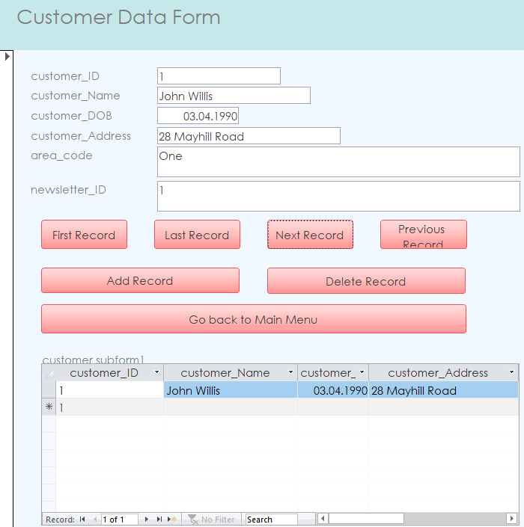

This is the customer form that I have created, users can go to the first record, last record, next record, previous record and also delete and add record. They are also able to go back to the main menu. This form includes all the important information that the user might want to know. This form also has a sub-form built in just in case the user might want to search through the existing records or get a bit more accurate overview on certain records.

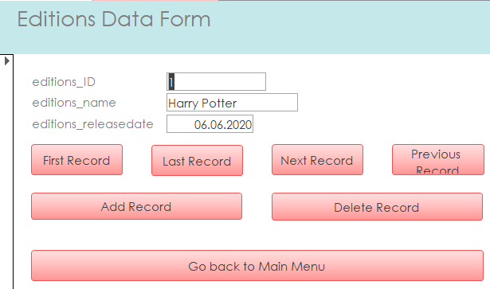
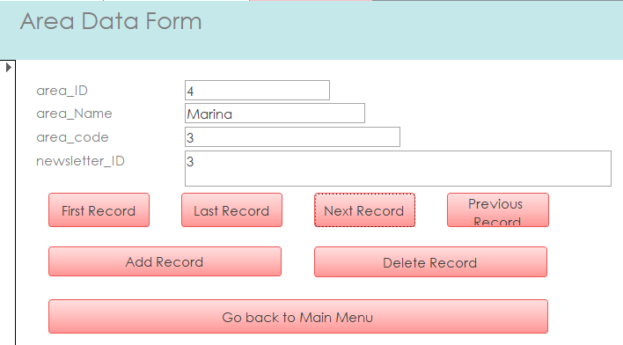
This is the area data form that has been created. This form includes all the important information about the area that user might want to know. Users can go to the first record, last record, next record, previous record and also delete and add record. They are also able to go back to the main menu.
This is the editions data form that has been created. This form includes all the important information that the user might want to know. Users can go to the first record, last record, next record, previous record and also delete and add record. They are also able to go back to the main menu.
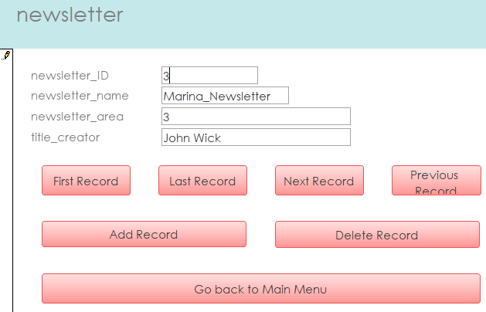
This is the newsletter data form that has been created. This form includes all the important information that the user might want to know. Users can go to the first record, last record, next record, previous record and also delete and add record. They are also able to go back to the main menu.
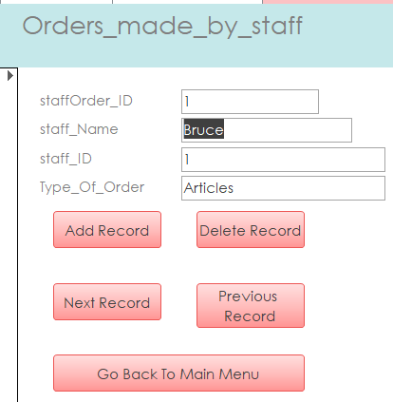

This is the form for staff to make any orders. This form includes all the important information that the user might want to know. Users can go to the next record, previous record and also delete and add record. They are also able to go back to the main menu.

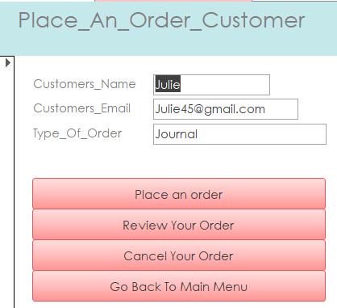

This is the form made for the customers to place orders. This form includes all the important information that the user might want to know. Customers can place their orders, go back to the order to review them and cancel. They are also able to go back to the main menu.
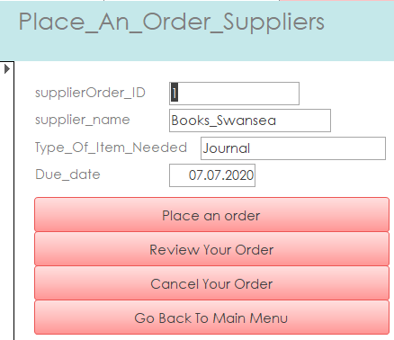

This is the form to place an orders for suppliers. This form includes all the important information that the user might want to know. Customers can place their orders, go back to the order to review them and cancel. They are also able to go back to the main menu.
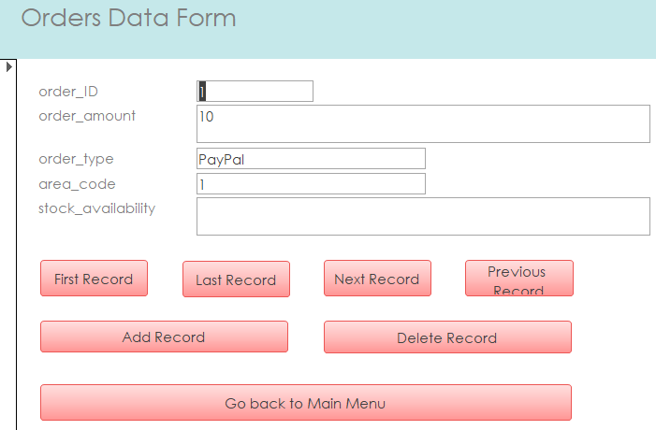

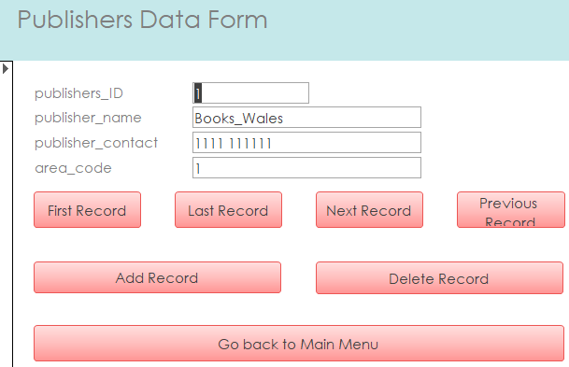
This is the orders form. This form includes all the important information that the user might want to know. Users can go to the first record, last record, next record, previous record and also delete and add record. They are also able to go back to the main menu.
This is the publishers form. This form includes all the important information that the user might want to know. Users can go to the first record, last record, next record, previous record and also delete and add record. They are also able to go back to the main menu.

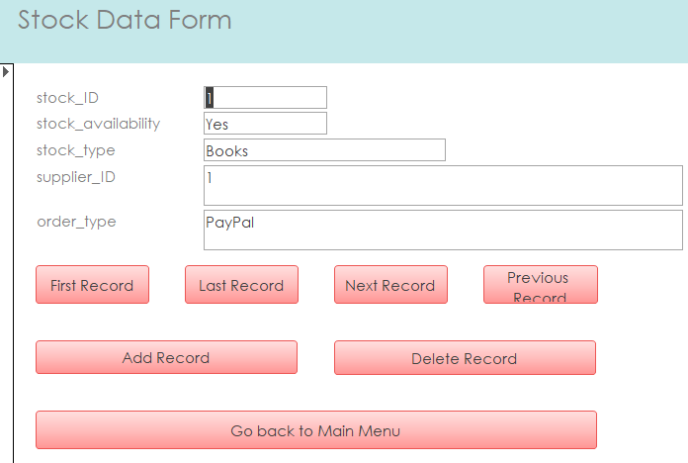

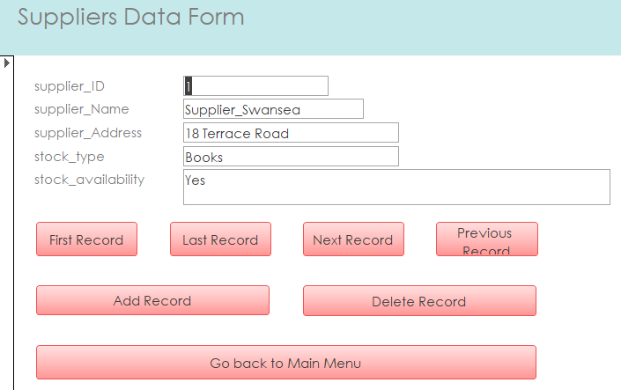
This is the stock form. This form includes all the important information that the user might want to know. Users can go to the first record, last record, next record, previous record and also delete and add record. They are also able to go back to the main menu.

This is the suppliers form. This form includes all the important information that the user might want to know. Users can go to the first record, last record, next record, previous record and also delete and add record. They are also able to go back to the main menu.

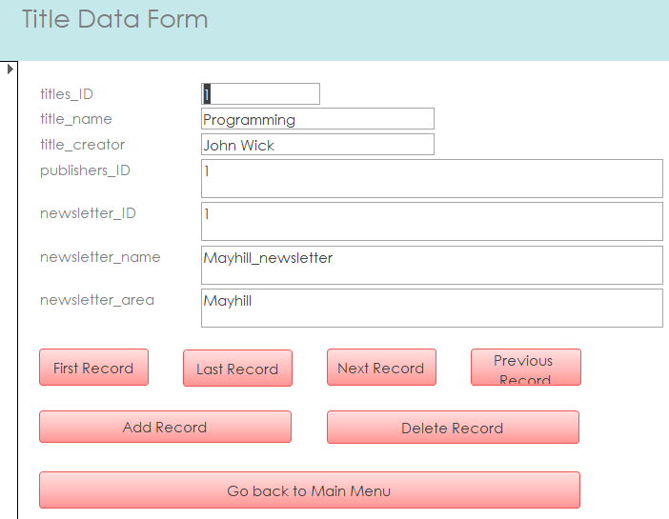
This is the title form. This form includes all the important information that the user might want to know. Users can go to the first record, last record, next record, previous record and also delete and add record. They are also able to go back to the main menu.

Evidence of SQL

I am going to show every single piece of used SQL inside my database.
Area table
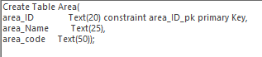
This is a piece of SQL code created for Area Table.
Customer table
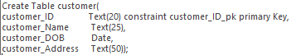

Editions table

This is a piece of SQL code created for Editions Table.

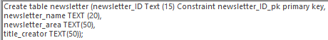
Newsletter table

This is a piece of SQL code created for Newsletter Table.
Orders table
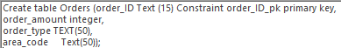
This is a piece of SQL code created for Orders Table.
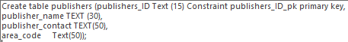
Publishers table

This is a piece of SQL code created for Publishers Table.
Stock table
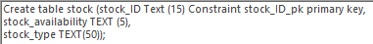
This is a piece of SQL code created for Stock Table.
Suppliers table
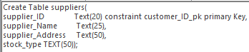
This is a piece of SQL code created for Suppliers Table. .

Titles table
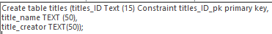
This is a piece of SQL code created for Titles Table.
Orders made by staff table
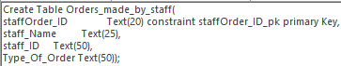
This is a piece of SQL code created for Orders Table.
Place an order (customer only) table
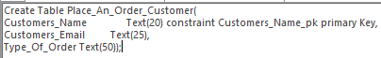
This is a piece of SQL code created for placing an order Table.
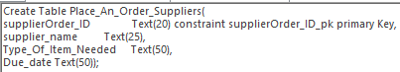
Place an order (suppliers only) table

This is a piece of SQL code created for Area Table.

Output from the report

Here are the outputs from the reports showing report for every single form used in the database, the user can use the main menu to print out any report and then go back to the main menu with just one click and do something else.
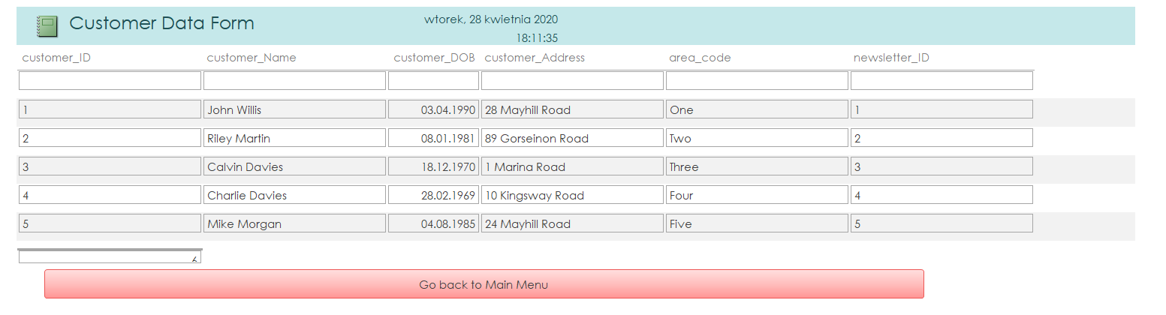
Customer report

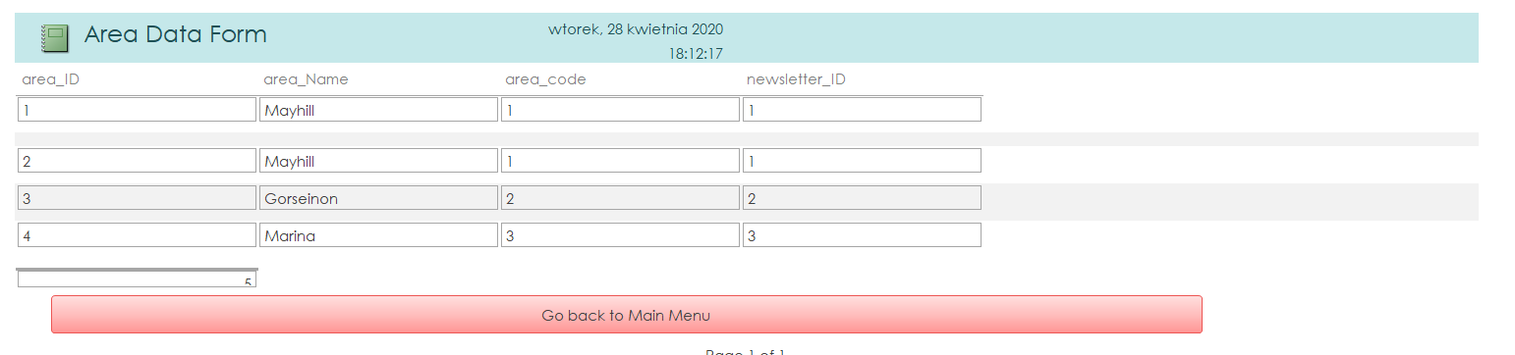
Area report

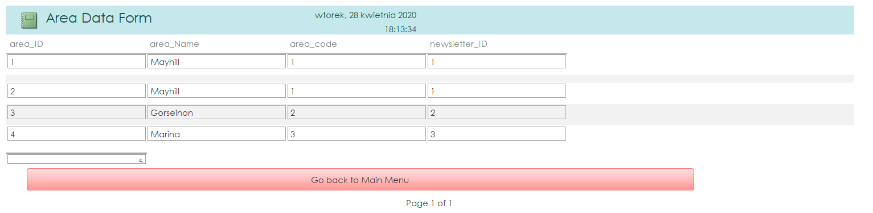
Editions report

Newsletter report
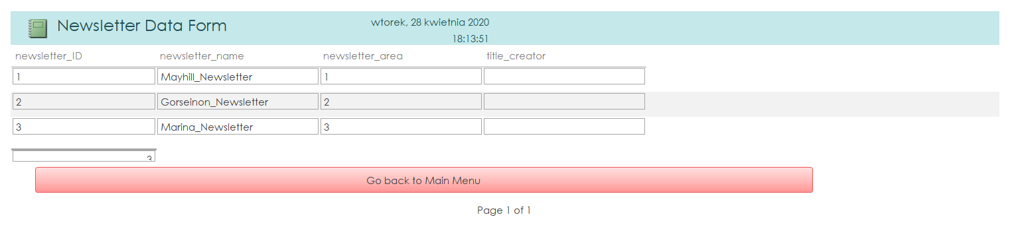
Order made by staff report

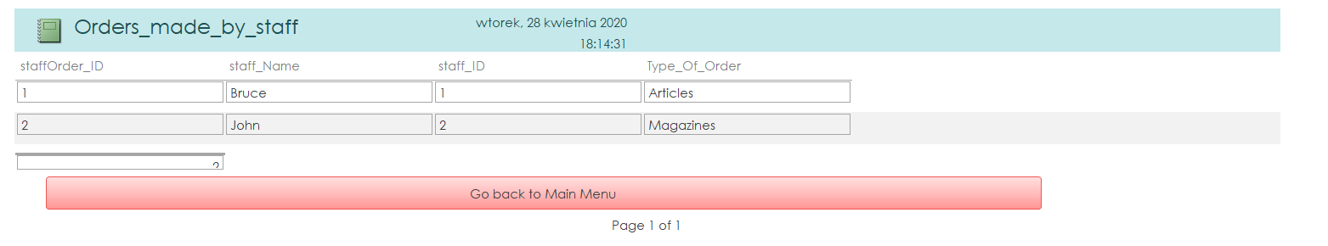

Orders report (WITH CALCULATION OF HOW MANY ITEMS HAVE BEEN SOLD)
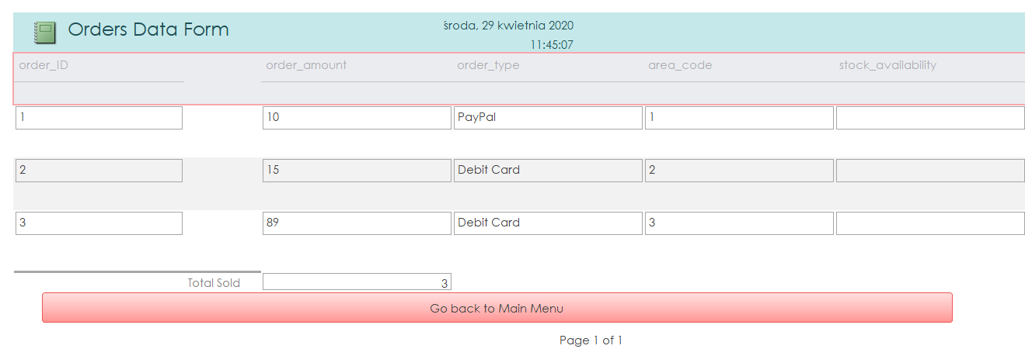

Publishers report
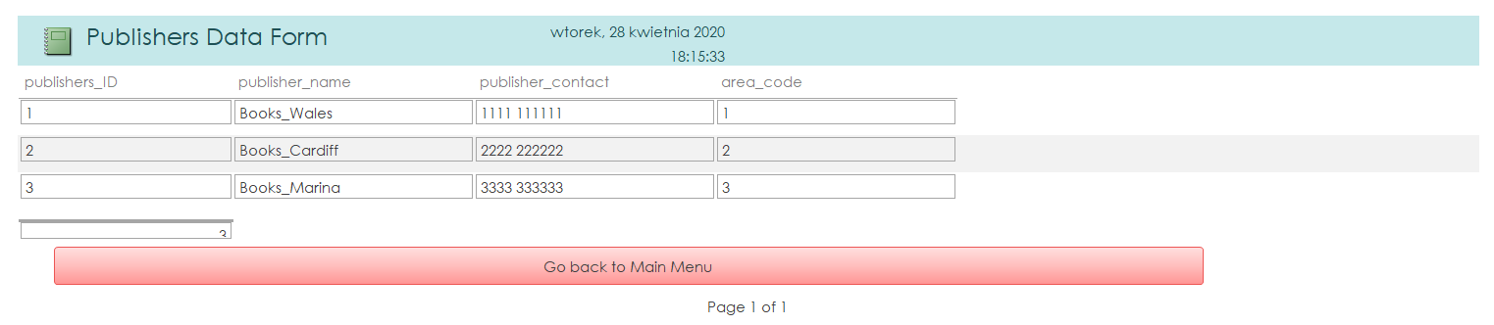
Stock report

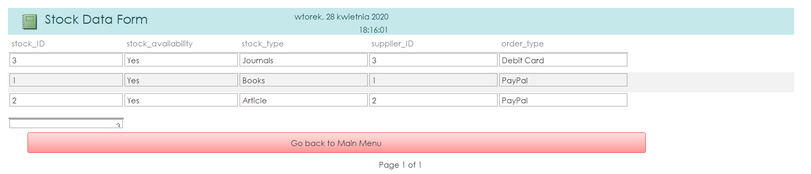
Suppliers report
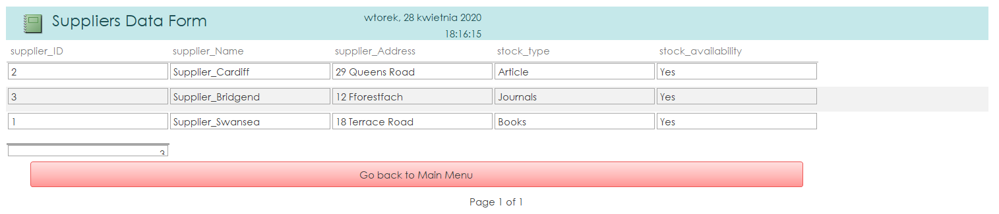

Title report

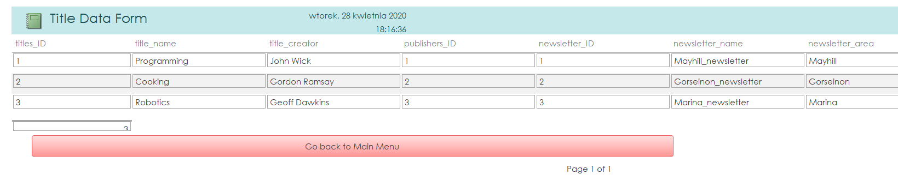

Place an order customer report
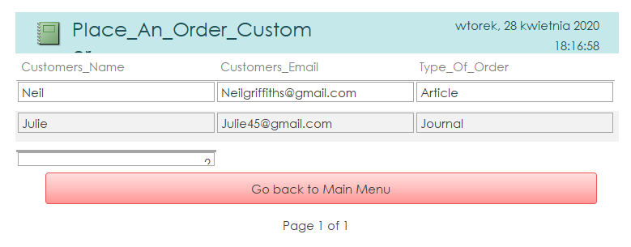

Appendix

Brief user guide

FOR MEMBERS OF STAFF:
In order to get the most out of the database and be as efficient as possible, a special switchboard or main menu has been created which makes the database user-friendly and easy to navigate around. When the database is executed, the user can see the main menu with all the forms such as customer form, area form, editions form etc. There are also forms for customers only and for employees only. Place and order form has been created for customers to place any orders they want which then is stored inside the table that employees can see, once they see what needs to be ordered, they need to open Order items form which is only for employees and place the order for any missing items that customer wishes to order. Members of staff are allowed to find the last record, find first record, find next record, find previous record, add record, delete record and also go back to the main menu from any form which is good because it offers them a full flexibility and efficiency. Here is a screenshot of what forms are available for staff.

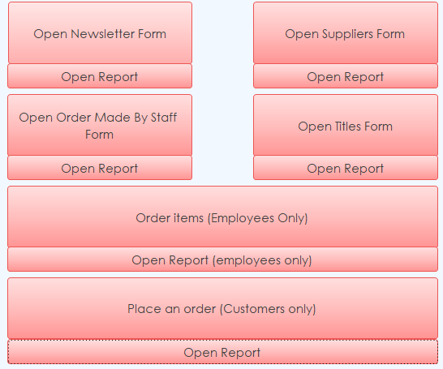
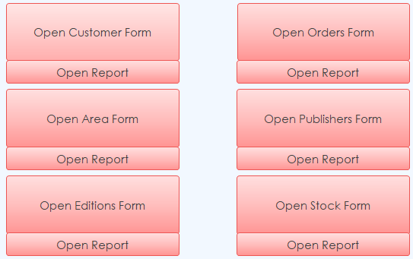

FOR CUSTOMERS:
Customers are only allowed to use one form which has been especially created for them. This for is called “Place an order (Customers only)” They are allowed to place any order they want. They can open the form and they have to type their name, their email address so it is easy to contact with them just in case there are any changes made or important things to be asked, they can also decide what type of order do they want – they can pick things such as journals, books, audiobooks, articles etc. so the variety of available stock is quite large. They can also review their order just in case they decide to change their mind, customers are also allowed to cancel their order which is permanently going to erase all the data that they have type in and they are going to be able to place a new order. All the data entered by the customer is going to be stored inside a special table which has been created for this purpose only so the employees can go back and check what needs to be sold or ordered if the item is missing. Here is a screenshot of the only form which customer needs to be aware of in order to properly use the system.
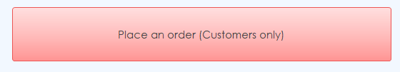

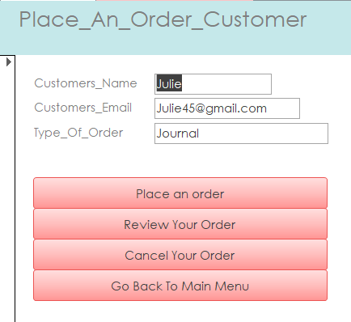

No references needed for this assignment

