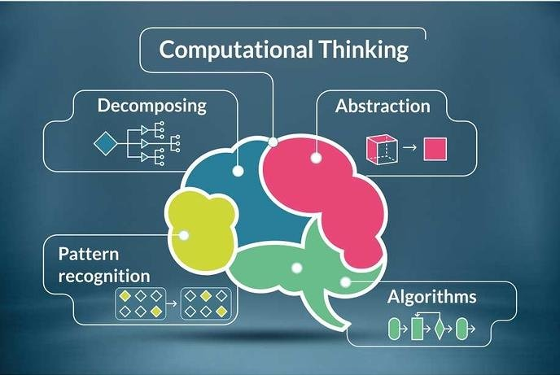

[Place Image Here]

Assessment
Name: Zaeem
Student No.: 1902036
Course: Applied Computing (Web Development)
Module: Computational Thinking
Date: 20/01/2020

Table Of Contents
Content Page Number
1. My Use Case Documentation 3
2. My Use Case Diagram 4
3. My BPM Diagram 1 5
4. My BPM Diagram 2 6
5. My BPM Diagram 3 7
6. My BPM Diagram 4 8
7. My BPM Diagram 5 9
8. My BPM Diagram 6 10
9. My BPM Diagram 7 11
10. My BPM Diagram 8 12
11. My BPM Diagram 9 13
12. My BPM Diagram 10 14
13. My BPM Diagram 11 15
14. My BPM Diagram 12 16
15. My BPM Diagram 13 17
16. My BPM Diagram 14 18
17. Evidence of Implementation 19
17.1. Code Created 19
17.2. Photo of Robot 20
18. Evidence of Testing 21
1. My Use Case Documentation
The use case documentation for the robot will be shown underneath as this is used to create the use case diagram.
- The robot will need to look for the marker pen
- The robot will need to move
- The robot will need to report it to the system
- The robot will need to lift up and carry the marker pen
- The robot will need to draw a path on each shape
- The robot will need to report it to the system
- The robot will need to draw a path on each shape again but increase 10cm
- The robot will need to report it to the system
- The robot will need to draw a path on each shape again but increase another 10cm
- The robot will need to report it to the system
- The robot will need to calculate each area of each shape
- The robot will need to report it to the system
- The robot will need to see a red object
- The robot will need to report it to the system
- The robot will need to halt
- The robot will need to report it to the system
- The robot will need to raise an alarm
- The robot will need to report it to the system
- The robot will need to remove the red object
- The robot will need to report it to the system
- The robot will need to continue on its course
- The robot will need to see an irremovable object
- The robot will need to report it to the system
- The robot will need to halt
- The robot will need to report it to the system
- The robot will need to raise an alarm
- The robot will need to report it to the system
- The robot will need to stop drawing the shape
- The robot will need to break the program
- The robot will need to report it to the system

2. My Use Case Diagram
The use case diagram for the robot will be shown underneath as this is used from the use case documentation.
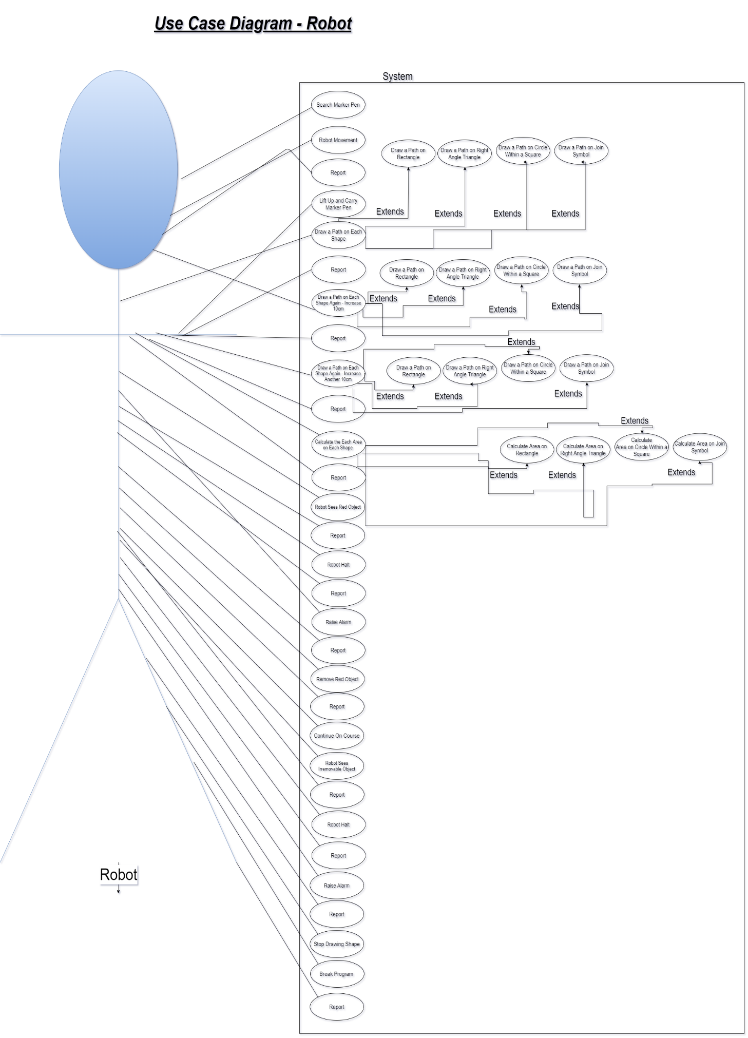

3. My BPM Diagram 1
The BPM for the robot to draw on the rectangle will be shown underneath as this is used from the use case documentation and the assessment brief.
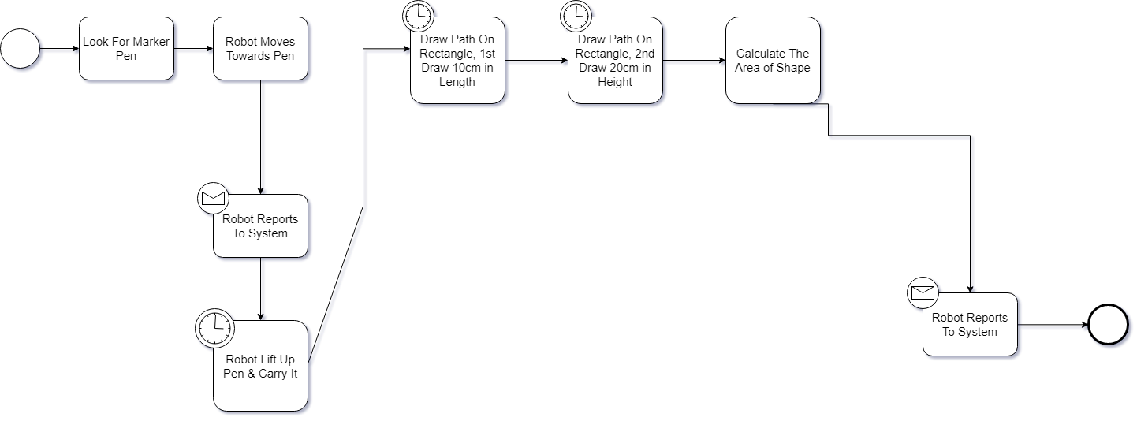

4. My BPM Diagram 2
The BPM for the robot to draw on the right-angle triangle will be shown underneath as this is used from the use case documentation and the assessment brief.
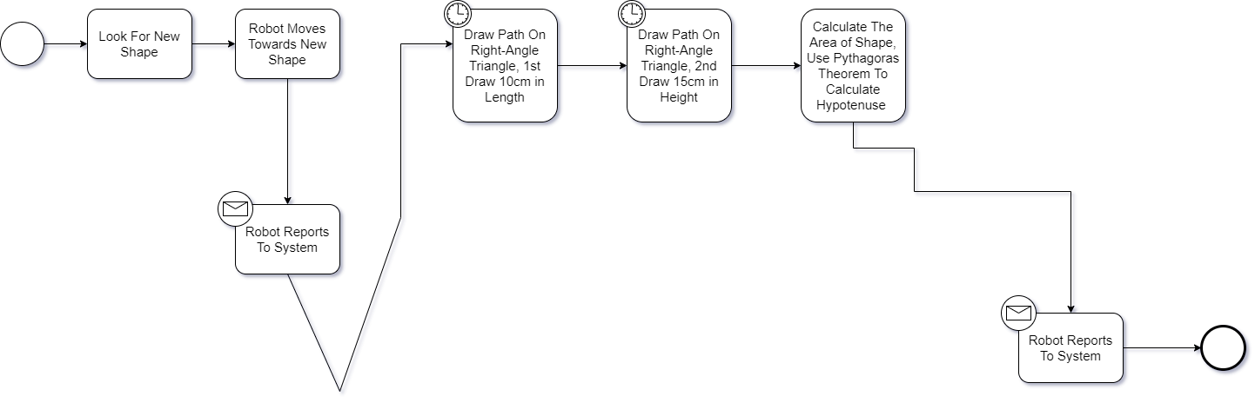

5. My BPM Diagram 3
The BPM for the robot to draw on the circle within a square will be shown underneath as this is used from the use case documentation and the assessment brief.
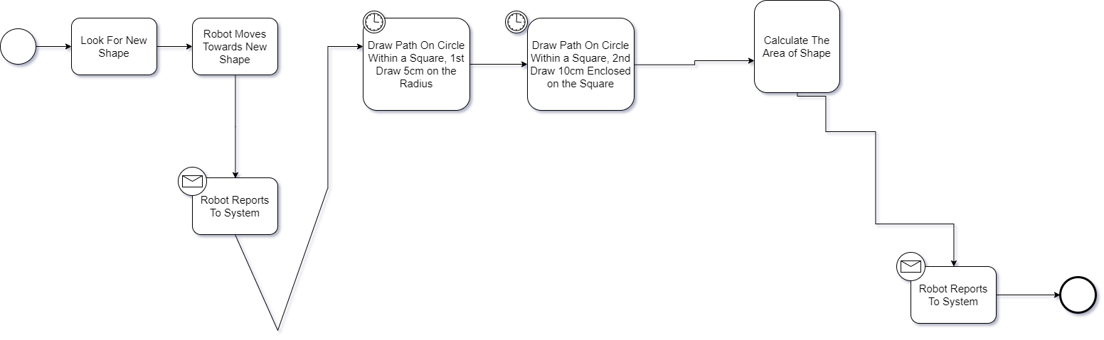

6. My BPM Diagram 4
The BPM for the robot to draw on the join symbol will be shown underneath as this is used from the use case documentation and the assessment brief.
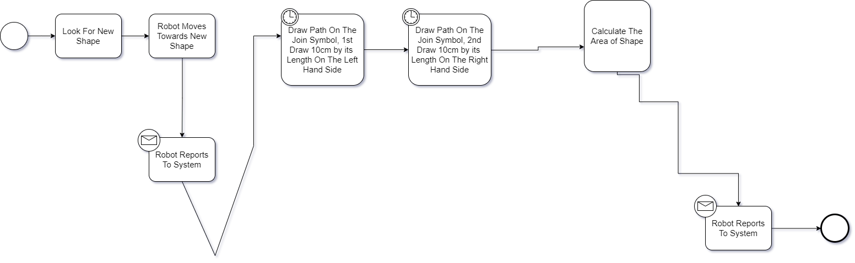

7. My BPM Diagram 5
The BPM for the robot to draw on the rectangle for the 2nd time will be shown underneath as this is used from the use case documentation and the assessment brief.
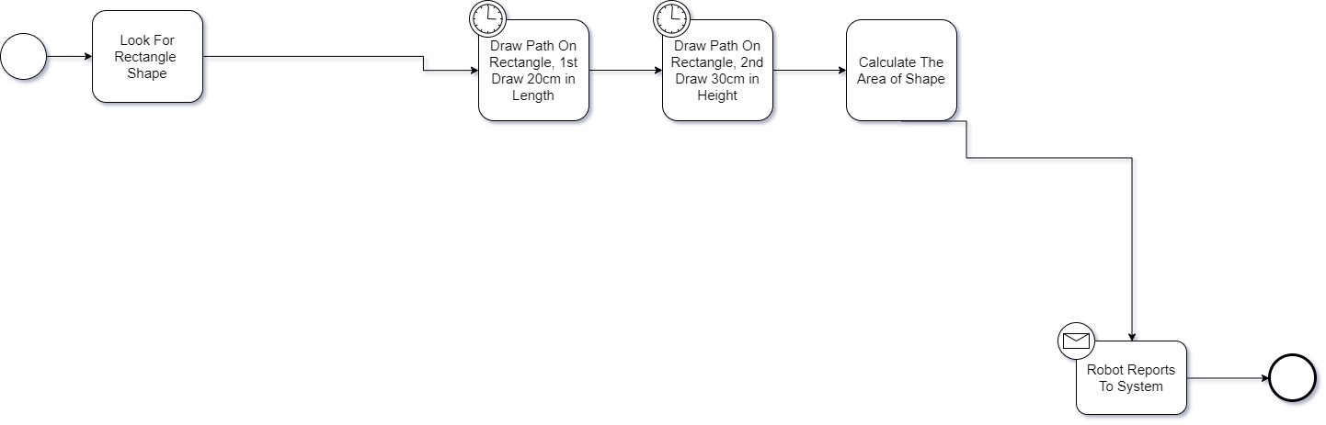

8. My BPM Diagram 6
The BPM for the robot to draw on the right-angle triangle for the 2nd time will be shown underneath as this is used from the use case documentation and the assessment brief.
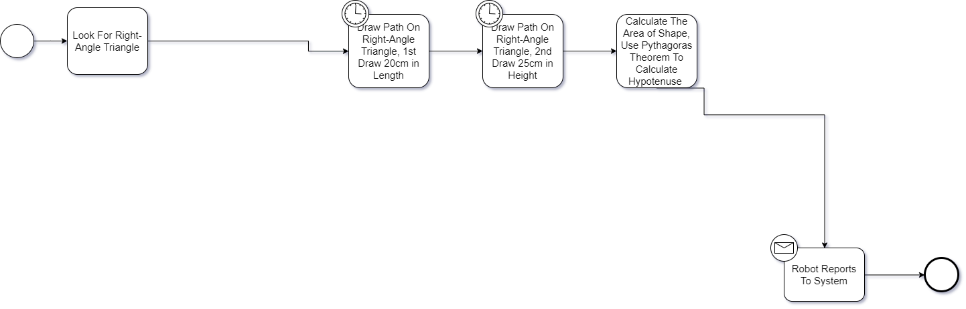

9. My BPM Diagram 7
The BPM for the robot to draw on the circle within a square for the 2nd time will be shown underneath as this is used from the use case documentation and the assessment brief.
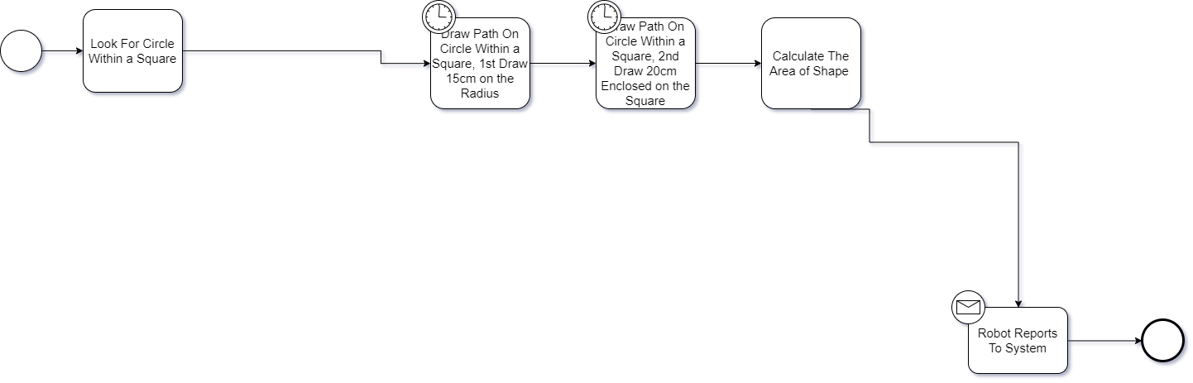

10. My BPM Diagram 8
The BPM for the robot to draw on the join symbol for the 2nd time will be shown underneath as this is used from the use case documentation and the assessment brief.
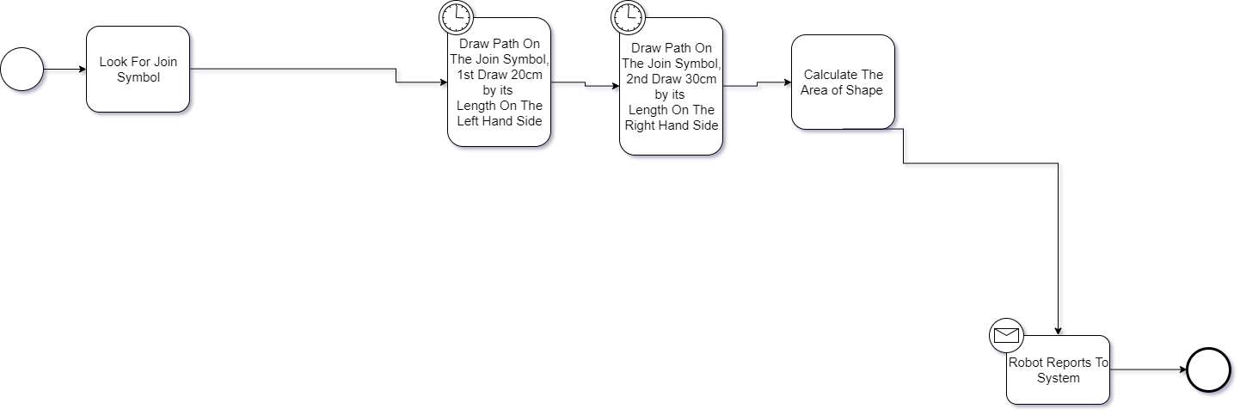

11. My BPM Diagram 9
The BPM for the robot to draw on the rectangle for the 3rd time will be shown underneath as this is used from the use case documentation and the assessment brief.
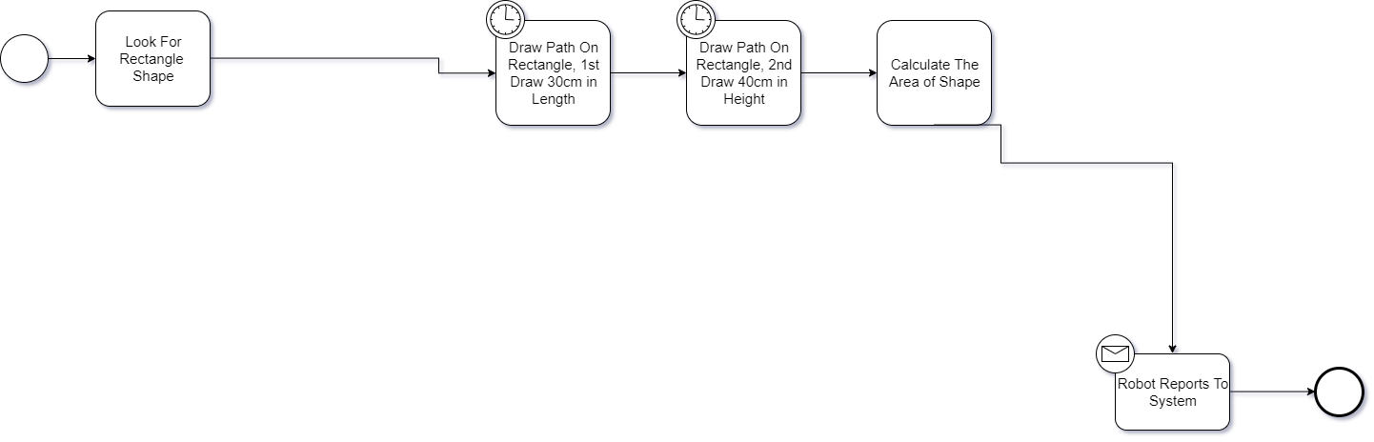

12. My BPM Diagram 10
The BPM for the robot to draw on the right-angle triangle for the 3rd time will be shown underneath as this is used from the use case documentation and the assessment brief.
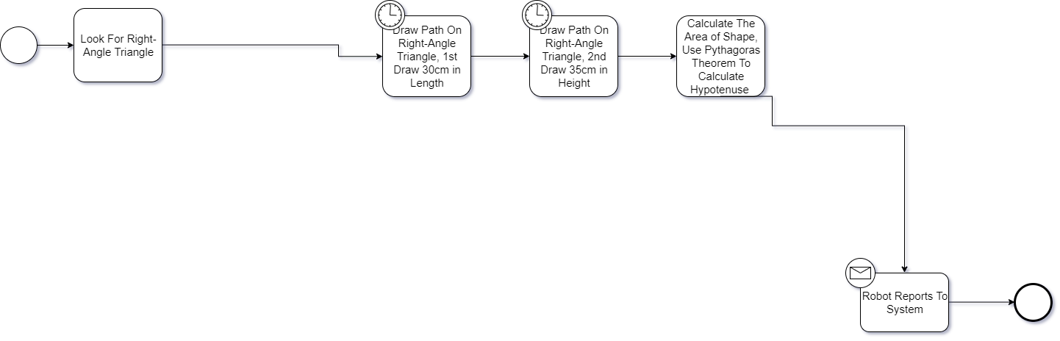

13. My BPM Diagram 11
The BPM for the robot to draw on the circle within a square for the 3rd time will be shown underneath as this is used from the use case documentation and the assessment brief.
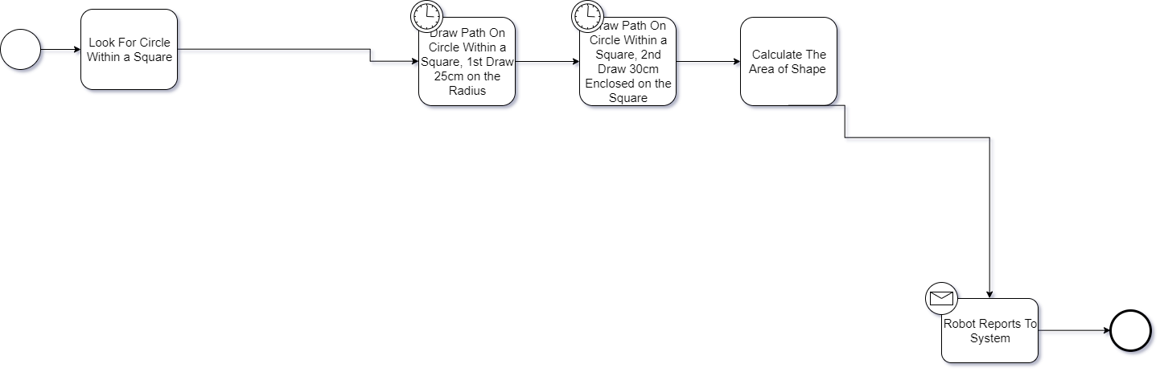

14. My BPM Diagram 12
The BPM for the robot to draw on the join symbol for the 3rd time will be shown underneath as this is used from the use case documentation and the assessment brief.
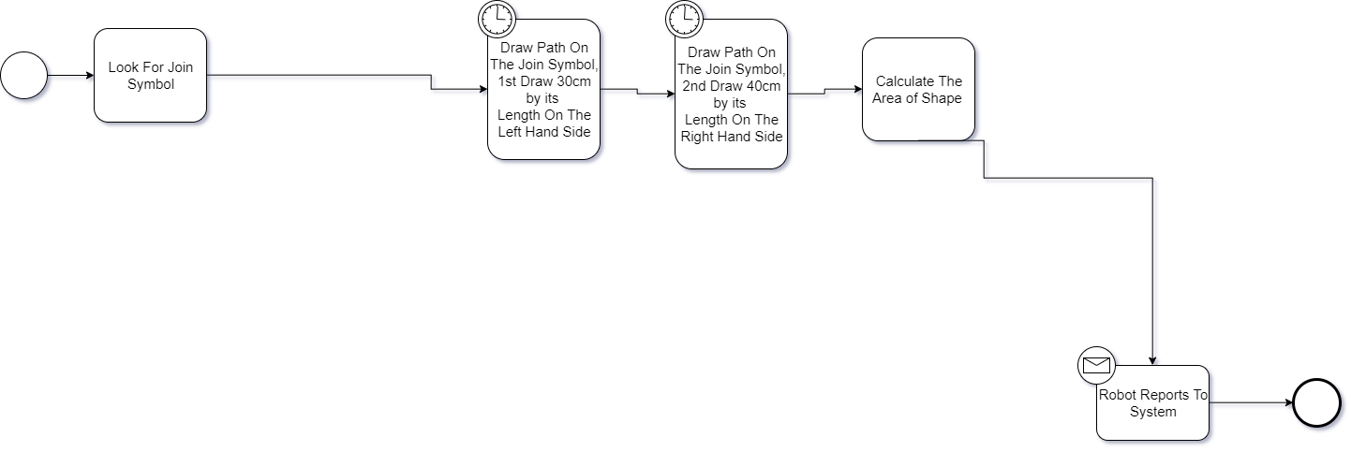

15. My BPM Diagram 13
The BPM for the robot when they see a red object will be shown underneath as this is used from the use case documentation and the assessment brief.
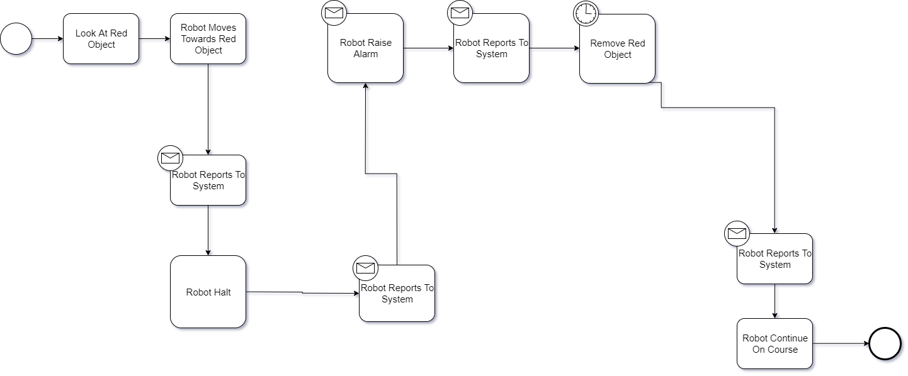

16. My BPM Diagram 14
The BPM for the robot when they see a irremovable object will be shown underneath as this is used from the use case documentation and the assessment brief.
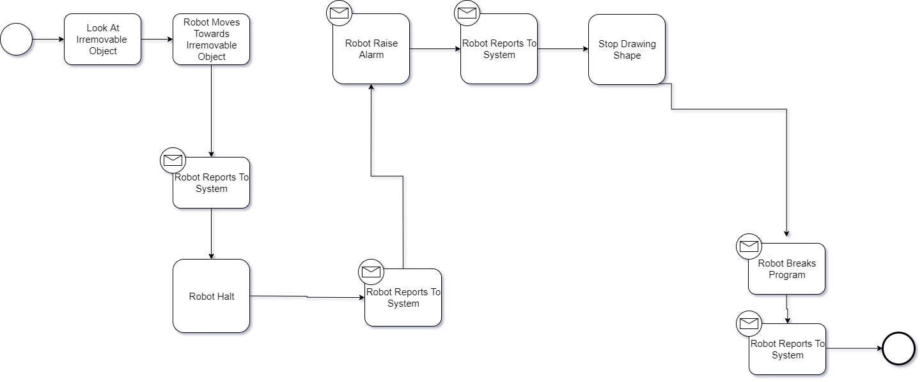

17. Evidence of Implementation

17.1. Code Created
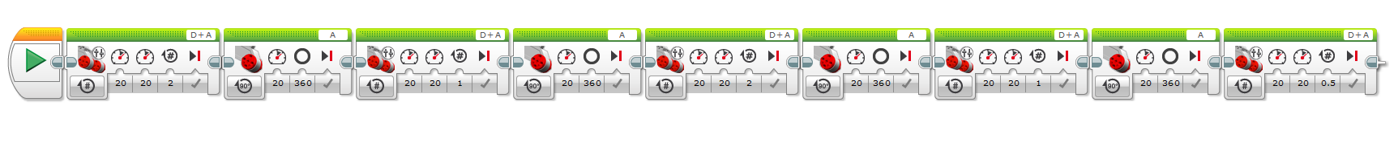
This is the program code for rectangle.

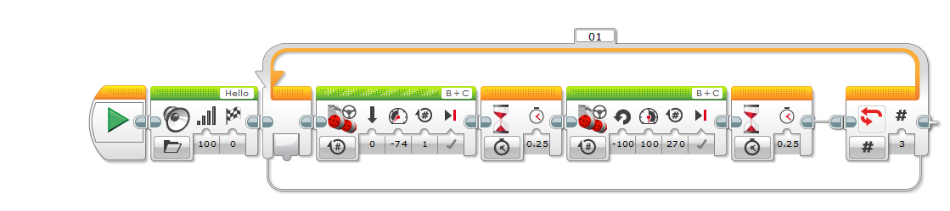
This is the first attempt of the program code for the right-angle triangle.

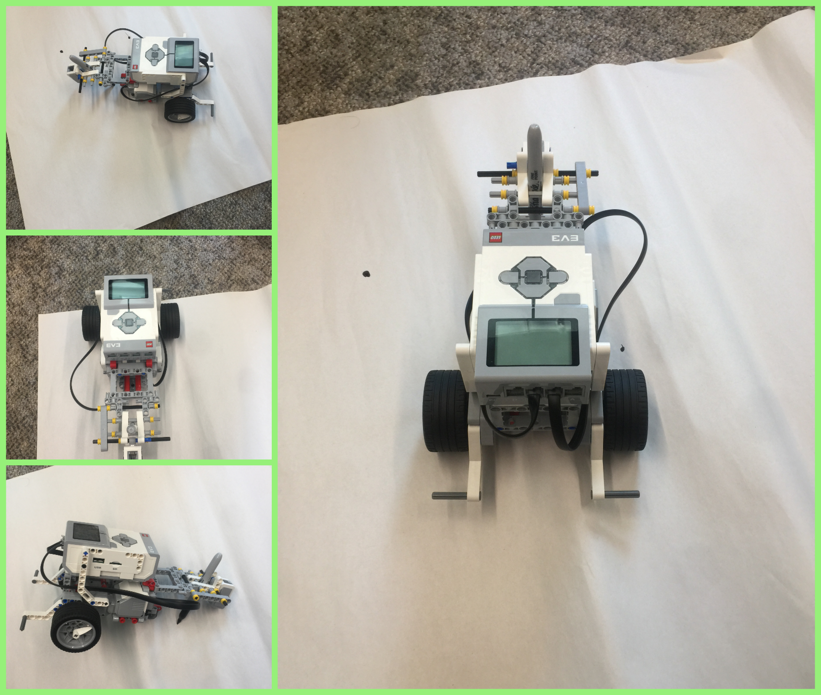
17.2. Photo of Robot

These are pictures of the robot that we created during this assessment.

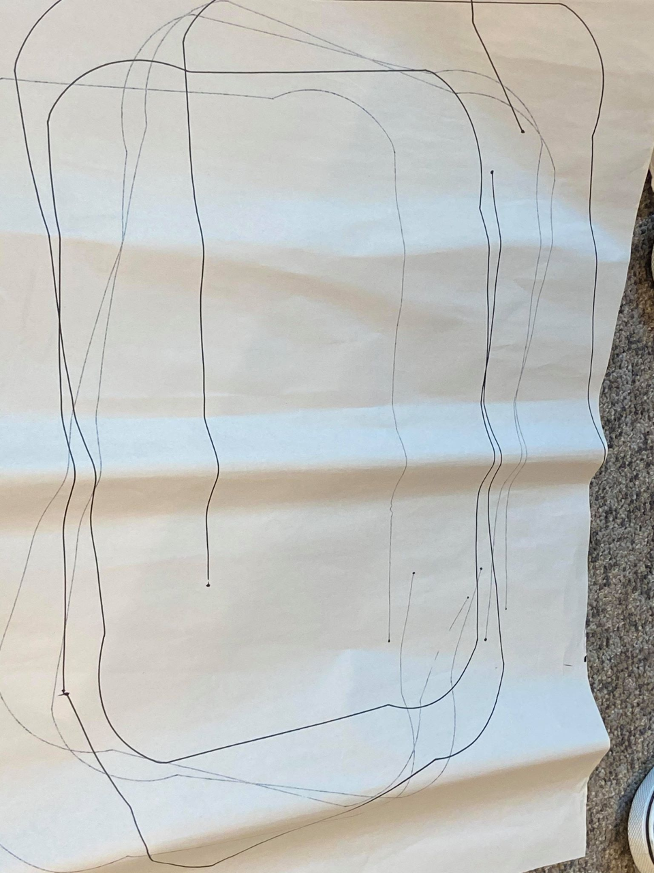
18. Evidence of Testing
This is the first attempt of testing for the rectangle

