Module: Developing workplace critical thinking
Module code: BMSW5101
Student Name: Vasilica-Madalin Iliuta
Student ID: 2007277
Lecturer’s name: Zahra Mohammadnazari
Reflective report

Task 3. A reflection of how my critical thinking skills and understanding of management have developed based on my learning in the module.

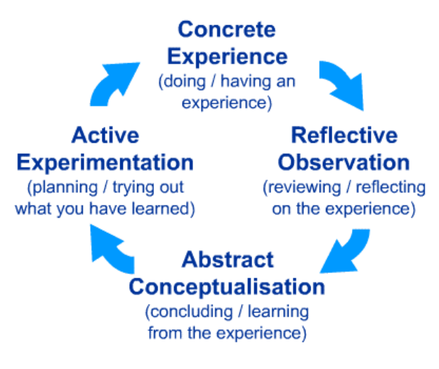
I used Kolb’s reflective model to reflect on my learning in this model. Kolb’s learning cycle is a theoretical and practical method of measuring learning efforts (McLeod, 2017).
Kolb suggested that learning is a combined process with every step of the cycle being mutually helpful and effective learning happens only when all stages are accomplished (Finlayson, 2015).

1. Concrete Experience.
In week five I had a multiple-choice quiz based on what we have learned during the classes in the first four weeks, about the CRAAP test and how to be a critical learner. A quiz where from several answers I should choose the right one was a great experience for me. Logic and reasoning and causes and consequences of critical thinking part look like to be the most complicated ones to me, so this was the part where I was struggling when giving the right answer. I was very nervous about the test, and unfortunately, I didn’t know the answer to all the questions.

2. Reflective Observation.
At the point when I finished developing the workplace critical thinking module, I gained a lot of useful information and understanding of what management theories are better to be applicable in the future workplace. After assessing my beliefs, attitudes, and values the impact on workplace behavior has changed in a better way.
I found out that being a critical learner and critical writing was a hard part for me, and I should practice more on how to ask and answer questions to critically evaluate the situation in the workplace. I have tried to use the critical thinking I have learned during this module, which was an advantage to me, for future assignments writing as well as for the workplace.

3. Abstract Conceptualization.
Effective management is essential in the workplace, as it is not only used to increase organizational production and profitability, but as well to effectively plan and organize, and control the employees.
Learning about how to use critical thinking as a learner by implementing credible sources, and how to assess correctly resources found online I will be able to use in the writing of assignments for other modules.
While learning in this module I had a great experience learning about management theories which I could as well implement in the chosen organization for my assignment. Management theories are used by skilled managers who have as well appropriate knowledge and abilities to help the company to implement and achieve common goals.

4. Active Experimentation.
In week six I learned about managing conflict situations. An important topic for conflict resolution in organizational development. The lecturer explained what is organisational conflict and how to manage a conflict efficiently. After the explanation of the theory, we have been given a study case to discuss and implement what we learned that day. I had to work with a colleague in a group to find out how the given conflict can be solved. After this, a person from each group, including me, had to say what we came up with.

References.

- Finlayson, A. (2015) ‘Reflective practice: has it really changed over time?’, Reflective Practice, 16(6), pp.717-730.
- McLeod, S. (2017) ‘Kolb's learning styles and experiential learning cycle’, Simply psychology, 5.

