

Assignment Title: Mental Health Awareness Campaign
Module name: Managing Projects in Organisations
Student name: Marian Mihai Luca (1712434)
Lecturer Name: Giulia Chifari
Submission deadline date: 03.07.2026

Word count: 1935

Mental Health Awareness Campaign

Executive Summary

This report critically examines the planning, implementation and evaluation of a Mental Health Awareness Campaign completed as part of the Managing Projects in Organisations module at UWTSD. The project was delivered by a group of four student, myself, Sanda, Catalina and Daniel with the aim of raising awareness of mental health issues among university students and generating charitable donations for Mind, a leading UK mental health charity.
The event took place on 16th of June 2026 and was well received by both students and staff. The report assesses the project management tools and techniques applied throughout the project lifecycle, including the Work Breakdown Structure (WBS), Gantt Chart and the Iron Triangle concludes with recommendations for future improvement.
The project was not without its challenges. The original event date had to be rescheduled after it was identified that university operational approval had not been obtained, which required the team to adapt plans under time pressure. This experience provided some of the most valuable learning opportunities of the project, particularly in relation to stakeholder mapping, risk management and contingency planning.
Five recommendations are proposed for future improvement. First, conduct a full stakeholder mapping exercise at initiation to ensure all approval authorities are identified early (Heagney, 2016; Bourne, 2015). Second, develop a formal risk register from the outset to anticipate and mitigate foreseeable risks (Kendrick, 2015). Third, build contingency time into the schedule to protect against delays caused by approvals and external dependencies (Wysocki, 2014; Burke, 2013). Fourth, create a formal written communication plan to ensure consistency and prevent key stakeholders from being overlooked (PMI, 2021; Newton, 2016). Fifth, conduct a structured post-project evaluation after every project so that lessons learned are recorded and applied to future work (Reiss, 2015; Lock, 2020).

Contents
Mental Health Awareness Campaign 2
Executive Summary 2
1. Introduction 4
2. Findings 4
2.1 Critical Discussion of Project Management Tools and Techniques 4
2.2 How the tools were used in the project 6
2.3 Communication and Stakeholders 8
3. Conclusion 10
4. Future improvements 10
5. Reference list 12

Introduction

The Mental Health Awareness Campaign was a real project completed as part of the Managing Projects in Organisations module and the project was carried out by myself, Sanda, Catalina and Daniel between 11th of May 2026 and 16th of June 2026. The main aims were to raise awareness of mental health issues among students at UWTSD and to collect voluntary donations for Mind, a well-known UK mental health charity.
The Project Management Institute (2021, p.4) defines a project as a temporary activity created to produce a unique product, service or result. This fits our campaign well as it had a clearly defined start and end date, a specific scope and a particular goal. Kerzner (2022) adds that successful projects are not only about completing tasks but about achieving measurable objectives within agreed limits of time, cost and quality.
Mental health is a very important issue for university students. Mind (2025) reports that one in four people in the UK will experience a mental health problem each year and those students are especially vulnerable due to academic pressure, financial stress and social changes. Reiss (2015) argues that projects with a genuine social purpose tend to generate stronger team commitment and this was true in our case as all four of us stayed dedicated throughout.

Findings

2.1 Critical Discussion of Project Management Tools and Techniques

Heagney (2016) argues that project management provides a structured way to define objectives, allocate resources, manage risks and deliver results within agreed constraints. Choosing the right tools is therefore very important for any project. This section critically examines the key tools relevant to our campaign and evaluates their strengths and limitations.
The WBS breaks a project into smaller, manageable tasks. Lock (2020) describes it as one of the most fundamental tools in project management because it transforms a complex goal into specific activities that can be assigned and tracked. Hollister (2017) argues that a clear WBS helps prevent scope creep, one of the most common causes of project failure. However, Wysocki (2014) warns that a WBS is only effective when regularly updated, because a static version quickly loses accuracy as the project evolves.
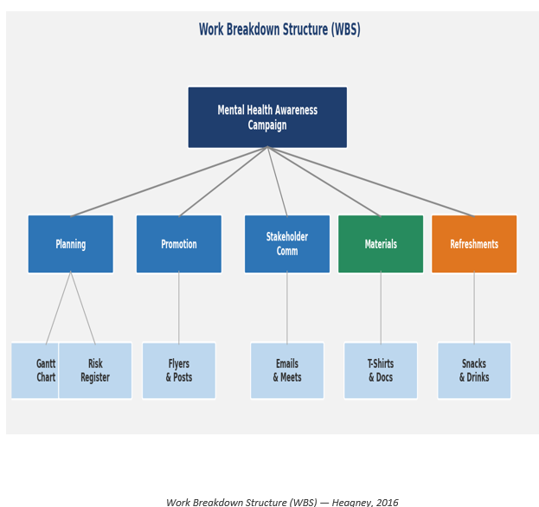
The Gantt Chart is a visual scheduling tool showing tasks, durations and their order. Clegg, Skyttermoen and Vaagaasar (2020) describe it as one of the most widely used tools in project management, arguing that it allows teams to monitor progress and make adjustments when plans change. Meredith and Mantel (2009) note that Gantt Charts can struggle with complex task dependencies and Heerkens (2015) adds they work best when treated as living documents rather than static plans.
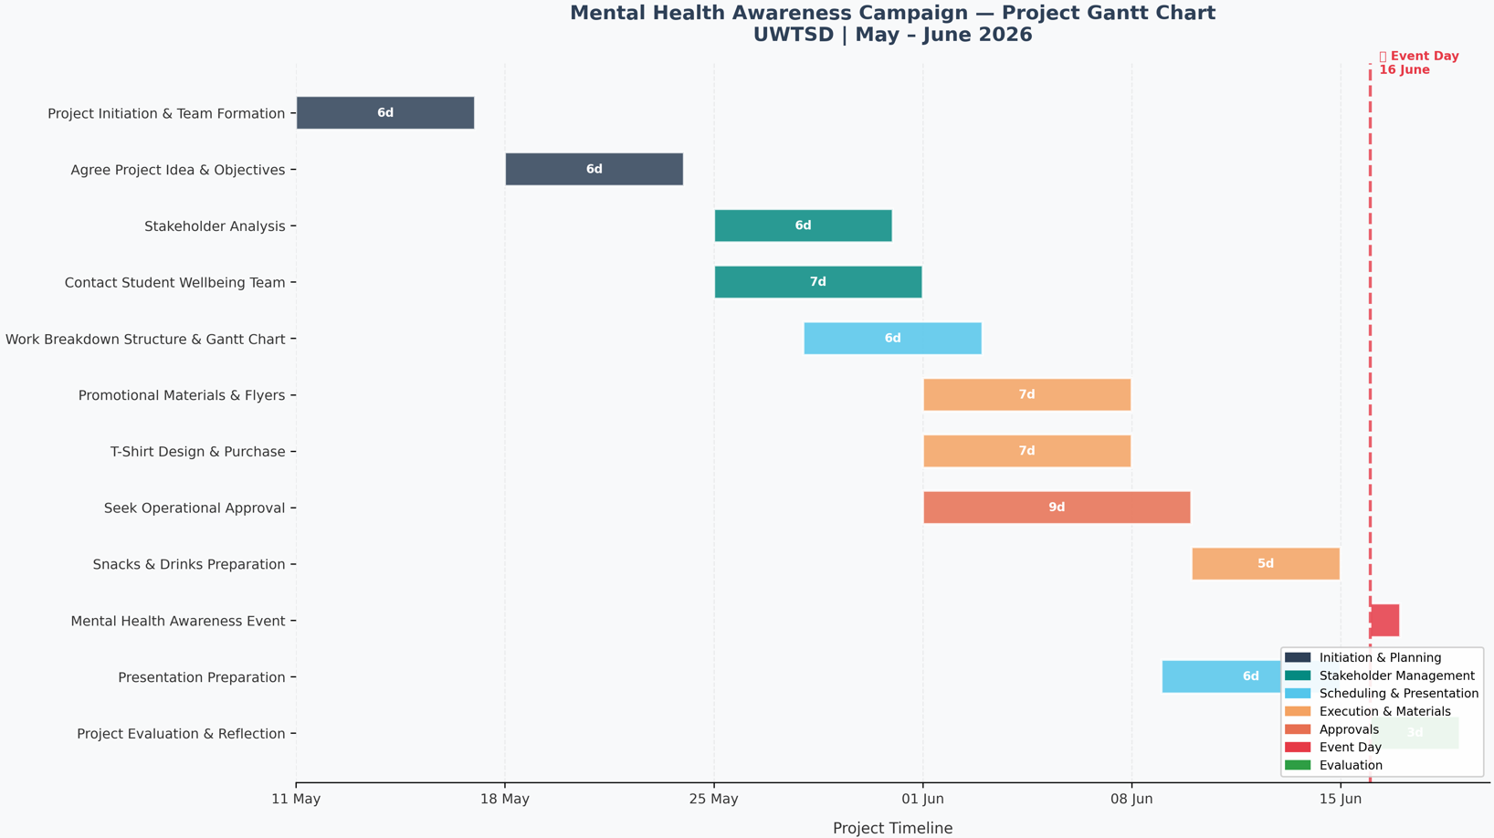
The Iron Triangle describes the relationship between time, cost and quality. Kerzner (2022) explains that these three constraints are inherently connected and changing one will affect the others. Burke (2013) adds that this concept helps project managers anticipate trade-offs and make informed decisions when under pressure.
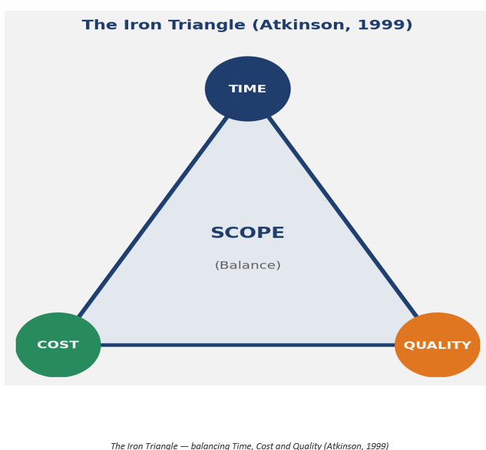
Wysocki (2014) distinguishes between traditional and Agile approaches. Our campaign followed a traditional sequential lifecycle as taught in the module, though the team demonstrated adaptive flexibility when the event had to be rescheduled, a characteristic Wysocki associates with more iterative approaches. Larson and Gray (2018) argue that effective teams draw on elements of both. Kendrick (2015) argues that identifying risks early and planning mitigation strategies allows teams to avoid many problems before they occur, and Newton (2016) adds that even a basic risk register significantly improves a team`s ability to handle unexpected events.

2.2 How the tools were used in the project

Turner (2014) describes the project lifecycle as a structured sequence of phases from initiation to closure. This section explains how the tools above were applied during the campaign with specific examples.
During initiation, roles and responsibilities were agreed. Belbin (2010) argues that clear roles are one of the most important foundations for effective teamwork. Tuckman (1965) identifies role clarity as essential in helping a team move from the forming stage to the performing stage. My Belbin questionnaire identified me as a Coordinator, meaning someone who encourages collaboration and keeps the team focused. Fisher, Hunter and Macrosson (2001) note that people often take on multiple roles depending on demands, which I also experienced at different stages of the campaign.
During planning, the team created a WBS structured around five areas: venue arrangement, promotional materials, refreshment procurement, stakeholder communication and presentation preparation. Each area was broken into tasks assigned to individual team members. For example, promotional materials including flyers, printing them and creating a social media event page. Before the WBS, the project felt very difficult to manage. Once tasks were clearly mapped, it became easier to understand responsibilities and estimate timelines.
The Gantt Chart scheduled all tasks from the 11th of May to 16th of June 2026. It showed that promotional materials needed to start early to allow enough distribution time, while refreshments should be purchased close to the event. The biggest test came when the team was told that the original event date could not proceed because university operational approval had not been received. The team used the Gantt Chart to review completed tasks, identify what needed to be accelerated and adjust the remaining timeline. Clegg, Skyttermoen and Vaagaasar (2020) argue that adaptive re-planning is one of the most valuable skills in project management, and it proved essential in this situation.
A significant weakness was that the university operations approval had not been included in the WBS or Gantt Chart. Wysocki (2014) warns that overlooking administrative approvals is a common planning error and Hollister (2017) notes that approval processes are often on the critical path and can cause major disruptions if not planned for.
The rescheduling illustrated the Iron Triangle practically. With less time available, the team prioritised the most visible elements including promotional materials, refreshments and the presentation. Burke (2013) argues that this prioritisation under pressure is exactly what the Iron Triangle is designed to support.
During execution, all activities were carried out in line with the revised schedule. Flyers were distributed across campus, Sanda managed the social media campaign and Daniel purchased the refreshments. I helped coordinate final preparations and contributed to group presentation, as well as ordering the campaign t-shirts.
Newton (2016) argues that execution is where the quality of planning proves its value. The event on 16th of June 2026 was delivered successfully with every positive feedback from students and lecturers.
A critical gap was the absence of a formal risk register. Kendrick (2015) argues that a simple list of potential risks and responses significantly improves team resilience. If we identified the operational approval as a foreseeable risk, we could have contacted the relevant team earlier and avoided the disruption entirely.

2.3 Communication and Stakeholders

Freeman (1984) defines stakeholders as any group or individual who can affect or be affected by the achievement of an organisation`s objectives. Bourne (2015) argues that stakeholder management is an ongoing process requiring continuous attention throughout the full project lifecycle.
The key stakeholders were university students, the Student Wellbeing Team, Mind charity, university staff, operation team and the project team itself. Project Management Institute (2021) recommends that stakeholder’s identification is one of the most common causes of avoidable disruption. In our project, the failure to identify the university operations team at the start was the primary reason, the event had to be rescheduled.
The Power-Interest Grid was used to prioritise stakeholders and plan communication. Bourne (2015) explains that this tool places stakeholders into four categories based on power and interest, helping the team decide where to focus effort. Students were high interest, but low power, so the goal was to keep them informed through flyers and a social media event page. The Student Wellbeing Team were high power and high interest, managed closely through formal e-mails. University staff were high power but lower interest and received less frequent updates.
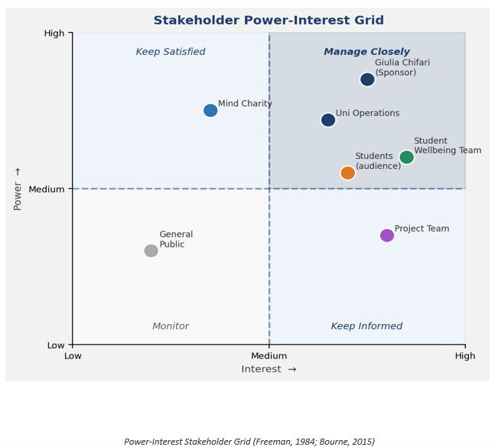
The team used a combination of formal and informal channels throughout the project. Formal e-mail was used was used for the Wellbeing Team and module leader, social media reached students and WhatsApp coordinated internal communication. Project Management Institute (2021) emphasises that effective communication required deciding not just who stakeholders are but what information they need, how often and through which channel. Newton (2016) adds that a formal written communication plan reduces misunderstanding and ensures consistency.
The main weakness was the failure to contact the university operations team during planning. Meredith and Mantel (20antel09) highlight that failing to engage key stakeholders early is one of the most common and avoidable causes of project delays, which our experience directly confirmed. Had this communication taken place at the outset, logistical constraints could have been identified and mitigated before they affected the project timeline. This oversight also limited the team's ability to allocate resources effectively, as key information about availability and access was only obtained reactively rather than proactively.

Conclusion

This report has shown that the Mental Health Awareness Campaign was delivered successfully through the application of appropriate project management tools and techniques. The WBS helped define scope and allocate tasks clearly. The Gantt Chart supported scheduling and adaptive re-planning when the event was rescheduled. The Iron Triangle provided a framework for managing trade-offs under time pressure, and the stakeholder’s analysis guided communication throughout.
The event achieved its core objectives, was well received by students and staff, and raised charitable donations for Mind. Heagney (2016) argues that success should be measured not only by whether a project was completed on time and within budget, but by whether it achieved its intended purpose. By this measure, the campaign can be considered largely successful. Attendance exceeded initial expectations, feedback gathered informally from participants indicated a high level of satisfaction with both the organisation and the content of the event, and the funds raised for Mind reflected genuine engagement from the wider university community. The key areas for improvement remain stakeholder mapping, risk management and contingency planning, not because they can cause the event to fail, but because addressing them would have made a successful outcome more assured and less dependent on the team's ability to respond to problems as they emerged.

Future improvements

Recommendation 1: Conduct Full Stakeholder Mapping at Initiation
The first recommendation is to conduct a full stakeholder mapping exercise at the start of any future project, ensuring all approval authorities are identified and engaged early. Heagney (2016) argues that early engagement reduces the risk of delays, and Bourne (2015) recommends maintaining a formal stakeholder register updated throughout the lifecycle.
Recommendation 2: Develop a Formal Risk Register
The second recommendation is to develop a formal risk register from initiation. Kendrick (2015) recommends identifying risks and planning responses before problems occur. A risk register would have identified the missing operational approval as a foreseeable risk and allowed the team to address it earlier.
Recommendation 3: Build Contingency Time into the Schedule
The third recommendation is to build contingency time into the schedule for approvals and external dependencies. Wysocki (2014) recommends buffer periods in all project schedules, and Burke (2013) adds that contingency allowances protect against uncertainties during execution.
Recommendation 4: Formalise the Communication Plan
The fourth recommendation is to create a formal written communication plan. Project Management Institute (2021) recommends this as a formal project deliverable, and Newton (2016) argues it ensures consistency and reduces the risk of key stakeholders being overlooked.
Recommendation 5: Conduct a Structured Post-Project Evaluation
The fifth recommendation is to conduct a structured post-project evaluation after every project. Reiss (2015) argues that lessons learned are only valuable when recorded and applied to future projects, and Lock (2020) adds that a formal review helps teams develop as project managers through honest and systematic reflection.

Reference list

- Belbin, R.M. (2010) Management Teams: Why They Succeed or Fail. 3rd ed. Oxford: Butterworth-Heinemann.
- Bourne, L. (2015) Stakeholder Relationship Management. Farnham: Gower.
- Burke, R. (2013) Project Management: Planning and Control. 6th ed. Chichester: Wiley.
- Clegg, S.R., Skyttermoen, T. and Vaagaasar, A.L. (2020) Project Management: A Value Creation Approach. London: Sage.
- Fisher, S.G., Hunter, T.A. and Macrosson, W.D.K. (2001) 'A validation study of Belbin team roles', European Journal of Work and Organizational Psychology, 10(2), pp. 121–144.
- Freeman, R.E. (1984) Strategic Management: A Stakeholder Approach. Boston: Pitman.
- Heagney, J. (2016) Fundamentals of Project Management. 5th ed. New York: AMACOM American Management Association.
- Heerkens, G. (2015) Project Management. New York: McGraw-Hill.
- Hollister, S. (2017) Project Management: A Quick Start Beginners Guide. Createspace Independent Publishing Platform.
- Kendrick, T. (2015) Identifying and Managing Project Risk. 3rd ed. New York: AMACOM.
- Kerzner, H. (2022) Project Management: A Systems Approach to Planning, Scheduling, and Controlling. 13th ed. Hoboken, NJ: Wiley.
- Larson, E.W. and Gray, C.F. (2018) Project Management: The Managerial Process. 7th ed. New York: McGraw-Hill.
- Lock, D. (2020) Project Management. 11th ed. London: Routledge.
- Meredith, J. and Mantel, S. (2009) Project Management: A Managerial Approach. Asia: John Wiley and Sons.
- Mind (2025) Mental Health Support and Information. Available at: https://www.mind.org.uk (Accessed: 16 June 2026).
- Newton, R. (2016) The Project Manager. 3rd ed. Harlow: Pearson.
- Project Management Institute (2021) A Guide to the Project Management Body of Knowledge (PMBOK Guide). 7th ed. Newtown Square, PA: Project Management Institute.
- Reiss, G. (2015) Project Management Demystified. London: Routledge.
- Tuckman, B.W. (1965) 'Developmental sequence in small groups', Psychological Bulletin, 63(6), pp. 384–399.
- Turner, J.R. (2014) Handbook of Project-Based Management. 4th ed. New York: McGraw-Hill.
- Wysocki, R.K. (2014) Effective Project Management: Traditional, Agile, Extreme. 7th ed. Indianapolis: Wiley.

