
LCMB7024 Marketing Management
Assessment Component 1- Essay
Programme: Master of Business Administration
Module: Marketing Management
Module code: LCMB7024
Lecturer: Haoran Liu
Assignment Title: Assessment Component 1- Essay
Student Name: MD JUWEL
Student ID: 2426380
Word Count: 2554
Submission Deadline: 28th March 2025 14:00 (2 pm)

Table of Contents
Introduction 3
Advantages of Being a Pioneer in the UK Market 4
Advantages of Being a Follower in the UK Market 6
Product Life Cycle Strategies for Pioneers and Followers 8
Conclusion 12
Reference List 13

Introduction
An important marketing tool of the Product Life Cycle (PLC) model helps businesses understand the stages in which their product goes from introduction to decline. The model is based on four stages of introduction, growth, maturity and decline for which competing strategies will be required to sustain competitiveness in different stages. In the UK market, you need to adjust to the changes of the market, technology progress, and the changes of the consumers’ taste (Santiago-Torner et al., 2025). During the maturity stage, the strategy employed by both pioneers, like Apple, and followers, like Huawei, to maintain market share, differentiate the products, and counter with the phenomenon of market saturation and increasing competition is different.
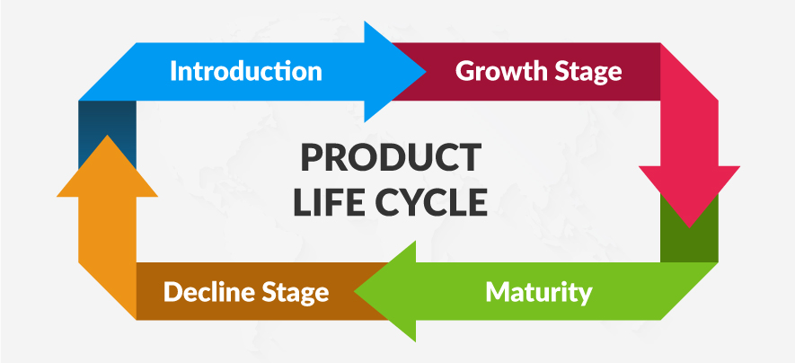
Figure: Product Life Cycle (PLC) (Rush, and Roy, 2023)

Advantages of Being a Pioneer in the UK Market

Pie Chart: Market Share Distribution: Pioneer vs Follower Companies in UK Market (Self-made)
Pioneer company is an innovative company, that constantly brings something new to the market; in simple words, a pioneer company is a first-to-market company. Offerings from these companies are in a way that they create a whole new market or disrupt in a significant way some existing markets (Berndt, Altobelli and Sander, 2023). They are very often, often pioneers, and are on the list of market leaders, which means that they become very visible and are even very heavily brand known in the Kenyan market at an early stage.

Benefits of Being a Pioneer
First Mover Advantage: The first mover’s advantage is by far the most notable thing about being the first mover. First to market companies can make themselves the exclusive choice of the consumer (Brem, 2008). Therefore, it can bring brands, customer recognition, and a lot of a competitive advantage. For instance, Dyson changed the vacuum cleaner business entirely with the introduction of the bagless technology, which now has become a well-established, top-of-the-line brand in the UK and indeed Worldwide.
Brand Leadership and Recognition: Several studies have shown that pioneers have long-lived market share advantages and are likely to be market leaders in their product categories. However, that research has potential limitations: the reliance on a few established databases, the exclusion of non-survivors, and the use of single-informant self-reports for data collection. With the Pioneer model, while most of the pioneers won’t warrant respect and loyal customers from the mainstream companies, you will discover the pioneers who make it are first discovered by other startups who want to cash in on their bandwagon of success (LeMay, 2017). One that sets the standard in the industry when becoming the first to introduce a product or technology.
Profitability and Market Share: Pioneers may receive increased profits and/or market shares early as consumers tend to be willing to experiment with new and latest technologies (Yang, 2020). The followers may not be able to act in such a way because they will be in competitive pressure, and that’s why setting prices is good for them. One such example is the vacuum cleaner introduced as rare offerings, which set premium pricing and drew in loyal customers ever since — Dyson being the first to bring in such unique vacuum cleaner models.

Risks Faced by UK Pioneers
High Investment Costs: Early days – research and Development costs: One of the costs incurred during the early days is the research and development, as well as the cost of market introduction (Memon, 2021). These companies in each of these would need to invest very gigantic sums for the education of the market, making the infrastructure, developing the technique or making the manufacturing process.
Market Uncertainty: This risk is posed by High Market Uncertainty regarding market rejection of the Pioneers. Despite spending a lot, there isn’t any promise because the consumer may have a lower degree of demand as compared to what is to be anticipated. For example, the UK may not be ready to take up such an electric car initiative as infrastructure and customers are not ready yet (Ennew, Waite and Waite, 2024).
Imitation by Followers: The competitor (the followers) imitates the Pioneering Innovation once the product or service is successful, and can lead to the demise of the pioneer’s market share (Lei, Xu and Yuan, 2025). Pioneers must have to innovate and improve their offers to retain their position.

Examples of Successful Pioneer Companies
Dyson is a UK-based pioneer company. However, Dyson’s first bagless vacuum cleaner attracted a lot of market attention and occupies a certain place in the household technology market. However, their secret sauce was consistent innovation and being able to market their products in the right manner to the UK and other global markets.
Spotify was the streaming pioneer in the UK as well as the rest of the world. It changed the music industry with a different subscription-based service for the general public to access millions of songs and became a dominant player against the competition, also entering the market (Lei, Xu and Yuan, 2025).

Capitalising on First-Mover Position
Truth be told, first mover advantage is a very real thing and companies such as Dyson gain from this by continually improving the product, introducing innovations (Czinkota et al., 2021). Just to give an example, Dyson did not stay with the vacuum cleaner, but also ventured into air cleaners, hand dryers, even hair care products: all product extensions based on their brand reputation and technological capabilities.
Continual innovation would enable Dyson to hold onto its market leadership in the household appliance sector as well as enhance the brand image as being a reflection of cutting edge, technology and design (Kotler et al., 2019).

Advantages of Being a Follower in the UK Market
Like other companies, a British company follow pioneers to introduce new products into that market. Market followers take the ideas from the existing universe, and through the application of strong tactics, they become leaders themselves in the market (Matsumoto et al., 2016). Getting there leads to the delivery of comparable products at considerably reduced prices or through improved procedures. But this means that when the demand foundation is established, the followers can start concentrating on improving their products within the piece of the established market.

Benefits of Being a Follower
Learning from the Mistakes of Pioneers: The main benefit that a follower firm receives in this scenario is from being able to learn about the mistakes that other market leaders make during the pioneer stage of their development. Being in line, once the pioneers have entered and then seeing how the market reacts to these products, allows the followers to observe potential product weaknesses to avoid consumer mistakes of the pioneers (Viki, Strong and Kresojevic, 2018). Pioneers make mistakes, and the followers have the opportunity to learn from pioneer mistakes; they can improve their products and service quality better than pioneers.
Reduced Costs: Companies that follow their competitors do not spend excessive research and development funds as the pioneering companies expend in product development (Gitman et al., 2024). Existing market leader technology, combined with their supply chains, and infrastructure, provide followers to have an immediate cost advantage. Enterprising firms generate savings that allow them to establish their spot in the market at competitive prices because they attract consumers who are cost conscious.
Established Market Trends: They gain an advantage from the trends that pioneers have set up in the market. These companies join existing markets that already have the market supporting infrastructure, such as brand awareness, as well as customer demands. The market is thus successful in improved environmental conditions, where the consumer knows the product and the service (Petrillo and De Felice, 2021).

Risks of Being a Follower in the UK Market
Market Saturation: Market saturation risk plays a crucial role in the success or failure of the follower brands. Many customers have made their purchase decisions after the pioneer has introduced its product, and so it is difficult for followers to get any share of the market, except in the case of a clear distinction or presumably lower value for money.
Brand Perception: The second possible customer perception could be if the followers are occupying an imitator position and not an innovator position, customers may develop a negative perception about the brand (Kotabe, and Helsen, 2022). When following competitive sectors, the possibility of creating strong market positions is compromised by market identity because brands are essential to the success of such competitive sectors.

UK-Based Examples of Successful Follower Companies
ASDA: A successful follower company in the UK supermarket sector is ASDA. Tesco also embraced many innovative strategies such as loyalty schemes and large hypermarkets which contributed to its domination of the UK grocery market. It was a success and other business models followed closely; ASDA, for example, did so to follow suit (van Overbeeke et al., 2019). The reason why ASDA was able to compete with Tesco at lower prices was that it focused on low prices, customer value and efficient operations. ASDA capitalised on this to define its loyal customer base and significantly surge its market share. ASDA used strategic focus on value for money as its strategy, as it could offer value for money to price-sensitive consumers while still being competitive with Tesco’s brand strength.
Huawei: Another prime example of a successful follower company in the UK mobile phone market is Huawei. Huawei arrived at the smartphone market with Apple and Samsung already in power. Huawei rather than trying to create an entirely new product, worked to refine the existing technologies that these pioneers introduced (Mohammadi, Saghaian, and Alizadeh, 2017). Exploiting the market trend created by Apple and Samsung, Huawei provided high quality smartphones with similar features but at the lower price point. For budget conscious consumers who wanted the smartphone characteristics at a lower cost, Huawei was able to capture a significant share of the market.

Profiling as an Adopter and Thriving in the UK Market:
Companies like ASDA and Huawei thrive as follower companies, improving themselves by adapting to market trends and learning from the pioneer companies. Therefore, this can take advantage of existing technologies and successful business strategy, and provide a competitive alternative. These companies have established themselves as strong competitors by concentrating upon the aspects of cost efficiency, value for dollar, and customer demand (Wurzel, Liefferink, and Torney, 2019). Pioneers provide them with the infrastructure, brand awareness and market trends, which enables them to enter the market with a higher potential of success at a much lower cost of operation. Adaptability and innovation in prescribed frameworks allow followers an edge during price-sensitive markets like the UK, notably.

Product Life Cycle Strategies for Pioneers and Followers
Marketing has one critical concept, the Product Life Cycle (PLC), which describes how a product proceeds from introduction until the decline. Introduction, Growth, Maturity and Decline are these stages, which help businesses gain insights about where their products are in the market and think of means to keep ahead in the market (Liefferink, and Wurzel, 2017). In the UK market, the PLC model is particularly relevant because companies have to address the market conditions, consumer preferences, as well as technological advancement. In the growth and maturity stages of maturity, the strategies of both pioneer and follower companies are different, with adjustments to keep the competitive edge.

Explanation of the Product Life Cycle (PLC) Model
The PLC model has four stages in the life of a product:
Stage | Description
Introduction | Slow sales and high development, marketing and distribution costs are incurred with the launch of a new product.
Growth | The market acceptance increases, and sales grow fast. There are increases in profits, and companies focus on increasing market share and enhancing product features.
Maturity | The growth slows down, the market becomes crowded. This is a source of defense, making use of differentiation, new features, and cost reductions to maintain the market share (Torney, 2020). Competition intensifies.
Decline | In cases of market saturation, technology changes or changes in consumer preferences, sales and profits decline. Companies can stop, or lower the marketing of, or innovate the product.
Table: of PLC Model Stages (Self-made).
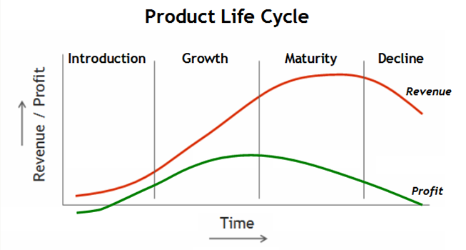
Cycle Graph: Product Life Cycle

PLC Strategies for Followers in the UK Market
However, in case of a mature stage, follower companies, such as Huawei, have to follow a cost leadership, product differentiation, and innovation strategy in order to compete in the market.

PLC Strategies for Followers in the UK Market
While follower companies are often competing with competitors in the smartphones market, they have to adopt a different type of strategy based on the growth and maturity stage, including cost leader strategies, product differentiated strategies and innovation (Wurzel, Andersen, and Tobin, 2021).
Growth Stage Strategies
During the growth stage, Huawei took cost leadership advantage based on the telephone that had similar features as iPhone or Samsung, with high resolution camera and fast processor, but at substantially lesser prices. With this strategy, Huawei easily captured a large share of the UK market, especially with the low end of the consumer market (Choi, and Jung, 2017). Huawei also spent on investment in branding, aiming at mid-range and budget consumers and facing off against Apple’s high-end. The P30 and Mate series, which had competitive pricing and innovative features, were well received models.
Maturity Stage Strategies
With Huawei’s products maturing, the company differentiated the products based on its technology advancements. To distinguish itself in the crowded UK market, Huawei also put out unique features, such as Leica camera technology and AI-powered functions (Mohammadi, Saghaian, and Alizadeh, 2017). The enhancements to distribution provided by strategic partnerships with UK telecom providers such as EE and Vodafone contributed towards strengthening Huawei’s market position.

Market Conditions in the UK
In current dynamic market conditions, any two pioneers or followers have to adopt strategies according to changing market conditions, consumer preferences and technological changes (Lim, Zheng, and Chen, 2020). Unlike Apple, Huawei targets a different market segment by emphasising its cost efficiency, advanced technology, as well as strategic pricing.
Example: It is a simple example, but Apple in the UK market has always maintained leadership by updating its product line and releasing new models and new features that pull its fanboys. Instead, Huawei, which has faced a rocky time in some markets across Europe and Asia, has ranged out on buying cheaper, if not equal or better, features for less in the UK, where a budget-friendly, high performance smartphone is very much in demand (van Overbeeke, et al., 2019).
Finally, both pioneers as well as followers such as Huawei follow certain strategies during the growth and maturity stage of the PLC to maintain their competitiveness. Pioneers pay attention to differentiation, brand loyalty, and continuous product innovation, while the followers do so on cost leadership, technological innovation, and strategic market positioning (Bey, 2017). Using the PLC model to understand and apply it, these companies can also cope with the market saturation, consumer preferences and technological change, this is to make sure they are successful in the highly competitive UK market.

Conclusion
Finally, the PLC model offers a structured method to resolve the complexities of product development and market competition to businesses. Being like Apple, the pioneers differentiate, build brand loyalty, and never stop innovating; that is how Huawei, the follower, follows the cost leadership, technological innovations, and strategic positioning (Lim, Zheng, and Chen, 2020). Companies in the UK can function in market dynamics, attend consumer demands, and have long-term successes by applying the PLC strategies.

Reference List
Berndt, R., Altobelli, C.F. and Sander, M. (2023) International Marketing Management. Springer Nature.
Czinkota, M.R. et al. (2021) Marketing management: Past, Present and Future. Springer Nature.
Ennew, C., Waite, N. and Waite, R. (2024) Financial Services marketing: A Guide to Principles and Practice. Taylor & Francis.
Gitman, L.J. et al. (2024) Introduction to business.
Kotabe, M.M. and Helsen, K., (2022) Global marketing management. John Wiley & Sons.
Kotler, P. et al. (2019) Marketing management. Pearson UK.
Lei, X., Xu, X. and Yuan, H. (2025) 'Marketing leadership: Does the presence of chief marketing officer improve marketing performance?,' Asia Pacific Journal of Marketing and Logistics [Preprint]. https://doi.org/10.1108/apjml-12-2024-1920.
LeMay, M. (2017) Product management in practice: A Real-World Guide to the Key Connective Role of the 21st Century. 'O’Reilly Media, Inc.'
Matsumoto, M. et al. (2016) Sustainability through innovation in product life cycle design. Springer.
Memon, T. (2021) Effective platform product management: An effortless strategy and execution guide for product managers who want to scale their platform business model and grow their customer base. Packt Publishing Ltd.
Petrillo, A. and De Felice, F. (2021) Product Life cycle: Opportunities for Digital and Sustainable Transformation. BoD – Books on Demand.
Santiago-Torner, C. et al. (2025) 'Impact of ethical leadership on Autonomy and Self-Efficacy in virtual work environments: The disintegrating effect of an egoistic climate,' Behavioral Sciences, 15(1), p. 95. https://doi.org/10.3390/bs15010095.
Stark, J., 2022. Product lifecycle management (PLM). In Product lifecycle management (volume 1) 21st Century paradigm for product realisation (pp. 1-32). Cham: Springer International Publishing. https://doi.org/10.1007/978-3-030-98578-3_1
Tao, F., Cheng, J., Qi, Q., Zhang, M., Zhang, H. and Sui, F., (2018) Digital twin-driven product design, manufacturing and service with big data. The International Journal of Advanced Manufacturing Technology, 94, pp.3563-3576. https://doi.org/10.1007/s00170-017-0233-1
Viki, T., Strong, C. and Kresojevic, S. (2018) The lean Product Lifecycle: A Playbook For Making Products People Want. Pearson UK.
Wurzel, R.K., Andersen, M.S. and Tobin, P., (2021) Climate governance across the globe: Pioneers, leaders and followers (p. 301). Taylor & Francis.
Yang, P. (2020) Principles of product management: How to Land a PM Job and Launch Your Product Career.

