Literature review

Covid-19 has brought immediate change to many construction companies and their place of work all over the world, but the reason for this literature review is to understand the affects the pandemic had on the UK but most importantly Wales which is where I would like to concentrate my research to where possible.

From the start of covid-19 to now there has been massive changes in the construction industry in Wales, such as the rise in Material costs, many companies struggling with cash flow problems, also projects being put on hold and delayed due to these issues.

According to (roofing today, 2022) the year-on-year change to may 2022 saw the material prices for new housing in the UK rise by up to 23% for general materials such as timber, masonry and aggregate. There was also an increase in the repair and maintenance sector with material prices there rising by up to 25.5% for the same material. There is very worrying to see as for big main contractors who have tendered for projects pre-covid 19 they would have had to take the increase of material prices on the chin as they might not have had anything in the contract to state if prices increase, they could then forward that cost on to the client.

In an article from (Narwan, A. 2022) it states that as material costs are rising house prices are not increasing in line with the cost of material, this is worrying as it shows that the profit in the house building sector is decreasing as everything is increasing in cost but the prices of houses are not, therefore reducing the return on investment for the contractor.

Although in may 2022 we are at the backend of covid and were no longer having to work from home, social distance or take tests, the affects were still being felt by contractors who have been starting to get back to projects which might have been on stop due to covid-19. An article on the CHAS website by Alex Minett (Minett, A. 2020) states that of the 857 business owners in the construction industry they surveyed 80% said that they had to cancel or postpone projects due to Covid-19, he goes on to say that this is because their supply chain could not operate as many of the suppliers and contractors they used either down scaled during covid-19 to save on running costs or just completely shut down due to their not being enough work or as employees were going on furlough as they were not required by law to come in.
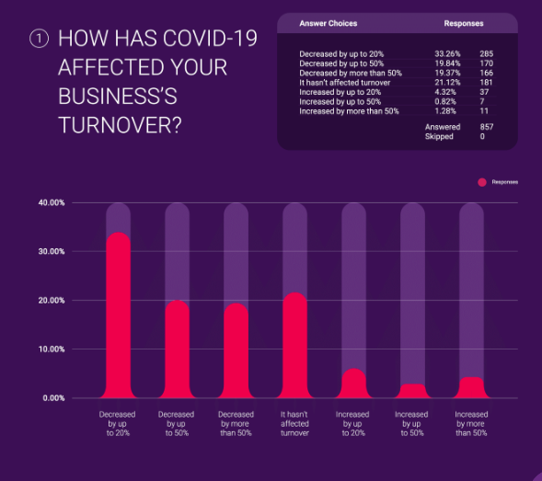
In the same article (Minett, A. 2020) it states that 40% of the 857 had to cease operations at some point during covid-19, this meaning they completely stopped trading for a certain period during covid, this could be down to supply chain issues as previously stated, staff not wanting to work during covid-19 as they did not want to gather the infection, it could also be down to the projects they were working on during covid as has been stated earlier in the article.

The graph which I obtained from
the CHAS website shows the analyse of a question given to the same 857 business people who are in the construction industry.
From analysing the data, you can see that about 75% (643 people) out of the total have seen their turnover decrease 20% - 50%+ from the effects of covid-19.

This is catastrophic for the construction industry as a lot more than 50% of companies asked have seen their turnovers decrease by a major amount.

This can lead to major problems such as making employees redundant as they cannot afford to keep them, losing projects due to not having the money to complete them, all coming from cash-flow problems that have come from covid-19 where companies still had to pay their employees when no work was getting done or limited work was getting done as people were having to social distance, meaning people could not work together encase of infection.

An article I found on Sky News (Narwan, G. 2022) sums up the problems facing construction companies due to decreased turnover and cash flow problems as she states that construction companies are going bust at their fastest rate in a decade, with the highest number of company insolvencies since the financial crisis, this really shows the issues covid-19 has had on construction companies over the last 2-3 years, these being rising material costs, staff shortages and consumer demand which has decreased heavily over the last couple years as clients don’t have the money to spent on multi-million pound projects.

Figures show that company insolvencies in the second quarter of 2022 were at their highest in Wales, for example JEHU Group, who were a family run construction company based in Swansea who were trading for the best part of 80 years went into administration due to not having the cash reserve in hand to pay back all debtors in order to keep running as a company, in my place of work we have recently had a number of ex-JEHU staff coming to work for us therefore something I would like to do is plan an interview with one or two of them to see their view on how covid-19 effected the company to end up going insolvent at the backend of 2022 (Narwan, G. 2022)

In the same article (Narwan, G. 2022) it states the cause for most of these insolvencies is the increase in costs but most importantly material costs, as Steel rose by 17% in the year leading to October 2022, concrete blocks which are used on most new construction jobs these days rose by up t0 18% in the same period and timber which is the most used material in the industry rose by up to 19% in Wales, as I said earlier these costs are hard to pass on the clients as they are not wanting to pay the extra fee for the materials, this is one of the main reasons that companies have gone insolvent as they are carrying on to do these projects for little to no profit as it is going towards increased costs, which ends up with them making no profit but still doing the projects as no new works is coming to tender as no one has the funding to do them.

From all companies that are exposed to this issue of going insolvent due to issues facing construction companies due to covid-19 local small builders are most at risk as they for one do not have economies of scale at their advantage (Narwan, G. 2022).

Moving on from material increases and their affects, there are also many more effects that covid had on the construction industry, my first point is that new construction work in the UK fell to £100,199 million in 2020, which is down 15.90% from the year before the pandemic first hit us in Wales and the UK (Office for national statistics, 2022), however this quickly rose after our first national lockdown as new orders of construction orders rose 30.50% in 2021, which is the highest level in over 45 years.

Although construction was on the decline during covid with many projects being put on hold as there was no funding for them to carry on, but for a couple contractors work carried on with more demand than ever as £166 million was spent in Wales on 19 new hospitals to help cope with the demand of people getting infected with covid-19 (GOV.WALES, 2020).

These hospitals brought double the number of beds than they had pre-covid to wales in just under 8 weeks, with stadiums, commercial sheds and new buildings being used to accompany the demand of extra beds, this meaning that some contractors even benefitted from covid-19 by building these hospitals for the government.

Another big area of construction that was affected during the pandemic was employment. During one of the peaks of the virus in 2020 total employment in the construction industry fell for the first time in 10 years (GILPIN, J. 2020).

Research Methodology

After completing my literature review there are still a few areas I would more of an insight into which I think would help tell a story of how badly covid-19 really did affect the construction industry, therefore I will be creating a questionnaire which I will be handing out to different professionals in the industry from groundworks to managing directors of companies so that I can get different views and opinions on the certain topic and hopefully tell me something that I don’t know so I have more data which I can analyse and compare with what I found by using the website and articles in the literature review.

I will create a questionnaire on Survey Monkey and send the link around my place of work and to people I know in the industry that I think will be able to give their opinion on the topic. I will mainly make my questionnaire around the increase in costs that have occurred from covid-19, whilst also getting their opinion on employment during and post covid-19, I can therefore get an overall view of the effects covid-19 has had.

As far as interviews go I would be interested to interview a couple different people, at the moment I am thinking a Buyer in a main contracting business, this would give me the insight I need to see the price increase materials has had since covid-19 struck us in Wales, I would also be interested in speaking to my Managing director, or any director in the business that I work for to get their opinion how covid-19 has affected the company not only financially but in terms of how its run and if they have changed their views on the company moving forward and if they had the chance to do something different during covid-19 which would have aided the company positively than what would that be.

If I get the time, I would also like to talk with people in contractors which have had a positive effect from covid-19 coming to Wales, this could include contractors that help build the nightingale hospitals all over Wales to help keep up with the demand for beds during the pandemic, this would help argue against my point as I believe that covid-19 has had a negative effect on the industry.

By completing questionnaires, I will be doing both quantitative and qualitative research, but this is dependent on the type of questions I ask, as yes/no questions are quantitative, whereas leaving a box for people to write would be classed as qualitative research. By completing interviews, I will be researching in only a qualitative method, this isn’t bad as it would give me a lot of data to analyse, but would make it harder to compare as there is so much to go through, so having a range of both quantitative and qualitative would be the best option for me in my opinion, and would best suit this project. There for I will be completing mixed method research to gather my primary data which I hope to analyse and create an argument with my secondary data that I have already gathered.

If any are available, I will like to look into case studies, but as this is a fairly new topic, I don’t think there would be many out there that would be of use to me for this project but I will give it a look to see what is out there.

Reference list
- Gilpin, J. (2022). Brexit & COVID-19 Impact on Construction Workers - Supply2Gov Tenders. [online] www.supply2govtenders.co.uk. Available at: https://www.supply2govtenders.co.uk/brexit-covid-impact-on-construction/.
- GOV.WALES. (2020). How Wales created 19 new field hospitals in less than 8 weeks…. [online] Available at: https://www.gov.wales/how-wales-created-19-new-field-hospitals-less-8-weeks [Accessed 6 Mar. 2023].
- Minett, A. (2020). The Impact of COVID-19 on Construction Businesses. [online] CHAS. Available at: https://www.chas.co.uk/blog/covid-impact-on-construction-industry/#:~:text=80%25%20of%20Businesses%20Cancelled%20or%20Postponed%20Projects&text=Construction%20work%20has%20already%20resumed.
- Narwan, G. (2022). Building firms going bust at fastest rate since financial crisis. [online] Sky News. Available at: https://news.sky.com/story/building-firms-going-bust-at-fastest-rate-since-financial-crisis-12770697 [Accessed 6 Mar. 2023].
- Office for National Statistics (2022). Construction statistics, Great Britain - Office for National Statistics. [online] www.ons.gov.uk. Available at: https://www.ons.gov.uk/businessindustryandtrade/constructionindustry/articles/constructionstatistics/2021.
- roofing today (2022). Construction Material Prices Risen by 27% in Past Year. [online] Roofing Today. Available at: https://roofingtoday.co.uk/construction-material-prices-risen-by-27-in-past-year/#:~:text=Breaking%20the%20increase%20down%2C%20the [Accessed 6 Mar. 2023].

