

Web Development
  - Internet Technology & Security
  - acca4018
Habib Muin | P150191 | 03/05/19
TABLE OF CONTENTS

Introduction 2
section 1 2
requirements 2 - 3
Section 2 3
implementation 3 - 5
section 3 6
validation 6 - 7
Evaluation 7 – 8
references 9

INTRODUCTION
A webpage had been created for a personal trainer containing 5 pages, the main/home page, programs pages – this is a page that displays the programs that is ran by the personal trainer followed by the prices of the programs. A testimonial page – this is where the clients of the trainer have produced a testimonial with pictures and also reviews. An accessories page – the clothing line that the trainer has created are displayed and lastly a contact page, this will allow future clients or individuals can contact the trainer for further information.

Requirements
The website created is specifically for a personal trainer whom trains clients and helps them reach their goals. The purpose for this website is to allow the trainer to advertise himself in better detail.
The home page display a simple biography of the trainer describing his own story, what he has dealt with himself to do with his weight and also displaying his skills and qualifications. On the homepage, a video from the personal trainer which displays the life of the personal trainer. This will allow the users to view the video comfortable and also gives the website a visually appealing look to it.
The second page displays the individual programs that he does, from doing one to one training, to running a boot camp. The one to one training is broken down into different sections. For example, it displays three training programs (muscle development, strength training and weight loss), then it gives a simple description of that program followed by the price at the end. That way the users have an idea of what it is that they may want to do and exactly how much it will cost them.
The third web page displays a gallery of a few of his clients before and after results that they gained with his training. The images display a noticeable difference in the results, this would signal to the users that the personal trainers training method have a higher success rate, convincing them to use his program.
The fourth webpage is for him to advertise his own branded unisex clothing line ‘I.M ELITE’. For now, the page is kept minimal because the personal trainer has not yet released the clothing brand to the public so there isn’t an option to view the product in depth or make a purchase. But it does display an example of the clothing brand and how it will look once released. In the future, when the product is ready for sale, a basket will be added as well as a payment system for when a user or customer may want to make a purchase of the item. Also more items will be added to the page besides clothing apparels.
Lastly the final page is a contact page, this allows any individual to contact him for either advice, further information on either training or classes. Unfortunately, the contact page does not seem to respond.
The website was created in order to target individuals ranging from teens to adult looking to either gain new knowledge on training for instants an individual may have limited or even no knowledge on a certain training method they want too or are currently undergoing. They could use the website to see other forms of how to do the exercises in order to reach their goal. Also, an individual may want to make a few changes to their selves for instants an individual may want to lose weight and after searching the web for hours at different websites they could stumble upon his page and find it more appealing because the location could be near them etc… or even an individual may try looking to start exercising and training for their first times but they are to un-confident because they either lack the knowledge or feel insecure.
Over all the website is simply targeted to anyone and everyone from newbies to hard gainers and more. Regardless or gender, age or disabilities.

Implementation
Here bellow are pictures of the website and each webpage:
Page 1 (HOME)
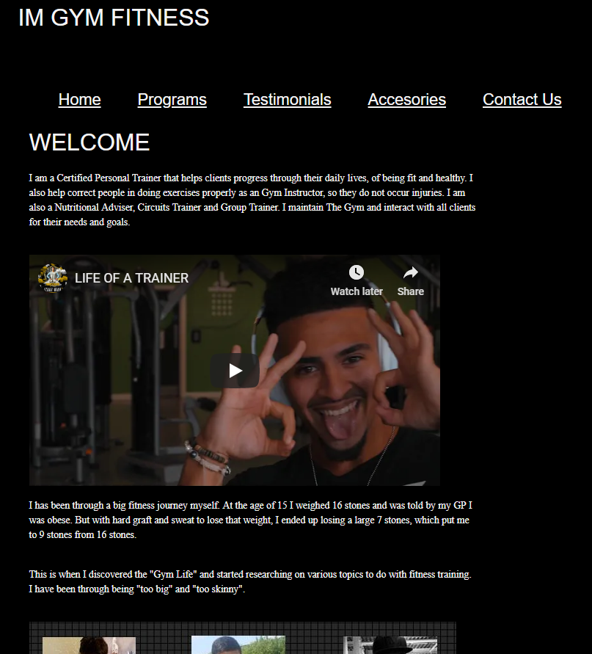

Page 2 (PROGAMS)
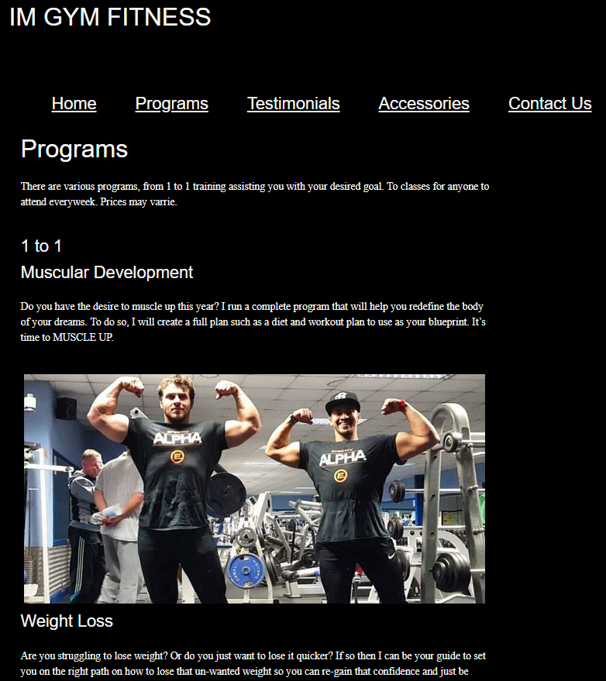
Page 3 (TESTIMONIALS)
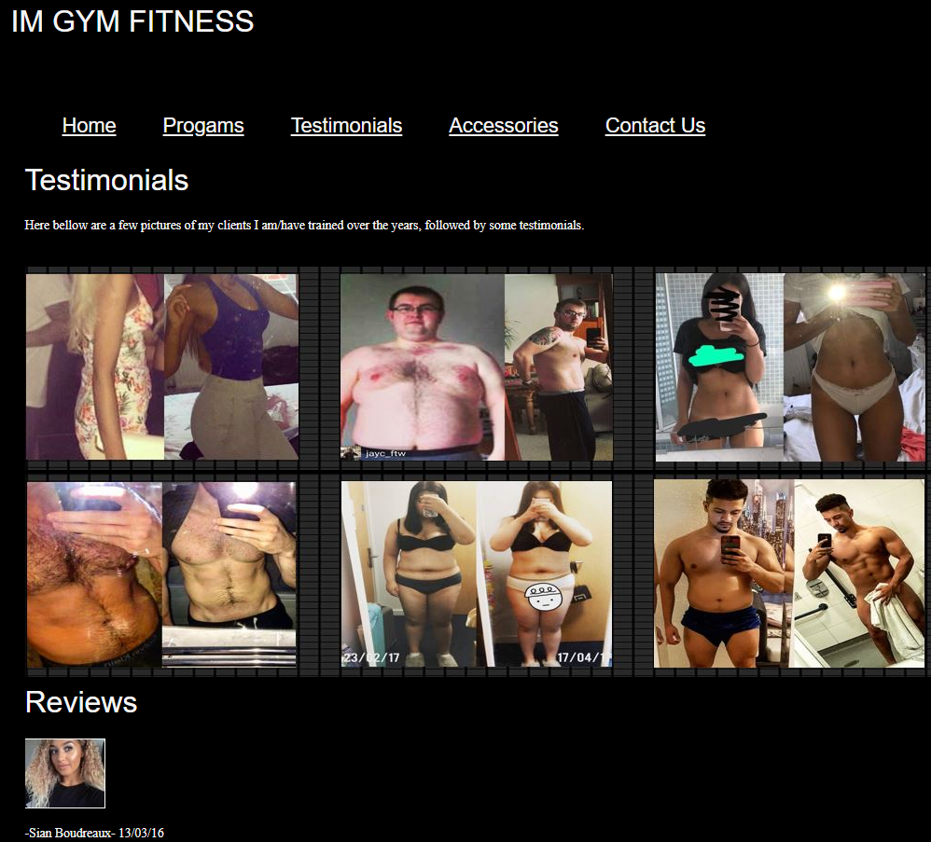
Page 4 (ACCESSORIES)
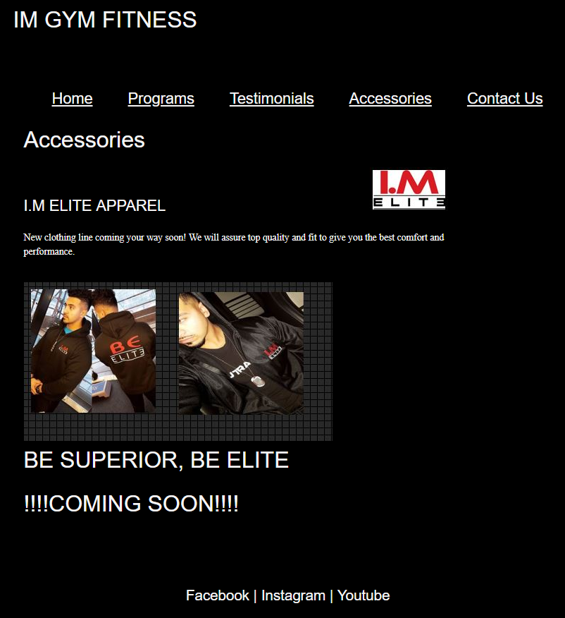

Page 5 (CONTACT)
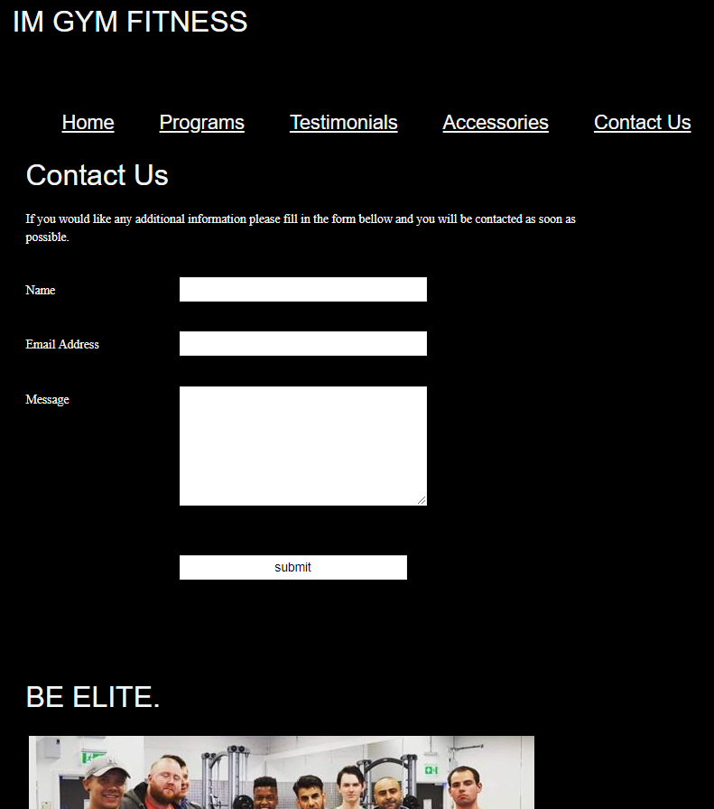

VALIDATION
A validation had been done for both HTML and the CSS code of the website. This is done by the use of a validating tool which displays any errors within the website. If any errors do occur, the tool will explain where the error is and cause of it.
Below is a picture of the results:
HTML (Home Page)
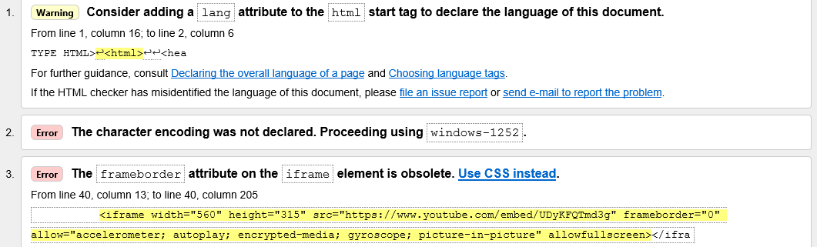
Running the HTML home page displayed 3 error. One of the error were for the YouTube video that had been displayed on the home page. The error said that the frame boarder is obsolete and suggested to use CSS instead. The creator of the website used a different method, instead of using CSS, he used copied the link from YouTube and pasted it into the code which he found simpler to do so.

CSS:

After using the tool to validate the websites main CSS, the results displayed that no errors have been found.

EVALUATION

Final evaluation of website
Overall, the website design is simple on a visual aspect. A color contrast has been used between white, black and red which follows the logo of the personal trainer. Although a lot more improvements can be made on the design such as breaking up the color of the background. For example, the whole background of the website is just a solid black color. If it was broken down such as keeping the body which contains the content black and making the header and footer red. There would be a more eye catching contrast. Also, the banner of the website could use a border around it so it is distinguished from the body of the webpage. Currently it just sits a float sort of margining in with the body.
The functionality of the website is kept minimal allowing users to navigate through with ease. Each page is however responsive and going from page to page does not break down. Every page does contains content that is appropriate to the title instead of being completely confusing to the users. Although the content is kept minimal it is effective, it will allow users to scan through the website without feeling as if there is too much to read and losing attention. The text within the website is set at a Smokey white color because the background is black it makes the text stand out a lot more so for people who may have poor vision, they wouldn’t have trouble reading it.
There have been pictures that are displayed appropriately so not only is there information on the pages, but visual data to back it up displaying results. Although a few of the pictures are different sizes in comparison to others so appearance wise it doesn’t seem that great.
On the home page a short video is displayed which is a good touch because it will allow users to have a warm welcome of what the website is about as well as making the appearance of the page look better. When an individual comes across a website, the first page that is displayed is the home page. So, if the home page doesn’t look very pleasing they begin to lose interest almost instantaneously.
For future recommendation, making the website a bit livelier would be beneficial for visual, reason being the website look bland, only three color had come into use. By using more colors and more graphics it would bring the website a bit more to life. Also on the testimonial page, some pictures are out of line to the webpage itself. The contact page currently does not respond, so for future recommendations making the contact page responsive would be a change to make. Creating a page that would allow users to appropriately interact with others online to discuss any queries or find out more information about either a workout or supplement would be a good touch. Also, mostly for the page of ‘accessories’, to add more items and set up a basket that allows users to select what product they want and successfully create a payment for them. Another recommendation would be to allow the personal trainer to interact with the users live between certain times, this would encourage individuals to ask their desired questions or even introduce or correct any ideas because instead of needing to fill out a form, they would just simply interact online and have a response almost instantly. Lastly, an idea of creating a way for the current clients for the personal trainer to have a method of logging in on the website and having a way to check when their next training session is, the nutrition’s plan, meal plan or what work out to do on what day.

References
Reviews: https://www.facebook.com/pg/IMGymFitness/reviews/?ref=page_internal
Weight loss information: https://www.nhs.uk/live-well/healthy-weight/start-the-nhs-weight-loss-plan/
Strength training information: https://www.nhs.uk/live-well/exercise/how-to-improve-strength-flexibility/
Muscle development: https://embryology.med.unsw.edu.au/embryology/index.php/Musculoskeletal_System_-_Muscle_Development

