Advance Physics of OME
ABCD5015

By Libbie Bush

Contents
Table of figures 2
Table of Tables 3
Abstract 3
Introduction 3
Introductions to shapes charges 3
History 4
Applications of shape charges 5
Research into shape charges 5
Cone shape and size 5
Material 6
Modelling of shape charges 6
Model 6
Materials 6
Properties 7
2D 8
Mesh 8
Method 9
Results 9
3D 9
Method 10
Results 11
Discussion 11
Conclusion 11
References 11

Table of figures
Figure 1 -Cross section of a shape charge [4] 4
Figure 2 - Jet formation from the liner [7] 4
Figure 3 - Cross-section of HEAT warhead [12] 5
Figure 4 – 2D shape charge 2 8
Figure 5 - 2D shape Charge 1 8
Figure 6 - 3D simulation 10

Table of Tables
Table 1 - Properties of HMX [17] 7
Table 2 - Properties of steel 4340 [2] [26] [27] 7
Table 3 - properties of copper [2] [17] 7
Table 4 - Mesh size of 2D models 8
Table 5 - mesh size of 3D model 10

Abstract
Shaped charges are specialized explosive devices used to penetrate solid materials like concrete and armour. They consist of a metallic liner, typically made of copper, a high-explosive filling. This paper examines the historical evolution of shaped charges, starting from early concepts by Franz von Baader and significant developments by Munroe, who demonstrated the principle of directing explosive energy. We explore the applications of shaped charges in various fields, particularly in defence (like HEAT warheads) as well as the mining industry
Recent research has focused on optimizing the design of shaped charges by studying different liner shapes, cone angles, and explosive materials. We employed the Johnson-Cook and JWL models for numerical simulations to assess how these design changes impact performance under high-stress conditions. The Research indicate that the shape and material of the liner significantly influence jet formation and penetration depth. These findings provide valuable insights into how shaped charges can be improved for future applications and showcase how simulation are not the true representation of the shape charge

Introduction
Shaped charges have become essential tools in various industries, particularly in defence and mining, due to their unique ability to concentrate explosive energy and achieve high penetration capabilities. These devices consist of a metal liner, a high-explosive filling, and a precisely positioned detonation point, all housed within a casing. [1] The design of shaped charges allows them to form a focused molten metal jet upon detonation, a phenomenon known as the Munroe effect. Understanding the principles behind shaped charges and their applications is critical, as advancements in this technology continue to play a significant role in military and industrial operations [2]. FEA is a large part of this industry in the development and optimising of shape charges.

Introductions to shapes charges
A shaped charge is a specialized explosive device consisting of a metal liner (typically copper), a high-explosive filling, and a detonation point. All of these components are housed within a casing that includes a hollow cavity following the liner, this design is shown in a basic form in figure 1 [3]. The shape charge must contain a metallic liner or it would be classified as a Hollow charge. The detonation point should always be opposite the cavity [1]

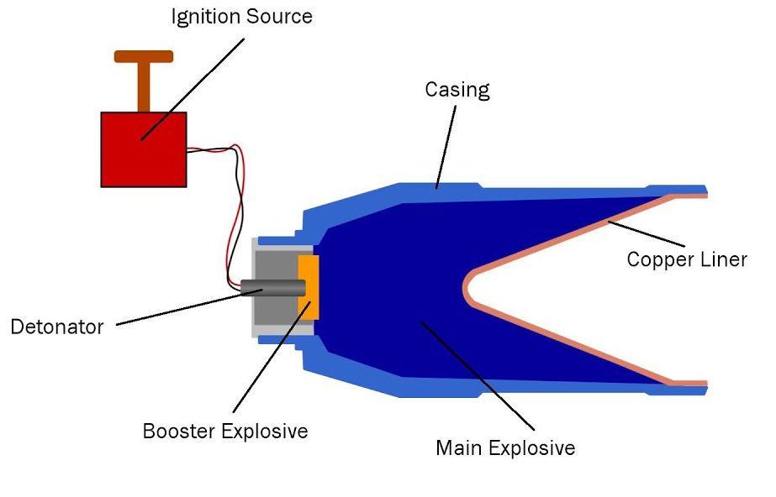
Figure 1 -Cross section of a shape charge [4]

These devices are used to help penetrate solid materials, like concrete or metal armours. Once the Ignition of the detonator occurs the high pressure shock wave moves though detonating the high explosive fill. This high pressure detonation wave causes the material to accelerate and cone shaped liner to collapse into to the open space and form a molten metal jet [5]. This is referred to as the Munroe effect (sometimes also referred to as the Von Baader Effect). This process is shown in figure 2. [6]

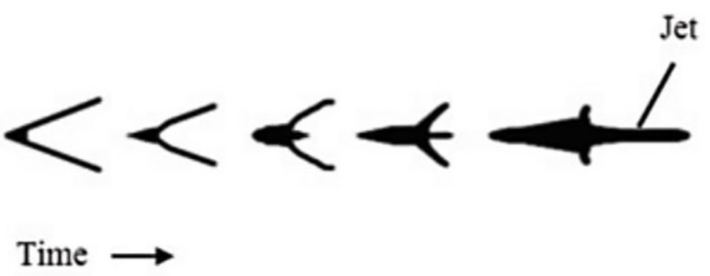
Figure 2 - Jet formation from the liner [7]

History
The turn shapes charge was coined during World War II however in 1792 Franz von Baader is one of the earliest to references to a cavity charge. [8] He used this hollow charge to direct the energy of the blast in a specific direction. However it did not contain a metallic liner and would be classified as a hollow charge from the 1920, it was the first step in the development of the shape charge. After the invention of detonator in 1867. G Bloem had developed a shell for the detonation caps that held a close relationship to shape charge as it used a lined cavity in the design. Then in 1888 Munroe conducted a range of experience into hollow charges, in one of these he detonated blocks of explosives with a cavities on a steel plate, [9]the charge was in the shape of the initial of the United States Navy opposite the detonation point, these letter where then shown on the steel plate and the Monroe effect was created. Monroe also found that less explosive and larger cavity to a point created a later cater when placed opposite the detonation point in the steel, this again did not utilise a liner but was vitally to the development to the shape charge we know today. [10] After these big development the first official shape charge was test by using a tin can with sticks of dynamite on the top and edges the open end of the can was placed on a safe and detonated. [8] The result was the explosive completely penetrating the safe. Since then the shape charges are still being improved as amour resilience improves.

Applications of shape charges
Shape charges are applicable to a variety of industry’s one of the main ones is defence, a HEAT (high explosive anti-tank) warhead shown in figure 3 is one example of this. This shape charge often uses a coper liner and helps to penetrate armour often used on vehicles more effectively than a standard artillery shell. [11]
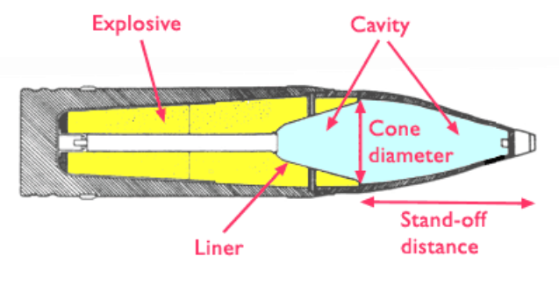
Figure 3 - Cross-section of HEAT warhead [12]
Shaped charges are also widely used in industrial applications, particularly in mining and quarrying. They enable the fragmentation of rock without the need for large quantities of traditional explosives. The design of shaped charges allows for controlled shapes to be created within the rock, which is useful for creating passageways. In the oil and gas industry, shaped charges are employed to create openings in wells to allow for extraction of the fuels. [13]

Research into shape charges
Since the original shape charge was designed there has been decades of research into how this design could optimised to produce looking at the liner shape and angle as well as the most effective material that can be used within. All of this was taken into consideration when modelling the 2D designs

Cone shape and size
Various studies have been conducted since the development of shape charges to try to optimise the product. In June 2020 K.M Ahmed published an article on numerical analysis into how angle can affect the overall performance [14] of the shape charge. His results shows that the mathematically Jet length, break up time and penetration performance all peak between 50°-55° so he conclude that it is the maximum theoretical value for the best performance. However it was also noted that the tip over the velocity of the jet would increase the smaller the angle.
Three researches hen conducted a study by modelling liner thicknesses at 4 different temperatures 50, 60, 70, 80. [15] Although he found that’s the jet-tip velocity decreased as the temperature went up as the liner thickness slowed down the velocity on all models with each increase in temperature the difference between the highest and lowest thicknesses highest velocity decreased.
The cone shape of the also is shown to effect preformed a study published in 2022 [16] showed out of 4 different liner shape biconical, bell, conical, hemispherical using a zirconium liner shows biconical was the most effective with a modelled penetration depth of 74cm then the experimental of 83cm where as the most common conical came third after the bell shape with the highest percentage difference between the numerical (56) and experimental (68) at 17.8%.
Another study shows that in the experimental and numerical of the biconial to have a higher penetration depth in mm although the percentage error is slightly higher with at 1.80% compared to 0.85. Although this is difference is not enough to draw any conclusion from. [5]

Material
Investigation into the liner and explosive used have also been conducted in 2018, an Aluminium, copper and tantalum was compared to each other with three different explosive (RDX, Comp B and HMX). Results are shown in Appendices D [17]. The results were plotted jet velocity against jet length and modelled. The aluminium liner had erratic results that follow no pattern and in the model no jet was formed therefore it is a very ineffective liner. The Tantalum preformed had a stable graph with the best preforming explosive having a peek jet length at 25mm and roughly 5500m/s jet velocity. The copper liner was the best preforming overall with the peak for the best performing explosive with a velocity of 7000m/s and 55mm jet length. The best preforming explosive was the HMX which scored 11% high the RDX and Comp B on both models. His results show cased copper preforming around 27% better than tantalum on all compounds, concluding copper is the best known liner.

Modelling of shape charges

Model
There are two methods the simulation can be ran in Lagrangian or Eulerian. In Langrangain model it focuses on the tracking of individual particles with each element. [18] This provides detailed descriptions on the interaction. This method requires high amount resource and can lead to large amounts of distortion when the model has lots of deformation. [19] This is the best choice when looking into material behaviour.
Eulerian Focuses on specifics points on the model, it analysis property’s like pressure, density and velocity at fixed points in the grid so it is more useful when looking at fluid dynamics and is much more successful at large scale and because the grid is fixed allows for fluid flow and shock waves to be easier to view. However it can’t capture detail about how the materials interact [20]. For this design Lagrangian was used

Materials
Jonson cook is a material model used throughout not just ballistics but a wide variety of different models. It is used to help describe and understand material behaviour under severe loading conditions. It can model the materials at higher stain rates. [21] It is perfect for scenarios where materials experience high deformation like in the instance of a shape charge as it incorporates stress strain and temperature. The value for Johnson-cook for each material is derived though numerical analysis and observations so may not always completely exact to the scenario however it is the more versatile and produces the most reliable results in the high stress and strain models. [22]
The Jones-Wilkins-Lee (JWL) model is an equation of state used when modelling explosives. [23] These values are determined though experimental data which does have some discrepancy from study to study the equation is shown bellow
p(S,V) = Ae−R1V + Be−R2V + C ∗ (S)V −(ω+1) [24]

HMX was selected as the high explosive in this charge from the study into materials [17] HMX is proven to be the most effective explosive used in the shape charge for the furthest pentation depth. However the risk with this explosive is it have a very high velocity and could cause some interference within the model.
A study into get formation and penetration capability [2] showed that steel 4340 was a an effective case used in the experimental and numerical investigation
Copper Liners are the most common form of liner used within a shape charges. They have very strong penetration performance and have been shown to have a high jet velocity [17]. Although other liner have been shown to have higher jet velocity’s and form fast under certain conditions they often sacrifice the penetration depth because of this [25]

Properties
 | ρ0 (kg/m³) | A (kPa) | B(kPa) | R₁ | R₂ | ω | Detonation energy | Pre-deton bulk modulus
HMX | 1891 | 778280000 | 7071400 | 4.2 | 1 | 0.3 | 1600000 | 9
Table 1 - Properties of HMX [17]
 | ρ0 (kg/m³) | A | B | m | n | Melting point | Transition temp | C | E˙0 | Young’s modulus | Poisson’s ratio
Steel | 7850 | 792000000 | 510000000 | 1.03 | 0 | 1792 | 3000 | 0.014 | 1 | 2000000000 | 0.3
Table 2 - Properties of steel 4340 [2] [26] [27]
 | ρ0 (kg/m³) | A | B | m | n | Melting point | Transition temp | C | E˙0 | Shear modulus
Copper | 8930 | 615800000 | 66700000 | 1.078 | 0.0225 | 1623 | 298 | 0.0134 | 1 | 25000000000
Table 3 - properties of copper [2] [17]

2D
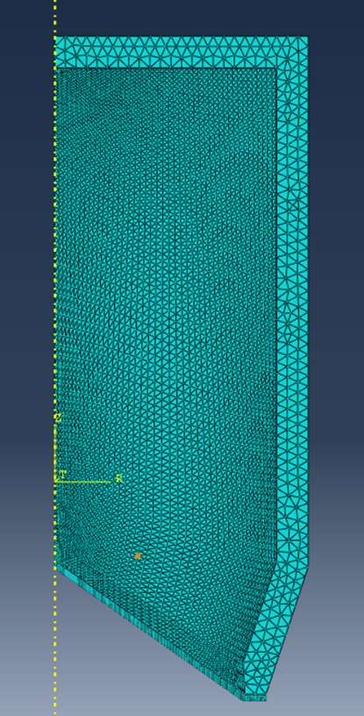
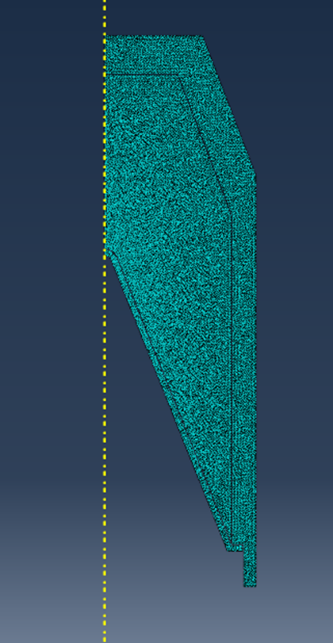
Two shapes charges where created in 2D using the same materials with slightly different dimensions.
Detonation point

Case

High explosive

Liner

Figure 4 – 2D shape charge 2
Figure 5 - 2D shape Charge 1

Figure 4 and 5 show the two these two different geometries used the orange line indicates where the boundary condition was created. The two models had different apex angles and where modelled with the same materials under equal conditions. The mesh densities shown in the models were the densities that provided the best overall jets. The block dot shows the location of the detonation point. Both the mesh densities were modelled contained triangular nodes only.

Mesh

Figure 4
Mesh dencity (meters) | Shape Charge 1 | Shape charge 2
Liner | Has a bias mesh, at the apex angle it is 0.0005 then gradually increases size to 0.001. | Has a bias mesh, at the apex angle it is 0.0005 then gradually increases size to 0.001.
he | The mesh has a size of 0.005, then from the top of the HE at the boundary conditions and the bottom of the HE it gradually deceases along the edged till the apex angle of the liner meets the HE where it has a density 0.001. | The mesh has a size of 0.0005, then from the top of the HE at the boundary conditions and the bottom of the HE it gradually deceases along the edged till the apex angle of the liner meets the HE where it has a density 0.001.
cASE | 0.005 throughout the Case | 0.001 throughout the Case
Table 4 - Mesh size of 2D models

Method
Lagrangian model was used to create this the following steps where followed
- Take the tree parts that have been sketched create an dependant instance in the assembly modal
- Go to the step module and create an explicit dynamic solve set the set the Tmax which was 50e-06 then under field output request and choose the interval a step will be taken in this case it was 20.
- In load Module create a mechanical symmetry in boundary conditions select all the points that come in to contact with the Y axis and select done
- In the interaction module. Create an explicit general contact and continue, ten edit the contact behaviour to be mechanical tangential and normal
- Then the mesh is created in the mesh module and using local seeds a gradient of increasingly dense mesh can be created.
The simulation is then ran in the job module to see if the material or mesh is correct. If there is high amounts of defamation on single elements then its shows a finer mesh is required around the area. After the intimal run it was found that the initial Mesh selected created high amounts of deformation within the High explosive fill where it contacts the liner which cause the simulation to crash showing a high mesh was needed at these points before running the second iteration. This was then run again with the mesh in figure 4.
This same process was then completely to create the second of the 2D simulation this simulation took quite a while to find the mesh size shown in figure 5. Which allowed it to run in full with a jet created and encoder high distortion however this was mostly seen on apex angle at the liner so the mesh density was increased around that area.

Results
Shape charge 2 had with the smaller angle had the highest jet velocity and created the most cohesive jet formation over the set time. The larger angle in shape charge 2 however had the largest deformation shown overall.

3D
The best simulation to take though to run in 3D was the second shape charge. The model is shown below. The mesh used a Tetrahedrons nodes throughout the model. Figure 6 shows the mesh used to obtain a jet formation.
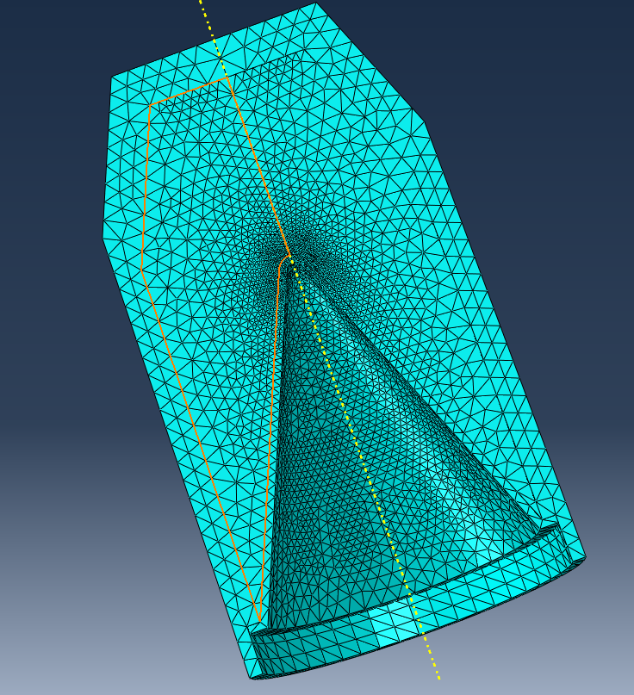
Detonation point

Case

HE

Liner

Y-axis

Figure 6 - 3D simulation

 | Mesh dencity (meters)
Liner | At the apex angle it had a density of 0.0005 then as it moves down the liner it increases to a size of 0.0005.
he | At the detonation point and down the y-axis to where the highest part of the liner meets HE it has a mesh density of 0.0005, the mesh then decreases as it travels out towards the case to a density of 0.005
cASE | Constant density of 0.005
Table 5 - mesh size of 3D model

Method
After selecting to use the second 2D model for the 3D run the sketches must be revolved to create the 3D version and boundary condition will reselected to suit the new geometry. The part will be re-meshed to fit the new design which is shown in figure 6.
For the 3D simulation there was the option to use adaptive meshing in Abaqus. This technique allows for the mesh to adapt to the needs of the material, it can become finer or courser dependant the materials need. [28] During simulation with high amounts of deformation it allows the complex geometry’s to run smoother and removes the need for multiple simulation to perfect the more ideal mesh size. However the setup of this is relatively complex to set up and can be much harder to analyse the results across the varying mesh densities and harder to track singular points. It was found when attempting to run an adaptive mess it was quite instable so the best result came from the standard meshing.

Results
The 3D simulation took high amounts of computing power to achieve and showed slightly high amounts of deformation within the liner compared to its 2D predecessor. The velocity also showed as slightly higher however the jet did not form as cleanly as it did in 2D.

Discussion
Overall it was found that the mesh of the model have very high effect on the results. The same material would perform comply differently depending on the mesh size, so although the simulation are useful to gain an idea as to how they could perform under those conditions it is not the most true result. No conclusion can be drawn unless there is numerical and experimental data to back it up.

Conclusion
In conclusion, shaped charges represent a fascinating intersection of engineering, physics, and materials science. Their ability to effectively penetrate hard targets has made them indispensable in both military and industrial applications. Through historical exploration and recent research focused on optimizing design parameters, we have gained valuable insights into how factors like liner shape, explosive composition, and detonation dynamics influence performance. As technologies advance, continued innovation in shaped charge design will enhance their effectiveness and safety, ensuring they remain vital tools in various fields.

References

[1] | A. Oguzhan and M. Kaya, “Determination of Shaped Charge Jet Characteristics Using a Neural Networks Model Based on Hydrocode Simulations,” in 10th ANKARA INTERNATIONAL AEROSPACE CONFERENCE, Ankara, Turkey, 2019.
[2] | W. Xu, C. Wang and D. Chen, “The jet formation and penetration capability of hypervelocity shaped,” International Journal of Impact Engineering, vol. 132, 2019.
[3] | W. Walters and J. Zukas, FUNDAMENTALS OF SHAPED CHARGES, 1989.
[4] | Operational Facts, Shaped Charged, YouTube, 2021.
[5] | X. Cheng, G. Huang, C. Liu and S. Feng, “Design of a Novel Linear Shaped Charge and Factors,” 10 October 2018.
[6] | J. Carles, Munroe shaped charge effect, YouTube, 2014.
[7] | H. Mehmannavaz, A. Ramezani, M. A. Nabakhteh and G. Liaghat, “A practical review study on shaped charge in the last two decades (2000–2020),” International Journal of Protective Structures, vol. 12, no. 4, pp. 665-693, 2021.
[8] | W. Walter, “A Brief History of Shaped Charges,” ARmy Research laboraty , 2008.
[9] | W. P. Walters, “THE SHAPED CHARGE CONCEPT,,” Maryland, 1996.
[10] | R. Moore and E. N. Brown, “Munroe Jets and the Trinity Gadget,” Nuclear Technology, vol. 207, no. 1, pp. 5222-5230, 2021.
[11] | B. Janzon, J. Joseph Backofen, R. E. Brown, R. Cayzac, A. Diederen, M. Giraud, M. Held, A. W. Horst and K. Thoma, “THE FUTURE OF WARHEADS, ARMOUR AND BALLISTICS,” in 23RD INTERNATIONAL SYMPOSIUM ON BALLISTICS, Tarragona, Spain, 2007.
[12] | M. Beam, “Nuclear EFP and HEAT,” Tough SF, 21 May 2017. [Online]. Available: https://toughsf.blogspot.com/2017/05/nuclear-efp-and-heat.html. [Accessed 2025 Janurary 2025].
[13] | Z.-X. Zhang, “Special Blasting Techniques,” in Rock Fracture and Blasting, 2016, pp. 483-491.
[14] | K. M. Ahmed, Effect of variation of conical liner apex angle on shaped charge performance, Dept. of Aeronautical Engineering, Faculty of Engineering, 2020.
[15] | M. Kumar, Y. Singh and . P. Kumar, “Effect of Liner Cone Angle, Liner Thickness and Wave Shaper in Large Caliber Shaped Charge Warheads,” Explosion Shock Waves and High Strain Rate Phenomena, 2019.
[16] | T. Elshenawy, Q.-m. Li and A. Elbeih, “Experimental and numerical investigation of zirconium jet,” Defence Technology , vol. 18, pp. 12-26, 2022.
[17] | s. Zaki, E. Uddin, B. Rashid, B. Mubashar and S. R. Shah, “Effect of liner material and explosive type on penetration effectiveness of shaped charge,” Institution of Mechanical Engineers, vol. 233, no. 7, 2018.
[18] | D. J. Bensin, “Computational methods in Lagranian and Eulerian Hydrocodes,” San Siego.
[19] | D. G. Spear, A. . N. Palazotto and R. A. Kemnitz, “Modeling and Simulation Techniques Used in High Strain Rate,” Mathematics, vol. 274, no. 9, 2021.
[20] | Z. Zhang and Q. Chen, “Comparison of the Eulerian and Lagrangian methods for predicting,” Atmospheric, vol. 41, no. 25, pp. 5236-5248, 2007.
[21] | “A thermodynamically consistent formulation of the Johnson–Cook model,” Mechanics of Materials, vol. 143, 2020.
[22] | N. Ojal, H. P. Cherukuri, . T. L. Schmitz, K. T. Devlugt and A. W. Jaycox, “A combined experimental and numerical approach that eliminates,” The International Journal of Advanced Manufacturing Technology, vol. 120, pp. 2372-2384, 2022.
[23] | G. Farag and A. Chinnayya, “On the Jones-Wilkins-Lee equation of state for high,” Propellants, Explosives, Pyrotechnics, vol. 49, no. 3, 2024.
[24] | S. B. Segletes, “An Examination of the JWL Equation of State,” US Army Research Laboratory, 2018.
[25] | V. Bohanek, M. Dobrilović and V. Škrle, “THE EFFICIENCY OF LINEAR SHAPED CHARGES,” vol. 21, no. 3, pp. 525-531.
[26] | AZO Materials, “AISI 4340 Alloy Steel (UNS G43400),” 13 September 2012. [Online]. Available: https://www.azom.com/article.aspx?ArticleID=6772. [Accessed 26 December 2024].
[27] | M. Arriaga and H. Waisman, “Multidimensional stability analysis of the phase-field method for fracture with a general degradation function and energy split,” Computational Mechanic, 26 May 2017.
[28] | L. Giraud‐Moreau, H. Borouchaki and A. Cherouat, “Adaptive remeshing method in 2D based on refinement and coarsening technique,” in ESAFORM CONFERENCE ON MATERIAL FORMING, Zaragoza, 2007.

