Principles of Learning and Teaching
Phoebe James
SJIE4006

Principles of Learning and Teaching
This paper is going to analyse the principles of learning and teaching for the reception students aged between 4 to 5 years.
figure 1 reception students- drawing
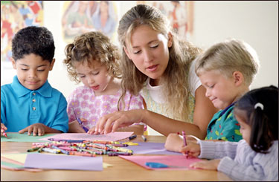
Fig. 1 (Gilliver, 2016) preschoolers drawing with the guidance of their teacher
To best explain how teaching and learning in this setting occurs, this essay is going to refer to different learning theories, strategies and resources that best works for this category of children. The discussion will further be based on the preschool approaches to learning competencies based on interaction with peers and parents, directive and selective attention, purposeful play, self-direction and monitoring, planning and cognitive strategies.
Hiniker, Kim and Kientz (2015) state that by the time a child reaches four years, he or she can comprehend how people behave and some little concepts on what the world is about. Despite lacking interpreters, the author progress to add that a child relies on different elements of cognitive development to understand new concepts. At this age, the majority of the children develop creativity, self-control and greater independence. They further generate great pleasure in playing with their toys for a longer period as well as readily want to try new things. Jacobi-Vessels and Do (2016) further note that this group of children can express their emotions and this is most evident when they get frustrated. A good teacher in such a setting is thus one that can understand all these and come up with a lesson plan that will make teaching and learning process a fun activity with less frustration on the children.
One theory that dictates what a teacher in a reception class should implement in their teaching and learning strategy is the theory of mind. This is a theory that explains how humans think and based on this comes up with ways to enhance learning (Gilliver, 2016). One of the main concepts to take from this theory is that humans do not think alike. Before reaching four years, children have a great challenge in distinguishing what someone else knows from what they know, and as a result, they tend to use an egocentric approach. However, between 4 to 5 years, Ronfard and Corriveau (2016) argue that children can tell a difference of what they know and what someone else knows which forms the basis for social development. Theory of mind further argues that at the age of 4-5 years, children are better able to influence, predict and interpret other people’s behaviors, response and emotions (Vidakis, 2014). All these are important elements that can be used in class to help children differentiate between acceptable and unacceptable conduct as well as punish and reward bad and good behaviors respectively. A smile, for example, can be a sign of approval whereas a frowning can be used to discourage unacceptable conduct as shown in figure 2. These are simple but yet important approaches of helping children in this setting learn principles that will be a foundation to their future academic and social life.
The curriculum of reception age children is further very simple however it must incorporate play with the learning and teaching process. Strouse and Ganea (2016) argue that this group of children learns best when fun activities are part of the learning process; figure 2 below shows how incorporating playing in learning activities maximises the learning process. Interactive playing is part and parcel of the learning activities of a reception class, between the ages of 4-5; children readily play with their peers.

Fig. 2 (Vidakis, 2014) a teacher smiling to a child as a sign of approval for good work
Jacobi-Vessels and Do (2016) state that at these ages’ children cooperatively play with each other with the aid of language to orient a unison goal is common. Pretense playing further is a common trait in these games enhanced by dramatic play which is valuable for supporting social and cognitive development as shown in fig. 3. Children between the ages of 4-5 can negotiate while playing with their peers and in the process solve conflicts. This is a sign of a change from ineffective problem-solving skills to effective interactions and negotiations.

Fig. 3 (Hiniker et al. 2015) children pretense playing as pirates
The discussion above has focused on the theories that support learning; this other section will thus focus on the strategies that teachers can use to enhance the teaching and learning process amongst a reception class. As noted above, children in this setting learn best when the teaching and learning process is made fun and interactive. The classroom setting, therefore, needs to bring out an element of play which will allow for both outdoor an indoor play, especially during bad weather. The resources available and the color on the walls should speak a fun and play mode. Figure 4 shows how a classroom setup for this group of kids should look like to enhance maximum learning.
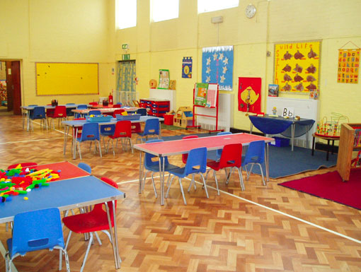
Fig. 4 (Gilliver, 2016) an ideal classroom set-up for preschoolers
Secondly, a cooperative Learning structure as advocated by Vidakis (2014) readily enhances indoor and outdoor play. Effective teachers today are implementing a student-centered approach of teaching to spark the right reaction which further promotes learning. This is an approach that encourages the child to explore and in the process make choices on what he or she will learn. Teachers, on the other hand, take note of the cues and interests and use them to come up with a curriculum that is student based. Gilliver (2016) thus notes that a student-centered approach addresses individual needs of each student promoting 1:1 support which sees them realise individual goals. Some students may need specialist equipment while others an individual education plan to realise set out goals within a given time frame. It is the role of the teacher to take note of such requirements and make the learning environment adaptive for these kids to maximise the teaching and learning experience.
Thirdly, Cooperative learning, this is all about encouraging engagement between children alongside solely focusing on a student at a time. This is an approach that is still student-centered, but as opposed to handling a child at a time it focuses on class discussions and group works which increased the levels of participation. The teacher thus embraces the role of a facilitator which results to the realisation of higher achievement complemented by increased class and team building. Some students may develop a general interest for the same thing; it is up to the teacher to figure this out and group such children together to work on common projects that fascinate them (Hiniker et al. 2015). The differential elements between individual and classroom need to be well defined to encourage both individual and group learning, some of these may include offering children extension of deadlines as needed, providing needed interventions and focusing on areas that interests a child to promote learning. A child needs to be part of the goals-setting process which encourages them to own their learning experience. One of the best ways of achieving this is by having conversations on progress and basing future programs on this.
Fourthly, cross-curriculum teaching and assessment of learning help the children develop and master deeper skills and concepts, e.g. combining maths with reading helps the child learn mathematical concepts and writing at the same time. Assessment involves monitoring the child's progress to gauge if they are grasping taught concepts and in the process adjust the teaching program based on the needs of the children. This ensures that all children are learning at the same pace by receiving necessary support when needed (Gilliver, 2016).
Lastly is creativity and imagination enhanced by parents and caregivers involvement in a child’s learning activities. Hiniker et al. 2015note that creativity and imagination is an important element in shaping a child’s motor skills. This may include activities such as movements, singing and drawings that help the child understands cause and effect, express emotions and articulate experiences. A creative project thus complements the curriculum at school, but when the same is not implemented at home, it hinders learning. Parents need to be aware of their student's curriculum as well as advice on what to do to enhance learning in the home environment. Figure 5 shows a parent-teacher meeting where discussions on the child's academic progress are prioritised.

Fig. 5 (Jacobi-Vessels and Do, 2016): parent-teacher meeting
In conclusion, teaching and practices learning amongst a reception class need to be fun and engaging. The teachers should make use of the learning environment and lesson plan that address individual and group learning needs of the students. Lastly, parents need to be part of the teaching and learning process for the child to maximise the learning process.

Bibliography
Gilliver, M., 2016. Developing sound skills for reading: Teaching phonological awareness to preschoolers with hearing loss. Journal of deaf studies and deaf education, 21(3), pp.268-279.
Hiniker, A., Kim, D. and Kientz, J.A., 2015, June. Touchscreen prompts for preschoolers: designing developmentally appropriate techniques for teaching young children to perform gestures. In Proceedings of the 14th International Conference on Interaction Design and Children (pp. 109-118). ACM.
Jacobi-Vessels, J.L., and Do, A., 2016. Teaching preschoolers to count: Effective strategies for achieving early mathematics milestones. Early childhood education journal, 44(1), pp.1-9.
Ronfard, S. and Corriveau, K.H., 2016. Teaching and preschoolers’ ability to infer knowledge from mistakes. Journal of experimental child psychology, 150, pp.87-98.
Strouse, G.A. and Ganea, P.A., 2016. Are prompts provided by electronic books as effective for teaching preschoolers a biological concept as those provided by adults?. Early Education and Development, 27(8), pp.1190-1204.
Vidakis, N., 2014, June. Combining ludology and narratology in an open authorable framework for educational games for children: the scenario of teaching preschoolers with autism diagnosis. In International Conference on Universal Access in Human-Computer Interaction (pp. 626-636). Springer, Cham.

