

Module: Data Handling and Business Intelligence
Module code:LCBB5000
Lecturer Name: Ejike Robert Udeogu
Student Name: Deni Apostolov
Student ID- 2244458

Table of Contents
Introduction 3
Section 1: Analysis of USA housing Data 3
Summary of Data set 4
Visualisation between Price and Other Factors 5
Price and Number of Bedroom Graph 5
Price and Number of Bathroom Graph 6
Price and Square footage of living space 7
Price and Year Built 8
Correlation Analysis 8
Recommendations 10
Section 2: SPSS Advantages and Disadvantages 11
SPSS 11
Advantages of SPSS 11
Disadvantages of SPSS 12
Meaning and importance of Data Mining Cycle 12
Process of Data Mining 13
Conclusion 14
Reference list 15

Introduction
This report has two parts. Section 1 analyses the dataset using descriptive statistics, data visualisations, and correlation analysis to discover patterns and associations between variables such property price, square footage, and bedrooms and bathrooms. These findings also inform homebuyer recommendations. Section 2 offers a critical assessment of SPSS, discussing its advantages and limitations in comparison to Excel, alongside a detailed explanation of the Data Mining Cycle, emphasizing its importance in data analysis.

Section 1: Analysis of USA housing Data
In today's fast-changing world, accurate, timely information is essential for success and competitiveness. BI is a management concept and instrument that helps organisations manage and improve business information to make better business choices (Talaoui and Kohtamäki, 2020). Organisations with varied activities, contexts, and dimensions may have trouble using current data in sales, finance, and storage systems efficiently. Data is useful for information extraction and management choices in several business sectors. Increasing data in organisations and analysing it is a new management technique (Ragazou et al., 2023). The US housing market has long been of interest owing to its economic impact on personal wealth. The Global Financial Crisis showed how important housing markets are for macroeconomic stability, national and individual well-being (Atalay and Edwards, 2022). A variety of factors drive housing prices, from square footage and location to the number of rooms and year of construction. This paper analyses a large dataset of home prices in major U.S. cities from the "USA Housing Dataset." This investigation aims to provide important insights into home pricing variables to enable potential buyers make educated purchases and stakeholders understand housing market developments. As a real estate analytics intern data analyst for a reputed research institution, I must analyse this dataset using statistical methodologies. Our centre, famed for its data-driven insights, uses Microsoft Excel for basic data processing. To improve analysis, it included SPSS, a strong statistical program. I will analyse the housing dataset using SPSS to generate a strong statistical analysis.

Summary of Data set
Data visualisation that is open and honest is a must-have for every scientific presentation. Visualising continuous quantitative data just as summary statistics (measures of central tendency and dispersion) has been criticised for not showing the actual data distribution (Loffing, 2022).
Descriptive Statistics
 | price | bedrooms | bathrooms | sqft_living | sqft_lot
Mean | 553062.877 | 3.400 | 2.1630 | 2143.64 | 14697.640
Median | 460000.000 | 3.000 | 2.250 | 1980.00 | 7676.000
Std. Deviation | 583686.453 | 0.904 | 0.785 | 957.482 | 35876.838
Range | 26590000.000 | 8.000 | 6.750 | 9670 | 1073580

The descriptive statistics for the dataset reveal substantial variation across key property characteristics, such as price, number of bedrooms, number of bathrooms, and square footage of both the living area and lot size. The average property price is approximately 553,063, while the median price is lower at 460,000. This difference suggests a right-skewed distribution, with a few high-priced properties likely driving the average upward. The large standard deviation of $583,686 and the wide range of 26,590,000 further indicate significant diversity in property prices, pointing to a mix of both modest and high-end homes.
In terms of property features, the average number of bedrooms is 3.4, and the median is 3, suggesting that most properties in the dataset are relatively similar in bedroom count. The standard deviation for bedrooms is low, indicating limited variation around this average. Bathrooms show a similar pattern, with an average of 2.16 and a median of 2.25, suggesting a slightly right-skewed distribution but relatively consistent counts across properties. The moderate standard deviation of 0.785 implies that most properties do not deviate widely from the typical number of bathrooms.
For square footage, the average living area is around 2,144 square feet, while the median is slightly lower at 1,980 square feet. This small discrepancy implies a right-skewed distribution, with some large properties pushing the mean upwards. The standard deviation of 957.482 square feet reveals considerable variability, as does the range of 9,670 square feet, indicating that the dataset includes both compact and very spacious homes. Lot size displays an even greater spread, with an average of 14,698 square feet but a median of 7,676 square feet. The large difference between mean and median suggests that some exceptionally large lots heavily influence the average. The substantial standard deviation of 35,876.838 and an extreme range of 1,073,580 square feet highlight the broad variety in lot sizes, likely reflecting a mix of urban and rural properties with vastly different land areas.

Visualization between Price and Other Factors
Data visualisation is graphical depiction of data. Data visualisation tools make trends, anomalies, and patterns easy to see using charts, graphs, and maps (Lin et al., 2023).

Price and Number of Bedroom Graph

In this line graph, house prices are correlated with number of bedrooms. The x-axis displays property prices, which range from $0 to around $1,200,000, and the y-axis shows the number of bedrooms, which ranges from about 0 to 8. The plot reveals that the average price rises consistently from 1 to 8 bedrooms, which is corelated with the notion that larger homes are more expensive. The properties with 6 to 8 bedrooms have a slower pace of price increasing, even though the prices are rising simultaneously with the number of bedrooms. This would suggest that the demand for larger houses is smaller than for medium or small houses.
Within this price range, there are many fluctuations, indicating a variety of bedroom counts across properties. However, as prices increase beyond $400,000, the number of bedrooms stabilizes, mostly around 3-4 bedrooms, with a few properties showing slightly higher counts before levelling out. For extremely high-priced properties (those above $650,000), the number of bedrooms remains stable at 6, suggesting that properties in this price range do not necessarily have more bedrooms than lower-priced ones. This could imply that beyond a certain price threshold, factors other than bedroom count (such as location, luxury amenities, or land size) drive the high property prices.

Price and Number of Bathroom Graph

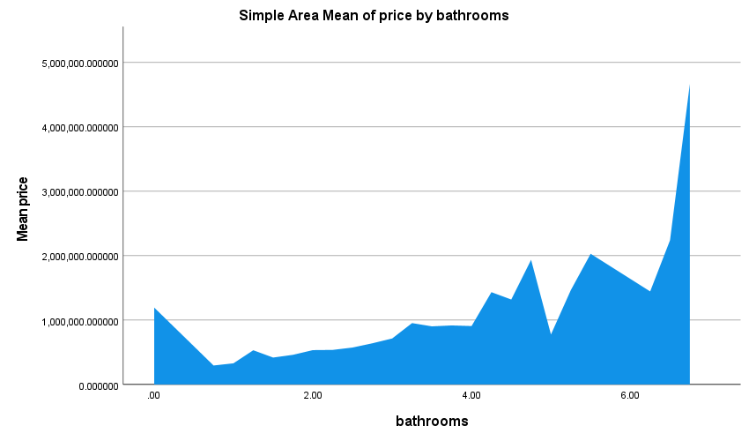

This area plot shows the relationship between property prices and the number of bathrooms. The x-axis represents property prices, which range from $0 up to around $30,000,000, while the y-axis shows the number of bathrooms, ranging from 0 to over 6. The graph reveals that for lower-priced properties, there is considerable variability in bathroom counts, with a clustering of properties having between 2 and 4 bathrooms. As property prices increase (particularly between $0 and around $5,000,000), there is a rise in the number of bathrooms, with some properties in this price range having up to 6 bathrooms. This increase suggests that higher-priced properties tend to have more bathrooms, reflecting greater luxury or larger property size. However, as prices continue to rise beyond $5,000,000, the number of bathrooms generally decreases and stabilizes around 2 bathrooms. This trend is counterintuitive, as one might expect higher-priced properties to consistently have more bathrooms. The decline suggests that for extremely high-end properties, factors other than the number of bathrooms, such as location, amenities, or land area, may be driving the prices. These ultra-luxury properties might not prioritize an increased number of bathrooms but instead focus on other luxury features.

Price and Square footage of living space
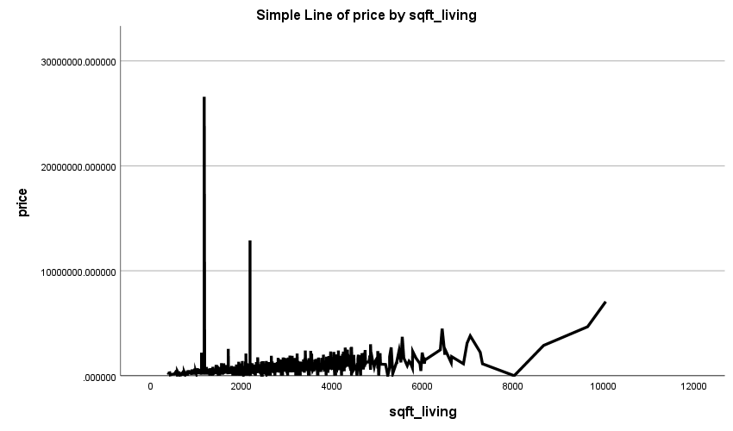

The above chart illustrates the relationship between the price of houses and their living area (square footage). The data points are predominantly clustered towards the lower price range, suggesting that most properties have prices below $5 million and feature a variety of square footage sizes. As the price increases, the variability in square footage also increases, with some higher-priced properties showing significantly larger living spaces. A notable aspect of the graph is the presence of several outliers, particularly at higher price points (exceeding $10 million), where the square footage does not consistently follow an increasing trend. This indicates that while larger homes tend to be more expensive, beyond a certain price range, factors other than square footage might drive the price, such as location, luxury features, or unique property attributes. The line connecting the points is misleading, as it suggests a continuous trend, which does not accurately reflect the relationship in this context. Additionally, the x-axis scale appears stretched due to the extreme price values, making it difficult to observe subtle differences in lower price ranges.

Price and Year Built
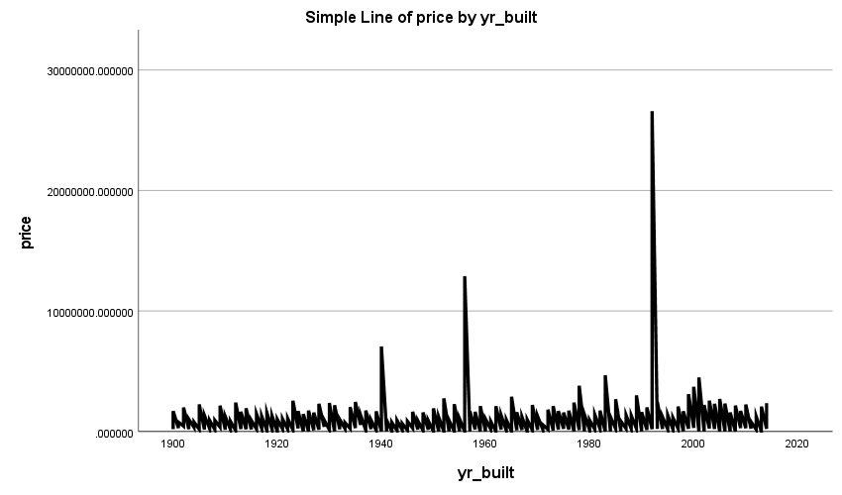

The line graph shows the relationship between the price of properties and the mean year built. Most data points are densely clustered towards lower price ranges (below $5 million), indicating that a significant portion of the properties were built in the early 20th century. As the price increases, the mean year built becomes more variable, suggesting a mix of older and newer constructions in higher-priced segments. There is a noticeable dip in the mean year built for properties priced between $5 million and $10 million, implying that some higher-priced homes may be historical or older buildings that retain high value due to factors other than modern construction. Beyond $10 million, the trend line indicates an increase in the mean year constructed, implying that luxury, contemporary facilities, or recent developments make more costly houses newer.

Correlation Analysis
Correlation analysis is often used to find interesting data associations. These relationships show how qualities relate to the target class to be predicted (Kumar and Chong, 2018).
 |  | price | bedrooms | bathrooms | sqft_living | sqft_lot
price | Pearson Correlation | 1 | .189** | .318** | .419** | .046**
price | Sig. (2-tailed) |  | .000 | .000 | .000 | .003
price | N | 4140 | 4140 | 4140 | 4140 | 4140
bedrooms | Pearson Correlation | .189** | 1 | .543** | .590** | .066**
bedrooms | Sig. (2-tailed) | .000 |  | .000 | .000 | .000
bedrooms | N | 4140 | 4140 | 4140 | 4140 | 4140
bathrooms | Pearson Correlation | .318** | .543** | 1 | .760** | .097**
bathrooms | Sig. (2-tailed) | .000 | .000 |  | .000 | .000
bathrooms | N | 4140 | 4140 | 4140 | 4140 | 4140
sqft_living | Pearson Correlation | .419** | .590** | .760** | 1 | .194**
sqft_living | Sig. (2-tailed) | .000 | .000 | .000 |  | .000
sqft_living | N | 4140 | 4140 | 4140 | 4140 | 4140
sqft_lot | Pearson Correlation | .046** | .066** | .097** | .194** | 1
sqft_lot | Sig. (2-tailed) | .003 | .000 | .000 | .000
sqft_lot | N | 4140 | 4140 | 4140 | 4140 | 4140
**. Correlation is significant at the 0.01 level (2-tailed).

The correlation study sheds light on how home prices relate to property attributes like bedrooms, baths, living space size (sqft_living), and lot size. The square footage of the living area has the largest positive link with property values, showing that bigger living rooms attract higher prices. This shows that useable interior space drives buyer preferences and property worth. The second most important factor is bathroom count, which also positively affects property values. Properties with greater convenience and comfort are worth more, particularly for bigger families. The number of bedrooms has a modest association with price, demonstrating that although more bedrooms might raise the price, they have less of an influence than living area and bathroom count. Interesting, lot size has the least correlation with home price. In many circumstances, outdoor space or lot size may not affect a property's market value. Buyers choose interior features and comfort above land area, perhaps because living space practicality and aesthetics are more important.

Recommendations
What Factors Should They Prioritize If They Are Looking for Affordable Housing?
- Opt for Smaller Living Spaces: Since the square footage of the living area has the highest impact on price, selecting homes with smaller indoor living areas can help buyers find more affordable options.
- Consider Fewer Bathrooms: Choosing homes with fewer bathrooms can be a cost-effective strategy, as the number of bathrooms is a significant factor driving up house prices. If buyers do not require multiple bathrooms, they can save money by selecting properties with fewer amenities.
- Flexibility on Lot Size: Given the minimal impact of lot size on price, buyers seeking affordability should not prioritize lot size. Larger lots may be available without a substantial increase in price, providing an opportunity for outdoor space without affecting the budget.
2. What Factors Seem to Drive the Price Upwards?
- Larger Living Areas: The size of the living area is the most influential factor in determining house prices. Properties with spacious living areas tend to be priced higher due to the perceived value of additional indoor space.
- Higher Bathroom Count: The number of bathrooms is a key driver of price increases. Homes with multiple bathrooms offer enhanced comfort and convenience, making them more attractive to buyers, especially families, thus driving up the property’s market value.
- Overall Interior Features Over Exterior: Features that enhance the indoor living experience, such as additional living space and multiple bathrooms, contribute more to price increases compared to exterior features like lot size.

Section 2: SPSS Advantages and Disadvantages

SPSS
SPSS Statistics from IBM is used for data management, advanced analytics, multivariate analysis, corporate intelligence, and criminal investigation. First and foremost, SPSS was designed for non-technical users, primarily social scientists, therefore no programming language experience is needed to start using it. The software is user-friendly and suitable for any quantitative study. Its data handling capabilities make it a favoured option for academics worldwide. The software generates excellent reports. Comprehensiveness and flexibility in quantitative data analysis are essential to pick this software above others. SPSS is used in social science research for survey data authorisation, cooperation, and strategic data mining for statistical analysis (MacInnes, 2016). Researchers can better analyse quantitative data using SPSS if they understand its basics. It aids the researcher in overcoming obstacles.

Advantages of SPSS
There are various advantages of SPSS as far as its usability is concerned:
- According to Rahman and Muktadir (2021), one of the main benefits of this program is its Graphical User Interface (GUI), which makes it simple to learn and use. The statistical capabilities are extensive. Its ability to generate new variables from preexisting data is its distinguishing feature. It comes with most of the advanced statistical tests already installed. Many well-known file formats are compatible with SPSS, including Excel, SAS, Stata, tab-delimited, and a handful of others.
- When compared to other statistical programs, SPSS has all the benefits, and platform compatibility is a major concern for software in the modern world. It has been reported that SPSS is compatible with LINUX, Windows, and macOS (Loffing, 2022). Consequently, researchers are no longer limited to working on their data on certain computer systems. Cluster analysis is another area where SPSS shines .
- SPSS takes care of everything from managing and preparing data to analysing and reporting on that data. By substituting predicted values for missing ones, regression and expectation-maximization enhance both predictions and plans (Loffing, 2022).
- If any outliers are found, the SPSS features can automatically detect them and apply statistical changes to deal with them. One of the best things about SPSS is the tables and how well it displays the data. Additionally, it is capable of making predictions about the values of target variables using the values of predictor variables. Another path opens for researchers when linear and non-linear interactions can be accurately modelled (Rahman and Muktadir, 2021). For instance, retail companies need to gather, analyse, and transform a mountain of data into useful insights. Businesses may provide their consumers great experiences by making good use of the data using SPSS software. Additionally, SPSS is an all-inclusive suite for analysing quantitative data.

Disadvantages of SPSS
SPSS has few disadvantages too:
- One drawback is that users have to shell out cash to use the application, thanks to its commercial licensing. Not even students will be able to get the software without paying for it. You may get discounts, but they do come with a price.
- There are situations when the usability may not feel the same, particularly for those who often use Microsoft Excel. Making changes to the graphs might be challenging. Additionally, there aren't many graphing choices. Rahman and Muktadir (2021) observe that graphic quality is another potential big negative. Modifying the output is a challenge.
- The installation machine determines how slowly the application runs. Some optional modules are more complicated than they need to be.

Meaning and importance of Data Mining Cycle
Data mining analyses massive databases to detect trends, patterns, linkages, and actionable information to assist organisations solve problems. It helps companies forecast trends and find new possibilities. They need information to make educated judgements (Qiao and Jiao, 2018). Data mining involves finding patterns and drawing conclusions from large data sets. Marketing and sales teams utilise this to analyse structured and unstructured data to find new insights and customer behaviours. Data mining can identify and forecast customer churn, fraud, market basket analysis, and more (Schuh et al., 2019).
The data mining sector is booming. Data mining technologies are available from AWS, Oracle, Microsoft, SAP, and SAS Institute. Its significance is undisputed. Data must be mined before it can help organisations succeed. Nothing can be done with raw data. Data mining extracts meaningful information from raw data for the company and its clients (Jassim and Abdulwahid, 2021). Data mining aids fraud detection, spam filtering, risk management, and cybersecurity. Marketing uses it to predict consumer behaviour. In banking, it may detect fraudulent transactions. Not just organisations benefit from data mining. Everyone uses it, from governments to hospitals.
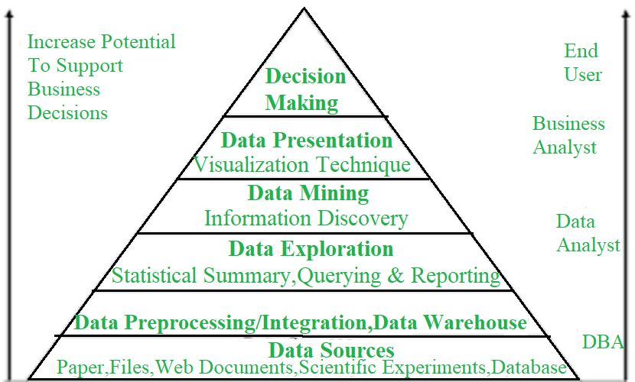

Process of Data Mining
The data mining process typically involves the following steps:
Business Understanding: This phase includes outlining the data mining project's goals and issue. This comprises establishing the business challenge, project goals, and success KPIs. This stage ensures that the data mining project meets corporate goals (Jassim and Abdulwahid, 2021).
Data Understanding: Collect and analyse data to comprehend its structure, quality, and substance. This involves analysing data sources, recognising data quality concerns, and studying data for patterns and linkages (Jassim and Abdulwahid, 2021). This phase ensures data quality for analysis.
Data Preparation: This involves cleaning the data to eliminate mistakes and inconsistencies, converting it for analysis, and combining data from diverse sources to produce a unified dataset. This process prepares data for modelling (Kotu and Deshpande, 2015).
Modelling: This stage builds a prediction model using machine learning methods. This comprises choosing an algorithm, training the model using data, and assessing its performance (Plotnikova et al., 2022). This is the core phase of data mining and entails creating a model that can reliably anticipate fresh data outcomes.
Evaluation: Model performance is assessed here. This contains statistical methods to evaluate the model's ability to predict new data outcomes. Making ensuring the model is realistic and usable in real life is important.
Model deployment: This phase puts the model in production. To produce real-time predictions, integrate the model into current systems and processes. This stage makes the model practical and valuable to the organisation (Plotnikova et al., 2022).

Conclusion
This report used USA Housing Dataset data to uncover home price drivers and give purchasers and industry stakeholders with insights. We found that square footage of living space and the number of bathrooms greatly drive-up home prices using descriptive statistics, data visualisations, and correlation analysis. The number of bedrooms somewhat affected pricing, but lot size had little influence, showing that inner space is more valuable than external space. The results suggest that affordable purchasers should choose residences with smaller living spaces and fewer bathrooms and be flexible regarding lot size. However, purchasers eager to invest in higher-value houses should select homes with larger living spaces and more bathrooms, which rise in price. The second section critically analyse SPSS for data analysis. Additionally, we examined the Data Mining Cycle and its importance in gaining insights from complicated datasets.

Reference list
Atalay, K. and Edwards, R. (2022). House prices, housing wealth and financial well-being. Journal of Urban Economics, 129. doi:https://doi.org/10.1016/j.jue.2022.103438.
Jassim, M.A. and Abdulwahid, S.N. (2021). Data Mining preparation: Process, Techniques and Major Issues in Data Analysis. IOP Conference Series: Materials Science and Engineering, 1090(1), p.012053. doi:https://doi.org/10.1088/1757-899x/1090/1/012053.
Kotu, V. and Deshpande, B. (2015). Introduction. Predictive Analytics and Data Mining, pp.1–16. doi:https://doi.org/10.1016/b978-0-12-801460-8.00001-x.
Kumar, S. and Chong, I. (2018). Correlation Analysis to Identify the Effective Data in Machine Learning: Prediction of Depressive Disorder and Emotion States. International Journal of Environmental Research and Public Health, 15(12). doi:https://doi.org/10.3390/ijerph15122907.
Lin, Y., Tang, Y., Zhu, Y., Song, F. and Tang, W. (2023). A Perception Study for Unit Charts in the Context of Large-Magnitude Data Representation. Symmetry, 15(1), p.219. doi:https://doi.org/10.3390/sym15010219.
Loffing, F. (2022). Raw Data Visualization for Common Factorial Designs Using SPSS: A Syntax Collection and Tutorial. Frontiers in Psychology, 13. doi:https://doi.org/10.3389/fpsyg.2022.808469.
Paura, L. and Arhipova, I. (2012). Advantages and Disadvantages of Professional and Free Software for Teaching Statistics. Information Technology and Management Science, 15(1). doi:https://doi.org/10.2478/v10313-012-0001-z.
Plotnikova, V., Dumas, M., Nolte, A. and Milani, F. (2022). Designing a data mining process for the financial services domain. Journal of Business Analytics, 6(2), pp.1–27. doi:https://doi.org/10.1080/2573234x.2022.2088412.
Qiao, X. and Jiao, H. (2018). Data Mining Techniques in Analyzing Process Data: A Didactic. Frontiers in Psychology, 9. doi:https://doi.org/10.3389/fpsyg.2018.02231.
Ragazou, K., Passas, I., Garefalakis, A. and Zopounidis, C. (2023). Business intelligence model empowering SMEs to make better decisions and enhance their competitive advantage. Discover Analytics, 1(1). doi:https://doi.org/10.1007/s44257-022-00002-3.
Rahman, A. and Muktadir, G. (2021). SPSS: An Imperative Quantitative Data Analysis Tool for Social Science Research. International Journal of Research and Innovation in Social Science, 05(10), pp.300–302. doi:https://doi.org/10.47772/ijriss.2021.51012.
Schuh, G., Reinhart, G., Prote, J.-P., Sauermann, F., Horsthofer, J., Oppolzer, F. and Knoll, D. (2019). Data Mining Definitions and Applications for the Management of Production Complexity. Procedia CIRP, 81, pp.874–879. doi:https://doi.org/10.1016/j.procir.2019.03.217.
Talaoui, Y. and Kohtamäki, M. (2020). 35 Years of Research on Business Intelligence process: a Synthesis of a Fragmented Literature. Management Research Review, 44(5), pp.677–717. doi:https://doi.org/10.1108/mrr-07-2020-0386.

