

Academic critique of current thinking in relation to the use of reflective practice in teaching and learning

Kierran Tomkins|PGCE (PCET) Level (7) | 31st May 2019



Introduction
This written extract will analyse the definition of reflection and reflective practice within current and modern realms. To intensify this written passage, a critique on reflective theorists and models will be at the forefront of this document to pinpoint positives and negatives based on their usefulness to the current and contemporary educator or learner. A sophisticated link between the current thinking of reflective practice in teaching and learning will interlink throughout this document as a method of conducting research and gaining further knowledge as a professional and developing educator.

Defining Reflective practice
Reflection is the process of using perceptions of an array of experiences that have taken place prior to an experience or before and after the occurrence of an action. The reflection is the concluding phenomenon that enables us as humans to learn, progress and develop (Cirocki, et al, 2014). Reflective practice is the vital attention to detail that one uses to analyse and demonstrate the link between the development process and one’s ability. Reflective practice empowers us to find out who, and what we are, and enhances one’s ability to recognise how to become more effective when operating in any industry or speciality, (Bolton & Delderfield, 2018).
The reflective experience enables someone to reflect on what has changed and how, and when someone recognises the change, they attain a new perspective of the experience. When someone has a new perspective of an experience, one develops a deeper understanding of it and gains the ability to reflect in a deeper and more focused manner, this enables the knowledge of fully understand the reasons from experiences (Sicora, 2017).
By defining reflection as something humans can use to recall experiences or to look back at themselves with, this is known as the normality of basic reflection. When someone puts this into continuous practice, ‘reflective practice’ starts to evolve, and one who undertakes this can acquire a deeper understanding of how experiences formulate, and where to make improvements. In teaching reflection is significant, educators use reflective mannerisms to analyse and ‘critically question’ any grey areas before and after the attained experience. By carrying out this aspect of reflection proactively, teachers can also continue to pursuit development opportunities, in the same way their students can. By continuously reflecting on the betterment of oneself with the ability to recognise what to develop, this is effective reflective practice taking place (Jackson, 2019).

The use of models and theorists to enhance reflective practice
As a method of reflective enhancement or embellishment, many people favour using a variety of reflective models, brought into existence by an assortment of theorists. Some of the giants who have structured the reflective frame works are, John Dewey, Graham Gibbs, and David A, Kolb, although the trio are not the only reflective theorists, they are pronounced as three of the most common and adhered to logicians. The frame work structures from these theorists can be seen in appendix (1), (2) and (3). The prime reason for such a variety of different reflective models is that each theorist believed that there are different cycles of learning and reflecting. However, there is no right or wrong model or framework that you should adhere to, all frameworks have different stages. The many similarities of almost all models summarise with this structural nature, “what happened, why does this matter, and what are the next steps or stages after this?” (Koshy, et al, 2017).
Reflective practice is an asset to the development of anyone; it plays a dominant part in progression generally, and primarily for individual functionality and personalised progression. When someone recognises their own experiences and actions, they can professionally enhance and develop aspects of them. A major benefit of reflective practice is one can define and focus what they want and where they want to improve, (Mathew, et al, 2017). As defined, there are a variety of different models, however, these models offer a variety of different steps and stages to carry out an effective reflection and encourage different ways of recognising potential personal developments prior to experiences (Middleton, 2017) . For example, Gibbs (1988) model of reflection has an emphasis on the personal thoughts and feelings around an experience, and lays the whole reflection in six different steps. The different stages can give a reflector a very embellished and personal reflective experience. Donald Schön’s model of reflection consists of two different stages, reflection in action and reflection on action, these stages adhered to the notion that learning in general cannot take place without reflection, and it enables a developer to reflect within the experience and after it (Sartain, 2015). All models and frameworks provide someone with different stages and depths of reflective analysis, and none of the models are tailored to anyone specific. However different types of people may favour the more simplistic models or the ones with numerous stages, it is open to personal taste and interpretation of how deep the learner wants to reflect and analyse elements for improvement. Regardless of the different stages between any reflective models, any reflective cycle that gives someone the opportunity to develop is a positive thing.
The barrier or disadvantages of reflective practice can be the breaking of bad habits or the discovery of negative aspects of one’s practice. Many people find it very difficult to change their methodology, or the way they do things. This can be very prevalent in teachers changing the ways they teach or to break usual classroom pedagogy procedures, (Hudaya, 2017). Another disadvantage here is that developers may not have the time to participate in effective reflection, and “learner vulnerability” or low self-esteem and low confidence may occur from exploring one’s practice deeply and critically, which can be seen to affect the individual in a negative way (Baldwin and Lucas, 2012). Individuals may even lack the knowledge of how to carry out reflective practice or even lack the time and motivation to do so, this is not targeting a specific age group, but can occur in anyone of any age and any type of person.

The contemporary mind set and current thinking of reflective practice
Reflective practice has been passed through all generations and always will, it’s how us as humans learn and progress from experiences regardless of the frameworks that assist us within structuring and undertaking the reflective process. The contemporary mind on reflective practice may not be what we think, as technology has progressed and social media has become a part of life, as well as materialistic things. People may not use reflective practice for personal development, and the modernised society may use it as a way of ‘keeping up with the jones’s’ or as a way of impressing people. To approach this from another angle, reflective practice can be utilized to identify things we don’t have or want, it can be adapted in multiple ways to suit different needs. However, due to the advancement of modern technologies, reflective practice can be far easier to structure and document in a variety of different ways to ensure effective and meaningful reflection has taken place, and one can view where they were and where they are now. Regardless of undertaking reflective practice before time, or undertaking it now, its enhancement on learning and improving is positive on our overall learning performance and regular practice can aid us in achieving future goals and aspirations (Miller, 2019).

Conclusion
There can be no doubt that reflective practice is primarily a positive thing, but every positive also has a negative. However, as reflective practice is focused on personal development, the positives outweigh the negatives in numerous ways. I have used reflective practice throughout the PCET course, and it has helped me identify who I am and what my strengths and limitations are. Although there are a variety of different frameworks or models to be adhered to, Gibbs model of reflection has been the most useful to me, as it has six different steps that can be used to analyse experiences in greater detail, with a focus on personal feelings, which is an important factor to understand when reflecting.
The six different stages assisted me in breaking down experiences and analysing them in fine detail to ensure further growth and development could take place. The model of Gibbs has helped me shape the way I feel about teaching, and how I educate by using the six different stages. I would use this system to reflect after any lesson undertaken on the PCET placement to ensure I could set achievable and realistic goals on a weekly basis. To continue the reflective and developmental journey whilst being a teacher in training, there can be no don’t that the nurturement of reflective practice will result in positivity, but many can argue that reflective practice can upset people when they discover their limitations or things they need to improve. To round this off, improvement alone can only be positive, people should strive to be the best they can be. People should not be negative about what they need to improve but should start showing the willingness to progress and advance, this is most important aspect to learning.

References
Baldwin, K. Lucas, B (2012) Promoting reflective practice skills for postgraduate Gps: Do journals aid journeys? Education for primary care. Volume 23. PP 213-216. [Accessed 16/05/2019]
Bolton, G. Delderfield R (2018) Reflective practice, writing and professional development. Sage publishing. Los Angles, London, New Delhi, Singapore, Washington DC, Melbourne. PP 34-35. [Accessed 26/04/2019]
Cirocki, A. Tennekoon, S. Pena, C, A (2014) Research and reflective practice in the ESL Classroom: Voices from Sri Lanka. Australian Journal of teacher education. Volume 39. Issue 4. Article 2. Australia. PP 27-28. [Accessed 26/04/2019]
Hudaya, D, W (2017) Reflective teaching [Online] Available from: https://medium.com/@diahwulanhudaya/reflective-teaching-79e2d9c3dd20 [Accessed 16/05/2019]
Jackson, G (2019) What is reflective practice? [Online] Available from: https://impact.chartered.college/article/what-is-reflective-practice/ [Accessed 11/05/2019]
Koshy, K. Limb, C. Gundogan, B. Whitehurst, K. Jafree, D, J (2017) International journal of surgery oncology. Reflective practice in health care and how to reflect effectively. Education article. PP 01-03. [Accessed 13/05/2019]
Mathew, P. Mathew, P. Peechattu, P (2017) Asia pacific journal of contemporary education and communication technology. Reflective practice: A means to teacher development. Volume 3, issue 1. Apiar. Asia. PP 126-127. [Accessed 16/05/2019]
Middleton, R (2017) International practice development journal. Critical reflection on practice development. Critical reflection: the struggle of practice developer. IPDE, Wollongong, New South Wales, Australia. PP 01-03. [Accessed 16/05/2019]
Miller, J (2019) Achieve your 2019 goals with the help of regular reflection. Forbes human resource council. [Online] Available from: https://www.forbes.com/sites/forbeshumanresourcescouncil/2019/01/16/achieve-your-2019-goals-with-the-help-of-regular-reflection/#2a9a56468b01 [Accessed 18/05/2019]
Sartain, P, J (2015) An exploration of the effectiveness of reflective practice on adult learning. Coda Partners inc. PP 01-05. [Accessed 16/05/2019]
Sicora, A (2017) Reflective practice and learning from mistakes in social work, Social science. Illustrated. Policy Press Publishing, Great Britain. PP 08-09. [Accessed 26/04/2019]

Appendices
Appendix (1)

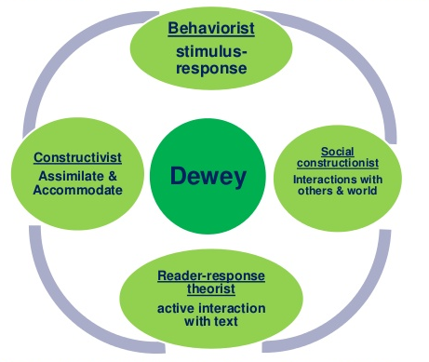

Appendix (2)



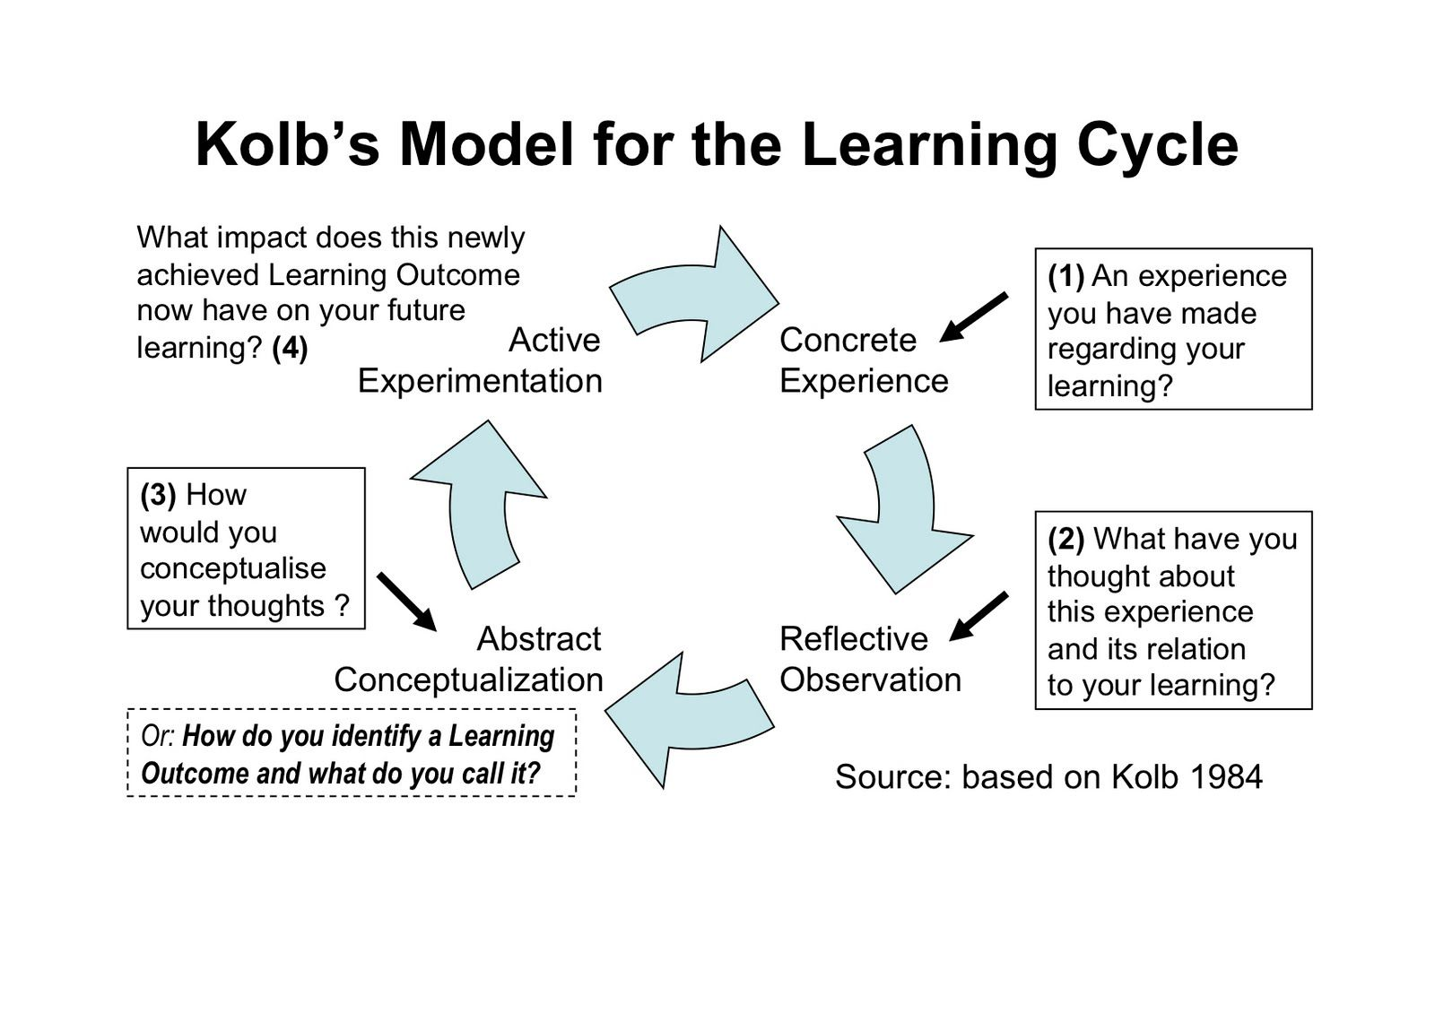
Appendix (3)

