Marketing Management TESLA 75%



Marketing Management (LCMB7001)
Name: Curtis McKenzie
Student Number: 1808750
Lecturer: Tushara Balendran
7/01/2022



This Photo by Unknown Author is licensed under CC BY-SA

Table of Contents

Introduction

Background of the company

Definition of communication

Communication model

Definition of Integrated Marketing Communications (IMC)

Promotional strategies used by Tesla to raise awareness of the brand

Definition of branding and brand equity

Keller’s Brand Equity model

The customer journey and customer touch points for Tesla

Describing what is happening in the customer journey map for buying a Tesla car and determine the main strengths and weaknesses.

Recommendation for new touch point

The Total Engagement Model

Conclusion

References

Introduction:
Marketing management is known as an organisational discipline which concentrates on practical application of market orientation, methods, and techniques of internal process as well as the management of the company in marketing resources and activities. The primary function of marketing management is to perform all the business tasks by converting potential customers into actual customers. This is done with customer satisfaction and meeting their requirements by delivering quality services. The following report will discuss the effectiveness of communication and integrated marketing communication in the proposed organisation named Tesla, through a communication model. Promotional strategy of the company along with its customer experience has been described through brand equity and total engagement theory.

Background of the company
Tesla Inc is an American electronic vehicle and clean Energy organisation. It is one of the largest companies in automobile industries globally which is famous for its battery energy storage photovoltaic systems. The company was founded in 2003 by Martin Eberhard and Marc trading as Tesla Motors. Letter on, the company name has been changed to Tesla Inc as a tribute of inventor and electrical engineer Nikola Tesla. In recent days, the owner of the organisation is Elon Musk. Tesla is famous for designing and manufacturing battery energy storage electric cars solar panels grid-scale solar roof tiles etc. The battery electric vehicles and plug in electric vehicles have captured 16% of the plug-in market and the battery electric market by 23%. It is also called the largest battery energy storage system supplier all over the world. This largest automobile organisation is trading as Nasdaq stock market, Nasdaq Stock 100 index, S&P 100 index and Standard and Poor’s 500. The headquarter of the firm is based in Palo Alto, California, United States. More than 598 retail stores or galleries and service centers are available all over the world as per 2021 report. There are several products available within the organisation such as vehicle servicing software update and upgrade insurance charging premium connectivity etc. (Thomas and Maine, 2019).
The vision of the organisation is to create the most compelling organisation by driving the world transition to electric vehicles in the 21st century. The mission of the company is to accelerate the appearance of sustainable transport by piloting the compelling mass market electric cars in the global market as soon as possible. According to a 2020 report, an estimated 70,757 employees are associated with the organisation to serve global people. The production output of the organisation in 2020 is 205 MB solar, 50, 9737 vehicles and 3 GWh battery energy storage systems (Gilson and Abbott, 2017). The revenue earned by the firm in 2020 is 3.5 billion US dollar and the operating income is to billion-dollar. The total asset of the firm is US$52.2 billion and equity of amount to US$2.2 to billion.
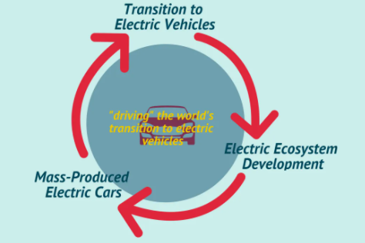
Figure 1: Vision and Mission of Tesla
(Source: Thomas and Maine, 2019)

Definition of communication
Communication in business is known as the process of shearing essential data or important information between the organisational stakeholders such as employees, managers, shareholders, clients etc. for maintaining the business operation. It has been observed that within an organisation transparent communication establishes a healthy relationship among the employees as well as the managers that improves productivity up to 25%. The purpose of communication in business is to improve business back to face and reduce errors (DiNardi and DiNardi, 2019). The important business communication lies in different factors such as presentation of new business ideas, successful sales, effective client meetings, executing business decisions, formation of business proposals and plans etc. Business communication has two types: internal business communication and external business communication. Internet business communications are upward communication, downward communication and Lateral communication. Upward communication refers to exchange of information from managers to organisational hierarchy. Downwards communication is known as managerial communication that directly comes from supervisor to a subordinate (Chen et al., 2020). Lateral communication is cross departmental communication between the coworkers. External business communication refers to the exchange of information between internal staff to an outsider person (Morgan, 2017). This type of communication involves vendor customers, clients and anything that impacts the brand. Business communication can be done through several ways such as telephone meetings, face to face communication, video conferencing, presentations, surveys, Customer Management activities, report or official documents, web based communication, digital media etc.

Communication model
Models of communication are known as conceptual models that are used to explain human communication processes. The communication process involves message, sender, media, receiver etc. There are several communication models available such as Aristotle's model, Lasswell's model, Shannon Weaver model, and Barlow's S-M-C-R model. However, this study uses Shannon Weaver model as required model for describe communication human communication within company.
Shannon Weaver model
Shannon Weaver model of communication is considered as mother of all human communication models. According to Teixeira et al. (2017) it is a mathematical theory which is considered to linear communication model because of one way communication and this model is also known as information theory. This model deal with the concept of information source, transmitter, noise, channel, message, encode and decode.
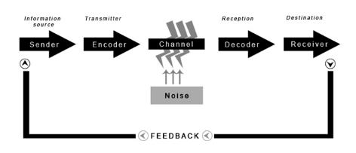
Figure 2: Shannon Weaver’s model of communication
(Source: Created by learner)
Implementation of this model of communication is beneficial for company because it is one of simplest model that can be applied in various communication theories. Along with this model is based on sender and receiver in which sender play a primary role and receiver play the secondary role. In addition to this implementation of this model is beneficial for the company because it helps in solving various problem of human communication.

Definition of Integrated Marketing Communications (IMC)
Integrated Marketing Communication (IMC) is considered as a business strategy that takes the marketing department from a desperate function to an interconnected approach. It is beneficial for an organisation as it considers various marketing Collateral and channels starting from digital to social media PR and direct mail. In another word, IMC can be defined as a business process that is utilised by the marketer in the marketing communication elements as public relation, business development principles, direct marketing, brand identity and social media advertising to build brand identity make a constant position across distinct media channels (Grace, 2018). Application of Integrated marketing communication in a private and public organisation and businesses to deliver a seamless and engaging customer experience on their products and services that build organisational image as well as relationship with stakeholders. Marketers of organisations apply IMC with an integrated marketing plan to describe different types of marketing Search Engine Optimisation (SEO) tactics, brand advertisement in different media. Traditional communication marketing used to be done through magazines, billboards and newspapers. Through IMC, marketers nowadays use a combination of traditional digital communication to target their potential audience and build a strong relationship. It can be said that the IMC process is crucial for a company as it ensures the message passed by marketers is consistent and incredible across all the communication channels (Hooley et al, 2020). In addition, the process is cost-effective and time consuming which is reducing organisational expenses and enhancing productivity (Gilkerson et al., 2019).

Promotional strategies used by Tesla to raise awareness of the brand
Tesla is the largest automobile and Technology organisation all over the world and independent automakers which of the organisation aims to provide affordable electric cars to average consumers worldwide. The organisation has millions of customers who are increasing productivity as well as brand image. The marketing and promotional strategies that can be used by Tesla, for raising their brand awareness can be enlisted as follows:
Content marketing- Content marketing refers to spreading information regarding the product to the customers, through immersive marketing contents (Brand, 2021). Tesla aims to reach out to its customers through immersive advertisements, wherein the company can utilize technologies like 3D mapping of the objects, to help the customers gain a 360-degree view of the cars, along with all the amenities and accessories within the car, to get the real feel of driving a Tesla model. Apart from this, podcasts and blogposts regarding the cars can be prepared by the content writers employed within the company as well as by the loyal customers, regarding the experience of driving the cars or the unique features hosted by the cars, to help the customers gain complete understanding of the same and thus, get attracted towards purchasing the same.
Digital media marketing- Pop-up advertisements over the digital media platforms as well as those in between video games and others can also be used as an effective strategy for reaching out to the prospective customers (Christina et al., 2019). Most of the customers preferring to drive Tesla belongs to the youth or the millennial population and thus, avails digital media for reviewing products and for decision-making for purchases. They also tend to play games online and thus, pop-up ads within the video games could serve as effective means of showcasing the features of the cars and thus, marketing the same.
Event sponsoring and influencer marketing- This is another way to reach out to the customers in which Tesla can opt for celebrity endorsements, sponsoring major events as are popular within the youth and millennial population and contacting influencers over social media platforms like Facebook and Instagram, for spreading word regarding he products being offered by Tesla, the level of comfort offered by the products, the quality of the services, the benefits that can be accrued by the customers and similar such attributes. Sponsoring the events would help in increasing the transparency of the brand amongst the global customers and thus, facilitates raising awareness of the brand in numerous developing and developed markets at the same time (Osei-Frimpong et al., 2019).
Arranging for customer loyalty programs- Apart from these initiatives, Tesla can also arrange for organizing customer loyalty programs, wherein they can offer their loyal customers with lucrative offers and recognize the support the customers have given to the company, thus, allowing the prospective customers to feel the urge of joining the lineage of loyal customers of Tesla. The after-sales services offered to the customers as well as the surveys conducted to understand the expectations of the customers and improvising the models according to the same could also act as a measure for increasing brand awareness in the market, amongst the customers, for Tesla (Raut et al., 2019).

Definition of branding and brand equity
Brand equity basically refers to the brand value. In marketing terms, brand equity refers to the level of sway of a brand name in the mind of consumers. Every organisation established brand equity by forming positive experiences of customers to make them engage with the company for the long run. Moreover, it increases customer engagement by creating competition over the other companies who deliver the same products (Theurer et al., 2018). It is done by a company by generating an awareness campaign that focuses on target customer values delivering promises and quality products. Moreover, it can be said that brand equity establishes loyalty among the customers and is known as retention efforts. Brand equity has two key components: awareness and experience.
- Brand awareness- An Organisation needs to be focused on imagery and messaging cohesively so that customers can easily identify the band. Focusing on customer value is one of the important aspects to maintain brand awareness (Tansel, 2015).
- Brand experience- Brand experience is concentrated on how the product has performed. Quality of products and customer service create brand experience towards the customers. It can be improved by several loyalty programs.
The key benefit of creating positive brand equity is it has control on ROI. If an organisation has leverage power on their brand, the firm can earn huge profits from the market in comparison to the competitors. Positive brand equity enables the company to switch to the price premium. At the same time, providing customers’ values is important as it generates trust towards the brand if the qualities of the products are premium. Thus, consumers will pay a higher amount for their purchase which will accelerate the organisational growth along with productivity.

Keller’s Brand Equity model
Keller's brand equity model is called customer based brand equity model. New model has been introduced by the marketing professor at Truck School Business. This model is concentrated on brand equity. As per the model statement strong brand image can be created by shaping customer perception are their feelings about the products. The model is divided into four steps which are described below:

““Satisfaction is a rating. Loyalty is a brand.” – Shep Hyken
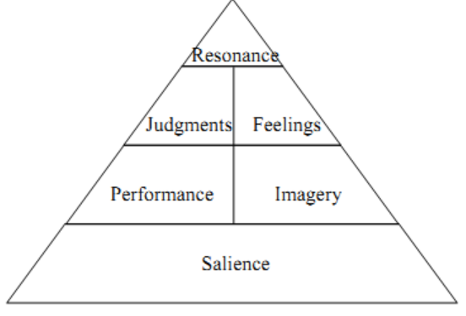
Fig 3: Keller’s Brand Equity Model
(Source: Farjam and Hongyi, 2015)
Step1: brand identity- in the first tape the organisation needs to create brand awareness and its position so that the customer can easily recognise the company. Market research is important for Tesla to understand their potential customers or audiences who can improve productivity and help in gaining brand awareness (Keaton, 2019). Moreover, the organisation needs to identify customer choices between Tesla and other brands by which the marketers can take strong marketing decisions in classifying the product which will differ from other companies. The existing brand positioning strategy that Tesla utilizes is the high-quality high-price strategy. The products are offered at high prices, so the target customers are usually the ones in the elite class, or the high-middle class and premium pricing strategy is utilized by the organization. The quality of the finished cars is also maintained at a premium level, to ensure full satisfaction of the customers.
Step 2: Brand meaning- In the second step taken to identify the brand meaning and its position by two elements: performance and imagery. Performance defines the effectiveness of a product in meeting customer needs and requirements. As per the model performance includes four categories:
- Primary characteristics and features
- Service effectiveness, efficiency and empathy.
- Product durability, reliability and serviceability.
- Product price.
- Product style and design
Imagery refers to how the brand Tesla has met the customer's needs and demands on physiological and social level.
Step 3: Brand response- The response of customers towards brand falls into two categories: judgments and feelings. In the case of Tesla customers’ judgment depends on four categories: quality, Credibility, consideration and Superiority. Tesla always focuses on their customer and provides them with the best quality products by analysing customer demands and feelings. As per the model, there are 6 positive brand feelings that customer experience: warmth, security, excitement, fun, self-respect and social approval.
Step 4: Brand resonance- Brand resonance has a place on the top of the brand equity pyramid as it is the most difficult and desirable level to reach. Tesla can achieve brand resonance when their customers feel a physiological bond with the brand. The reason has four categories: behaviour loyalty, attitudinal attachment, sense of community and active engagement. Behaviour loyalty includes regular and repeat purchase. Active engagement refers to the online chats, participation in brand campaigns and other events, following on social media etc.
The advantages of Keller’s Brand Equity model can be enlisted as follows:
- It helps in establishing sustainable customer loyalty, through brand equity- Brand equity results in increased preference of the products amongst the customers, owing to improved brand presence and awareness, resulting in customer loyalty.
- The model also fosters less cost allocation on customer retention- The model focuses on delivering a better experience to the customers, catering to all their needs and since their needs are prioritized, so customers are automatically retained, without the need of implementing any other customer retention strategies (Farjam and Hongyi, 2015).
- Better profit margins are also stimulated through the utilization of brand equity, according to this model- Since less is spent on customer retention strategies and the brand presence stimulates more spread of word-of-mouth and thus, better sales owing to the marketing, so the profit margins of the company increase resultantly.
The disadvantages of Keller’s Brand Equity model can be enlisted as follows:
- Resonation with customers in a market which is overloaded with information, becomes difficult, since there are lots of information available, which confuses the customers and might affect their purchase intentions adversely, thus, resulting in loss for the companies.
- Very talented team of staff including PR members are required by the company for maintaining brand equity vide this model, which brings in more financial liabilities for the company. Aligning the brand equity with the vision, mission and strategic objectives of the company also becomes difficult often and thus a liability for the organizations utilizing the model (Vasileva and Vasileva, 2017).

The customer journey and customer touch points for Tesla
Customer experience mapping is a business process of discovering how the potential customers and new users are feeling about the brand and their products. Tesla provides the positive customer experience which is holistic as well as practically seamless. The organisation is critically focused on customer service and turning their experience into a positive result. Customer touch point can be easily determined with the help of customer journey. According to Stein and Ramaseshan (2016) customer touch point is any phase where customer directly or indirectly contacts the management. The marketers need to understand and develop customer touch point to grow their business in short duration of time. Implementation of customer touch point can vary from company to company. However, the most in case touch point can be implemented in 3 stages pre- purchase, purchase and post purchase. In case of Tesla as well touch point of customer is completed in 3 stages. The detail of each stage along with their visual representation is given below
Pre purchase
Pre purchase of company is generally completed with the help of social media, referrals and company event. According to report Tesla has invested $0 in their conventional method to connecting to customers before purchasing of car while their competitor such as BMW and Audi have investing around $195 million per year (Light, 2021). Thus, it can be evident that Tesla connects to their target audience in pre purchase session through word of mouth and referral that encourage doing selling for them.

Figure 4: Pre purchase touch point of Tesla
Purchase
The next important phase of conducting business is purchasing and company need to get strongly connected with their customers in this phase of sales of product or service (Kotler et al, 2020). In the context of Tesla touch point that create benefit to the company include discussing the product performance, product assortment and point of purchase display. Adapting product assortment and product performance as the touch point capture the attention of target audience. Similarly adapting of discussing the product performance act as good touch point for company because it is converting leads into sell.

Figure 5: Purchase touch point of Tesla
Post purchase
In case of tesla post purchase touch point include customer services, 24*7 online technical online service and billing. These touch point help Company by connecting customer at end of the business. Moreover, touch point of this stage act as touch point of pre-purchase for other customers.

“Customer service is the new marketing, it’s what differentiates one business from another.” – Jay Baer



Figure 6: Post Purchase touch point of Tesla
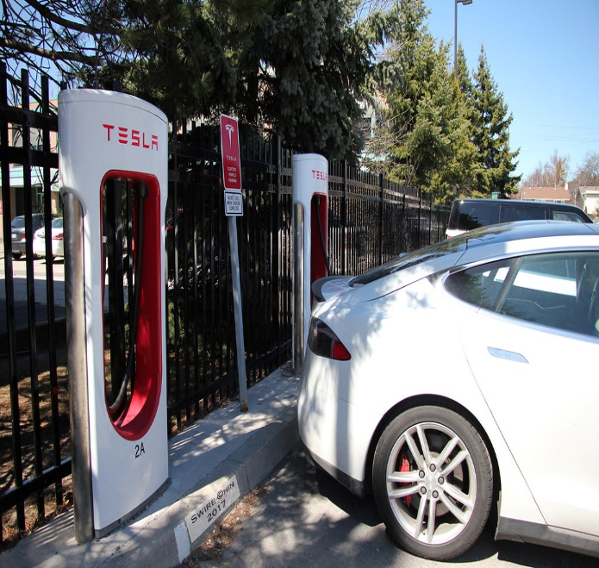
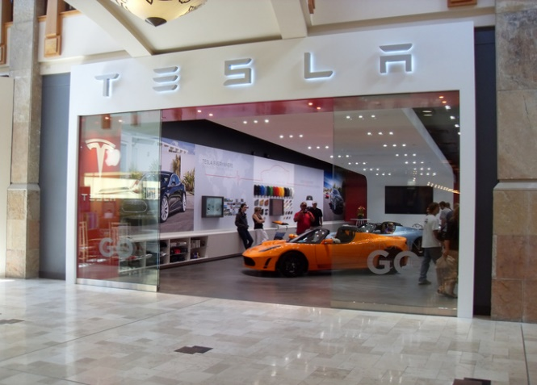

Selection of target audience
Awareness
Consideration
Purchase
Customer service, resulting in retention and advocacy
Carries out
market
research
Determines
Strategies for
effectively reaching
out to customers
Advertisements on social media
Newspapers, other marketing initiatives by Tesla
Customers check on websites for product details
Checks on social media as well as
website for pricing and features
Customers checks reviews of existing customers
Visits Stores
Website and social media page acts as touchpoint
Online and offline-stores acts as touchpoints
Free servicing
Effective grievance redressal
Websites, email ids registered with the company,
social media pages act as touchpoints between
customers and Tesla
Fig 7: Customer journey map of Tesla, with touchpoints

The different stages in the customer journey includes selection of the target audience, which includes identifying the target audience, understanding their demand and planning the product as well as promotional strategies likewise. In the second stage, which is the creation of awareness, the customers are made aware regarding the product through the promotional strategies like newspaper advertisements, social media advertisements and others. The customers touchpoints of website, social media page and others, as implemented by Tesla, are utilized in this stage. The third stage in the consideration, wherein the impact of the marketing initiatives of the company plays a role. The customers consider buying the product depending on the creativity and reachability of the products as well as considering the reviews of the existing customers. The social media and digital media fan pages act as the touchpoint for Tesla in this case. The fourth stage is the purchase, wherein the customers purchase the products from store and thus, online as well as offline stores acts as the touchpoint. The last stage is the customer service, wherein after-sales services are provided to the customers of Tesla, like offering free services, checking up on any problems being faced by the customers and similar such initiatives. The phones as well as company websites and social media pages plays the role of touchpoints for the customers of Tesla in this stage.
Selection of target audience is carried out by Tesla through studying the market and the likely referrals carried out by the existing customers. The information for creating awareness amongst the prospective customers is relayed through utilizing social media as well as word-of-mouth of the existing customers. The awareness generates demand and later the product features are described, along with product assortment, which leads to consideration by the target customers for purchasing the product. The point of purchase display is the last touchpoint that the customer avails before the purchase. The billing procedure, technical support and customer loyalty programs are all after-sales services offered to the customers, for generating customer loyalty, so that the referrals and word-of-mouth continues, and the sales figure is maintained appropriately.

Recommendation for new touch point
On evaluation of market status and business condition of Tesla it can be evident adding few touch point at every stage can be beneficial for company. For example, rating and review can be recommended as additional touch point for Tesla in pre purchase of tesla. Similarly, it is recommended that adding catalog can act as good touch point for tesla as it increases attraction toward product. In addition to this marketing mail and phone call can be recommend as touch point that increase business.
Adding the touch point may not be useful from every perspective as it required additional investment and planning. To minimize the weakness, it is necessary to conduct proper monitoring and evaluation of each activity. In addition to this weakness can be minimized by proceeding designed plan in presence of experts.

The Total Engagement Model
The total engagement model is critically focused on linking 4 key elements: customer value proposition, brand advertisement, culture and customer experience. Within Tesla, these elements can be observed which are providing individual benefits and are well documented.
- Customer value proposition refers to the value that is offered to the customer by the organisation. Tesla provides high value to their customers which are increasing customer base towards the company and the purchase rate in comparison to the competitors.
- Brand advertising refers to the sum of the whole brand position for Tesla, including name and logo. Effective brand advertisement within the company is strengthening the communication with their customers and increasing brand awareness (Ian, 2018).
- Culture refers to the organisational activities and representation of internal aspects within Tesla such as value, internet behaviour and goals. The culture of the company has been designed in an effective way which encourages their staff in delivering high quality customer experience as well as brand value proposition.
- Customer experience is considered as a combination of emotional and physical elements which affect their experience throughout the journey (Gao et al., 2018). Tesco maintains communication with their customers and interacts with them in a continuous way to understand their issues and resolve those immediately.

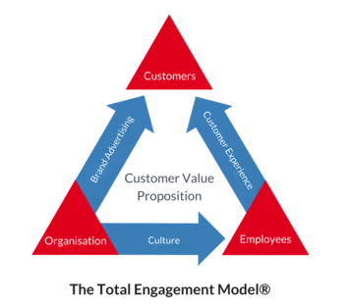
Fig 8: The Total Engagement Model
(Source: Gao et al., 2018)

Conclusion
The following report has evaluated integrated communication within Tesla by application of the communication model. Different strategies of promotion in Tesla have been identified to maintain its brand recognition. Branding and then equality has been described through Keller's brand equity models. Customer journey and touch point of Tesla has been evaluated through the total engagement model.

References
Bhasin, H. (2019). Marketing Strategy of Tesla. [Online] Marketing91. Available at: <https://www.marketing91.com/marketing-strategy-of-tesla/> (Accessed: 28 October 2021).

Bhasin, H. (2021). All the Communication Models in Businesses Explained. [online] Marketing91. Available at: <https://www.marketing91.com/communication-model/> (Accessed: 28 October 2021).

Chen, R.R. Davison, R.M. and Ou, C.X., (2020). A symbolic interactionism perspective of using social media for personal and business communication. International Journal of Information Management, 51, p.102022.

DiNardi, G. and DiNardi, G., (2019). What is Business Communication? Why Do You Need It? [online] Nextiva Blog. Available at: <https://www.nextiva.com/blog/what-is-business-communication.html> (Accessed:28 October 2021).

EFFY, P. (2020). Tesla’s Marketing Strategy: What Your Company Can Learn | SB. [online] Startingbusiness.com. Available at: <https://www.startingbusiness.com/blog/marketing-strategy-tesla> (Accessed: 28 October 2021).

Gao, N., Xie, T. and Liu, G. (2018), December. A learning engagement model of educational games based on virtual reality. In 2018 International Joint Conference on Information, Media, and Engineering (ICIME) (pp. 1-5). IEEE.

Garabinovic, D. and Papic, M. (2018). Analysis of attitudes about the use of information technologies and Internet marketing within different promotional strategies. Successful implementation of information technology: IT, marketing, education, and business working together for business success, 14, pp.51-82.

Gilkerson, N.D. Swenson, R. and Likely, F. (2019). Maturity as a way forward for improving organizations’ communication evaluation and measurement practices: A definition and concept explication. Journal of Communication Management.

Gilson, S.C. and Abbott, S. (2017). Tesla Motors (A): Financing Growth. Harvard Business School case study (218-033).

Grace, P. (2018). What is IMC? A Beginner's Guide to Integrated Marketing Communications. [online] Available at: <https://www.g2.com/articles/integrated-marketing-communications> (Accessed:28 October 2021).

Ian, L., (2018). Tesla delivers high voltage customer experience | Customer Gauge. [online] Customer Gauge. Available at: <https://customergauge.com/blog/tesla-delivers-high-voltage-customer-experience> (Accessed:28 October 2021).

Hooley, G. et al. (2020) Marketing strategy and competitive positioning 7th ed. Harlow: Person.

Keaton, H. (2019). Keller’s Brand Equity Model — What It Is & How to Use It. [online] Medium. Available at: <https://medium.com/@keatonhawker/kellers-brand-equity-model-what-it-is-how-to-use-it-84e42d562299> (Accessed: 28 October 2021)
Kotler, P. et al. (2020) Principles of marketing. 8th ed. Harlow: Pearson.

Light, L. (2021). The Natural: Elon Musk’s Non-Traditional Approach to Tesla Advertising. [online] Forbes. Available at: <https://www.forbes.com/sites/larrylight/2020/06/01/the-natural-elon-musks-non-traditional-approach-to-tesla-advertising/?sh=6ae853a4512a> (Accessed: 1 November 2021).

Morgan, P. (2017). Business student's guide to study and employability. London: Sage Publications Ltd.

Piyali, S. (2021). Communication Models (With Diagram) | Business Communication. [online] Your Article Library. Available at: <https://www.yourarticlelibrary.com/business-communication/communication-models-with-diagram-business-communication/70134> (Accessed: 25 November 2021).

Stein, A. and Ramaseshan, B. (2016). Towards the identification of customer experience touch point elements. Journal of Retailing and Consumer Services, 30, pp.8-19.

Tansel, A. (2015). Analysis of Tesla Motors’ Marketing Communications Strategy. [online] Grin.com. Available at: <https://www.grin.com/document/341486> (Accessed: 28 October 2021).

Teixeira, M.M. de Souza, J.V. Homenick, D.B.D. da Silva Medeiros, E. dos Santos, H.P.B. da Silva, F.A.L. dos Santos, A.S. de Morais, C.A. da Silva, L.U. Ribeiro, G.J.M. and Lima, T.F.V. (2017) From mathematical model of communication to the communication model of virtual universe. In 2017 12th Iberian Conference on Information Systems and Technologies (CISTI) (pp. 1-8). IEEE.

Theurer, C.P. Tumasjan, A. Welpe, I.M. and Lievens, F. (2018). Employer branding: a brand equity‐based literature review and research agenda. International Journal of Management Reviews, 20(1), pp.155-179.

Thomas, V.J. and Maine, E. (2019). Market entry strategies for electric vehicle start-ups in the automotive industry–Lessons from Tesla Motors. Journal of Cleaner Production, 235, pp.653-663.

Vasileva, I.V. and Vasileva, T.N. (2017). KELLER''S BRAND EQUITY MODEL. Modern Science, (6-1), pp.93-98.

"When something is important enough, you do it even if the odds are not in your favour."
Elon Musk CEO and Product Architect of Tesla

