5/15/2023
Kelly Casey (2106451)

HTML & CSS Web Development
ACCA4023

Contents
Introduction 3
Requirements 4
Implementation 4
Home screen 4
About screen 5
Hogwarts screen 6
Characters screen 7
7
Places page 8
J.K.Rowling page 9
Validation 10
HTML 10
CSS 10
Evaluation 11
Usability 11
Accessibility 11
Search engine optimisation 12
Evaluation on the Harry Potter website 12
Functionality 12
Usability 12
Content 13
SEO 13
Accessibility 13
1. Perceivable 13
2. Operable 13
3. Understandable 14
4. Robust 14
Bibliography 15
Appendices 16
Index 16
About 17
Books 18
Hogwarts 21
Characters 25
Places 30
J.K.Rowling 36

Introduction
This report is going to provide a summary of a web development project. The web development project is going to include the creation of multiple pages about the chosen subject of Harry Potter.
The report if going to be divided into several sections, this introduction section will provide a summary of the report. The requirement section will then also provide the reason for the report, the subject that was chosen and who the website is aimed at.
Then there will be an implementation section which will include screen shots of all the web pages as well as showing validation of the code.
The next section of the report is about the usability, accessibility, and search engine optimization of the website. It will also provide review of the website to show what can be improved in the future.

Requirements
The website has been based on Harry Potter which was created by J.K.Rowling. The website serves as a resource to fans which provides information related the Harry Potter universe.
The purpose of the website is to celebrate and explore the word of Harry Potter, providing visitors with information about Harry Potter, the books, the characters, magical places and about the author J.K.Rowling.
The target audience for the website is if for a wide range of ages of Harry Potter fans. It caters not online to long-time fans who have followed the series from the beginning but also new fans who are eager to explore and learn more about Harry Potter.
Overall, the Harry Potter Website is a platform for Harry Potter enthusiasts offering information about the beloved books and their creator.

Implementation

Home screen
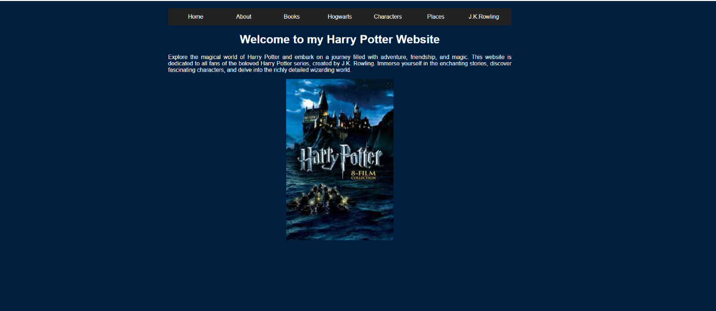

About screen
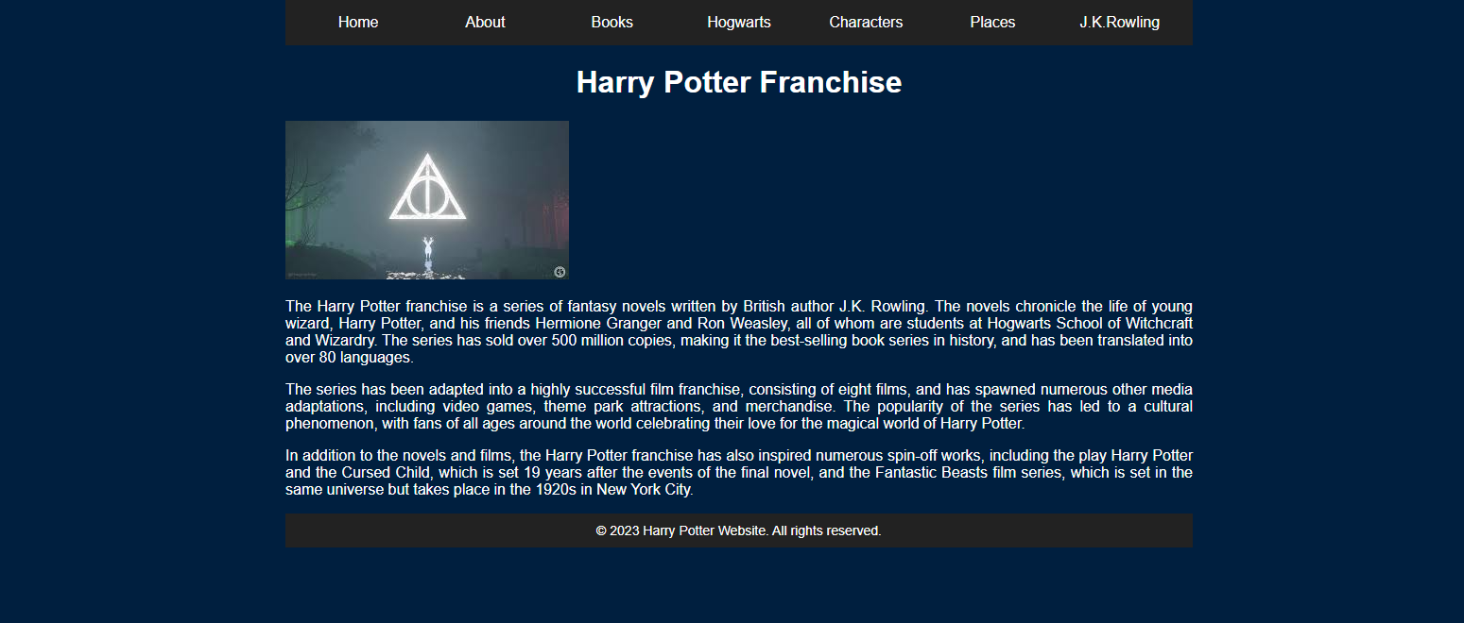Book screen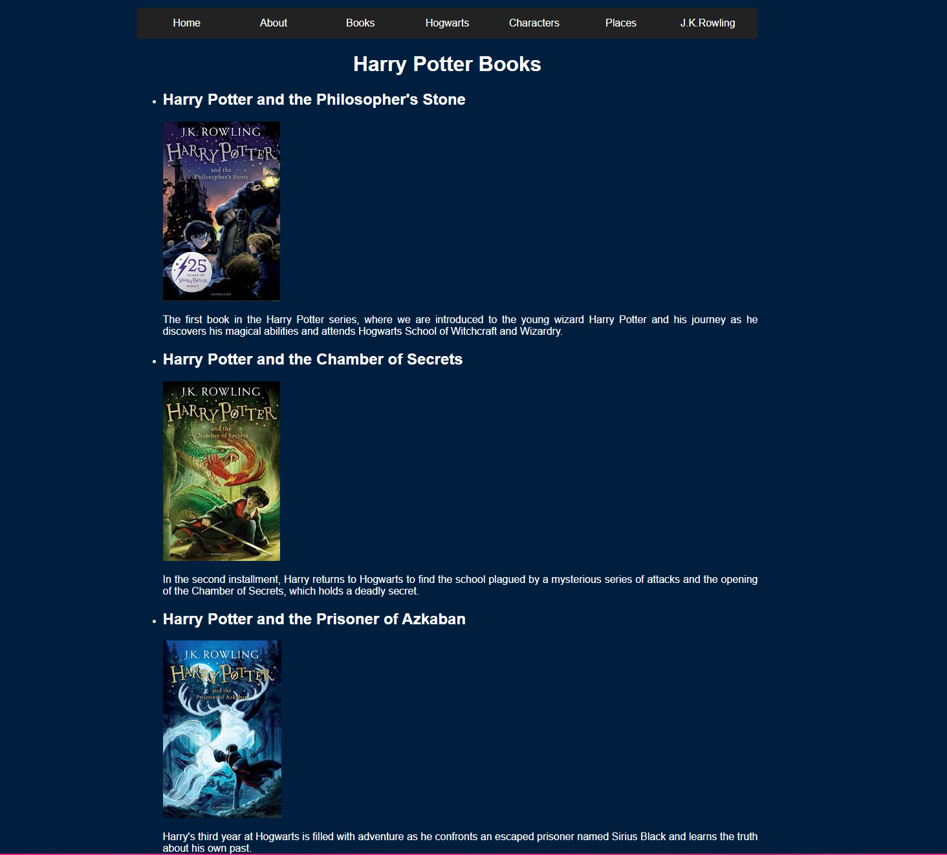

Hogwarts screen
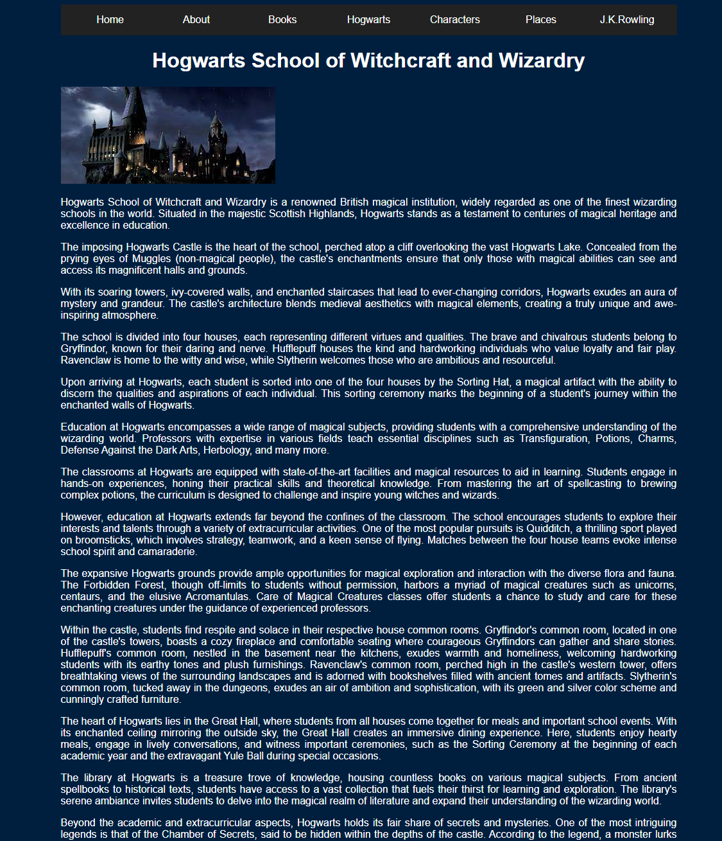

Characters screen

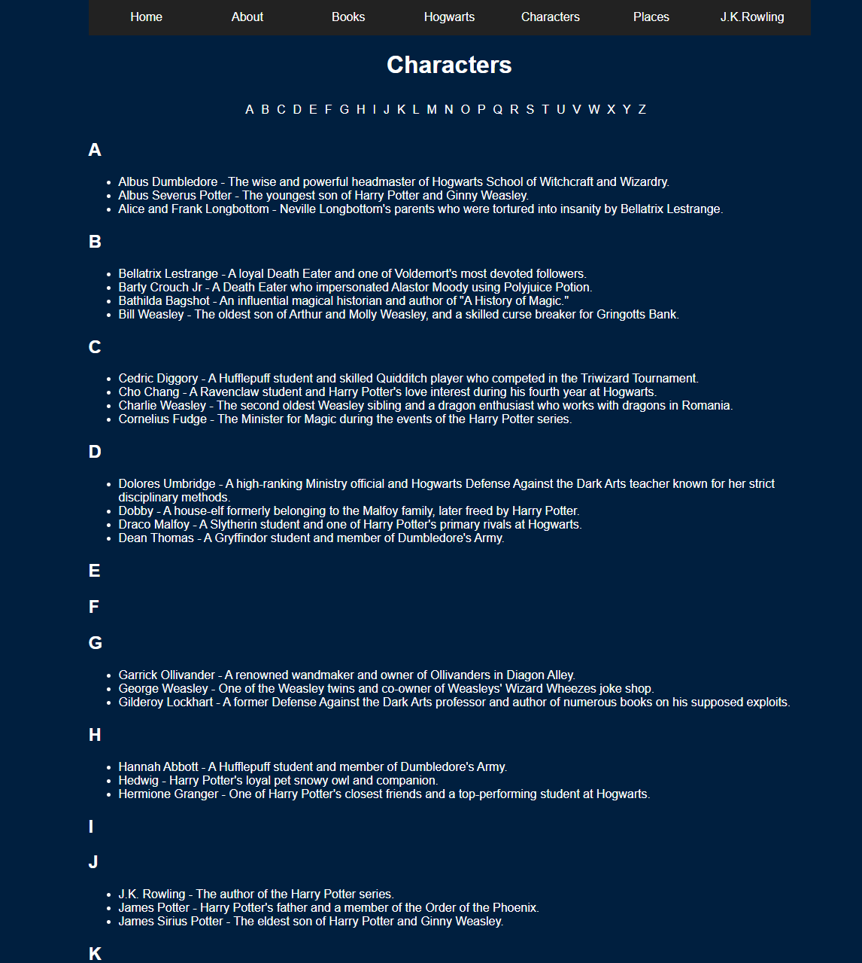

Places page
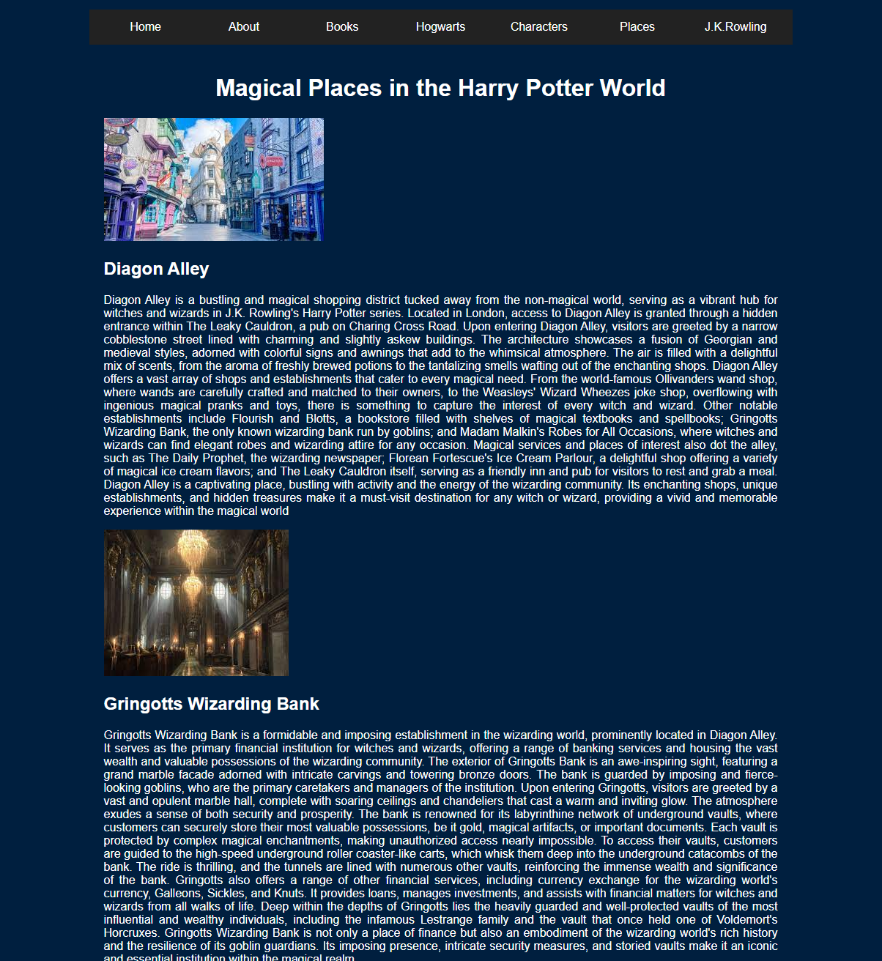

J.K.Rowling page
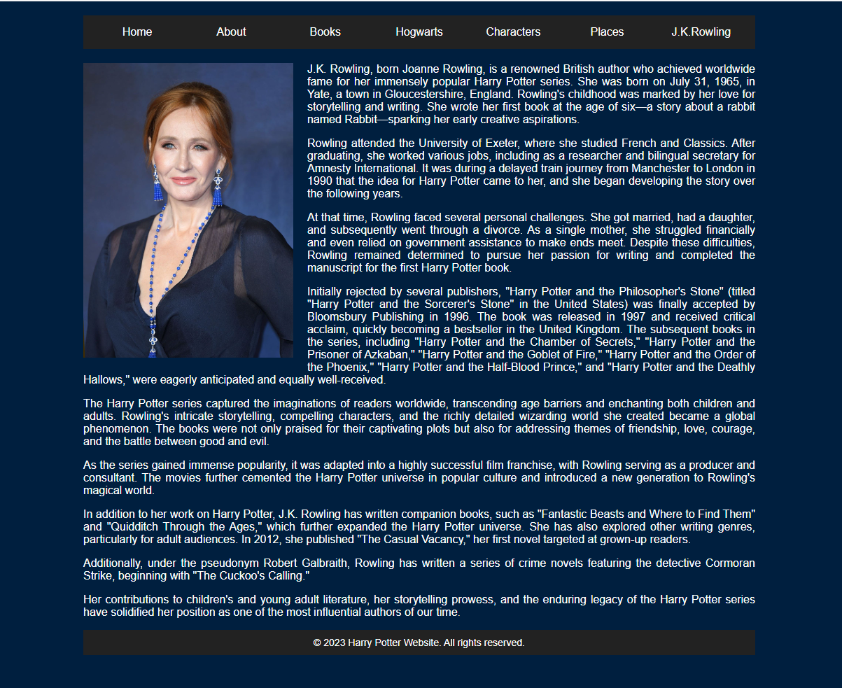

Validation
Validating the HTML and CSS code is essential part of web development, identifies errors and helps improve accessibility. It promotes high quality web development practices and provides a better user experience across devices and browsers.

HTML
Firstly, the index page was validated using W3C Markup Validation service which shooed an error of “the character encoding was not declared. Proceeding using windows-1252. To rectify the error a <meta> tag with the ‘charset’ attribute was then added to the <head> section. Doing this specifies the character encoding for the document.
The validation also showed a warning saying to “consider adding a lang attribute to the HTML start tag to declare the language of this document” which was then again rectified by adding lang to the top of the page next to the HTML.
Lasting on the index page there was an info stating, “trailing slash on void elements had no effect and interacts badly with the unquoted attribute values”, this was revolved by simply removing the slash.
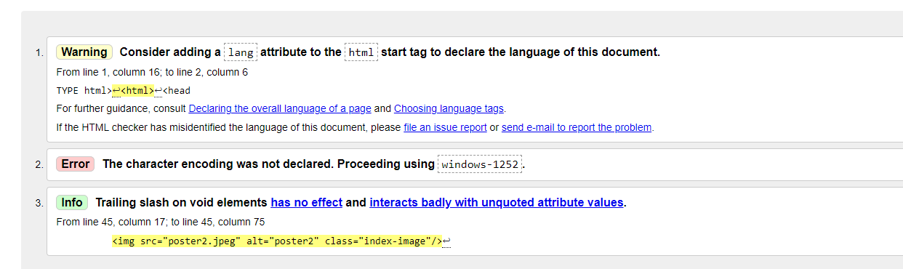

CSS
The CSS code was validated by using the W3C CSS Validation Service. The validation then showed up no errors.


Evaluation

Usability
Usability in web development is an important part of creating websites. It is important for the website to be user friendly and intuitive. It involves creating interfaces that let users easily navigated and understand the web content.
Essential elements of usability are simplicity, consistency, and clarity. Websites need to have clear navigation structures, intuitive layouts as well as organized content. Using the same design on buttons and menus and extremely helping in helping users navigate the website.
Developers need to make responsive design a priority which will allow the website to adapt effortless to different devices and screens sizes. Also making the loading times fast and efficient is essential to stop the user from becoming frustrated and therefore leaving the webpage.
Testing the usability plays an important role in the web development process. By conducting research and getting feedback from the target audience will help identify any areas that need improvement.
In conclusion, usability is an important factor in successful web development, by focusing on simplicity, consistency, and clarity you can create a website that is easy to use. Through testing and continuous improvement websites can be continually fined tuned to meet the expectation of the targeted users. [1]

Accessibility
Web accessibility in web development is an important part of creating websites that allow inclusivity and equal access for users with disabilities. It involves creating websites that can be used fully by a range of users regardless of their abilities.
The be able to provide web accessibility designers need to consider several factors such as providing alternative text for images which will allow users with visual impairments to understand the content with screen readers. Captions and transcripts for media content to allow those with hearing impairments to access the information.
Another essential feature is keyboard navigation with will allow users who cannot use a mouse navigate the web page. Using the same design, language will enhance the understanding for all users not just those with any disabilities.
Web accessibility is also a legal requirement. Laws such as “American with disabilities act” guidelines like the “web content accessibility guidelines” stress the importance of inclusive design.
In conclusion, web accessibility is a crucial in making sure websites are accessible and usable by everyone, regardless of any ability. By making accessibility a priority web developers can make a more inclusive digital environment. [2]

Search engine optimisation
Search engine optimisation is an important practice in web development. It involves numerous strategies which are aimed at improving websites visibility and organic search rankings.
One of the important aspects of SEO is keyword research, which helps by identifying the relevant search words and phrases that are likely to be used by the desired audience when they are searching for information. By adding these words into the website, meta tags, headings, and URLs, can help improve the websites chances of ranking higher in search results.
Technical is another important aspect of SEO, it works by making sure the websites performance is mobile friendly, web friendly, site speed and making sure the proper indexing by search engines.
By gaining high quality backlinks from websites web developers can signal to search engines that their website is trustworthy and relevant,
SEO is always evolving as search engines continuously update their algorithms to make sure the most relevant information to users. Staying up to date with SEO trends is extremely important for improving search visibility.
In conclusion, SEO is a multifaced practice which aims to optimize websites for search engines by using effective keywords and prioritizing user experience.[3]

Evaluation on the Harry Potter website

Functionality
The Harry Potter Website shows a strong functionality in fulfilling its purpose of providing information to Harry Potter fans, it shows a range of pages including a home page, about page, a page about all the books, a page about many of the main characters, a page about magical places, a Hogwarts page which although is a magical place, it deserved its own stand alone page and finally a page about the author J.K.Rowling. All these pages cover all essential aspects of the Harry Potter universe, such as, relevant content and details.
However an improvement in the future is would make the website better if it had interactive features such as, quizzes to further engage visitors experience.

Usability
The website has a clean and visually appealing design, the layout is structured that as well as having the menu on every page makes it easy for users to navigate the site. It has a responsive design making the website accessible on different devices.
Again, to approve in the future it would help to enhance the visual consistency throughout the website, ensuring consistency in the typography, spaces and paragraphs on all pages, making it more polished.

Content
The content on the website is informative and engaging, the pages offer detailed descriptions of J.K Rowlings, Hogwarts and of key elements as well as relevant images. However, going forward there needs to be more content, the characters page could be filled with all characters, more places added as well as more information about the whole Harry Potter Universe. Also adding more media content such as videos, would provide a better and more inclusive feel the site.

SEO
- Keyword Optimization - relevant key words and phases related to Harry Potter are used throughout the website.
- Clean URL Structure – the websites URLs have been made to be descriptive and user friendly. For example, the “Hogwarts” page is “Hogwarts.html”. all other pages are named similarly.
- Meta Descriptions – meta descriptions have been added to all pages to provide concise summaries of their content.
- Relevant page titles – Each page of the website has its own descriptive title and represents the content. For example, the “Books” page title is “Harry Potter Books”.
- Image Optimization - each image on the website has an appropriate tag that describes the image, which will help the search engines understand the visual elements of the page. For example, the tag for the image of J.K.Rowling is “portrait of J.K.Rowling”
- Internal linking – the website uses internal linking by providing hyper links within the content which will connect to different pages or places on the page. For example, on the characters page there is the alphabet and when you click on any of the letters it will take you to the part of the page where all the characters name which starts with said letter will be.

Accessibility
The four main principles outlined on the Web Content Accessibility Guidelines are Perceivable, Operable, Understandable and Robust. The Harry Potter website has been evaluated by all 4.

Perceivable
- All images on the website have appropriate alt tags which provides text alternatives for users who cannot see images.
- the colour contrast between the text and background meets the WCAG requirements.

Operable
- The website has a consistent navigation structure on all pages.
- The website is fully navigational using only a keyboard.
- All links have visible focus indicators.

Understandable
- The website uses clear and concise language making easily readable.
- The websites content is organized using appropriate heading tags which facilitates comprehension.

Robust
- The website is compatible with many assistive technologies.
- The HTML code has been validated ensuring it meets web standards.

Bibliography
[1] “Website usability,” Balanced Website Design, pp. 37–58, 2007. doi:10.1007/978-1-84628-795-4_3
[2] P. Brophy and J. Craven, “Web Accessibility,” Library trends, vol. 55, no. 4, pp. 950–972, 2007, doi: 10.1353/lib.2007.0029.
[3] S. Schultheiß and D. Lewandowski, “Data set of a representative online survey on search engines with a focus on search engine optimization (SEO): a cross-sectional study [version 2; peer review: 2 approved],” F1000 research, vol. 11, pp. 376–376, 2022, doi: 10.12688/f1000research.109662.2.

Appendices

Index
<!DOCTYPE html>
<html lang="en">
<head>
<meta charset="UTF-8">
<title>My Website</title>
<link rel="stylesheet" href="styles.css">
</head>
<body>
<div class="container">
<header>
<nav class="menu">
<div class="menu-section">
<a class="menu-text" href="index.html">Home</a>
</div>
<div class="menu-section">
<a class="menu-text" href="about.html">About</a>
</div>
<div class="menu-section">
<a class="menu-text" href="books.html">Books</a>
</div>
<div class="menu-section">
<a class="menu-text" href="hogwarts.html">Hogwarts</a>
</div>
<div class="menu-section">
<a class="menu-text" href="characters.html">Characters</a>
</div>
<div class="menu-section">
<a class="menu-text" href="places.html">Places</a>
</div>
<div class="menu-section">
<a class="menu-text" href="jkrowling.html">J.K.Rowling</a>
</div>
</nav>
</header>

<main>
<div class="content">
<p>
Explore the magical world of Harry Potter and embark on a journey filled with adventure, friendship, and magic. This website is dedicated to all fans of the beloved Harry Potter series, created by J.K. Rowling. Immerse yourself in the enchanting stories, discover fascinating characters, and delve into the richly detailed wizarding world.
</p>
<p>

</p>
</div>
<div class="poster">
<img src="poster2.jpeg" alt="poster2" class="index-image">
</div>
</main>
</div>
</body>
</html>

About
<!DOCTYPE html>
<html>
<head>
<title>My Website</title>
<link rel="stylesheet" href="styles.css">
</head>
<body>
<div class="container">
<header>
<nav class="menu">
<div class="menu-section">
<a class="menu-text" href="index.html">Home</a>
</div>
<div class="menu-section">
<a class="menu-text" href="about.html">About</a>
</div>
<div class="menu-section">
<a class="menu-text" href="books.html">Books</a>
</div>
<div class="menu-section">
<a class="menu-text" href="hogwarts.html">Hogwarts</a>
</div>
<div class="menu-section">
<a class="menu-text" href="characters.html">Characters</a>
</div>
<div class="menu-section">
<a class="menu-text" href="places.html">Places</a>
</div>
<div class="menu-section">
<a class="menu-text" href="jkrowling.html">J.K.Rowling</a>
</div>
</nav>
</header>

title>Harry Potter Franchise</title>
<link rel="stylesheet" href="style.css" />
</head>
<body>
<header>
<h1>Harry Potter Franchise</h1>
</header>
<main>
<div class="image-container">
<img src="DHS.jpeg" alt="Harry Potter" />
</div>
<p>
The Harry Potter franchise is a series of fantasy novels written by British author J.K. Rowling. The novels chronicle the life of young wizard, Harry Potter, and his friends Hermione Granger and Ron Weasley, all of whom are students at Hogwarts School of Witchcraft and Wizardry. The series has sold over 500 million copies, making it the best-selling book series in history, and has been translated into over 80 languages.
</p>
<p>
The series has been adapted into a highly successful film franchise, consisting of eight films, and has spawned numerous other media adaptations, including video games, theme park attractions, and merchandise. The popularity of the series has led to a cultural phenomenon, with fans of all ages around the world celebrating their love for the magical world of Harry Potter.
</p>
<p>
In addition to the novels and films, the Harry Potter franchise has also inspired numerous spin-off works, including the play Harry Potter and the Cursed Child, which is set 19 years after the events of the final novel, and the Fantastic Beasts film series, which is set in the same universe but takes place in the 1920s in New York City.
</p>
</main>
</body>
</html>

<footer class="footer">
&copy; 2023 Harry Potter Website. All rights reserved.
</footer>
</div>
</body>
</html>

Books
<!DOCTYPE html>
<html>
<head>
<title>My Website - Books</title>
<link rel="stylesheet" href="styles.css">
</head>
<body>
<div class="container">
<header>
<nav class="menu">
<div class="menu-section">
<a class="menu-text" href="index.html">Home</a>
</div>
<div class="menu-section">
<a class="menu-text" href="about.html">About</a>
</div>
<div class="menu-section">
<a class="menu-text" href="books.html">Books</a>
</div>
<div class="menu-section">
<a class="menu-text" href="hogwarts.html">Hogwarts</a>
</div>
<div class="menu-section">
<a class="menu-text" href="characters.html">Characters</a>
</div>
<div class="menu-section">
<a class="menu-text" href="places.html">Places</a>
</div>
<div class="menu-section">
<a class="menu-text" href="jkrowling.html">J.K.Rowling</a>
</div>
</nav>
</header>

<h1>Harry Potter Books</h1>

<div class="content">
<ul class="book-list">
<li>
<h2>Harry Potter and the Philosopher's Stone</h2>
<img src="HPPS.jpeg" alt="Harry Potter and the Philosopher's Stone" class="book-image" />
<p>
The first book in the Harry Potter series, where we are introduced to the young wizard Harry Potter and his journey as he discovers his magical abilities and attends Hogwarts School of Witchcraft and Wizardry.
</p>
</li>
<li>
<h2>Harry Potter and the Chamber of Secrets</h2>
<img src="HPCS.jpeg" alt="Harry Potter and the Chamber of Secrets" class="book-image" />
<p>
In the second installment, Harry returns to Hogwarts to find the school plagued by a mysterious series of attacks and the opening of the Chamber of Secrets, which holds a deadly secret.
</p>
</li>
<li>
<h2>Harry Potter and the Prisoner of Azkaban</h2>
<img src="HPPA.jpeg" alt="Harry Potter and the Prisoner of Azkaban" class="book-image" />
<p>
Harry's third year at Hogwarts is filled with adventure as he confronts an escaped prisoner named Sirius Black and learns the truth about his own past.
</p>
</li>
<li>
<h2>Harry Potter and the Goblet of Fire</h2>
<img src="HPGF.jpeg" alt="Harry Potter and the Goblet of Fire" class="book-image" />
<p>
The fourth book brings forth the Triwizard Tournament, an exciting competition among the three magical schools, but dark forces are at play, putting Harry's life in danger once again.
</p>
</li>
<li>
<h2>Harry Potter and the Order of the Phoenix</h2>
<img src="HPOP.jpeg" alt="Harry Potter and the Order of the Phoenix" class="book-image" />
<p>
In the fifth book of the Harry Potter series, "Order of the Phoenix," Harry Potter returns to Hogwarts School of Witchcraft and Wizardry to confront a Ministry of Magic in denial about Lord Voldemort's return, while forming a secret organization, Dumbledore's Army, to resist the oppressive rule of the new Defense Against the Dark Arts professor, Dolores Umbridge.
</p>
</li>
<li>
<h2>Harry Potter and the Half-Blood Prince</h2>
<img src="HPHBP.jpeg" alt="Harry Potter and the Half-Blood Prince" class="book-image" />
<p> In the sixth book of the Harry Potter series, "Half-Blood Prince," Harry Potter delves deeper into Voldemort's past, unraveling secrets and gathering vital information with the guidance of Dumbledore. As Hogwarts prepares for the looming battle between good and evil, relationships are tested, dark forces rise, and Harry uncovers a shocking truth that changes everything.</p>
</li>
<li>
<h2>Harry Potter and the Deathly Hallows</h2>
<img src="HPDH.jpeg" alt="Harry Potter and the Deathly Hallows" class="book-image" />
<p>In the seventh book of the Harry Potter series, "Half-Blood Prince," serves as a prelude to the epic final installment. As Harry, Ron, and Hermione embark on a dangerous quest to find and destroy Voldemort's Horcruxes, they face numerous challenges, loss, and sacrifices while the wizarding world descends into chaos and a climactic battle</p>
</div>

<footer class="footer">
&copy; 2023 Harry Potter Website. All rights reserved.
</footer>
</div>
</body>
</html>

Hogwarts
<!DOCTYPE html>
<html>
<head>
<title>My Website</title>
<link rel="stylesheet" href="styles.css">
</head>
<body>
<div class="container">
<header>
<nav class="menu">
<div class="menu-section">
<a class="menu-text" href="index.html">Home</a>
</div>
<div class="menu-section">
<a class="menu-text" href="about.html">About</a>
</div>
<div class="menu-section">
<a class="menu-text" href="books.html">Books</a>
</div>
<div class="menu-section">
<a class="menu-text" href="hogwarts.html">Hogwarts</a>
</div>
<div class="menu-section">
<a class="menu-text" href="characters.html">Characters</a>
</div>
<div class="menu-section">
<a class="menu-text" href="places.html">Places</a>
</div>
<div class="menu-section">
<a class="menu-text" href="jkrowling.html">J.K.Rowling</a>
</div>
</nav>
</header>

<h1>Hogwarts School of Witchcraft and Wizardry</h1>

<div class="content">
<img src="hogs.jpeg" alt="Hogwarts School of Witchcraft and Wizardry" class="float-left" />

<p> <p>
Hogwarts School of Witchcraft and Wizardry is a renowned British magical institution, widely regarded as one of the finest wizarding schools in the world. Situated in the majestic Scottish Highlands, Hogwarts stands as a testament to centuries of magical heritage and excellence in education.
</p>
<p>
The imposing Hogwarts Castle is the heart of the school, perched atop a cliff overlooking the vast Hogwarts Lake. Concealed from the prying eyes of Muggles (non-magical people), the castle's enchantments ensure that only those with magical abilities can see and access its magnificent halls and grounds.
</p>
<p>
With its soaring towers, ivy-covered walls, and enchanted staircases that lead to ever-changing corridors, Hogwarts exudes an aura of mystery and grandeur. The castle's architecture blends medieval aesthetics with magical elements, creating a truly unique and awe-inspiring atmosphere.
</p>
<p>
The school is divided into four houses, each representing different virtues and qualities. The brave and chivalrous students belong to Gryffindor, known for their daring and nerve. Hufflepuff houses the kind and hardworking individuals who value loyalty and fair play. Ravenclaw is home to the witty and wise, while Slytherin welcomes those who are ambitious and resourceful.
</p>
<p>
Upon arriving at Hogwarts, each student is sorted into one of the four houses by the Sorting Hat, a magical artifact with the ability to discern the qualities and aspirations of each individual. This sorting ceremony marks the beginning of a student's journey within the enchanted walls of Hogwarts.
</p>
<p>
Education at Hogwarts encompasses a wide range of magical subjects, providing students with a comprehensive understanding of the wizarding world. Professors with expertise in various fields teach essential disciplines such as Transfiguration, Potions, Charms, Defense Against the Dark Arts, Herbology, and many more.
</p>
<p>
The classrooms at Hogwarts are equipped with state-of-the-art facilities and magical resources to aid in learning. Students engage in hands-on experiences, honing their practical skills and theoretical knowledge. From mastering the art of spellcasting to brewing complex potions, the curriculum is designed to challenge and inspire young witches and wizards.
</p>
<p>
However, education at Hogwarts extends far beyond the confines of the classroom. The school encourages students to explore their interests and talents through a variety of extracurricular activities. One of the most popular pursuits is Quidditch, a thrilling sport played on broomsticks, which involves strategy, teamwork, and a keen sense of flying. Matches between the four house teams evoke intense school spirit and camaraderie.
</p>
<p>
The expansive Hogwarts grounds provide ample opportunities for magical exploration and interaction with the diverse flora and fauna. The Forbidden Forest, though off-limits to students without permission, harbors a myriad of magical creatures such as unicorns, centaurs, and the elusive Acromantulas. Care of Magical Creatures classes offer students a chance to study and care for these enchanting creatures under the guidance of experienced professors.
</p>
<p> Within the castle, students find respite and solace in their respective house common rooms. Gryffindor's common room, located in one of the castle's towers, boasts a cozy fireplace and comfortable seating where courageous Gryffindors can gather and share stories. Hufflepuff's common room, nestled in the basement near the kitchens, exudes warmth and homeliness, welcoming hardworking students with its earthy tones and plush furnishings. Ravenclaw's common room, perched high in the castle's western tower, offers breathtaking views of the surrounding landscapes and is adorned with bookshelves filled with ancient tomes and artifacts. Slytherin's common room, tucked away in the dungeons, exudes an air of ambition and sophistication, with its green and silver color scheme and cunningly crafted furniture.</p>

</p>
<p>The heart of Hogwarts lies in the Great Hall, where students from all houses come together for meals and important school events. With its enchanted ceiling mirroring the outside sky, the Great Hall creates an immersive dining experience. Here, students enjoy hearty meals, engage in lively conversations, and witness important ceremonies, such as the Sorting Ceremony at the beginning of each academic year and the extravagant Yule Ball during special occasions. </p>

</p>
<p> The library at Hogwarts is a treasure trove of knowledge, housing countless books on various magical subjects. From ancient spellbooks to historical texts, students have access to a vast collection that fuels their thirst for learning and exploration. The library's serene ambiance invites students to delve into the magical realm of literature and expand their understanding of the wizarding world.</p>
</p>
<p> Beyond the academic and extracurricular aspects, Hogwarts holds its fair share of secrets and mysteries. One of the most intriguing legends is that of the Chamber of Secrets, said to be hidden within the depths of the castle. According to the legend, a monster lurks within the chamber, unleashed only by the heir of Slytherin. Exploring the castle's secret passageways and discovering hidden rooms becomes an adventure for curious students, with whispers of secret societies and magical artifacts adding to the allure.</p>
</p>
<p>Hogwarts is not just a school; it represents a sanctuary for young witches and wizards, a place where they can develop their magical abilities, forge lifelong friendships, and discover their true potential. The sense of community fostered within its walls creates lasting bonds that extend far beyond graduation. Many alumni have gone on to make significant contributions to the wizarding world, becoming esteemed Aurors, Potion Masters, influential researchers, and influential figures within the Ministry of Magic. </p>
</p>
<p>The spirit of Hogwarts lives on, even after students leave its hallowed halls. It serves as a symbol of hope and inspiration, a testament to the power of magic and the resilience of the human spirit. Hogwarts will forever hold a special place in the hearts of all who have had the privilege of calling it home, reminding them of the transformative journey they embarked upon and the magical legacy they carry with them throughout their lives. </p>
</p>
<p> As you can see, Hogwarts is not just a school but a world unto itself—a place of wonder, knowledge, friendship, and self-discovery. Its rich history, enchanting atmosphere, and vibrant community make it an iconic institution within the wizarding world.</p>
</div>
<footer class="footer">
&copy; 2023 Harry Potter Website. All rights reserved.
</footer>
</div>
</body>
</html>

Characters
<!DOCTYPE html>
<html>

<head>
<title>Characters</title>
<link rel="stylesheet" href="styles.css">
</head>

<body>
<div class="container">
<header>
<nav class="menu">
<div class="menu-section">
<a class="menu-text" href="index.html">Home</a>
</div>
<div class="menu-section">
<a class="menu-text" href="about.html">About</a>
</div>
<div class="menu-section">
<a class="menu-text" href="books.html">Books</a>
</div>
<div class="menu-section">
<a class="menu-text" href="hogwarts.html">Hogwarts</a>
</div>
<div class="menu-section">
<a class="menu-text" href="characters.html">Characters</a>
</div>
<div class="menu-section">
<a class="menu-text" href="places.html">Places</a>
</div>
<div class="menu-section">
<a class="menu-text" href="jkrowling.html">J.K.Rowling</a>
</div>
</nav>
</header>

<h1>Characters</h1>

<div class="alphabetical-selector">
<a href="#A">A</a>
<a href="#B">B</a>
<a href="#C">C</a>
<a href="#D">D</a>
<a href="#E">E</a>
<a href="#F">F</a>
<a href="#G">G</a>
<a href="#H">H</a>
<a href="#I">I</a>
<a href="#J">J</a>
<a href="#K">K</a>
<a href="#L">L</a>
<a href="#M">M</a>
<a href="#N">N</a>
<a href="#O">O</a>
<a href="#P">P</a>
<a href="#Q">Q</a>
<a href="#R">R</a>
<a href="#S">S</a>
<a href="#T">T</a>
<a href="#U">U</a>
<a href="#V">V</a>
<a href="#W">W</a>
<a href="#X">X</a>
<a href="#Y">Y</a>
<a href="#Z">Z</a>
</div>

<div class="content">
<h2 id="A">A</h2>
<ul>
<li>Albus Dumbledore - The wise and powerful headmaster of Hogwarts School of Witchcraft and Wizardry.</li>
<li>Albus Severus Potter - The youngest son of Harry Potter and Ginny Weasley.</li>
<li>Alice and Frank Longbottom - Neville Longbottom's parents who were tortured into insanity by Bellatrix Lestrange.</li>
</ul>

<h2 id="B">B</h2>
<ul>
<li>Bellatrix Lestrange - A loyal Death Eater and one of Voldemort's most devoted followers.</li>
<li>Barty Crouch Jr - A Death Eater who impersonated Alastor Moody using Polyjuice Potion.</li>
<li>Bathilda Bagshot - An influential magical historian and author of "A History of Magic."</li>
<li>Bill Weasley - The oldest son of Arthur and Molly Weasley, and a skilled curse breaker for Gringotts Bank.</li>
</ul>

<h2 id="C">C</h2>
<ul>
<li>Cedric Diggory - A Hufflepuff student and skilled Quidditch player who competed in the Triwizard Tournament.</li>
<li>Cho Chang - A Ravenclaw student and Harry Potter's love interest during his fourth year at Hogwarts.</li>
<li>Charlie Weasley - The second oldest Weasley sibling and a dragon enthusiast who works with dragons in Romania.</li>
<li>Cornelius Fudge - The Minister for Magic during the events of the Harry Potter series.</li>
</ul>

<h2 id="D">D</h2>
<ul>
<li>Dolores Umbridge - A high-ranking Ministry official and Hogwarts Defense Against the Dark Arts teacher known for her strict disciplinary methods.</li>
<li>Dobby - A house-elf formerly belonging to the Malfoy family, later freed by Harry Potter.</li>
<li>Draco Malfoy - A Slytherin student and one of Harry Potter's primary rivals at Hogwarts.</li>
<li>Dean Thomas - A Gryffindor student and member of Dumbledore's Army.</li>
</ul>
<h2 id="E">E</h2>
<ul>
</ul>
<h2 id="F">F</h2>
<ul>

</ul>
<h2 id="G">G</h2>
<ul>
<li>Garrick Ollivander - A renowned wandmaker and owner of Ollivanders in Diagon Alley.</li>
<li>George Weasley - One of the Weasley twins and co-owner of Weasleys' Wizard Wheezes joke shop.</li>
<li>Gilderoy Lockhart - A former Defense Against the Dark Arts professor and author of numerous books on his supposed exploits.</li>
</ul>
<h2 id="H">H</h2>
<ul>
<li>Hannah Abbott - A Hufflepuff student and member of Dumbledore's Army.</li>
<li>Hedwig - Harry Potter's loyal pet snowy owl and companion.</li>
<li>Hermione Granger - One of Harry Potter's closest friends and a top-performing student at Hogwarts.</li>
</ul>

<h2 id="I">I</h2>
<ul>
</ul>

<h2 id="J">J</h2>
<ul>
<li>J.K. Rowling - The author of the Harry Potter series.</li>
<li>James Potter - Harry Potter's father and a member of the Order of the Phoenix.</li>
<li>James Sirius Potter - The eldest son of Harry Potter and Ginny Weasley.</li>
</ul>

<h2 id="K">K</h2>
<ul>
<li>Katie Bell - A Gryffindor student and Quidditch player.</li>
</ul>

<h2 id="L">L</h2>
<ul>
<li>Lily Potter - Harry Potter's mother and a member of the Order of the Phoenix.</li>
<li>Lucius Malfoy - A wealthy pure-blood wizard and father of Draco Malfoy.</li>
<li>Luna Lovegood - A Ravenclaw student known for her eccentricity and belief in mythical creatures.</li>
</ul>

<h2 id="M">M</h2>
<ul>
<li>Minerva McGonagall - The strict but fair Transfiguration professor and Deputy Headmistress of
Hogwarts.</li>
<li>Molly Weasley - Arthur Weasley's wife and the loving mother of the Weasley family.</li>
<li>Moaning Myrtle - The ghost haunting the girls' bathroom at Hogwarts.</li>
</ul>

<h2 id="N">N</h2>
<ul>
<li>Neville Longbottom - A Gryffindor student and member of Dumbledore's Army who grows into a brave and important figure.</li>
<li>Nymphadora Tonks - A talented Metamorphmagus and member of the Order of the Phoenix.</li>
</ul>

<h2 id="O">O</h2>
<ul>
<li>Oliver Wood - The captain of the Gryffindor Quidditch team during Harry Potter's early years at Hogwarts.</li>
</ul>
<h2 id="P">P</h2>
<ul>
<li>Peter Pettigrew - A former friend of James Potter and Sirius Black, who later becomes a loyal servant of Lord Voldemort.</li>
<li>Peeves - The mischievous poltergeist who causes trouble at Hogwarts.</li>
<li>Pansy Parkinson - A Slytherin student and member of Draco Malfoy's group.</li>
</ul>
<h2 id="Q">Q</h2>
<ul>
<li>Quirinus Quirrell - The Defense Against the Dark Arts professor in Harry Potter and the Philosopher's Stone who is revealed to be hosting Lord Voldemort.</li>
</ul>
<h2 id="R">R</h2>
<ul>
<li>Remus Lupin - A werewolf and former Defense Against the Dark Arts professor who becomes a mentor to Harry Potter.</li>
<li>Regulus Black - Sirius Black's younger brother and a former Death Eater who later turns against Voldemort.</li>
</ul>
<h2 id="S">S</h2>
<ul>
<li>Severus Snape - The enigmatic Potions professor at Hogwarts with a complex history and loyalty.</li>
<li>Sirius Black - Harry Potter's godfather and a loyal member of the Order of the Phoenix.</li>
</ul>
<h2 id="T">T</h2>
<ul>
<li>Tonks - See Nymphadora Tonks</li>
</ul>
<h2 id="U">U</h2>
<ul>
</ul>
<h2 id="V">V</h2>
<ul>
<li>Victor Krum - A skilled Bulgarian Quidditch player and Durmstrang champion in the Triwizard Tournament.</li>
</ul>
<h2 id="W">W</h2>
<ul>

</ul>
<h2 id="X">X</h2>
<ul>

</ul>
<h2 id="Y">Y</h2>
<ul>

</ul>
<h2 id="Z">Z</h2>
<ul>

</ul>
</div>
<footer class="footer">
&copy; 2023 Harry Potter Website. All rights reserved.
</footer>
</div>
</body>

</html>

Places
<!DOCTYPE html>
<html>
<head>
<title>My Website</title>
<link rel="stylesheet" href="styles.css">
</head>
<body>
<div class="container">
<header>
<nav class="menu">
<div class="menu-section">
<a class="menu-text" href="index.html">Home</a>
</div>
<div class="menu-section">
<a class="menu-text" href="about.html">About</a>
</div>
<div class="menu-section">
<a class="menu-text" href="books.html">Books</a>
</div>
<div class="menu-section">
<a class="menu-text" href="hogwarts.html">Hogwarts</a>
</div>
<div class="menu-section">
<a class="menu-text" href="characters.html">Characters</a>
</div>
<div class="menu-section">
<a class="menu-text" href="places.html">Places</a>
</div>
<div class="menu-section">
<a class="menu-text" href="jkrowling.html">J.K.Rowling</a>
</div>
</nav>
</header>

<title>Magical Places</title>
<link rel="stylesheet" href="styles.css">
</head>
<body>
<div class="container">

</header>

<h1>Magical Places in the Harry Potter World</h1>

<div class="content">
<div class="place">
<img src="DA.jpeg" alt="Diagon Alley" class=""Diagon Alley" />
<h2>Diagon Alley</h2>
<p>
Diagon Alley is a bustling and magical shopping district tucked away from the non-magical world, serving as a vibrant hub for witches and wizards in J.K. Rowling's Harry Potter series. Located in London, access to Diagon Alley is granted through a hidden entrance within The Leaky Cauldron, a pub on Charing Cross Road.

Upon entering Diagon Alley, visitors are greeted by a narrow cobblestone street lined with charming and slightly askew buildings. The architecture showcases a fusion of Georgian and medieval styles, adorned with colorful signs and awnings that add to the whimsical atmosphere. The air is filled with a delightful mix of scents, from the aroma of freshly brewed potions to the tantalizing smells wafting out of the enchanting shops.

Diagon Alley offers a vast array of shops and establishments that cater to every magical need. From the world-famous Ollivanders wand shop, where wands are carefully crafted and matched to their owners, to the Weasleys' Wizard Wheezes joke shop, overflowing with ingenious magical pranks and toys, there is something to capture the interest of every witch and wizard.

Other notable establishments include Flourish and Blotts, a bookstore filled with shelves of magical textbooks and spellbooks; Gringotts Wizarding Bank, the only known wizarding bank run by goblins; and Madam Malkin's Robes for All Occasions, where witches and wizards can find elegant robes and wizarding attire for any occasion.

Magical services and places of interest also dot the alley, such as The Daily Prophet, the wizarding newspaper; Florean Fortescue's Ice Cream Parlour, a delightful shop offering a variety of magical ice cream flavors; and The Leaky Cauldron itself, serving as a friendly inn and pub for visitors to rest and grab a meal.

Diagon Alley is a captivating place, bustling with activity and the energy of the wizarding community. Its enchanting shops, unique establishments, and hidden treasures make it a must-visit destination for any witch or wizard, providing a vivid and memorable experience within the magical world
</p>
</div>

<div class="place">
<img src="GG.jpeg" alt="Gringotts Wizarding Bank" class="Gringotts Wizarding Bank" />
<h2>Gringotts Wizarding Bank</h2>

<p>
Gringotts Wizarding Bank is a formidable and imposing establishment in the wizarding world, prominently located in Diagon Alley. It serves as the primary financial institution for witches and wizards, offering a range of banking services and housing the vast wealth and valuable possessions of the wizarding community.

The exterior of Gringotts Bank is an awe-inspiring sight, featuring a grand marble facade adorned with intricate carvings and towering bronze doors. The bank is guarded by imposing and fierce-looking goblins, who are the primary caretakers and managers of the institution.

Upon entering Gringotts, visitors are greeted by a vast and opulent marble hall, complete with soaring ceilings and chandeliers that cast a warm and inviting glow. The atmosphere exudes a sense of both security and prosperity.

The bank is renowned for its labyrinthine network of underground vaults, where customers can securely store their most valuable possessions, be it gold, magical artifacts, or important documents. Each vault is protected by complex magical enchantments, making unauthorized access nearly impossible.

To access their vaults, customers are guided to the high-speed underground roller coaster-like carts, which whisk them deep into the underground catacombs of the bank. The ride is thrilling, and the tunnels are lined with numerous other vaults, reinforcing the immense wealth and significance of the bank.

Gringotts also offers a range of other financial services, including currency exchange for the wizarding world's currency, Galleons, Sickles, and Knuts. It provides loans, manages investments, and assists with financial matters for witches and wizards from all walks of life.

Deep within the depths of Gringotts lies the heavily guarded and well-protected vaults of the most influential and wealthy individuals, including the infamous Lestrange family and the vault that once held one of Voldemort's Horcruxes.

Gringotts Wizarding Bank is not only a place of finance but also an embodiment of the wizarding world's rich history and the resilience of its goblin guardians. Its imposing presence, intricate security measures, and storied vaults make it an iconic and essential institution within the magical realm.
</p>
</div>
<div class="place">
<img src="HM.jpeg" alt="hogsmede " class="hogsmede" />
<h2>hogsmede</h2>

<p>
Hogsmeade is a charming and picturesque village in the Harry Potter series, situated near Hogwarts School of Witchcraft and Wizardry. It is the only all-wizarding village in Britain, serving as a beloved destination for students and residents alike.

Nestled among rolling hills and nestled next to a river, Hogsmeade exudes a cozy and welcoming atmosphere. The village is characterized by its cobblestone streets, quaint cottages, and rustic buildings that house various magical establishments.

One of the most iconic landmarks in Hogsmeade is The Three Broomsticks, a historic inn and pub known for its warm and inviting interior. It is a popular gathering spot for both Hogwarts students and village residents, where they can enjoy delicious food and beverages, including the famous Butterbeer.

Another notable establishment is Honeydukes, a delightful sweet shop that entices visitors with its colorful displays of magical confections. From Chocolate Frogs to Bertie Bott's Every Flavour Beans, Honeydukes offers a wide range of delectable treats that make it a must-visit destination for anyone with a sweet tooth.

Zonko's Joke Shop adds a touch of mischief to Hogsmeade, offering a plethora of playful and whimsical magical tricks and pranks. Students from Hogwarts often visit Zonko's to stock up on their supplies for practical jokes and humorous mischief.

For those seeking magical supplies, Dervish and Banges is the go-to destination. This quaint shop provides a wide array of magical instruments, such as telescopes, cauldrons, and broomstick servicing kits, catering to the needs of Hogwarts students and practicing witches and wizards.

Apart from these key establishments, Hogsmeade boasts several other enchanting shops and attractions, including the Shrieking Shack, a famously haunted building, and the Hog's Head Inn, a cozy establishment where visitors can enjoy drinks and engage in conversation.

Hogsmeade serves as a treasured escape from the confines of Hogwarts, offering a sense of freedom, exploration, and community for the young witches and wizards. With its charming ambiance, bustling streets, and unique shops, Hogsmeade provides a delightful and magical experience for all who visit.
</p>
</div>
<div class="place">
<img src="MOM.jpeg" alt="Ministry of Magic" class="Ministry of Magic" />
<h2>Ministry of Magic</h2>

<p> The Ministry of Magic is the central governing body and administrative institution of the wizarding world in J.K. Rowling's Harry Potter series. Located in London, it is a massive and imposing structure hidden from the non-magical world, serving as the hub of magical governance, law enforcement, and regulation.

The exterior of the Ministry of Magic is a grand and impressive sight, composed of a series of interconnecting buildings that stretch underground. The entrance is marked by a massive, ornate wrought-iron gate, beyond which lies a vast atrium filled with magical artwork, soaring ceilings, and bustling activity.

Within the Ministry, numerous departments and offices are responsible for managing various aspects of the wizarding world. Notable departments include the Department of Magical Law Enforcement, which handles law enforcement, the Auror Office, responsible for apprehending Dark wizards, and the Department of Magical Accidents and Catastrophes, which deals with magical mishaps and emergencies.

The Ministry also houses the Department of International Magical Cooperation, which oversees relations with foreign wizarding communities, and the Department of Magical Transportation, responsible for regulating magical transportation methods, including Floo Network and Apparition.

The heart of the Ministry is the Minister for Magic's office, where the current Minister oversees the overall operations and policies of the wizarding government. The office is located on the top floor, providing a panoramic view of the bustling atrium below.

Access to the Ministry is strictly regulated, and individuals must pass through security checks and present appropriate identification to enter. The visitor's entrance is guarded by vigilant security personnel who ensure the safety and security of the premises.

The Ministry of Magic serves as the primary administrative and legislative body for the wizarding community, drafting and implementing laws, maintaining order, and overseeing the welfare of magical citizens. It is a complex and intricate institution that reflects the diverse needs and challenges faced by the wizarding society.

However, the Ministry is not without its flaws and corruption. Over the course of the series, it becomes evident that some high-ranking officials within the Ministry abuse their power and perpetuate prejudice, leading to a struggle between those seeking to uphold justice and those who embrace discrimination.

The Ministry of Magic represents the seat of authority and governance within the wizarding world, embodying the complexities and intricacies of magical society. It is a crucial setting that showcases the interplay between power, bureaucracy, and the fight for a just and inclusive magical community. </p>
</div>
<div class="place">
<img src="plat.jpeg" alt="platform " class="platform" />
<h2>platform 9 3/4</h2>
<p>Platform Nine and Three-Quarters is a magical and mysterious location at King's Cross Station in London, featured in J.K. Rowling's Harry Potter series. It serves as the departure point for Hogwarts School of Witchcraft and Wizardry, offering a hidden entrance to the Hogwarts Express, the iconic train that transports students to the magical school.

The platform is not visible to Muggles (non-magical people), and it is cleverly concealed between Platforms Nine and Ten. To access Platform Nine and Three-Quarters, witches and wizards must pass through a seemingly solid barrier that separates the two visible platforms.

Upon passing through the barrier, students find themselves in a bustling and lively platform. It is a captivating scene, with steam billowing from the scarlet Hogwarts Express, the gleaming crimson train that stands ready for boarding. The platform is adorned with luggage trolleys, owls in cages, and excited students and their families bidding tearful farewells.

A large, arched sign reading "Platform Nine and Three-Quarters" hangs overhead, marking the magical portal to the train. The platform itself is elongated, extending beyond the visible sections, and is large enough to accommodate the hundreds of students and their belongings.

As the clock nears the designated departure time, the platform buzzes with anticipation. Students gather with their friends, find compartments on the train, and wave goodbye to their loved ones. The station staff, who are aware of the magical world, assist in ensuring a smooth departure and provide any necessary guidance to those new to the platform.

Platform Nine and Three-Quarters holds a special significance for Harry Potter and his friends, as it is their gateway to the wizarding world and their beloved Hogwarts School. It is a place where friendships are forged, adventures begin, and the anticipation of the magical school year ahead is palpable.

While the exact location of Platform Nine and Three-Quarters remains a closely guarded secret, its existence represents the hidden and enchanting nature of the wizarding world. It serves as a symbol of the boundary between the ordinary and the extraordinary, where ordinary platforms transform into portals to a world of magic, friendship, and extraordinary adventures.</p>
</div>

<footer class="footer">
&copy; 2023 Harry Potter Website. All rights reserved.
</footer>
</div>
</body>
</html>

J.K.Rowling
<!DOCTYPE html>
<html>
<head>
<title>My Website</title>
<link rel="stylesheet" href="styles.css">
</head>
<body>
<div class="container">
<header>
<nav class="menu">
<div class="menu-section">
<a class="menu-text" href="index.html">Home</a>
</div>
<div class="menu-section">
<a class="menu-text" href="about.html">About</a>
</div>
<div class="menu-section">
<a class="menu-text" href="books.html">Books</a>
</div>
<div class="menu-section">
<a class="menu-text" href="hogwarts.html">Hogwarts</a>
</div>
<div class="menu-section">
<a class="menu-text" href="characters.html">Characters</a>
</div>
<div class="menu-section">
<a class="menu-text" href="places.html">Places</a>
</div>
<div class="menu-section">
<a class="menu-text" href="jkrowling.html">J.K.Rowling</a>
</div>
</nav>
</header>

<div class="content">
<img src="jkrowling.jpeg" alt="Portrait of J.K Rowling" class="image" />
<p>
J.K. Rowling, born Joanne Rowling, is a renowned British author who achieved worldwide fame for her immensely popular Harry Potter series. She was born on July 31, 1965, in Yate, a town in Gloucestershire, England. Rowling's childhood was marked by her love for storytelling and writing. She wrote her first book at the age of six—a story about a rabbit named Rabbit—sparking her early creative aspirations.
</p>
<p>
Rowling attended the University of Exeter, where she studied French and Classics. After graduating, she worked various jobs, including as a researcher and bilingual secretary for Amnesty International. It was during a delayed train journey from Manchester to London in 1990 that the idea for Harry Potter came to her, and she began developing the story over the following years.
</p>
<p>
At that time, Rowling faced several personal challenges. She got married, had a daughter, and subsequently went through a divorce. As a single mother, she struggled financially and even relied on government assistance to make ends meet. Despite these difficulties, Rowling remained determined to pursue her passion for writing and completed the manuscript for the first Harry Potter book.
</p>
<p>
Initially rejected by several publishers, "Harry Potter and the Philosopher's Stone" (titled "Harry Potter and the Sorcerer's Stone" in the United States) was finally accepted by Bloomsbury Publishing in 1996. The book was released in 1997 and received critical acclaim, quickly becoming a bestseller in the United Kingdom. The subsequent books in the series, including "Harry Potter and the Chamber of Secrets," "Harry Potter and the Prisoner of Azkaban," "Harry Potter and the Goblet of Fire," "Harry Potter and the Order of the Phoenix," "Harry Potter and the Half-Blood Prince," and "Harry Potter and the Deathly Hallows," were eagerly anticipated and equally well-received.
</p>
<p>
The Harry Potter series captured the imaginations of readers worldwide, transcending age barriers and enchanting both children and adults. Rowling's intricate storytelling, compelling characters, and the richly detailed wizarding world she created became a global phenomenon. The books were not only praised for their captivating plots but also for addressing themes of friendship, love, courage, and the battle between good and evil.
</p>
<p>
As the series gained immense popularity, it was adapted into a highly successful film franchise, with Rowling serving as a producer and consultant. The movies further cemented the Harry Potter universe in popular culture and introduced a new generation to Rowling's magical world.
</p>
<p>
In addition to her work on Harry Potter, J.K. Rowling has written companion books, such as "Fantastic Beasts and Where to Find Them" and "Quidditch Through the Ages," which further expanded the Harry Potter universe. She has also explored other writing genres, particularly for adult audiences. In 2012, she published "The Casual Vacancy," her first novel targeted at grown-up readers.
</p>
<p>
Additionally, under the pseudonym Robert Galbraith, Rowling has written a series of crime novels featuring the detective Cormoran Strike, beginning with "The Cuckoo's Calling."
</p>
<p>
Her contributions to children's and young adult literature, her storytelling prowess, and the enduring legacy of the Harry Potter series have solidified her position as one of the most influential authors of our time.
</p>
</div>
<footer class="footer">
&copy; 2023 Harry Potter Website. All rights reserved.
</footer>
</div>
</body>
</html>

