Part-Time Engineering Portfolio

Group Project

ACMA5009

Richard Sutton

Garin Mann

2115399

Friday 27th May 2022

Celsa Steel – Rod & Bar Mill Maintainability Project

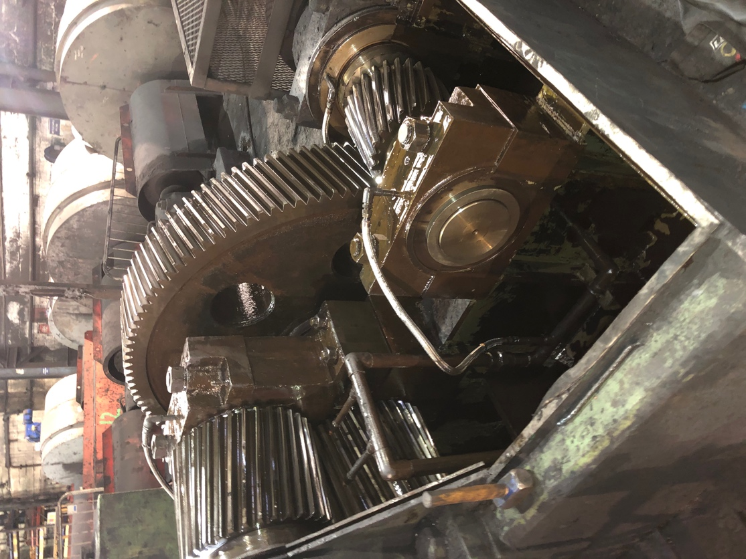

Table of Contents
Introduction 3
Report Brief 4
Potential Project Ideas and Opportunities 5
Project Charter 6
Project Description 7
Evaluation of Three Potential Project Areas & Conclusion 9
1 – Characteristic Selection Matrix 10
Project Name: Roller Table & Turn Table Chains Snapping 11
2 – RAG Analysis Matrix 12
Problem 1 – Roller Table & Turn Table Chains Snapping 12
Problem 2 – Water Ingress to ‘H’ System Oil Tank 12
Problem 3 – Strapping Machine Welding Tips failing to weld 12
3 – Feasibility Study 13
Problem 1 – Roller Table & Turn Table Chains Snapping 13
Conclusion & Final Selection of Chosen Problem 14
Project Initiation Summary 15
Further Investigation and Data Collection of the Chosen Problem 16
Project Charter Review 19
Initial Gantt Chart 21
Chosen Solution to the Maintainability Problem 22
1 – Produce a Shadow Board which contains all relevant spares for a chain change 22
Conclusion of best solution to the problem 23
Pros & Cons Result: 23
Payback Result: 23
Characteristic Selection Matrix (XY Matrix) Result: 24
Summary 24
Project Implementation: 25
Finalising the Design of the Modification & Implementation Plan 25
Interim Gantt Chart 26
Impact of the solution 27
Does this solution have a positive impact on Maintainability? 28
Conclusion 29
Overall Project Evaluation 29
Final Gantt Chart 30

Introduction

My name is Garin Mann, I am 21 years old and recently completed a 4-year apprenticeship with Celsa Steel UK. I am now a qualified Mechanical Craftsman and aspire to be a Mechanical Engineer in the future.
I also have a smallholding where I keep some livestock, and have old agricultural machines, including a 1977 Thwaites dumper which I am currently refurbishing, as well as a 2001 Jinma Rhino Compact Tractor. The skills and knowledge that I have learnt from my apprenticeship within the steelworks are also benefitting me with day-to-day tasks that I carry out on these machines.
Celsa Steel UK belongs to the Celsa Group of companies. Celsa, later to become Celsa Group, was established in 1967 as a reinforcing bar re-rolling mill. Over four decades later, Celsa Group has grown to be one of the largest steel manufacturers in Europe, producing over 10 million tonnes of steel each year from its group companies in Spain, the UK, Poland, Norway, and France.
At Celsa UK, we produce steel via the electric arc furnace (EAF) route, making new steel products by recycling scrap metal. The EAF process uses 100% recovered ferrous scrap metal as the primary raw material, which is melted down in the furnace using an electric current to make molten steel from which new steel products can be manufactured. The EAF process is more flexible, produces around a sixth of the CO2 emissions, with steel manufactured this way containing about a third of the embodied energy when compared with other, more traditional steelmaking methods.

Report Brief

This report is covering all aspects of reflecting on a past ‘Managing a Professional Engineering Project’ and ‘Engineering Design Project’.
Therefore, the project data and information run from the 8^{th of} October 2020 – 28th May 2021, as these were the deadlines that were set by my employer.
Throughout the project I have been continually working towards the standards set by my tutors as well as my managers within the workplace, to maintain and achieve the goals that have been set at the beginning of the academic year.
This year’s theme has been set by the Engineering Department as Maintainability. As a craftsman I’ve been tasked by my current department to upgrade/monitor part of the manufacturing and production system that I work in. During my time on shifts, there have been countless breakdowns and incidents which are either, Mechanical, Electrical or Production issues. Because of these issues, it has led to manufactured components being made which are either:
- Out of Specification (Failed at the Quality Stage)
- Components become expensive to manufacture (Caused Production Downtime)
- Unreliable systems/production methods (Can cause quality failures/can potentially lead to accidents)
Therefore, my job is to formulate a plan to manage the project from the beginning to the end. Through my research I identified the nature of the problem and conducted a feasibility study to identify the constraints and produce an outline specification.

Potential Project Ideas and Opportunities

As previously mentioned in the Introduction, I have covered the majority of the Rod & Bar Mill when it comes to breakdowns and delays that occur during my shift, as well as repairs, checks and maintenance on machinery when we are rolling down one of the three production lines.
Therefore, to ensure that I cover the whole mill, I decided to hold an engagement workshop with the team members on my current shift, this way I guaranteed that I maximised the range carrying out maintenance activities throughout the mill. I also visited the departments where I had worked previously so that I could listen to their potential project ideas. I also included some of the Mechanical Engineers and Graduates in my workshop as they have their own specific departments in which they oversee. By doing this, it allowed a wide range of people to be involved, whilst covering every aspect of maintenance delay that currently occur within the mill. This allowed all members of the Mechanical Maintenance departments to have their input as to what their biggest issues are during their day-to-day activities and highlight potential issues which have been previously overlooked.

Project Charter

Project Charter: Roller Table & Turn Table Chains Snapping
Process Name & Purpose:  Chain Shadow board which reduces the amount of mechanical downtime when a chain snaps. | Process Owner:  Garin Mann
Workshop Leader:
Neil Moore – Spooler Workshop Team Leader.
Shane O’Keefe – Spooler Graduate Engineer.

Team Members:
Garin Mann, Shane O’Keefe, Neil Moore, Steve Jones, Russell Hopkins, Kevin Heard, Elliot Gully, Ian Moore, Stephen Roberts.
Process Sponsor:  Spooler Department (Shane O’Keefe) | Process Sponsor Expectations:  Shane O’Keefe & Neil Moore would expect:  - A significant reduction in Maintenance breakdown callouts.  - Reduce downtime.  - Payback for engineering change in under 1 year.  - Full implementation of the project.  - Reduction in the risk of quality concern due to machine downtime/failure.
Resource Team:
Russell Taylor
Carl Taylor
Lee Parkman
Dave Hughes

Project Description

The project team (listed above) have concluded that when we are producing spooled coils, that we are receiving breakdown callouts as well as mechanical delays. When the Roller Table/Turn Table chains snap, it puts the mill on stop as there is no other way for the coils to be dispatched from the running line and into the warehouse.
Therefore, this reduces the number of coils that can be produced per shift, which has a knock-on effect towards the top end of the mill where they control the specification of the billets that are being put into the furnace by the furnace man. It also influences the maintenance fitters as well as the mechanical engineers as the maintenance fitters must respond as soon as possible to the fault.
One of the main causes of the chains snapping is because of what’s called ‘a bad end’, this is where the coil that’s being produced gets put onto the weighbridge without the bad end being spotted. There are several precautions that are already in place to stop this from occurring, such as the Spooler Pulpit operator, observing the coil before it’s put onto the weighbridge, as well as the weighbridge operator spotting the bad end and cutting it off before it’s moved further on the roller tables. However, often, the bad end goes unnoticed and then catches on the casting of the roller tables, causing either the drive or idler chain to snap, which results in the roller table not rotating and moving the finished coil further North towards the warehouse.
My proposed solution to this problem is as follows:
- Notify Spooler Pulpit and Weighbridge operators regarding the possibility of a ‘bad end’ and the damages it can cause.
- Improve the guarding around the sprocket drive and idler chains.
- Produce a shadow board containing all the necessary equipment that’s required to replace a snapped chain

Budget for solving this problem - £200 (All to be made from scrap material).

Pros and Cons of Pursuing Issue
Pros | Cons
One outcome of the project is that it reduces the amount of downtime that occurs for breakdowns. | May not include enough information to carry out a project.
Another outcome of the project is that it will increase production. | May not have time during my current shift rota to introduce a full project plan and implementation stages. (Insufficient resources)
The project will also improve the quality of the maintenance systems that are currently in place.
The project also provides a low-cost solution to repair the problem.
The project can be completed within the specified timeframe (34 weeks).
The goal of the project is realistic and achievable (Budget, time, and resource).
The improvements that the project will introduce will be measurable as I can compare the process improvement and cost avoided, before and after the implementation.
The project can begin as soon as possible as all resources are at hand and can also be implemented within a short period.
The project can heavily reduce wastage, which is currently one of the main issues. Additionally, being one of the largest recycling companies within the UK, this theme ties heavily in with the foundations that they companies built upon.

Evaluation of Three Potential Project Areas & Conclusion

After finalising my three potential project ideas, I then had to decide which of the three ideas was going to be carried forward and used as my final idea. I then met with the team that was involved to critically evaluate each of the ideas. Between the three groups it was decided that the most effective method of analysing and concluding which idea was going to be used, would be done by using a combination of the following techniques:
A Characteristic Selection Matrix - This method was chosen because it is an easy and effective way of comparing my three final ideas. It also makes it easy to see which idea is the best out of the three once they’ve all been ranked against the selection criteria.
A RAG Analysis Matrix – The RAG Analysis method was chosen because exactly like the characteristic selection matrix, it’s a very effective and easy method of comparing the three final ideas amongst one another. Additionally, it indicates which of the final three ideas rank the highest based off the selection criteria.
A Feasibility Study - A feasibility study is an analysis that takes all a project's relevant factors into account—including economic, technical, legal, and scheduling considerations—to ascertain the likelihood of completing the project successfully

The results of these techniques were as follows:

1 – Characteristic Selection Matrix

Project Name: Roller Table & Turn Table Chains Snapping
Project Manager: Garin Mann |  |  |  |  |  |  |  |  | Date: 11th December 2020
 |  |  | Selection Criteria
 |  |  | Low Effort | High Impact | Acceptable Cost | Acceptable Time | Acceptable Risk | Resources Available | Cultural Acceptance | Addresses Root Cause
Weight |  |  | 9 | 7 | 9 | 8 | 7 | 9 | 9 | 7 | Total Score | Implement (Y or N)
Output (y) CTC | Root Cause | Potential Solution | 1 = No, 5 =Somewhat, 9 = Yes |  |  |  |  |  |  |  | Total Score | Implement (Y or N)
No | ‘Bad Ends’ left on coil. | Easy to access to replacement chains. | 9 | 7 | 9 | 8 | 7 | 9 | 9 | 7 | 65 | Y

2 – RAG Analysis Matrix

Problem proposal | See problem proposal images and written description
Selection criteria | Problem 1 – Roller Table & Turn Table Chains Snapping | Problem 2 – Water Ingress to ‘H’ System Oil Tank | Problem 3 – Strapping Machine Welding Tips failing to weld
Materials | 3 | 2 | 3
Ease of Manufacture | 3 | 2 | 2
Cost | 3 | 1 | 2
Simplicity of Mechanism | 3 | 2 | 3
Design for Ease of maintenance | 3 | 1 | 2
Sustainability/ Environmental Issues | 2 | 2 | 3
Safety | 3 | 3 | 3
Ergonomics | 2 | 2 | 1
Score Total | 22 | 15 | 19
Rank order | 1 | 3 | 2
RAG Status – GREEN = POSITIVE, RED = NEGATIVE
1 = POOR, 3 = EXCELLENT

RED | AMBER | GREEN

3 – Feasibility Study

Problem 1 – Roller Table & Turn Table Chains Snapping

Technical
Celsa Steel UK has a vast amount of technically skilled employees with a wide range of valuable experience. Therefore, I believe that the problem that we are dealt with can easily be rectified to a high standard. Additionally, I believe that the attitude of the employees would be very optimistic when it comes to solving the problem.
The issue that occurs when a chain snaps on either the roller table or the turn table is major, as it has a knock-on effect due to its downtime, therefore, slowing down production rates. However, the solution for the problem has been handed a budget of no more than £200. I believe that the budget for this project idea is achievable as the solution to the problem doesn’t require a high number of materials and resources. This would prove to be a low-cost high value solution.
Legal
Mainly, since the solutions were designed and created in house, there are no legal issues which would prevent the team members of the project from making any changes to what they are going to carry out.
Operational
With the project being completed within one shift (12 hours) it would allow the team to design, test and implement the project without having to schedule downtime and have no effect on production.
Scheduling
The team members feel that this task could be easily achieved within the allocated timescale as it would be a very simplistic implementation due to the simplicity of what’s required.

Conclusion & Final Selection of Chosen Problem

Analysis using the 3 techniques listed has resulted in the Roller Table & Turn Table Chains Snapping project being chosen, not only does this prove to be a very low-cost solution, but it will also significantly improve flow and the process, reducing waste and downtime, ultimately improving productivity.
The decision to opt for this project was also supported by the following additional facts.
- The highest scoring project from the evaluation techniques.
- This issue occurs frequently, and as a result loses productivity and time for Celsa, time costs money.
- The benefits to be realised from this project are significant, reducing time wasted, waste in terms of process flow, and increasing productivity on the line.
- The project team feel confident that this project can be delivered in a short time frame, with little cost and resource.
- This project qualifies against the Maintainability brief
- This issue affects teams both upstream and downstream and whilst a full process flow hasn’t been undertaken for the whole process, it is anticipated that benefits may be realised on other parts of the line. These will be followed up using a PDSA approach Plan, Do, Study, Act to revisit additional opportunities.
- We rarely produce Spooled coils as it’s a specific product that’s ordered by specialist companies, therefore, by ensuring that the downtime is decreased, then it optimises the production of the product, resulting in the company earning more money from the campaign.
- The Team Members, that are listed in the Project Charter for this specific idea also voted that they recognise that this problem is a re-occurring issue and needs to be addressed to a particular standard, to improve the process capabilities.
- Pareto Analysis was also carried out with all the initial ideas that were produced in my ‘Workshop’ at the beginning of this report and the issue that had the most downtime was in fact the project that I have chosen to carry forward.

Project Initiation Summary

Before the project was initiated, I felt that this was the perfect time to meet with the team members that were included in my Project Charter. The general outcome of this was that everyone within the team felt I had used an inclusive approach to discussing the project options and in allocating roles and responsibilities. They all confirmed that they clearly understood what was being asked of them, as well as allowing to share their thoughts and any concerns that may influence the overall outcomes.
One stage that I found difficult during this initiation phase was trying to get my concerns and thoughts across such many people within a quick period. However, I feel that I provided sufficient confidence in my briefing and opportunity for any of the team members to contact me if they wanted to raise any concerns.
Additionally, with our 12-hour shifts overlapping, both in the morning and evenings, I ensured that I gave everyone enough notice so that they were all aware of my expectations.
Therefore, throughout this initiation phase of the project, the team have, efficiently, been able to:
- Within their smaller teams (separated by their shifts as in ‘A’, ‘B’, ‘C’ and ‘D’) successfully highlight several issues that currently occur within the section of the mill in which the project will be introduced into.
- Critically analysed these problems and then reduced them down into a final 3 (depending on the amount of downtime that occurs), therefore these three require the most attention as the project gets carried forward.
- Identified the labour and skillset required within the company to overcome the issues with more evidence behind the problem statements.
- Establish rough budgets for overcoming the issues.
- Generate pros and cons for pursuing the issues.
- Evaluating the 3 problem areas using 3 industry recognised evaluation techniques.
- Concluding which is the most effective problem to take forward and complete a project on.

Further Investigation and Data Collection of the Chosen Problem

Once the final project was chosen, then I began to investigate further and collect data that will support me throughout my project. For example, some of the date and information that I have acquired is as follows:
- Rod & Bar Mill Rolling Programme (Appendices 1) – This is an excel document that’s available to all employees at Celsa via W: Drive. The document contains a monthly planner that shows what product we are producing on every day of the month, along with the amount of tonnage that’s being produced as well as any down days/lack of billets days.

- Rod & Bar Mill Shift Manager’s Report (Appendices 2) – This is also an excel document that can be accessed via W: Drive. The document is a live document that is filled out each shift by the Shift Manager (In my case Philip Eades). It contains information such as Mechanical, Electrical and Production downtimes, as well as the number of Billets Pushed per hour, compared to the target. It also contains a safety report, any quality issues, absenteeism and then the managers comments that get produced when a stoppage occurs, this ensures that any problem that occurs get tracked.

- Spooler Plant Cards (Appendices 3) – Again, this is an excel document that can be accessed via W: Drive and contains the names of the spare parts used within the Spooler Mill, for example, it contains the part name, number, the drawing number, the stores code, and the location of the part within the stores. This information proves critical once the mill is on stop as spare parts can be sourced quickly and easily, and therefore, reduce downtime.

- CAB-i-NET– This is internal software that’s installed on the computers within work. It contains drawings for every component within the mill. Additionally, it can be cross-referenced and used to retrieve the relevant information from the plant cards. The drawings that were required for this project were obtained from this software.

- Standard Operating Procedure for replacing a damaged chain – There is a Standard Operating Procedure that was produced by the company when the Spooler mill was commissioned and it shows how to replace a damaged roller that’s on the roller tables, however, within the SOP it also shows how to replace a damaged chain.

The graph above is a simple bar chart which indicates the name of the Shift on the Horizontal Axis, and the Downtime in minutes on the Vertical Axis. From this graph it is evident to see that ‘C’ Shift take the longest time to change a damaged chain, whereas ‘D’ Shift take the shortest amount of time to change a damaged chain.
Shift Team Leaders comments when asked the question “How do you feel about the current procedure to replace a damaged chain?”

‘A’ Shift Mechanical Team Leader (Andrew Tudor) – “Our downtime, compared to other shifts, is fairly different, I believe this is down to myself, Nathan Phelps and our apprentice Callum Ponting being well trained within the Spooler department, therefore we are familiar with the equipment”

‘B’ Shift Mechanical Team Leader (Neil Harrison) – “I understand that our downtime exceeds that of other shifts, however, I feel this is due to the lack of spares that are over the stores, with this being one of the main problems it increases our downtime significantly. My solution to this is to ensure that the stock level of the spares is increased as well as them being easily accessed”

‘C’ Shift Mechanical Team Leader (Ronald Gray) – “With me and the other mechanical craftsman on the shift having a combined age of 120, we want to make our job as easy as possible and have received no training within the Spooler department that was introduced in 2007. Additionally, there have been several occasions where the production lads have tried to get us to speed up our downtime, however, me and Mark are both working as fast and as safely as we can”

‘D’ Shift Mechanical Team Leader (Steve Jones) – “Our downtime is significantly lower than the other three shifts, this is mainly due to Ian Moore having spent 3 months with the Spooler departments, as well as our current apprentice Garin Mann having spent 12 months with the department. This leaves them familiar with the mechanical processes that occur within the area. We hope to increase Stephen Roberts’ familiarity within the department as he is new on our shift”

Production Team Leaders Comments when asked “How do you feel about the current procedure to replace a damaged chain?”

Production ‘Bottom End’ Team Leader (Dave Hughes) – “I’m not mechanically minded, and I understand that the mechanical fitters know what they are doing. However, if it takes one shift a maximum of 17 minutes to replace a damaged chain, and a different shift a maximum of 47 minutes to carry out the same job, then something needs to be done about the problem, whether this be an improvement in the stock limits or having them carry out the same procedure when we aren’t producing Spooler so that we can analyse and improve where they need to improve upon.”

Production ‘Top End’ Team Leader (Liam Rich) – “With me and my production team controlling the speed at which we produce Steel, then we want to reduce the amount downtime that occurs per shift anyways. If we can get all the shifts completing the task within the same time, then the production of Steel will increase.”

Project Charter Review

Project Charter: Roller Table & Turn Table Chains Snapping
Process Name & Purpose:  Introducing a Shadow Board which will hold the stock count for the chains that are used to drive the roller tables and coils into the warehouse. The Shadow board will allow the maintenance department to replace a damaged chain within a shorter period, resulting in increased production. | Process Owner:  Garin Mann
Workshop Leader:

Neil Moore – Spooler Workshop Team Leader.
Shane O’Keefe – Spooler Graduate Engineer.

Team Members:
Garin Mann, Shane O’Keefe, Neil Moore, Steve Jones, Russell Hopkins, Kevin Heard, Elliot Gully, Ian Moore, Stephen Roberts, Andrew Tudor & ‘A’ Shift Fitters, Neil Harrison & ‘B’ Shift Fitters, Ronald Gray & ‘C’ Shift Fitters.
Process Sponsor:  Spooler Department (Shane O’Keefe) | Process Sponsor Expectations:  Shane O’Keefe & Neil Moore would expect:  - To increase productivity, recognising that some shifts aren’t as productive as other, however, collectively reduce downtime by 50%.  - To payback the costing of the project within a 2-week period.  - Full implementation of the project within the timescale provided by Bridgend Technical College (34 weeks)  - Reducing the risk of the quality concern due to the machine’s downtime/failure.
Resource Team:
Russell Taylor
Carl Taylor
Lee Parkman
Dave Hughes
Liam Rich

I felt that the Project Charter needed to be reviewed as the project was now finally chosen. This allowed me to alter the Process name & Purpose within the charter as well as clearly indicate the Process Sponsor’s expectations. It also benefitted me when I had to meet with the team members as it assured me that I covered the entire basis of the purpose of this project and that nothing went unnoticed.
Additionally, the team members have been altered and extra personnel have been added due to the problem occurring on any one of the four shifts. Therefore, they were all briefed with the importance and the relevance of this project. Also, it enhances the possibilities of solution that can be developed in the future, allowing me to gather a range of high-quality proposals that I can incorporate into my designs and eventually the outcome.

Initial Gantt Chart

A Gantt chart is a project management tool assisting in the planning and scheduling of projects of all sizes, although they are particularly useful for simplifying complex projects. Project management timelines and tasks are converted into a horizontal bar chart, showing start and end dates, as well as dependencies, scheduling and deadlines, including how much of the task is completed per stage and who is the task owner. This is useful to keep tasks on track when there is a large team and multiple stakeholders when the scope changes.
As it's in a bar chart format it is possible to check on progress with a quick glance. You can easily see:
- a visual display of the whole project,
- timelines and deadlines of all tasks,
- relationships and dependencies between the various activities,
- project phases
In addition to the Gantt chart, I was able to construct a Critical Path Analysis (CPA). The CPA highlights the critical tasks as well as their completion dates. Once I had mapped out the key tasks with definitive dates, it then allows the team members to meet their smaller targets.

Chosen Solution to the Maintainability Problem

1 – Produce a Shadow Board which contains all relevant spares for a chain change

Estimated Costs:
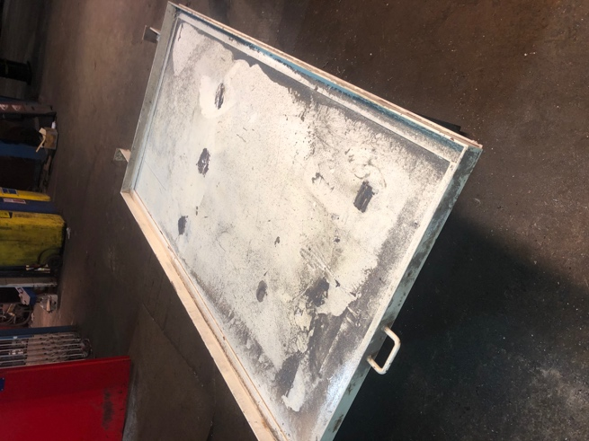
The initial sketch of the Shadow Board was based off, what is currently being used as a coat-hanger outside of the Spooler workshop. Therefore, the cost to produce the Shadow Board is £0 due to the product already being commissioned. My proposal is to re-use the coat-hanger to house the relevant spares that are required to change a chain on either the Spooler roller or turn tables.
The only costing that will affect the outcome is that of manning, paint, and time.

Estimated Implementation Timescale:
The project can be implemented within one shift, this includes the following:
- Gaining a Hot-Work Permit – This must be done to be able to carry out any burning, cutting, and welding activities.
- Carrying out a Point of Work Risk Assessment – This must be done before any working task gets carried out to ensure that the working party remains safe.
- Gathering all the necessary tools required to transform the coat-hanger into a Shadow Board.
- Transforming the coat-hanger into a satisfactory Shadow Board that can be implemented.
- Transporting the finished Shadow Board from outside the Spooler Workshop and into the most ideal place or it to be commissioned. (In this case, directly under a flight of stairs right next to the roller tables)
- Hanging the chains onto the Shadow Board in their relevant positions
- Signing of the Hot-Work Permit – This shows the management department that I have finished carrying out the relevant activities in the specific area.

Conclusion of best solution to the problem

Pros & Cons Result:
Potential Solutions | Pros Score | Cons Score | Overall Total
Produce a Shadow board which contains all relevant spares for a chain change | +7 | -2 | +5
Improved guarding around Sprocket Drive Chains | +1 | -5 | -4
Educate production workers regarding ‘bad ends’ on coil | +1 | -4 | -3

Payback Result:

Characteristic Selection Matrix (XY Matrix) Result:
Potential Solutions | Total Score | Rank
Solution One | 231 | 1
Solution Two | 201 | 2
Solution Three | 145 | 3

All 3 of the potential solutions posed both their strengths and weaknesses, however, from the table above it is evident that Solution One ranked the highest score out of the 3.

Summary

To conclude on the results of the three evaluation techniques that I have carried out to best summarise the potential solutions I can pose towards the ongoing problem area.
Evidently, Solution One - Produce a Shadow board which contains all relevant spares for a chain change, resulted in being my chosen solution due to the following key factors:
- Ranked First when it came to Pro’s and Con’s.
- Ranked First when it came to Payback (weeks).
- Ranked First when it came to my Characteristic Selection Matrix’s.
- The cheapest of the three solutions.
- Has the ability to be implemented for one 12-hour shift.
- Within the budget provided by the Process Sponsor’s.
- Within compliance to all my Specification points.
These are the main why the team members included within the project feel that this is the most sensible and worthwhile solution for the company as well as themselves.

Project Implementation:

Finalising the Design of the Modification & Implementation Plan

The final Design of the project has been produced by myself and reviewed by the process sponsors, who were pleased with the outcome. Now with the design complete, production of the final solution can commence.
My design was heavily based upon the fact of me already having the solution produced, however, innovating and enhancing the solution to meet the goals and outcomes that were expected by myself.
I decided to go with a blue and yellow colour scheme as it stands out and attracts attention, which might be required during a breakdown situation where one shift is struggling to find the Shadow Board.
Additionally, the colour scheme was based upon the two different roller tables that are within the Spooler mill. My thought process behind this was that if one side of the Shadow Board was blue, then that would indicate that the chains hung on that side of the board were only to be used in the event of a roller table chain snapping. Also, this rule applies to the yellow half of the board.
However, in the case of the stock levels being at a minimum for whatever reason, then the size of the chain can be altered and interchanged as a last resort.
Personally, I felt that the best way of implementing the solution was to create a plan that could be followed to implement the solution efficiently and effectively. The Implementation Plan is attached in the Appendix of this report.
(Appendices 4)

Impact of the solution

Once the solution was implemented, it was then the perfect opportunity for me to begin to analyse the downtime that now occurred, and then can compare it to the previous downtime to gain a summary of the impact that it has produced.

My results are as follows:

 | Downtime (Minutes) |  | % Reduction
Name of Shift | Before | After
‘A’ | 26 | 13 | 50%
‘B’ | 34 | 16 | 53%
‘C’ | 47 | 19 | 60%
‘D’ | 17 | 10 | 42%

As can be seen from the table above, the introduction of the Shadow Board has created the opportunity for all four of the shifts to improve their downtime, even ‘D’ shift who initially took 17 minutes to complete the procedure have managed to reduce their downtime which is great to see.
When downtime first occurred and was recorded, a combined total of 124 minutes of downtime was being lost across the four shifts, whereas after the project was implemented only 58 minutes of downtime was being lost across the four shifts. This shows a reduction of 46.77%.
Additionally, in terms of money that it saved the company, a similar result can be shown as follows:

 | Downtime (Minutes x Money) |  | £ Reduction
Name of Shift | Before | After
‘A’ | 26 x £2,000 = £52,000 | 13 x £2,000 = £26,000 | £26,000
‘B’ | 34 x £2,000 = £68,000 | 16 x £2,000 = £32,000 | £36,000
‘C’ | 47 x £2,000 = £94,000 | 19 x £2,000 = £38,000 | £64,000
‘D’ | 17 x £2,000 = £34,000 | 10 x £2,000 = £20,000 | £14,000

When downtime first occurred and was recorded, a combined total of £248,000 was being lost across the four shifts every time a chain snapped, whereas when the project was implemented, £116,000. This shows a saving of £132,000.

Does this solution have a positive impact on Maintainability?

When analysing the results, the question was asked about the solutions impact on Maintainability, and whether this is a positive impact. The team members all agreed on them feeling as if we have improved the general maintainability procedure for the given task.
The team members can justify the impact with the points that follow:
- They have ensured that the procedure is as simplistic as possible, and any unnecessary steps that occurred before having now been removed from the process so that the maintenance job can be carried out more efficiently and effectively.
- They’ve also ensured that they participated well throughout the duration of this project, additionally helping when carrying out their check sheet in the Spooler area and realising that there are chains missing from the board, they have then written this down, as well as reported it to their Shift Manager who highlights that at every morning meeting.
- Reduced the material wastage by realizing that if one of the longer length chains have failed and snapped, then they can be shortened to gain a different desired length where they can be used across one of the other sections.
- Ensured that the process is as safe as possible by always following the same standardised procedure of carrying out a POWRA, as well as gaining a Hot-Work Permit and signing onto DECAP.

Conclusion
To conclude, I feel that this project has ended very well, considering that it’s my first one. Additionally, the project wasn’t aimed to come across as a vital project, however, since implementation I’ve had a handful of production operators, mechanical shift fitters, the production manager as well as the works engineer come up to me to congratulate the success that the project have proven. This has hugely boosted my confidence and ensured that I maintain this work ethic and efforts to produce something like this in the not-too-distant future.
I’ve thoroughly enjoyed the challenges posed along the way and thrive upon pressure; without forgetting that every day is a learning day. Also, I’ve been asked to carry out some other projects with the similar theme in the Bar Mill as their process heavily depends on the transfer of bars via chains, therefore my now expertise can benefit another part of the plant, and hopefully improve their process by doing so.

Overall Project Evaluation
What Went Well:
- The project was fully completed, and signed off, within the targeted timescale.
- My time management skills prove to be effective and efficient.
- Internally, the maintenance department have gained huge benefits from the solution.
- The Product Design Specification was 100% achieved.
- I managed to complete the project and report all to a satisfactory standard.
Even Better If:
- I improve upon the time management of the Gantt Chart.
- I ensure that my Logbook gets updates weekly, I think there were 3 occasions where I hadn’t updated my logbook due to my tight schedule.
- Involving some of the younger apprentices within the phases for them to gain an understanding of the process and structure that a project entails.

Appendix/References

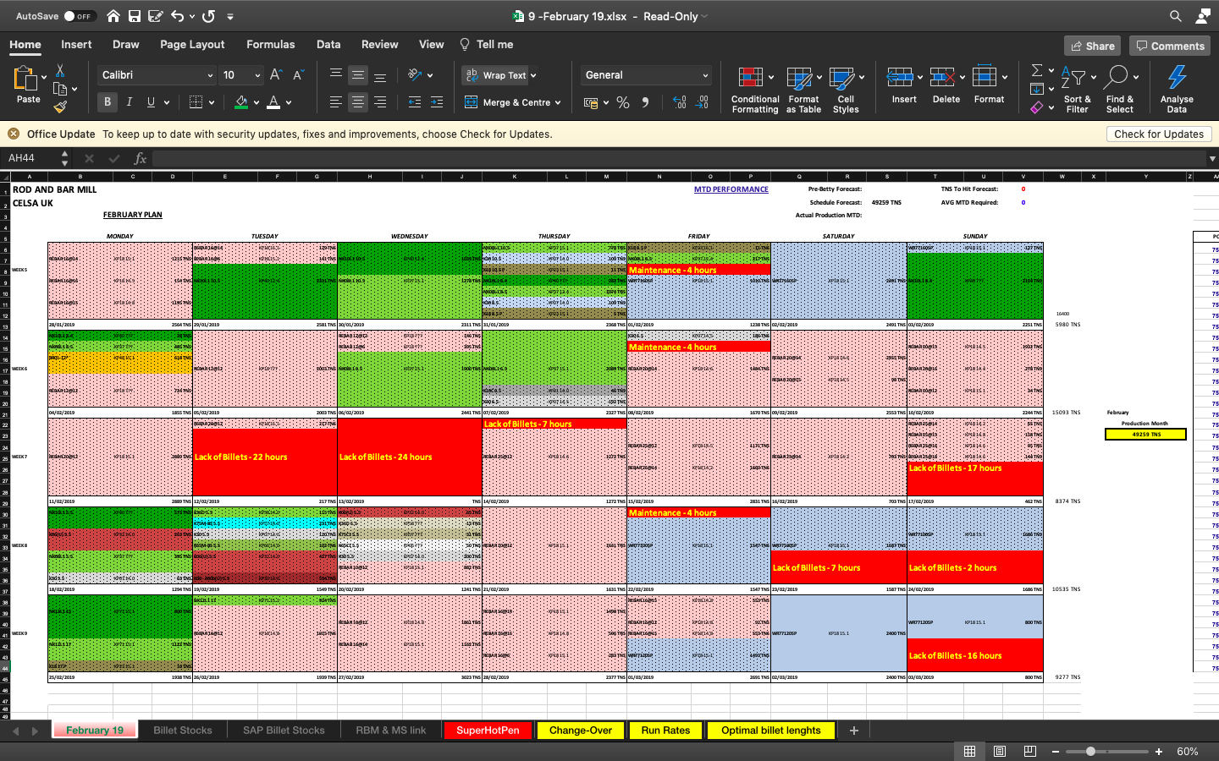
Appendices One – Rod & Bar Mill Rolling Programme (February 2019)

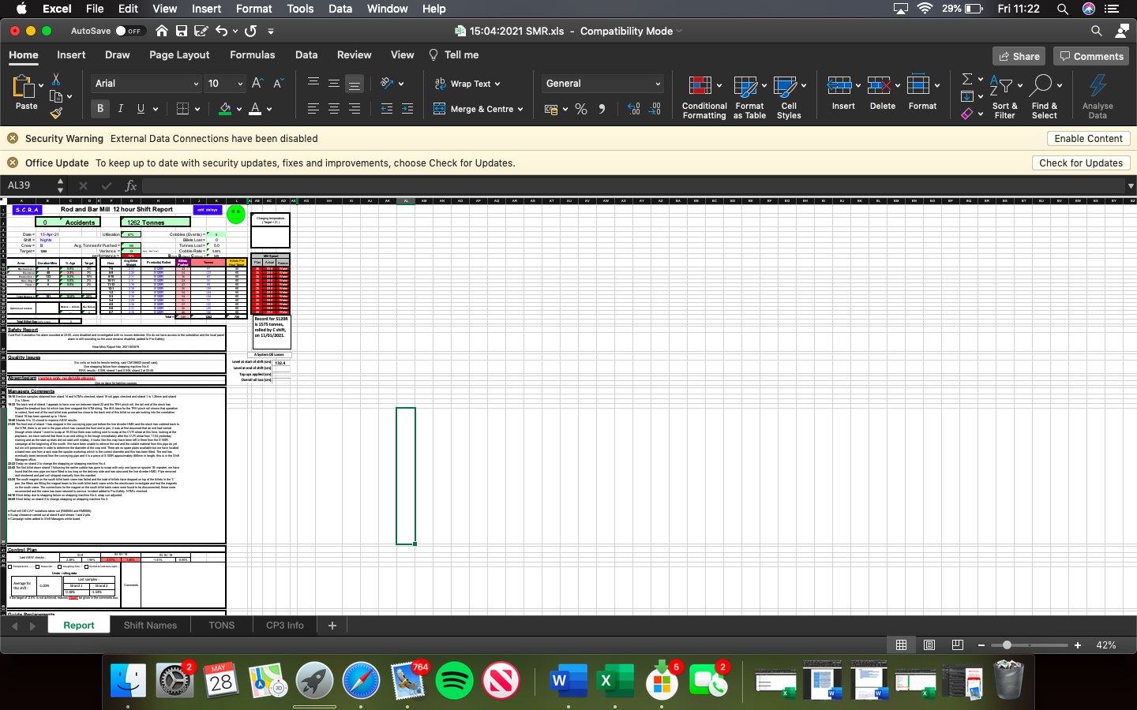
Appendices Two – Rod & Bar Mill Shift Mangers Report (15th April 2021)

Appendices 3 – Spooler Plant Cards
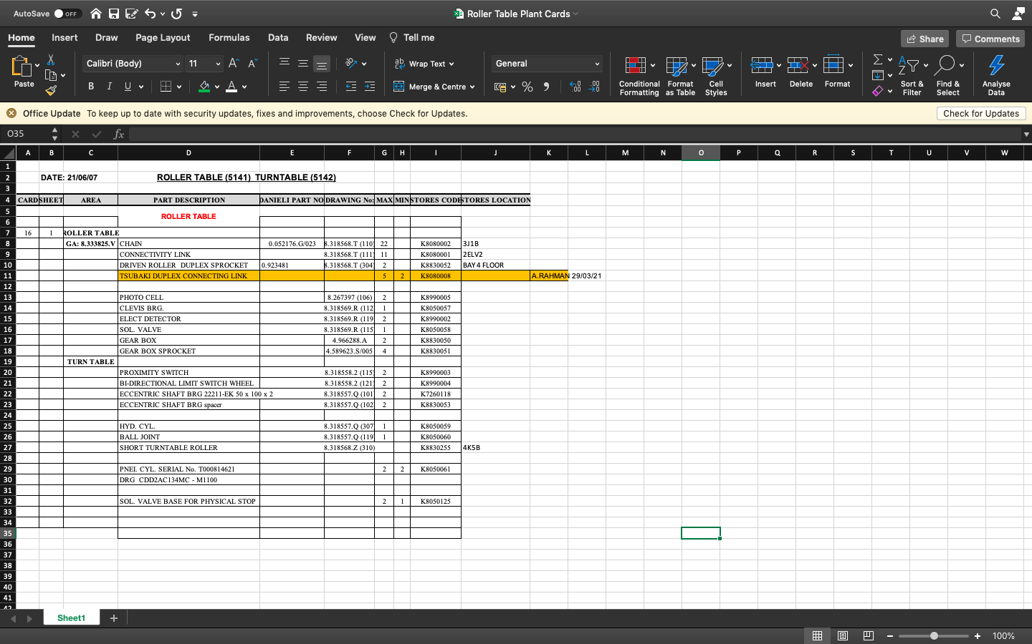

Appendices 4 – Implementation Plan

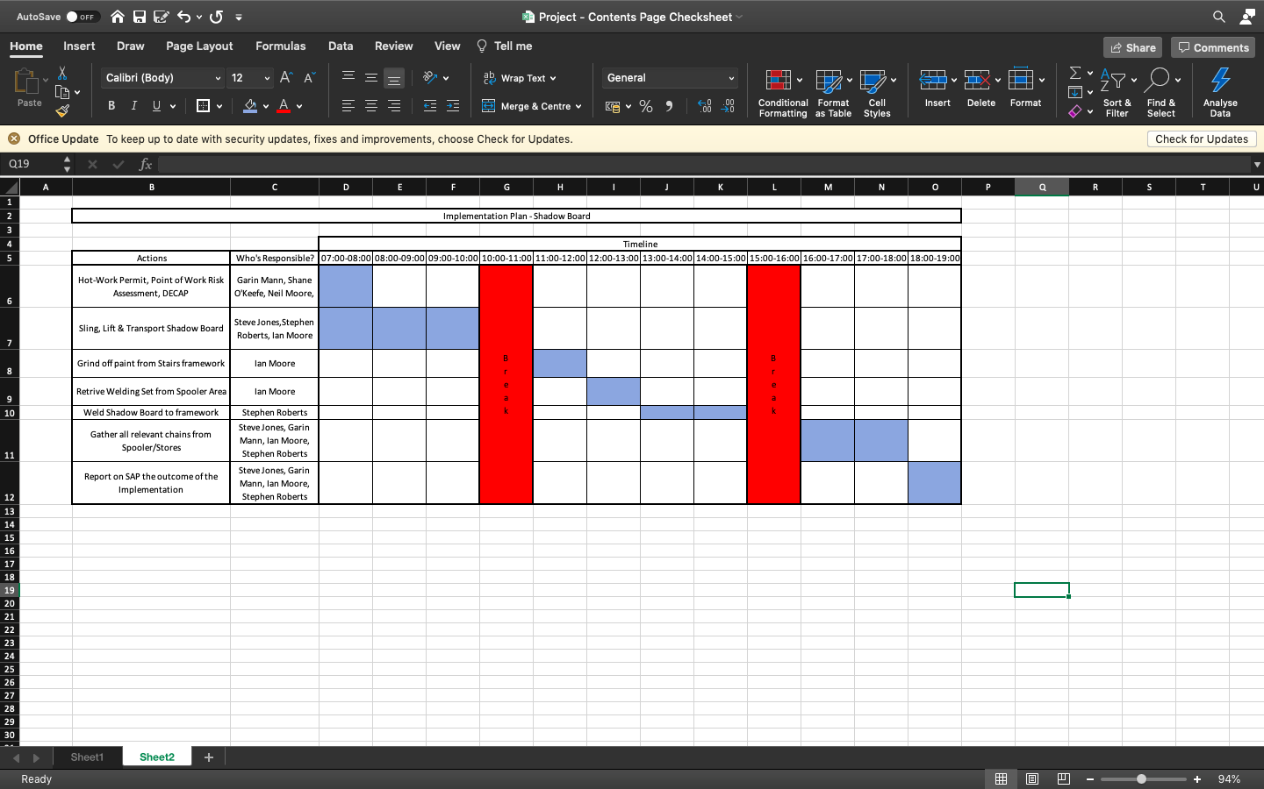

Appendices 5 – Initial Gantt Chart
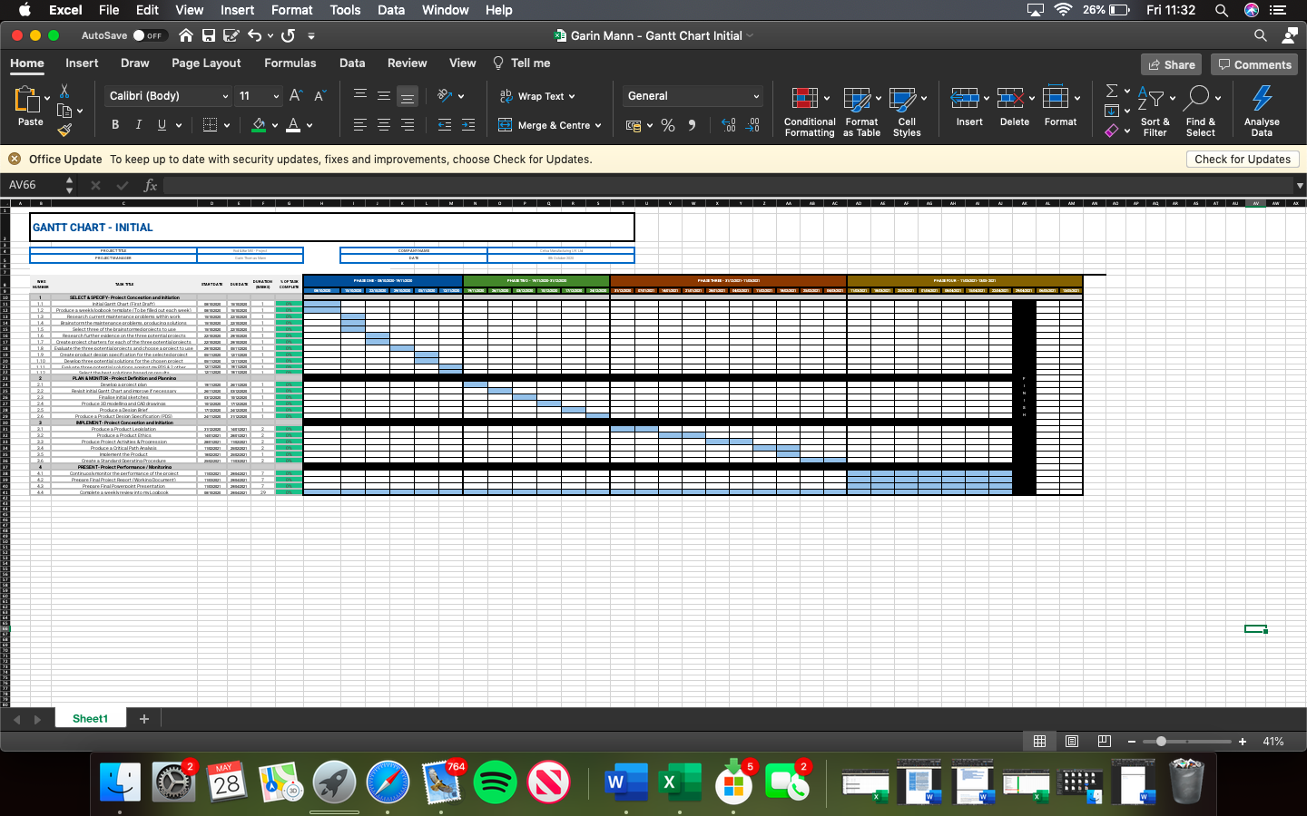

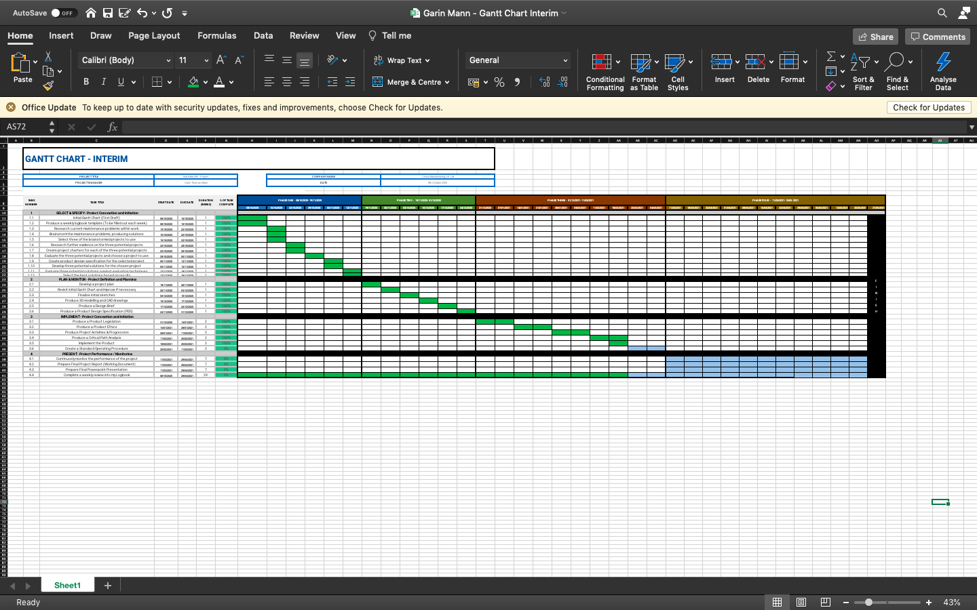
Appendices 6 – Interim Gantt Chart

Appendices 7 – Final Gantt Chart
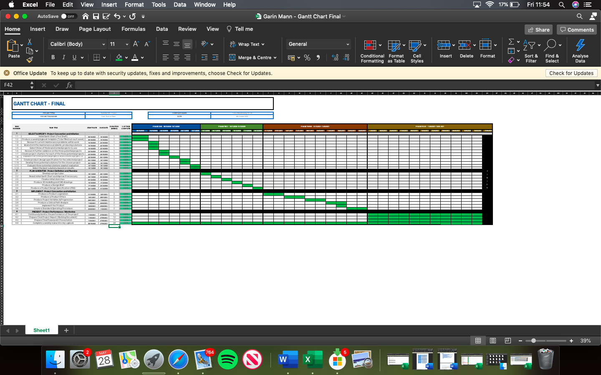

Appendices 8 – Project Drawings


