Diamond Centre Wales
Integrating Augmented Reality at Diamond Centre Wales
Assessment of a luxury jewellery manufacturer and retailer’s current method of the presentation of products and how technologies, processes or ideologies from industry 4.0 can make improvements.
Chun Ho
4-1-2023

Abstract
Diamond Centre Wales currently utilises various methods to create customer interest and customer engagement. Interests are created in the form of photos and videos, presented as stories and posts on social media platforms. Customers are engaged via the Ceric webGL app on the company website as well as the native iOS and Android apps.
Various industry 4.0 technologies, processes and ideologies can be applied to DCW in the form of human-computer interaction to gain improvements. Specifically, augmented reality for short-term benefits and research into the progress of metaverse for long-term benefits by engaging the economically powerful demographics of Millennials and Gen Z.
Introduction
This technical report assesses the current sales operations of a luxury jewellery manufacturer and retailer to explore how technologies, processes or ideologies from industry 4.0 can add value to the company. This report will undertake research from recent journals, survey reports, briefing papers from influential bodies such as the World Economic Forum (WEF) as well as technological advancements from technology providers.

Aim & Objectives
The aim of this report is to propose improvements to the current sales operations of a luxury jewellery manufacturer and retailer with technologies, processes or ideologies from industry 4.0.
The objectives to achieve this aim is by:
- assessing the current method of presenting the products to customers; and
- exploring technologies, processes or ideologies from industry 4.0 that can improve the current method

Implementation Method
Steps has already undertaken to implement industry 4.0 technologies, processes and ideologies into DCW’s business. This is in the form of two Knowledge Transfer Partnership (KTP) projects. The first is a project based around processes of additive manufacturing.
The second KTP project is related to the subject of this report. The project is undertaken by the author of this report whose role as a KTP Researcher will explore how to implement augmented reality into the current customer-facing Ceric mobile application. The research will be exploring the range of methods to implement AR into DCW’s sales process.

Background research – the current method of presenting products to customers
Diamond Centre Wales (DCW) is based out of a purpose-built building incorporating a workshop, office spaces and retail areas. Located at Talbot Green, Llantrisant. DCW provides a ‘complete concept to creation’ service to produce bespoke diamond jewellery customers. Jewellery pieces include rings, necklaces and earrings.
DCW presents its products via several channels: the company website, social media accounts and a dedicated mobile app (Ceric). DCW’s social media accounts raises customer interests via short narrative stories composed from photos or videos of products.
Whereas the Ceric app engages customers by allowing its customers to browse the catalogue of jewellery. The native mobile app can be downloaded from the iOS App Store or the Android Play Store. The purpose of the current release of the Ceric app facilitates bespoke jewellery customisation. The collection of products are presented as 2D images (whilst in catalogue view) and 3D meshes within an interactive 3D model viewer.
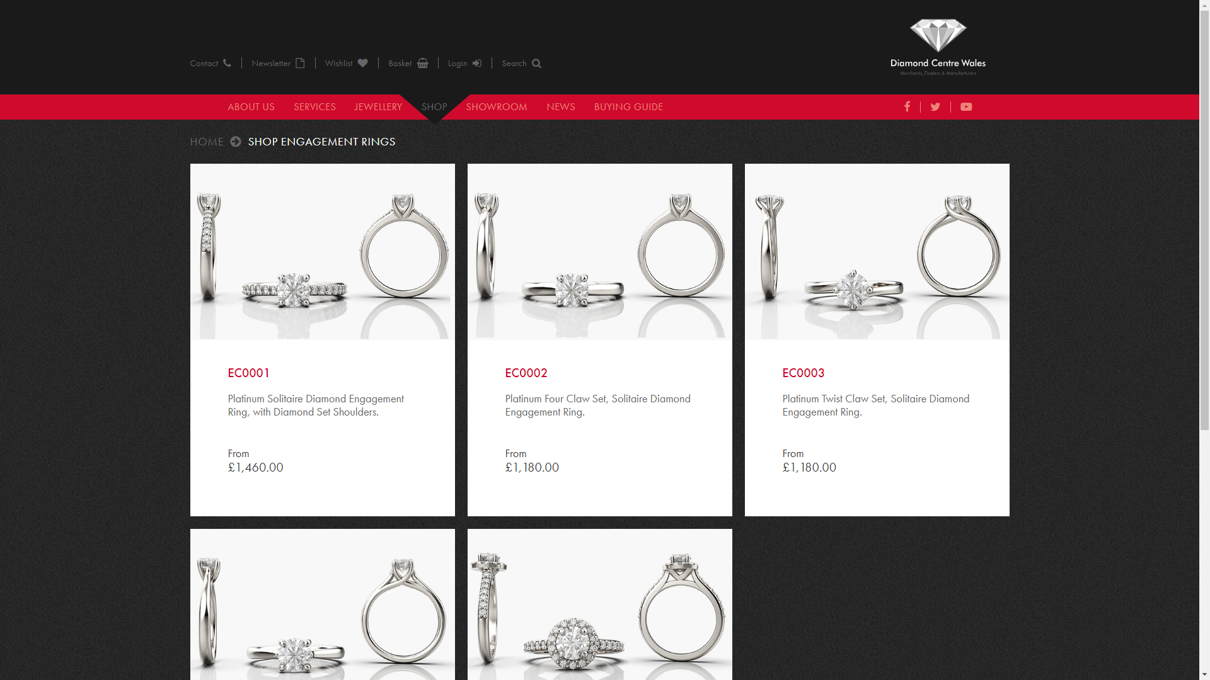
Figure 1 DCW's website (left). Ceric app (right)
For example, customers can pick a style of ring, material for each part of the ring (yellow gold, silver, platinum etc), and stone (diamond, ruby, sapphire etc). This is then communicated to the company’s sales team who arranges an in-store appointment with the user.
Following an initial deployment of the app, there are several areas of improvements and additions suggested by the app’s users and stakeholders (DCW’s owners). The main feedback point is to include a function which allows users to visualise them wearing the piece of jewellery eg. seeing how a wedding ring will look on their ring finger.

Background research - how can industry 4.0 improve the current method?
Within industry 4.0, there are “four foundational types of disruptive technologies … that can be applied all along the value chain” (McKinsey & Company, 2022): connectivity, data, and computational power; analytics and intelligence; human–machine interaction; and advanced engineering.
Within these categories are the technological fields driving industry 4.0, including: internet of things (IoT), cloud computing, AI and machine learning, edge computing, cybersecurity, digital twin (IBM, n.d.). In addition to this list, technological advancements in extended reality (augmented, virtual and mixed reality), cryptocurrency, robotics, additive manufacturing.
The transformation to industry 4.0 for luxury jewellery manufacturers and retailers can be accelerated via the strategic adoption of several industry 4.0 technologies such as extended reality, additive manufacturing. However, this report will focus on the sales process at Diamond Centre Wales and how augmented reality and the metaverse can accelerate DCW’s transformation to industry 4.0.
A study has shown augmented and/or virtual reality can improve online experiential retailing (Hilken, et al., 2021) especially when product-related uncertainty is high (including fit uncertainty) (Tan, Chandukala, & Reddy, 2022) such as ring sizes. In addition, AR and VR can help retailers create a sense of presence for its customers shopping at home (Garnham, August 2021).
Background research - range of development platforms and channels
There are increasingly more options for retailers to present their wares in augmented reality. Different options has its own costs, advantages and disadvantages. Some of the popular options are via:
- native app development (app developed to work on a particular platform or device). Utilising software development kits and platforms ie. Apple’s ARKit, Google’s AR Core, Snap Inc’s AR Enterprise Services (ARES), Unity, Unreal.
  - Advantage: make use of features with complex algorithms such as facial and hand tracking.
  - Disadvantage: this option requires programming languages and regular updates inline with operating system updates
- social media development platforms eg. Meta’s SparkAR, Snap Inc’s Lens Studio:
  - Advantage: make use of platform developed by the provider
  - Disadvantage: a ‘filter’ or ‘lens’ is limited to the platform it was developed for eg. a filter created on SparkAR is only available to users of Meta’s Facebook app or Instagram app.
- webAR - augmented reality content that can be embedded onto webpages within a 3D viewer (eg. Niantic’s 8th Wall, Vuforia, Google’s model-viewer).
  - Advantage: customers will be able to view and interact with content without the need to download an app. Thus, a creation can be deployed to devices running different operating systems.
  - Disadvantage: whilst there are online resources to help developers such as Model-viewer’s documentation (Google Inc, n.d.), this option of AR deployment requires knowledge of programming languages.
At a technical level, advancements are being made in the file formats for which the AR content are saved ender. The Graphics Language Transmission Format (glTF), developed by the Khronos Group (Khronos Group, n.d.), is royalty-free and widely supported by development software including the open-source 3D graphics software Blender which can export 3D scenes as glTF files.
USDZ is an alternative file format used for AR. It is a variant of Pixar’s Universal Scene Description (USD) file format (Pixar Animation Studios, n.d.). USDZ was developed by Apple and the company announced it at the Apple’s Worldwide Developer’s Conference (WWDC) 2018 (Sanders, 2018). Furthermore, USD is also currently being developed upon by Adobe and Qualcomm as a file format for AR (Qualcomm, 2022), which promises compositions of complex 3D scenes.

Background research - future-proofing the company
Retailers connecting physical and digital channels will create business advantages by engaging the economically powerful demographical groups of the near future (Millennials and Gen Z): “tomorrow’s winners in retail will connect physical and digital channels to create a seamless experience, enabling them to offer more targeted, personalized, and lower-friction in-store shopping for their customers in a few ways.” (Lippert, Koetter, Cheris, & Heck, 2023) The same survey brief also claims “Gen Z and millennials are significantly more likely than older generations to have used emerging media to shop.” Where ‘emerging media’ refers to ‘virtual try-on’, ‘virtual try-out’, ‘livestreaming’ and ‘e-commerce via social media’.

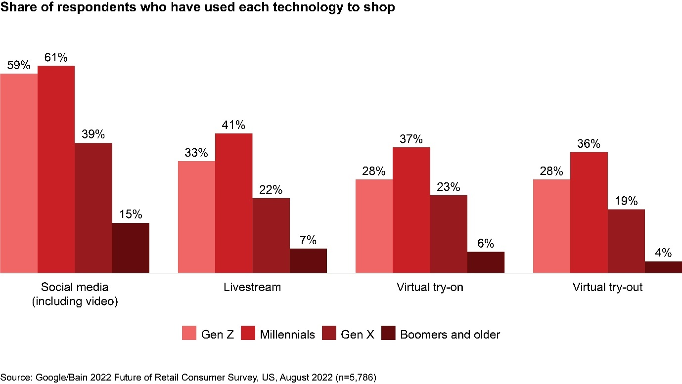
Figure 2 Share of respondents who have used 'emerging media' to shop

The briefing paper Demystifying the Consumer Universe (World Economic Forum, 2023) suggests one of the long-term benefits of embracing industry 4.0 technology such as augmented reality is placing companies ahead of the curve when it comes to new streams of revenue via ‘phygital’ products and assets. “The metaverse unlocks a new frontier with digital products and assets” (World Economic Forum, 2023, p. 31). Phygital (portmanteau of ‘physical’ and ‘digital’) assets, within DCW’s context, can refer to real diamond jewelleries sold to customers where they can redeem a digital ring and vice-versa. The digital ring can then be worn by the user’s digital character within virtual worlds (eg. Roblox, Meta Horizon).
Nike is a company already taken steps to connect the physical and digital channels. They launched a ‘phygital’ product on 21st July 2022 in collaboration with RTFKT Studios. The Nike Genesis Hoodie utilises AR, NFT and Web3 technologies. A near field communication (NFC) chip connects the physical and digital assets. The actual hoodie allows owners to redeem an NFT minted virtual version to be worn by a digital character. The graphical design on the actual hoodie has a QR code where it leads to an animated set of wings when viewed in AR. Furthermore, this product rewards customer loyalty as “access to attain a limited hoodie will initially be given to holders of Clone X and RTFKT x Nike Dunks Genesis CryptoKicks” (Waldman, 2022).
Conclusion
Industry 4.0 can deliver short-term benefit to DCW via the integration of augmented reality technologies into its existing customer-facing mobile app. Whilst the ideologies of the metaverse allows DCW, and other retailers, to deliver long-term benefits by engaging the economically powerful demographic of the future (Millennials and Gen Zs).

Recommendations
The metaverse is still being shaped by its stakeholders. The stakeholders can be defined as providers, participants, creators and society (World Economic Forum, 2023). Hardware, software and infrastructure providers (eg. Apple, Google, Meta, Snap, Roblox, Decentraland, Niantic) shapes the possibilities and limitations. End-users (eg. consumers, game players) participates within the metaverse. Creators (eg. the next wave of content creators, game developers, retailers) provides content for end-users to consume. And the society (including academia, government, businesses and citizens) create governance frameworks including retail-related laws exclusive to the metaverse.
The development of the Metaverse, extended reality, hardware, software and infrastructure are constantly progressing. And this field should be explored in the form of annual developer conferences from technology providers; as well as retailing laws and regulations from governing bodies.

References
Garnham, R. (August 2021). Creating a Sense of Presence: The power of virtual and augmented reality. Ipsos.
Google Inc. (n.d.). Documentation. Retrieved from <model-viewer>: https://modelviewer.dev/docs/#loading-attributes
Hilken, T., Chylinski, M., Keeling, D. I., Heller, J., de Ruyter, K., & Mahr, D. (2021). How to strategically choose or combine augmented and virtual reality for improved online experiential retailing. Psychology & Marketing, 495-507.
IBM. (n.d.). What is Industry 4.0? Retrieved from IBM: https://www.ibm.com/topics/industry-4-0
Khronos Group. (n.d.). glTF runtime 3D asset delivery. Retrieved from Khronos Group: https://www.khronos.org/gltf/
Lippert, L., Koetter, L., Cheris, A., & Heck, J. (2023, March 14). Four Ways Younger Shoppers Will (and Won’t) Change Retail. (Bain & Company, Google) Retrieved from Bain & Company: https://www.bain.com/insights/four-ways-younger-shoppers-will-change-retail/
McKinsey & Company. (2022, August 17). What are Industry 4.0, the Fourth Industrial Revolution, and 4IR? Retrieved from McKinsey & Company: https://www.mckinsey.com/featured-insights/mckinsey-explainers/what-are-industry-4-0-the-fourth-industrial-revolution-and-4ir#/
Pixar Animation Studios. (n.d.). Introduction to USD. Retrieved from Universal Scene Description: https://openusd.org/release/intro.html
Qualcomm. (2022, November 15). Qualcomm and Adobe Unleash Creativity Across Snapdragon Mobile, Compute and XR Devices. Retrieved from Qualcomm: https://www.qualcomm.com/news/releases/2022/11/qualcomm-and-adobe-unleash-creativity-across-snapdragon-mobile
Sanders, J. (2018, June 5). Apple’s USDZ AR file format: What you need to know. Retrieved from Tech Republic: https://www.techrepublic.com/article/apples-usdz-ar-file-format-what-you-need-to-know/
Tan, Y., Chandukala, S. R., & Reddy, S. K. (2022). Augmented reality in retail and its impact on sales. Research Collection Lee Kong Chian School Of Business, 48-66.
Waldman, S. (2022, July 22). RTFKT x Nike AR Hoodie Set to Launch This Week. Retrieved from HypeBeast: https://hypebeast.com/2022/7/rtfkt-x-nike-ar-hoodie-set-to-launch-this-week
World Economic Forum. (2022, April 22). What is 'Industry 4.0' and what will it mean for developing countries? Retrieved from World Economic Forum: https://www.weforum.org/agenda/2022/04/what-is-industry-4-0-and-could-developing-countries-get-left-behind/
World Economic Forum. (2023). Demystifying the Consumer Metaverse. World Economic Forum.
World Economic Forum. (2023, January). Interoperability in the Metaverse. World Economic Forum in collaboration with Accenture.

