Information Engineering – ACCA4013
By Connor Ellement 1803452
Web Development
Submission date: Monday 6th May

Contents
1) Introduction 4
2) ERD 4
3) Tables 5
3.1) Customers 5
3.2 Employees (Staff) 5
3.3 Supplier 5
3.4 Stock 6
3.5 Books 6
3.6 Orders 7
4) Forms 7
4.1 Main Menu 8
4.2 Queries 8
4.3 Tables 9
4.4 Forms 9
4.5 Reports 10
4.6) Overview of Menus 10
4.7) Customer Form 10
4.8) Staff Form 11
4.9) Supplier Form 11
4.10) Books Form 12
4.11) Stock Form 12
4.12) Orders Form 13
4.13) Overview of Data Entry Forms 13
5) Queries 13
5.1) First Edition Books 13
5.2) Cashiers 14
5.3) Stock less than 5 14
5.4) Who ordered Book ID 8? 15
5.5) Suppliers from Wales 15
5.6) Books from Supplier 3 15
6) Reports 16
6.1) Books Report 16
6.2) Customer Report 17
6.3) Suppliers Report 17
6.4) Orders Report 17
6.5 Staff Report 18
6.6 Stock Report 19
6.7 Overview of Reports 19
7) User Guide 20
Michal Wiewior said 20
8) Normalization 20
9) Evaluation 20
Bibliography 21

Introduction
In this assignment the task has been set to create a relational database for Dylan’s Book Store that contains relevant tables, forms, queries and reports. This is due to the company getting more traffic as of late and require an improved system for viewing their data, such as there lists of books, customer details, staff members etc.
The goal is to implement a system for Dylan’s Book Store that is menu driven and user friendly in Microsoft Access that satisfies their needs.

ERD
Below you will find the Entity Relationship Diagram that was made to structure the design of the new system for Dylan’s Book Store.
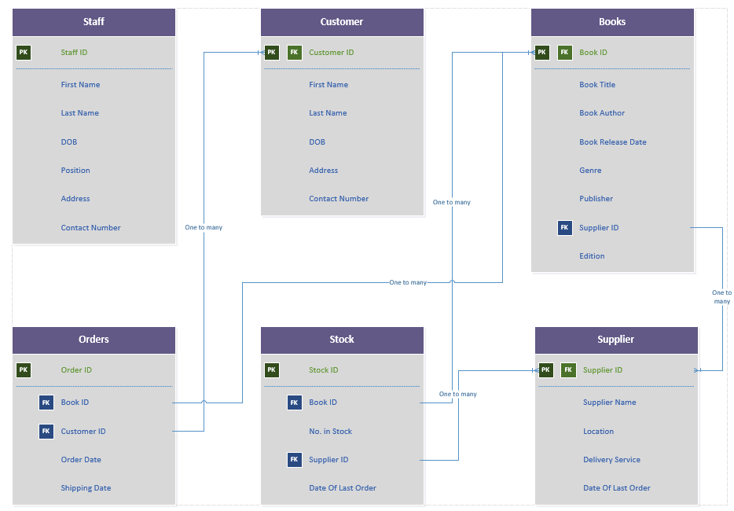
Margaret Rouse said for TechTarget [1], “Entity relationship diagrams provide a visual starting point for database design that can also be used to help determine information system requirements throughout an organization.”
The ID’s for each entity is the primary keys for each one as they are the most significant field of the entity. Some primary keys are also foreign keys, along with other fields in the entities as some fields will appear in other entities. This is was makes a relational database. Clare Hopping and Rene Millman said [2], “A relational database is a type of database where, put simply, data is related to other information across databases.”

Tables

3.1) Customers
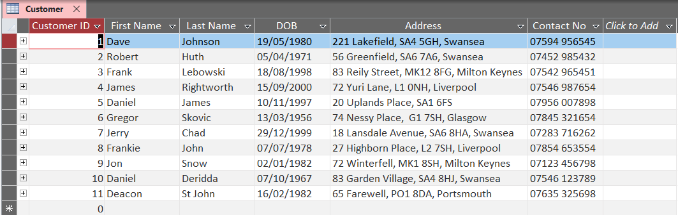
As Dylan’s Book Store is a business that sells books, they will need a table of previous customers in case of an issue with an order or if there was an error with their payment (E.g. Payment could be charged back). It includes important fields such as the customers name, as well as their address, used for orders, and for contact in the case of an error. As well as the primary key, in this case being Customer ID.

3.2 Employees (Staff)
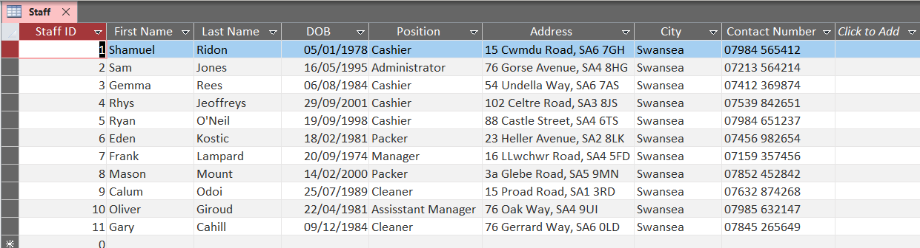
A list of employees/staff details are obviously needed to be able to contact employees/staff for last minute shifts, un-explained absences, and to send documentation like their P45’s and P60’s. It includes standard fields such as the employees name as well as their address and contact number in the case any of the scenarios from above were to happen. As well as the primary key, in this case being Staff ID.

3.3 Supplier
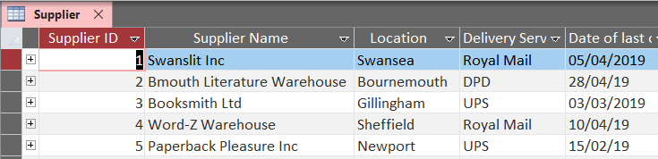
A table of the suppliers Dylan’s Book Store use is required so that they can keep track of what books are ordered from where and when the last order was made to help reduce the risk of over ordering. The primary key is Supplier ID, and includes other needed fields such as the suppliers name, location, and the delivery service they use. The date of the last order is also included to help with future orders as well as stock checks.

3.4 Stock
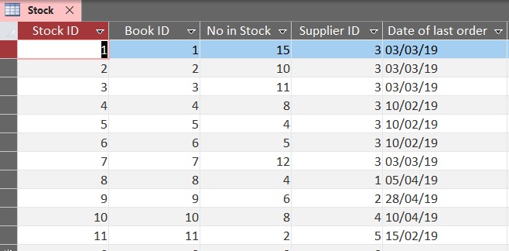
One of the bigger uses of the relational system used in the database. This table is able to identify books from the books table (Mentioned below) as well as identify the supplier that supply’s that specific book from the suppliers table (Above). The primary key is Stock ID, and is followed by 2 foreign keys, being Book ID and Supplier ID evidently taken from their own individual tables.

3.5 Books
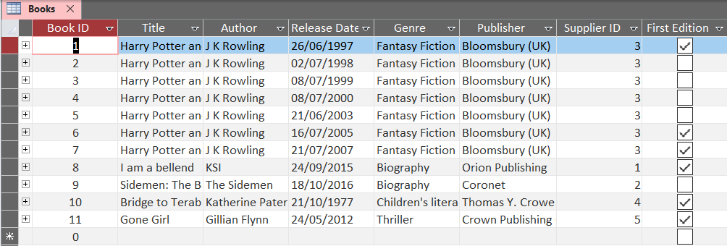
A list of the books sold by Dylan’s Book Store is needed so they in principal, know what they are selling. It also allows them to identify which books they sell are first editions, which means they are more valuable and can be sold for more to customers who are collectors. Having the field also means that books that are first editions can be specifically looked for in a query, which will be shown later. Primary key is Book ID, and also includes a foreign key of Supplier ID to identify which supplier supplied the book. Also has other standard information such as the books titles, author, genre and release date.

3.6 Orders
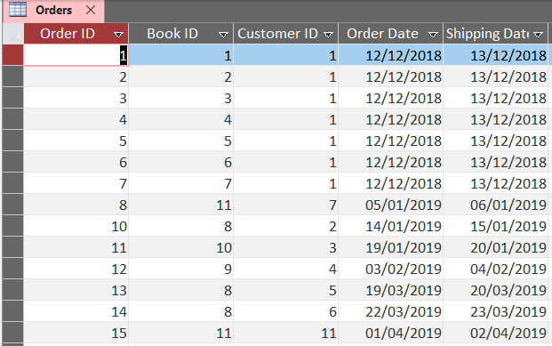
The orders table is important as it keeps track of all previous orders from customers. Using the relationships set up in the database it is able to track the customer ID’s and the book ID’s from their own individual tables.

Forms
Cheryl Adams, a data engineer for Quora stated [3], “In a database context, a form is a window or screen that contains numerous fields, or spaces to enter data. Each field holds a field label so that any user who views the form gets an idea of its contents. A form is more user friendly than generating queries to create tables and insert data into fields.”

4.1 Main Menu
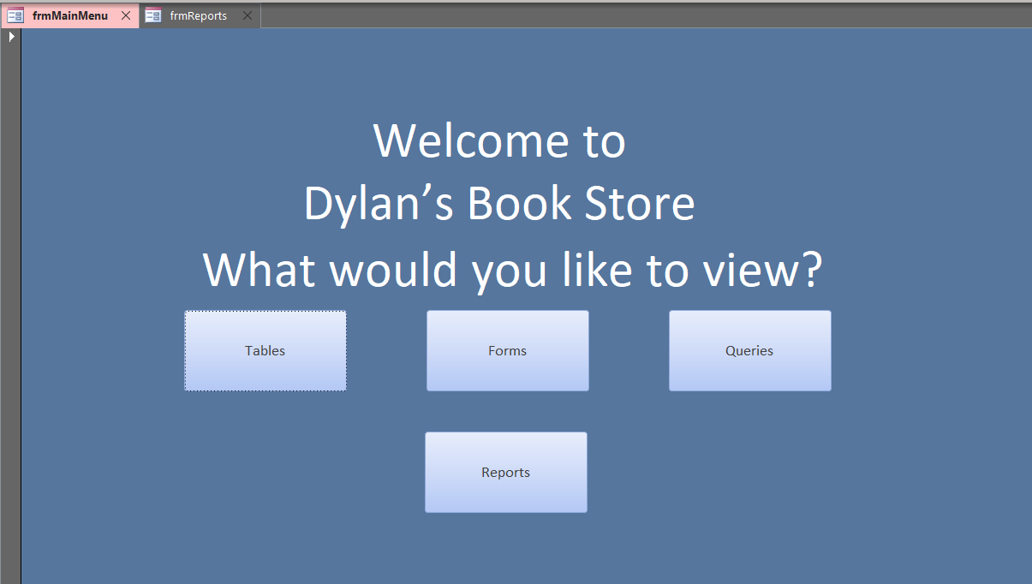
This is the main menu for the database that was made for Dylan’s Book Store. It is all menu driven with links to further forms (Mentioned below) for the tables, forms, queries and repors that are in the database.

4.2 Queries
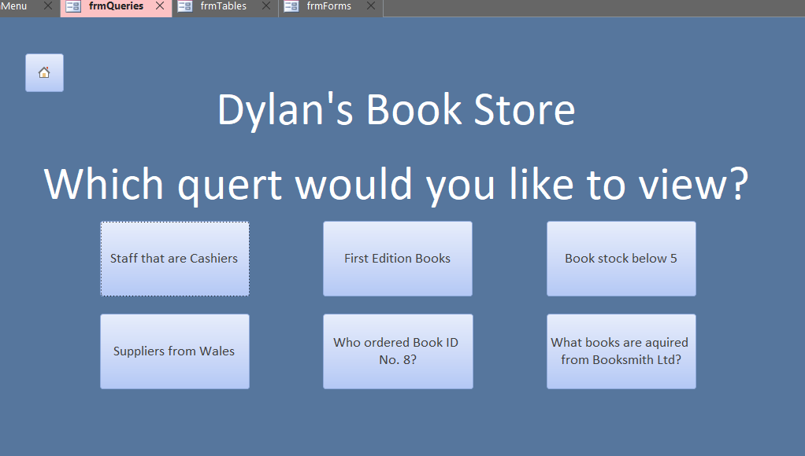
This is the queries menu page that links to each query that is included in the database.

4.3 Tables
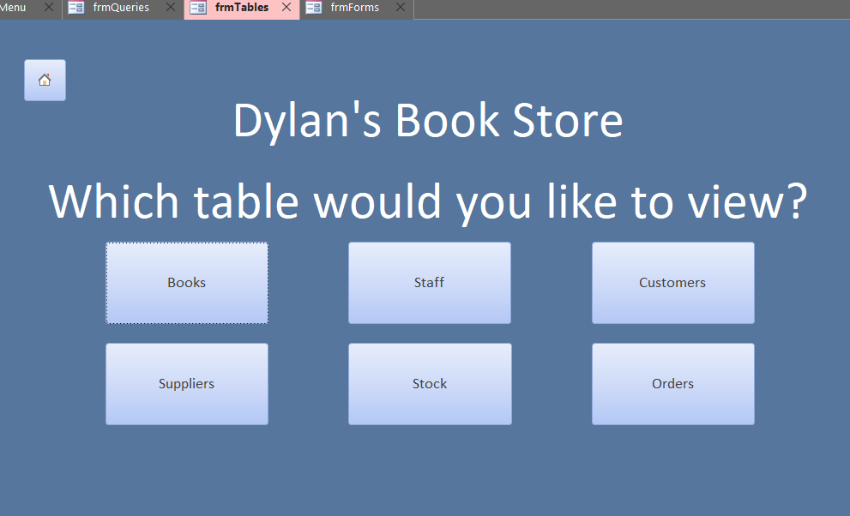
This is the tables menu page that links to each table that is included in the database.

4.4 Forms
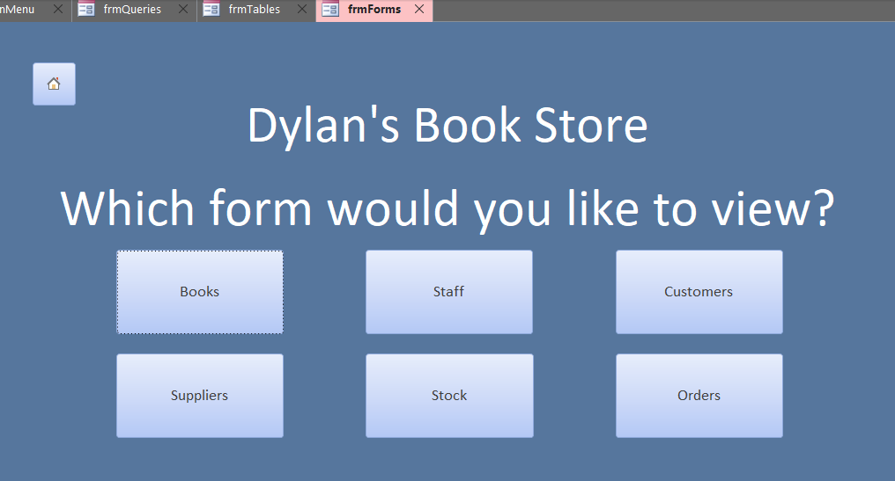
This is the forms menu page that links to each form that is included in the database.

4.5 Reports
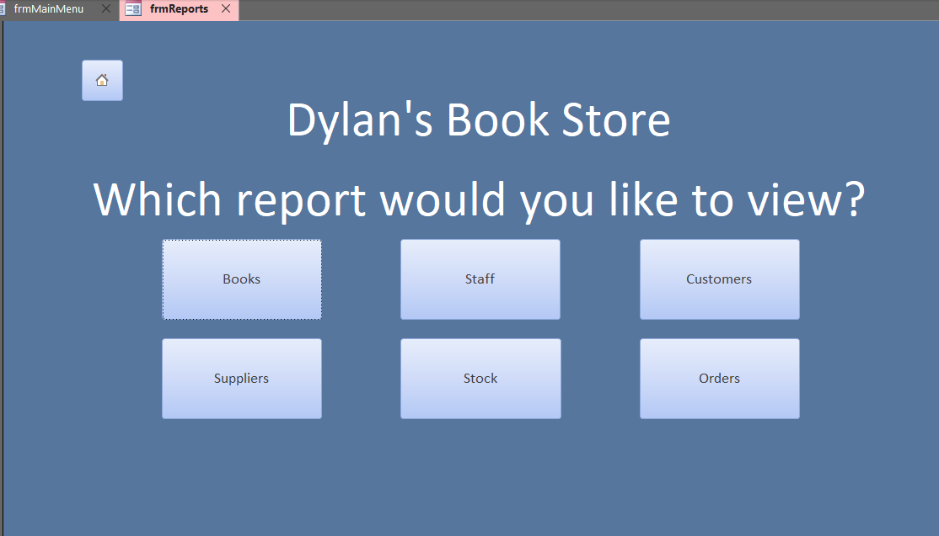

4.6) Overview of Menus
The menus created for the database follow a simplistic design which makes the system easy to use. The colour scheme works well together for accessibility, and each extension from the Main Menu includes a home button to return to the main menu.

4.7) Customer Form
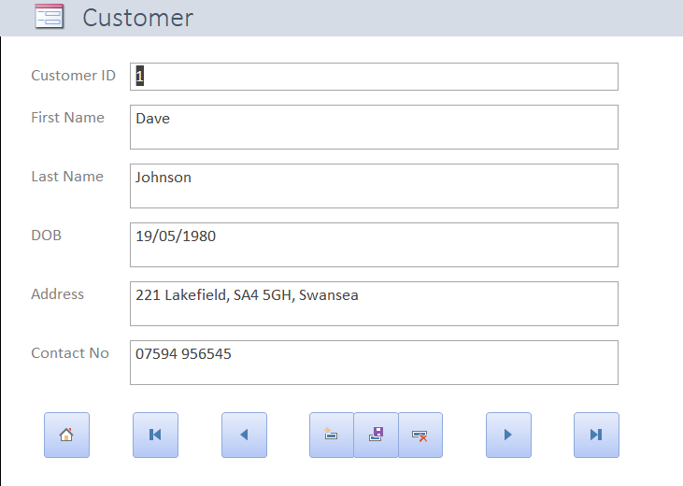

4.8) Staff Form
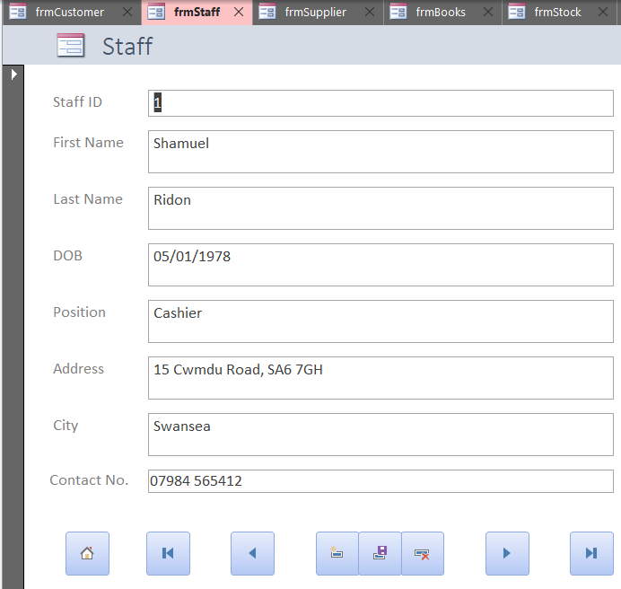

4.9) Supplier Form
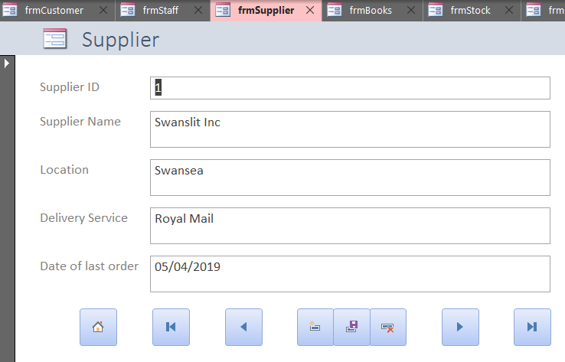

4.10) Books Form
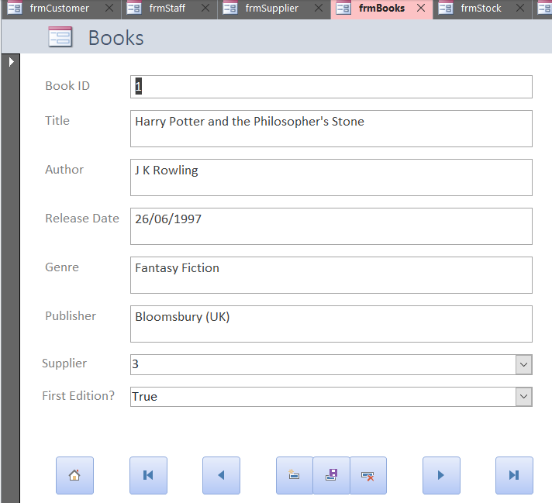

4.11) Stock Form
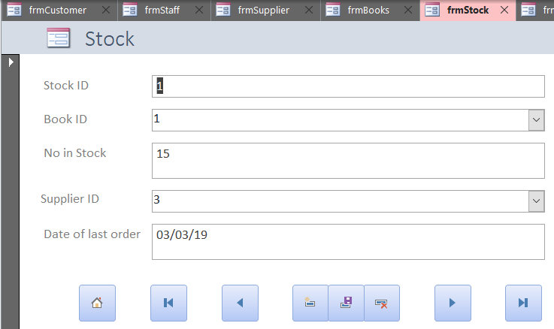

4.12) Orders Form
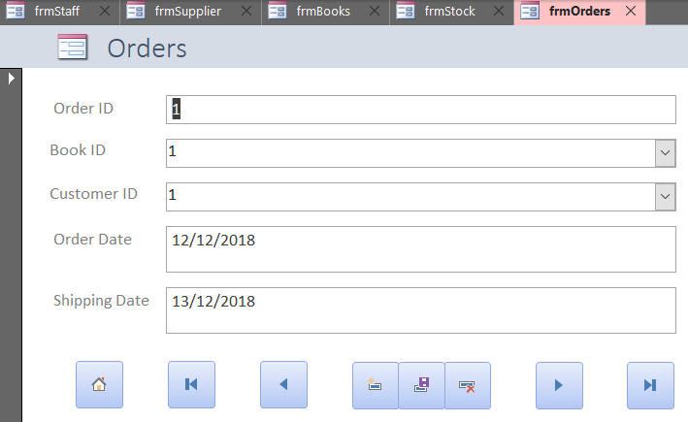

4.13) Overview of Data Entry Forms
The data entry forms are useful as they are a simple and easy data entry method for the tables. They are all menu driven with buttons at the bottom of each form preforming required actions (First record, Previous Record, New Record, Save Record, Delete Record, Next Record, Last Record, and a home button to return to the main menu).

Queries
Dan Brodt said [4], “If the data is the heart of a database, queries are the soul. A database is worthless if you can’t get meaningful information from it. To that end, a query is simply a method of extracting the data you want.”

5.1) First Edition Books
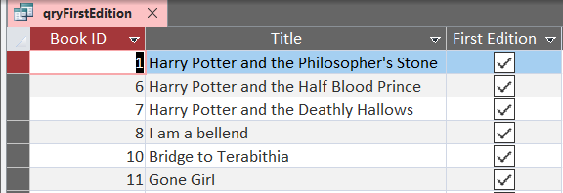
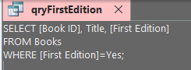
This query selects the fields ‘Book ID’, ‘Title’ and ‘First Edition’ from the books table and shows the results. However, using the ‘Where’ search in SQL, the results were able to be dictated to only show books that are first edition copies.

5.2) Cashiers
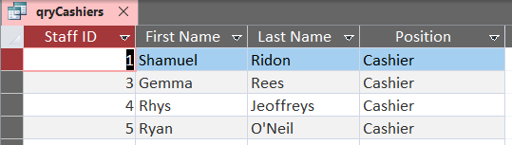
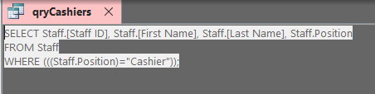
This query is used to identify all the staff that have the position of ‘Cashier’ and list their details. This query would be useful to identify other cashiers available if one cashier phones on sick or is on holiday so they can cover shifts.

5.3) Stock less than 5
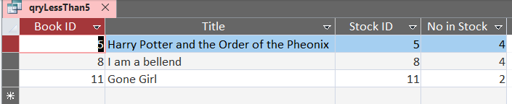
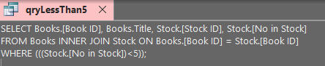
This query identifies every book that has less than 5 in stock. This is a useful took to be able to determine what books need to be ordered on the next order from a supplier. The query looks up from two different tables, in this case being the stock table and book table. It does this by using an INNER JOIN within the SQL code.

5.4) Who ordered Book ID 8?
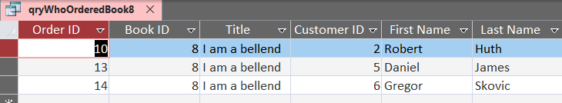
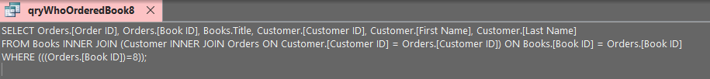
This query is used to identify all customers who ordered the book under Book ID 8. This can be used to identify customers and contact them if there is a book recall for whatever reason. It can also be used to identify how popular a certain book is and help determine how many need to be kept in stock and ordered at any one given time.

5.5) Suppliers from Wales
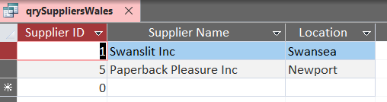
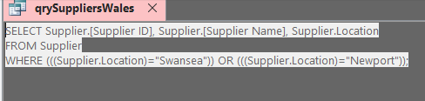
This query is used to identify which suppliers that Dylan’s Book Store are also located in Wales. This can be used to determine delivery times for books to arrive in stock if they are in high request.

5.6) Books from Supplier 3
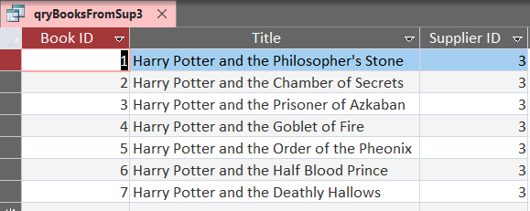
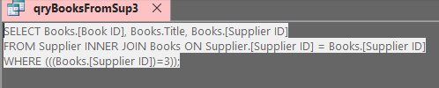
This query is used to identify which books come from specifically supplier 3, being Booksmith LTD. This can be used to determine how much of a loss it would be if Dylan’s Book Store were too cut ties with that specific supplier by determining what books they would lose access too if not available anywhere else.

Reports

6.1) Books Report
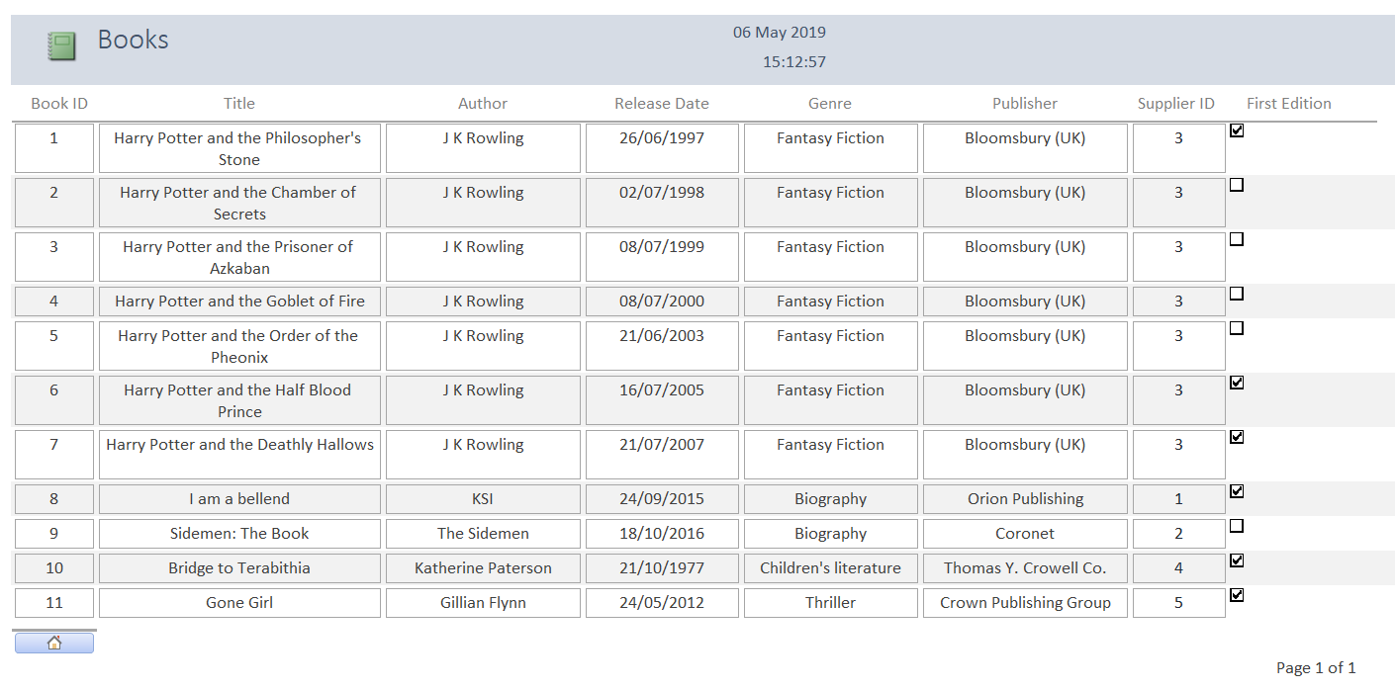

6.2) Customer Report
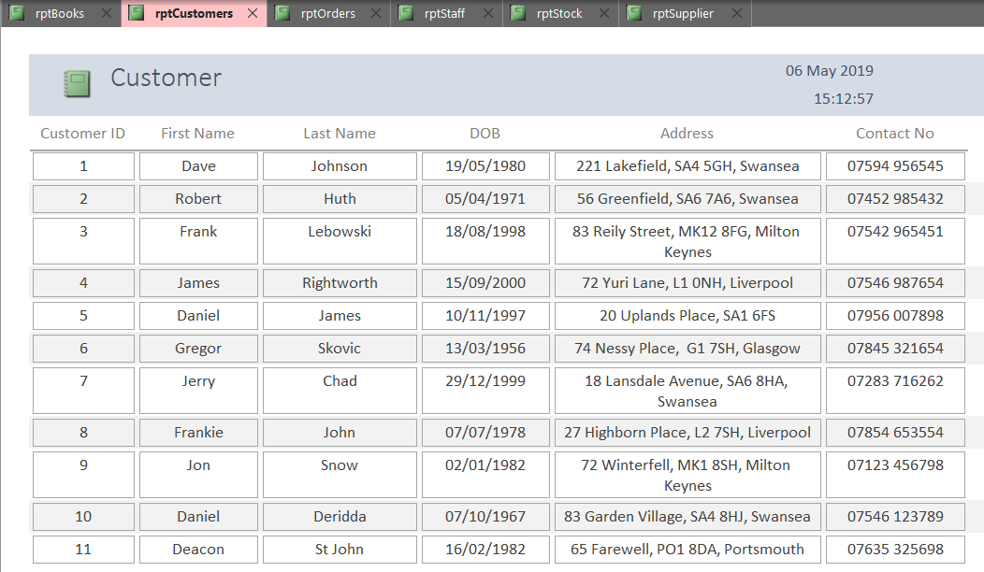

6.3) Suppliers Report
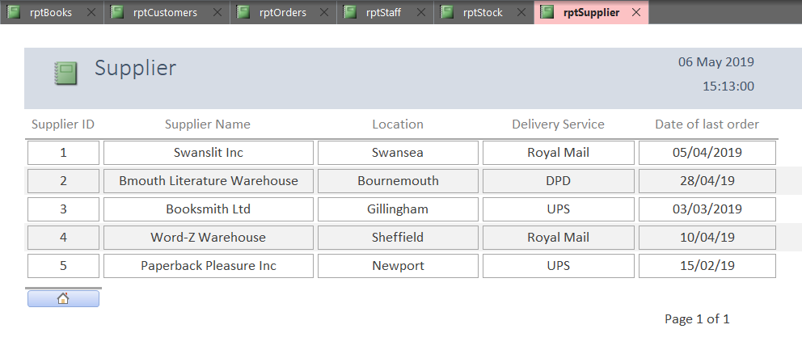
6.4) Orders Report
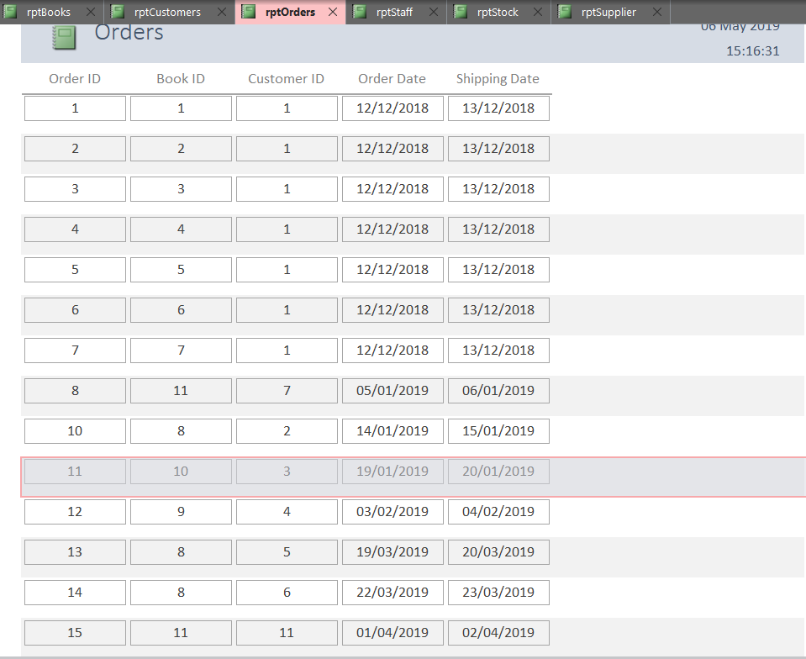

6.5 Staff Report
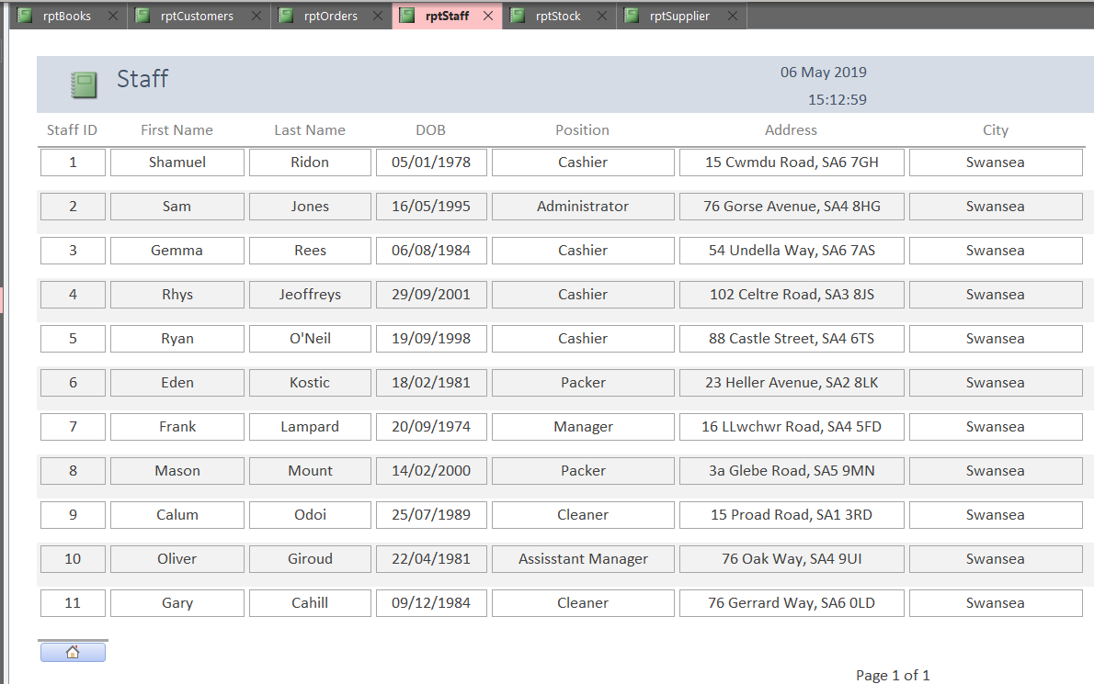
6.6 Stock Report
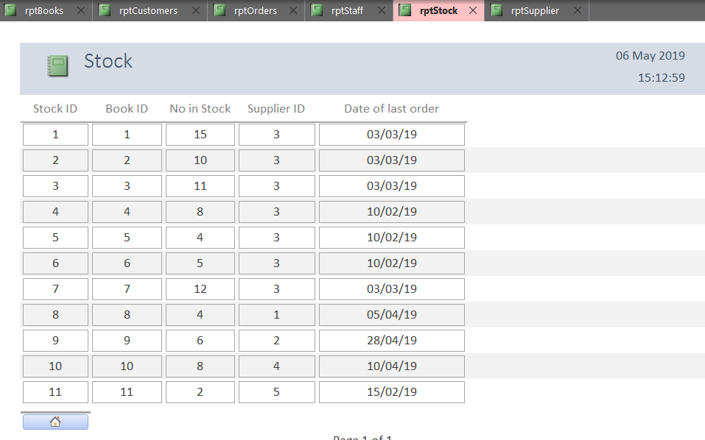
6.7 Overview of Reports
The reports are simple to use, and menu driven. They display all data from the tables in a presentable format by making it clear to read. It includes dates and times of when the report was printed to it can be looked back on and identified to when it was created to track the relevancy and how up-to-date the data is. This would be important if the report has been printed out, left around and turns up a few months later. This was that report wouldn’t be treated as or thought of as up-to-date data.

- User Guide
The database created is very easy to use. Someone with a very small amount of knowledge of IT could operate it. It is all menu driven which adds to the simplicity of it. With the tables, data is very easily entered, simply click on an empty space (or a used one, if editing) under the field name you would like to add data to, and then enter the data. With the forms, it is very similar to the tables. Once on the form you with to add to or edit, click on the text box next to the field name you wish to add data too, and then enter the data. The queries and reports are already set up, so simply use the menu driven menu to navigate to the queries and reports page.
Michal Wiewior said [5], “User manual? Providing people with the services and products they need definitely feels great. Not only are you making a profit, but you are also helping people with their problems.”

- Normalization
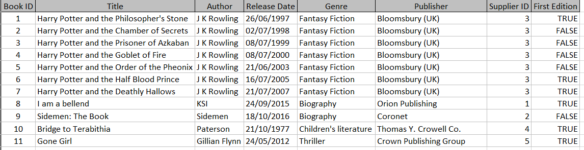
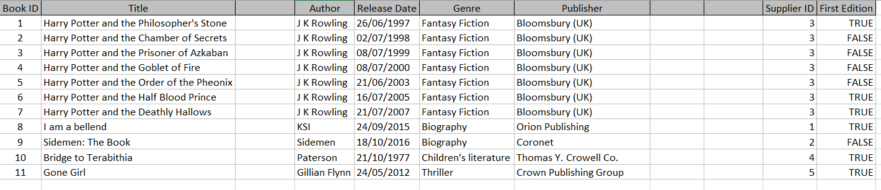
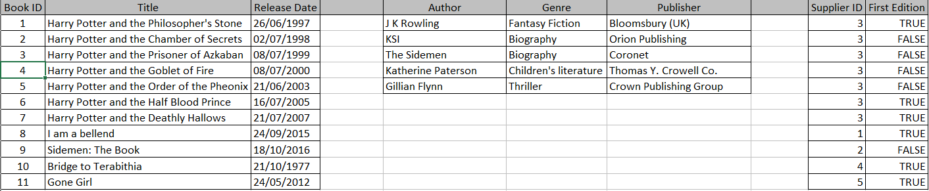
Above is the normalization process I went through to turn my Customers table from 1NF to 3NF. By the final stage, repeated data is removed and narrowed down the only the important information. The supplier ID was unable to be cut down, specifically all of the ‘Supplier ID = 3” fields, and this was because of the First Edition feed not allowing it, as each individual book is different, and one book from supplier 3 is indeed first edition.
- Evaluation
As a whole, this project has been a success. The goal of creating a relational database system for Dylan’s Book Store that is simple, easy and menu driven has been achieved. The database has relevant tables, forms and reports. The ability to use queries to isolate books that are specifically first edition has been added also for ease of access and to cut down searching time.

Bibliography

[1] | M. Rouse, “Entity Relationship Diagram (ERD),” TechTarget, [Online]. Available: https://searchdatamanagement.techtarget.com/definition/entity-relationship-diagram-ERD. [Accessed 04 May 2019].
[2] | R. M. Clare Hopping, “Relational databases underpin many applications and software, but what is it?,” ITPRO, 31st January 2019. [Online]. Available: https://www.itpro.co.uk/data-insights/31725/what-is-a-relational-database. [Accessed 1st May 2019].
[3] | C. Adams, “What is a database form?,” Quora, 12 July 2018. [Online]. Available: https://www.quora.com/What-is-a-database-form. [Accessed 04 May 2019].
[4] | D. Brodt, “What is the importance of a query?,” Quora, 24 August 2018. [Online]. Available: https://www.quora.com/What-is-the-importance-of-a-query. [Accessed 03 May 2019].
[5] | M. Wiewior, “Why It’s Important to Have a User Manual for Your Products,” Slavis.net, 08 August 2016. [Online]. Available: http://blog.slavis.net/translations/why-its-important-to-have-a-user-manual-for-your-products/. [Accessed 04 May 2019].

