Leadership and Change
BMPF7309/D

Kristy Gordon
Student Number: 2431950

Word count: 4786

Contents
Artificial Intelligence Statement 3
Glossary 4
Leadership and Change 5
References 20
Appendix 1 – Microsoft CoPilot Questions 28
Appendix 2 - SWOT Analysis 31
Appendix 3 - PESTLE Analysis 35
Appendix 4 – Change Management Plan 37
Appendix 5 – WAST Staff Survey Results 46
Appendix 6 - Care Home Questionnaire Results 49

Artificial Intelligence Statement
I acknowledge the use of Microsoft Copilot (https://m365.cloud.microsoft/) on multiple dates between 12/01/26 to 15/04/26 to support my assignment in research, searching for bibliography and for summarising, comparing and interrogating materials. A full list of questions asked to Microsoft CoPilot can be found in Appendix 1 – Microsoft CoPilot Questions
.

Glossary
ADRT – Advanced directive to refuse treatment
APP – Advanced paramedic practitioner
CCC – Command and control centre
CEO – Chief executive officer
CMT – Clinical model transformation
DNACPR – Do not attempt cardiopulmonary resuscitation
EAP – Emergency ambulance practitioner
ePCR – electronic patient care record
EMT – Emergency medical technician
HBCL – Health board clinical lead
HIW – Healthcare Inspectorate Wales
IMTP – Integrated medium term plan
LM – Locality manager
NHS - National Health Service
ReSPECT – Recommended summary plan for emergency care and treatment
ROSC – Return of spontaneous circulation
SICAT - Single Integrated Clinical Assessment & Triage
SP – Senior paramedic
WAST – Welsh ambulance services university NHS trust

Leadership and Change
I currently hold the role of senior paramedic (SP) within the Welsh Ambulance Services Universities NHS trust (WAST), a role which I have held since October 2024. The SP role is a clinical leadership role within the wider management team, which includes frontline clinical practice, operational delivery, and organisational leadership. I am responsible for delivering clinical excellence, providing leadership and guidance to paramedics, emergency medical technicians (EMTs) and emergency ambulance practitioners (EAPs), and contributing to the development and implementation of service improvement initiatives. I am immersed within the values and norms that create WAST’s workplace culture due to a proportion of my role taking place on a frontline ambulance, leading staff in unscheduled and emergency conditions, frequently in teams I haven’t worked with previously and may not have met. Consequently, I can also influence the culture of the organisation from the centre, by understanding how culture shapes, and is shaped by, staff behaviours, values and engagement with change and how frontline staff’s experience of culture may differ from the culture imagined by higher management.
WAST operates within a complex national health and social care landscape that continues to experience significant strain. High demand for emergency services, hospital handover delays, workforce pressures and an ageing population across Wales (Berg, 2025; Healthcare inspectorate Wales, 2020; Ombudsman Wales, 2026) contribute to a challenging clinical environment. These pressures are mirrored across NHS Wales more broadly, creating the need for ongoing development in WAST to ensure sustainable and safe patient centred care. WAST has introduced several change initiatives in recent years, with the appointment of a new chief executive officer (CEO) in 2025, the introduction of the clinical model transformation (CMT) strategy, digitisation of patient care records and wellbeing initiatives. These changes are necessary, but often difficult to implement in a system where cultural norms, resource limitations, and emotional fatigue strongly influence how change is experienced and accepted by frontline clinicians. With so much change happening at once, acceptance of further change may be difficult to successfully achieve.
It is widely agreed that culture is central to the functioning of an organisation and will determine whether change initiatives succeed or fail (Almutari, et al., 2022). Scholars struggle to agree on a definition for the concept (Khaddour, 2025), however it is broadly described as the shared values, feelings, behaviours, and underlying assumptions that guide how people work together, but is not exclusively a set of desired ideals put forward by the organisation (Almutari, et al., 2022; Hofstede, Hofstede and Minkov, 2010; Khaddour, 2025; Mannion & Davies, 2018). In an ambulance service, culture develops over time through shared experiences of high-intensity environments, autonomous and team working and adaptation of policy to suit individual situations. Whilst aspects of this culture such as camaraderie, resilience and commitment to patient care support effective teamwork, other embedded values and habits can create barriers to change. These may include resistance to new practices, burnout, outdated thinking, or a disconnect in priorities between frontline staff and senior management. Understanding the impact of culture is essential to consider when evaluating why some change initiatives succeed while others fail (Senior & Fleming, 2006). Khaddour (2025) argues that there are opposing theories to organisational culture, in that it can be something an organisation has, that can be measured and controlled, or that culture is something an organisation is, which cannot be controlled by managers and is innate to people’s everyday interactions.
There are a number of conceptual frameworks, such as Schein’s three level model of culture (Schein, 2010), Hofstede’s cultural dimensions (Hofstede, Hofstede and Minkov, 2010), and the Johnson and Scholes cultural web (Johnson, Scholes & Whittington, 2008) which offer differing perspectives on how organisational culture is constructed and how it manifests during periods of change. Critically evaluation of these models enables a clearer understanding of their strengths and limitations, particularly in complex healthcare environments where culture is often deeply embedded.
Schein was a pioneer in the understanding of organisational culture and through decades of research and development, he developed three levels of culture as depicted in Figure 1. These levels represent the visibility of a cultural phenomenon to the observer, from superficial values to the deep, unconscious beliefs that shape behaviour (Schein, 2010). Schein was the first to suggest that culture could be a dominant force within an organisation (Chartered Management Institute, 2015) and he postulated that misalignment of the 3 levels of culture could make change harder to implement (Schein, 2010).
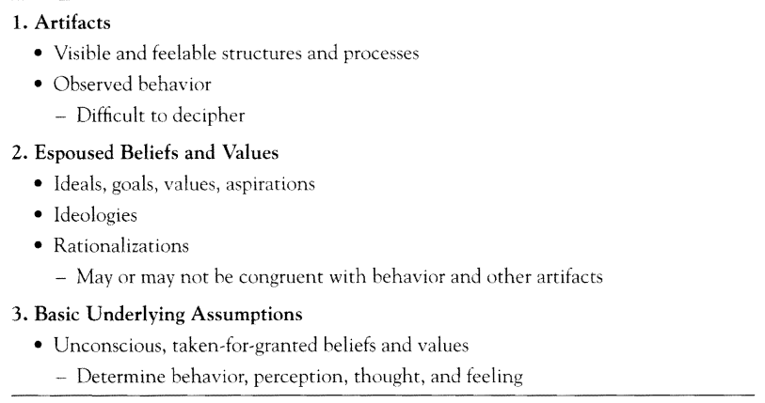
Figure 1 - Schein's three levels of culture (Schein, 2010)
The superficial, level 1 “artifacts” of Schein’s (2010) model, are the observable, overt elements of an organisation, such as uniforms and epaulettes, policies and procedures, observed behaviours on shift and information dashboards. Espoused values within WAST relate to advertised core values such as patient centred care, “to support, to serve, to save” (WAST, 2025b) and the WAST behaviours (WAST, 2024c) (as detailed in Figure 2).
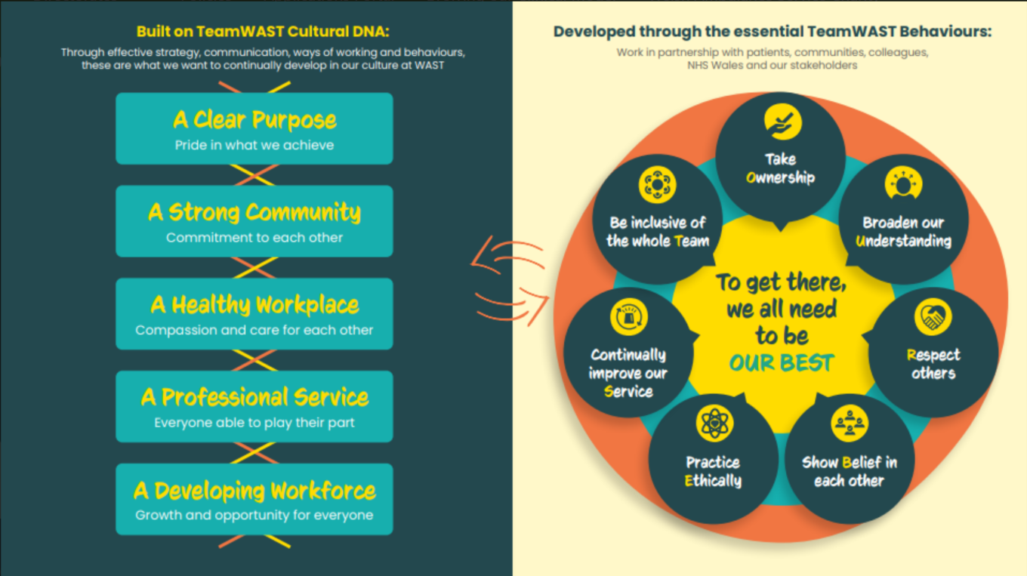
Figure 2 OUR BEST, WAST's behaviours (WAST, 2024c)

The deeper basic underlying assumptions within WAST, are the “how things are done” beliefs that are passed on from senior members of staff to new starters and are the underlying essence of organisational culture (Schein, 2010). Examples of these unconscious, embedded beliefs and values within WAST are patient centred care focus, management and the command control centre (CCC) having little concern for staff’s wellbeing, with operational pressures always overriding staff wellbeing, blame culture rather than a learning culture of clinical governance and budgets before staff welfare. These deep-rooted beliefs are the most influential and non-debatable layer of Schein’s model, making them the most difficult to change. This can be in part due to initiating change in this area, requires the organisation to upset it’s stable base, causing high levels of anxiety for all involved (Schein, 2010). Despite low morale and ill feeling within frontline staff (Healthcare inspectorate Wales, 2020; Ombudsman Wales, 2026), upsetting this stable base would cause increased feelings of uncertainty and chaos. This contradiction presents a challenge to leaders in their management of transformation.
Within these cultural assumptions, Schein argues that change initiatives regularly fail because they fail to successfully challenge the basic underlying assumptions of an organisation (Schein, 2010). If initiatives seek to only change surface level artifacts, without addressing the underlying basic assumptions, they will easily resort back to the original stance (Westover, 2024). Westover (2024) argues that as Schein’s model allows for deep cultural understanding, facilitating modelling of artifacts and espoused values in a way that aligns all three levels and gradually changes basic assumptions over time. This will therefore give leaders the understanding to implement change.
The introduction of WAST behaviours (Figure 2) in 2023 (WAST, 2025b) was a change of espoused values (the behaviours themselves, training in the behaviours and the introduction of behaviour champions) with a consequent change in superficial artifacts (posters, change of language used, visible changes to IT elements including email sign offs etc). The challenge arose with challenging staff ‘s basic underlying assumptions and a reluctance of staff to accept these new behaviours. Staff were sceptical of the new branding just being a plaster on a large wound. Although there were some efforts to change basic underlying assumptions, resistance from management also made the change harder to translate to the wider workforce. Westover (2024) also argues that directly confronting these assumptions rarely works in transforming culture.
The emphasis from WAST on staff wellbeing and compassionate management within its Our WAST Way management and leadership guide (WAST, 2024b) and the WAST wellbeing objectives (WAST, 2024d) under the Welsh Governments Wellbeing of Future Generations Act 2015 (Welsh Government, 2025b), has been met with further scepticism and resistance and the lived reality is different on the frontline. The underlying basic assumptions are that staff wellbeing is a lower priority than meeting strategic targets. Low staff morale (Healthcare inspectorate Wales, 2020) is not helped by staff wellbeing initiatives being removed, plus pressure from WAST to abide by the behaviours (Figure 2). Staff were previously allowed a £5 concession at hospital canteens for a ninety-minute wait outside hospital. This initiative made the demoralising hospital waits more bearable, but in the past month this concession has been changed from ninety minutes to four hours. Staff feel further demoralised and underappreciated, particularly where hospital waits are still extensive. This attempted change to the espoused values of WAST’s culture, to improve compassion and staff wellbeing, is on track to fail in part due to its inability to change the underlying basic assumptions that WAST has true concern for its staff wellbeing and part because WAST has sabotaged itself in the removal of a simple initiative, presumably for financial reasons. Staff will be further reluctant to engage with future initiatives and consequently the change may fail. The ADKAR model for organisational change utilised in my change project, states that a successful period of staff awareness would combat some of these barriers (Prosci, n.d.), as if staff understood that the reason for the removal of certain wellbeing initiatives was down to finances, and that budgetary constraints in some areas could potentially save more lives in other, then they may be more accepting of change. Acceptance is difficult to achieve, in a top heavy, hierarchical organisation such as WAST, with limited justification from higher management on the loss of a much-loved initiative as the £5 concession. Staff awareness of what wellbeing initiatives are being maintained or introduced would allow staff to have more trust in the wellbeing and compassion messages WAST is delivering.
Fripp (2026) and Khaddour (2025) argue that Schein’s model is too oversimplified for a dynamic area as organisational culture. Existing basic assumptions have allowed people to succeed thus far, therefore adapting to new change can cause anxiety and fear of failure (Schein, 2010). Fripp (2026) also argues that Schein’s model doesn’t allow for the influence of external factors such as the political environment and regulatory bodies on organisational culture. External factors are numerous and wide reaching and are discussed in a PESTLE analysis in Appendix 3 - PESTLE Analysis. Hogan and Coote (2014) argue that there is very little empirical testing of Schein’s model which could question its validity in the field and difficulties arise in the measuring of basic assumptions. This could cause issues for leaders in the organisational application of the model during change, if elements are difficult to measure against what is good, bad or changing.
Hofstede developed six dimensions of national culture (Figure 3), which was used to explain a person’s culture as the influence of how they were raised, the societal norms and shared values of that country. This was then expanded to a separate model for organisations, with Hofstede describing how a person’s national culture would dictate how they would behave within an organisation (see Figure 4)(Hofstede, n.d.). Hofstede stated that organisation’s themselves have a separate culture, and an understanding of national culture can be utilised by organisational leaders to understand how people will react in certain circumstances (Hofstede, Hofstede and Minkov, 2010). For instance, how some staff members react to the strict hierarchical structure of WAST may mean some people are less willing to challenge leaders even if there is an obvious issue.
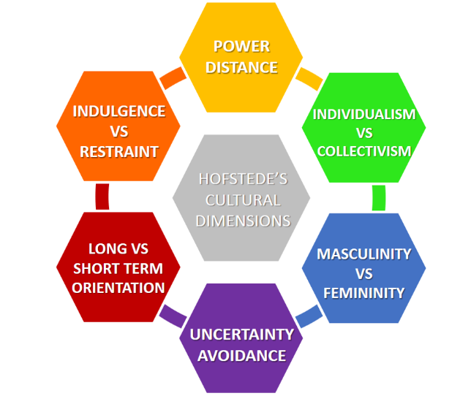
Figure 3 - Hofstede's Cultural Dimensions (de Bruin, 2017)
Hofstede’s model of organisational culture described 6 dimensions of practice, as illustrated in Figure 4 (Hofstede, n.d.). This study however was completed in only 2 countries both with similar cultural dimensions, looking at 20 similar corporate organisations in the 1980s. Hofstede himself states that this model may therefore not be applicable in other, culturally different countries and organisations (Hofstede, n.d.).
The organisational model provides some insight into change within an organisation. WAST’s position has been included within Figure 4 for comparison.
Organisational Model Dimensions |  |  | WAST
Process-oriented | vs | Results-oriented, | Balance between process and results orientated
Job-oriented | vs | Employee-oriented | Job orientated
Professional | vs | Parochial | Professional identity (but strong “that’s how we’ve always done it”)
Open systems | vs | Closed systems | Both open and closed system due to subcultures
Tightly | vs | Loosely controlled | Tightly controlled
Pragmatic | vs | Normative | Normative approach, but still patient centred (pragmatic)
Figure 4 - Hofstede's organisational model (Hofstede n.d.) and WAST's position
According to Hofstede, Hofstede and Minkov (2010), because of the strongly job orientated culture, change may be met with compliance, but lack engagement from staff as they are pressured to just “get on with it”. The strong professional identity amongst paramedics, EMTs and EAPs make adoption of clinical changes easier to implement than cultural and behaviour changes in the wider organisation. Clear communication within an open system may make change easier, but the elements of closed subcultures on individual stations may make new starter inclusion less likely. Due to the tightly controlled system, with a strong focus on policy, change must be meticulously planned and communicated, as staff dislike uncertainty and inconsistency. This has been reflected in the upcoming changes to the termination of resuscitation guidelines, where significant staff communication has been undertaken, alongside training and reminders. WAST also sits within the centre of normative and pragmatic, with strict focus on policy, rules and procedures, but with additional focus on patient care and outcomes.
An example of a failed change initiative that contradicts Hofstede’s organisational model was the introduction of the Paramedic Pathfinder triage tool. The tool was introduced in 2015, to facilitate the safe assessment of patients over the age of 16 (Jones, 2015). By 2022, Paramedic Pathfinder had been removed from use by paramedics within WAST, citing “data indicates that this tool has not been routinely documented on paper PCRs prior to the deployment of ePCR, therefore use is inconsistent” as the reason for removal (Swinburn, 2022). Staff resistance levels were high due to removal of autonomy, forgetting to utilise the tool and increased paperwork. I previously worked within an ambulance service where the same tool was used with excellent results. The tool became part of our day-to-day role, following a thorough awareness period during its implementation. Staff became invested in its usefulness for increased patient safety and consequently welcomed its use when they discovered the ease if its use. It therefore became the norm. The clinical leadership team were fully invested in the tool and acted as role models in its use. Any resistance was faced with reasoning, discussion supporting its implementation and a shift in cultural norms towards the inclusion of it by all staff. The underlying WAST culture, particularly in Powys, is one of resistance to change, with some members of frontline staff attempting to dictate how the service runs, through stubbornness and bullying. Hofstede’s theory that cultures with a strong emphasis on the professional identity are more likely to adopt clinical change was contradicted in this instance (Hofstede, Hofstede and Minkov, 2010).
Hofstede’s models were based on studies with narrow demographics in the 1960s-1970s (Tan, 2025), using only one corporate company in the original national cultures research (Worthy, Lavigne & Romero, 2020) and therefore has limited use within healthcare organisations. His studies are criticised for being outdated and Western centric, with further questions about his methodology and data collection (Worth, Lavigne & Romero, 2020). His work only offers a static view of culture, ignoring the change that occurs following social, economic and globalisation influences on organisations (Tan, 2025).
The cultural web developed by Johnson and Scholes identified 6 aspects that feed into the organisational culture paradigm (Figure 5). The seven interconnected aspects analyse the current organisational culture and assist leaders with assessing the impact of culture on strategic challenges with identification of barriers or enablers of change (Johnson, Scholes & Whittington, 2008). The paradigm also effectively aligns leadership behaviours with organisational values and facilitates the identification of misalignment between the workforce and the culture, and consequent barriers to change (Balogun & Johnson, 2004).
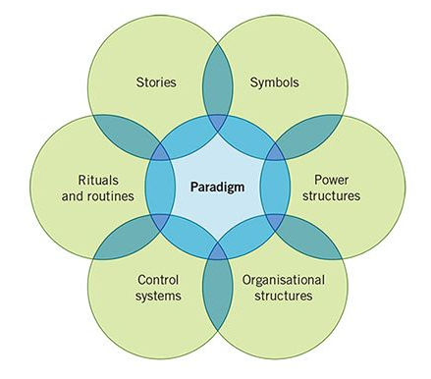
Figure 5 –Johnson and Schole’s cultural web (Whittington et al., 2023)
The paradigm at the centre of the web is a set of a core assumptions that are taken for granted within an organisation (Whittington et al., 2023), for instance the core values of WAST being patient centred care and “to support, to serve, to save” (WAST, 2025b). Johnson and Scholes (Whittington et al., 2023) described the rituals and routines as those day-to-day tasks such as vehicle checks, ePCR completion, clinical assessment etc. Routines may be difficult to change as they have become semi-conscious in their execution and therefore pose a challenge to any leader attempting to implement change within the routine running of frontline emergency care. Stories within WAST generally involve heroic acts, interesting incidents, crew room discussion and stories told to newcomers. This can be interpreted as an important method of debrief (Kolbe, et al., 2019), but may verge on arrogance and egotism. Stories tend to be interpreted as what is important within the culture of an organisation (Whittington et al., 2023), and if this is perceived to be arrogance or bravado, then new members of staff may feel reluctant to come forward with points for discussion and learning. I have witnessed senior members of staff belittling newer staff members for discussing incidents which upset them, causing the newer member to be reluctant to voice concerns in the future, damaging their psychological safety and causing them to internalise traumatic incidents (Snowdon, 2021). There is a traditional culture within ambulance services not discussing traumatic incidents and whilst this is changing, there is still a subculture of the workforce that believe that it isn’t necessary. WAST is attempting to combat this with their WAST behaviours, “respect each other”, compassion and “building a stronger workforce” (see Figure 2 (WAST, 2024c)).
Symbols play a significant role within WAST, in the uniform, fleet and station layouts. These are used to promote professionalism and establish the hierarchy under control systems of the cultural web, which is heavily relied upon within WAST. Organisational structure within WAST follows a strict hierarchy and control systems would include the areas which leadership and management rely on, such as clinical indicators, monitoring of response categories, compliance with mandatory training and sickness rates. Strict reliance and imposition of these aspects can cause staff to feel overly controlled. Over emphasis on areas such as clinical indicators can leave staff with the “nagging” feeling which may cause them to disengage. This can make change particularly difficult to implement in these areas, in an organisation where staff morale is already low, further pressure from leaders can leave them feeling underappreciated. Power structure within WAST highlights the distinct divide between the operations and clinical arms of the organisation. Frequent disagreements occur between the arms with regards to the approach to patient centred care and the heavy influence of financial pressures in the operations arm. These barriers have been felt by SPs during their change projects, encountering hurdles from the operations directorate in implementing projects which may require funding, or in areas that may question policies or procedures originally instigated by members of management higher in the power structure.
The cultural web explains why some change projects fail, due to the collision between power structures (operation vs clinical directorates), attempting to change existing routines and the disconnect between frontline staff and management. Critics of the cultural web argue that it is too simplistic and lacks depth in its exploration of the fluidity and ambiguity of culture within complex organisations, which may include subcultures and conflict between aspects of the web (Cooper et al., 2018; McDonald & Foster, 2013). McDonald & Foster (2013) also argue that the cultural web assumes cohesion and one single shared paradigm as the core of the organisation, however complex systems such as NHS trusts may have competing paradigms. This is true of WAST, with their core paradigm being patient centred care, but to function as an organisation, staff wellbeing is equally as important according to the trust. As with the other models, the cultural web provides a static view of culture and doesn’t account for its evolution, external pressures and threats and doesn’t account for differences in the individuals who make up the organisation (Cooper, et al., 2018; McDonald & Foster, 2013).
Change programmes frequently fail, not because the change itself is flawed, but because cultural norms, unwritten rules and values and collective staff attitudes undermine the efforts of the leaders implementing the change. It is important to consider the extent to which organisational culture supports or inhibits successful change initiatives during the planning stages of a change project and allow for these cultural elements during implementation. Anecdotal evidence from professional practice, such as staff resistance, anti-organisation feelings and poor attitudes to new staff, helps demonstrate how cultural dynamics influence outcomes in real settings. Organisational change is a necessary and constant factor within ambulance services and paramedic leadership due to the high pressure, multifaceted and ever-changing environment of pre-hospital care. Rising service demands, wellbeing concerns, workforce shortages, staff morale and leadership pressures all combine to create significant and recurring challenges to the leadership team during these times of change. The most significant of challenges to the leader during times of organisational change involves the management of the human response during prolonged periods of uncertainty. Trust, engagement, attitudes, psychological safety and perceptions are all to be considered during times of instability and whilst under continued operational pressures (Ahmad & Cheng, 2018; Eaton-Williams & Williams, 2023; Makrides et al., 2023). With higher-than-average levels of poor staff morale, stress and burnout a feature within WAST (Health Education and Improvement Wales, 2024), managing change requires significant emotional intelligence, flexibility and excellent communication from leaders (Cavaness, Picchioni, & Fleshman, 2020; Makrides et al., 2023). Staff develop fear and negativity towards the change and perceive it as unfair, this is known as “resistance to change” (Rehman et al., 2021). It has been suggested that deep-rooted cultural behaviours, such as workforce beliefs, attitudes and emotions, can determine their level of resistance to change (NHS England, 2024; Rehman, 2021). Leaders must initially address staff’s readiness for change and provide support and a positive attitude during the change to reduce resistance for project success (Niehoff et al., 2001; Rehman, 2018).
The constant monitoring, support and emotional intelligence required during times of change is accompanied by huge psychological burden to the leader (Makrides, 2023). Leaders are required to be credible, positive role models during times of change (NHS England, 2024) and supress their own doubts, to foster feelings of trust and enthusiasm from the workforce (Cavaness, Picchioni, & Fleshman, 2020; Eaton-Williams & Wiliams, 2023; Sekiguchi & Cuyper, 2022). Leaders must also be able to adapt their leaderships styles to the cultural context and situation (Viana & Machado, 2025). They must do this with limited support from the organisation (Sekiguchi & Cuyper, 2022), but with pressure from both senior management and frontline staff (Makrides, 2023). This is reflected in my own role, as during the clinical model transformation, staff members would approach the SP team with queries and concerns, negative feelings and scepticism regarding the efficacy of the changes and we were expected to provide answers and promote WAST’s changes, with limited prior consultation and no additional information regarding the project. This placed great stress and cognitive burden upon my shoulders, which affected my bandwidth for undertaking my basic role as a frontline paramedic. Furthermore, SPs are required to support and implement change but are given no protected time to do so. Whilst my immediate managers are supportive of change projects and are in similar positions of pressure from above and below, studies show that the move from frontline worker to leadership role is without sufficient preparation and formal training (Waller, 2022). Consequently, leading during organisational change, whilst learning to be a leader becomes a mountainous challenge.
Inconsistent and fragmented communication is challenge throughout a change project. Leaders often underestimate how much communication is required for successful change projects, leaving staff unclear about what the change involves and the reason for the change (Kotter, 1995; Taruchain-Pozoa et al., 2025). Effective communication can shape the shared understanding of change and foster trust, rather than just informing staff of implemented change (NHS, 2026), but with the digitisation of communications in most organisations, information overload and lack of face-to-face discussions with leaders can be barriers. Furthermore, the limited capacity leaders possess for effective communication of changes can lead to potentially distorted messages and misunderstandings amongst staff (Taruchain-Pozoa et al, 2025).
There are significant levels of change already underway within WAST, with the 2018-2030 “delivering excellence” strategy, CMT, IMTP, wellbeing plan 2025-2029, revised Emergency Ambulance Performance Framework and the strategic quality plan 2025-2028. WAST only has a finite capacity and financial availability for change projects and with the management of several major change plans currently underway, is at risk of underperforming on some projects and stifling the implementation of new ones (Auditor General for Wales, 2025). Leaders also face “change fatigue” in staff who are already unsettled and anxious, creating further barriers to successful change implementation (Auditor General for Wales, 2025; Eaton-Williams & Williams, 2023; Makrides, 2023).
Specific to my role as a clinical leader within Powys, locality discrepancies play a major role in the challenges faced during change. Powys is the largest locality in Wales, covering a wide range of mainly rural areas, with a sparse, widespread, above average age population (Office for National Statistics, 2024). Because of these external factors, Powys has different demands from the ambulance service than areas such as Cardiff and Swansea, where higher management tends to sit. Higher management appear to misunderstand the important differences in Powys and seem reluctant to change this stance, despite differences such as increased travel times, a lack of hospitals and training centres and lack of non-conveyance pathways etc. Management is unwilling to treat Powys as a different entity and projects that attempt to transform Powys specifically can be met with resistance. To combat this, middle management within the locality are starting to implement change to suit Powys, then present the successful results later. This is a positive step towards the implementation of change projects at a local level.
Further external issues that can impact the implementation of change within WAST are covered in a PESTLE analysis (Appendix 3 - PESTLE Analysis). Significant top-down pressures from Welsh government, NHS Wales and budgetary constraints collide with operational pressures, public perception and an ageing population to create a complex environment for the implementation of change. A SWOT analysis has also been performed (Appendix 2 - SWOT Analysis) to assess the current position of WAST in its readiness for change. Priority for change is given to projects which will have a broad impact to the trust, are financially viable (or have negligible financial impact) and on assessment by higher management, will be worth their time investment, or are to be solely led by middle leaders such as SPs, with minimal support from above. Such change projects as I have proposed in my change management plan (Appendix 4 – Change Management Plan) may be viewed by higher management as insignificant, however such projects tend to be important to improve the day-to-day frustrations of frontline staff. Whilst WAST is a strong proponent for change, currently the organisation is implementing a significant amount of change at once (Auditor General for Wales, 2025), with naïveté to how such levels of transformation will be implemented and adopted by an already stretched, fatigued and burned-out workforce.
The change management plan (Appendix 4 – Change Management Plan) details the proposed change project for the development of a flow chart to improve handover delays to ambulance crews when attending care homes. During the development of the change plan, several change management models were studied and critically analysed and the results were discussed in a presentation. The chosen change management model utilised in my project was the ADKAR model, which can help address challenges such as resistance and psychological aspects (Anjum, 2024) whilst focussing on the individuals who makes up the organisation (Prosci, n.d.). It provides a practical, stepwise approach which strays from the linear approach proposed by many other models (Mengsha, 2023).
Leading a change project within an organisation presents a cognitively challenging and multifaceted task, which more than two thirds of leaders fail (Beer and Nohria, 2000). Leaders attempting to successfully implement a change project within a healthcare organisation, with pressure from Welsh government and higher management, frontline staff and the public, need to possess high levels of emotional intelligence, resilience, and flexibility (Viana and Machado, 2025). Leaders must address the psychological aspects of change to the workforce, including anxiety, burn out and change saturation, whilst being positive role models, adapting their leadership techniques to individual circumstances and still performing as outstanding clinicians. Whilst the ADKAR model fails to address culture, through additional awareness of organisational cultural challenges proposed by scholars, leaders can adapt the implementation of change plans to ensure success in any dynamic culture. Successful change management requires clear and regular communication through multiple modalities, which is where the majority of projects fail. Leaders must motivate, foster trust from staff during times of instability and monitor staff wellbeing, whilst undertaking thorough preparation, alignment of leadership behaviours and ensure a comprehensive knowledge of the proposed change. Leaders must challenge basic underlying assumptions, but also tackle superficial elements for change to be sustained (Schein, 2010). The task of change management within WAST is a gargantuan one, particularly for those members of the leadership team who are learning to lead at the same time as implementing change projects to a workforce that are resistant to change, but one that can be mitigated by thorough preparation, emotional intelligence and excellent communication.

References
Ahmad, A.B. & Cheng, Z. (2018). The role of change content, context, process, and leadership in understanding employees’ commitment to change: the case of public organizations in Kurdistan region of Iraq. Public Person. Manag. 47 (2) 195–216. Available at: https://journals.sagepub.com/doi/abs/10.1177/0091026017753645 (accessed: 08/04/26)
Almutairi, R.L., Aditya, R.S., Kodriyah, L., Yusuf, A., Solikhah, F.K., Al Razeeni, D.M., Kotijah, S. (2022) Analysis of organizational culture factors that influence the performance of health care professionals: A literature review. J Public Health Afr. 7;13(Suppl 2). Available at: https://pmc.ncbi.nlm.nih.gov/articles/PMC10367033/ (accessed: 05/04/26)
Anjum et al. (2024) Adapting & Mitigating Employee Resistance to Change: Contrasting ADKAR and Lewin’s Model. Journal of Entrepreneurship and Business Resilience (JEBR). 7(1) Available at: https://jebr.fimek.edu.rs/index.php/jebr/article/view/118 (Accessed: 16/03/26)
Auditor General for Wales (2025) Structured Assessment 2025 Welsh Ambulance Services University NHS Trust December 2025. Available at: https://www.wao.gov.uk/sites/default/files/publications/wast_structured_assessment%202025_final.pdf (accessed: 06/04/26)
Balogun, J. and Johnson, G. (2004) ‘Organizational restructuring and middle manager sensemaking’, Academy of Management Journal, 47(4), pp. 523–549. Available at: https://www.jstor.org/stable/20159600 (accessed: 05/04/26)
Beer, M. & Nohria, N. (2000). Cracking the code of change. Harv. Bus. Rev. 78133–141. Available at: https://scholar.google.com/scholar_lookup?author=M..%2BBeer&author=N..%2BNohria&publication_year=2000&title=Cracking%2Bthe%2Bcode%2Bof%2Bchange.&journal=Harv.+Bus.+Rev.&volume=78&pages=133-141 (accessed 08/04/26)
Berg, V. (2025) Care home facts & stats | Settings, population & workforce. Accessed 10/03/26. Available at: https://www.carehome.co.uk/advice/care-home-stats-number-of-settings-population-workforce (Accessed 04/03/26)
Cavaness, K., Picchioni, A., Fleshman, J.W. (2020) Linking emotional intelligence to successful health care leadership: the big five model of personality. Clinics in Colorectal Surgery. 33. Pp. 195-203. Available at: file:///C:/Users/ki267548/OneDrive%20-%20NHS%20Wales/Leadership%20PGCert/Authenticity%20and%20the%20role%20of%20the%20leader/Emotional%20intelligence/EI%20and%20Healthcare%20Paper.pdf (accessed 09/04/26)
Chartered Management Institute (2015) Edgar Schein: Career, culture and organisational learning. Available at: file:///C:/Users/ki267548/OneDrive%20-%20NHS%20Wales/Leadership%20PGCert/Leadership%20and%20Change/Schein%20Overview.pdf (Accessed: 30/03/26)
Cooper, M., Collins, M., Bernard, R., Schwann, S. and Knox, R. (2018) Criterion-related validity of the cultural web when assessing safety culture, Safety Science, 111 (1), pp. 49-66. Available at: https://www.sciencedirect.com/science/article/abs/pii/S092575351830403X (accessed: 05/04/26)
De Bruin, L. (2017) Hofstede’s Cultural Dimensions. Available at: https://www.business-to-you.com/hofstedes-cultural-dimensions/ (accessed 04/04/26)
Eaton, G. (2023) Addressing the challenges facing the paramedic profession in the United Kingdom. British Medical Bulletin, 148(1) Pp. 70–78. Available at: https://academic.oup.com/bmb/article/148/1/70/7262998 (Accessed: 07/04/26)
Eaton-Williams, P.J. and Williams, J. (2023) “See us as humans. Speak to us with respect. Listen to us.” A qualitative study on UK ambulance staff requirements of leadership while working during the COVID-19 pandemic. BMJ Leader 7. Pp.102-107. Available at: https://bmjleader.bmj.com/content/7/2/102 (accessed: 07/04/26)
Fripp, G. (2026) Schein’s Model of Organizational Culture. Available at: https://www.myorganisationalbehaviour.com/scheins-model-of-organizational-culture/ (accessed: 03/04/26)
Healthcare inspectorate Wales (2020) HIW review of the Welsh Ambulance Service finds handover delays, call centre staffing levels and staff training are causes for concern. Available at: https://www.hiw.org.uk/hiw-review-welsh-ambulance-service-finds-handover-delays-call-centre-staffing-levels-and-staff (Accessed: 10/03/26)
Health Education and Improvement Wales (2024) NHS Wales Staff Survey 2024 National Findings Report. Available at: https://heiw.nhs.wales/files/nhs-wales-staff-survey-2024-national-findings-report/ (accessed: 08/04/26)
Hofstede, G. (no date) The organizational culture project. Available at: https://geerthofstede.com/culture-geert-hofstede-gert-jan-hofstede/6-dimensions-organizational-culture/ (accessed 04/03/26)
Hofstede, G., Hofstede, G.J., and Minkov, M. (2010) Cultures and Organizations: Software of the Mind. 3rd Ed. New York: McGraw-Hill
Hogan, S.J. and Coote, L.V. (2014) Organizational culture, innovation, and performance: A test of Schein's model. Journal of Business Research. 67(8) Pp. 1609-1621. Available at: https://www.sciencedirect.com/science/article/abs/pii/S0148296313003342?via%3Dihub (accessed: 03/04/26)
Johnson, G., Scholes, K. and Whittington, R. (2008) Exploring Corporate Strategy. 8th ed. Harlow: Pearson Education.
Jones, T. (2015) Introduction of Paramedic Pathfinder. Clinical Notice 01/2015. Available at: https://nhswales365.sharepoint.com/sites/AMB-Intranet-Medical/Clinical%20notices/Forms/AllItems.aspx?id=%2Fsites%2FAMB%2DIntranet%2DMedical%2FClinical%20notices%2F2015%2FCN%2001%20%2D%202015%20Introduction%20of%20Paramedic%20Pathfinder%2Epdf&parent=%2Fsites%2FAMB%2DIntranet%2DMedical%2FClinical%20notices%2F2015 (Accessed: 30/02/26)
Khaddour, W.N. (2025) Critical Realism and Organizational Culture—Framing Schein’s Model of Studying Organizational Culture by Using Critical Realism Philosophy. Open Journal of Philosophy, 2025, 15(1), 77-97. Available at: https://www.scirp.org/pdf/ojpp2025151_61652005.pdf (accessed 02/03/26)
Killens, J. (2024) Welsh ambulance service NHS Trust Delivering Excellence Our Vision for 2030. Available at: https://nhswales365.sharepoint.com/sites/AMB-Intranet-Performance/SitePages/Long-Term-Strategy--Delivering-Excellence.aspx (accessed: 06/04/26)
Kolbe, M., et al. (2019) Managing psychological safety in debriefings: a dynamic balancing act. 6: pp.164-171. BMJ Stel. Available at: https://www.upstate.edu/academic-affairs/pdf/managingpsychsafetyindebrief.pdf (accessed: 05/04/26)
Kotter, J.P. (1995) Leading Change: Why Transformation Efforts Fail. Harvard Business Review. Available at: https://www.ala.org/sites/default/files/pla/content/education/leadershipacademy/Leading%20Change%20-%20Kotter.pdf (accessed: 08/04/26)
Makrides, T., Law, M.P., Ross, L., Gosling, C., Ackler, J. and Meara, P. (2023) Shaping the future design of paramedicine: A knowledge to action framework to support paramedic system modernization. Australasian Emergency Care. 26(4) Pp.296-302. Available at: https://www.ausemergcare.com/article/S2588-994X(23)00023-4/abstract (Accessed: 07/04/26)
Mannion, R., Davies, H. (2018) Understanding organisational culture and its role in healthcare quality improvement. BMJ. Available at: https://www.bmj.com/content/bmj/363/bmj.k4907.full.pdf (Accessed: 30/03/26)
Mengsha (2023). Model of Change Management Using ADKAR Model in Organization. Journal of Management Scholarship. 2(1) Available at: https://jmscholarship.org/issues/v2-i1/management-adkar-organization.pdf (Accessed: 16/03/26)
Minhas, A. (2026) Number of people living in care homes in the United Kingdom in 2022, by country. Accessed 10/03/26. Available at: https://www.statista.com/statistics/1082379/number-of-people-living-in-care-homes-in-the-united-kingdom/
NHS (2026) NHS Staff survey local results. Available at: https://www.nhsstaffsurveys.com/results/local-results/ (accessed: 08/04/26)
NHS England (2024) Culture review of ambulance trusts. Available at: https://www.england.nhs.uk/wp-content/uploads/2024/02/Culture-review-of-ambulance-trusts.pdf (accessed: 07/04/26)
Niehoff, B.P., Moorman, R.H., Blakely, G. & Fuller, J. (2001). The influence of empowerment and job enrichment on employee loyalty in a downsizing environment. Group Organizational Management. 26(1) Available at: https://journals.sagepub.com/doi/abs/10.1177/1059601101261006 (accessed: 08/04/26)
Office for National Statistics (2024) Local indicators for Powys. Available at: https://www.ons.gov.uk/explore-local-statistics/areas/W06000023-powys/indicators (accessed 07/04/26)
Ombudsman Wales (2026) Ambulance Delays. Accessed 10/03/26. Available at: https://www.ombudsman.wales/fact-sheets/ambulance-delays/
Prosci (n.d.) The Prosci ADKAR Model. Available at: https://www.prosci.com/methodology/adkar (Accessed: 18/03/26)
Rehman, N., et al., (2021) The Psychology of Resistance to Change: The Antidotal Effect of Organizational Justice, Support and Leader-Member Exchange. Front. Psychol.12. Available at: https://www.frontiersin.org/journals/psychology/articles/10.3389/fpsyg.2021.678952/full (accessed: 08/04/26)
Schein, E. H. (2010). Organizational culture and leadership (4th ed.). San Francisco: Jossey-Bass
Sekiguchi, T. & De Cuyper, N. (2022) Addressing new leadership challenges in a rapidly changing world. Applied Psychology. 72. Pp. 1741-1750. Available at: https://iaap-journals.onlinelibrary.wiley.com/doi/epdf/10.1111/apps.12401 (accessed: 08/04/26)
Senior, B., & Fleming, J. (2006) Organizational Change. (3rd Ed.) Harlow: Pearson Education Limited
Snowdon, K. (2021) Exploring the clinical debrief: benefits and barriers. Journal of Paramedic Practice. Available at: https://www.paramedicpractice.com/content/features/exploring-the-clinical-debrief-benefits-and-barriers (accessed: 05/04/26)
Swinburn, A. (2022) Withdrawal of Paramedic Pathfinder. Clinical Notice 18/2022. Available at: https://nhswales365.sharepoint.com/sites/AMB-Intranet-Medical/Clinical%20notices/Forms/AllItems.aspx?id=%2Fsites%2FAMB%2DIntranet%2DMedical%2FClinical%20notices%2F2022%2FCN%2018%202022%20%2D%20Withdrawal%20of%20Paramedic%20Pathfinder%2Epdf&parent=%2Fsites%2FAMB%2DIntranet%2DMedical%2FClinical%20notices%2F2022 (Accessed: 30/03/26)
Tan, K.H. (2025) Beyond Cultural Essentialism: A Critical Examination of Hofstede's Cultural Dimensions Theory and the Development of a Dynamic Cultural Framework. Available at: https://www.researchgate.net/profile/Kwan-Hong-Tan/publication/393066380_Beyond_Cultural_Essentialism_A_Critical_Examination_of_Hofstede's_Cultural_Dimensions_Theory_and_the_Development_of_a_Dynamic_Cultural_Framework/links/685e141b39c358351204ec9e/Beyond-Cultural-Essentialism-A-Critical-Examination-of-Hofstedes-Cultural-Dimensions-Theory-and-the-Development-of-a-Dynamic-Cultural-Framework.pdf (Accessed: 05/04/26)
Taruchaín-Pozoa, F., Avilés-Castillob, F., Cuesta-Andaluzc, E., Bueleb, J. (2025) Organizational communication in change management: A narrative review. Multidisciplinary Reviews. Available at: https://www.researchgate.net/publication/394282275_Organizational_communication_in_change_management_A_narrative_review/fulltext/6890f7fa58199117bcaa4d90/Organizational-communication-in-change-management-A-narrative-review.pdf (accessed: 08/04/26)
Thomas, G. (2026) Newly qualified paramedics told to apply for jobs abroad due to hire freeze. (Available at: https://www.bbc.co.uk/news/articles/c70dnkqjyvlo (Accessed: 06/04/26)
Viana, P., Machado, C.F. (eds)(2025) Leadership, Organizational Culture, and Change Management: Navigating Complexity in a Disrupted World. In: Human Resource Management in a Disrupted World. Springer: Cham. Available at: https://link.springer.com/chapter/10.1007/978-3-031-89948-5_7 (accessed: 08/04/26)
Waller, J. (2022) Identifying effective paramedic leadership skills. International Paramedic Practice. Available at: https://www.internationaljpp.com/content/features/identifying-effective-paramedic-leadership-skills (accessed: 07/04/26)
WAST (2026) EMS Operations (AS1). PowerBi Dashboard (internal documents). [Accessed 10/03/26]
WAST (2025a) Integrated Medium Term Plan 2025-2028. Available at: https://ambulance.nhs.wales/files/publications/strategies-and-plans/2025/integrated-medium-term-plan-imtp-2025-2028/ (Accessed 10/03/26)
WAST (2024a) Manager Toolkit. Available at: https://nhswales365.sharepoint.com/:u:/r/sites/AMB-Intranet-HR/SitePages/Manager-Toolkit(1).aspx?csf=1&web=1&e=8RWKh3 (Accessed 06/04/26)
WAST (2023) Our People and Culture Plan 2023-2026. Available at: https://nhswales365.sharepoint.com/sites/AMB-Intranet-HR/Our%20People%20and%20Culture/Forms/AllItems.aspx?viewid=b29392f2%2D3537%2D4900%2D8b1f%2D0b1905b1fd61&id=%2Fsites%2FAMB%2DIntranet%2DHR%2FOur%20People%20and%20Culture%2FPeople%20and%20Culture%20Plan%202023%2D26%2Epdf&parent=%2Fsites%2FAMB%2DIntranet%2DHR%2FOur%20People%20and%20Culture (accessed 17/03/26)
WAST (2025b) Our Vision, Aims and Behaviours. Available at: https://join-wast.co.uk/our-vision-aims-and-behaviours/ (Accessed 17/03/26)
WAST (2024b) Our WAST Way. Available at: https://nhswales365.sharepoint.com/sites/AMB-Intranet-HR/SitePages/OD_Our%20WAST%20Way%20Main%20Page.aspx (Accessed 30/03/26)
WAST (2024d) Our Wellbeing Objectives: Focused on the future. Available at: https://ambulance.nhs.wales/files/publications/strategies-and-plans/our-wellbeing-objectives-focused-on-the-future-final-bilingual-pdf/ (accessed: 06/04/26)
WAST (2025c) People and culture committee annual report 2024/2025. Available at: https://ambulance.nhs.wales/files/committee-meetings/people-and-culture-committee-files/pcc-annual-report-202425/ (Accessed: 16/03/26)
WAST (2024c) WAST Behaviours. Available at: https://nhswales365.sharepoint.com/sites/AMB-Intranet-HR/SitePages/WAST-Behaviours(1).aspx?startedResponseCatch=true (accessed: 30/03/26)
Welsh Government (2025a) Big improvement in ambulance patient handover times. Available at: https://www.gov.wales/big-improvement-ambulance-patient-handover-times (accessed 10/03/26)
Welsh Government (2025d) Well-being of Future Generations (Wales) Act 2015: the essentials Available at: https://www.gov.wales/well-being-future-generations-act-essentials-html (accessed: 06/04/26)
Westover, J.H. (2024) Understanding organizational culture through Schein’s model. Available at: https://www.innovativehumancapital.com/article/understanding-organizational-culture-through-schein-s-model (Accessed: 30/03/26)
Whittington, R. et al., (2023) Fundamentals of Strategy. 6th Ed. Harlow:Pearson Education
Worth, L., Lavigne, T., & Romero, F. (2020) Culture and Psychology. Arizona: Maricopa Millions

Appendix 1 – Microsoft CoPilot Questions
12.01.26
- What pressures do NHS Wales predict will be worsening in the future
- What was the cabinet secretary's announcement in March 2025 regarding ambulance response targets
27.02.26
- Tell me about change management theories, models and tools
- Please tell me about ADKAR and how to implement it
02.03.26
- What is the overall culture of the Welsh ambulance service
10/03/26
- What are the costs to the welsh ambulance of on scene delays
- What is organisational culture
- What is a SWOT analysis specifically for organisations
- What is a PESTLE analysis for organisations specifically
13/03/26
- Wan you summarise Lewins 3 step model for organisational change please
- What are the benefits to Lewin’s model and does it work in an organisation like the ambulance service
- Compare Lewin and ADKAR models
16/03/26
- Please explain Lewin’s change theory
- What is the theory behind Lewin’s
- Can you provide scholarly references for Lewin’s please
- Can you explain Kotter’s 8 step theory please and provide references
- Can you explain ADKAR model
  - Can you provide references please
- Can you summarise this article please Adapting & Mitigating Employee Resistance to Change: Contrasting ADKAR and Kurt Lewin’s Three Steps Change Model
- Please explain the Kubler ross transition curve
17/03/26
- What are the positives and negatives of nudge theory
  - Provide scholarly references
  - How would nudge theory be implemented in real world
18/03/26
- Please tell me how many care home residents there are in wales and give a reference
- Can you find me a reference that WAST used the ADKAR model please
- Look for ADKAR in NHS Wales documents
- Please provide some references for criticism of lewins 3 step theory
- Please tell me about kotters 8 step process, positives and negatives, with scholarly references
- When did prosci develop the adkar model
- What is the disadvantage of ADKAR not focussing on organisational culture
- Please explain the kubler ross change curve with relevance to change management
- please explain nudge theory with references
- Please summarise Bridges transition model and provide references
- Please explain the positives and negatives of the bridges model with references
27/03/26
- Please summarise Geert Hofstede’s organisational culture dimensions
- How do I complete a stakeholder analysis
30/03/26
- What is the influence of organisational culture in the context of change initiatives
- Please explain Schein’s 3 levels of culture model
03/04/26
- What are the criticisms of Schein’s 3 level model
  - Please provide journal articles for the criticisms
- When did WAST introduce their OUR BEST behaviours
04/04/26
- Please tell me about Hofstede’s culture model
- How does Hofstede’s model work across a healthcare setting
- How does Hofstede’s model allow us to understand organisational culture within the ambulance service
- Does Hofstede talk about organisations culture directly
- How does Hofstede's organisational culture model effect change in an organisation
05/04/26
- What are the criticisms of Hofstede’s organisational model
  - Please provide references
- Please explain Johnson and Scholes cultural web
- What are the criticisms of the cultural web
07/04/26
- Please find me paramedic journal articles that talk about the challenges to leaders during times of change
8/04/26
- What do researchers say are the challenges to the leadership role during times of organisational changes
- What are the communication issues for leaders during change

Appendix 2 - SWOT Analysis
Strengths
- Clinical excellence with specific clinical team
- “Quality driven and clinically lead” – Integrated medium term plan (IMTP)(WAST, 2025a)
- Organisational purpose statement “to support, to serve, to save”
- Skilled workforce with potential for further training (EMT to EAP to Paramedic to SP/advanced paramedic practitioner (APP) etc)
- Change management – management toolkit (WAST, 2024a)
- Patient centred care “Right advice and care, in the right place, every time” (WAST, 2023)
- Future focussed
  - “Delivering excellence” long term strategic framework 2030 (Killens, 2024)
  - IMTP: New clinical model (purples, reds, orange etc) focus away from just response times, adapting to population changes (WAST, 2025a)
  - Improved outcomes for time critical conditions
  - Joint commissioning committee – core demands balanced with transformational agenda for changing demographics (WAST, 2025a)
  - Falls response
  - WAST Single Integrated Clinical Assessment & Triage (SICAT)
  - Palliative care paramedics
  - Increased APPs
- APP navigators and improved call prioritisation and triage at point of call
- Leadership development plan
  - Our WAST Way (WAST, 2024b)
- Technologically advanced
  - ePCR, video triage, improved communications
  - Trial of drone defib delivery
- Strong emphasis on staff
  - Staff survey
  - Cultural change
  - Leadership development
  - Inclusion
  - WAST behaviours OUR BEST
  - Increased workforce numbers and emphasis on sustainability
  - Increased numbers of volunteers
  - Wellbeing
- Close working with Welsh Government – WAST Wellbeing objectives realised 2024 (WAST, 2024d) under Wellbeing of Future Generations Act (Welsh Government, 2025b)
- Diversity monitoring
Weaknesses
- Huge discrepancies between different localities
  - Performance
    - Huge improvements in some areas, none in others (Welsh Government, 2025a)
  - Pathways discrepancies in Powys
    - No WAST Single Integrated Clinical Assessment & Triage (SICAT)
    - No palliative care paramedics or out of hours palliative provisions
  - No mental health response cars in Powys
  - No district general hospitals within Powys
  - Training – no training centres in Powys
    - SP’s unable to deliver training due to wanting standardised teaching, but teaching available in all localities
  - Huge distances to travel for hospitals and specialisms within Powys
- All localities treated the same ie city vs rural areas
  - Lack of understanding of rural localities by WAST centre in Swansea
- Discrepancies in services depending on locality
  - Powys different demographic, environment etc
- Workforce shortages and no further employment of newly qualified paramedics (Thomas, 2026)
- Hospital handover delays causing ambulance delays
- Slow to implement change
- Limited mental health provisions
- Cessation of the mental health response car early 2026.
- Reactive rather than proactive regarding staff wellbeing
  - No standardised approach to alert leaders and managers to challenging incidents
  - TRiM limited
- Disjointed communication
  - Many communications don’t get to every area
  - Limited communication between SPs of differing localities
- Outdating thinking
  - Racism, sexism, intolerance
- Ageing infrastructure (stations)
- Digital capability limitations
- Lack of female representation in senior management
- Paramedic role lacking clearly defined personal identity
  - Is it an autonomous, allied or supportive role (Eaton, 2023)
Opportunities
- Welsh government targets for urgent and emergency care
- Long term strategic framework 2030 (Killens, 2024)
- Medium term planning – IMTP (WAST, 2025a)
  - Clinical model transformation
    - Purple and red calls – focus on outcomes not just target times
- Development of APP navigator role
- Female CEO in 2025
- Development of digital tools and technologies
- Research
  - PRONTO study
    - Acute stroke patients in Swansea
  - 999RESPOND-2
    - Vide consultation and dispatch
  - RAPID-2
    - Analgesia for hip fractures
- Increasing change capacity expertise
- Changes to remote clinical assessment services
- Powys falls response
Threats
- Ageing population
- Increased service demands
- Deterioration of staff health and wellbeing
- Increasing workforce shortages
- High absence rates impacting patient safety (WAST, 2025c)
- Budget cuts and funding pressures
- Damage to Trust’s reputation due to loss of stakeholder confidence (WAST, 2025c)
- Government changes – Senedd election 2026
- Limited capacity to innovate

Appendix 3 - PESTLE Analysis
Political
- Destabilisation due to governments involvement in USA’s war against Iran
- Changes to performance measurements (Ambulance performance framework)
- Organisational changes to enhance urgent care
- Welsh government approval
- Health board boundaries
- Changes to ambulance response targets made by cabinet secretary in March 2025 in Senedd.
- Changes to procurement of Older Person Care Home Accommodation for Powys in 2026
- Political instability – Senedd elections 2026
Economic
- Cost of living crisis
- The government’s budget
- Increasing oil prices
- Inflation
- Funding shortfall for 2026/27
- Changes to skill mixes affecting recruitment
- Increased spending on Senedd may affect NHS spending
- Reduced spending on WAST recruitment
- Fleet investment £22-23 million in 2026
Social
- Ageing population
- Health inequalities between cities in the south and rural areas in central Wales
- Staff morale and wellbeing
- Rise of “fake news” in the media
- Public trust in changes to clinical model
- Concern regarding emphasis moving away from target times as key performance indicator
- Social media negativity regarding hospital delays
- Cultural issues within ambulance services across the UK
- Negative press due to halt on newly qualified paramedic recruitment
Technological
- Adoption of electric and hybrid vehicles
- Digital transformation programmes
- Improved performance monitoring technology for new call categories (purple/reds)
  - No longer just time based, outcome based also
- Video triage for strokes
Legal
- Changes to legal expectations of ambulance handover times
- NHS Wales Ambulance Patient Handover Guidance
- Maximum handover time 45 minutes
- Health board responsibility for ensuring processes
- Enhanced monitoring and escalation (Welsh Government, 2026)
- Monitoring by HIW
- Compliance with environmental standards
Environmental
- Fleet investment for electric and hybrid vehicles in 2026/27
- Adherence to government policy regarding emissions
- Electric vehicles, low emission vehicles
- Government CO2 targets
- Climate changes affecting flooding, snow and consequently travel

Appendix 4 – Change Management Plan

Change Management Plan for the Improvement of Obtaining Information on Arrival of Ambulance Crews at Nursing Homes.

for
Welsh Ambulance Services Universities NHS Trust (WAST)
By Kristy Gordon

Introduction
This document seeks to outline the need for the proposed change in context of the wider organisational transformational model. The proposed change plan is based upon the question, “what are the causes of delays to ambulance crews in obtaining patient information on arrival at nursing homes”. Consequently, this plan proposes to implement a flow chart and training, to be provided to care homes across Wales to assist care staff when calling for ambulances and for the preparation of the arrival of an ambulance. This in turn, aims to streamline the handover of care from care staff to ambulance staff, to ensure time critical patients can be treated swiftly and appropriately and those patients who are not for escalated care to be made comfortable and alternative care provided.
This proposal fits into the following strategic plans, to improve patient outcomes and ensure correct and appropriate care to each patient.
- Welsh Government 6 goals for urgent and emergency care
  - Reacting quickly in a health emergency – ensuring our crews know what they are responding to, where they are to go and can provide the appropriate care.
  - Ensuring patients are involved in their care, by ascertaining patient’s wishes are respected by understanding if ADRTs, DNACPRs/ReSPECT and care plans are available on arrival.
- 2019-2030 WAST’s “Delivering excellence” long term strategic framework – transformation of clinical services model.
  - Ensuring that patients receive “right advice and care, in the right place, every time”. Therefore, patients who are not for resuscitation or transfer to hospital are provided appropriate care and their dignity is always respected.
  - Improving outcomes for time critical patients, by ensuring ambulance are met with all pertinent information on arriving at the nursing home.
- 2023 organisational purpose statement “to support, to serve, to save”
- Integrated medium term plan
- Wellbeing of future generations (Wales) act 2015
  - Legal requirement to support improvements in healthier and equal access population.
- Ambulance response targets shift from time based, to outcome based following cabinet secretary’s announcement in March 2025

Scope and objectives
According to statistics, there were approximately 24,178 residents in care homes in Wales in 2022 (Minhas, 2026). In December 2025 alone, WAST attended 1,696 calls in the Powys locality, with 145 of these incidents attending patients within care homes. This equates to 8.55% of calls in December 2025. With an ever-ageing population within the UK, it is predicted that there will be a requirement for a further 144,000 care home beds over the next 10 years in the UK (Berg, 2025), it can be extrapolated that the number of calls received by ambulance services from care homes will increase in the coming years.
Of the 1,696 patients attended in December 2025 in Powys, 136 patients had or were showing signs of dementia (WAST, 2026). With 47 of these patients (2.77%) deemed to lack capacity (WAST, 2026), patient information will have to be obtained from care staff, which further supports the need for a robust framework for the handover of care on arrival of an ambulance.
Following a survey distributed to emergency medical technicians (EMTs), emergency ambulance practitioners, (EAPs), paramedics, locality managers (LMs), health board clinical leads (HBCL) and advanced paramedic practitioners (APPs) within WAST, 100% of staff surveyed state they have experienced delays when attempting to obtain patient information when arriving at a care home and 62% of staff surveyed state the delays experienced negatively impacted or delayed patient care (Appendix 5 – WAST Staff Survey Results). Interestingly, in a further survey submitted to care home staff across Wales (Appendix 6 - Care Home Questionnaire Results), 100% of respondents state they have a procedure to follow when ambulances arrive on scene and 100% state that this procedure is regularly followed.
Delays on scene can lead to poor patient care, potential worsened patient outcomes, reduced ambulance availability and therefore increased systemic pressures and decreased staff morale (Healthcare inspectorate Wales, 2020; Ombudsman Wales, 2026).
Because of the conflicting opinions obtained from the surveys, the above statistics and my own firsthand experience of delays, this project aims to improve the handover of care from care staff within care homes to ambulance crews, by improving the preparation of care staff following the initial call to 999 for a patient in their care. I have experienced delays of upwards of 15 minutes when arriving at nursing homes, to be met by staff who are unaware of the ambulance call out, who don’t know the patient, don’t work in that area, and have no written information regarding the reason for the call, or any of the pertinent patient information on hand to hand over to the ambulance crew. In time critical situations, this can either mean the inappropriate initiation of resuscitation of a patient who has a valid DNACPR or ReSPECT form, lack of understanding of the patient’s baseline condition and patient’s past medical history which may inform treatment, and the inability to respect patient’s wishes with regards to treatment and transport to hospital. These delays can be further compounded by patient notes only being held on electronic devices, of which not all staff have access. Accessing patient notes on electronic devices can also hinder already pressurised care staff from continuing their daily duties, as they must support ambulance colleagues in accessing care notes on laptops or handheld devices, which they have no knowledge of. In less time critical incidents, often limited information has been handed over from the previous shift, therefore care staff on scene may be unaware of why an ambulance has been called in the first place, causing miscommunication and frustration for ambulance staff.
I believe that implementation of a regularly followed flow chart when calling 999 can reduce frustration of both care staff and ambulance crews and would help improve speed and provision of appropriate patient care.
Barriers to potential change may arise from multiple areas, including but not limited to:
- Care Homes:
  - Large corporate care homes with their own procedures
  - Reluctance from care home staff
  - High turnover of care home staff
  - Lack of available training
  - Care home governance is out of WAST’s control/influence
- WAST:
  - Lack of funding
  - Lack of management support
  - High number of change projects already underway in WAST
  - No protected time for implementing such changes
  - Operational pressures on SPs
- Logistical barriers;
  - Delivering flowcharts to individual care homes
  - Delivering training to care staff

Current position of organisation
WAST is already undergoing a significant number of large organisational transformation projects (as mentioned in the introduction). WAST has a finite capacity for change and is therefore currently prioritising projects. Whilst WAST may be open to this change project on a small scale, the nationwide implementation of such a project may be difficult and challenged by WAST due to financial and logistical barriers. This is supported by the new CEO and he stance on financial savings and budgetary constraints across the organisation. Frontline ambulance staff are supportive of the project due to their individual frustrations experienced on a regular basis. There is potential for further staff buy in and therefore achieving further assistance with the implementation of the project.

Implementation plan
Development
- Develop flowchart in consultation with key stakeholders
  - LMs, HBCL, care home managers, frontline ambulance staff
- Logistics of printing, laminating, delivery of physical flow charts to care homes
  - Small initial communications package to accompany
- Pilot scheme?
  - Powys wide initially
- Develop communications package
- Discuss training packages
  - Face to face or online
  - Development with HBCL and care home managers
  - Potential for delivery by other parties eg. St.John
- Request buy in from WAST staff for development and implementation

Implementation
- Follow ADKAR change model
- Awareness
  - Stakeholder engagement
  - Communications regarding proposed changes with care homes
  - Communications with frontline staff
  - Information packs
  - Further consultations
  - Development of training package
- Desire
  - Discuss importance of change from ambulance service perspective
  - Discuss benefits to care homes and patient population
  - Request for staff support in implementation
- Knowledge
  - Dissemination of flowcharts care homes
  - Training packages to care homes
  - Email communications with frontline ambulance staff for awareness
- Ability
  - Care staff engagement with training
- Reinforcement
  - Reinforcement/reminder emails to care homes
  - Follow up training with care staff on a regular basis,
  - Frontline ambulance staff monitoring care homes when on incidents for compliance
  - Request feedback from frontline ambulance staff and care homes for further development of flow charts and training

Risks
RACI responsibility charting;
 |  | Roles
 |  | Senior Paramedic | Health board clinical lead | Higher WAST management | Care staff | Care staff managers | Ambulance staff | Patients in care home
Decisions to be made | Whether to implement flowchart in all care homes | R | A | A | C | C | C | I
Decisions to be made | Training for care staff | R | R | A | C | C | I | I
Decisions to be made | What to include in the flow chart | R | A | A | C | C | I | I
Decisions to be made | Who is to print off, laminate and distribute the flowcharts | R | A | A | / | I | / | /
Decisions to be made | Who is responsible for monitoring the use of the flow chart | R | R | / | I | R | I | /
Decisions to be made | Who is responsible for implementing the flowchart day to day | I | / | / | I | R | I | /
R – Responsible A – Accountable C – Consulted I - Informed

Stakeholder analysis
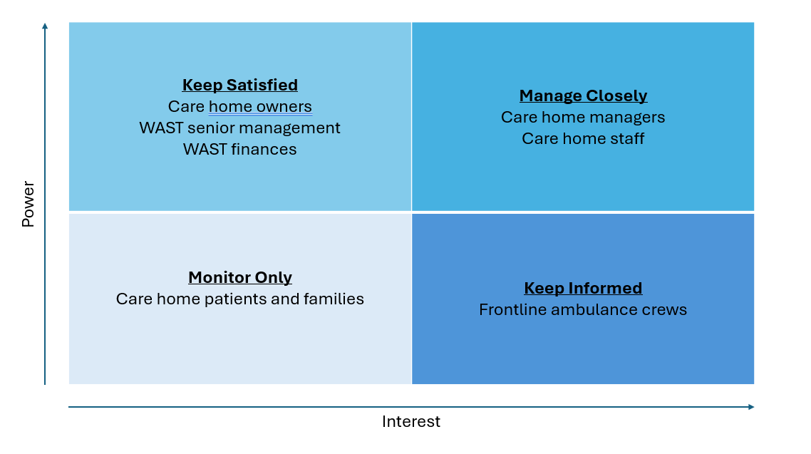
SMART Plan
Specific
- Delivery of flow chart to all care homes, initially within Powys.
- Follow up communications via email for reminders
- Delivery of training packages to care homes
Measurable
- All 32 Care homes within Powys according to WAST’s held list will receive a flow chart
Achievable
- This will be achieved by either hand delivery or postal delivery of flow charts with an accompanying email or telephone call to advise of use of flow chart.
Relevant
- Relevance is covered within the Scope and Objectives section of this plan.
Time
- Initial delivery of flow charts to Powys care homes will be completed by end of 2026
- Training programmes will commence by October 2026
- Wider distribution to other localities in Wales starting January 2027 following pilot scheme
- Full implementation of flowcharts across Wales by June 2027

Once this has been implemented, further SMART plans will be developed for the implementation of training to care staff.

Proposed monitoring of change plan
- Initially (<12 months): monthly email communications with care homes to remind of importance of compliance
- Communications to frontline crews to ensure they speak to care homes regarding use of flow chart for each call
- Yearly: Telephone/teams/face to face meetings to discuss compliance, ease of use, developments with care homes
- 2 yearly: Training to be redeployed

Appendix 5 – WAST Staff Survey Results
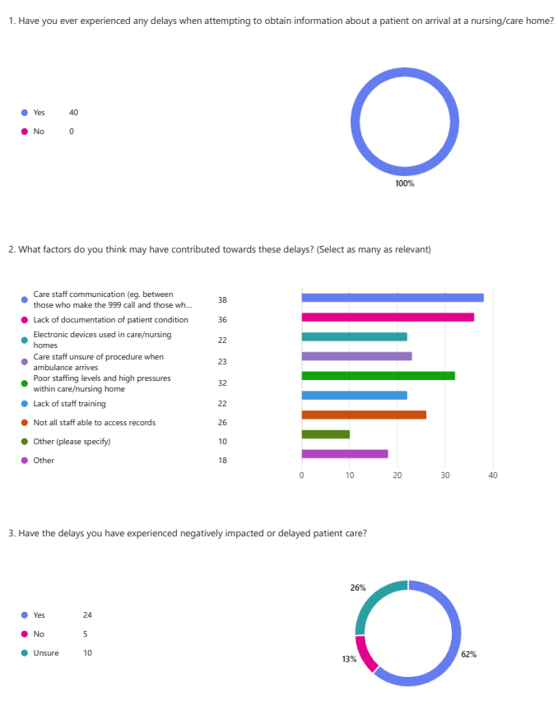

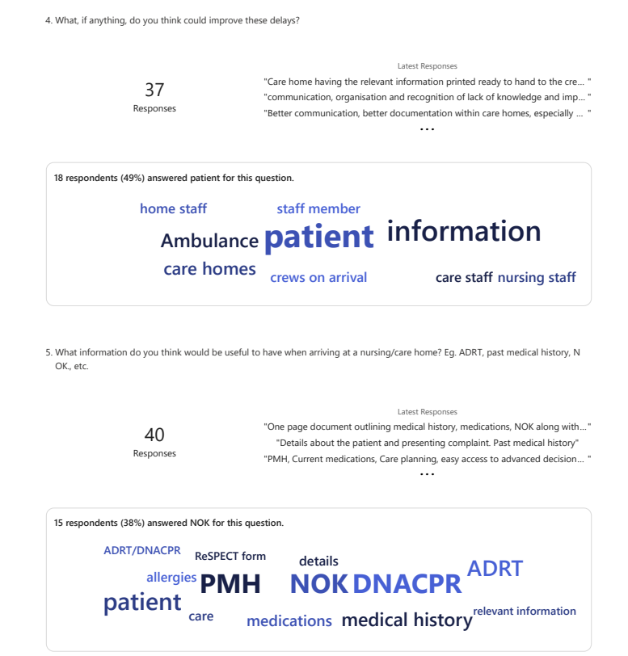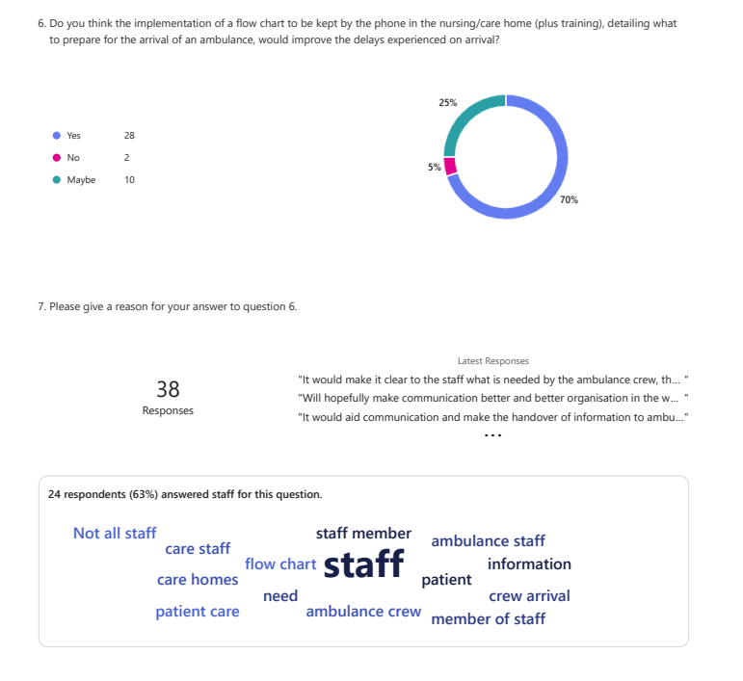
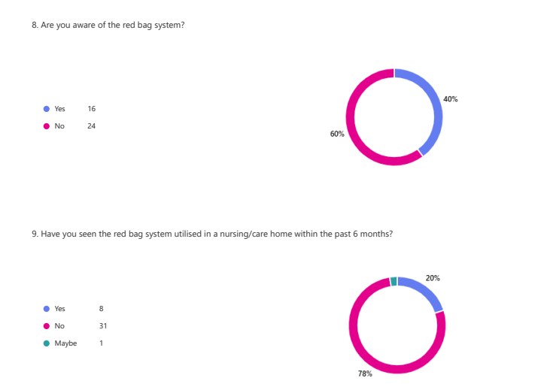

Appendix 6 - Care Home Questionnaire Results

