Supporting Abilities and Behaviours Module Handout
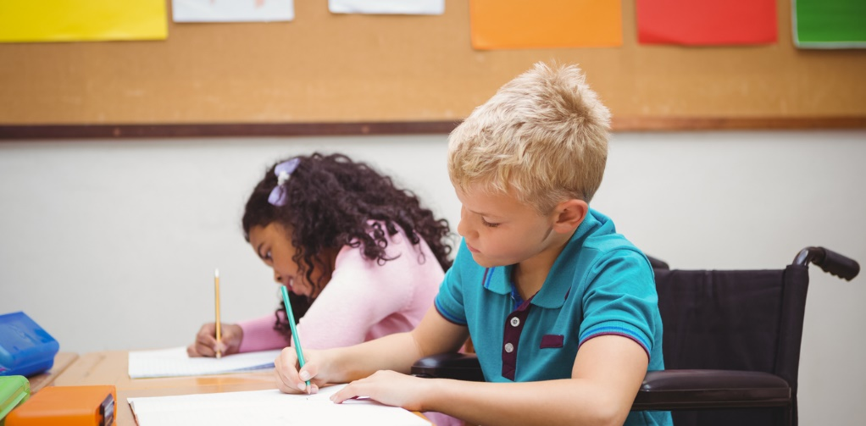
Inclusion of disabled children and young people in schools and other services
Key Legislation


The United Nation’s Convention on the Rights of the Child (1989)
States the right of all children and young people. The UK government ratified (signed up to) the treaty in 1991 and must ensure that the rights of children in the UK are protected through law. These rights are extensive and include the right to education and the right for children to have their views respected.

Disability Discrimination Act 1995
Protects the rights of all those with disabilities. It also places a duty on schools (and other organisations) to eliminate barriers to ensure that individuals can gain equal access to services.

Disability Discrimination Act 2005
Places a duty for schools to produce a Disability Equality Scheme (DES) and an Access Plan. Schools must encourage participation in all aspects of school life and eliminate harassment and unlawful discrimination.

Special Educational Needs and Disability Act 2001
Makes it unlawful for educational providers to discriminate against pupils with a special educational need or a disability.

Human Rights Act 1998
Sets out rights of all individuals and allows them to take action against authorities when their rights have been affected.

Children Act 1989
Sets out the duty of local authorities (including schools) to provide services according to the needs of children and to ensure their safety and welfare.

Children Act 2004
Sets out the duty to provide effective and accessible services for all children and underpins the five Every Child Matters outcomes. The Every Child Matters outcomes were introduced in 2004 in response to the inquiry following the death of Victoria Climbié. The inquiry
highlighted the need for services, including schools, to work more closely to protect and support the needs and rights of all children. Schools and other childcare services must demonstrate ways that they work toward each of the 5 outcomes:

● be healthy;
● stay safe;
● enjoy and achieve;
● make a positive contribution;
● achieve economic well-being.

Schools may need to work with specialist services, such as physiotherapy
or speech therapy, so that children are able to reach their full potential.
Education Act 1996
Sets out the school’s responsibilities towards children with special educational needs. The Act also requires schools to provide additional resources, equipment and/or additional support to meet their needs.

Equality Act 2010
Sets out the legal responsibilities of public bodies, including schools, to provide equality of opportunity for all citizens. This brings together nine equality laws.

Relevant guidelines



The Special Educational Needs Code of Practice (2001)
This outlines the statutory guidance for policy and the procedures and responsibilities towards children with special educational needs. It includes the levels of support which should be provided to children, depending upon their individual need.

Removing Barriers to Achievement: The government’s strategy for SEN (2004)
This provides a framework for schools to remove barriers and raise achievement of children with special educational needs and disabilities.
The principles included are the need for:

● early intervention;
● the removal of barriers;
● raising achievement;
● the delivery of improvements through partnerships across services.

Disability Equality Scheme and Access Plan
The Disability Discrimination Act 2005 builds on the 1995 Act by requiring all schools to produce a Disability Equality Scheme (DES). The DES must set out ways that schools promote equality of opportunity and promote positive attitudes towards pupils, staff and others with disabilities. In addition there must also be an Access Plan. This plan must identify how discriminatory barriers are removed. For example:

● an improvement to the physical environment, such as ramps, lifts, room layout, lighting;
● providing information in different ways for children with a disability, such as audio, pictorial, larger print.

Inclusion and Pupil Support (Welsh Government, 2015)
This guidance covers the inclusion and support of pupils of compulsory school age (although some elements apply to post-16 education). It provides advice and sets out responsibilities for maintaining high levels of attendance, positive behaviour in schools and supporting those pupils who require extra support to ensure they
receive suitable education and avoid becoming disengaged from education. It also covers education provided outside the school setting.

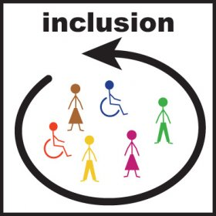
Inclusive Practice: medical and social models of disability
To understand the issue of inclusive practice for children and young people, it is helpful to understand the medical and social model of disability.

The medical model of disability

The medical model is based on an assumption that the child must adapt to the environment which exists. This model promotes an atmosphere of ‘dependence’.

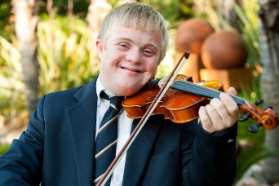
The social model of disability
The social model starts with the assumption that the way a school operates, the barriers present and different attitudes can prevent individuals from participating in society. This view of disability works to empower children and young people.

Inclusive practice is based upon the social model of disability. Legislation requires schools to make ‘reasonable adjustments’ and remove barriers so that children and young people can take part in educational and social activities within the school alongside other pupils. Pupils with additional needs often require the additional support of a teaching assistant or school support worker, but inclusion for pupils is not only about providing additional support. Adjustments may relate to:

● the physical environment, such as providing lifts, ramps, rails and furniture at the correct height for children with a physical disability, or improved lighting for children with a visual impairment;
● providing information, such as worksheet and books with larger print, audio tapes, symbols or alternative forms of communication;
● the curriculum, such as groupings, timetabling, additional support, technology (touch-screen computers, text to speech software) or adjustments to assessment (extra time, using different methods to capture evidence).

An inclusive setting is one which uses a whole-school approach to learning. Barriers are recognised and strategies are used to remove them.

Where children experience difficulties such as special educational needs or disabilities, there is a an approach which focuses on what the child or young person can do rather than the difficulties they are experiencing.

Best Practice Checklist: Contributing to an inclusive environment

• Know the individual needs of children and any potential barriers to
their learning.
• Listen to children and involve them in their own learning.
• Know the background and interests of individual children, and draw on these when supporting their learning.
• Include materials and resources in your work with children which reflect diversity in society.
• Find out about the individual targets of the children with whom you work.
• Use different strategies to support children with their learning.
• Have high expectations of all children.
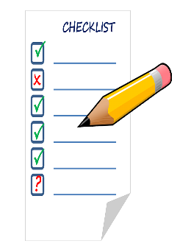
• Report any concerns that you have about children’s progress and/or well-being.

