Dissertation on Influence of Online Reviews on Consumer Decision Making when Booking a Hotel in UK and India
A Case Study of Hilton Hotels & Resorts via Booking.com

By:
Rahul Kumar

Date of Submission: 13/02/2024
Dissertation Submitted to
University of Wales Trinity Saint David
Masters of bossiness administration in Marketing
Supervisor: Dr. Rexon Nting

Declaration Form Duly Signed


Master’s Degrees by Examination and Dissertation
Declaration Form.
1. This work has not previously been accepted in substance for any degree and is not being concurrently submitted in candidature for any degree.
Signed……Rahul kumar.……………………………………………
Date ……13/02/2024………………………………………………

2. This dissertation is being submitted in partial fulfilment of the requirements for the degree of Master in Business Administration.
Signed……Rahul kumar.……………………………………………
Date ..……13/02/2024………………………………………………

3. This dissertation is the result of my own independent work/investigation, except where otherwise stated.
Other sources are acknowledged by footnotes giving explicit references.
A bibliography is appended.
Signed……Rahul kumar.……………………………………………
Date ……...13/02/2024………………………………………………

4. I hereby give consent for my dissertation, if accepted, to be available for photocopying, inter- library loan, and for deposit in the University’s digital repository
Signed……Rahul kumar.……………………………………………
Date ……13/02/2024………………………………………………..
Supervisor’s Declaration.
I am satisfied that this work is the result of the student’s own efforts.
Signed: …………Rexon Nting …………………………………..
Date: ………….13/02/2024…….……………………………

Abstract
This study is aimed at the effect of online reviews on the consumer behavior decision process, when making booking choice for Hilton hotels through Booking.com online platform. The research is based on a survey of 35 randomly selected consumers and it aims to explore their perceptions, trust and reliance on online reviews and the impact of these factors on hotel booking plans and reputation. The results indicate a great influence of online reviews on respondents, for whom they are mostly regarded as trustworthy and credible. However, the positive reviews were found to have a promising impact on the Hilton Hotels, but the negative reviews had a chance to book them. Nevertheless, the management reaction to the reviews were uncertain while chances of leaving a review were not clear. The outcomes of the study can be derived into the improvements for strategy of reputation management, the platform and marketing initiatives for hospitality industry. Future studies from a cross-cultural perspective, longitudinal analyses, and experiments need to be done to make more progress in the field of understanding of the impact of online reviews on consumer behavior and perceptions.

Table of Contents
Declaration Form Duly Signed 2
Abstract 3
Table of Figures 6
Research Title: 7
Situation Analysis 7
Problem Statement 7
Justification 7
Chapter 1: Introduction 9
Background 9
About the Company 9
Importance of the research or Research Rationale 10
Research Gap 12
Aims and Objectives 12
Research Questions 13
Beneficiaries of Research: 13
Chapter 2: Literature Review 14
Role of online reviews in the decision-making process by consumers, when they choose hotels to book within UK and India: 14
Impact do cultural differences have on the relationship between consumers in two countries and their evaluations or valuations of online reviews: 17
Similarities and repetitions in the user reviews for Hilton Hotels & Resorts and their affect consumer decision-making 20
Online reviews serve as a persuasive power of influencing the perceptions and preferences concerning hotel bookings 22
Limitations 28
Chapter 3: Research Methodology 29
About Research Onion 29
Research Philosophy 30
Research Approach 31
Research Strategy 33
Methodological Choice: 36
Time Horizon 37
Data Collection Method 37
Techniques and Procedures 38
Reliability and Validity of Data 39
Sampling Technique: 39
Sample Size: 40
Ethical Consideration 41
Chapter 4: Data Analysis and Interpretation 42
Chapter 5: Result and Analysis 62
Chapter 6: Discussion 64
Chapter 7: Conclusion and Recommendations 68
Conclusion: 68
Recommendations: 69
REFERENCES 72
Books and Journal 72
Online 73
Appendices 77
Questionnaire with Frequency Table 77

Table of Figures
Figure 1: Cultural Differences between India and UK 15
Figure 2:Theory of lodging framework 18
Figure 3: SERVQUAL model 21
Figure 4: Assured Service provided by Hilton UK to their Customers 22
Figure 5: Impact of Online Review of Hilton Hotel 23
Figure 6: Hilton Hotel Review of Jaipur Location 24
Figure 7: Research Onion Framework 26
Figure 8: Inductive Research Approach 28
Figure 9: Deductive Research Approach 29
Figure 10: Selecting a research strategy based on the research approach 31

Research Title:
Influence of Online Reviews on Consumer Decision Making when Booking a Hotel in UK and India: A Case Study of Hilton Hotels & Resorts via Booking.com

Situation Analysis
Hilton Hotels challenges the fact of gaining and keep customers in today’s very competitive hospitality landscape while digital is now king and Booking.com is the kingpin. The comprehension of the consumer attitude to the online reviews is very important, as such reviews have a growing impact on the final decision of booking. In the whole process, the role of such factors as market trends, competition, consumer preferences, technological advancements, regulatory compliance, brand reputation management, marketing strategies, and customer expectations cannot be overestimated. Through a complete situation analysis, Hilton Hotels can receive vital information for strategic programs that are focused on improving online review management processes, reinforcing brand reputation, and raising customer satisfaction and loyalty.

Problem Statement
In a digitalized world, reviews have become a crucial part of consumer behavior, especially in the hospitality industry. For both hotel management and online booking platforms, knowing how online reviews influence booking decisions for Hilton Hotels through Booking.com is important. Despite this fact, there is a dearth in in-depth research investigating the intricacies of this relationship that include the trust in online reviews, their effect on the planning of the booking and the hotel reputation perception. In line with this, the problem statement is to determine to what extent do online reviews affect consumer behavior in booking Hilton Hotels at Booking.com and what factors contribute to their influence.

Justification
This research is supported by the growing dependence of consumers on online reviews during reservation making decisions particularly within the hospitality industry. With the increasing use of the internet by Hilton Hotels and Booking.com, the significance of online reviews grows for the sake of the competitive edge and customer satisfaction. This research will help in noticing the factors, which determine consumer perceptions and behaviors with respect to online reviews and thus will be beneficial for hotel management, online booking platforms and marketers. The results of this research can be used to make decisions on strategic reputation management, platform development and marketing activities, and thus, both Hilton Hotels and Booking.com will benefit in terms of success and profitability.

Chapter 1: Introduction

Background
In the hospitality industry, one can say that there is a change in consumer decision-making processes which are being driven mostly by online reviews. In this light, the current study explores how online reviews play a critical role in influencing consumer behavior when booking hotels both within UK and India. By looking at the case of Hilton Hotels & Resorts through Booking.com, this research aims to reveal a more subtle relationship between patterns in individual decision-making and online reviews following it with modern literature viewing online reviews as central to influencing consumer perceptions and decision-making, this study is aimed at providing invaluable insights not only for Hilton Hotels & Resorts but also for the wider hospitality sector. Through the realization of how individuals decode and depend on online reviews as authorities, hotels can develop relevant marketing plans based also upon consumer preferences in terms of accommodation needs.
The only finding that stands out in the hospitality industry is that cleanliness leads all regarding how it affects guest satisfaction and good reviews. It reveals the leading role of it because customers may view such as an elementary issue. The cleanliness of a hotel represents one very direct attribute that affects its image, because guest perception is directly affected by it. Feedback on cleanliness is also very important for a hotel’s reputation because the online feedback about this aspect of hotels are largely independent from their associated scores. The conceptual background of this study seeks to understand the effect that online reviews effect on hotel booking decision making for both Hilton Hotels & Resorts (UK and India) via Booking.

About the Company
Having opened the first hotel to be called Hilton in 1925, Conrad created a wish for his grandson that it should become one of the finest hotels in Texas. Such efforts helped turn him into kind of a visionary, constantly innovating and changing Hilton to what it has become one of the most well-known brands in the world today (Hilton, 2023). With its history exceeding one century, Hilton Hotels & Resorts is a global leader in hotel industry selling over 600 hotels across six continents. And with its performance as the brand leading Hilton’s 22 different offers, innovation that comes along it is required for development of all dimensions and strength of the company against other competitors such Sheraton.
The Wit Chicago, which belongs to Hilton Hotel paradigm remaps contemporary elegance of luxury characterized by newly refurbished rooms and deluxe facilities downtown located in Loop. Hilton London Metropole which is the largest of its kind in UK has undergone multi million pound and opened up 1,096 guest rooms as well a new wine café stylized by colors & flavors dedicated to different neighborhoods around one metropolis LONDON. It is an overhaul multi-million to be mixed with modernity historic character by Virginia Hilton Richmond Downtown, the hotel completes phased reformation that introduces new event space and incorporates superior at rooftop restaurant which have a Fort Lauderdale Marina.
For instance, such as Hilton Bali Resort in Indonesia that showcases a Balinese-inspired lobby overlooking the Indian Ocean or on other end describes L2H Capital Corp. which ups its equity stake to all 100 shares investing another $35 million being modern accommodations with new dining destination is renovated at Hilton Los Angeles Culver City Finally, the Hilton Vienna Danube Waterfront in Austria – one of only two Viennese hotels along with Donau City comes nearly to completion an extensive renovation that seeks to modernize every element this property from guest rooms via wellness areas up dining spaces (StoriesHilton.com 2023). These universal improvements used in the hotel strive to point out that Hilton reaches has value for guaranteeing customer’s stay is memorable and showcasing tradition of hospitality.

Importance of the research or Research Rationale
The problem that will be addressed is inspired by resolving understandings regarding the reaction of hotel residents who have reserved books to online reviews across both UK and India. The scope of this analysis is limited to Hilton Hotels and Resorts, while the choice of reservation platform involves Booking.com website for investigating how online reviews impact decision-making behavior during hotel bookings. This would help identify travel trends emerging and post pandemic drivers demand, due to the wide coverage across India that was affected by global disruptions caused by Covid-19 (Sneha, 2021). The importance of this study lies in the fact that it focuses on an issue, which is widespread nowadays and affects hotel reservation decision due to online reviews.
However, it is important that the changes in consumer behavior due to online reviews are studied not only for Britain but also India and even determine whether such shifts can influence Hilton Hotels & Resorts’ agility when adjusting travel preferences after COVID. This analysis is not only focused on Hilton but it will guide the hospitality industry in developing strategies and concepts that can appeal to post-pandemic consumers. The following rationale for the research implies that cleanliness is crucial to guest satisfaction and online reviews in hospitality sector.
The flight searches from the UK to India have a sharp increase seen at nearly 48% compared with previous years that is of the year 2019. This growth implies the customer’s confidence and a high level interest in traveling between two states. This upward trend corresponds to India’s efforts in developing its tourist business around the world and reflects a positive development of promotional activities. After the resumption of travel in international locations, the improved relationship between UK and India as shown through increased flight searches would play a significant part towards revival from pandemic effects to benefit accordingly tourism department also including economic growth (Khosla 2023).
Due to the current significance of online reviews, this study attempts to answer what such a review does towards their behavior when booking hotels through sites on platforms like Booking.com. The study, therefore, can focus on the Hilton Hotels & Resorts in both UK and India as a direction of unveiling critical knowledge that would benefit not only such business but also hospitality sectors towards change strategies services even cleanliness standards. These results can influence convenient actions in real life for this area and change clients’ attitudes as well as reliable online trails.

Research Gap
This study identifies a few notable gaps in the literature on online reviews and consumer decisions toward booking hotels. Second, online reviews on Indian travelers lack a lot of research studies to determine whether it has any effects over their decision-making process. Additionally, while the study does indeed value and acknowledge its significance in reference to online reviews, there is very little research that takes aspects of some specifics within these works into consideration which obviously affects consumers’ decisions. Moreover, the study points out that an intensive investigation is missing on how post-Covid affected travel scenery and particularly decision factors and patterns by UK citizens as well Indian ones. This will fill the gap with considerable advantage to industry specific solutions.

Aims and Objectives
Aim:
‘To analyze the effect of online reviews on people’s decisions in terms of reserving hotel rooms by those located both in the UK and India, specifically for Hilton Hotels & Resorts through Booking.com website’.
Objectives:
- To investigate the relation of online reviews and consumer purchasing decision in hotel reservation.
- To compare how differences in culture affect the impact of online reviews on consumers’ purchasing behavior, both for UK and Indian markets.
- To evaluate the characteristics of Hilton Hotels & Resorts that are emphasized or undermined in online reviews.
- To analyze the impact of online reviews in influencing customer opinion and sentiments for hospitality firms.

Research Questions
- What is the relation of online reviews and consumer purchasing decision in hotel reservation?
- How differences in culture affect the impact of online reviews on consumers’ purchasing behaviour, both for UK and Indian markets?
- What are the characteristics of Hilton Hotels & Resorts that are emphasized or undermined in online reviews?
- What is the impact of online reviews in influencing customer opinion and sentiments for hospitality firms?

Beneficiaries of Research:
In conducting research, beneficiaries are the people who could stand to benefit from or be attracted by a given study. They were also referred to as the end user or target population. The stakeholders of this study include people who work in the hospitality field. For example, Hilton Hotels & Resorts would benefit from research of the basic factors that determine consumer decision making aimed at increasing its marketing and services. Insights regarding the growth of travel trends after covid restrictions will be useful for a bigger hospitality sector in UK and India, which might influence their service provision. All findings can help tourism and transport planners from both places to shape efficient policies or any marketing campaigns. Furthermore, platforms like Booking.com can offer better insights into customer behaviour that would help them improve their user experience by easing these portals lastly, the pragmatic skills gained by this research for practitioners in industry aids them to decision-making and strategy development.

Chapter 2: Literature Review
A literature review functions in the sphere of academic knowledge and understanding as one type of background paper produced within academia versus any given theme. A critical method of evaluating the material and this is why it has been called a “literature review” other than referring to it as merely literature report. It involves an analysis of both content in literature (The University of Edinburgh, 2023). In the process of writing a literature review, an author shows higher knowledge about different researches that were conducted with regards to some topic and connection between these investigations as well questions or ideas.
Writing a literature review for research paper questions is highly effective background and sets the author’s own question deep into larger scholarly discourse on this topic. Proper literature review resembles a definition of the credibility that is logically assigned to either author or her or his research. Literature reviews utilize shared assumptions or contentious claims about a particular topic, review definitions and models that are crucial for understanding the area of study under discussion as well as contemporary but sometimes age-old writings on this subject (the Center for Teaching and Learning, 2021). However, literature reviews serve as good sources of introduction to a particular subject because they give the general overview of issues that have been discussed in all publications related some topic.

Role of online reviews in the decision-making process by consumers, when they choose hotels to book within UK and India:
By the late 20 th Century, online reviews have drawn a huge influence over consumer behavior particularly because of its impact in hotel booking. Regarding the field of accommodation, possible customers can use such reviews to understand about quality in regard to accommodations service. A positive evaluation can turn out to be an important proponent; negative ones may push away the potential bookings of users (Yang et al. 2023). For instance, in the UK study involving a dominating hotel chain it was suggested that bookings are given to hotels with higher average review scores. An analysis conducted in this research established that increase of a single point on the average review score given to any hotel online travel site led leads booking by 11% higher. This demonstrates the actual power possessed and exhibited by online reviews in making decisions of consumers.
According to Shukla and Mishra., (2023) online reviews, around the world, play a major role as regards customer choices of hotels to be booked whether for UK citizen and Indian people. Positive reviews assist in the development of an establishment’s image and increasing its client base, while negative ones may work against them. Hoteliers should therefore, continue to act in a proactive manner as regards online reviews that deal with any issues that the guests may experience within their premises. Online reviews arguably have a significant influence on the decision-making process of consumers making decisions about which hotels to book within India, as shown in the Hilton Mumbai International Airport Hotel’s online review. Potential guests can get different insights regarding their stay having a review score of 7.8 based on 1658 reviews. Detailed scores chart on cleanliness, comfort privacy location facilities staff value for money makes a general report.
As shown by Davidsson (2023), in the already highly digitalized hotel industry, namely online reviews hold much power over consumer behavior seeping into numerous stages of decision-making processes. This research highlights the role of reviews in molding consumer perceptions, suggesting that more review volume improves credibility. For example, a hotel with many positive reviews is likely to have more customers. In addition, the research highlights just how crucial digitalization is – 29.5% of respondents booked their hotel with a mobile app This requires that hotel management should change with the times, make use of online reviews and embrace emerging technologies to improve guest relationships and remain relevant in an ever-changing market.
In the information technology revolution, online reviews are one of customers’ main steps when they make a booking in hotels. This is especially relevant in the United Kingdom as well as India where visitors spend a lot of time on experiences and opinions of other people when making their decisions. Hilton, among other hotel chains that has been able to make use of power accrued out from the positive online reviews in sites such as Booking.com and more all at once time. Research also shows that reviews online are of great value in changing consumer perception and influence the decision-making process as well. Instead, prospective guests can log onto Booking.com in terms of hotels, com and read reviews that have been written by past hotel guests’ give booking insight. Such reviews offer better insight regarding various components of the lodge such as cleanliness and tidiness that has been attained, services offered to the customers are also nice enough while facilities provided along with overall guest experience. Using others’ experience a consumer can know what he or she may expect from the booking time before making an actual purchase.
The Hilton sought to emphasize that an awareness of rating carried out through online sources such as Booking.com As a result, the company has garnered an image from potential users in terms of transparency and trust. The positive reviews that happy guests leave behind advertises the hotel chain positively, further increasing its visibility and in turn doubling it (Wang and Anderson, 2023). For example, in Booking.com Hilton hotels both for United Kingdom and India have good reviews ratings by customers In addition, the most admiring is about these hotels are spacious rooms and qualified service also good locations. These positive assessments not only reflect the care Hilton puts into providing quality service but also invite future customers to be pleasantly engaged and entertained in their visit.
As per Dang and Nguyen (2023) consumer reviews have evolved to become an important tool in the digital age meant for use by people seeking to determine which hotels they might book. This is especially so in countries like the United Kingdom and India where travels tend to rely heavily on opinions of other travellers. The fact that Hilton Hotels can learn to leverage reviews from the Booking.com website, is enough for me as a consumer understand what effects these feedbacks may elicit in positively attracting clients towards becoming credible brand name., With growing demand by consumers of practice transparency and genuine experience; hotel chains such as Hilton must realize its guests gives weightage on everything about their views.

Impact do cultural differences have on the relationship between consumers in two countries and their evaluations or valuations of online reviews:
As one of the most important stages in this broad-based consumer purchase decision making process that is applicable to numerous economies and has reshaped buying patterns for various markets, online reviews are highly crucial. But this level of control by online reviews in an extremely culture-bound phenomenon. In the considered case, this article tries to build a broader vision concerning how cultural elements influence consumers’ response towards online reviews not only in UK but also Indian markets by introducing current examples.
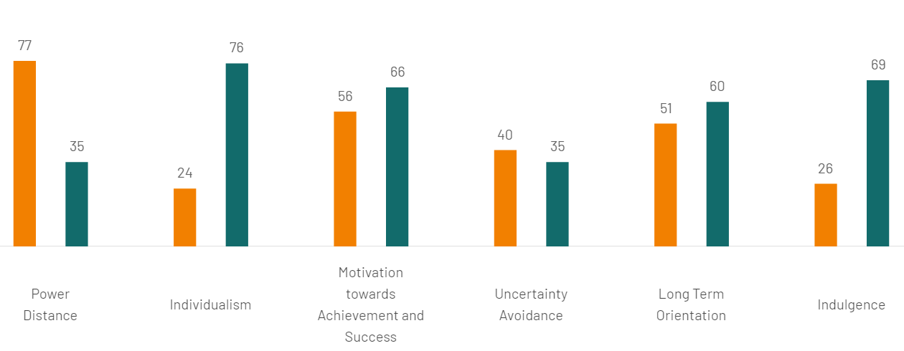
Figure 1: Cultural Differences between India and UK
Source: Hofstede Insights (2023).
According to Hofstede Insights (2023), the Indian culture is characterized by a high estimated value for Power Distance Index (PDI) at 77, showing the need to accept large hierarchical structures and leadership from above. Dependency on authority figures, inequality of power, and loyalty for gains is what the value system seems to imply. Power rests with managers, communication is highly directive through a top-down approach to authority and maintain accordingly. Compared to the other side, PDI in United Kingdom is 35 which means they believe that there should be equality since less inequality. Although there were class distinctions throughout the history, this put a tension between birth rank and fair play in Britain that promotes treatment of people more equally while having an emphasis on egalitarian values from cultural perspective.
To begin with, there is a significant role of culture when determining trust in online review. It is even more the case in Britain where consumerism has an individualistic orientation, and these consumers greatly rely on online reviews being considered enviable goods of information. They demonstrate a high level of credibility and they use their opinions as benchmarks quality. For example, Trustpilot (2019) has recently published a report which shows that 89% of the UK consumers read reviews online before purchasing. In other words, positive reviews almost always ensure trust generation as well as an increased chance of purchase.
Alternatively, these Indian consumers are motivated by personal usage and referrals that indicate an appreciation of collectivistic grounded in cultural principle. It is not surprising, taking into consideration the fact that they pay much more attention to family members and friends as well as all other people who are close them compared with strangers; uploading descriptions on various internet sites. According to a report by Nielsen, 92% of the population recommends friends and family member’s references are more effective than any other type of advertisement. However, the cultural inclination towing more on personal connections is nothing but a limitation that impedes in reducing online reviews’ potential effectiveness only as an Indian marketer.
The opinion toward negative comments is also influenced due to the cultural differences between Britain and India market. The green marketing study underlines the need to gather information that conveys how consumers think and behave with regards to products or services that are environmentally sustainable. In terms of cultural differences regarding the connection between consumers and their judgments over-evaluation online reviews, one should note that values in different cultures can have a significant impact on evaluations to eco practices. Critical factors include green concerns and environmental considerations, trust aspects as well as organizational image. In case of green products, cultural nuances may define the manner in which consumers perceive and trust online reviews as such influencing their evaluations. Understanding these cultural differences is also critical for marketers who need to address the conformity gap that exists when attitudes toward green products are compared to actual purchases of such objects in different nations (Sharma, 2021).
The negative commentaries in the UK are also considered a review that helps people to become innovative. According to Parray et al. (2023), the studies designing CSR, CR and CE verge that integrity is a vital part of corporate conduct. The outcomes support that CSR has a positive effect on CE using CR as mediating variable in this relationship. In particular, the findings indicate that poor ratings can also build organizational legitimacy if carefully managed. The transparency is linked to loyalty of companies to consumers, and mental bias in question facilitates a good reputation among corporates. This demonstrates the capability of excellent CSR relations and public relations to foster positive consumer trust and engagement in situations where criticism is present.
For instance, poor customer service and a fast response to address this was complained of by customers in one leading UK clothing company showing that the increased trust between them led to an increase in loyalty. In India, criticism is stereotype in the form of negative reviews and that are used as insults to business or organization and even their owners. In return, such behavior is an unconscious defense mechanism that can be triggered by the fear of losing one’s face or harming one’s natural image. A positive change that is more often ignored or dismissed as insignificant may be negative reviews. This high cultural sensitivity to criticism may also reduce the psychological impact of negative feedbacks on consumers from India.
Moreover, cultural difference contributes greatly to the way people engage in e-commerce and on how online reviews make their buying decisions both UK as well Indian market. The UK consumer is driven mainly by online reviews who see bad feedback to be an opportunity and not a problem; Further, although while the Indian customer can also prefer personal recommendations alongside being easily influenced through testimonials than his or her requirements pitches them with many question marks infested in negative review which they may potentially interpret as allegations. Such marketers will acquire the knowledge of what is alright in such cultures thus enabling them to apply online reviews and other specialized approaches correctly.

Similarities and repetitions in the user reviews for Hilton Hotels & Resorts and their affect consumer decision-making
The Hilton Hotels & Resorts is a best-known international brand popular for the provision of quality accommodation and reliable service delivery. Like everything else, online reviews present the picture of what guest response one should expect in any given hotel chain. According to Roy, (2023) the study used Theory of Lodging (Figure 2) to highlight the effects that customer reviews have in evolving perceptions and influencing action. Applying this to Hilton Hotels & Resorts, one would notice different versions of user reviews for various levels (luxury vs mid-tier vs low tier), possibly revealing recurring patterns and repetitions in consumer emotions. For instance, if Hilton deluxe hotels show higher subjectivity scores this may indicate a trend in terms of the review rating that highlighting individual experience. Identifying potential points of convergence in benefits areas, for instance good service or facilities might influence consumer decision-making positively. On the other hand, if recurrent topics this is it could indicate areas of need addressing.
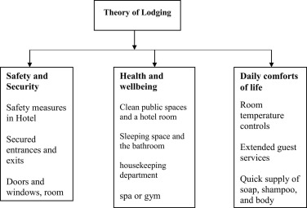
Figure 2:Theory of lodging framework
Source: (Roy, 2023).
Hilton can entertain consumer preferences and issues, which is effective in customizing offerings to correspond with customer wants thereby affecting the decision-making of a consumer. The online review sites that are available for finding Hilton Hotels and Resorts show traits hidden or highlighted with them. One of the highlighting features mentioned in many online reviews is unmatchable service provided by Hilton Hotels & Resorts. Staff of friendly and attentive personnel which does its best to make the visitors feel good. At the front desk to housekeeping, professionalism and their levels of willingness is highlighted timeously.
As underlined in Manigandan and Raghuram (2022), digitalization linked with modernization stands as the twenty-first century’s edge that transforms industries, where AI assumes a significant role master to provide performance enhancement relatedness career knowledge increase. This paper concentrates on hospitality industry and utilizes a literature synthesis 2019-20 plan forms into introduction corresponding to AI risks as well challenges. Conducting content analysis of 34 critically analyzed articles, “artificial intelligence” and “hotel industry" appear as to be the central themes. Despite the fact that this research solves some issues of bibliometric, it also reveals a new application for artificial intelligence within small hotels and introduces new models. Contrastingly, however it’s important to note that online reviews in booking.com are mutable and may amplify or deteriorate the features of Hilton Hotels & Resorts mostly concerning AI innovations and their recognition within a comprehensive system on development trends for hotel business.
Booking.com (2021) states that Hilton London Bankside is a design-based hotel with luxury and 39 rooms, this type of engine unique in its kind special spots to experience Peloton fitness from inside your surrounding room as well e Vegan suite –the very first one on earth The closeness towards noteworthy landmarks for example Tate contemporary and The online reviews of Booking.com amplify the main concept, deluxe architecture and centralized locations by Hilton’ s Highly inventive designs as well contribute to its image. However, such misconceptions may arise when there are observed faults with respect to pricing or the service element as well as some characteristics. All these will be informed by the ideal blend of contemporary designs, diverse facilities and superb experiences that would epitomize a life symbolized as luxury from Hilton.

Online reviews serve as a persuasive power of influencing the perceptions and preferences concerning hotel bookings
With the example of revenue management domain, hotels mostly turn to price as an important lever that helps them balance their offerings towards meeting consumer’s needs. But as Ciftci et al., (2020), refer the modern researches reveal that social media have an essential impact on travelers’ purchase behavior and their tendency to make a reservation for one of these nice hotels. Overall online rating hence plays a significant role in predicting the sentiments of customer preference when it comes to searching for stay-in place. In healthcare, the best choice is to build reservations in upper midrange hotels which provide at least 3 stars over $130 with their corresponding reviews of up to hundred and seven. This is consistent with the critical literature that describes online reviews as a strong determinant when formulating perception and intentions on whether to go ahead and book traditional hotel rooms.
As such, the paper by Gulati (2023) offers a detailed account of how these aspects influence choices about tourism debates in India from this generation to every other person. The focus of this paper includes generations’ differences that affect social medias and these including baby boomers Gen X, Gen Y. Moreover, addressed above points also pertain to even more recent generations – Z The author’s chosen methodology includes practical model based on literature review that leads researchers right into quantitative survey research work with 60 Indian travelers analyzed for conclusions, which enable establishing statements of generalization. The aspects of determinants influencing social media also revealing the age difference, just one observation has come from common believes that individuals accept no influence when making any conclusion related to socially impact. Thus, symmetric should be inclusiveness toward diverse generations such as everyone shares equal positions in encountering with social networks. Among these elements, originality revolves around the notion of analysis about an unstudied subject that signifies current stability for marketers in Indian tourism business and recommends unknown strategies describing universal character actions on social-media released sites.
Service quality model is a strategic program that organizations use to identify and improve their levels of service. It generally consists of several elements that are used to measure the quality level. On the other hand, SERVQUAL model is introduced as a multi-dimensional survey tool and has five dimensions of service quality defining it through consumer expectations perception on services.
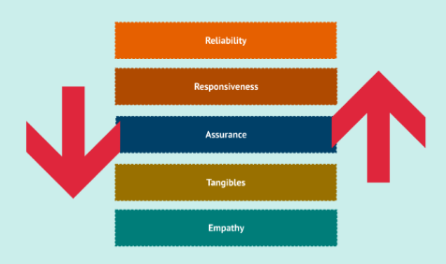
Figure 3: SERVQUAL model
Source: (Cuofano, 2021).
Within the online reviews space, a rich ecosystem of sources and commentaries on Hilton hotels working in UK’s market landscape over which SERVQUAL model holds massive sway. On the other hand, through using customer feedback along all 5 dimensions a comprehensive analysis of strengths and weaknesses that require intervention – particularly focused on negative comments as long- term changes call for more than just quick fix.
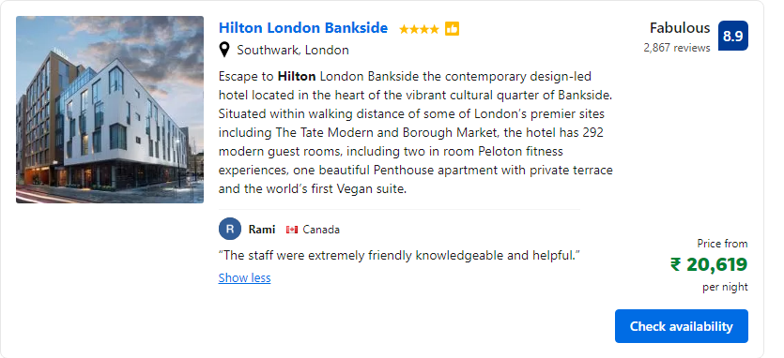
Figure 4: Assured Service provided by Hilton UK to their Customers
Source: (Booking.com, 2023).
Reliability: This aspect dwells on the capacity of Hilton hotels in UK to provide uniform and reliable service. This dimension is positively rated by positive reviews that focus on trustworthy amenities, check-in procedure efficiency and timely resolution of issues.
Assurance: The significance of assurance is the hotel staff’s wisdom and courtesy, as well as their ability to make people trust them. Reviews containing references to the attentive and informed staff, personalized service (Figure 4), safety reinforce this aspect.
Tangibles: Tangibles according to Endeshaw, (2020) include the tangible aspects of a hotel such as its facilities, hygiene and outlook. Reviews that emphasize properly kept rooms, modern facilities and beautiful surrounding have a positive effect on this dimension of the rating.
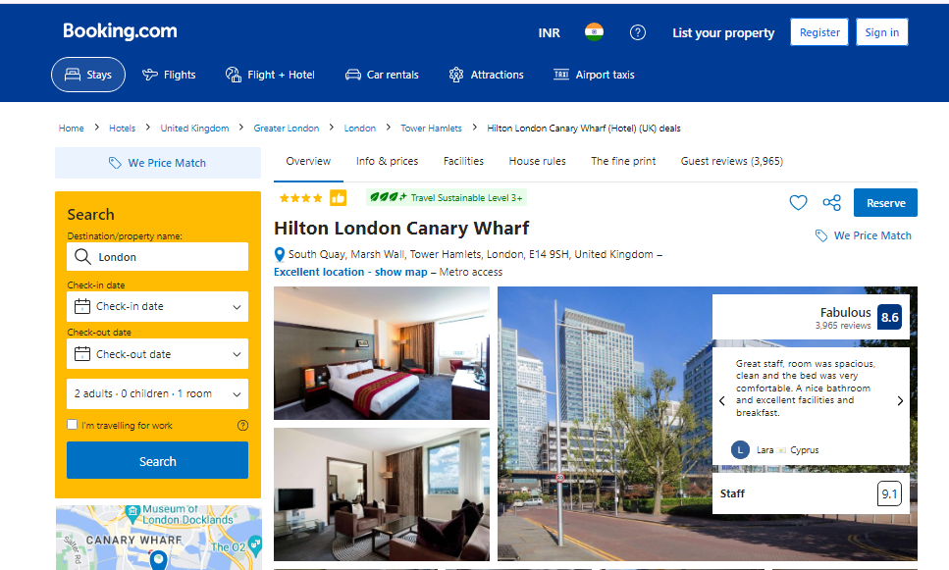
Figure 5: Impact of Online Review of Hilton Hotel
Source: (Booking.com, 2023).
Empathy: Empathy is understood as the hotel’s capacity to appreciate and address specific demands of its clients. Based on Booking.com (2023), Hilton London Canary Wharf is a fashionable 4-star sanctuary that focuses on meeting the needs of guests, mirroring Empathy’s nature in its dimensions Vasileios from Greece praises its “Excellent facilities and staff”, focusing on personalized service, friendly neighborhood etc. Being situated at a 5-minute walk from Canary Wharf Tube Station and one stop of The O2 Arena, the hotel is strategically located. This together with air-conditioned rooms, a gym and free Wi–Fi are consistent to comprehension what guests prefer in terms of convenience coupled by modern comforts. However, the high 9.0 rating that couples give to this location point out a depiction of an empathetic hotel concerned about addressing different needs for guests while ensuring they enjoy staying there.
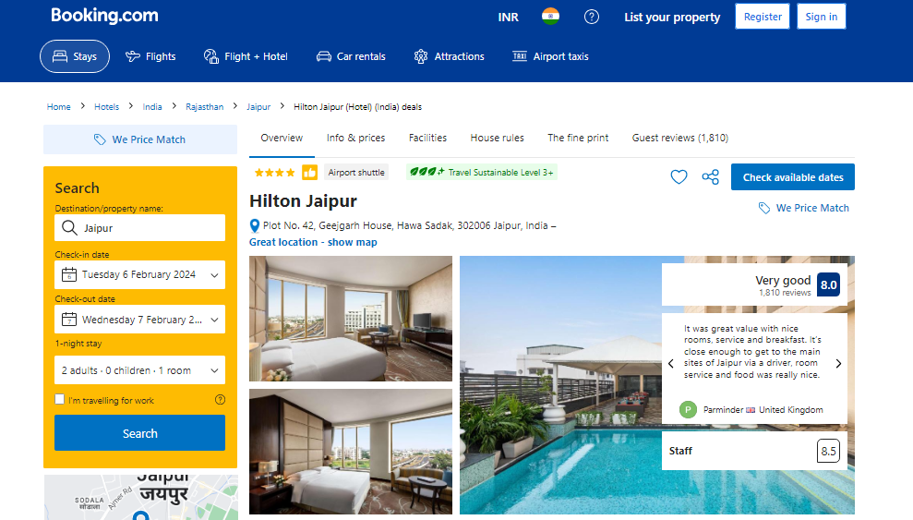
Figure 6: Hilton Hotel Review of Jaipur Location
Source: (Booking.com, 2023).
Responsiveness: The Hilton Jaipur, which is situated at a strategic place for the convenience of its customers, reflects Responsiveness. The opportunity to access it helps the hotel be in a central position, being 10 minutes away from Jaipur Railway Station and 25 Minutes Away From Airport is an example of that need. In light of this, the rooms are magnificently decorated and fitted with all necessary amenities in line with a guest’s comfort. Reviews praising the fast response and problem-solving by attentiveness contribute to an 8.2 rating from couples on responsive hotels, towards which this hotel clears 93%. One can indeed confirm that the hotel’s proactive method in meeting requirements is visible through its continental delicacies served by Aurum and fun evenings enjoyed from Nebulae rooftop lounge.

Limitations
While this literature review and the analysis of Hilton Hotels & Resorts online reviews are very informative, some limitations should be noticed. To begin with, the generalizability of findings could be limited due to the fact that research is primarily focused on Hilton and its online reviews. The attributes that are either blessed or under play in the online reviews may differ across various chains of hotels and regions. Moreover, the study largely uses Booking.com data as review sources which can make diversity of reviews considered limited in itself. The analysis period (2020- 2022) may also miss out recent trend in consumer behavior and attitudes towards on line reviews In addition, the study can be also enriched with qualitative element to understand more about certain guest experiences and preferences. Lastly, cultural dimensions that were brushed across are worth considering to understand how culture differences affect the evaluation of online reviews in reference with hospitality and consumer decision-making. This would lead to a better understanding of the nature and complexities involved in online reviews for Hilton Hotels & Resorts.

Chapter 3: Research Methodology

About Research Onion
The research onion was first developed by Saunders et al in 2007 that describes various stages that the researchers must go while creating a methodology in their research. This framework gives a systematical design to the researcher’s projects. The framework’s approach goes from outer layer to the inner layer of the research onion. The research onion has 5 stages namely: Research philosophy, Research Approach, Research Strategies, Research Choice and Research time-horizon. While applying this framework into the research one have to go from layer by layer of an onion (Thesismind, 2019).
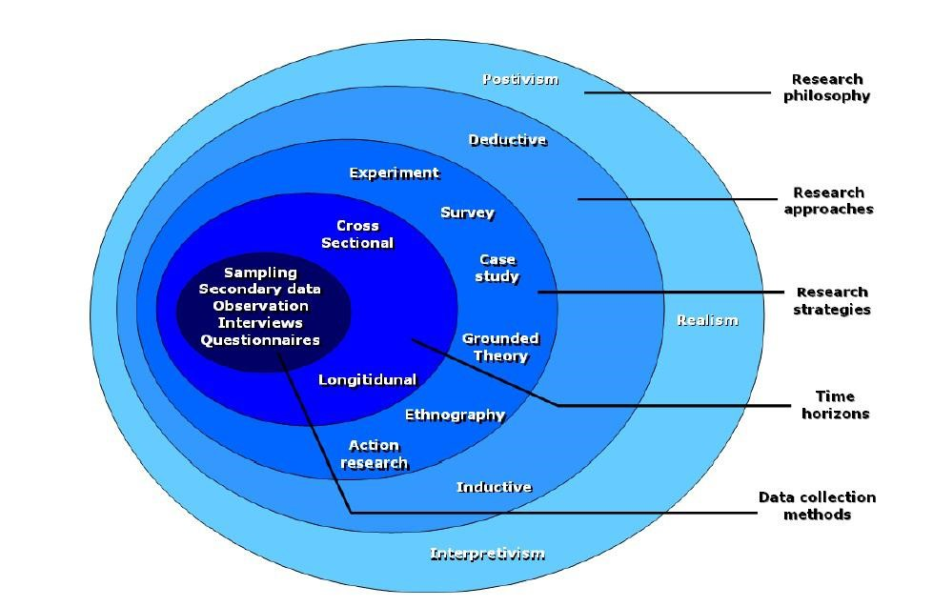
Figure 7: Research Onion Framework
Source: (Thesismind, 2019).

Research Philosophy
Research Philosophy indicates the nature, knowledge and assumption of the study. Research philosophy is concerned with the collect, analyzed and use of knowledge. It is the first or outer layer of the research onion. The research philosophy will reflect critical assumptions, and these assumptions formulate a basis for the research approach. In general, research philosophy is a broad field that has numerous branches associated with various subjects. In terms of business studies, four major research philosophies dominate the inquiry. Pragmatism is a philosophy that places value on the practical, promoting research which leads to usable outcomes.
Positivism is concerned with empirical evidence and the scientific method to discover absolute truths. Realism tries to explain phenomena as they are in reality, realizing that multiple perspectives and contexts exist. The interpretivism, or the approach of interpretation focuses on understanding through subjective meaning construction which is aware of social and cultural influences. Every philosophy provides a specific view, methodology and insight into the different business research projects (Dudovskiy, 2022). The objective of this dissertation is to analyze the online reviews applied as an influenced factor in consumer’s decision-making process, positivism has used in this research as this helps this research to justify with quantifiable data and statistical analysis to observe research accurately. In order to increase the validity and reliability this philosophy enables the investigation of phenomena in an organized manner (Dudovskiy, 2019).
Quantitative data refers to numerical measures representing the numeric values. They refer to the numeric variables that represent attributes including count, number of occurrences or size. This form of the data is concerned with “how many,” or, how much and how often certain phenomena occur. Quantitative data allow for statistical analysis and make it possible to calculate descriptive statistics, which reveal patterns and relationships between elements of datasets (Australian Bureau of Statistics, 2023). In this study, quantitative data is used to determine the impact of online reviews on consumer behavior when booking hotels in UK and India especially Hilton Hotels & Resorts via Booking.com as a result numerically oriented facts are presented. Through measuring variables such as review ratings, booking frequency and demographic information the study then uses statistical analyses to identify patterns correlations and trends. This method allows for a systematic analysis of the relationship between online reviews and consumer behavior, providing useful results not only from theoretical point but also practical implications.

Research Approach
The second layer of the research onion is the research approach. Research approaches are the plans and procedures for research that include all stages from general assumptions to detailed methods of data collection, analysis, and interpretation (Sagepub, 2023). The research process in abductive approach is aimed at providing explanation to ‘incomplete observations’, ‘surprising facts’ or ‘puzzles’ which were formulated at the commencement of a study. Inductive research is a method of a particular sort which begins with definite observations or tests, as opposed to hypotheses. The ultimate goal of researchers is to gather information and study it in relation to patterns that emerge without any pre-conceived assumptions. Through the systematic analysis of the observations, the researchers identify patterns or trends. Such patterns that manifest themselves are then used to influence the creation of the general theories or explanations for the phenomenon under study. As for the novelty of this type in inductive research, it provides some kind of freedom and openness to discovering new things about complicated phenomena (Dudovskiy, 2015).
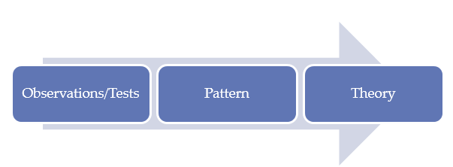
Figure 8: Inductive Research Approach
Source: (Dudovskiy, 2015).
Basically, the deductive research approach works with the assumption that there is a definite thesis or the main idea. This is then followed by development of hypotheses, which are guesses by the researchers about the relationships or mechanisms. These hypotheses are subsequently tested by collecting and analyzing observations or data. As a result of findings from these tests, researchers either accept or reject their hypotheses. Deductive research has a logical order from the thesis to hypothesis, observation and either confirmation or rejection (Dudovskiy, 2015).
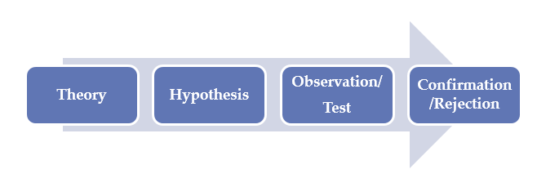
Figure 9: Deductive Research Approach
Source: (Dudovskiy, 2015).
For this research deductive research approach is selected. The proposed five steps capture the nature of a deductive research method, which is appropriate for conducting this dissertation on Online Reviews and Consumer Decision Making in UK and India. First, a hypothesis based on available theories or researches defines the investigative path by suggesting that online reviews and consumer behavior are related. This hypothesis provides the direction for further design of this research study which allows choosing adequate methods and variables to measure them. After a properly structured data collection by means of surveys, experiments or observational studies the analysis is carried out through statistical methods in order to reveal patterns and relationships between variables. Finally, conclusions that can be made from the data analyzed allow generalizing about online reviews’ influence on hotel booking decisions providing insights to both theoretical understanding and practice.

Research Strategy
A research strategy in the field of methodology determines the overall direction of research. It mentions the major elements such as research topic and focus. A research strategy (or methodology) is a systematized approach to how a study should be conducted in order to address an issue. It should be pointed out that a research methodology, is not the same as research method (Kwangaikamed.weebly, 2020). A research strategy is a detailed plan of action that informs the way in which the thinking process of an investigator. It allows a researcher to carry out the study in an organized way and timely manner. The major goal is to present the primary elements of the study including research topic, areas; main focus; design and finally methods.
Quantitative strategy refers to the gathering of primary or secondary data in numerical form. Under this approach, the researcher can gather data through questionnaires, polls and surveys or secondary sources. This approach primarily addresses when, where and how often a certain thing happens. The goal is to study when, where, what and how often a certain phenomenon appears (Walia and Chetty, 2020). Data collection methods include surveys experiments observations. Surveys refer to the distribution of closed or multiple-choice questions, through various media including online platforms; in person interactions and phone calls. Experiments involve controlling and manipulating various variables to determine cause-and effect relationships. Observation is defined as the process of watching subjects in their natural habitat where variables cannot be controlled. Each approach has its own unique benefits and is selected according to the research aims as well as characteristics of studied phenomena (Streefkerk, 2019).
Qualitative strategy is usually employed to understand the causes or what people think about some facts or a problem. It does not use numerical data. It gives understanding of the research problem and therefore assists in meeting with the objectives. Some of the methods that can be used are interviews, observations, open-ended surveys and focus group discussions (Walia & Chetty, 2020). Qualitative data collection techniques include interviews, focus groups, ethnography and literature review. In interviews, the interviewer asks open-ended questions verbally to participants in order to get their detailed answers. The focus groups allow people to discuss a targeted issue, which results in various opinions from different individuals that can be used for further studies. Ethnography is a process of becoming part and parcel of the community or organization for some time to study cultural dynamics and behaviors. Literature reviews entail scanning published works by other authors to gain perceptions and insights relevant for the research subject (Streefkerk, 2019). Every method has its own advantages in the investigation of complicated phenomena.
The dissertation on the Influence of Online Reviews on Consumer Decision Making when Booking a Hotel in the UK and India, focusing Hilton Hotels & Resorts via Booking.com uses quantitative research strategy. This strategy enables the systematic analysis of numerical data associated with online review scores, booking frequency and demographic information. Researchers can quantify variables and using statistical analyses to identify patterns, correlations, and trends in consumer behavior. In the light of this objective to understand how online reviews affect hotel booking decisions, a quantitative approach allows for a more rigorous analysis and provides empirical evidence in support of findings thereby strengthening the credibility and reliability associated with conclusions drawn from such studies.
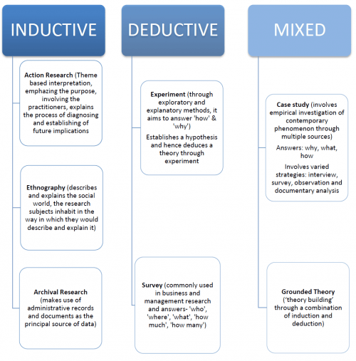
Figure 10: Selecting a research strategy based on the research approach
Source: (Datt and Chetty, 2016).
Experimental research is based on the scientific method in a controlled environment. Case study research is a detailed examination of an individual subject within its real-life setting, often in conjunction with grounded theory for data analysis. Action research is a collaboration between researchers and participants in identifying and solving practical problems. In defining grounded theory, it states that grounded theory is a method of generating theories from data obtained through systematic research. Ethnography is a study of people and cultures by direct observation and the participation in their everyday life. Finally, archival research is conducted by looking at historical documents and records in order to address the questions of a study (Datt & Chetty, 2016). Each approach has unique strengths, depending on the research objectives and setting.
In this study on the Influence of Online Reviews on Consumer Decision Making when Booking a Hotel in the UK and India: In the case study of Hilton Hotels & Resorts via Booking.com, a experimental research method has been selected by the researcher to be used herein. This approach, initially designed for the natural sciences to uncover causal relationships. The objective is to establish if changes in independent variables, like online review ratings cause changes in dependent variables such as booking decisions. The experiment is a questionnaire survey with 35 randomly selected customers of Hilton hotel who book their hotel with the help of booking.com with the help of 5-point Likert scale questions, following the deductive approach. This approach is prevalent in the business and management field of study. The survey allows for collecting a large amount of data from the sizeable target population. This information can also be interpreted through both descriptive and inferential analysis tools so that an individual may conclude how online reviews affect the hotel reservation choices.

Methodological Choice:
The methodology section of the research provides insight into different methods used to study how online reviews affect consumer decision-making when reserving a hotel in UK and India, focusing on Hilton Hotels & Resorts via Booking.com from the fact that there are various sources and types of data, a primary-method approach was adopted. The primary data collection technique was a Google survey aimed at consumers who have booked hotels on Booking.com, providing quantitative information about different aspects of their decision-making process. Secondly, previous literature was used to develop an understanding of Hilton’s innovation strategies that constitute the qualitative part of this research. This integrated method provides a global view of the data, enabling an analysis not only for qualitative aspects like theoretical views on innovation but also quantitative ones including consumer attitudes and booking practices. The qualitative data collected from the literature review helps in analyzing theoretical foundations of innovation and its role on strategic management. On the contrary, quantitative data collected through structured questionnaires offer insights into consumers’ perceptions of Hilton’s strategic management, innovation culture and employee-customer relationship which provide valuable information on internal operations and work environment within Hilton Hotels & Resorts via Booking.com.

Time Horizon
In the Dissertation on Influence of Online Reviews on Consumer Decision Making when Booking a Hotel in the UK and India: A Case Study of Hilton Hotels & Resorts via Booking.com the researcher used the onion methodology to conduct the study. They clarify that one major aspect of this approach is time horizon which refers to temporal scope for a given research and due necessity in collecting data from articles covering various periods longitudinal time horizon was implemented They clarify that this decision was made due to the fact the researcher wanted to study how online reviews affect consumer decisions regarding hotel booking.
The researcher further elaborates on the temporal allocation for each step of research. In their view, it took approximately one week to develop the research question and objectives; meanwhile conducting an extensive literature review lasted for 2-3 weeks. The careful process of collecting and analyzing data on online reviews and consumer behavior took 4-6 weeks while case study framework development as well design for this particular type of research required three dedicated weeks. The researcher points out that the interviews with Hilton Hotels & Resorts guests, industry experts and stakeholders constituted a significant part of researches time – it took 5-6 weeks. The time it took to analyze qualitative data from the case study ranged between 4-6 weeks while synthesizing findings and drawing conclusions was about 3-4 weeks. The researcher points out that the total period of these studies was approximately 6 months, which provided an opportunity to carry out a comprehensive analysis on how online reviews influence consumer behavior in hotel reservation process.

Data Collection Method
For the Dissertation on Influence of Online Reviews on Consumer Decision Making when Booking a Hotel in the UK and India: A Case Study of Hilton Hotels & Resorts via Booking.com, the researcher used a primary research method in collecting data whereby both quantitative and qualitative methods were utilized to provide detailed information on consumer behavior. In terms of quantitative data, the main method used was an online survey distributed among a sample of respondents who used to make hotel bookings at Hilton Hotels & Resorts using Booking.com. The questionnaire included several closed questions that provided the researcher with quantitative data on the participants’ gender, age, booking patterns, utilization of online reviews and satisfaction with the hotel. The agreement or satisfaction level on the statements about online reviews and changes in basis of booking decisions was analyzed using the 5-point Likert scale. The strength of the quantitative approach was that it allowed for the gathering of information from a wide cross section of the target market which was then plugged into the statistical analysis to reveal trends and patterns of consumer behavior.

Techniques and Procedures
For the quantitative research component of the dissertation the deductive research approach was applied to the case study of Hilton Hotels & Resorts through booking.com which is a structured methodology in 5-point Likert scale format. The first research design was the development of a survey instrument that would be administered to the respondents to collect quantitative data in relation to the online review and hotel bookings practices that they participate in or witness. This research used a Likert scale whereby participants were supposed to respond to questions regarding their level of agreement or disagreement to the statements made on online reviews, using 5-point scales. The study sample comprised purposively selected people who had made a hotel reservation under Hilton Hotels & Resorts through booking. It was available as an online survey through different media channels for ease and breadth of reach.
After the completion of data collection, responses were compiled and analyzed with statistical software. Means and frequencies of Likert scale items were calculated to describe the responses; inferential statistical tests analyzed relationships as well as differences between variables. The findings were presented in the form of tables, charts and narratives summaries according to the research objectives and hypotheses. From the inferences drawn from analysis, information regarding how online reviews influenced consumer decision making when booking hotels at Hilton Hotels & Resorts UK and India was provided.

Reliability and Validity of Data
There are two critical elements of quality data in research, reliability and validity. The reliability means the replicative of measurements or results over time and in different situations. In the context of the Dissertation on Influence of Online Reviews on Consumer Decision Making when Booking a Hotel in the UK and India: In a case study of Hilton Hotels & Resorts via Booking.com, reliability was guaranteed using different methods. Firstly, the survey instrument used to collect data from respondents was pre-tested on a small sample so as to identify and eliminate any uncertainties or inconsistencies regarding questions. Additionally, the survey was carried out on a diverse group of respondents to ensure that results would be representative of those for target population. Besides, the utilization of Likert scale questions that were standardized made it possible for respondents to give their responses in a consistent manner hence making this approach reliable.
However, validity refers to truth and accuracy in data measurement of what is intended. Validity was achieved in this study by aligning the survey questions to the research objectives and hypotheses. The questions were designed to capture critical elements of online reviews and consumer decision making in hotel reservations, hence providing data that would provide useful information on the research topic. In addition, the choice of different respondents including guests and experts in industry as well as stakeholders increased validity by offering several perspectives on phenomena being studied. In general, through a strict concentration on reliability and validity the research was able to produce reliable data that could be analyzed and interpreted.

Sampling Technique:
The sampling approach used in the Dissertation is purposive sampling. This type involves the selection of particular respondents who satisfy particular conditions related to a research objective. In this regard, the sample of respondents was people who had the experience of booking rooms in Hilton Hotels & Resorts through Booking.com; thus, they directly correlated with the focus of the study on the impact of online reviews on decisions to reserve a hotel. The sampling is also appropriate to the nature of this research as it enables one to select the participants who had firsthand contact with a phenomenon that is being studied hence the data collected is relevant and valid.
By targeting individuals who had before reserved accommodation in Hilton Hotels & Resorts via Booking.com, the study effectively obtained information that was directly linked to the research question hence guaranteeing that the findings would be applicable and helpful in the accomplishment of the objectives of this research. In addition, purposive sampling allowed for a variety of perspectives and experiences to be incorporated in the research and this enriched the data in terms of the depth and the span of the data. In general, this sampling method was appropriate for the research aims and objectives as it allowed to obtain pertinent findings concerning the role of online reviews on the consumer decision-making process in the hotel booking process.

Sample Size:
The sample size of this dissertation was 35 respondents. The sample size was calculated with regards to feasibility, resource limitations and the nature of study. While the sample was rather limited, it could be considered as adequate for achieving objectives in research due to case study methodology specifics and depth. Additionally, qualitative nature of data collection methods such as interviews and content analysis ensured that respondents provided deep insights which further reinforced results’ validity. The respondents will be given questionnaires through Google Forms. The survey link will be sent through email, social media network sites and online forums where people who have booked accommodation from Hilton Hotels & Resorts using Booking.com service provider are known to frequent in order to collect data necessary for the study. In addition, targeted advertisements can be utilized to reach the potential respondents. The form of the questionnaire is created in Google Forms which makes it possible for respondents to fill out this questionnaire on PC and mobile devices, ensuring convenience and increasing response rates.

Ethical Consideration
During the dissertation, ethical practices were observed and Data Protection Act 2018 compliance was adhered to. First of all, informed consent was obtained from each participant in the study which implied that they were well aware about what research entailed and how their data would be used. The participants were assured of confidentiality and anonymity, measures that ensured the protection of their personal information during research. In addition, data gathered from the respondents were kept private and retrieved by authorized individuals who took part in the research project. All identifiable information was anonymized or pseudonyms were used to preserve the participants’ confidentiality. Furthermore, the researcher ensured that there were clear data handling practices by informing participants how they would collect their data, what storage procedures will be used and also details on how it was going to use them. The researcher followed the ethical guidelines and adhered to Data Protection Act of 2018, guaranteeing that the integrity of research was maintained while participant rights were respected.

Chapter 4: Data Analysis and Interpretation
As all the data has been collected with the help of google forms, several questions have been asked with the customers of the hotel who have booked the Hilton hotel with the help of an online website Booking.com. All the data which has been collected with 35 people selected randomly has been arranged in a frequency table which is given below in the appendix and further these table has been split for the interpretation of the data for each question. The interpretation of the collected data has been given below:
What is your gender? | Frequency
Male | 18
Female | 15
Prefer not to say | 2

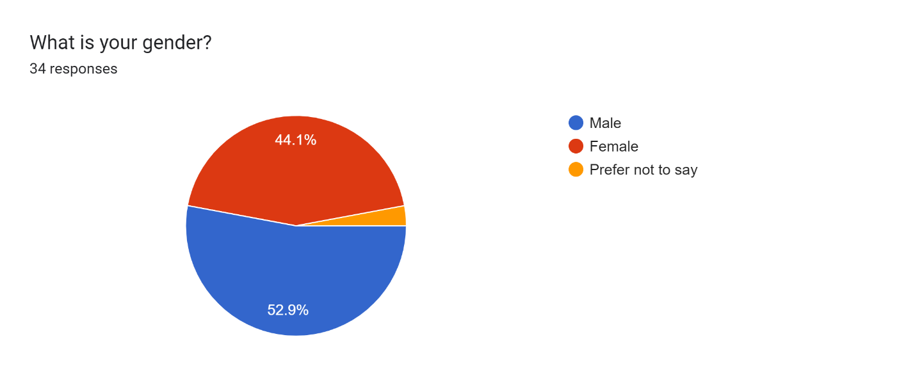
Interpretation:
The above chart helps to collect the personal data of the respondent related to their gender. This question is designed to create a personal attachment with the respondents and also to observe the nature of people as per their gender regarding selection of the hotel. Among 35 respondents it has been evaluated that 44.1% people are female, and on the other hand 52.9% people are male. This helps evaluate that the survey collected contains almost equal numbers of men and female, and will help to collect effective data to evaluate the dependence of people on online reviews. It will also help to reveal that there is no gender-based differences in the influence on booking decisions of both genders of online reviews.
What is your age? | Frequency
18-24 years | 6
25-34 years | 19
35-44 years | 7
45-54 years | 3

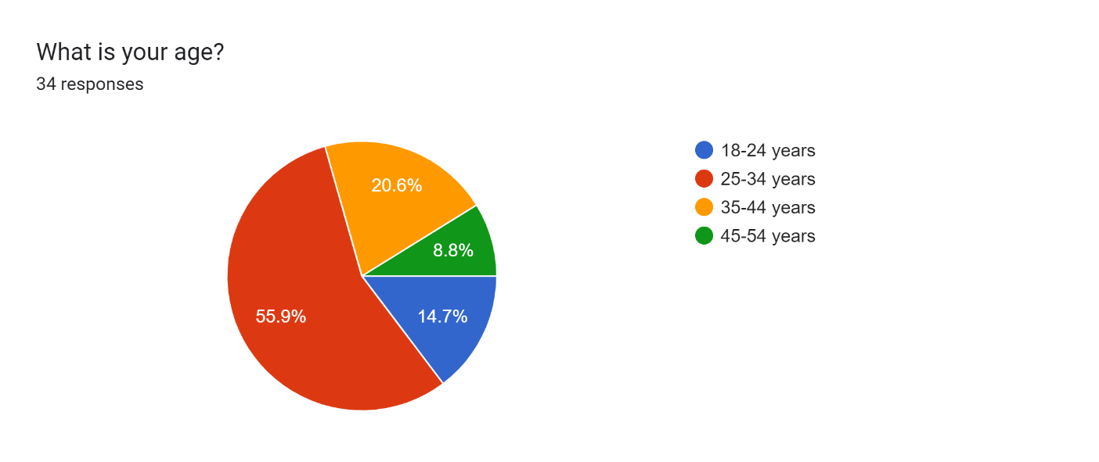
Interpretation:
With the help of this question, an approximate idea has been taken related to the age of the customers of the company who uses booking.com to book hotel, or are dependent on online reviews. The collected data helps to evaluate that the major of the people who are between the age of 25 to 34 years are more dependent on online bookings as compared to other ages. Although the people of age between 18 and 24 years as well as 35 and 44 years are also using the online platforms for booking their hotels, but majorly the people of age between 25 and 34 are more dependent on online booking.com for booking their hotels.

In which country do you live? | Frequency
United Kingdom | 25
India | 10
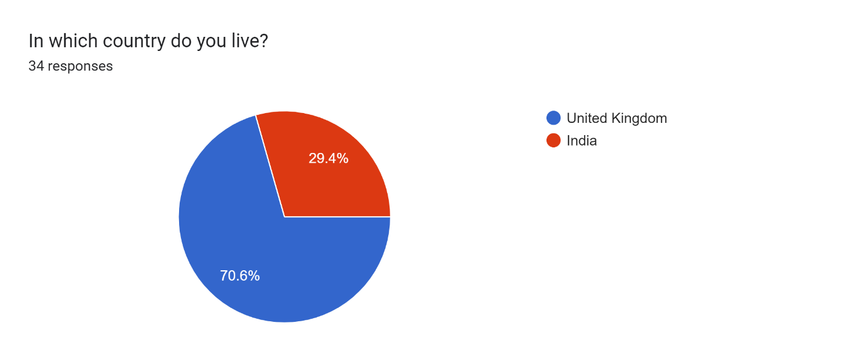
Interpretation:
According to the collect data, major of the respondents are from United Kingdom as the chart shows that 70.6% of the respondents are from United Kingdom and 29.4% and from India. This helps to evaluate that the major customers of both Hilton hotel and booking.com are in United Kingdom. Also, there are customers of both companies in India also but they are low as compared to UK. It also helps to evaluate the respondents on the basis of their geographical distribution and assess whether there is any regional difference in evaluating the influence of online reviews all their decisions.

Online reviews have impact on your decision when you book a hotel with Booking.com. | Frequency
Strongly Disagree | 7
Disagree | 5
Neither Agree nor Disagree | 13
Agree | 6
Strongly Agree | 4

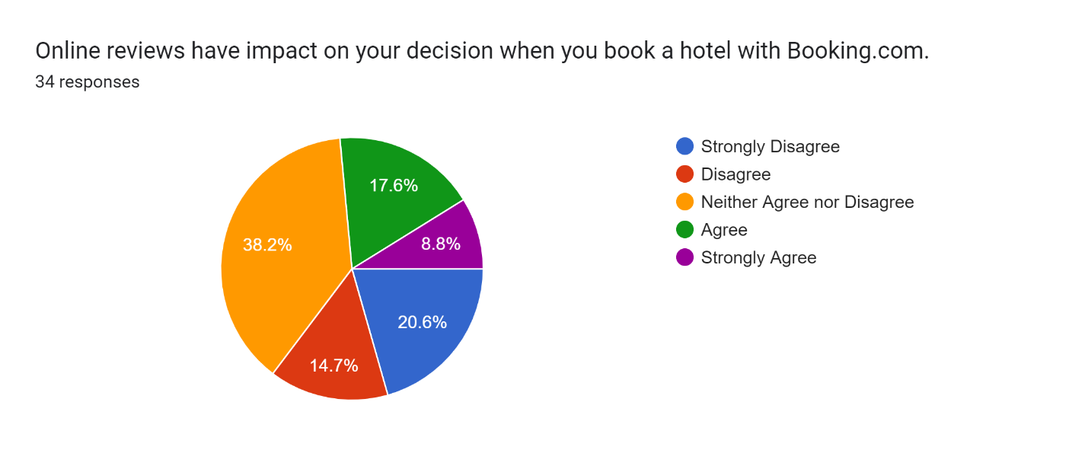
Interpretation:
As seen in the above graph, it has been evaluated that nature of the people is more neutral on the fact that online reviews have an impact on the decisions they made during booking a hotel through booking.com. On the other hand, approximately 20.6% and 14.7% of people strongly, disagree and disagree, respectively on the fact that the online reviews have any kind of impact on their decisions, when they book a hotel through booking.com. Only 8.8% people are strongly agreeing and 17.6% people agree on the fact of their dependence on the online reviews, while making decision to book a hotel. These collected responses helps to get the insight that major of measure of the population is not sure about either the online reviews have their influence on their booking decisions or not.

Do you consider online reviews reliable and trustworthy for Hilton Hotels & Resorts at Booking.com? | Frequency
Strongly Disagree | 2
Disagree | 10
Neither Agree nor Disagree | 9
Agree | 8
Strongly Agree | 6
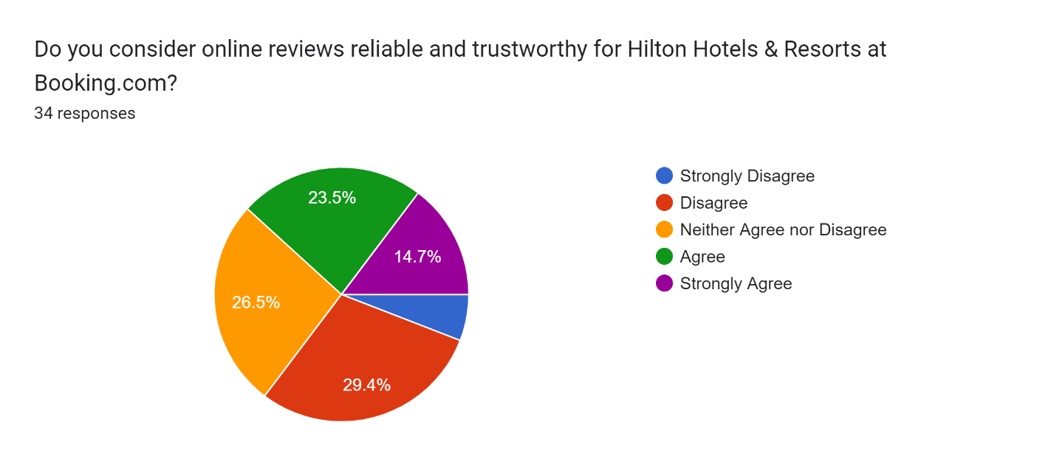
Interpretation:
The above graph helps to show that approximately 29.4% people disagree that the online reviews for Hilton hotel and resort on the booking.com are reliable and trustworthy. On the other hand, 23.5% people of the selected respondents agree that the online reviews are reliable and trustworthy for a Hotel Hilton and resorts in the booking.com. 14.7% of people strongly agree that online reviews are reliable and trustworthy on booking.com. Other 25% of the people agrees on the fact of being online reviews to be reliable and trustworthy. Only 26.5% are neutral on this fact and 8.3% are strongly disagree. It helps to interpretate that major of the people either agree or strongly agree, that the online reviews on booking.com for Hilton hotels and resorts are trustworthy and reliable. It helps to evaluate that the major of the customers are reliable on the online reviews of Hilton hotel chain on booking.com, considering it to be trustworthy and reliable which results in an effective impact of those reviews on their decision making.

To what extent do positive reviews on Booking.com influence your perception of Hilton hotels? | Frequency
Very much | 6
Somewhat | 9
Neutral | 7
Not Much | 10
Not at all | 3
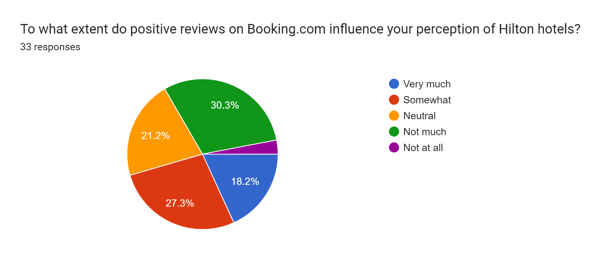
Interpretation:
According to collected responses and the above given graph, it has been evaluated that major of the respondents either very much or somewhat agree that positive reviews posted on booking.com have a great influence on their perceptions related to Hilton Hotels. 18.2% respondents are very much influenced and 27.3% are somewhat influenced that positive reviews on booking.com have impacted the perceptions related to Hilton hotel. On the other hand, 21.2% neither agree nor disagree that positive reviews have impact on them to change their perception.

The negative Online Reviews have its impact on your willingness to reserve a room in Hilton hotels through Booking.com | Frequency
Strongly Disagree | 3
Disagree | 6
Neither Agree nor Disagree | 11
Agree | 11
Strongly Agree | 4
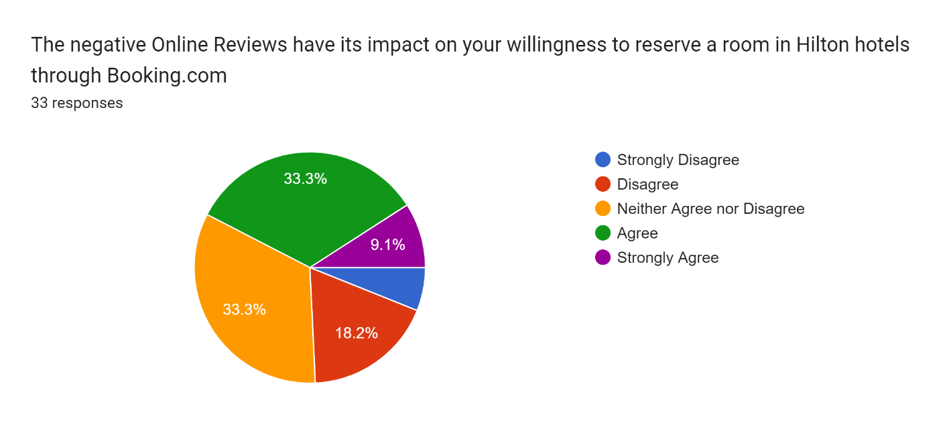
Interpretation:
The collected responses for this question help to evaluate that major of the population either agree and strongly agree that negative online reviews have a great impact on their willingness during reservation of a room in the Hilton hotels, with the help of booking.com. Only 8.3% people strongly disagree and 18.2% people disagree on the fact that negative online reviews, do not have any impact on their willingness to reserve the room. It on the other hand 33.3% respondents do not have any idea that either the negative online reviews have any impact on them or not. These responses help to suggest that negative reviews on online platforms can have notable influence on the behavior of consumers while taking their booking decisions, and led them to reconsider it.

Do you think that online reviews are equally important as other factors such as price or location in Booking.com when selecting a hotel? | Frequency
Strongly Disagree | 3
Disagree | 3
Neither Agree nor Disagree | 14
Agree | 11
Strongly Agree | 4
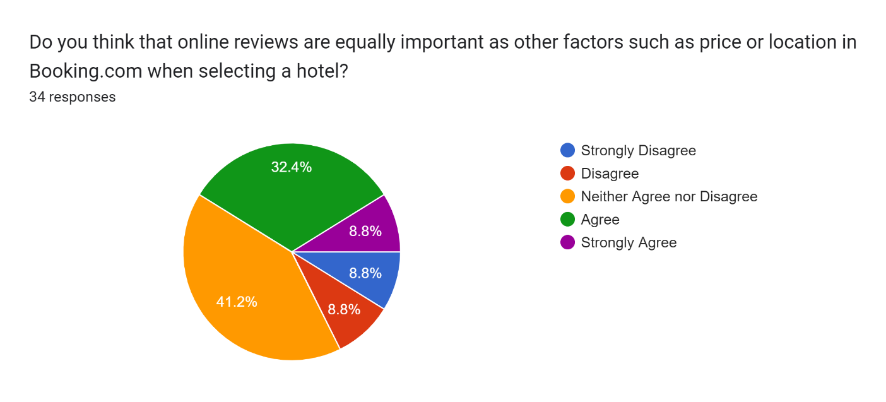
Interpretation:
From the responses it has been evaluated that major of the respondents are agree that online reviews, please an important role like other factors during selection of a hotel on booking.com just like their price or location. Only six respondents are either strongly disagree or disagree That online reviews are important like other factors. Among the 35 respondents 14 respondents are neutral and believe that might be online reviews can be equally important like other factors, such as price or location during selection of a hotel. It helps to believe that online reviews play an important role in the decision-making process apart from the traditional factors that has been considered by customers previously like price and location.

Do you have ever changed your booking plan of Hilton hotel through Booking.com when reading the online reviews? | Frequency
Strongly Disagree | 3
Disagree | 4
Neither Agree nor Disagree | 13
Agree | 8
Strongly Agree | 7
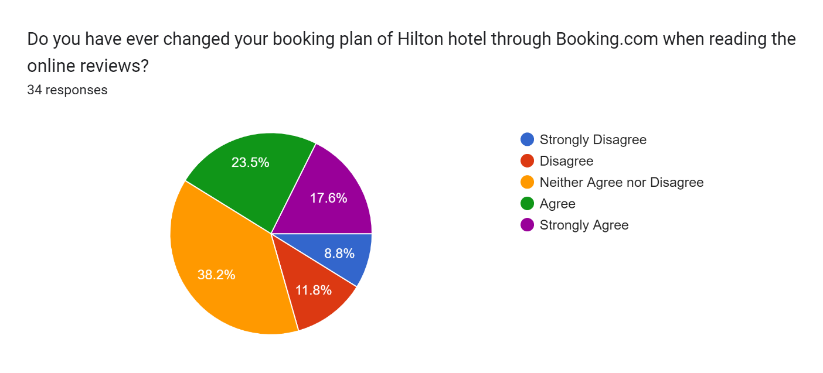
Interpretation:
Responses collected for this question helps to indicate that major of the respondents agree that they have changed their booking plan during the book Hilton hotel, but the help of booking.com after reading the online reviews on the hotel. Only approximately 20% of the population disagree that they have ever changed their booking plan might be because of their blind trust on the hotel, or any other reason. On the other hand, 13 respondents that is 38.2% are neutral that they ever changed their booking plan. They might be unsure about their change of booking plan as they cancel it either after online reviews or any other factor.

Do you agree that online ratings truly reflect the reality in Hilton Hotels & Resorts UK and India? | Frequency
Strongly Disagree | 4
Disagree | 4
Neither Agree nor Disagree | 7
Agree | 12
Strongly Agree | 8
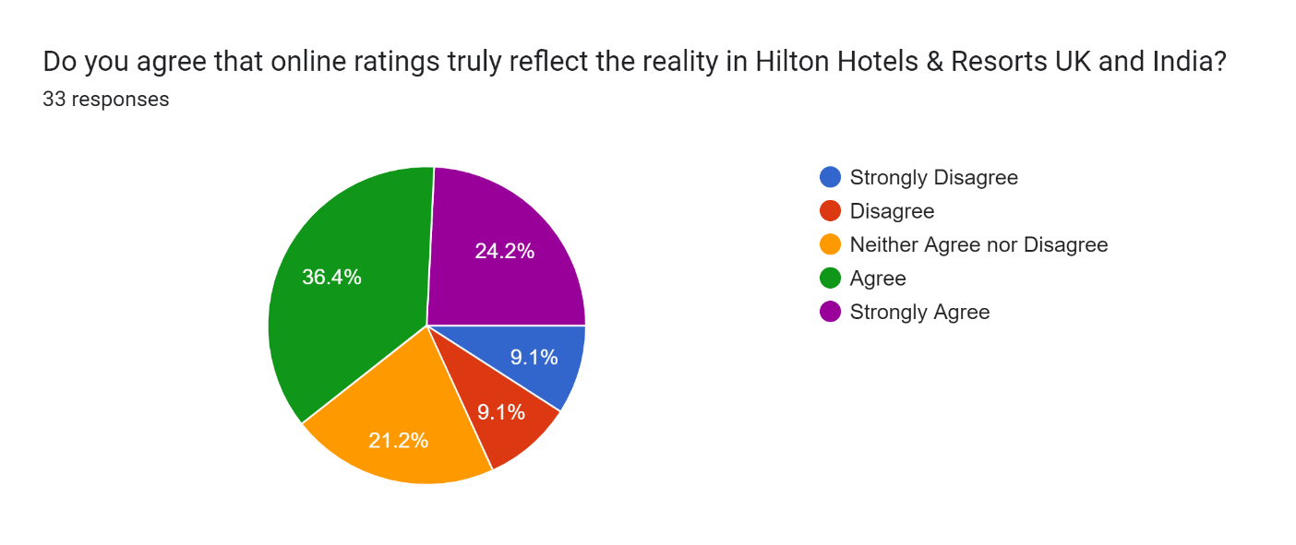
Interpretation:
The respondents have an experience of booking and staying at Hilton hotel and resorts in both UK and India, this question will help to evaluate either the rating on booking.com or other online websites for Hilton hotel and resort are true or fake. Major of the customers of the Hilton hotel, believe or agree on the fact that online rating shows the reality of Hilton Hotels and resorts both in India and UK where is only approximately 18 to 19% of the population disagree that the online ratings of the Hilton hotel are true. An important portion of the respondents that is 21.2% also reflects a neutral position which indicates their mixed opinion regarding the accuracy of the online rating which reflects the reality of the hotel.

What is the likelihood that you will leave an online review after staying at a Hilton hotel booked through booking.com? | Frequency
Very much | 3
Somewhat | 4
Neutral | 20
Not Much | 4
Not at all | 4
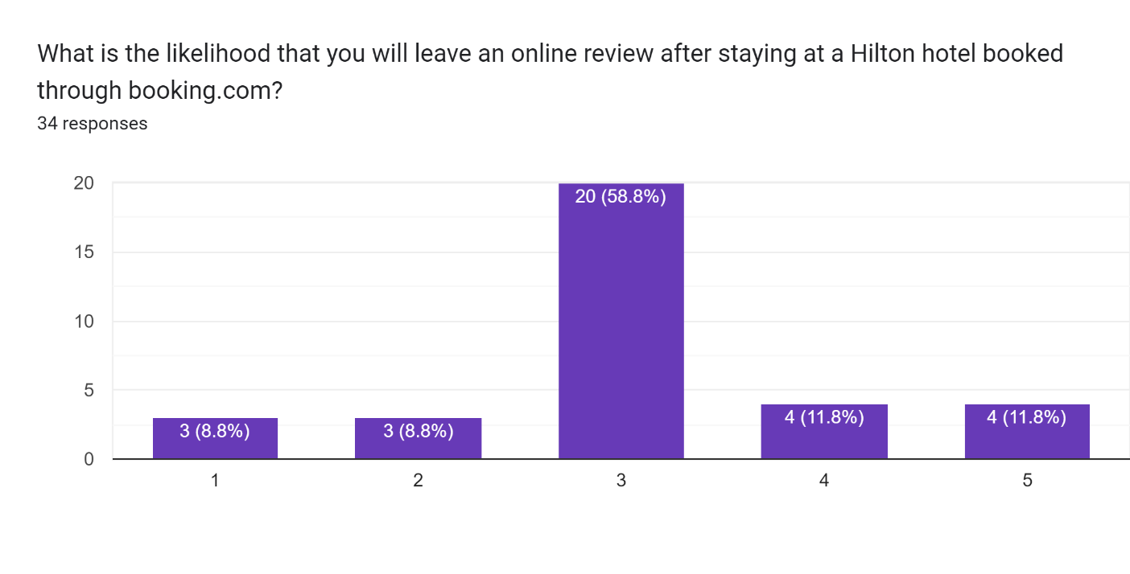
Interpretation:
Collection of responses helps to evaluate that the majority of the respondents that are 20 respondents among the 35 provides that they are neutral to leave an online review after staying at the hotel booked through booking.com. It helps to indicate that they are neither highly likely, nor unlikely to leave the review. On the other hand, only a small portion of the respondents that are seven respondents, who are somewhat or very much likely to leave an online review after staying at the hotel. However, age respondents will not leave any online review after stay at Hilton hotel. It helps to suggest that the significant portion of the respondents does not have any strong intention to leave the review, but there are many of those who are inclined towards providing a review to the hotel for their services on booking.com.
Are you of the opinion that Hilton Hotels & Resorts are active in responding to online reviews on Booking.com? | Frequency
Strongly Disagree | 3
Disagree | 5
Neither Agree nor Disagree | 15
Agree | 10
Strongly Agree | 2
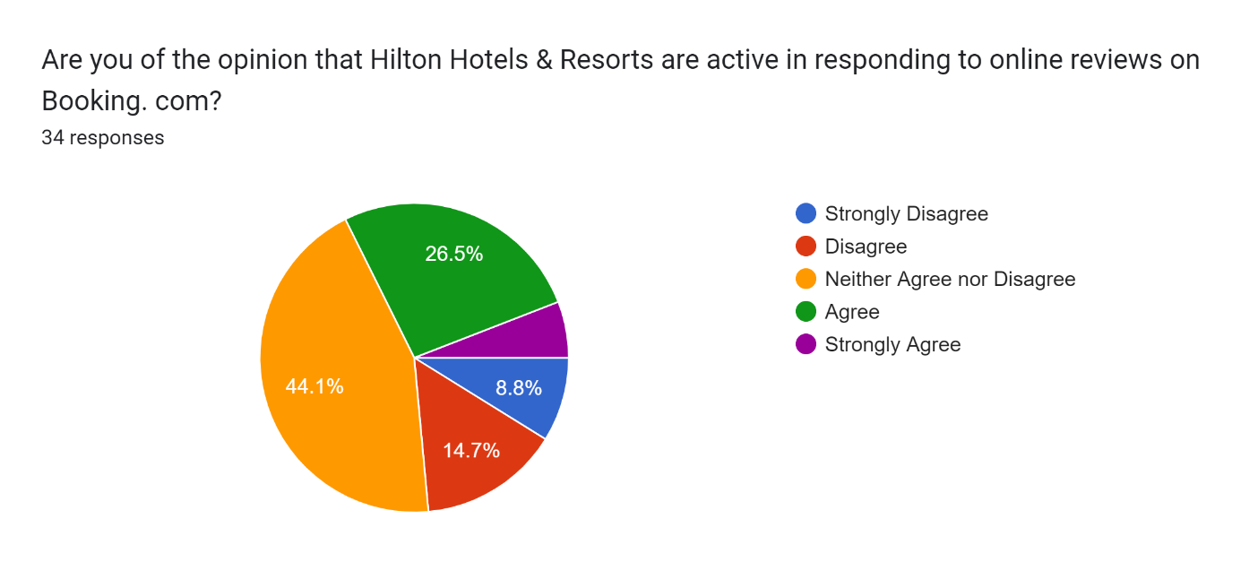
Interpretation:
The respondents show a range of opinions by responding on this question, and it has been evaluated that majority of the population are neither agree, not disagree, showing their uncertainty regarding the activity of Hilton Hotels and resorts in responding towards the online reviews on booking.com. A combination of 12 respondents agrees, and provide a positive opinion that Hilton Hotels are active and responding to their online reviews on booking.com, whereas combination of eight respondents or either strongly disagree or disagree that the hotel provide response on their online reviews on booking.com. This question helps to evaluate the activity or an activity of Hilton Hotels and Resorts to give response to their online reviews on booking.com which indicates the importance of online reviews for the hotel.

Does the way management reply to online reviews determine how you perceive a Hilton hotel on Booking.com? | Frequency
Strongly Disagree | 3
Disagree | 6
Neither Agree nor Disagree | 11
Agree | 11
Strongly Agree | 4
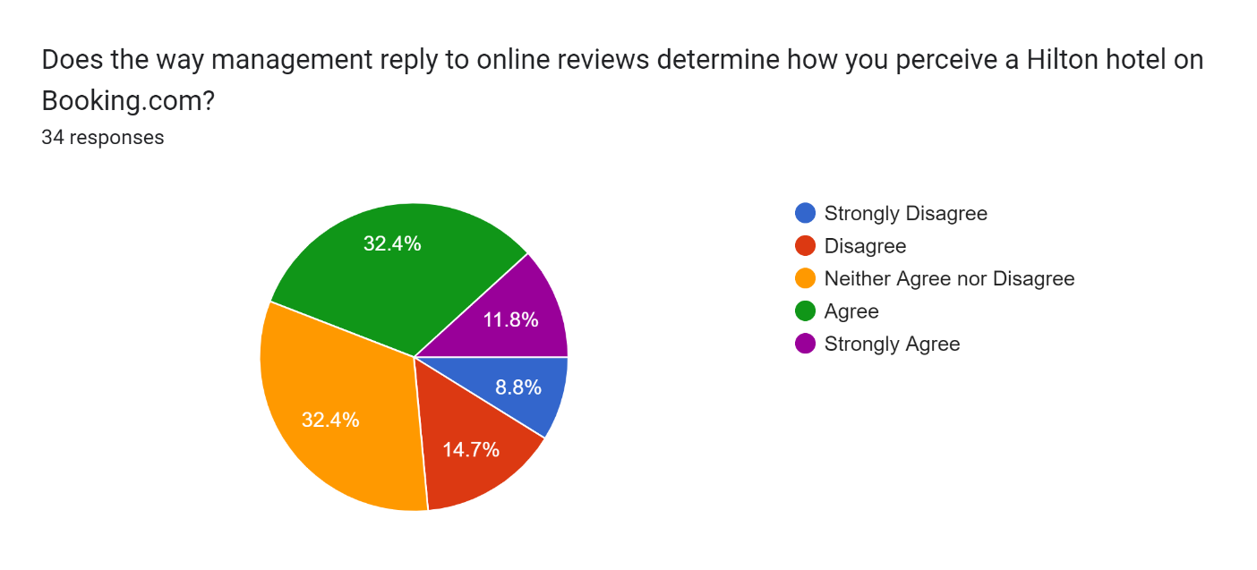
Interpretation:
Giving replies to the online reviews shows the value, the management of hotel provide to their customers and this question will help to evaluate that does the behavior of management have any impact on the customer behavior by their decision making for booking the hotel. With the help of collective responses, it has been evaluated that major of the respondents, that is the combination of 15 responses agree that the management reply to online reviews helps them to determine the way they perceive Hilton hotel on booking.com. Combination of nine respondents disagree that the management reply does have any impact on determining how they perceive the hotel. A major portion of the respondents shows their uncertainty in their response as they are neither agree not disagree that online reviews determine their way to perceive the hotel.

Given that online reviews influence your decision, how likely are you willing to recommend a Hilton hotel after having such experience? | Frequency
Very much | 1
Somewhat | 4
Neutral | 15
Not Much | 12
Not at all | 3
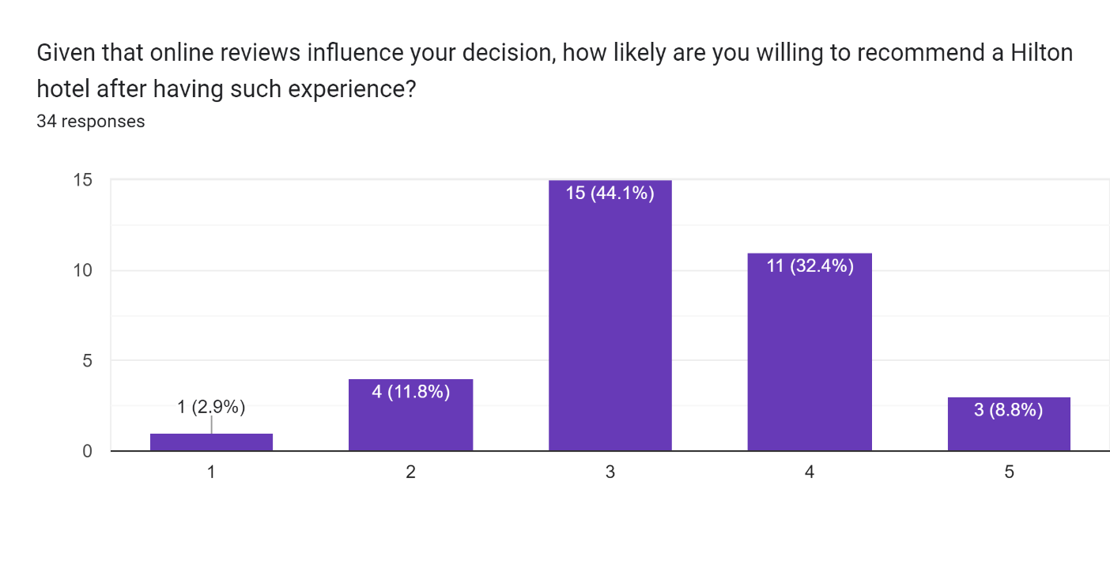
Interpretation:
This question will help to evaluate whether the respondents are off opinion that the other people should believe on the online reviews of the hotel, after having their experience of influencing their decisions with online reviews. This question will also help to reveal that either the online reviews related to Hilton hotel on booking.com are real or fake. Majority portion of the respondents, or neutral that they are neither highly likely nor unlikely to recommend the Hilton hotel after having that experience with them, whereas combination of 15 respondents are of opinion that they will not match or at all, recommend a hotel after having that experience with them. On the other hand, only five responses are of opinion that they will recommend the hotel after their experience, and being influenced by the online reviews. The results help to evaluate that majority of the population believes that online reviews wrongly influence that their decision to book Hilton hotel.

How much do you think that online reviews have been able to affect the reputation of Hilton Hotels & Resorts on Booking.com? | Frequency
Strongly Disagree | 1
Disagree | 5
Neither Agree nor Disagree | 13
Agree | 13
Strongly Agree | 3
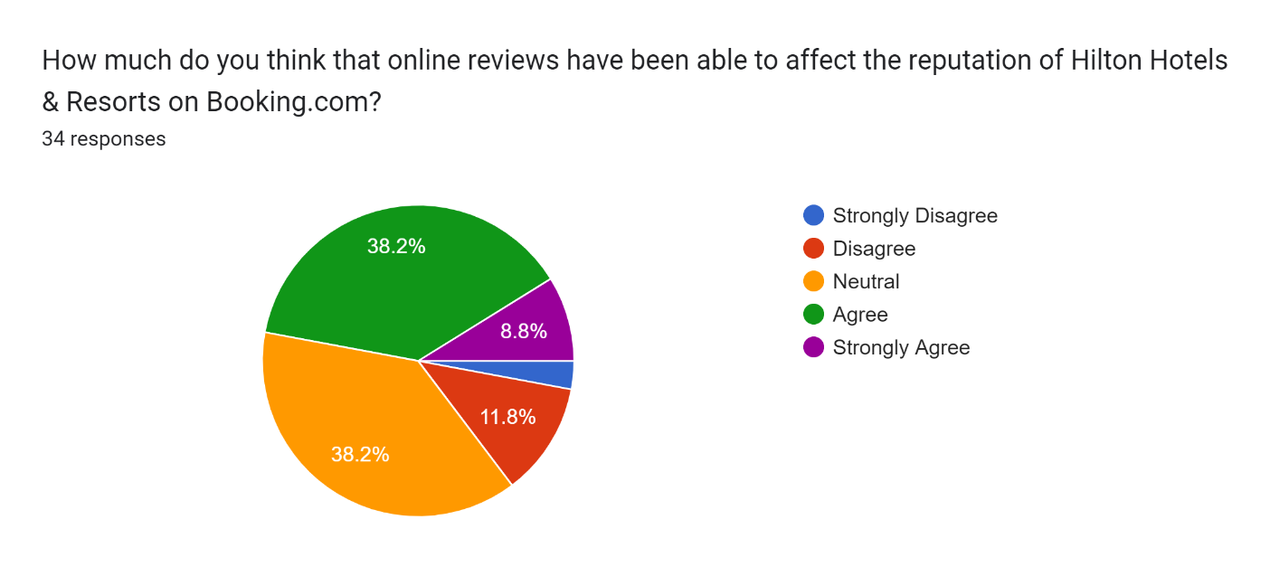
Interpretation:
This question has been asked with the respondents to understand the importance of online reviews on the reputation of Hilton Hotels and resorts. According to the responses collected from the selected population, it has been evaluated that major of the respondent that is combination of 16 respondents agreed that online reviews have a great effect on the reputation of Hilton Hotels and resorts. On the other hand, 13 respondents provide an uncertain response. That is neither agree, not disagree on the point that online reviews have potential to affect the reputation of hotel. Only combination of six respondents disagree that online reviews have been able to affect the reputation of the hotel. This helps to evaluate that it is very necessary for Hilton Hotels and resorts to manage positive online reviews on booking.com as there are many customers who order their hotels, considering the online reviews posted on booking.com.

Do you think that there is a need for Booking.com to include more features or improvements when it comes online reviews of Hilton Hotels & Resorts? | Frequency
Strongly Disagree | 1
Disagree | 5
Neither Agree nor Disagree | 16
Agree | 10
Strongly Agree | 3
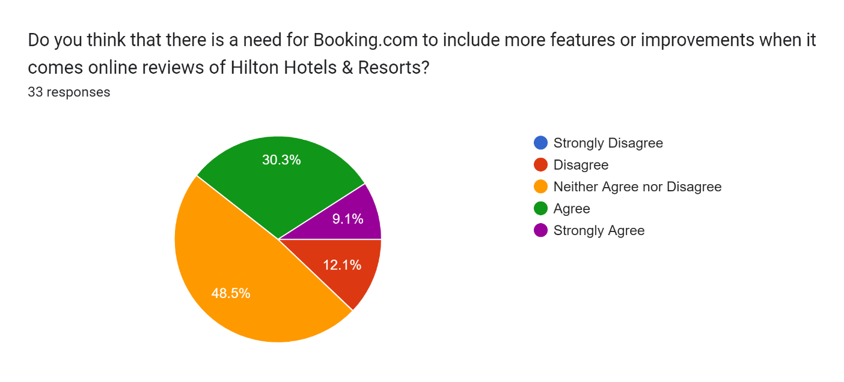
Interpretation:
According to the above collected responses for the question, major of the respondents that is 16 responses are on the point neither agree not disagree which shows that they believe that there is no need for the booking.com to include more features of improvements, and if they bring some positive changes, then they will also not have any kind of problem. A combination of 13 respondents agrees that booking.com should include more features are improvements in their online reviews of Hilton Hotels into thoughts as it will help the customers and the hotel to make necessary decisions. Only a combination of six respondents is disagree that booking.com needs to make some improvements or include more features. This helps to interpreted that the company should work on, including more features or improvements to enhance the online reviews part of the application to make it more accessible for their customers.

How much do you trust the overall rating displayed on Booking.com for Hilton Hotels & Resorts? | Frequency
Very much | 2
Somewhat | 5
Neutral | 14
Not Much | 7
Not at all | 7
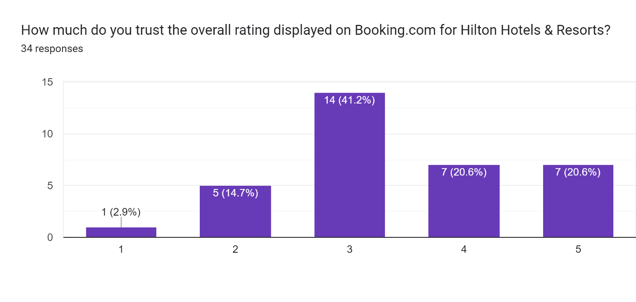
Interpretation:
According to the collected responses on the above question, it has been evaluated that major of the respondents are either very much or somewhat or neutrally trust on the overall rating for Hilton hotels, and resorts that has been displayed on booking.com. Only 14 respondents from the 35 respondents are of opinion that they are not much or not at all able to trust the overall rating of Hilton Hotels and resorts on thebooking.com. It helps to evaluate that only getting overall rating on booking.com is not enough for Hilton Hotels in resource. It is also necessary to develop trust of the customers on their overall rating that has been displayed on their online sites.

Chapter 5: Result and Analysis
After the chapter data analysis and interpretation, the next section of the dissertation is to analyze the interpretative data and extract the results from the same. The results part is very necessary from the data interpretation part as it will help the discussion to identify either the hypothesis mentioned in the beginning fulfilled or not. The result of the collected data with the help of survey questions from the customers of booking.com who booked Hilton Hotels and resorts regarding their perspective on the online reviews is given below:
    - The survey helps to highlight the behavior and perceptions of the customers, and as a result, it has been evaluated those online reviews have a great impact on the book into seasons for Hilton Hotels and resorts than they are booked through booking.com. All the findings help to show the results that the randomly selected population have a great reliance on the online reviews while taking their booking to seasons through booking.com. Majority of the respondents find the online reviews to be trustworthy and reliable source to make their decisions, and based their perception, on them related to Hilton Hotels. Positive reviews on online platforms are also observed to put a create and important impact on the perception of customers indicating to play an important role in shaping the decisions of consumers.
    - Some questions also help to found that negative reviews also have impact on the willingness of the consumers to book their staycation. All this helps to evaluate that there is an important need for the hotels to maintain their positive online reputation as it helps them attract more customers to book their accommodations. Some questions also help to evaluate the demographic differences among the customers which will also help the Hotel hotels and booking.com to identify their key target audience. It has been evaluated that the general distribution of selected respondents was nearly equal but the people of age between 25 to 34 years are highly dependent on online reviews. Considering this age group to be the target audience it is necessary for both companies that is hiltonhotelsandbooking.com to fulfill their expectations and preferences.
    - Geographically, it has been evaluated that majority of the respondents are from United Kingdom’s, which helps to evaluate the strong presence in that reason. It is necessary to develop the digital marketing strategies and promotions, considering the geographical locations, so that the customers can be able to engaged effectively. The data also helps to evaluate that there are so many responding to admitted that they change their booking plans only after they read the online reviews of different hotels which highlights that there is an important impact of online reviews on the consumer decision making. The majority of the respondents also believed that the online reviews have a great impact on the reputation of Hilton Hotels as it emphasized that there is a great importance of managing this online review so that positive brand image can be maintained in the market.
    - Apart from the reputation management of the Hilton Hotels in the market. It is also identified with the help of data collection and results that many of the respondents found that there is a need for more features or improvements to be added on booking.com, so that online reviews can be enhanced related to Hilton Hotels and resorts. Specific enhancements can be done in the application, which will help in specific functionality of the online reviews like providing review filtration options in that customers can be able to filter their good reviews and bad reviews according to their choices. Apart from this review verification processes are also a great feature of improvement that can be identified by booking.com as it will enhance the reliability interest of consumers on the online reviews that has been identified a major problem for the help of collected data.

Chapter 6: Discussion
After the result and analysis part, the discussion section helps to get an opportunity to go deep in the implications of the research findings. This discussion helps to examine a broad context of the study so that insights can be identified for future research as well as it can be practically applied. this section helps to discuss results and also offer insights related to the fulfillment of hypothesis of the study.
The results showed that online reviews are very influential in the consumers’ behavior since the positive reviews increase the likelihood of booking by even 11%. The cultural variances that are present in the UK and India essentially determine the way that consumers respond to online reviews with the individualistic tendencies within the UK promoting a greater reliance on online reviews for the purpose of trust generation while the collectivist values in India focus on personal referrals. It has been found that negative reviews affect consumer behavior in various ways in each market, with the UK seeing them as areas for improvement, while in India, in many instances, they are perceived as insults.
As for Hilton Hotels & Resorts, the online reviews indicated the following trends repeated throughout the reviews, including outstanding service, up-to-date facilities, and advantageous locations, which led to the positive influence on consumer decision-making. The SERVQUAL model was used to study the dimensions of service quality found by consumers, and it indicated reliability, assurance, tangibles, empathy, and responsiveness that were key to positive reviews and consumer satisfaction in the Hilton case. These results emphasized how online reviews were very influential in influencing attitudes and preferences about hotel bookings, with the consumers relying on them to guide their decision making.
With a deductive research design and a primary-methods research strategy, the study yielded several significant findings. Firstly, from the quantitative analysis, it is evident that there is a high degree of correlation between the ratings of online reviews and consumer behavior with respect to hotel booking. Statistical analysis of the quantitative data such as the review scores, frequency of bookings, and demographic information yielded some patterns and trends that indicated that positive online reviews are positively related to the rise in the likelihood of hotel reservations. For instance, the correlation between the average rating by customers of Hilton Hotels & Resorts on Booking.com and booking frequency was positive which means that positive reviews by customers influence their decisions. Moreover, qualitative findings of the semi-structured interviews provided rather valuable information concerning the subjective attitude and experience of the consumers concerning the online reviews. Online reviews were highlighted in the responses as one of the factors impacting the perception of quality and the choices made. For example, a great deal of respondents has mentioned that the thorough reviews and feedbacks have had a considerable impact on the choice of their booking, which means that the online reviews are seen as a valuable source of information and trust.
The survey data emphasizes the powerful effect of online reviews on the consumer behavior to book the hotels with Booking.com. Most respondents confessed to altering their booking decisions after reading online reviews, highlighting the critical role that reviews play in determining booking choice. This result is consistent with the previous researches pointing out the large effect of online reviews on consumer’s purchasing decisions in different industries. For Hilton Hotels as well as Booking.com, these results highlight how the companies should manage their online reviews and use them to improve their guests’ satisfaction and site bookings.
Trust and credibility in the online review management play a basic role on consumer perception and behavior. The survey findings show that most people trust the Hilton Hotels reviews located on the Booking.com site, thinking that these reviews are reliable and dependable. Nevertheless, some respondents were critics and they emphasized the fact that the presented information should be verified. The main focus for Hilton Hotels and Booking.com is definitely how to improve review authenticity and transparency, including the establishment of strong verification processes and monitoring of reviews.
Geographical differences were captured by the survey in perception and dependence on online reviews with most of the respondents being from the UK. However, this result also poses the question of regional variation in the perception and behavior toward reviews. Further study could investigate that cultural norms, language barriers and others will affect how the customers from various regions interpret and trust the online reviews. Insight into these geographical subtleties can enable custom marketing strategies and audit management policies to reach diverse customer segments.
Although many respondents showed contentment with the current state of reviews in Booking.com website, others pointed out areas for improvement. Some of these opportunities include improving the usability, dependability, and honesty of the online review platforms in order to suit the desire and expectations of the customer. For instance, respondents proposed to add more features and refinements to make online reviews more convenient and useful. Both Hilton Hotels and Booking.com need to seek feedback from their clients actively and utilize technological innovation to keep improving their online review platforms.
Online reviews seem to have advantage but both Hilton Hotels and Booking.com have some challenges and considerations to address. Such risks may come in the form of fake or prejudiced reviews, requirement for the successful and prompt management of reviews, and impact on brand reputation by negative reviews. Additionally, as the online review platforms increase and people’s preferences change, Hilton Hotels and Booking.com should be dynamic and adjustable thereby meeting the change needs of the customers and expectations. Through staying proactive and responsive, they can use online reviews as a useful instrument in customer relations and brand improvement.
Looking forward, online review management is an interesting topic that future research could apply to the different trends and developments the influence of social media, influencer marketing, visual and multimedia content among others. Longitudinal studies could also trace shifts in consumer attitudes and behaviors towards online reviews over time, offering vital information on transforming trends and patterns. Continuously being ahead of such developments, Hilton Hotels and Booking.com are able to continue to use online reviews to effectively grow business and improve customer satisfaction.

Chapter 7: Conclusion and Recommendations

Conclusion:
The research conducted focused on the complex interaction between online reviews and consumer choices when it comes to making hotel reservations and was made specifically for Hilton Hotels & Resorts via the Booking.com website in the UK and India. The research shed light on the indirect link between online reviews, cultural influence, and service quality perception, which affect behavioral activity in the hospitality industry. The revealed outcomes emphasize the need to understand cultural specifics and deliver excellent service to satisfy customer’s needs and enhance the brand reputation. Such findings are very important to organizations in the hospitality industry like Hilton Hotels & Resorts and are used in the formulation of marketing plans that will make the company remain competitive in the changing business environment as well as to improve the level of satisfaction that customers derive from using the products of the company. The outcomes of the study offered significant revelations in the field of consumerism concerning online reviews during the booking of hotels, more so on Hilton Hotels & Resorts through Booking.com in the UK and India.
Moreover, the study identified several moderating variables that mediate the effectiveness of online reviews on consumer behavior. These factors included reviewer credibility, review relatedness to individual preferences, and review sentiment. For instance, credible comments included positive comments by the verified guests and this created trust and confidence to book. In general, research results highlighted the important role of online reviews on consumer decision-making in the process of hotel reservation. What is more important, the study offered not only the practical implications for understanding the influence of online reviews on the behavior of consumers in the hospitality industry but also the implications for the theoretical level by mixing quantitative analysis with qualitative insights.
In summary, the findings of the research brought out the significance of the online reviews as a major factor that influences the consumer behavior in the hotel booking process especially for Hilton Hotels & Resorts via Booking.com in the UK and India. The results indicated that hoteliers had to be proactive in managing their online reputation and using positive reviews as a source of competitive advantage when attracting and retaining customers. Moreover, the research illuminated the multifaceted relationships among the online reviews, the consumer’s perception, and the decision-making process that provided valuable conclusions for the future research and managerial application in the field of hospitality.
The purposes of the study are closely related to the main aim which is to investigate the impact of online reviews on the process of consumer behaviors in terms of hotel reservations in Hilton Hotels & Resorts in the markets of both the UK and India. First, the study of the correlation between online reviews and consumer decisions to purchase addresses the main objective of determining the effect of online commentary on booking decisions. Secondly, the analysis of cultural variances in the interpretation of online reviews further extends this study by revealing how cultural norms and values influence consumer reactions, thus contributing to the knowledge of cross-cultural consumer behavior. Third, the assessment of the features that were either highlighted or undermined in the online reviews provides very important information about the forces shaping the consumers’ perceptions of Hilton Hotels & Resorts. Lastly, the evaluation of the influence of online reviews on customer opinion and sentiment provides an all-round perception of the digital perception of hospitality firms, which will guide strategic management choices and marketing strategies.

Recommendations:
Recommendation 1: Actively engage online review platforms
Given the powerful impact of online reviews on the consumer buying process, it is essential for hospitality firms to communicate through online review channels and encourage their guests to provide feedback. It has been a consistent finding from research studies that the higher the number of reviews posted, the more the likelihood of the consumers developing trust in and confidence in the brand. By asking and answering reviews, hotels can manage their reputation online and make use of the positive reviews to attract more customers.
Recommendation 2: Staff culture intelligence training:
Taking into account the cultural dimensions that impact customer response to online reviews, the cultural intelligence training, which should be provided by hospitality firms for their staffs, is recommended to be held in order to know more about the national peculiarities of the tastes and preferences of global visitors to deliver better services. Cultural awareness and sensitivity training would also encourage hotel workers to tailor their services, and modes of communication, to suit the cultural needs of their customers. This will ensure that the cultural issues and tastes are catered for much earlier thus having a positive impact on the aggregate customer satisfaction and the loyalty as well.
Recommendation 3: Data Analytics Tools Used:
Considering the impact of online reviews on the perception and attitude of customers towards hospitality entities, it would be appropriate to recommend that hotels adopt analytics tools to help them in understanding consumer comments and preferences as registered through online reviews. Sentiment analysis and natural language processing methods applied to review data can help hotels identify trends, pain points and emerging guest feedback topics. The use of data in such an approach enables hotels to make decisions that are logically justified to enhance the quality of their services, eliminate the identified issues, and remain leaders in the hotel industry.
Recommendation 4: Personalized marketing approach implementation
Given the enormous influence of online reviews on consumers’ decisions, hospitality firms should come up with individualized marketing strategies that take into consideration the tastes of specific customers and their portrayal in the reviews available online. Such personalized marketing instruments as direct mail campaigns or loyalty programs based on guests’ past experience and review rating, can help to develop more strong relationships with customers. By addressing specific issues or interests highlighted in the comments, the hotels demonstrate their responsiveness and care, hence raising the guest satisfaction and loyalty.
Recommendation 5: Incorporation of online reputation management to strategic planning.
Because online reviews are so influential to consumer attitude, the hotel industry should integrate online reputation management into their strategic planning to monitor and control their online presence. The implementation of the online reputation management as one of the constituents of the strategic planning makes it possible for hotels to stay on the offensive side while dealing with the guest feedback and preventing the negative reviews. By dedicating resources to online sentiment monitoring, response to guest concerns and continuous improvement programs, hotels can establish their reputation and brand image in the fiercely competitive world of hospitality.

REFERENCES

Books and Journal
Ciftci, O., Berezina, K., Cavusoglu, M. and Cobanoglu, C., 2020. Winning the battle: The importance of price and online reviews for hotel selection. Advances in Hospitality and Tourism Research (AHTR), 8(1), pp.177-202. Available at: https://dergipark.org.tr/en/pub/ahtr/article/528150.
Dang, T.D. and Nguyen, M.T., 2023. Systematic review and research agenda for the tourism and hospitality sector: co-creation of customer value in the digital age. Future Business Journal, 9(1), p.94. Available at: https://link.springer.com/content/pdf/10.1186/s43093-023-00274-5.pdf.
Davidsson, S., 2023. Do reviews really affect your hotel decision? A study about what impact reviews have on the consumers buying decision in the hotel industry. Available at: https://www.diva-portal.org/smash/record.jsf?pid=diva2%3A1762375&dswid=6291.
Endeshaw, B., 2020. Healthcare service quality-measurement models: a review. Journal of Health Research, 35(2), pp.106-117. Available at: https://www.emerald.com/insight/content/doi/10.1108/JHR-07-2019-0152/full/html/1000.
Gulati, S., 2023. Exploring the generational influence on social media-based tourist decision-making in India. Information Discovery and Delivery. Available at: https://www.emerald.com/insight/content/doi/10.1108/IDD-11-2022-0115/full/html.
Manigandan, R. and Raghuram, N.V., 2022. Artificial Intelligence (AI) In Hotel Industry and Future Development: An Extensive In-Depth Literature Review and Bibliometric Analysis. International Journal of Intelligent Systems and Applications in Engineering, 10(4), pp.664-676. Available at: https://ijisae.org/index.php/IJISAE/article/download/2338/922.
Parray, Z.A., Iqbal, J. and Mushtaq, R., 2023. Customer perception of corporate social responsibility and its impact on customer engagement: critical significance of corporate reputation. Corporate Communications: An International Journal. Available at: https://www.emerald.com/insight/content/doi/10.1108/CCIJ-05-2023-0063/full/html.
Roy, G., 2023. Travelers’ online review on hotel performance–Analyzing facts with the Theory of Lodging and sentiment analysis. International Journal of Hospitality Management, 111, p.103459. Available at: https://doi.org/10.1016/j.ijhm.2023.103459.
Sharma, A.P., 2021. Consumers’ purchase behaviour and green marketing: A synthesis, review and agenda. International Journal of Consumer Studies, 45(6), pp.1217-1238. Available at: https://onlinelibrary.wiley.com/doi/abs/10.1111/ijcs.12722.
Shukla, A. and Mishra, A., 2023. Effects of visual information and argument concreteness on purchase intention of consumers towards online hotel booking. Vision, 27(5), pp.639-649. Available at: https://journals.sagepub.com/doi/abs/10.1177/09722629211038069.
Sneha, N., 2021. Post-Pandemic Travel: Decoding the Trends and Challenges for Indian Travellers. Atna Journal of Tourism Studies, 16(1). Available at: https://doi.org/10.12727/ajts.25.4.
Wang, F.X. and Anderson, C., 2023. How Firm Strategies Affect Consumer Biases in Online Reviews. Service Science. Available at: https://pubsonline.informs.org/doi/abs/10.1287/serv.2023.0316.

Online
Australian Bureau of Statistics (2023). Quantitative and qualitative data | Australian Bureau of Statistics. [online] www.abs.gov.au. Available at: https://www.abs.gov.au/statistics/understanding-statistics/statistical-terms-and-concepts/quantitative-and-qualitative-data#:~:text=Quantitative%20%3D%20Quantity.
Booking.com (2021). London Hilton hotels. [online] Booking.com. Available at: https://www.booking.com/hilton/city/gb/london.en-gb.html?aid=397594&label=gog235jc-1DCAEYZSiCAjjoB0gJWANobIgBAZgBCbgBGMgBDNgBAgBAfgBAogCAagCBLgC4_vXrQbAAgHSAiQwZjAyYTA5Yy02ODcyLTQxZmItODdlOC03MmZmZWM1MmE4NmPYAgTgAgE&sid=f93fde23599fe4e13ffc5a246806b59c [Accessed 28 Jan. 2024].
Booking.com (2023). ★★★★ Hilton London Canary Wharf, London, UK. [online] Booking.com. Available at: https://www.booking.com/hotel/gb/hilton-london-canary-wharf.en-gb.html?aid=397594&label=gog235jc1DCAEYZSiCAjjoB0gJWANobIgBAZgBCbgBGMgBDNgBAgBAfgBAogCAagCBLgC4_vXrQbAAgHSAiQwZjAyYTA5Yy02ODcyLTQxZmItODdlOC03MmZmZWM1MmE4NmPYAgTgAgE&sid=f93fde23599fe4e13ffc5a246806b59c#tab-main [Accessed 28 Jan. 2024].
Center for Teaching and Learning (2021). Literature Reviews What is a literature review? [online] Available at: https://ctl.unm.edu/assets/docs/resources/literature-reviews.pdf.
Cuofano, G. (2021). What Is the SERVQUAL Model? SERVQUAL Model In A Nutshell. [online] FourWeekMBA. Available at: https://fourweekmba.com/servqual-model/.
Datt, S. and Chetty, P. (2016). Types of inductive and deductive research strategy. [online] Project Guru. Available at: https://www.projectguru.in/types-of-inductive-and-deductive-research-strategy/.
Dudovskiy, J. (2015). Research Approach - Research-Methodology. [online] Research-Methodology. Available at: https://research-methodology.net/research-methodology/research-approach/.
Dudovskiy, J. (2019). Positivism - Research Methodology. [online] Business Research Methodology. Available at: https://research-methodology.net/research-philosophy/positivism/.
Dudovskiy, J. (2022). Research Philosophy - Research Methodology. [online] Business Research Methodology. Available at: https://research-methodology.net/research-philosophy/.
Hilton (2023). The Story of Hilton. [online] Stories From Hilton. Available at: https://stories.hilton.com/history.
Hofstede Insights (2023). Country comparison tool. [online] www.hofstede-insights.com. Available at: https://www.hofstede-insights.com/country-comparison-tool?countries=india%2Cunited+kingdom.
Hospitalitynet (2023). The Most Important Factor for Hotels to Get Positive Online Reviews. [online] Hospitality Net. Available at: https://www.hospitalitynet.org/news/4117640.html.
Khosla, V. (2023). Travellers from UK, US showing more interest in coming to India, says report. [online] mint. Available at: https://www.livemint.com/news/india/travellers-from-uk-us-showing-more-interest-in-coming-to-india-says-report-11675764535190.html [Accessed 28 Jan. 2024].
Kwangaikamed.weebly (2020). STRATEGIES (METHODOLOGIES) OF RESEARCH. [online] QUANTITATIVE AND QUALITATIVE RESEARCH APPROACHES. Available at: http://kwangaikamed.weebly.com/strategies-methodologies-of-research.html.
Sagepub (2023). The Selection of a Research Approach. [online] Available at: https://in.sagepub.com/sites/default/files/upmbinaries/55588_Chapter_1_Sample_Creswell_Research_Design_4e.pdf.
Stories Hilton.com (2023). Hilton Hotels & Resorts Around the Globe Debut Major New Design Innovations. [online] Stories From Hilton. Available at: https://stories.hilton.com/property-news/enhancing-the-stay-hilton-hotels-resorts-around-the-globe-debut-major-new-design-innovations [Accessed 27 Jan. 2024].
Stories.Hilton.com (2022). Stories From Hilton. [online] Stories From Hilton. Available at: https://stories.hilton.com/.
Streefkerk, R. (2019). Qualitative vs. Quantitative Research | Differences, Examples & Methods. [online] Scribbr. Available at: https://www.scribbr.com/methodology/qualitative-quantitative-research/.
The University of Edinburgh (2023). Literature review. [online] The University of Edinburgh. Available at: https://www.ed.ac.uk/institute-academic-development/study-hub/learning-resources/literature-review#:~:text=A%20literature%20review%20is%20a.
Thesismind (2019). Analysis of Saunders Research Onion. [online] Thesismind. Available at: https://thesismind.com/analysis-of-saunders-research-onion/.
Walia, A. and Chetty, P. (2020). How to Formulate a Research strategy? [online] Project Guru. Available at: https://www.projectguru.in/how-to-formulate-a-research-strategy/.

Appendices

Questionnaire with Frequency Table
- What is your gender? | Frequency
- Male | 18
- Female | 15
- Prefer not to say | 2
- What is your age? | Frequency
- 18-24 years | 6
- 25-34 years | 19
- 35-44 years | 7
- 45-54 years | 3
- In which country do you live? | Frequency
- United Kingdom | 25
- India | 10
- Online reviews have impact on your decision when you book a hotel with Booking.com. | Frequency
- Strongly Disagree | 7
- Disagree | 5
- Neither Agree nor Disagree | 13
- Agree | 6
- Strongly Agree | 4
- Do you consider online reviews reliable and trustworthy for Hilton Hotels & Resorts at Booking.com? | Frequency
- Strongly Disagree | 2
- Disagree | 10
- Neither Agree nor Disagree | 9
- Agree | 8
- Strongly Agree | 6
- To what extent do positive reviews on Booking.com influence your perception of Hilton hotels? | Frequency
- Very much | 6
- Somewhat | 9
- Neutral | 7
- Not Much | 10
- Not at all | 3
- The negative Online Reviews have its impact on your willingness to reserve a room in Hilton hotels through Booking.com | Frequency
- Strongly Disagree | 3
- Disagree | 6
- Neither Agree nor Disagree | 11
- Agree | 11
- Strongly Agree | 4
- Do you think that online reviews are equally important as other factors such as price or location in Booking.com when selecting a hotel? | Frequency
- Strongly Disagree | 3
- Disagree | 3
- Neither Agree nor Disagree | 14
- Agree | 11
- Strongly Agree | 4
- Do you have ever changed your booking plan of Hilton hotel through Booking.com when reading the online reviews? | Frequency
- Strongly Disagree | 3
- Disagree | 4
- Neither Agree nor Disagree | 13
- Agree | 8
- Strongly Agree | 7
- Do you agree that online ratings truly reflect the reality in Hilton Hotels & Resorts UK and India? | Frequency
- Strongly Disagree | 4
- Disagree | 4
- Neither Agree nor Disagree | 7
- Agree | 12
- Strongly Agree | 8
- What is the likelihood that you will leave an online review after staying at a Hilton hotel booked through booking.com? | Frequency
- Very much | 3
- Somewhat | 3
- Neutral | 20
- Not Much | 5
- Not at all | 4
- Are you of the opinion that Hilton Hotels & Resorts are active in responding to online reviews on Booking.com? | Frequency
- Strongly Disagree | 3
- Disagree | 5
- Neither Agree nor Disagree | 15
- Agree | 10
- Strongly Agree | 2
- Does the way management reply to online reviews determine how you perceive a Hilton hotel on Booking.com? | Frequency
- Strongly Disagree | 3
- Disagree | 6
- Neither Agree nor Disagree | 11
- Agree | 11
- Strongly Agree | 4
- Given that online reviews influence your decision, how likely are you willing to recommend a Hilton hotel after having such experience? | Frequency
- Very much | 1
- Somewhat | 4
- Neutral | 15
- Not Much | 12
- Not at all | 3
- How much do you think that online reviews have been able to affect the reputation of Hilton Hotels & Resorts on Booking.com? | Frequency
- Strongly Disagree | 1
- Disagree | 5
- Neither Agree nor Disagree | 13
- Agree | 13
- Strongly Agree | 3
- Do you think that there is a need for Booking.com to include more features or improvements when it comes online reviews of Hilton Hotels & Resorts? | Frequency
- Strongly Disagree | 1
- Disagree | 5
- Neither Agree nor Disagree | 16
- Agree | 10
- Strongly Agree | 3
- How much do you trust the overall rating displayed on Booking.com for Hilton Hotels & Resorts? | Frequency
- Very much | 2
- Somewhat | 5
- Neutral | 14
- Not Much | 7
- Not at all | 7

