Op AMP LOG BOOK
University of Wales Trinity Saint David
L4 - Workshop Skills/Learning in the Digital Era ACCA4025
Owen Wild
2022
Contents
They aim was to create and test a 741-op amp and see where its saturation. 2
Making my circuit on breadboard 6
Testing: 7
Creating a circuit on easy pcb to then be manufactured. 9
comparison of results 17
Summery 18

To create a simulation and take reading, using breadboard and the designing and developing on pcb board.

They aim was to create and test a 741-op amp and see where its saturation.

I have crated on proteus a simple amplifiers circuit containing resisters, capacitor and a 741-op amp. I added a sine wave to the impute and attracted an oscilloscope to read my results of on the input and output ends of my circuit.
I have calculated the gain of this circuit which is 3 because of are rf/r1 +1 = 3
20k/10K + 1= 3

How I did this was by adding resisters, capacitors and a 741 amp and constructing them to the schematics I had by placing them from my component library and connecting them with wires and also grounding my circuit. I then added an oscilloscope to be able to read the input and output signal of my circuit and a sin wave in the input.
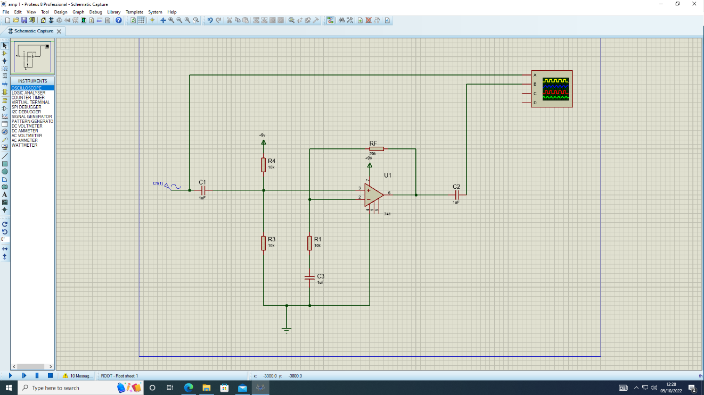

When changing the different sine wave frequencies, I saw that the blue line (output signal) was three times as big as the yellow (input signal) Which told me I had a gain of three, this is correct with my calculation earlier.
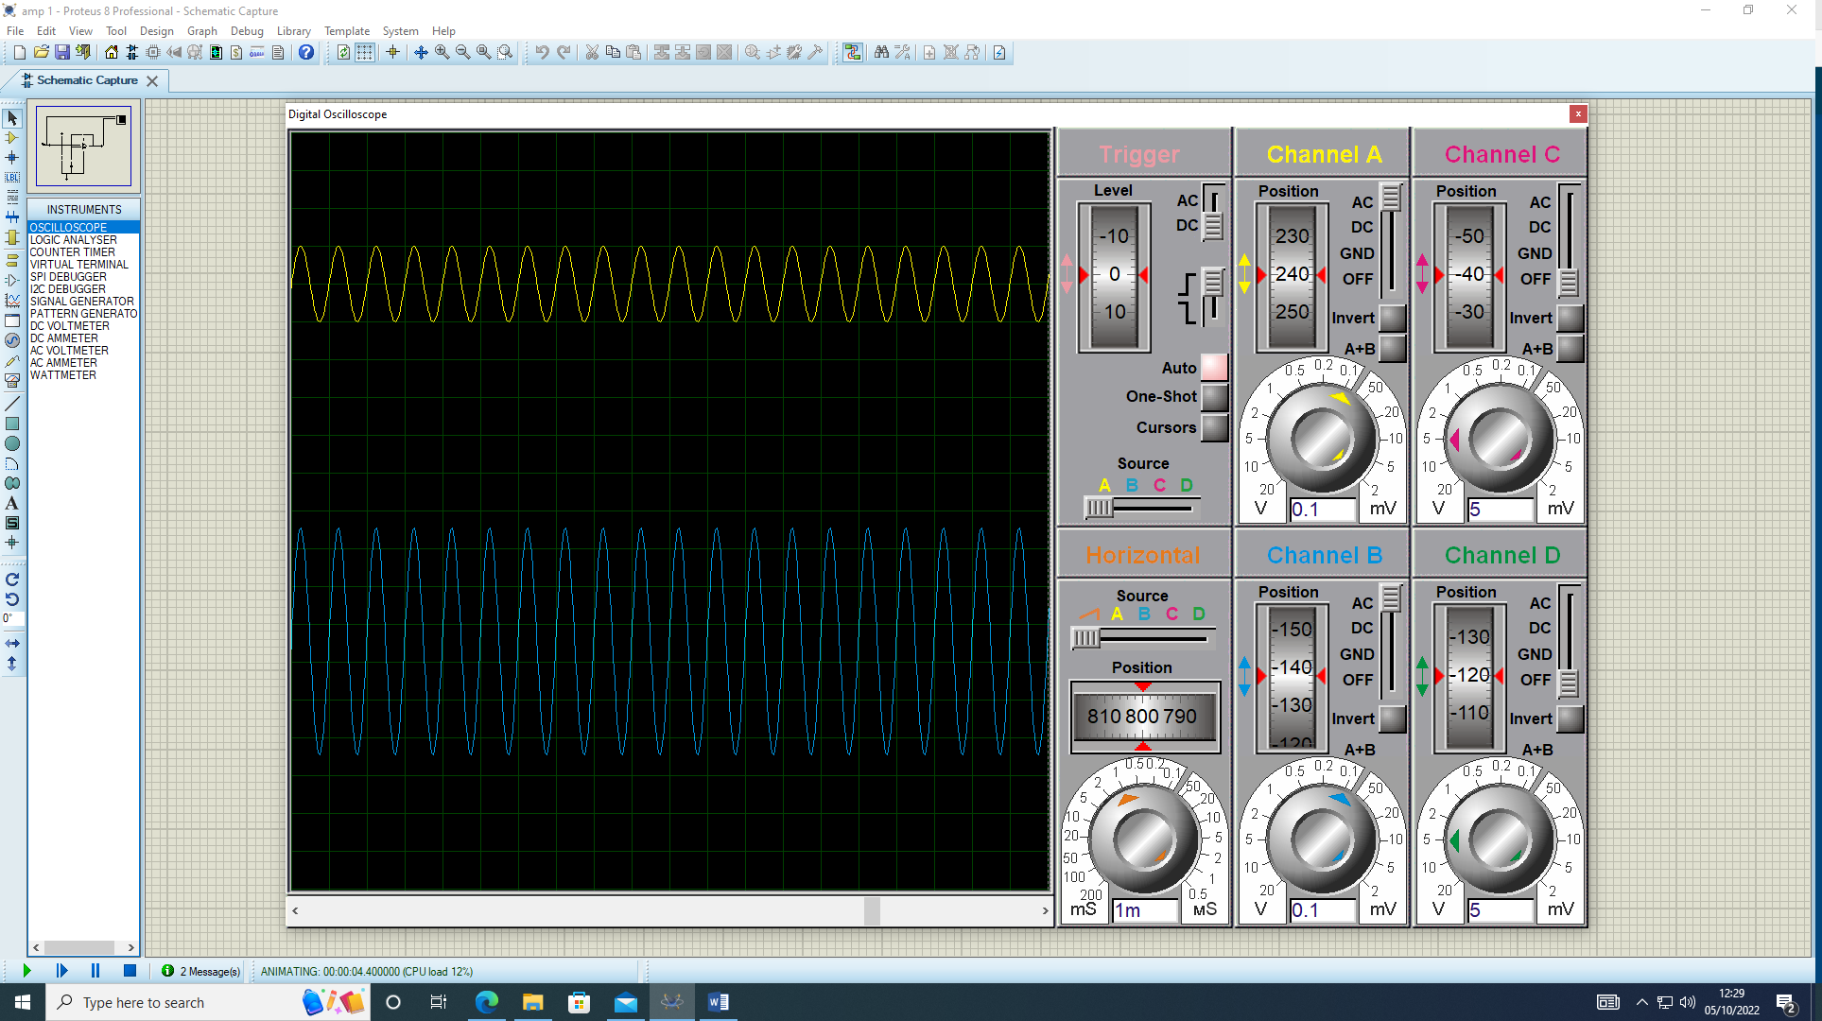
I have now added a signal generator to replaces my sine wave input, by adding this I am able to change the frequencies with more precision to get a more accurate result. I’ve changed the frequencies on the signal generator which I started from 100Hz up to 500kHz and recorded the results.
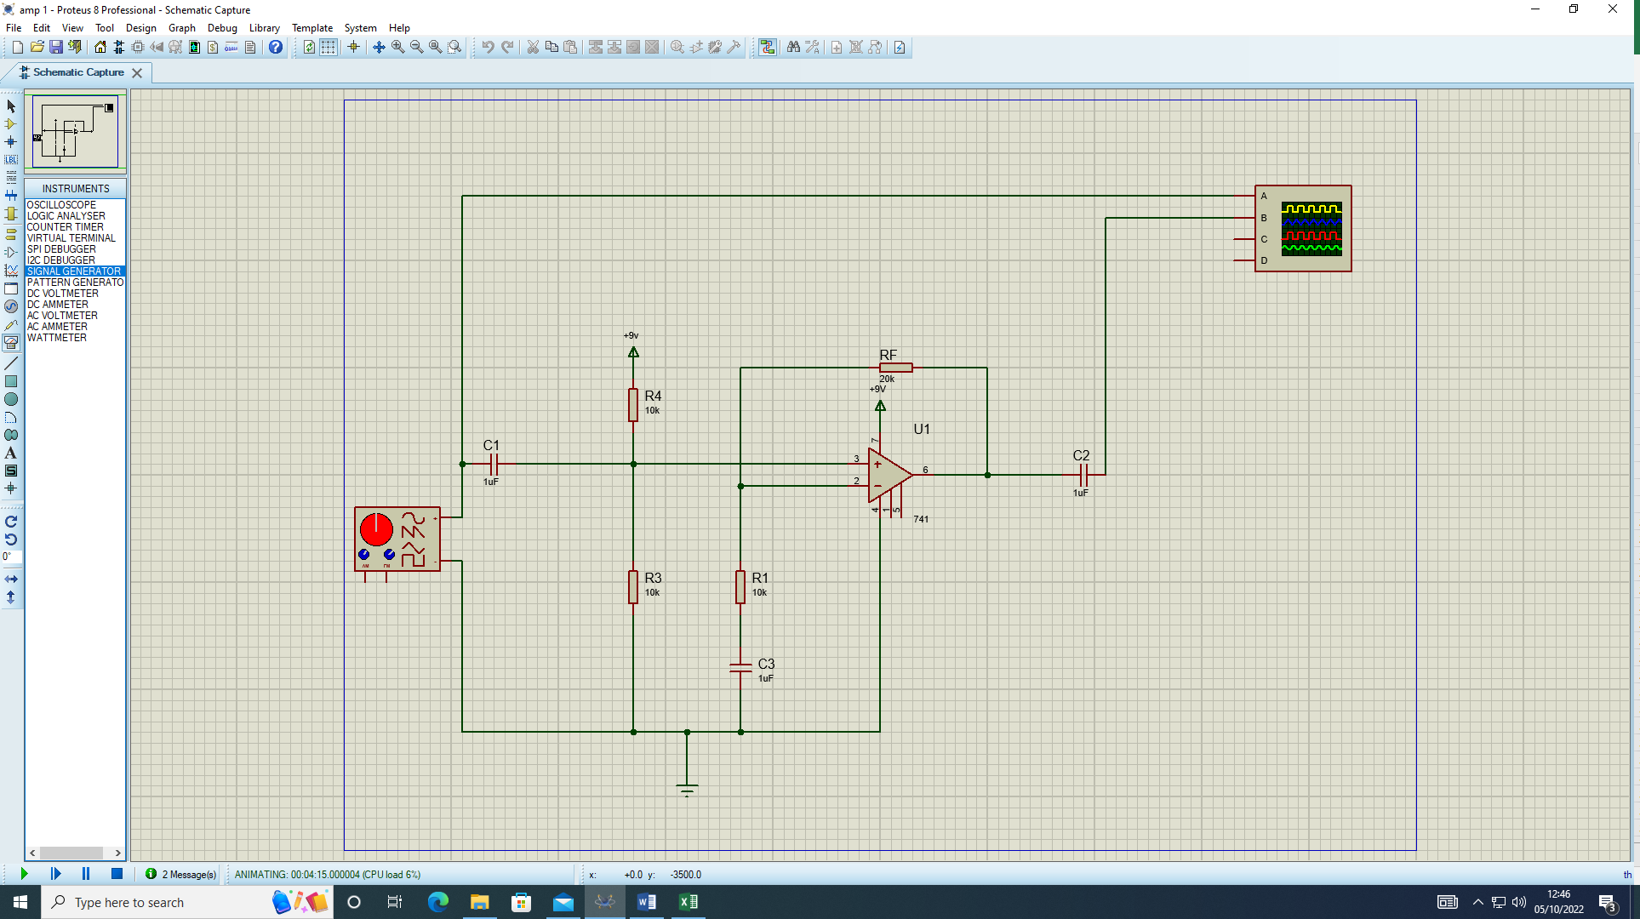
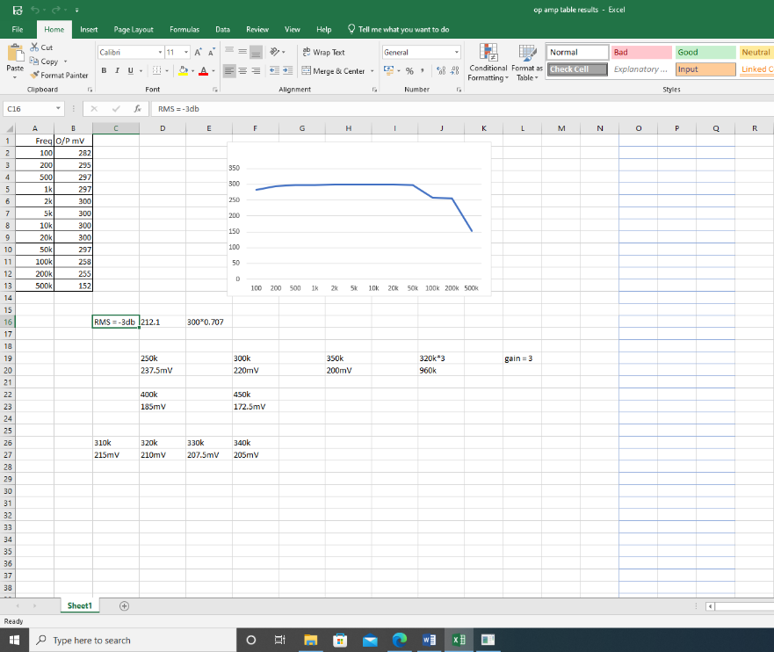
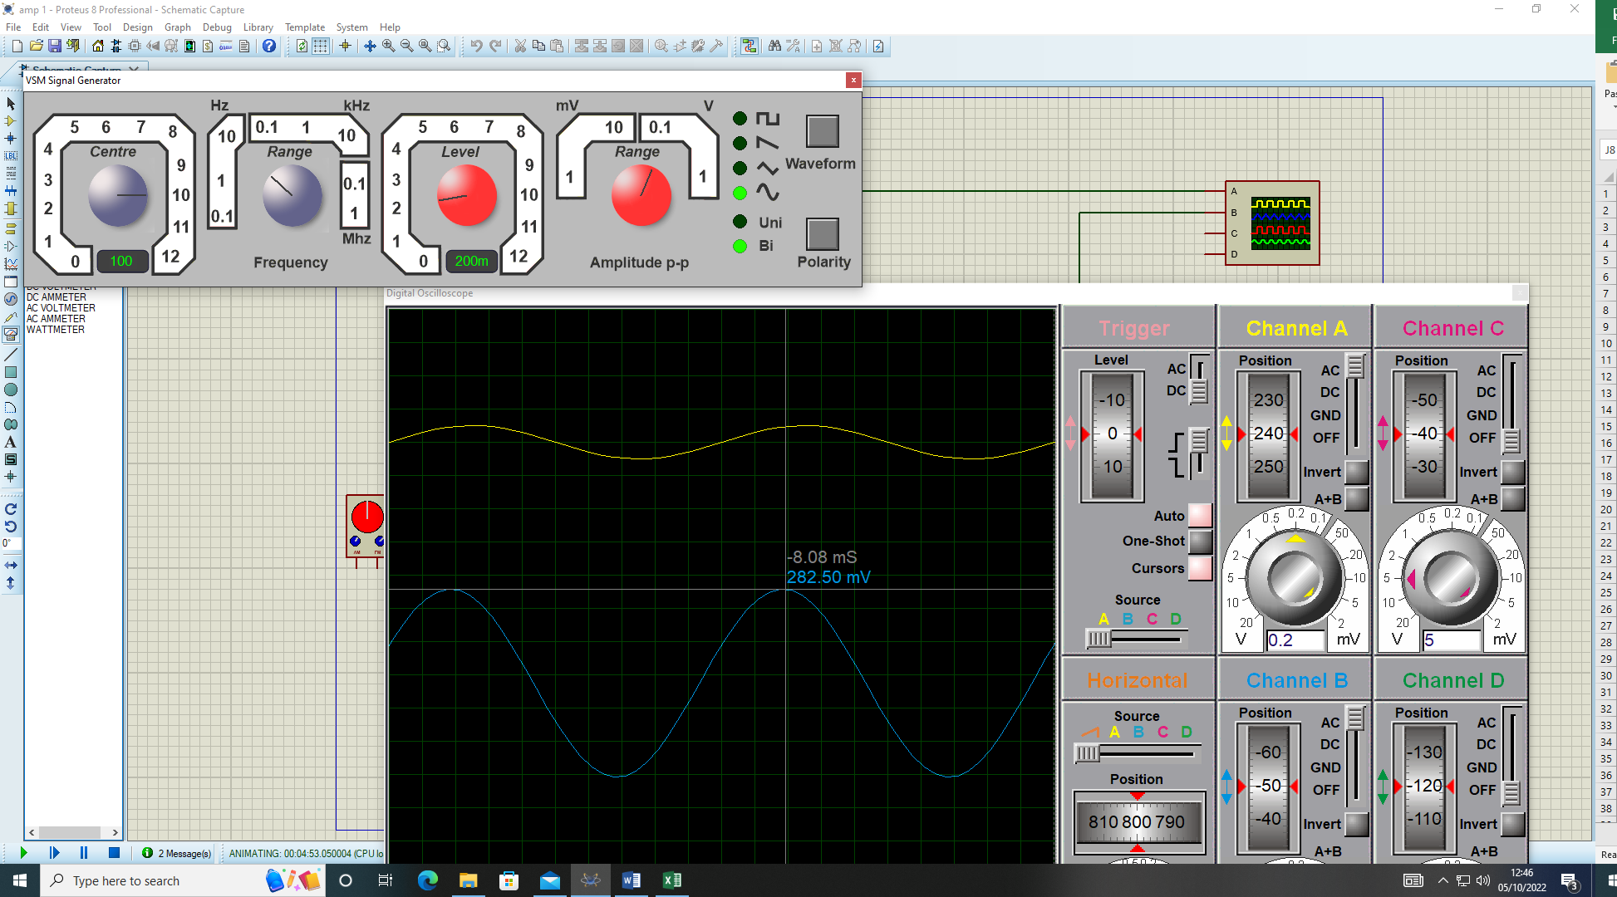
After collecting my results I caculated the RMS value of the 741 opamp by doing 300*0.707 which gave me 212.1, so by doing this I looked at my results and decided to go in smaller increments from 250k up to 450k because the 212.1 fell between 200k and 500k. I then found out that I needed to go small so whent from 310k to 340k to get a more closer and more accurat reading.
I then decided to take the t 320k was is the closes I can get to the rms value of 212.1. I the took the 320k and times it by my gain of 3 to get a value of 960k this shows the max input and output that I can get befor saturation which then after that it slowly decreses.

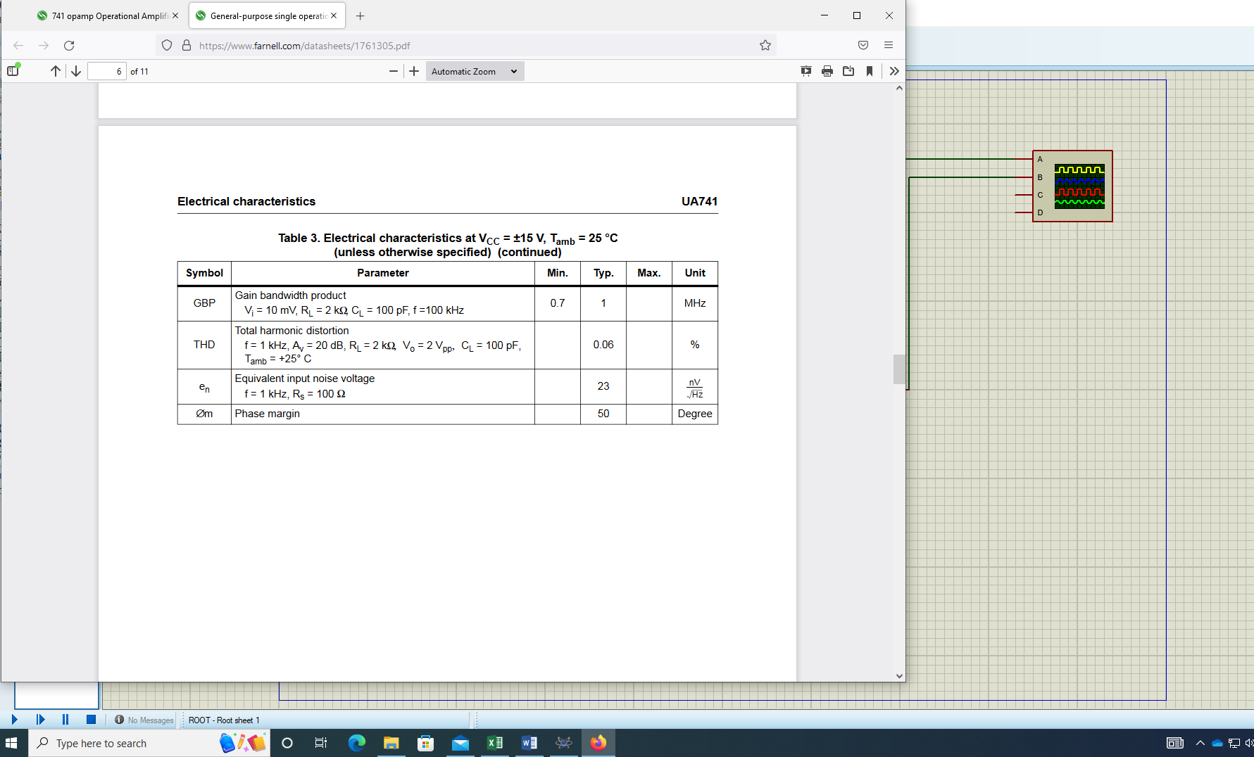
https://uowtsd-my.sharepoint.com/personal/2214461_student_uwtsd_ac_uk/Documents/Desktop/log%20book/embed%20workshop/op%20amp%20table%20results.xlsx
This image above shows that manufactories specification of a 741-op amp I have got from Farnell.com. Which we compared the GBP of the simulated circuit to the manufacturing specification.

Making my circuit on breadboard

I have crated on breadboard my simulated amplification circuit. But before I did this I constructed it on pebble to show where it would configure on breadboard, how I did this is that I got my schematic of my amplification circuit and work out where it would go on breadboarded within pebble.

https://uowtsd-my.sharepoint.com/personal/2214461_student_uwtsd_ac_uk/Documents/Desktop/log%20book/embed%20workshop/pebble%20opamp.docx
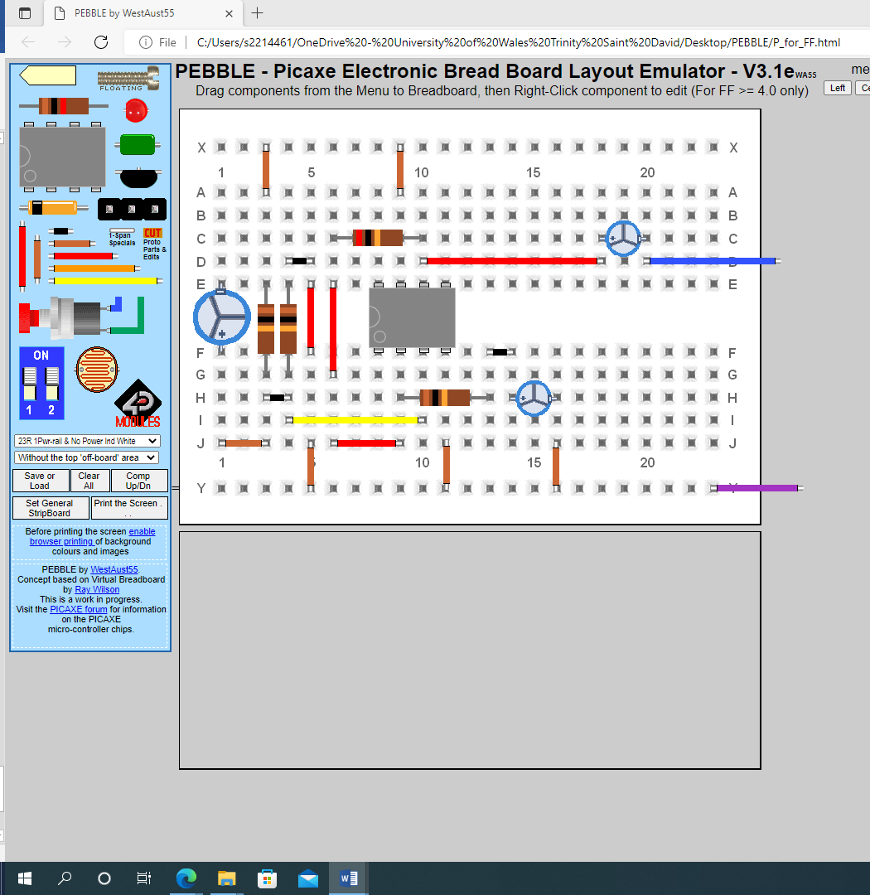
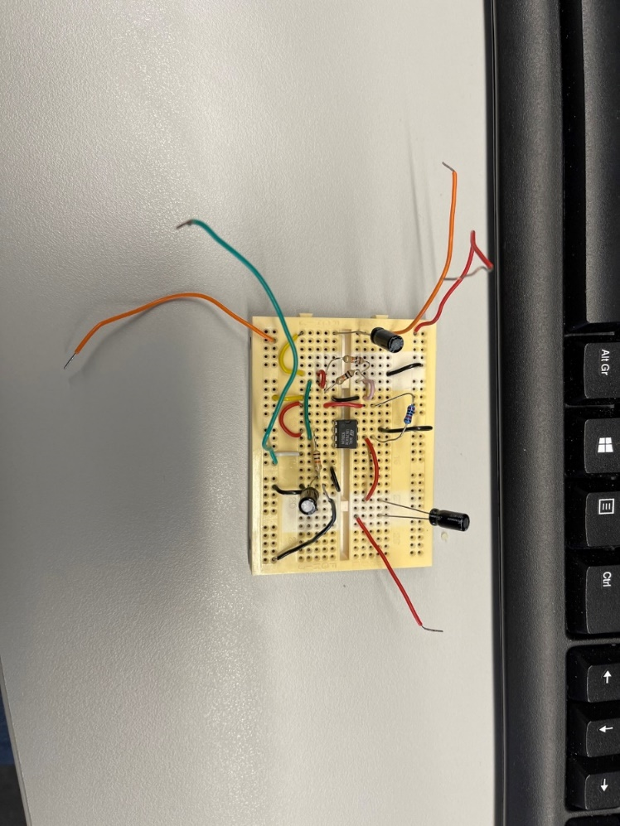
I have successfully constricted my amp 1 circuit from a schematic design on to breadboard. Using all the components on my schematics and connecting them with wires. The circuit is now ready to be tested.

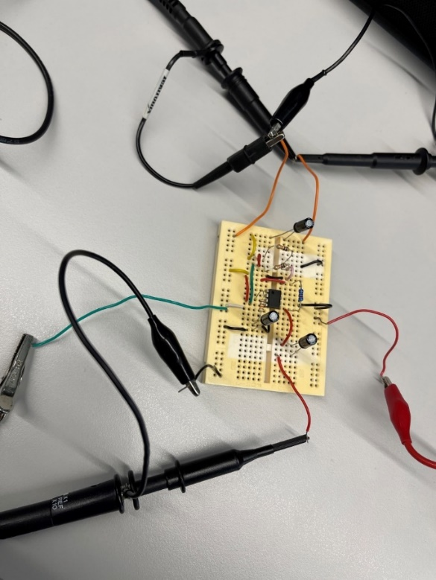

Testing:

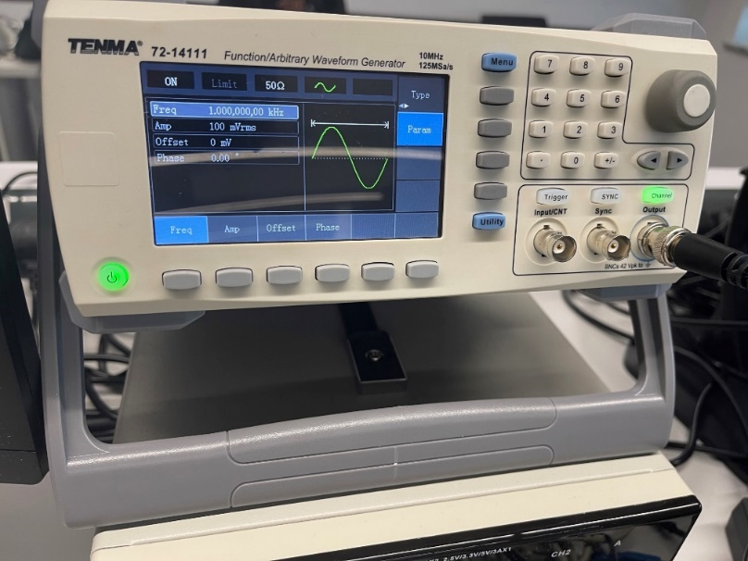
How I tested the breadboard was to hook it up to a power supply and a signal generator that was 100mVpp amplitude and a range of 100HZ to 500k HZ and an input voltage of 9V to my circuit. To test my circuit, I used an oscilloscope to show how the sin wave reacted in my amplification circuit. I measures the signal generated signal first to make sure I was putting in the correct signal. Then I measured the output and the input to make sure the input signal was still correct.
As I was going through the different frequencies I record My results on an excel spreadsheet

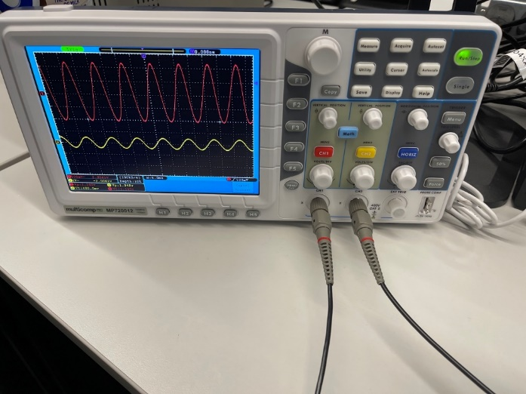
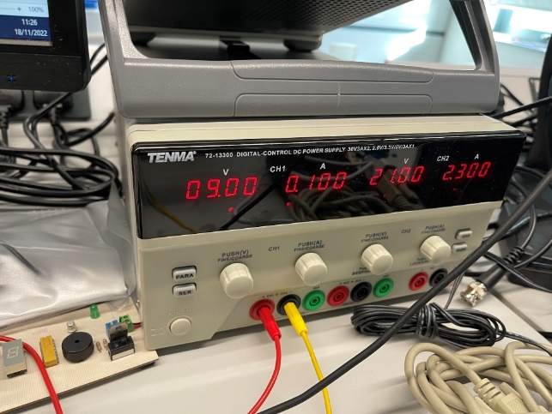

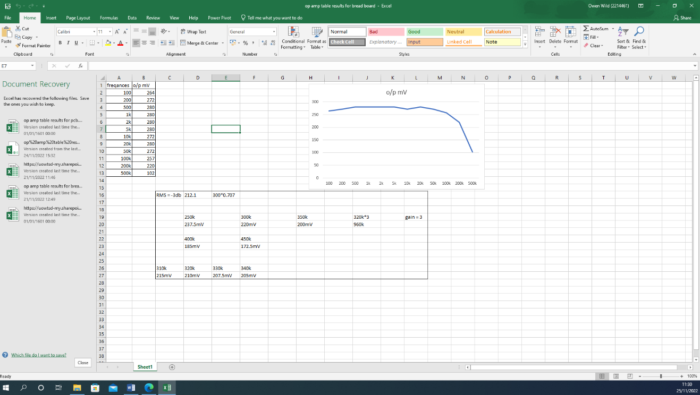
My result for my breadbord where similery to the one I simulated on protuse with a slight different because we are dealing with really components and not ideal so the tolleranes withh differ silightly.

Creating a circuit on easy pcb to then be manufactured.

On easy pcb I crated a circuit to the same specification that I made on proteus as this was tested and simulated and got the correct values. After create my design by adding all the components and connecting them all up. I added in the power connecters as a 4 pined, 3pined and 2 pined to my circuit as to give it power and to be able to put an input and output signal in it as well. Once I made my schematic I put it in an technical drawing with the correct informant at the bottom.
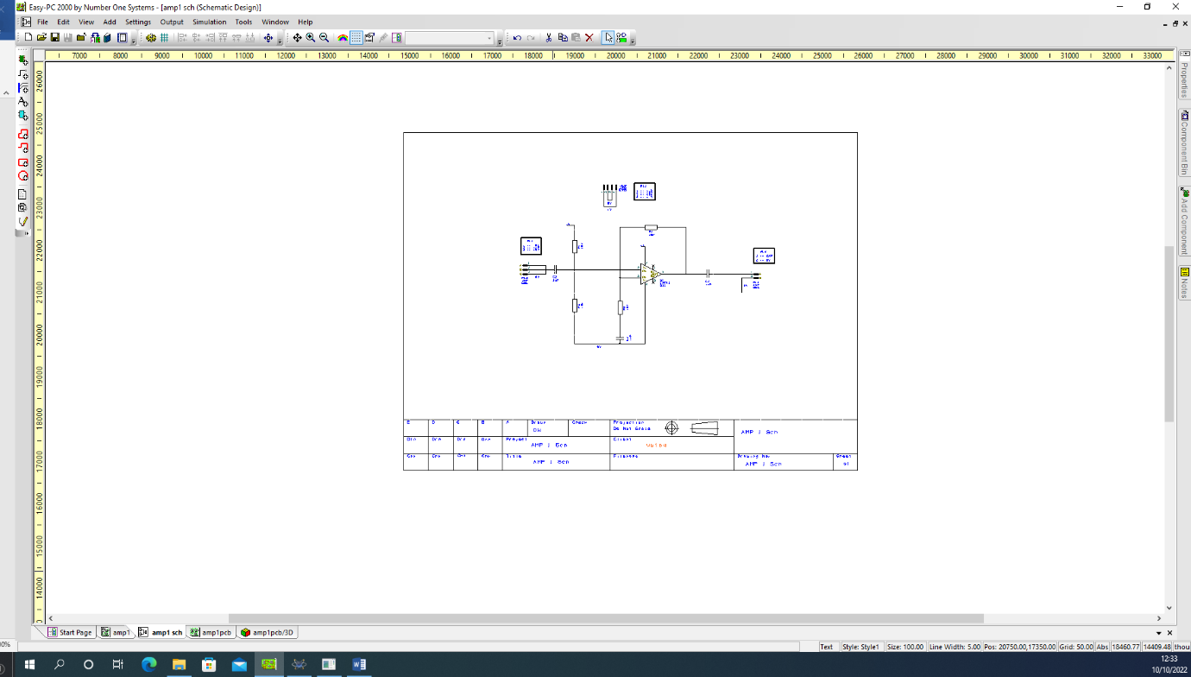

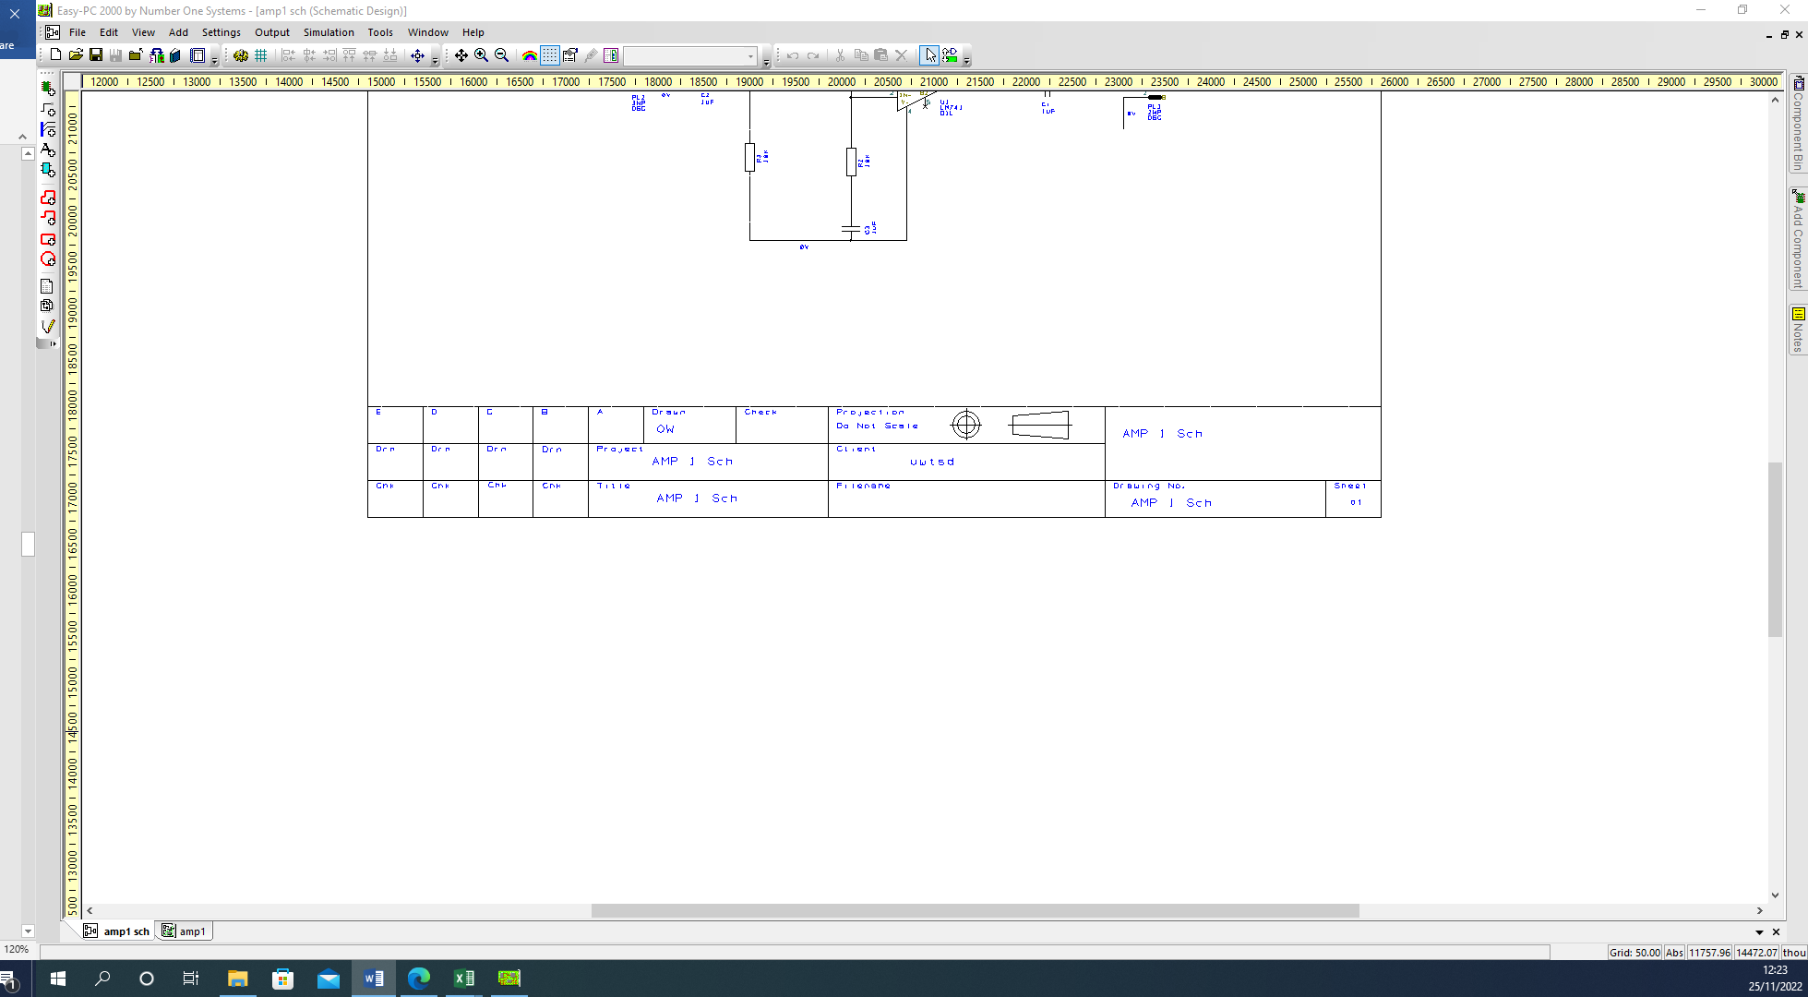
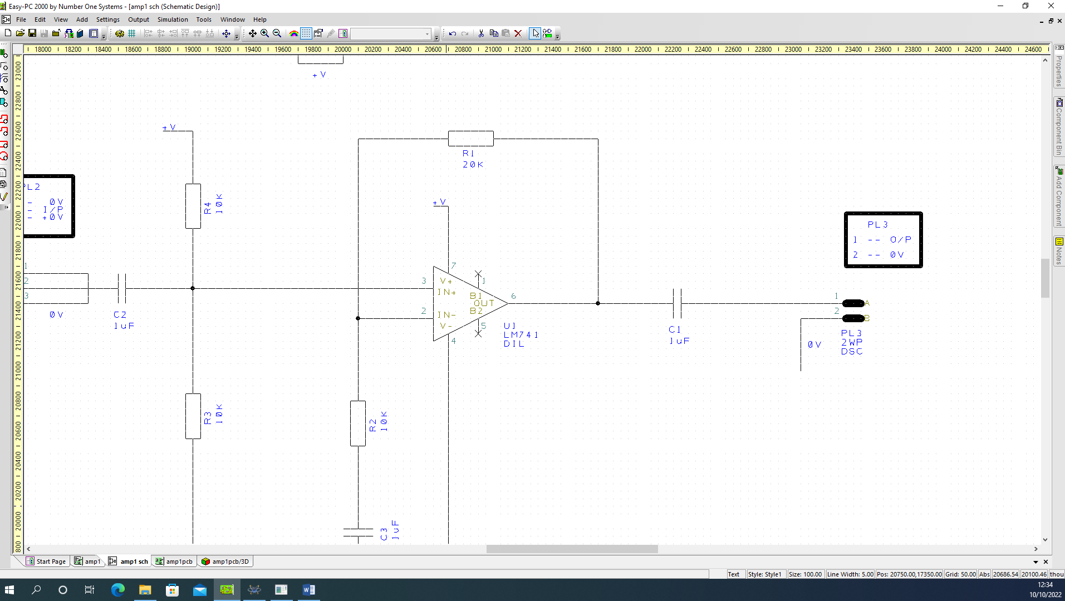

After completion of the schematic design I then went on to creating a pcb by picking up and dragging components on to a grid. I then move the components around to fit them as closely together and to make sure that the connections didn’t overlap. Once this was done I draw a pcb boarder around them to crate my pcb board which I then viewed in 3d.
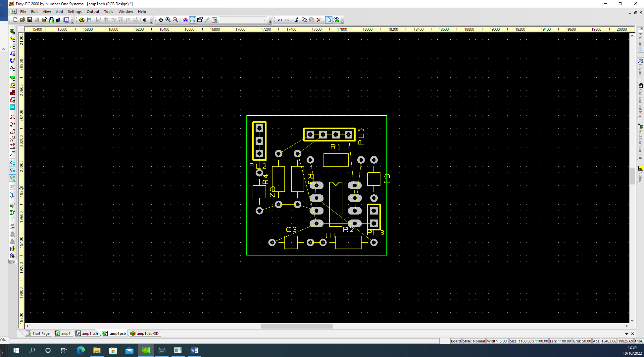

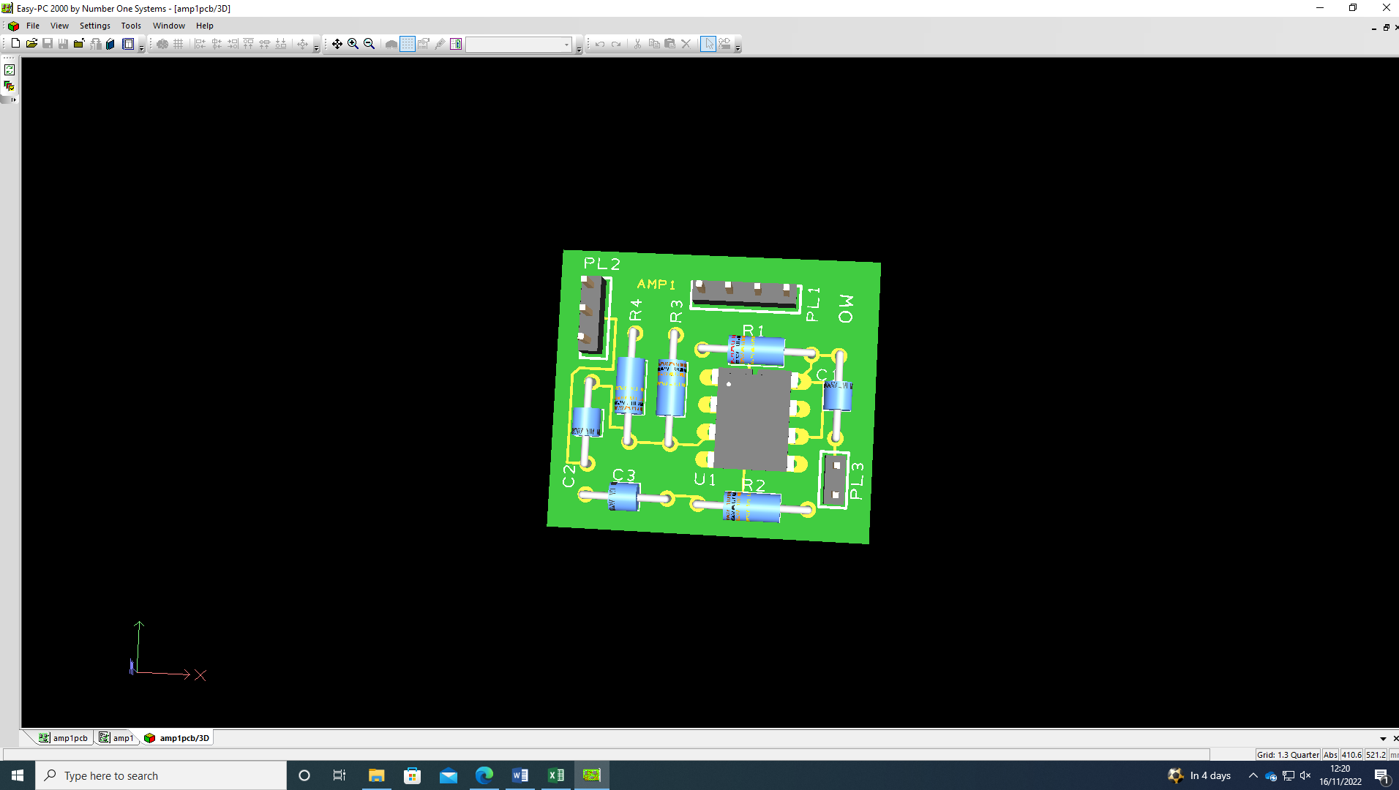

The next thing I did was to crated dummy layes of +V and 0V to reduces the number of connections we need to track on the end. The dummy layes acts as an itmiting for the other layes to pick up the connections.
After that I then added a coper pour area around the +V nets that I have hilighted the +V nets the poured the copper on the botttom layer. after that I drew a copper pour areara over the intire pcb board.
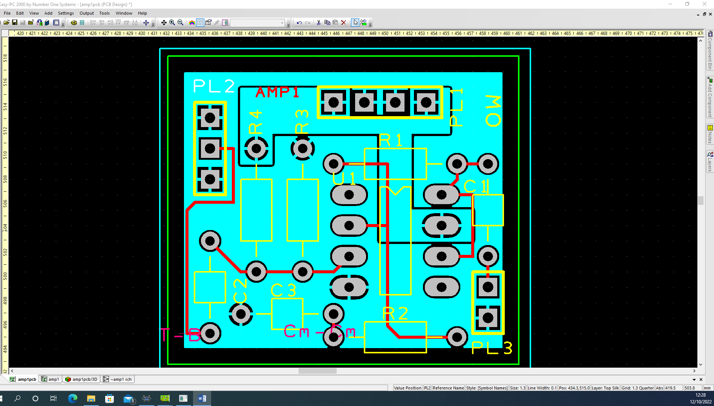

After adding the copper pouring I then hide the layer an optimised all nets to show the relvent ones, then rooted all the yellow connections.

After doing the connections I added the lable of what it is and my initals.
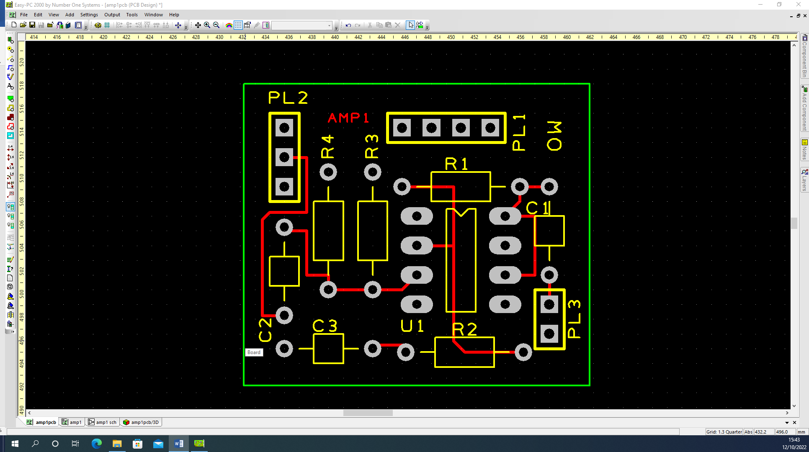
After doing the text and before I did the checked to see if my PCB can be manufactured successfully. I deleted the dummy layers as I don’t need then any more.

The checked I did on my pcb was an integrity checks and the connection checked, which both came out fine. Then I did a rule check on spacing, nets and manufacturing one by one and needed to change the copper pour size and pcb board size because I needed to rearrange the text identifies to fit on without and collision and with enough clearances. After I did theses changes it came out all fine.

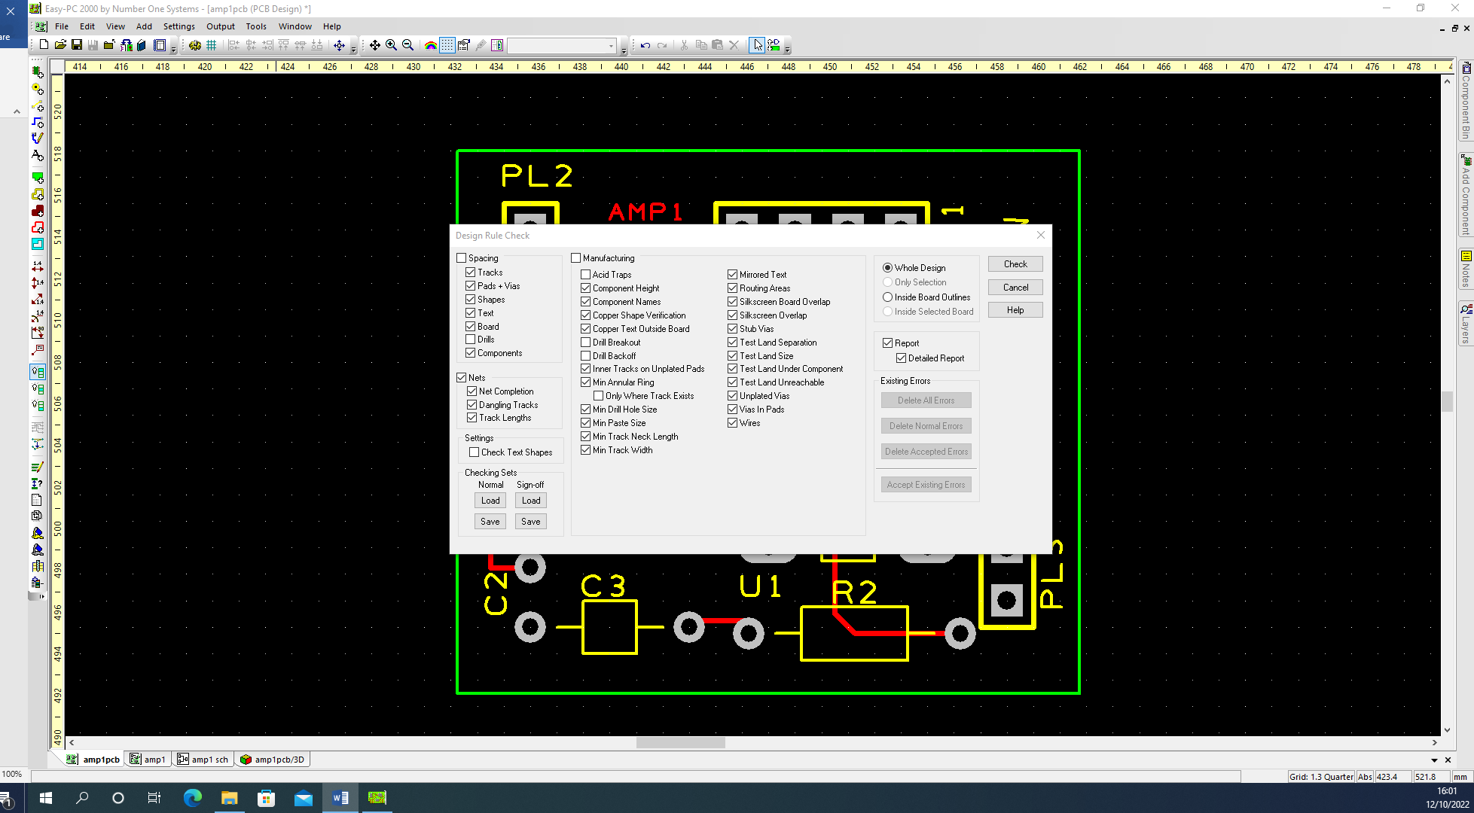

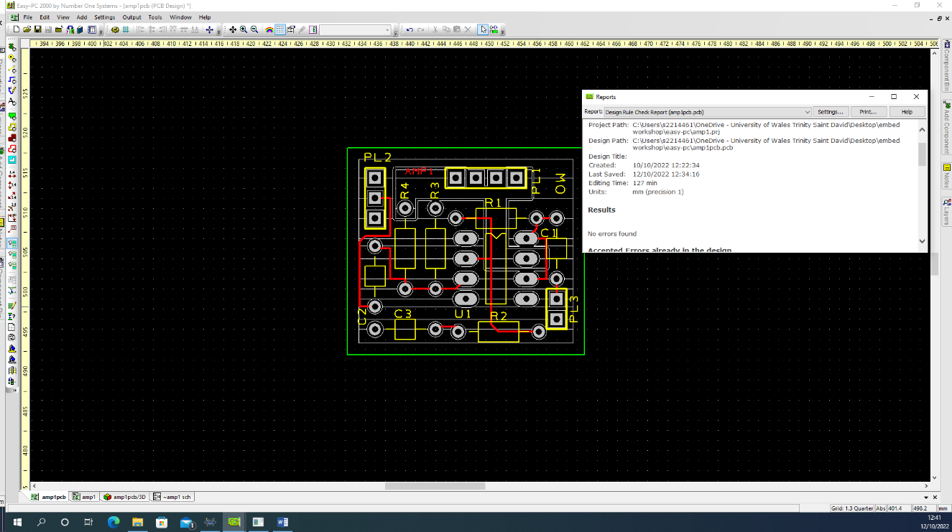

The final stage of my pcb is to get it ready for manerfacturing by doing a plotting and printing by giving all layes a boarder and make sure that their is a gerbar.
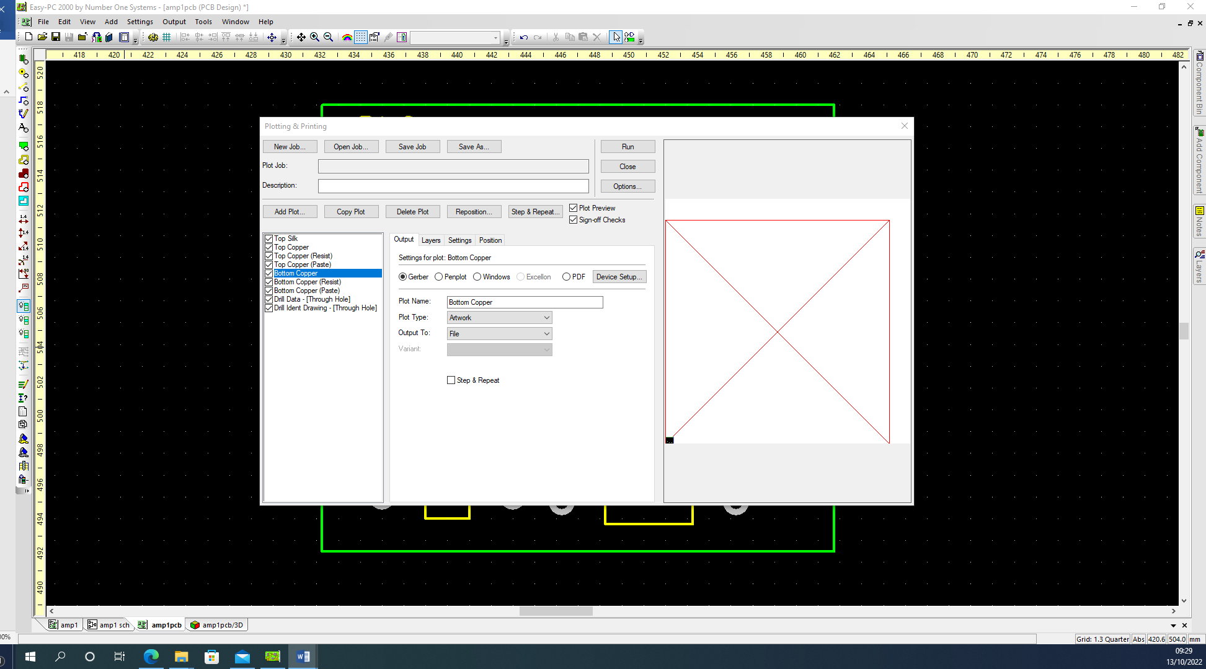After doing all the checks I now send of my amplification circuit on PCB to a manufacture to make than I solider on all the compounds.

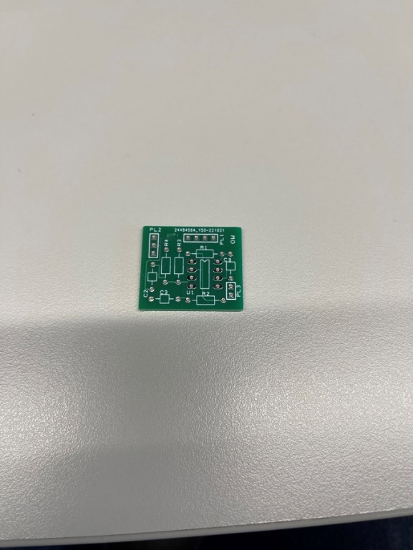
After receiving my pcb I went to check it to make sure it looks like the one I made on easy pc and to visually check it over for any miss print or marks or damage to it that could compromises the efferent of the circuit.
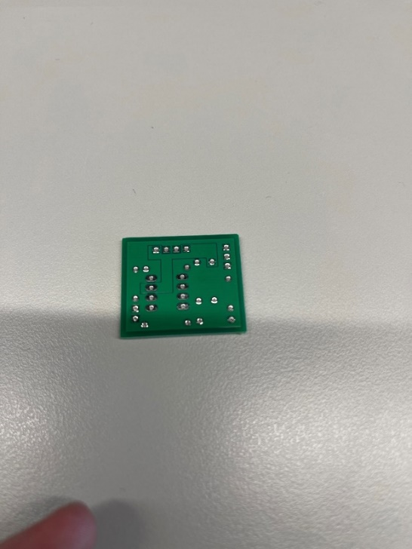

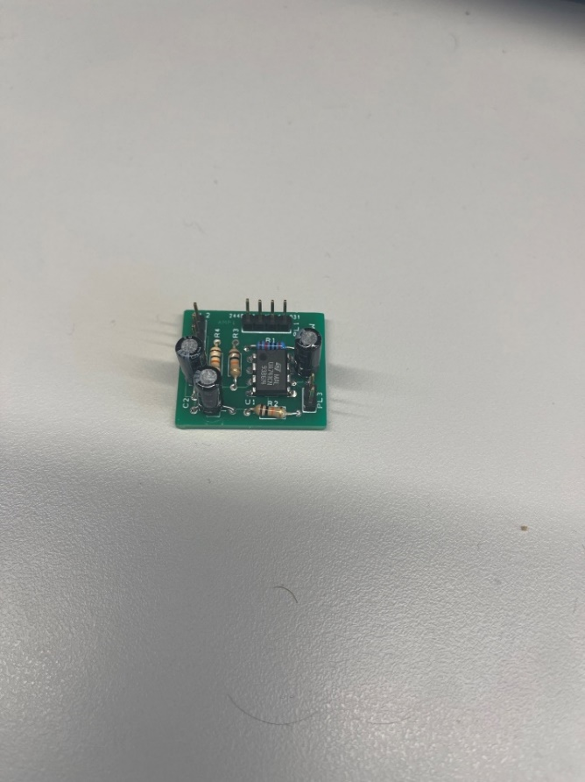
After my checks and the breadboard test was what I was expecting I now moved on to soldiering my components on to my pcb. But before I started to solider I got up my schematics on easy pc to make refer to it when soldiering to make sure I put the components in the right place. The equipment I use was a soldiering iron, extractor fan, solder and a clamp to hold my pcb in place to solder.

After I have successfully soldered my components on my pcb I then moved on to visual inspection of my soldering and to make sure all components are in the right place and the capacitors and chip is the right way around.
I did have to de-solder a capacitor because it was the wrong way around.
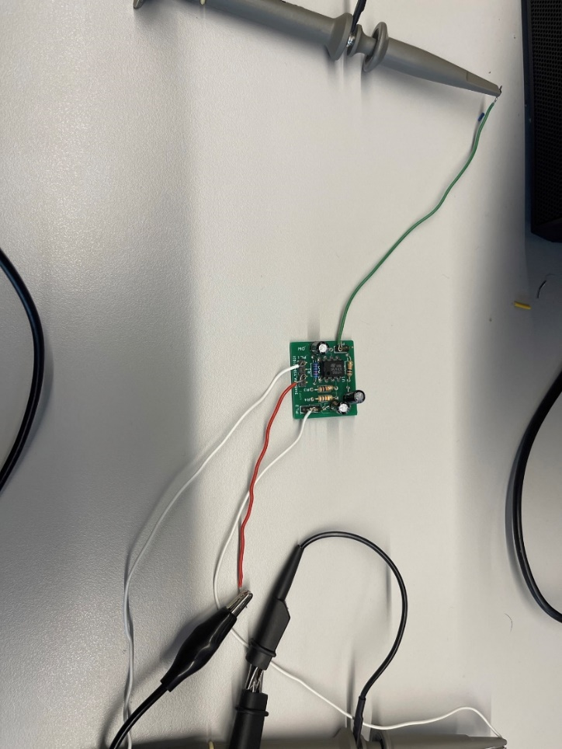

Setting up my testing for the pcb was the same way I did with my breadboard but attaching wires to my input, output and power supply by hocking them over the pins and to make sure from my schematics that they are connect to the right pin.

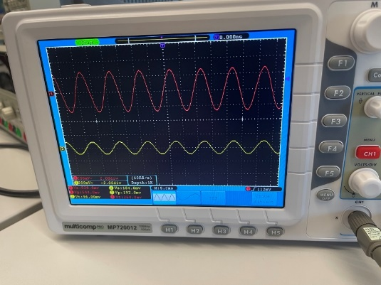

My results where similar to my breadboard and my simulated dater which is what I was expecting.
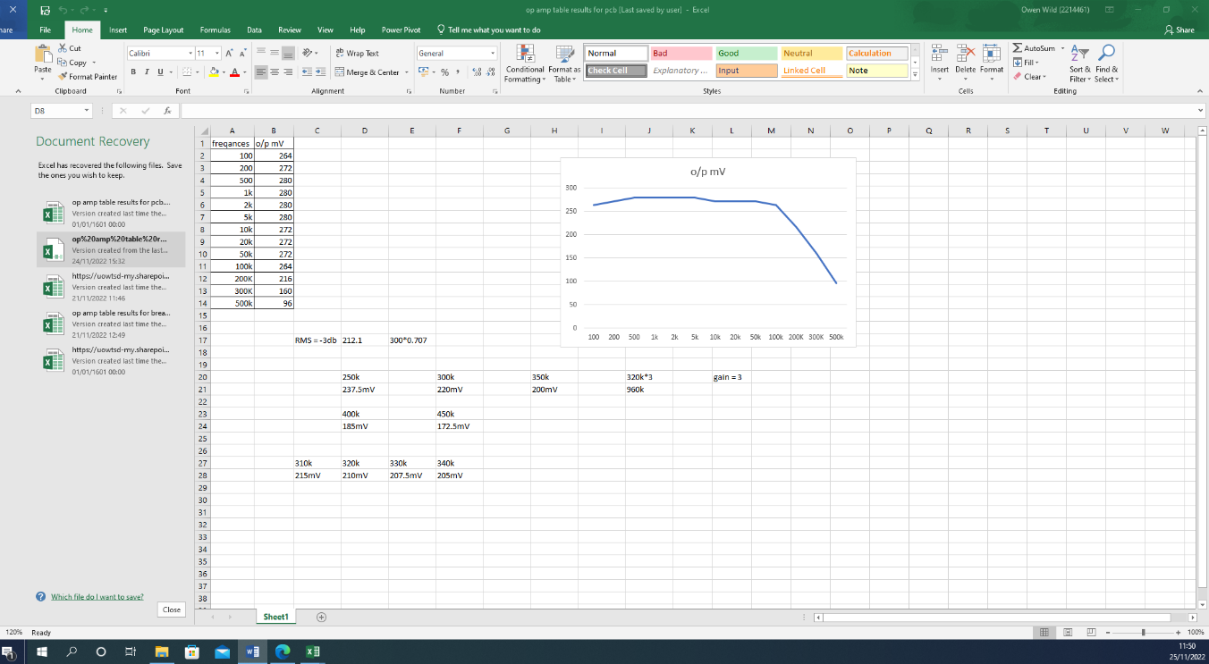

comparison of results

My results for all three tests where all similar to each other with all them following the same trend which is that the saturation point I calculated was about 320k because the rms value was 212.1 I calculated.

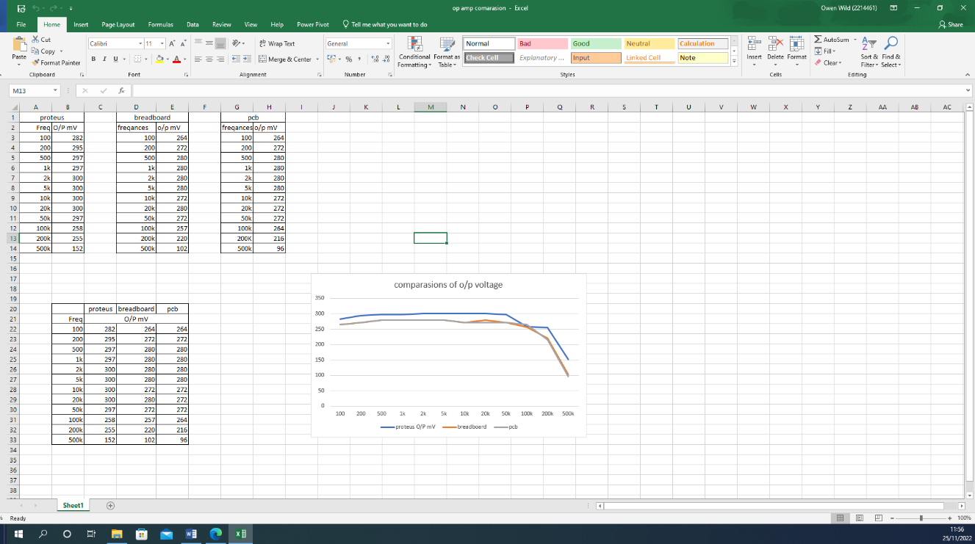

Summery

In summery my op amp was successful though all the three points of simulation, making and testing and the manufacturing on to pcb and building it. All three had similar results with all them following the same trend and all stating to saturate at a rms value of 212.1 and all having a gain of 3.

One problem I in counted was that I had a dud chip so when testing on breadboard I was getting 4V to 5V which is significantly higher than I was expecting and simulated so how I went about finding the fault was to attach a wire to one of my probes and go through my board and see at which point my signal got distorted and found it was happening on pin 6 of the chip so I knew it was then chip that was giving me the wrong signal output.

