HOTEL TRININTY
4* HOTEL AND SPA
Take away menu (Serving from 12pm until 5pm)
TEL: 01792 204978
Available for both delivery and collection

STARTERS
Mussels- Cooked with garlic, herbs, and cream £7.95
Welsh Rarebit -Hot Cheese based sauce served over toasted bread £6.50
Chicken Wings – Choose from BBQ, Sweet and Sour, Dynamite hot  £7.50
Grilled King Prawns- Cooked in Garlic, Lime Butter, and Chilli £8.50

Cesar Salad- Avocado and Fresh Beans topped with olive oil £6.50
This Photo by Unknown Author is licensed under CC BY-SA-NC
(Oliver and Loftus, 2019)
MAINS
Welsh Sirloin Steak- Accompanied with onion rings, fries, and watercress £18.95
(Welsh Sirloin Steak, 2022) (Served with a glass of red wine)
Pulled Beef Burger- Served with fries and coleslaw £10.95
Blue Cheese and Walnut Salad Bowl £8.95
This Photo by Unknown Author is licensed under CC BY-SA-NC
Baked Fillet of salmon- Served with spring onion Mash £14.95
(Served With a Glass of Sauvignon Blanc 2021)
(The best Sauvignon Blancs of 2021 - The Drinks Business, 2022)
DESERTS
Sticky toffee pudding £5.50
Salted Caramel Tart £5.50
Apple Crumble- Served with hot custard (G) £5,50
Passion fruit and pistachio crème Brulé £5.95
Tea/Coffee £1.50
(Food hygiene, 2022)
- - Vegetarian
- - Spicy
G- Contains Gluten

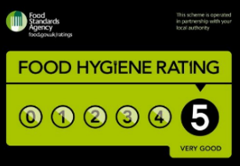
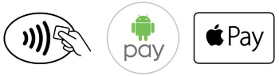
(Apple Pay, 2022)
References

Apple (United Kingdom). 2022. Apple Pay. [online] Available at: <https://www.apple.com/uk/apple-pay/> [Accessed 15 June 2022].

Edwards of Conwy Ltd. 2022. Welsh Sirloin Steak. [online] Available at: <https://shop.edwardsofconwy.co.uk/welsh-sirloin-steak/> [Accessed 14 June 2022].

Food Standards Agency. 2022. Food hygiene. [online] Available at: <https://www.food.gov.uk/business-guidance/food-hygiene> [Accessed 14 June 2022]

Oliver, J. and Loftus, D., 2019. Veg. UK: Michael Joseph, an imprint of Penguin Books.

The Drinks Business. 2022. The best Sauvignon Blancs of 2021 - The Drinks Business. [online] Available at: <https://www.thedrinksbusiness.com/2022/01/the-best-sauvignon-blancs-of-2021/> [Accessed 14 June 2022].

Mahir Mollik

