Student name:Maureen Ann Lyttle
Student number: 2029466
Programme: Certificate in Higher Education Skills for the Workplace
Module: Professional and Career development
Module code: BMSW 4005
Task: 03 Reflective Portfolio
Lecture: Farah Islam

Introduction

This reflective portfolio discusses the Johari Window SWOT analysis. I have been appointed with this assignment to complete as a manager within an organization. My role as a manager includes educating of my team to evaluate my won skills. My personal development test is about supporting all my staff to excel within the organization. Referring to effective work place training (2021). Reff 28, I base my theories around self analytic tools. My self-awarness theme learned from this module to evulate my skill and competencies to applies to my roles.

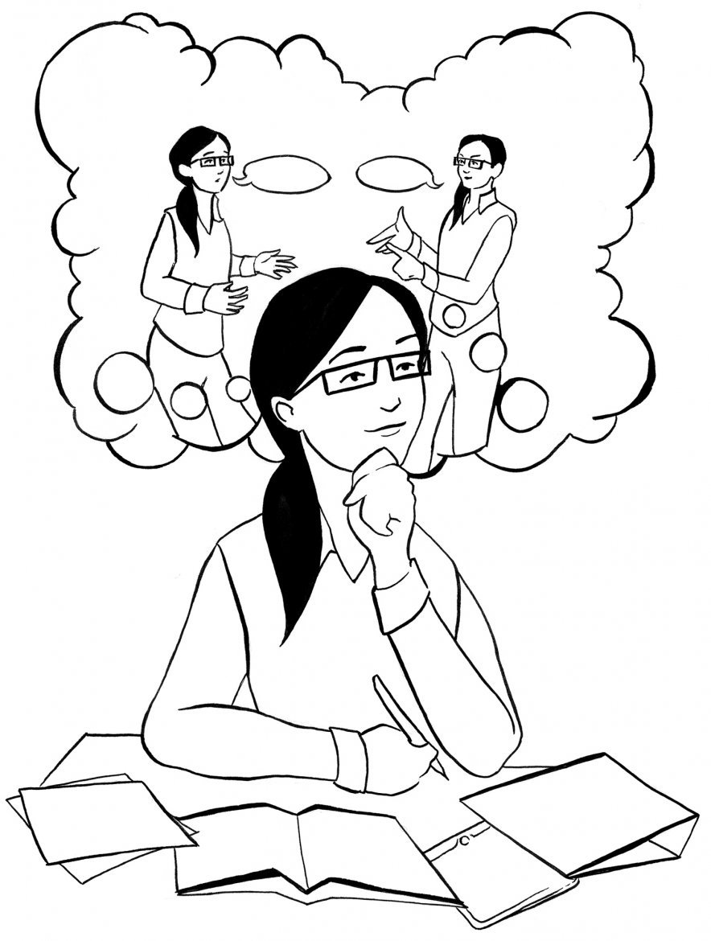

Self-Analysis

SWOT

Strength
- I am a detailed oriented and a quick self-starter
- Interpersonal and communication skills
- Time Management Skills in the office
- I have work experience with customer relations
- I am a skilled communicator, analytic, and critical thinker
- I am people-oriented
- Social Engagement is my superpower
- Good with Public Speaking
- Excellent Presentation skills

Weaknesses
- I do not know how to brand myself
- I have aLack of Business Connection
- I need to practice my verbal skills in English
- I do not have a clear career plan
- I find it difficult to visualize my potential
- Time Management for my personal, study, and work-life

Opportunities
- A job offer and visa sponsorship from the company
- Meeting new people
- Build professional connections
- Entrepreneurship boom, and I can apply my professional experience
- Attend workshops to develop new skills and learn about the UK system
- I can gain essential and relevant knowledge about hospitality

Threats
- Difficulty in getting a work permit and Personal Residence
- High Number of Qualified Members
- Rapid Changing Industry
- With open frontiers in the Labour Market, the demand for jobs is increasing
- Part-time work is not enough to pay bills, and also low wages for entry-level jobs
- New Variants of COIVID 19 and changes for the natural disaster may affect my work permit.

Personal Development Plan

Long Term Goals | Specific Career Goals | Key skills needed | What Skills need to work on? | Action Needed | Duration Required
Training  Program Manager | Project Coordinator | Leadership and Communication | Leaderships skills | Coordination Certification | 1 year
Training  Program Manager | Project Manager | Leadership, communication, Project management skills, Presentation skills | Project Management  Presentation skills  Management Skills | Project Management Degree | 3 Years
Training  Program Manager | Program Manager | Networking skills, Strategic and Analytical skills, Decision-making skills | Analytical thinking skills and High-end decision-making skills | PMP Certification | 5 Years

Analysis of SWOT & PDM
When coming to evaluating my SWOT and PDP, I am a mix of a team player and a motivator. I am a meticulous organizer and a self-starter. I have Proficiency in interpersonal and communicative abilities and Time management skills in the office; I have customer service experience. I am an effective communicator, an analytical thinker, and a critical thinker; I am also a people person. My superpower is social engagement. I have Excellent Public Speaking and Presentation skills. I have the ambition to be a Program manager in the next 5 years.

Learning and Development Plan
Developing team is a crucial element of my job. Furthermore, this is a general rule and not only for new hires. Both as individuals and as members of a team, they need training and guidance throughout their careers to continue to perform well. Recruiter, Trainer, and team leader all work for the betterment of the company. Human Resources or Learning and Development departments are likely to provide resources to prepare individuals for a role. As a manager of a care home that caters for people people with learning and mental disabilities, it is my duty to know how my staff work, identifying the training needs and close collaborations with the HR department is one of the biggest responsibilities to fulfil all training requirements.

Training Requirements Analysis
The most difficult part of building a team is figuring out where to start. Determine what the team members need to grow. I will make sure their job descriptions are up-to-date, chat with them, and monitor them in action to ensure they are doing their best (Nichols). Asking the appropriate questions can often expose gaps in your team's knowledge and abilities. In particular, if organization lacks a method for frequently evaluating and enhancing the performance of employees, this can be extremely beneficial. Assuming my team members have never had their performance assessed and developed in this manner, they may see the evaluation negatively. Having a clear understanding of what they will need to succeed in their positions will give them the confidence to work on their personal development. I can arrange training assessments to determine which employees need training. So arranging training assessments will help me to to focus on individual training efforts for those who truly need it. A self-assessment is a useful tool in this regard as well. It is possible to find areas of improvement that will benefit your team.

Making the Right Decisions About the Training

I will tailor training to my team members based on specific requirements. In the next stage I will identify growth opportunities. It may be challenging to find the right mix of teaching methods that will work for all team members. 70% of learning occurs through experience, for example, in daily work; 20% occurs through conversations with others, for example, in coaching; 10% occurs through traditional training courses (Bariuad, 2021). Individuals must get to practice their skills and communicate with senior employees to improve their learning.
Coaching
In many cases, effective communication as compared to training program is best to close performance gaps. Having one-on-one interactions with team members is a great way to coach them. Having direct communication with team member can assist individuals in dealing with a wide range of issues, from helping others achieve their goals to dealing with performance issues. The GROW coaching technique makes this possible. GROW (Goal, Reality, Options, and Will) is a discussion framework based on these four pillars of dialogue. Positivity helps individuals to find meaning in their job, while practice focuses on finding answers to issues. I should also make it a habit to provide employees with regular feedback.

Activities to Build Teamwork

Exercises like "team-building" games can help teams work better together and help team members to discover their strengths and limitations. Choosing an appropriate activity to fulfil goals is essential. I must first determine the most pressing issues facing the team before selecting an exercise that will help me address them. I will choose an exercise that promotes listening, empathy, and verbalization. The ability to solve problems and form a strategy can be enhanced through a team-building exercises, while others team activities will foster creativity and leadership.

Create a Program that is specifically tailored to the Organization.
The ability to match training programs with business objectives is critical. Leaders can guarantee that training is relevant to learners' professions and aspirations by designing programs to match corporate needs rather than merely purchasing generic off-the-shelf content. Moreover, to meet the training requirements, I will compare department needs and team member skills hence, this strategy will help me to bridge the gap between organizational goals and training requirements. After identifying the training needs, it is easier to build training that meets those needs because I can easily understand what causes business challenges, how training can help to improve business operation and team performance.

Create a fun and interactive learning environment.
However, training needs to hold the attention of its audience. It is necessary to make it appealing. After all, individuals do not learn when they are not interested in and are actively involved in the learning process. My training plan concluded that making learning fun and interactive is the most important content of the development approach. Educators should work to develop programs that hold the interest of their learners and encourage them to interact with one another to improve their overall performance (Biewener, 2021).

Learning Outcomes

Case studies
Real-world scenarios are used in learning case studies to test students' thinking and encourage them to make challenging decisions. To stimulate/engage learners, they are meant to raise questions and give just enough facts. As a result, learning case studies place the burden of learning fully on the shoulders of the students. For many learners, examples are preferable to logical growth from the ground up since they are more inductive than deductive reasons. Because of this, case studies can be a highly effective teaching method in the classroom (Mind Tools). Since business, law, and medicine all require their students to apply what they have learned to real-world situations, case studies have long been a staple of classroom instruction in those fields. However, they may be used by teachers in any subject area. In lecture-based learning, case studies have traditionally been used to demonstrate or support theoretical concepts. We as students are taught theory and then exposed to the practical ramifications of that theory by way of a case study. Moreover, doing case studies enhances my analytical skill and helps me to apply the theoretical knowledge on different phenomenons. Learning case studies must provide participants with insights and opportunities for self-reflection into their partnering processes. Overall, the case study has helped me in decision-making and evaluating the answers differently by brainstorming.

Mock Interviews
To become more comfortable with the interviewing process, candidates should engage in a series of simulated interviews, known as mock interviews. Using video recordings of your practice interviews is very beneficial since it allows us to watch and analyze our responses and facial expressions, eye contact, and interview dress. Candidates benefit from a mock interview process since it allows them to evaluate their nonverbal and verbal communication skills. It also gives interviewers a chance to practice making mistakes in a non-judgmental setting. Candidates' problem-solving abilities are enhanced as a result of the immediate feedback, which enhances their ability to communicate their ideas. A good way to prepare for a genuine interview is to do a mock interview. It gives us a sense of direction and clarifies our objectives. Practising will help us identify areas for growth. When the time comes for the real interview, Individuals will be well-prepared. The better I prepare for a job interview, the more I will be able to handle the many situations I will face there. As a result of the mock, I will be prepared to answer any unique questions during a real interview. There are plenty of opportunities to develop eye contact and positive body language, and a strong sense of self-assurance.

UK Employer Legislation
There are many different types of employment laws, all of which have the same purpose: to safeguard businesses, clarify their responsibility to employees, and give business owners certain rights and protections. They maintain a level playing field for both sides in the workplace. Employer-provided benefits like paid time off, written notice of termination, and other disciplinary procedures in the UK's employment legislation. Contracts provide clarity and agreement for both the employee and the employer, protecting the former from the latter's claims. Employer regulations in the United Kingdom, on the other hand, protect workers from unfair hiring practices and compensation. If a worker is under the age of 23, he or she is entitled to the National Minimum Wage; if the worker is over 23, they receive the National Living Wage. The Equality Statute of 2010 protects job applicants and workers against discrimination as soon as they seek a position. There are nine protected groups under the statute. The Health and Safety at Work Act 1974, which controls workplace safety, also applies to new hires. All employees have the right to work in a safe environment, and this law does just that. So overall, I have learned so much about UK employer legislation and employment laws and ethics. Hence, whenever i join a company I must check all the rules and regulations to keep myself away from risk of fraud and pay my full attention to fulfil job requirements.

References
Bariuad, Shera. "Best Practices in Training and DevelopmentBest Practices in Training and Development." (2021).
Beus, Blake. "Top Best Practices For Training And Development." (2019).
Biewener, Dan. "5 Best Practices for Training Global Employees." (2021).
Kuwa, Elizebeth. "How to Conduct an Effective Training Session." Learn tips and techniques for effective workplace training. (2021).
Mind Tools. Developing Your Team. 2021. <https://www.mindtools.com/pages/article/developing-your-team.htm>.
Nathan, Arte. "7 Key Steps for Better Training and Development Programs." (2016).
Nichols, Robin. "Training and Development Best Practices (Based on Data From 600 Learners)." (2021).
Royal, Sheldon C. "7 Best Practices for Employee Training." (2014).

