https://sway.cloud.microsoft/vEa8dWgTwUPweNu0?ref=Link

Language Development in Children with Autism
Raising a child with autism spectrum disorder has given me a unique perspective into atypical childhood development.
Naigles and Blavin (2012) suggests that exploring the differences between atypical and typical development in language, can potentially help practitioners understand the process behind individual language acquisition and assist in promoting development. Chomsky (1965) nativist theory of language acquisition suggests that children have an innate biological ability to form language without the need of any formal instruction, although this does not always account for deviations of the norm. Boyd and bee (2014, p.25) discuss how many developmentalists suggest that this theory is better explained when it is combined with constructivist theorists such as Vygotsky (1978) who emphasizes the sociocultural theory, that a child’s ability to learn is an amalgamation of biological factors that have been influenced greatly by social aspects and differentiates between an individual’s environment and cultures. The use of speech is dependent on the connection to their prelinguistic inner thoughts and feelings and how they must find ways to give expression to their inner monologue, with emphasis on how social interactions are key to developing communication.
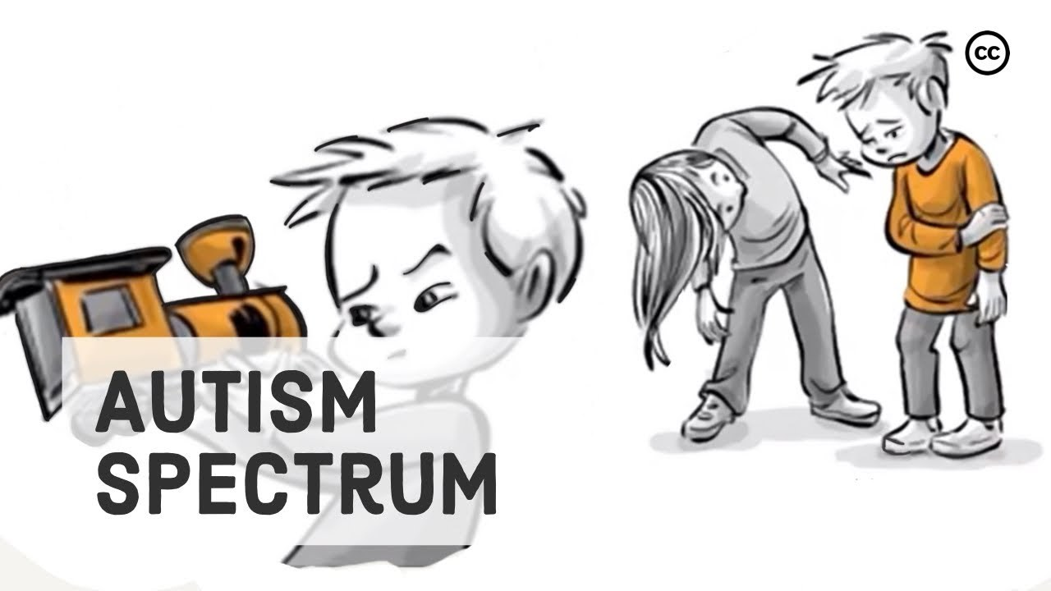
1 - Image source: (Youtube, 2022).
Eigsti et al. (2011) discuss research into the connection between language developmental delays in children with autism and how they correlate with a lack of social motivation and reciprocity amongst peers and caregivers. In circumstances where children present with both social and communication developmental delays that can be explained by a neurological disorder, intervention from specialist speech pathologists would be paramount in assisting language development.

Luyster, Zane and Weil (2022) discuss the unconventional patterns of language in children with autism and the value of language that is first presented through the form of onset and delayed echolalia. The rigid repetition of language through this form is closely linked to the behaviourist theorist Skinner (1957) in which he claims language acquisition is a learned skill through mimicking modelled language that is reinforced frequently over time. Although Chomsky (1965) heavily criticized Skinner’s theory, claiming that from a cognitive aspect, language input alone could not account for the vast amount of construction involved in compiling one’s thoughts into sentences and maintaining conversations.
In the circumstances of children presenting with atypical speech development patterns Blanc (2012, p.16) developed the natural language acquisition framework which outlines the stages of progression in gestalt language processers.
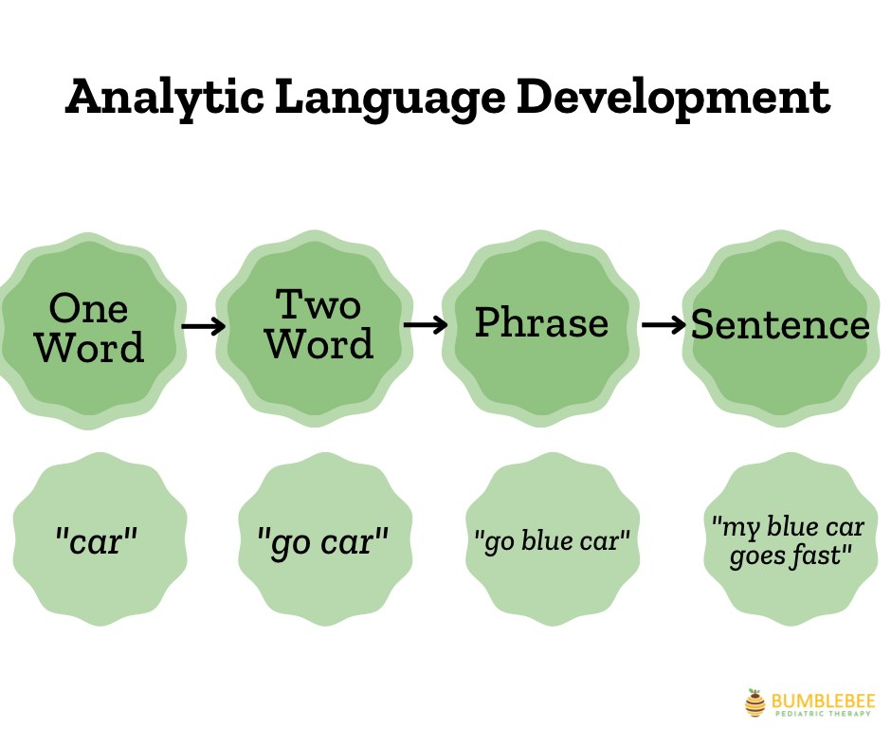
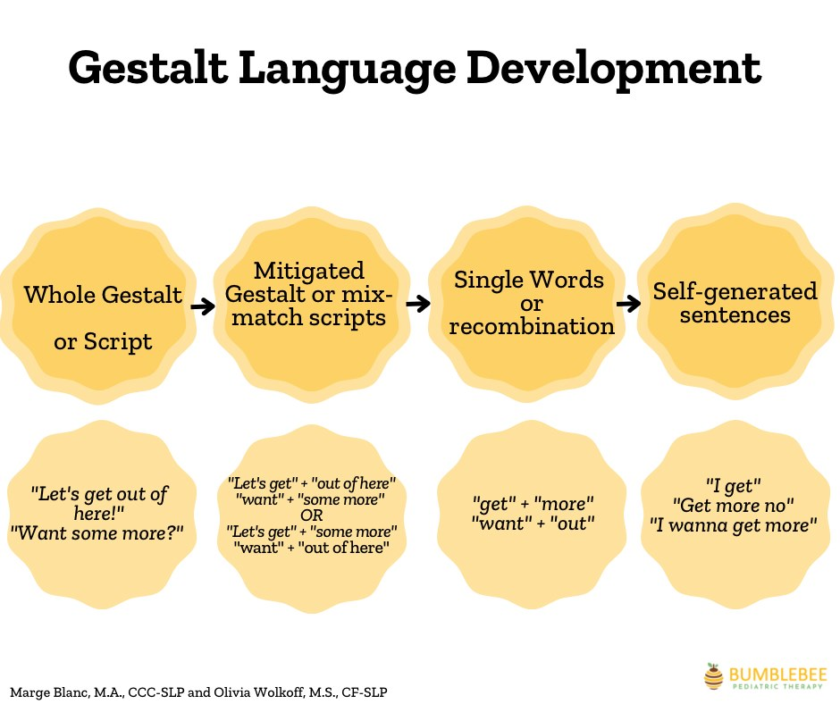
2 - Images Sourced: (Meaningful Speach, 2023).
Delayed echolalia uses gestalts, which are chunks of language rich in intonation and can be long or short and may seem unintelligible but will often have significant meaning to the child. For example, my son who is a gestalt language processer, at this stage of his progression echoed a script ‘it glows in the dark’ from a Halloween themed television programme. He would then use this phrase any time he saw formations of light in the darkness. When streetlamps would go on at dusk or when the festive period began, and he would see the lights on a Christmas tree, the script would be repeated time and time again. The second stage leads to mitigated echolalia in which the script is broken down into smaller gestalts where the child can combine part of the script with additional words to form new sentences to portray their thoughts. Stage three is when the gestalt is broken down into single words and can be combined as two independent words. From here the child can now develop onto the understanding of verbs and grammar and begin to produce independent intelligible speech which is an important milestone in developing social communication skills.
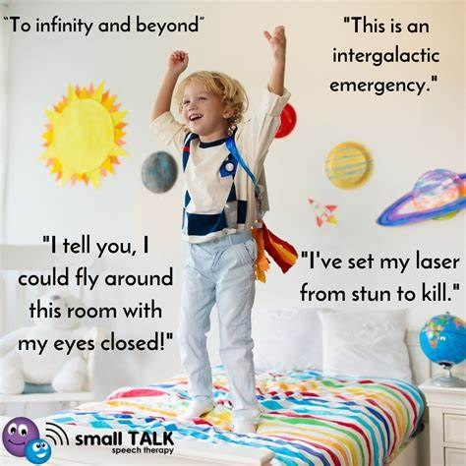
Image Source: (Small Talk Speach Therapy, 2022)
Meaningful speech (2023) explains that there are two additional stages of language development in gestalt language processers in comparison to the typical language development known as analytic language processing which is important to isolate when providing speech therapy intervention. This atypical language acquisition is important to identify by practitioners working in early years settings to provide early intervention. Therapy intervention would be based around modelling language through child led play, directed by an adult. Currently early years schooling is an ideal environment to model such therapies as policy and practice has been heavily influenced by Piaget (1957) and already promotes child led learning through play and exploration with adult guidance.
Lindon and Brodie (2016, p.144) discusses the importance of both verbal and nonverbal communication in developing social skills but particularly the development of speech, and how it is a fundamental stepping stone to literacy. It has been noted that typically, children who are exposed to an enriched vocabulary will progress faster than a child who has been victim of some form of childhood deprivation or isolation, highlighting the importance of environmental factors during the first few years of life.
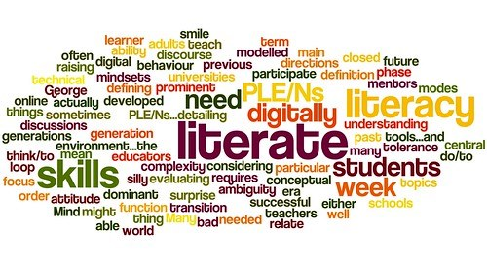
National literacy trust (2023) report that 16.4% of adults in England and 12% of adults in Wales are described to have poor literacy skills. Adults with poor literacy skills are at a significant disadvantage in terms of employability and every day functioning in society, which can affect self-esteem and emotional wellbeing. Department for Education (2021) linked the impact of early language skills with primary school attainment and set out, The reading framework (2021). This provides guidance to practitioners on how to promote the literacy and language skills that are vital to support children through the curriculum and promote academic success. The document also notes The SEND Code of Practice (2015) which highlights the importance of identifying children with additional learning needs, including those with speech language and communications difficulties and provides guidance on how to support them.
Doherty and Hughes (2013) discuss the historical views of classical conditioning in which some behaviourists believed that children were passive learners and could be shaped by experiences. The learning principles behind these behaviourist theories are often used as part of the psychological intervention of applied behaviour analysis for children with autism. Kirkham (2017) state that there is controversy from critics, claiming that the actions of using positive and negative reinforcement to extinguish autistic behaviours are abusive and these applications are based on outdated premises and should not be classed as gold standard methods of practice. Payne (2015) discusses how current policy in primary schools have been adopted by behaviouralist approaches through the use of sanctions and rewards. This Contentious issue has become prominent in recent years due to the formation of autism activists’ rights groups who attempt to alter the methods of pedagogy in children with autism.
With greater understanding of autism spectrum disorder in relation to the development of language, I believe that both nature and nurture play its role. Although we may draw some value from each theorist from both sides of the debate, it is no longer appropriate to rely on techniques based on archaic premises and educational policies should be adjusted to accommodate children with atypical development as well as typical.

The Impact of Maternal Attachment on Childhood Development
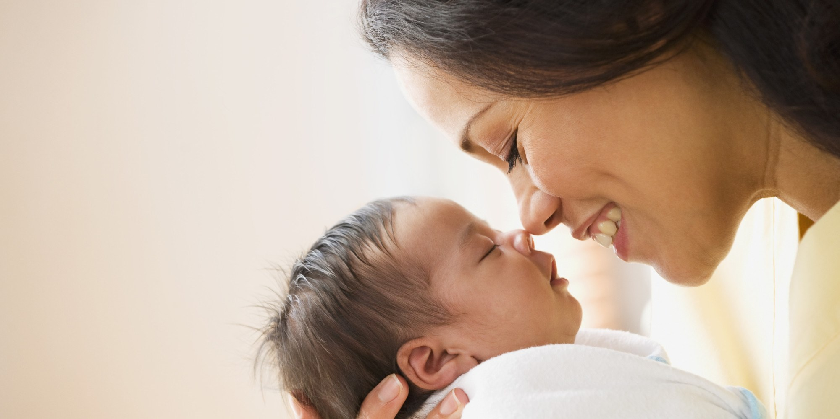
During the coronavirus lockdown I gave birth to my first child and throughout the first two years of his life I faced criticism in view of the level of attachment my son had for me. I was repeatedly told that I should let him ‘cry it out’ or that by holding him close to me I would be creating an unhealthy attachment. Although initially, many were quick to blame the lockdowns for what they described as an unnatural isolated childhood, I personally found my mothering instincts to keep my child close to me, to be a profoundly healthy and innate response.

According to Bowlby (1969) Children are biologically designed to form an attachment to a primary caregiver, most often the mother, as part of an evolutionary process. Bowlby (1969) monotropic theory of attachment hypothesized that children and their mothers have a uniquely strong bond and instinctive behaviours designed to ensure that they remain close to one another to maintain survival. The infant has an innate need to connect with the mother and will establish ways to maintain a secure bond. Commonly a child may smile to evoke a positive response or cry to gain attention and comfort from the mother.
Alternatively, behavioural theorists credit the learning theory of attachment, developed by Dollard and Miller (1950) and believe that children are conditioned to form attachments by a set of learned behaviours as opposed to any innate biological response. Research was developed using elements from the work of Freud (1926) who believed a child’s response was dictated by the need for food from mother and attachment would be built from this parental gratification. However, this is disputed after Schaffer and Emmerson (1964) published findings of children responding based on individuals’ attention and communication as opposed to the person providing food.
Doherty and Hughes (2014, p. 341) debate that the reliability of behavioural research based mostly around animals and has been disputed as not demonstrating the innate biological response from human mothers. Whereas Bowlby (1969) provided comprehensive research into the ethological theory of attachment and focused on the genetic predisposition of a child’s desire for their mother’s security.

3 - Image Source: (Pinterest, 2023).

Bowlby (1969) was influenced by Lorenz (1935) who studied imprinting in mammals and the adverse effects if the animal had not imprinted within the critical period. Urdman (2015) displays the benefits of skin-to-skin touch between mother and child with evidence demonstrating that this enables the infant to regulate its temperature and breathing against its mothers and how the impact of this initial bond from birth can have a lasting impact on development.
A key principle in Bowlby (1969) attachment theory was known as maternal deprivation. It was claimed that during approximately the first two to three years of a child’s life, they were at their most critical period. If there had been no specific bond with a caregiver, or one that was repeatedly disrupted during this time, there would be negative implications for long term development in social, emotional, and cognitive functions. The development of a child’s internal working system would evolve through experience and shape their social behaviours.
Expanding on this work Ainsworth (1976) conducted studies to observe the effect of attachment in children from the mother and identified three different attachment styles. Main and Solomon (1986) later discovered a fourth attachment style to contribute to these findings.
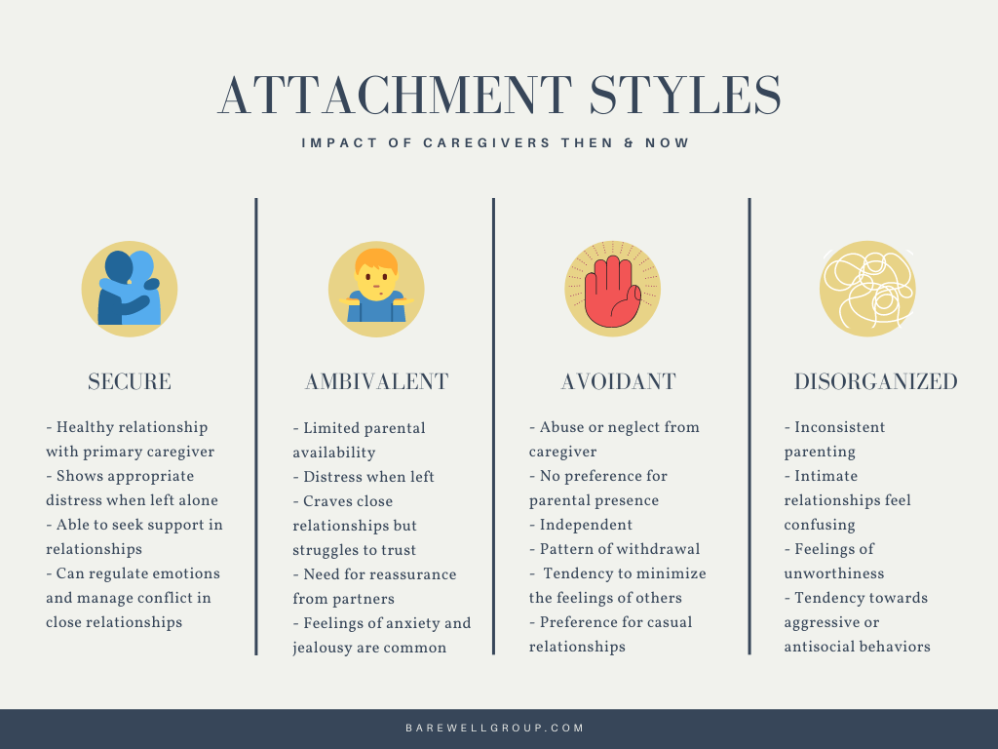
4 - Image Source: (Poppmeier, 2023).
Ding et al. (2014) discuss the research into the connection between an insecure bond between mother and infant and future behavioural repercussions. Children without a consistent maternal bond were reported to demonstrate aggressive behaviours during early childhood and presented with social incompetence in later life.
Lindon and Brodie (2016) explore the investigations performed by Bowlby (1979) during the second world war, on families who had been separated. Children were left in great distress when forced away from their mothers and it was documented that in the absence of a relationship with the mother during the first three years of life, the child was left with permanent emotional damage which would affect them in adult life. Influenced in part by this, post war British society considered home life to be based around the male figure providing for the family financially, while the woman would conform to a domesticated role and remain home to raise the children. Riley (1983, p. 173) discussed the socio feminist view, that the government closures of day nurseries after the war were partly in response to psychological theorists’ views surrounding child attachment and were commissioned to discourage mothers from leaving their children in another’s care and instead remain the primary caregiver. This is in huge contrast to modern day society, which now puts substantial pressure on women to return to work quickly after childbirth. UK Government (2013) set out The Free childcare Scheme initiative used to encourage and support women to return to employment.
Liss and Urchell (2012) claim that contrary to the common misconceptions surrounding stereotypical feminist parenting, research has demonstrated that although feminism itself has different levels with conflicting views, typically feminist mothers endorse attachment style parenting. The promotion of child centred practice and endorsement of specific components of attachment parenting, such as extended breastfeeding and co-sleeping, many feminists have expressed to be empowerin .
According to Berger et al (2020) a mother’s decision to return to work is heavily influenced by the social ideology of modern-day parenting. The societal pressures for mothers to return to employment within the first year of motherhood are becoming increasingly more prevalent. Expectations on women to gain employment and contribute to the economy along with the burdens of financial instability, modern day households no longer see the male figure as the sole income barer. In addition, Argawal (2023) highlights the impact social media has had on creating unrealistic standards for mothers to be both a present and nurturing caregiver, while maintaining a career and promoting gender equality in the workplace. Although ultimately it is down individual choice and circumstance, there are clear obstacles in place that dissuade women from staying home to raise their infants and with incentives to encourage women to return to work, early year childcare settings will need to adapt practices to ensure children’s developmental needs are met from an early age.

The Effect of Poverty on Early Years Childhood Development
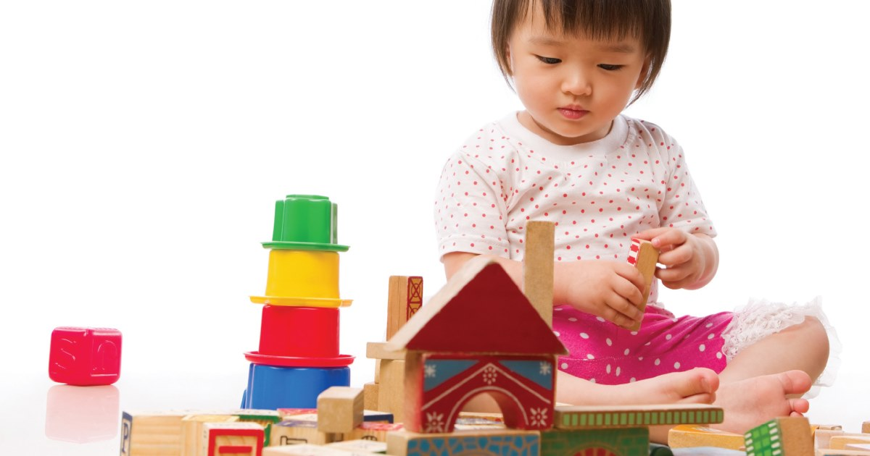
Department for Work and Pensions (2021) declared that 4.7 million people in the United Kingdom come from food insecure households. Action for Children (2024) identify that currently 29% of children in the UK are living in poverty and highlight the adverse effect this has on physical, cognitive, and social development in children.
Gessel (1925) maturational-developmental theory in the early twentieth century theorised that a child’s development was dictated by a biological nature and could be identified by a predictable sequence of milestones. However, Piaget (1936) argued that a child’s development was influenced by both internal and external factors and emphasized the contributions that environmental factors have on a child’s cognitive development. Piaget (1936) then produced the four stages of cognitive development, which Lefa (2014) claims has been paramount in understanding childhood intellectual development and has provided valuable guidance for many practitioners.
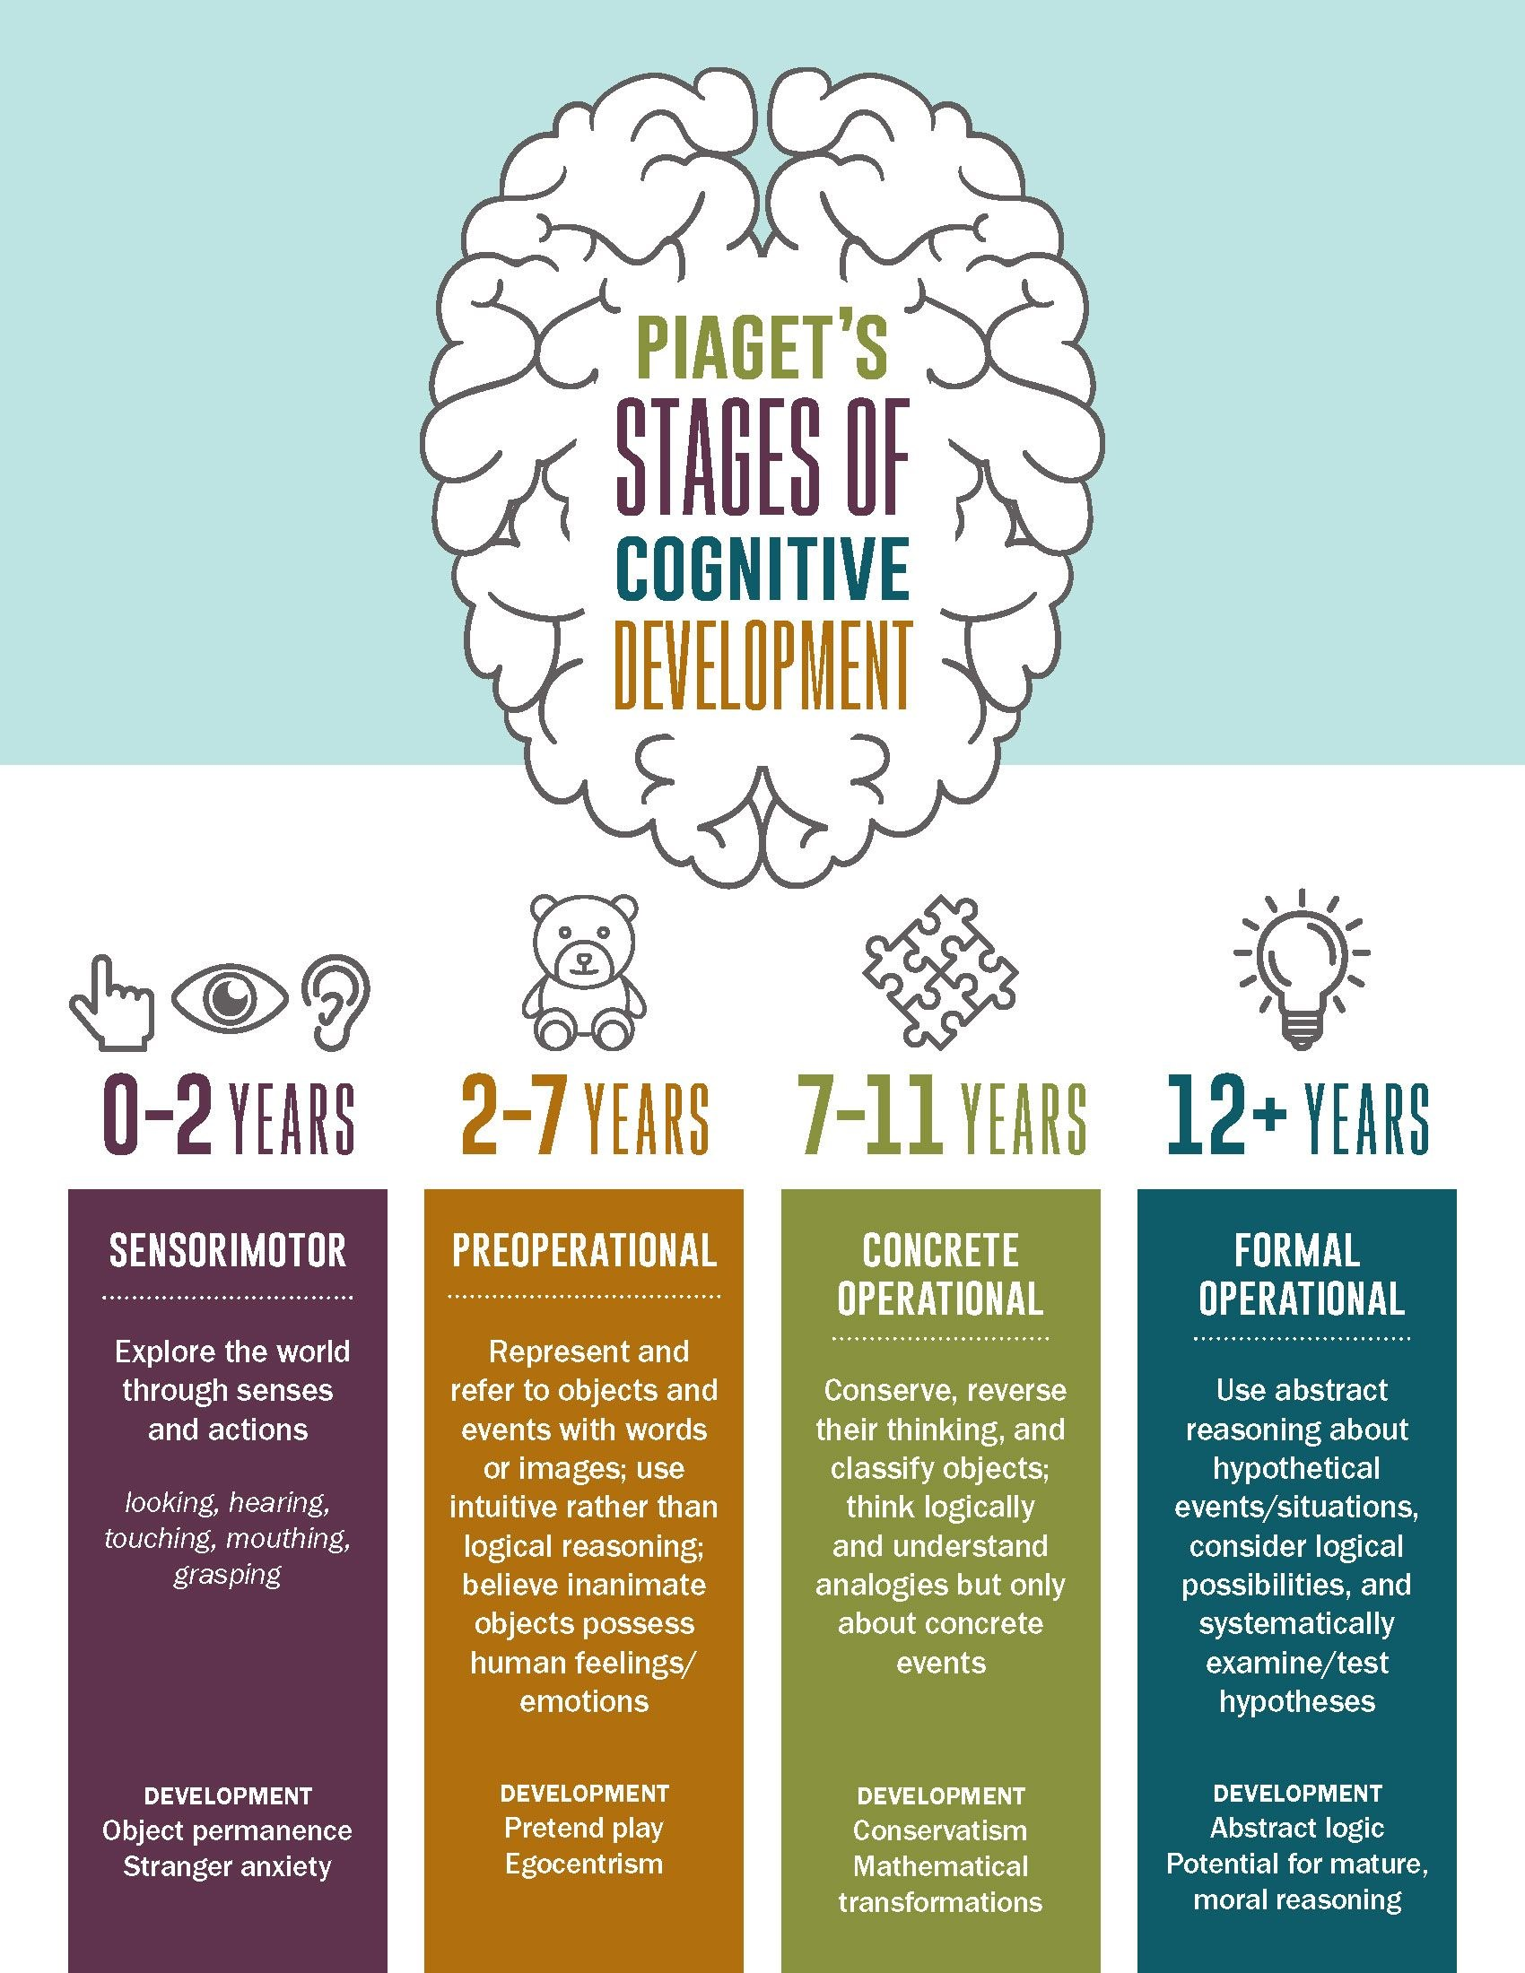
5 - Image Source: (Pinterest, 2024)
Piaget (1936) believed that children were active learners who could develop intellectual ability by discovering the world through exploration and interaction with their environment through schemas without the need of intervention. Alternatively, Vygotsy (1969) argued that the environment in which a child grew, greatly impacted how development would be affected and put emphasis on the socio-economic factors surrounding the child. Vygotsy (1969) believed that a child builds their knowledge from interactions, as opposed to Piaget (1936) who believed in universal stages which had little emphasis on the social or cultural differences between children. Both theories view children as active learners and have played a significant part in modern day pedagogy. Jackson (2017) hypothesises that recent research indicates a clear link between poverty and health concerns in children, with both biological and socioeconomic factors being major contributing elements into the child’s developmental process. The formation of cognitive function during the sensitive period in early childhood is an important indicator of their overall development throughout childhood.
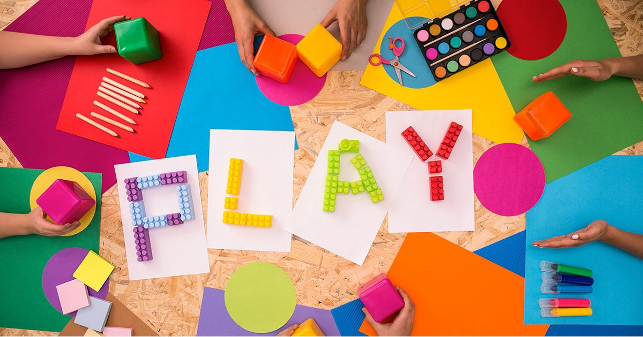
6 - Image Source: (Resilient Educator, 2018).
PACEY (2016) discuss the nature v nurture debate and how we can draw valuable insight from each developemtnal theory and use these frameworks to implement developmentally appropriate teaching practices in early years settings. Applications based on Piaget (1936) theory allows the child to explore through play-based learning and develop their understanding of the world and establish their creative and constructive thinking. Vygotsky’s (1969) alternative model suggests providing more input from teachers and learning through the zone of proximal development which allows the learner to build on their abilities with assistance from teachers and peers by using scaffolding techniques to build on knowledge. Both models have become common practice in many early year’s settings and allow practitioners to identify developmental delays and deficits based on the child’s age and ability. Weinert et al. (2023, p. 29) discuss the significance an early learning setting has at providing an environment rich in language and literature which will allow children to reach speech and literacy competencies. Royal college of speech and language therapy (2023) discuss the link between children from disadvantaged families and speech and language delays. For some children coming from a home environment that has a limited range of vocabulary, they will rely heavily on the input from the education system to promote speech and literacy skills, children who present with communication delays have difficulties in establishing positive educational outcomes.

7 - Image source: (Patnaik and Neilson, 2021).
Timmons et al (2021) raised concerns over the serious adverse effects that the lockdowns imposed on the public during the coronavirus pandemic had on children’s development. Specifically in early years education, isolated learning conditions that did not allow the facilitation of play based learning have been directly blamed for delays in children’s social and communication skills. Along with deficits in numeracy, literacy, and language there are substantial amounts of reports that children’s social and emotional wellbeing were significantly impacted.
Egan et al. (2021) claims that owing to the government-imposed lockdowns during a crucial time in early years childhood, the socio-emotional development of children were stunted. Without the nurturing environment of schooling to investigate and explore, the ability to learn about one’s emotions and develop self-regulatory behaviours were impeded.
Silton (2022, p. 155) discusses how Erikson (1950) theory of eight stages of psychosocial development have been used as a developmental benchmark for many practitioners and claims that the major upheaval of societal norms during the pandemic lockdowns have demonstrated the devastating effect that isolation and school closures have had on the normal development of children previously observed during the first few years of life, once again demonstrating the importance of a child’s environment.
World Health Organisation (2023) discuss how poverty can have a direct impact on the physical health of a child. From the time a mother is pregnant, if subjected to malnutrition, disease or addiction, evidence has shown this can affect the unborn babies physical and cognitive health. For families living in poorer conditions, children may grow in an environment that is lacking in the necessities to promote both physical and cognitive development. Malnourished children often are lacking essential nutrients to aid in brain function and were more likely to suffer stunted growth and a weakened immune system, affecting all aspects of physical growth.

8 - Figure 1 Source: (Department for Education, 2021).
Department for Education (2018) published guidance on the free school meal scheme which was created to enable children from disadvantage backgrounds access to meals rich in vitamins and nutrients each day during school, which many not otherwise be accessible. This provides a greater chance of assisting the growth and physical development of the child.

Doherty and Hughes (2014, p. 216) discuss how schools can provide many essential resources for children who would not otherwise have access to them. Sports facilities that aid in physical development also contribute to social and emotional wellbeing. Children living in poverty are often isolated from society and are unable to engage in activities outside of educational or childcare settings. Preedy, Duncombe and Corely (2020) emphasise the importance of identifying developmental delays in the early years. By recognising issues during the critical first five years of a child's life, practitioners can assist in corrective intervention and avoid long term deficits. Focusing policy on identification and implementation on children under five, through a curriculum that endorses cognitive and physical health education, will allow children from all backgrounds and class to participate in activities to promote their overall development.

Reference List

- Action for Children (2024) ‘Where is Child Poverty increasing in the UK’ Action for Children. 01 January. Available at: https://www.actionforchildren.org.uk/blog/where-is-child-poverty-increasing-in-the-uk (Accessed: 11 January 2024).
- AGSELAW (2016) Three Foreign Languages That Kids Should Learn Today. Available at: Three Languages for Future Multilingual Children | AgseLaw.com (Accessed: 15 January 2024).
- Ainsworth, M. D. S. (1979). Attachment as related to mother-infant interaction. In Advances in the study of behaviour. Cambridge: Academic Press.
- Berger, M., Asaba, E., Fallahpour, M. and Farais, L. (2020) ‘The Sociocultural Shaping of Mothers Doing, being, becoming and belonging after returning to work’ Journal of Occupational Science. 29 (1), pp. 7-20. Available at: https://doi.org/10.1080/14427591.2020.1845226
- Blanc, M. (2012) Natural Language Acquisition on the Autism Spectrum: The Journey from Echolalia to Self-Generated Language. Madison WI: Communication Development Centre INC.
- Bowlby, J. (1969) Attachment and Loss. New York: Basic Books.
- Boyd, D.G. and Bee, H.L. (2014) The Developing Child. 13th edn. England: Pearson Education Limited.
- Cherry, K (2023) What is Attachment Theory. Available at: Attachment Theory: Bowlby and Ainsworth's Theory Explained (verywellmind.com) (Accessed: 14 January 2024).
- Child Psychology (2024) Piaget Four Stages of Cognitive Development. Available at: Piaget's Four Stages of Cognitive Development Infographic | Child development psychology, Child development theories, Psychology (pinterest.com.mx) (Accessed: 12 January 2024).
- Chomsky, N. (2015) Aspects of the Theory of Syntax. 50th edn. The MIT Press: London.
- Department for Education (2018) Free School Meals: Guidance for Schools and local Authorities. Available at: Free school meals: guidance for schools and local authorities - GOV.UK (www.gov.uk) (Accessed: 12 January 2024).
- Department for Education (2021) Free School Meals: Autumn 2022. Available at: Free school meals: autumn 2020 - GOV.UK (www.gov.uk) (Accessed: 13 January 2024).
- Department For Education (2021) The Reading Framework. Available at: The reading framework - GOV.UK (www.gov.uk) (Accessed: 15 December 2023).
- Department for Work and Pensions (2021) Households below average income (HBAI) Statistics. Available at: Households below average income (HBAI) statistics - GOV.UK (www.gov.uk) (Accessed: 11 January 2024).
- Ding, Y., Xu, X., Wang, Z., Li, H. and Wang, W. (2014) ‘The Relation to attachment and Cognitive and Behavioural Outcomes in Early Childhood’ Ealy Childhood Development’, 90 (9), pp. 459-464. Available at: https://doi.org/10.1016/j.earlhumdev.2014.06.004.
- Doherty, J. and Hughes, M. (2013) Child Development: Theory and Practice 0-11. 2 edn. Harlow: Pearson Education LTD.
- Dollard, J., & Miller, N. E. (1950). Personality and Psychotherapy; an Analysis in Terms of Learning, Thinking, and Culture. New York: McGraw-Hill.
- Egan, S.M., Pope, J., Moloney, M., Hoyne, C. and Beatty, C. (2021) ‘Missing Early Education and Care During the Pandemic: The Socio-Emotional Impact of the COVID-19 Crises on Young Children’ Early Childhood Education Journal, 49, pp. 925-934. Available at: Missing Early Education and Care During the Pandemic: The Socio-Emotional Impact of the COVID-19 Crisis on Young Children | Early Childhood Education Journal (springer.com)
- Eigsti, M.P., De Marchena, A.B., Schuh, J.M. and Kelley, E. (2011) ‘Language Acquisition in Autism Spectrum Disorders: A Developmental Review’ Research in Autism Spectrum Disorder, 5(2), pp.681-691. Available at: https://doi.org/10.1016/j.rasd.2010.09.001.
- Erdman, L. (2015) ‘The Power of Touch Between Mom and Baby’ Huffpost Infant Health. The Pressures of Society on Mothers: Navigating Expectations and Striving for Balance. Available at: The Pressure of Society on Mothers: Navigating the Expectations and Striving for Balance | by Ritika Agarwal | Medium (Accessed: 10 January 2023).
- Erikson, E. H. (1950). Childhood and society. New York: Norton.
- Jackson, M. (2017) ‘Effects on Poverty and Health on Childrens Cognitive Development’ Poverty and Childhood Health, 33(2), pp. 31-33. Available at: foc332f2.pdf (wisc.edu)
- Kirkham, P. (2017) ‘The Link Between Intervention and Abuse- Autism and Applied Behaviour Analysis.’ History of The Human Sciences, 30 (2), pp. 107-126. Available at: https://doi.org/10.1177/0952695117702571
- Lefa, B. 2014. ‘The Piaget theory of Cognitive development: Educational implications’ Educational psychology, 1(1), pp.1-8. Available at: CognitiveDevelopmentTheoryGDS1.pdf (lcwu.edu.pk)
- Lindon, J. and Brodie, K. (2016) Understanding Child Development 0-8 years. 4 edn. London: Hodder Education.
- Liss, M., Erchull, M.J. (2012) Feminism and Attachment Parenting: Attitudes, Stereotypes, and Misperceptions. Sex Roles 67, pp. 131–142. Available at: https://doi.org/10.1007/s11199-012-0173-z
- Lorenz, K. (1935). Der Kumpan in der Umwelt des Vogels. Der Artgenosse als auslösendes.
- Luyster, J., Zane, E. and Weil, L. (2022) ‘Conventions for Unconventional Language: Revisiting a Framework for Spoken Language Features in Autism.’ Autism and Development Language Impairments, 7, pp. 1-19. Available at: https://doi.org/10.1177/23969415221105472.
- Main, M., Solomon, J. (1986) ‘Discovery of an Insecure-Disorganized/Disoriented Attachment Pattern’ Affective Development in Infancy, pp. 95-124. Available at: APA PsycNet Cited By Search Results (Accessed: 12 January 2024).
- Meaningful Speech (2023) The Stages of Gestalt Language Processors. Available at: The Stages of Gestalt Language Development (meaningfulspeech.com) (Accessed: 16 December 2023).
- Naigles, L.R., and Bavin, E.L. (2013) ‘Introduction: Special Addition on Atypical Development’ Journal of Child Language, 40 (1), pp.1-20. Available at: https://doi.org/10.1017/S0305000912000578.
- National Literacy Trust (2023) Adult Literacy. Available at: Adult literacy | National Literacy Trust. (Accessed: 15 December 2023).
- PACEY (2016) Theories of Child Development. Available at: https://www.pacey.org.uk/Pacey/media/Website-files/PACEY%20member%20practice%20guides%20(PDFs)/PG28-Theories-of-child-development.pdf (Accessed: 12 January 2024).
- Patnaik, A. and Neilson, M. (2021) The Great Educational Recession. Available at: The Great Educational Recession (thestatesman.com) (Accessed: 12 January 2024).
- Payne (2015) ‘Using Rewards and Sanctions in the Classroom: Pupils Perceptions of Their Own Responses to Current Behaviour Management Strategies.’ Educational Review, 67 (4), pp. 483-504. Available at: https://doi.org/10.1080/00131911.2015.1008407
- Piaget, J. (1957) Construction of Reality in the Child. London: Routledge and Kegan Paul.
- Piaget, J. (1971) The theory of stages in cognitive development. Measurement and Piaget. New York: McGraw-Hill.
- Poppmeier, T (2023) Attachment Style: The Theory Of Human Relationships. 10 March. Available at: Attachment Style: The Theory Behind Human Relationships | bareWell | San Diego, CA (barewellgroup.com) (Accessed: 15 January 2024).
- Preedy, P., Duncombe, R. and Gorely, T. (2022) ‘Phyisical development in the Eartl Years: The Impact of a Daily Movement Programme on Young Childrens Physical Development.’ Education 3-11, 50 (3), pp. 289-303. Available at: https://doi.org/10.1080/03004279.2020.1849345
- Resilient Educator (2018) The Importance of Play Based Learning. Available at: Play-based Learning: The Concept of Kids Learning by Playing | Resilient Educator (Accessed: 12 January 2024).
- Riley, D. (1983) War in the Nursery: Theory of the Child and Mother. Essex: Sage Publications.
- Royal College of Speech and Language Therapists (2023) The Links Between Speech and Language and Communication Needs and Social Disadvantage. Available at: rcslt-social-disadvantage-factsheet.pdf (Accessed: 12 January 2024).
- Schaffer, R. H and Emmerson, P. E. (1964) ‘The Development of Social Attachment in Infancy’ Society for Research for Child Development, 29 (3), pp. 1-70. Available at: https://doi.org/10.2307/1165727
- Silton, N. R. (Ed.). (2022). The impact of the COVID-19 pandemic on child, adolescent, and adult development. Information Science Reference.
- Skinner, B.F. (1957) Verbal Behaviour. New York: Appleton Century Crofts.
- Small Talk Therapy (2023) Gestalt Language Processing Stages. Available at: Gestalt Language Processing Stages » Small Talk Speech Therapy (Accessed: 13 January 2024).
- Timmons, K., Cooper, A., Bozek, E. and Braund, H. (2021) ‘The Impacts of COVID 19 on Early Childhood Education: Capturing the Unique Challenges Associated with Remote Teaching and Learning in K-2’ Early Childhood Educational Journal, 49, pp. 887-901. Available at : The Impacts of COVID-19 on Early Childhood Education: Capturing the Unique Challenges Associated with Remote Teaching and Learning in K-2 | Early Childhood Education Journal (springer.com)
- UK Government (2013) Tax Free Childcare. Available at:Tax-Free Childcare - GOV.UK (www.gov.uk) (Accessed: 10 January 2024).
- Vygotsky, L.S. (1978) Mind in Society: The Development of Higher Psychological Processes. Cambridge: Harvard University Press.
- Weinert, S., Attig, M., Linberg, A., Vogel, F. and Rossbach, H.G. (2023). Quality of Early Learning Environments: Measures, Validation, and Effects on Child Development. In Methodology of Educational Measurement and Assessment. Germany: Springer International Publishing.
- World Health Organisation (2023) Malnutrition. Available at: Fact sheets - Malnutrition (who.int) (Accessed: 12 January 2024).

