7 Real-Life Examples of AI in Education - Latest Digital Transformation Trends | Cloud News | Wire19

7 Real-Life Examples of AI in Education
By Jyotsana Gupta on September 21, 2020No Comments / 3602 views
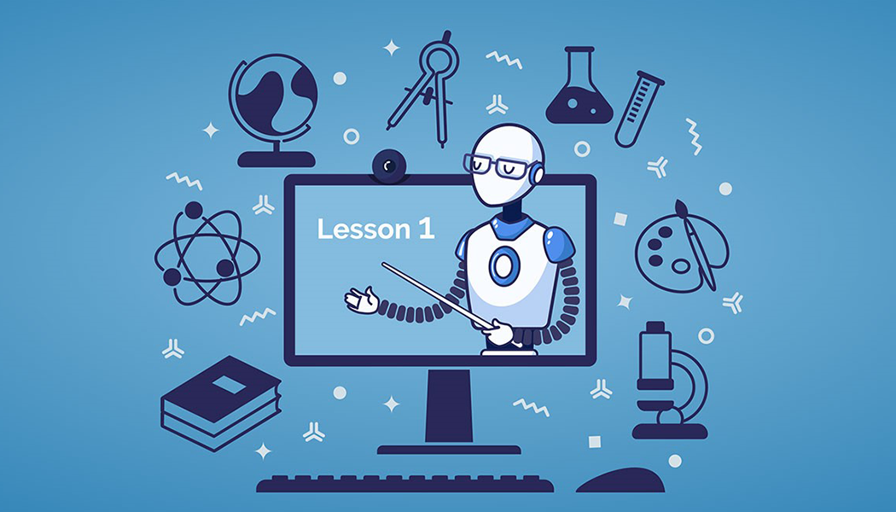
Artificial intelligence (AI) has impacted almost all sectors of human life, including education (ed). The latest advancements in this technology have since enhanced learning in ways that weren’t perceived previously. AI has led to the development of virtual tutors, which help learners’ study and prepare for the tests. And through games, VR (Virtual Reality), etc. AI has boosted student engagement significantly.
AI is impacting ed in varying ways, and this is expected to continue as the tech advances. Meanwhile, various AI-driven solutions are increasingly being leveraged in class. Let’s take a look at seven real-life cases of AI-based solutions in ed.

Jill Watson
The Georgia Institute of Technology introduced a virtual teaching assistant, Jill Watson, to offer individual attention to scholars to keep them from quitting school. It’s a bot that responds to different predictable queries such as how to format a paper.
This virtual assistant is trained on an exhaustive database that is filled with learner’s queries regarding the program, introductory emails, and the appropriate replies from the educators. At the time of launching, the accuracy of Watson’s answers was assessed by a human. Later, Watson began to auto-respond to the scholars’ introductions and repetitive queries alone.
After getting a query, Watson connects it to an applicable question-reply pair from the teaching database and offers an associated response.

Content Technologies, Inc.
This AI innovation firm has built a collection of smart content solutions for high school and higher educational levels. Case in point, Cram101, leverages AI to offer and explain textbook information into a more comprehensible guide. This breakdown consists of summaries, true/untrue exercises, and multi-option quizzes.
JustTheFacts101, another product from this developer, has a more defined role. It highlights and formulates summaries by chapter, which are later stored digitally and can be accessed on Amazon.

Duolingo

It is a language-learning tool that leverages AI to deliver a placement exam. The test is adaptive, meaning it will alter the questions based on the responses you’ve provided before. As such, it will offer a more straightforward query if you failed and a more challenging one if you give the right answer. The complexity of the phrases and grammar used also influences the nature of the test you are given.
Duolingo also leverages AI in optimizing and personalizing sessions. It has a feature that assesses mistake patterns that many language students make when practicing newly learned words. With this information, this tool can determine when you forget a specific term. This feature also factors in the complexity of phrases. All these details help in determining the best time to practice languages.
This application, at some point, also introduced AI-driven chatbots that conversed with users. Moreover, these chatbots offered appropriate responses based on each correct answer provided by the language learner. Importantly, these features came with an assistance functionality that facilitated replies when it’s challenging to identify the proper words or grammar.
Are you learning English? Do you need assistance with your composition? You can easily find a helper online at a leading assignment help service. While on such a platform, a message such as “do my essay” will see you get quick assistance.

Brainly
It’s a social network where learners can collaborate. Case in point, students can deliberate on matters regarding their assignments or access new ideas from their peers. This solution uses machine learning (ML) to offer a great experience. Moreover, thanks to ML, Brainly can quickly identify spam and irrelevant content. Importantly, AI helps the tool provided more customized resources.

Carnegie Learning
It leverages cognitive science and artificial intelligence to offer customized tutoring and live feedback for post-high school learners. Carnegie Learning assesses keystrokes and allows the tutor to view the learner’s progress.

ThinkerMath
This AI-based resource assists pupils in learning math. It has tons of games and awards that motivate learners and boost engagement. Best of all, this application provides a learning schedule that’s informed by the pupil’s knowledge.

Third Space Learning

This online learning platform offers one-on-one math classes to tons of leaners each week. It shines at enhancing student engagement and determining the most effective ways of teaching. With AI, this solution can evaluate recorded sessions and reveal patterns in the educator’s and learner’s mannerisms.
Case in point, artificial intelligence can determine if a student is exhibiting signs that denote a loss of interest. And in the future, this tool intends to offer live AI-driven feedback to educators during every session. With this, educators will be directed to slow down if they are talking too fast, and vice versa.
These are some of the many examples of AI-driven solutions in education. While they are quite useful on their own, the best results are attained when human instructors oversee the process.

