12/14/2023
Scott Copperthwaite

“Group Project Portfolio”

Course: OME level 4 – Group Project ACDA5022

Word Count (Excluding title page, abstract, contents, references, and figures):

5103

Abstract

A portfolio report based on a group coalition consisting of AWE and QinetiQ staff; tasked with managing and simulating a fireworks display. Background information on fireworks is given, proceeding into an introduction of the task set by the university for the students. The task is conducted by forming into individual teams to represent different subject areas in the creation of a fireworks display. The report breaks down each individual contributor's role and how they contributed to the project. Strong emphasis is on the student’s role within the project, that of Simulation Design Engineer and covers the aim, methodology and results of the student’s work. An overview with screenshots of the group’s formal presentation to university staff is included. The feedback from the presentation and scores received are incorporated within the conclusion.

Contents
Abstract 1
Figures 2
1. Background 3
2. Introduction 3
3. The Firework Display Team 4
3.1. Project Manager 5
3.2. Systems Design Engineer 6
3.3. Procurement Team 6
3.4. Testing Engineer 7
3.5. Safety Specialist 7
3.6. Weather Specialist 9
4. Simulation Design Engineer Role 9
4.1. Requirements 9
4.2. Method 10
4.3. Conclusion 13
5. Group Presentation 14
6. Evaluation of the Project 20
7. References 22
8. Annexes 23
8.1. Annex A – Team Communication Log 23
8.2. Annex B – ShellCalc use. 24
8.3. Annex C – Feedback Received 25

Figures

Figure 2-1 – Viewing and Firing locations defined. 4
Figure 3-1 – Safe storage locations 8
Figure 4-1 – Assigning Firing points – 7 total. 10
Figure 4-2—Assigning COBRA modules. 11
Figure 4-3 – Module positioning 11
Figure 4-4 – Year 1 versus Year 2 Firework usage. 12
Figure 4-5 – PDF Display snippet 12
Figure 4-6 – Estimated total NEQ for simulated display [11]. 13
Figure 5-1 – PM slides 1 14
Figure 5-2 – PM Slides 2 15
Figure 5-3 – SE Slide 1 15
Figure 5-4 – SDE Slide 1 16
Figure 5-5 – SDE Slide 2 16
Figure 5-6 – Procurement Team slides 17
Figure 5-7 – TE Slide 1 17
Figure 5-8 – TE Slide 2 18
Figure 5-9 – SS Slide 1 18
Figure 5-10 – SS Slide 2 19
Figure 5-11 – WS Slide 1 19
Figure 5-12 – Final Slide 20
Figure 6-1 – Feedback Received for the student. 20

Background

The discovery of fireworks was pure happenstance, stumbled upon by Chinese alchemists questing to find an alchemic formula for immortality, but instead discovered an explosive mixture known as black powder, and later, as gunpowder [1]. The chemistry behind the fireworks is based on the combustion of the mixture. The discovery contained oxidisers, such as potassium nitrate or perchlorates, provide oxygen, while fuels, such as charcoal or sulphur, facilitate the explosive reaction. Comprehension of this mixture paved the way for fireworks to become a widely used commodity, from rudimentary rockets through to celebrating cultural events and significant moments in a well-coordinated manner to create the desired visual and auditory effects [2].

A firework is a sum of only a few integral parts explicitly designed for a set purpose. A weak outer shell, composed of mainly cardboard or light material, encapsulates the fireworks’ inner machinations and is designed to break apart and disperse the desired effect. A simple fuse ignites the internal composition, tending to be black powder, which produces lift and propels the firework skyward. Once at a certain altitude, the explosive or burst charge takes over. This charge breaks the outer shell and releases pellets of various metals that, when ignited, create distinct colours. Metal salts add the desired colour to the mixture, and different salts produce different colours, such as red from strontium salts, green from barium salts, and blue from copper salts [3].

In the modern area, advancements and developments have given a greater focus on safety, variety, and precision. Pyrotechnicians use delay fuses to delay the ignition of certain parts of the firework, ensuring a sequence of effects or allowing time for the firework to reach a particular altitude before bursting. Computer-controlled systems further aid pyrotechnicians for even greater timed accuracy, timing sequences and choreography/synchronicity to music, enabling more intricate displays [4]. There has also been a significant shift toward environmentally safe fireworks, which includes developing low-smoke formulas and biodegradable waste for eco-friendliness.

Fireworks are a remarkable display of science and artistry, requiring a complex and well-coordinated system of components to create the desired effects. Understanding the composition and timing of these components is crucial for pyrotechnicians to create a visually stunning and well-coordinated firework display.

Introduction

The university set the students on the course to break away into teams and collectively produce a PowerPoint presentation on how they would create, manage, and execute a simulated fireworks display within the University campus as a small design team. The university set specific criteria that the team would be required to fulfil:
- The display theme needs to represent OME, the university and education.
- They will be fired from the quayside near the IQ building (Plans provided).
- The audience will be located in and around the IQ campus. (Safety trace to be calculated)
- A duration of at least 30 seconds is required (excluding any time to effect), though up to two minutes is desirable.
- The materials budget for the fireworks display is £2000 per minute of display or a max of £10000.
- The display shall not break any legal limitations/regulations.
- ‘Fall-Out’ (airborne display debris) shall be assessed, and any associated safety issues addressed.
- Logistics and safety plans will be required.
- Environmental effects are to be considered and documented (disposal, site contamination, air pollution, etc.)

The team had to consider the desired effect for the display, ideally synchronising it to a musical piece of their choosing and focusing heavily on safety. As well as these integral foundations, the team were to be mindful and include the logistics of storing, set up, initiation and clean-up whilst mitigating environmental factors that could impact the display on the day. Weather conditions and viewing/firing locations were given in advance to the team as an assisting foundation, figure 2-1.
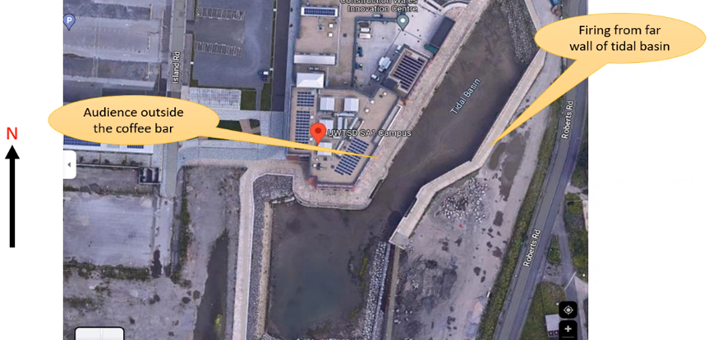

Figure 2-1 – Viewing and Firing locations defined.
Upon the first meeting, the students created a running log of communications to create accountability and a traceable archive of planning, see Annex- A. From this, the team, hereafter referred to as the Firework display team, and eventually, their individual titled roles could decide upon the specific roles for each member and the contribution towards the group project. Thus, this allowed trackable achievements, questions raised and subsequent help throughout the creation of the full presentation that aimed to achieve the required standards set by the university.

The Firework Display Team

During the display teams’ first meeting, seen in Annex – A, there was a proposal for the breakdown of which areas each person would cover. With the over-arching theme set as OME, the course throughout the years at the university, the team developed specified areas of contribution in a way that could represent the modules covered throughout the course. The title “Ode to OME” was agreed on, which set the team down a path of creating a display that wanted to show the disparity in organisation between the first and second years of university. This would be represented in the display itself as the first part of the fireworks display, which aimed to use dull colours, miss-timed deflagration of the fireworks to the beat, and a generically poor overall display. Whilst creating contrast, the second half would visualise the culmination of organisational expertise from the university, visualised by a perfectly synchronised firework display to symbolise the 2nd year running more smoothly. The chosen song would be Neil Diamond’s “Sweet Caroline” due to its recognisable beats and the perceived ease of hitting the big cacophony. Finally, the team wanted to represent the different areas the individuals worked in, whether in the UK or France, by desiring the colour theme to be displayed in the mutually shared colours of red, white, and blue.
The team was sectioned off into the following roles, roles in which individuals would utilise some of the areas learned in modules throughout the whole course:
- Project management – Callum – An overview of the project utilising Study Skills – Time management, planning, stakeholder engagement.
- Requirements of the Display – Jon – A systems engineering approach to requirement setting from the user.
- Simulated Firework display – Scott – Using the FWSim software to create the full display based on requirements set by the systems engineer.
- Testing engineer – Charlie – Utilising knowledge from OME/Pyro, discussing a full breakdown of the firework composition from tip to propellant and chemistry utilisation. Includes testing and waste disposal.
- Safety – Joe – Legal rules and regulations stipulating how to safely store fireworks and set up the displaying and viewing areas.
- Weather – Shawn – Different weather effects on the fireworks display – utilising physics calculations, maths, and the ShellCalc app.

The Simulation Design team will be covered under a separate section due to the student performing that role. The section will aim to cover in greater detail the tools used by the student and an account of methodology, results, and hindrances will be discussed in section 4 of the report.

Project Manager

Organising a fireworks display requires strong stakeholder engagement, coordination, and meticulous planning. The project manager will be linked in with and engaged with all aspects of the project and the team members to allocate resources, mitigate the risks and ensure compliance with regulations. They will also have to work closely with the pyrotechnicians' local authorities and are responsible for ensuring cost control throughout the display life management process.
The PM had to work closely with all separate teams but linked continuously with the Safety Specialist to help identify potential risks and develop mitigation techniques/strategies. The PM had to ensure that the logistics of transporting and sourcing the required fireworks for the Procurement Team were readily available and within budgetary constraints.
The PM embodied effective leadership and strong interpersonal communication skills and ensured all members involved adhered to the managed timeline. The PM certified that all objectives set by the University would be met and expectations exceeded. The PM, therefore, will play a critical role in the safe and successful organisation of the fireworks display.

Systems Design Engineer

When organising a fireworks display, different tools and techniques can be used to ensure the event meets the audience's expectations and is executed safely. The team determined that a Systems Engineer would be of the utmost importance and a vital member of the Fireworks display team. Colloquially, a systems engineer has a plethora of tools up their sleeves; however, in this instance, the SE would be focused on critical systems functionality, the “how” to set up the firework display, the “what” is required of the customer and the “what” should be displayed. To fulfil this, the SE utilised Quality Function Deployment (QFD) and Failure Mode and Effects Analysis (FMEA), processes developed in the 1960s in Japan and still widely used today [5].

QFD determined comparisons between non-functional and functional requirements, it highlighted the relationships and correlations between the two. This enlightened the SE to understand that firing points and viewing areas were rated highly, and the least rated was the delivery of the pyrotechnics. From this, high importance was also assigned to the correct timing of the music display.

On the other hand, FMEA is a technique that can identify potential risks and failures associated with the display, i.e., the fireworks, the fall-out, etc., with the fireworks to be used. It is a fantastic tool that can help identify potential failure modes of individual fireworks, such as premature ignition, misfires, or unexpected trajectory deviations. Furthermore, FMEA helps evaluate the severity of these failures (e.g., injuries, property damage), the likelihood of occurrence, and how easily they can be detected (e.g., through pre-checks).

When used together, QFD and FMEA can work synergistically. QFD ensures that the fireworks display meets audience expectations, while FMEA ensures that these expectations are met safely by addressing potential risks and failures associated with the fireworks. Both tools enable a feedback loop for continuous improvement, allowing the display team to refine the display's quality and safety for this specific display and any subsequent displays hereafter. To summarise the SE’s work, they concluded that the following were identified and should be resourced for primary focus by the PM and the following members of the team to focus their work on:

- Critical functions – Establish and set up firing points in relation to pre-determined audience location.
- Critical Features – Electronic timing, electronic firing.
- Areas of focus from FMEA – Effective planning and understanding of rules and legislation. Detailed simulation for weather purposes and varying fireworks effects.

Procurement Team

The role of the Procurement Team was not foreseen within the display teams’ original breakdown of roles. The team and the PM identified it as a missing link between the SDE suggesting the team would need X number of fireworks and the Testing/Safety representative not having accurate to-life information on the acquired fireworks and modules. This role was necessary in that there would be a specific need for an actual NEQ value of the fireworks for safety storage reasons mentioned later and for an accurate cost in purchasing the fireworks due to budgetary constraints.

Procurement decided to use the stock list provided by Kimbolton and the SDE use of MLE over custom-produced fireworks. This allowed the PT to create a near-certain NEQ value list that the SDE team required for their simulated display. As identified by the SDE team, the drawback was the inability to fit the custom FWsim fireworks with the real-to-life stock listing fireworks.
The PT team found that the free license of the SDE team meant that procuring the total 332 fireworks units could only be completed in batched quantities. This meant 681 units had to be purchased, leaving 349 units left over. However, due to the relatively short display length, 2 minutes 30 seconds, the total cost was only £2296.85, of which only £953.30 would be used. The disconnect between the units used and units wasted would need to be addressed by the SDE team for future firework display endeavours.

The PT was also able to source and break down the NEQ values for the set category of fireworks to be used. They procured 116.27 kg of pyrotechnics, an almost replica of the SDE requirements. Of which, 99.42 kg of HCC 1.3.G and 16.85 kg of HCC 1.4G were to be used. The importance of the firework category ratings would be supplied to the Safety Specialist as the categories have varying safety and storage implications.

Testing Engineer

Testing is essential to ensure the safe working of the various mechanisms involved within a firework display, namely the firework compositions themselves, the firing positions, the firing mechanisms and related equipment. Fault identification can highlight any malfunctions or safety-related issues that can be conveyed back up the project to change certain aspects and also down the project to better inform the Safet Specialist. The Testing Engineer can show an auditable trail as proof of safe conduction by conducting these tests. Conducting tests ensures compliance with safety standards and regulations set by local authorities. This step is significant since the safety of the spectators, structures, and the surrounding areas is at stake and was highlighted with the highest importance by the SE.
This can substantially reduce the risk of accidents during the actual display and allow for a safe display. The Testing Engineer played a pivotal role in understanding the components involved within the firing module, the COBRA system and its involvement/relationship with the set firing points and the 332 fireworks needing to be fired. The TE was able to fine-tune the process of ensuring the firing system managed the exact firing sequence the SDE set out when synchronised to the music. Rigorous testing of the modules was conducted to prove the system, ensuring timings and song synchronicity were correct.
The TE was responsible for the waste output produced from the show and any environmental concerns. Both were, again, highlighted by the SE during the requirement phase. The TE also had to account for compliance with set noise limits, no greater than 120db, adhering to smoke pollution rules and the litter produced from generic crowd gatherings. To comply with the environmental issues and to ensure all was adhered to, the TE linked in with the Weather Specialist and the SDE to understand the wind direction and firing point locations to ensure crowd safety. Acoustic testing was performed to satisfy the local authorities that the decibels did not exceed the 120Db limit.

Safety Specialist

The SE defined safety compliance as the highest-rated requirement for the display team to manage. Ensuring safety measures were in place for participants and spectators was a vital requirement. This included having trained personnel to handle the fireworks, providing adequate barriers and safety zones, and having firefighting equipment on standby. The university established the audience and firing points, subsequently hindering the SS in that of flexibility. As well as these points, conducting fireworks displays often requires a multitude of insurance and licenses that need to be obtained from the relevant local authorities, all of which add to the cost of hosting such a display.

The Safety Specialist was governed by the Health and Safety at Works Act 1974, the Explosive Regulations in ER2014 and the Fireworks Regulations Act 2004. These regulations provided a solid foundation for the SS to prove that, as far as reasonably practicable, the safety of employees was paramount [6]. The fireworks regulation set guidelines on the safe storage of the varying categories of fireworks, in particular to F categories [7]. The F category defines the set NEQ quantities against set safe distances. For example:
- F2 Safety Distance of 8-15m
- F3 Safety Distance 25+m
- F4 – Professional teams

Clarification was sought from the course’s professional body as to whether the display team was classed as amateurs or professionals. Initially perceived as amateurs, the team was prohibited from using F4 fireworks, which sent shockwaves up through the PM, the SE and the SDE, in which, especially for the SDE, the simulation would need to be altered and become lacklustre. The safety aspect of this meant the NEQ quantities would be significantly less. However, upon clarification, the team was able to be classed as professionals, and planned adjustments did not need to be made. The HSE stated that should the team use F4; a license would be required; however, as the team was to be classed as professionals, it was stipulated that the permit was already obtained and, therefore, able to store over 100 Kg of fireworks [8].

The specialist communicated with procurement to obtain a 20ft ISO container to store the 116 Kg of fireworks safely. The SS, Figure 3-2, identified the storage location concerning the firing points and safely recognised that the viewing and staging points complied with all regulations.
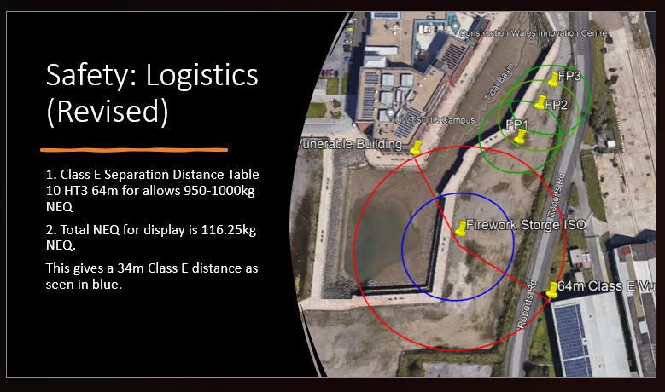

Figure 3-1 – Safe storage locations

Weather Specialist

The university provided the Display Team with a set date for the Fireworks display to commence. The date given was Friday, 4th August 2023; the weather specialist was therefore tasked with providing accurate real-time weather data on that date. The WS was to inform the respective other team members with precise weather data and how to mitigate against anything adverse.

Many weather conditions can affect a fireworks display, such as visibility, wind, rain, barometric pressure, fire risk, humidity, etc. The wind would be considered the crucial standout factor due to the nature of propelling small explosives into the air for auditory and visual purposes. Wind direction and speed can cause the proposed trajectories of fireworks to become skewed, leading to hazardous situations such as debris falling amongst the audience and fireworks drifting off course. The SS could adjust or postpone the event if the winds were too strong. The WS needed strong communication links with the SS to ensure compliance and safety of the audience. Cloud cover could hinder the audience's visibility; when a performance is based on auditory and visual stimulation, losing half the purpose of the show could result in financial losses.

To assess the risks involved in the aforementioned possibilities, the WS used the software known as ShellCalc to provide data on firework residue, waste and litter fall-out under multiple differing weather scenarios. ShellCalc worked by enabling the WS to input fireworks category data and manually input various weather conditions, wind speeds and wind direction [9]. The scenarios would consider real-time data and provide best- and worst-case scenarios for how wind direction, wind speed, cloud cover and generic weather effects could affect the movement of the fireworks during the lift, the waste produced location, amongst other vital readings.

Annex – B – ShellCalc use highlights some of the inputs and data readings from using the ShellCalc software. The WS predicted that fallout from the show, directed by the forecast winds, would land in the audience viewing area. The WS suggested the Comets were to be used as much as possible for the fireworks display to address the potential cloud cover concerns and mitigate the need for fireworks to burst above the clouds. The SDE, by chance, had, for the most part used Comet Fireworks and therefore a restructuring of the display was not required. However, the issue with the prevailing winds into the audience remained unresolved for the moment.

Simulation Design Engineer Role

Requirements

The student was tasked with the opportunity to design the fireworks simulation and embraced the role of the Simulation Design Engineer. The SDE was tasked with creating a simulation that met the requirements the Systems Engineer laid out. Due to the importance of safety derived from the SE, the SDE focused on the other highly rated requirements derived from the SE, which is that the display must represent the OME course theme. The requirements for the SDE were:

- Represent the OME theme.
- Establishing firing points.
- Ignition and timing modules to be electronic.
- Synchronicity of the timings to the chosen song.
- Display must be around 2-3 minutes in duration.

Method

The aim was to use the fireworks simulation tool known as FWsim. The software allowed the SDE to simulate various consumer and professionally used fireworks, using high-quality 3d rendering and varied firing modules [10]. The software simulations were able to facilitate precise timing and synchronisation of firework bursts to music or specific cues, resulting in a synchronised and aesthetically pleasing display.

The first important step was choosing the firing positions and ensuring the spread wasn’t over 100m due to firing area limitations. The SDE established the firing points of the fireworks, in which three distinct points were used, totaling 7 firing stations altogether. This information would allow the Safety Specialist to establish boundary lines and safe storage of set NEQ derived from the procurement team, Figure 4-1.

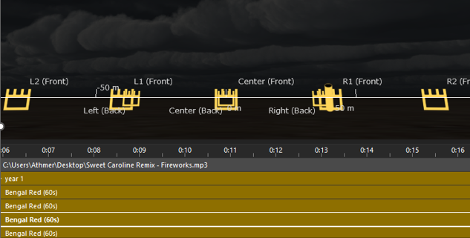
Figure 4-1 – Assigning Firing points – 7 total.

The use of an electronic module was a requirement set by the SE, and FWSim allowed a varied range of options. The COBRA module was chosen due to having the most channels/inputs which allowed for fewer modules required for the amount of fireworks used. Figures 4-2 and 4-3 show the addition of modules added close to the firing points and the dropdown menu for assigning the channels to the firing points.

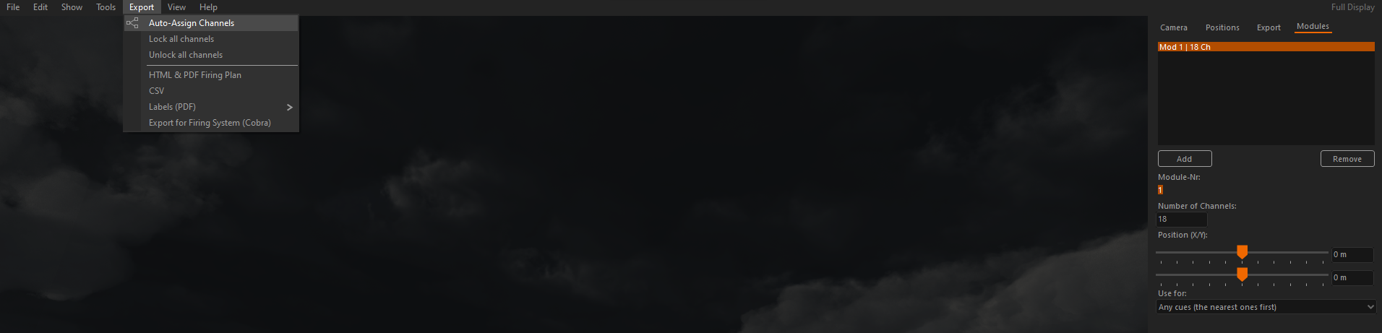

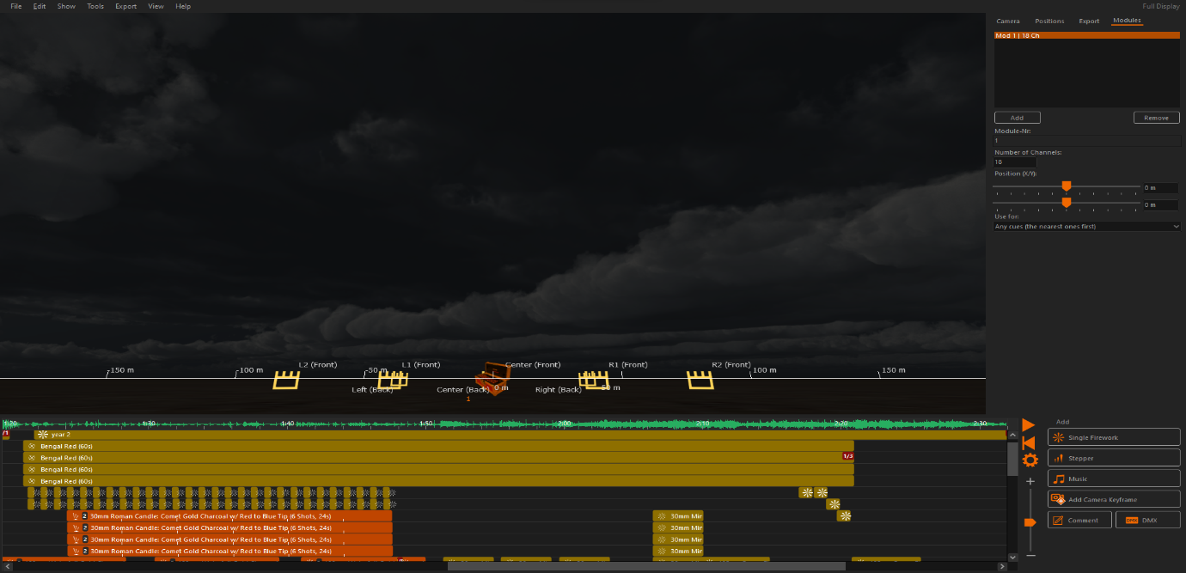
Figure 4-2—Assigning COBRA modules.

Figure 4-3 – Module positioning

The display team had already established that the song “Sweet Caroline” was to be used, and the SDE decided that to represent better the OME theme and the chosen theme of disparity, the song would be edited to the first verse and first chorus. This would subsequently be repeated for Year 1 and Year 2, highlighting the differences using the medium of the fireworks display, figure 4-4. Figure 4-4 also briefly visually highlights the differences between the years’ in fireworks use and complexity of firings. A strong visualized contrasting display for each year. The timing synchronisation, which is non-existent for the first year and perfectly synchronised for the second, cannot be viewed. This is best viewed in the entire display, with the link added to the results section.

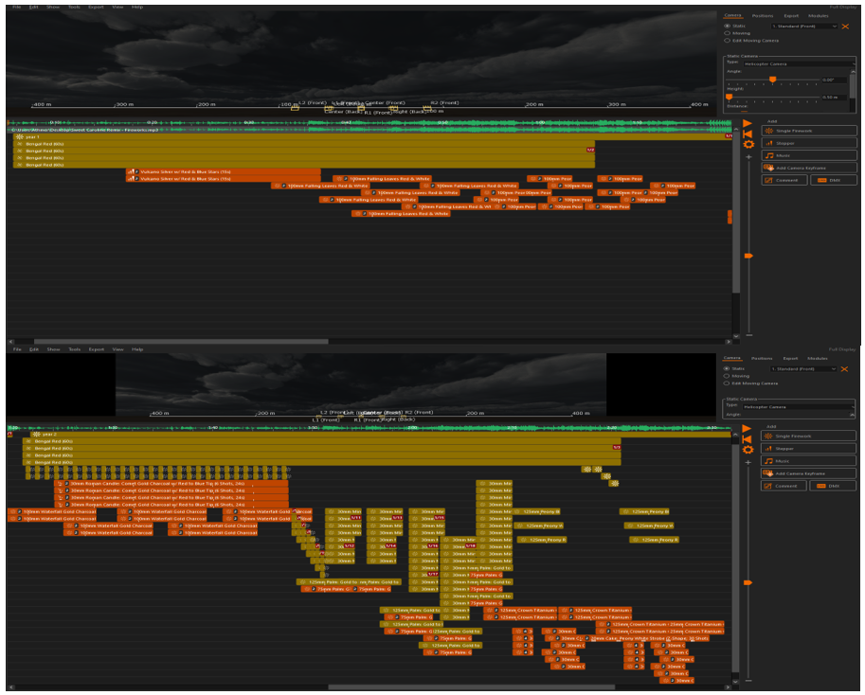

Figure 4-4 – Year 1 versus Year 2 Firework usage.
FWsim totalled the number of fireworks used, 332, and created a detailed plan of the exact firing timings created by the SDE, showcasing each firework ignition and the timing of such. It also produced the angle of the shot, the number of shots, the firing position, and the address – a.k.a. the module channel used. Figure 4-5 showcases a small snippet of the produced PDF.
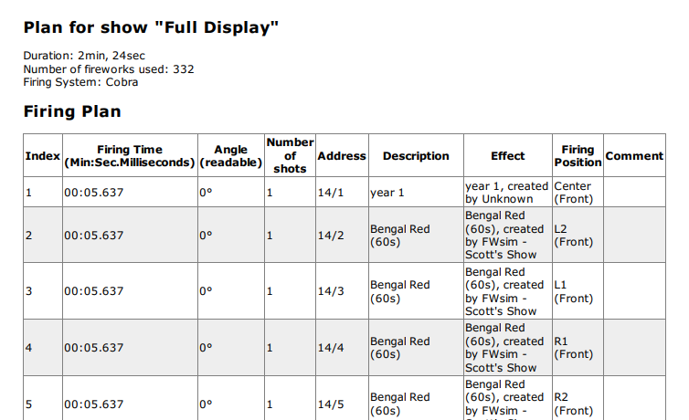

Figure 4-5 – PDF Display snippet
Unfortunately, Fwsim couldn’t assign NEQ weights to the fireworks, nor did it give the appropriate title to the chosen fireworks, thus making it difficult for the procurement team to procure exact replicas. It could do so, but the SDE was unaware of how to do this in the limited design phase. However, an educated guess of around 116.24 kg of pyrotechnics sourced from online fireworks directories [11], was estimated to be used; see Figure 4-6.
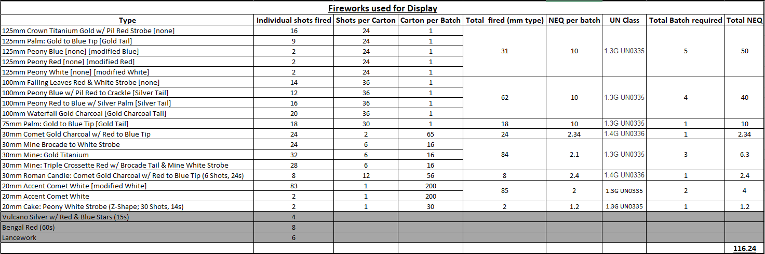

Figure 4-6 – Estimated total NEQ for simulated display [11].

Conclusion

By incorporating varied factors such as wind speed, direction, and weather data, simulations help designers to create a visually stunning and safe fireworks show. Using a simulation allowed a visual representation of the planned firework sequence, enabling the SDE to select the right combination for the desired effects. Simulation design aids in helping to minimise potential hazards identified in the FMEA process, be they to spectators, the campus buildings, and other structures, making it a safer option for everyone involved. Thus, this will ensure that the display is visually stunning and aiming to ultimately create a memorable, safe and fulfilling experience for the audience.

The created simulation, although somewhat basic due to the nature of the SDE not being a subject matter expert with the firework simulation software, was used as a medium to portray the team’s view of the course's handling, running, and content. Ultimately, it represents the disparity between years 1 and 2. In year one, the potential for a beautiful display was possible, yet the timings were off, out of sync and never quite reaching its potential. Yet, in contrast, in year 2, slick timings are witnessed after the reset, and the display finally comes together, fulfilling its potential all along.

The SDE determined that there were pros and cons, as with any project, when using this software; a list is provided below:

Pros –
- Ability to time fireworks to “big” moments – Even if manual calculations are done first.
- Customisable fireworks – Suitability can change to the desired theme.
- Wide range/choice of fireworks and timers

Cons –
- The fireworks didn’t match the given list.
- No NEQ value for fireworks on software.
- Difficult to match scenery locations.
- Weather cannot be genuinely factored in.

Finally, the link provided below is the culmination of the SDE’s work and showcases the final product of the task set out for them within the group project.

https://www.youtube.com/watch?v=8M51_2Gje8Y

Group Presentation

Although the importance and how the roles contribute to the display as a whole was defined in section three, it is more than worth exploring how the group presented their proposal to the university. Each member in their designated roles showcased their contribution, presenting for around 7 minutes, with the presentation lasting under 45 minutes. The presentation opened with the PM discussing the agenda and moving into the scope of their role, which is to manage the project, Figure 5-1.

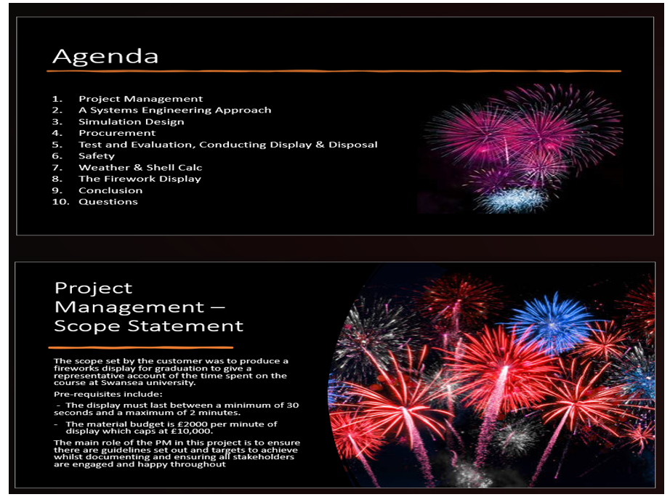

Figure 5-1 – PM slides 1

The PM progressed by discussing how they engaged with all stakeholders, including the customer and all contributors within the team, Figure 5-2.
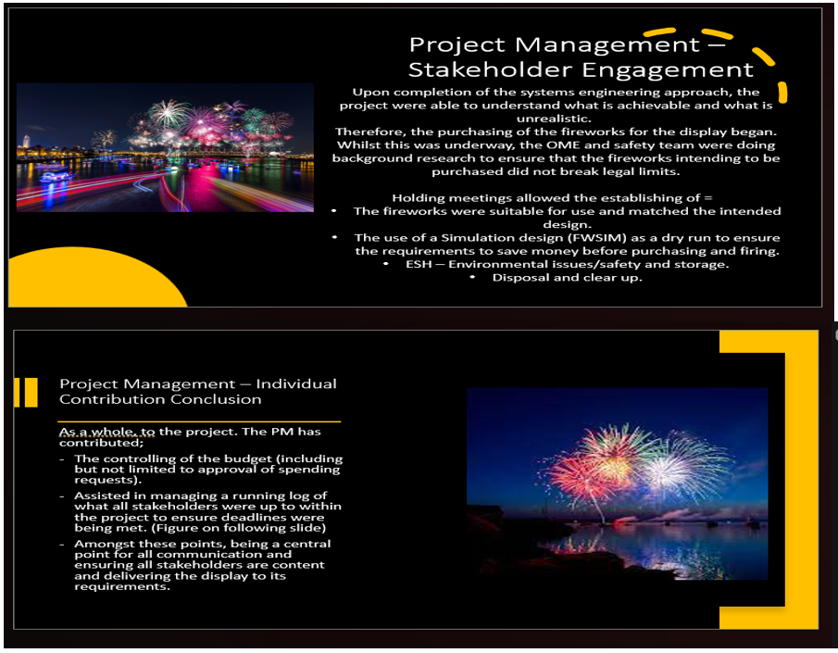

Figure 5-2 – PM Slides 2
The SE followed the PM and began broadly informing how taking a system thinking approach can create a requirement importance list for all teams to pursue and focus upon. The SE-produced slides to visualise graphically the importance ranking of the customer requirements, Figure 5-3. From there, the SE discussed the importance of FMEA and how it identified critical functions and features and, therefore, was able to identify failure modes with a severity ranking, allowing the Safety Specialist to link in with the SE. The SE summarised their findings so that the relevant parties could take the requirements and work around them.
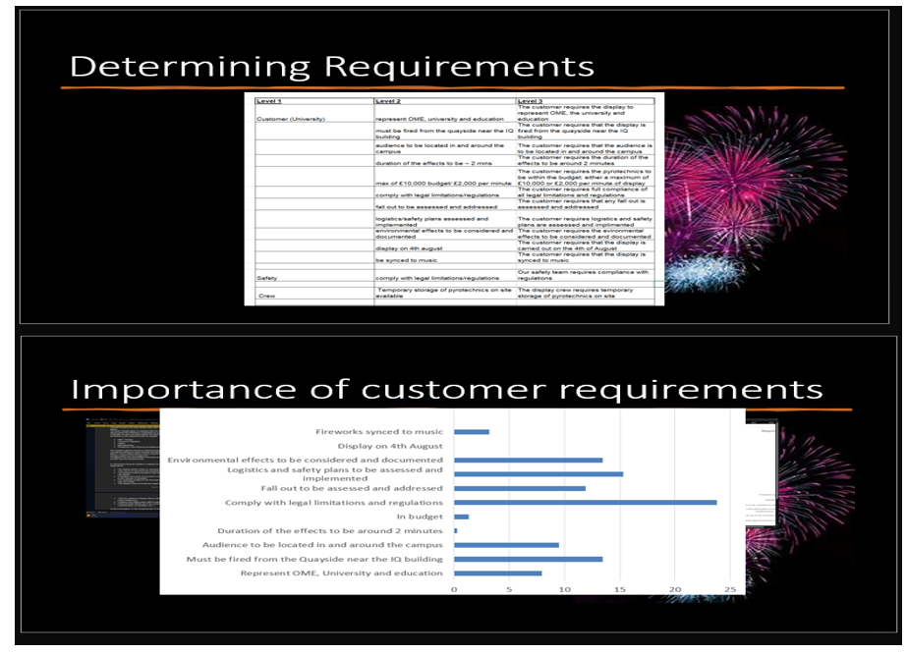

Figure 5-3 – SE Slide 1
The Simulation Design section followed, and it started with informing the audience about the requirements they would focus on. They began by discussing the positioning of the firing points and the chosen electronic firing module to be used in the display, Figure 5-4.
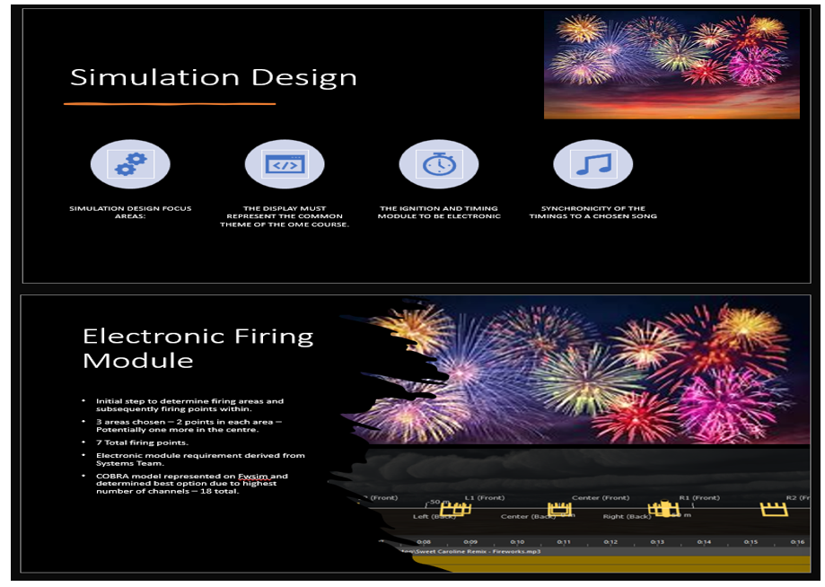

Figure 5-4 – SDE Slide 1
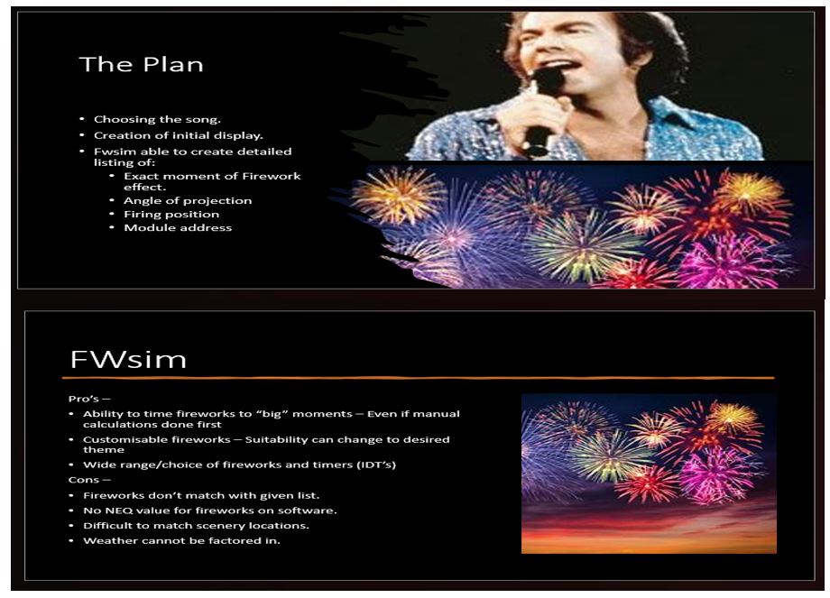
The SDE finished their contribution by discussing how the song was chosen and briefly discussing the data produced from FWSim, e.g., the detailed plan, number of fireworks, number of electronic modules and timings of shots to the music. They briefly summarised the Pros and Cons of using the FWSim software, Figure 5-5.

Figure 5-5 – SDE Slide 2
The procurement followed suit by briefly discussing the difficulties of procuring the Fireworks used by the SDE. The Procurement team discussed data-driven slides on budgetary restraints, total expenditure and firework category types. They also discussed the procured total NEQ of the fireworks, which was extraordinarily close to the SDE estimated usage, Figure 5-6.
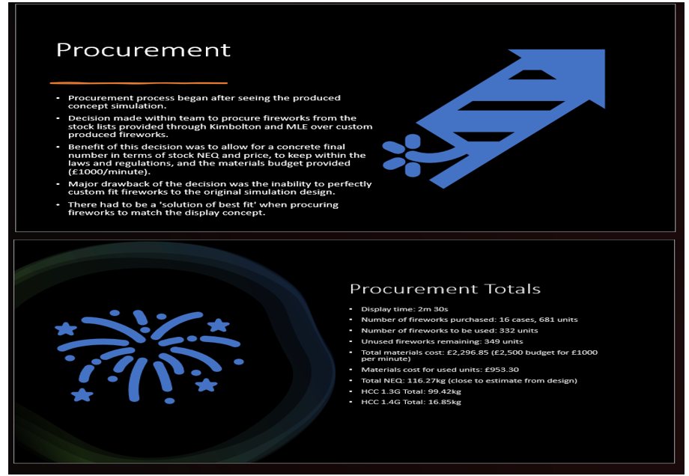

Figure 5-6 – Procurement Team slides
With all fireworks and modules procured, the testing engineer gave a brief overview of the testing regime conducted on the COBRA system and how the modules were to be placed around the seven firing points, Figure 5-7. The TE also discussed how the testing was conducted and evaluated, talking through the ignition systems of the firework stations/ firing points, Figure 5-8.
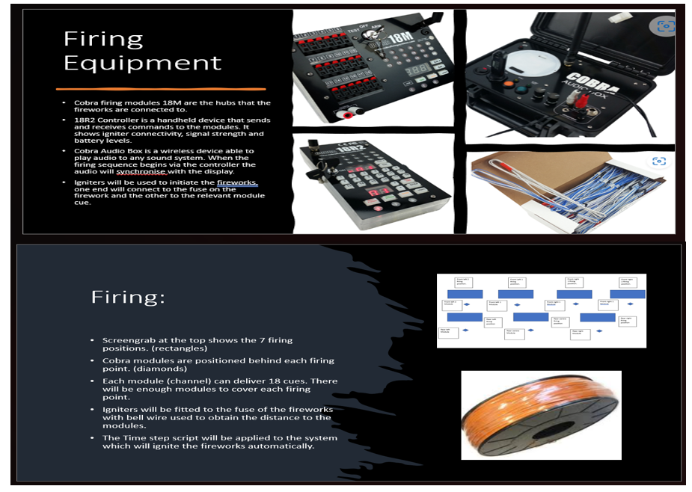

Figure 5-7 – TE Slide 1



Figure 5-8 – TE Slide 2
The presentation then transitioned into the safety aspects required for the display, presented by the Safety Specialist. The SS opened with generic regulations and laws set by governmental bodies that must be adhered to and explained how to recognise and understand the designations on the Fireworks. This was followed by safe storage the team would need to implement when conducting the display, Figure 5-9.
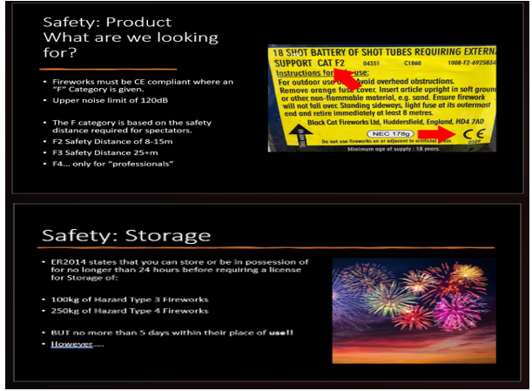

Figure 5-9 – SS Slide 1

The SS subsequently gave detailed descriptions of storage locations, explained explosive separation distances, and how more significant NEQ meant greater distances. The SS acknowledged that their original assessment was based on an amateur display team license before being informed the team was to be classed as professionals. This was indicated in Figure 5-10 and shows the new status with new separation distances.
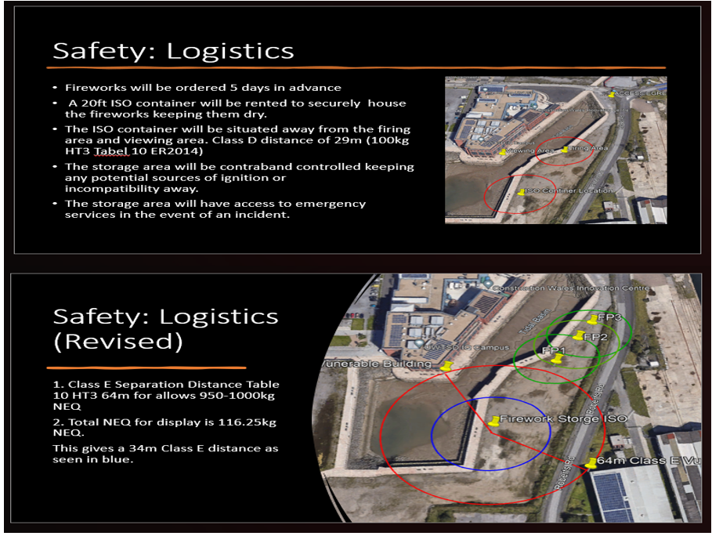

Figure 5-10 – SS Slide 2
The final contributor was the Weather Specialist, who discussed the usage of ShellCalc, how the software worked, how they inputted the data and how they interpreted the results. The WS presented the worst-case wind direction and weather scenery for the display day and gave many mitigation techniques to better aid the team in completing the spectacle, Figure 5-11.
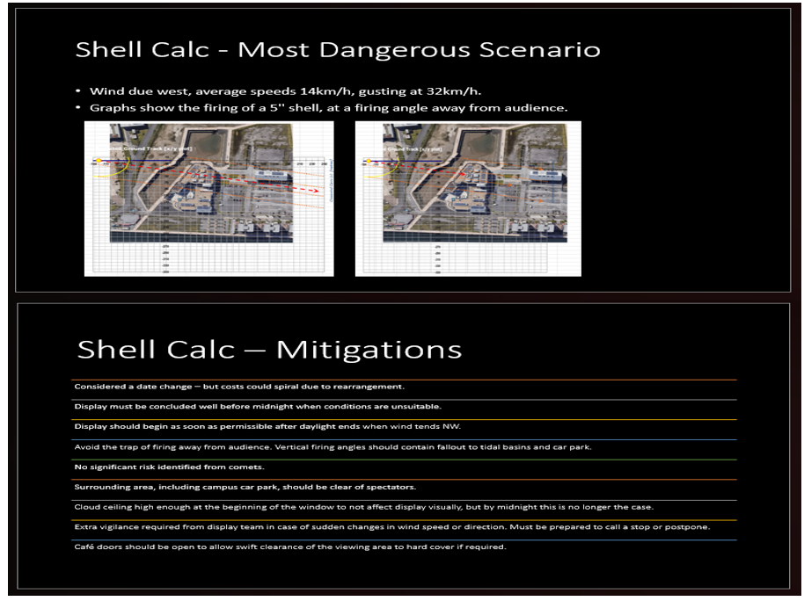

Figure 5-11 – WS Slide 1
The final slide of the presentation was presented by the SDE, in which there was a brief breakdown of the full simulated display, followed by showing the simulated display to the University, Figure 5-12.
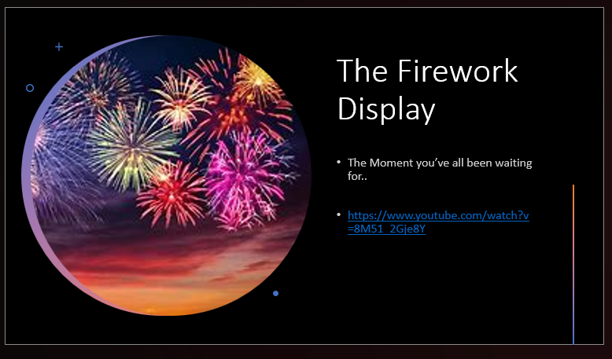

Figure 5-12 – Final Slide

Evaluation of the Project

The feedback received from the University to the team was exemplary. Each contributor was given feedback for their contribution to the presentation, see Annex – C. The display team scored 85/100 from the well-informed presentation they exhibited. This was an extraordinary achievement and could explain the limited constructed feedback given. One of the significant points received was for the WS, in that they had determined the wrong wind direction. The wind would not be directing fallout onto the audience but instead away from the audience. Although inaccurate in this instance, the University was thoroughly impressed with the ShellCalc use and for trying to mitigate such an extreme scenario; therefore, praise was still received. The student portrayed the role of the SDE and received some fantastic feedback. Figure 6-1 highlights the feedback received and also highlights the score received for the completed simulated display, 18/20, an incredible achievement.

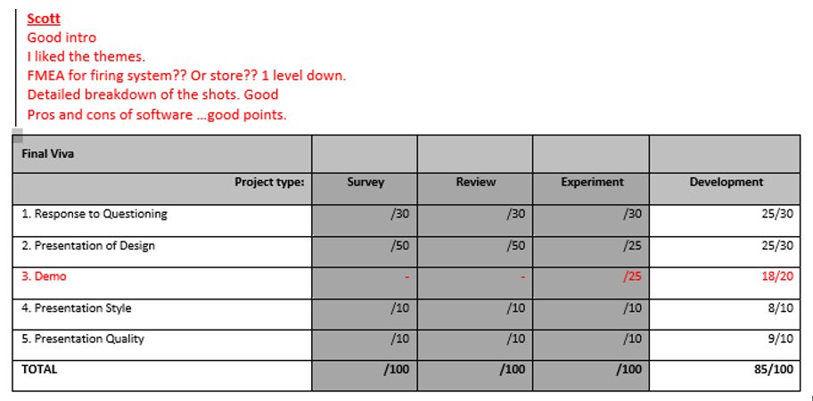

Figure 6-1 – Feedback Received for the student.
The key to the team’s success was communication. Continued communication and open lines of it throughout the project enabled concise and smooth transitions for the presentation. They allowed precise linking between the teams to better equip their respective roles in delivering the required requirements. This can be noted in various areas, notably with the addition of a procurement team to bridge the gap between the SDE and TE. Significantly, communication adjusted the SS safety separation distances once it was uncovered that the team represented a professional fireworks team. Of course, with any project, some areas didn’t quite meet the set criteria, that of the WS basing their calculations on the wrong wind direction. However, this was recognised and acknowledged, and having such a dedicated WS that mitigated worst-case scenarios; it was accepted that the WS would be more than capable of mitigating risks when the wind direction favoured the display and audience. Lastly, and not unimportant, the budget of £10000 was never reached, with the total fireworks costing £2296.85 and all other acquisitions costing around the same. This meant the display team used just under half their budget. The money saved would be put to use for the next display, or perhaps as a financial bonus for achieving such a fantastic result.

Ultimately, orchestrating a fireworks display is no easy feat; it demands meticulous planning, stakeholder management, coordination, and commitment to safety. An unwavering comprehensive comprehension of pyrotechnics risk/hazard mitigation was required throughout the project. The lessons learned, and actions performed during this project will undoubtedly be incorporated into our future strategies when creating mesmerising firework displays. The dedication, perseverance, and commitment to excellence within our group were instrumental in the successful execution of this event, fostering a sense of pride and accompanied by delightful visual and auditory spectacle for the audience.

References

[1] | P. E. Smith, “How do fireworks work? A pyrotechnics chemist explains the science behind the brilliant colors and sounds,” The Conversation, December 2021.
[2] | R. L. Simpson, W. Eckl and R. Gee, “Propellants, Explosives, Pyrotechnics,” International Pyrotechnics Society, vol. 48, no. 12, 2023.
[3] | A. Anirudha, K. Minsung and Y. Jack J, “Characterization of display pyrotechnic propellants: Colored light,” Applied thermal engineering, vol. 110, pp. 1066-1074, 2017.
[4] | P. W. Bateman, L. N. Gilson and P. Bradshaw, “Not just a flash in the pan: short and long term impacts of fireworks on the environment,” Pacific Convservation Biology, vol. 29, no. 5, pp. 396-401, 2023.
[5] | R. Wolniak, “The History of the QFD mothod,” Scientific Papers of Silesian Universtiy of Technology. Organisation and Management Series, vol. 2017, pp. 553-564, 2017.
[6] | Health and Safety Executive, “Health and Safety at Work etc Act 1974,” 1974. [Online]. Available: https://www.hse.gov.uk/legislation/hswa.htm.
[7] | Legislation Government UK, “Firework Regulations 2004,” 2004. [Online]. Available: https://www.legislation.gov.uk/uksi/2004/1836/contents/made.
[8] | Explosives Regulations 2014, “Legislation Government Uk,” 2014. [Online]. Available: https://www.legislation.gov.uk/uksi/2014/1638/contents/made.
[9] | ShellCalc, “ShellCalc,” ShellCalc Corporation, [Online]. Available: https://shellcalc.wordpress.com/.
[10] | FWsim, “FWsim: Fireworks Display Simulator,” 2023.
[11] | MLE Pyrotechnics, “MLE Pyrotechnics,” MLE, [Online]. Available: https://category4fireworks.co.uk/. [Accessed Decemeber 2023].

Annexes

Annex A – Team Communication Log

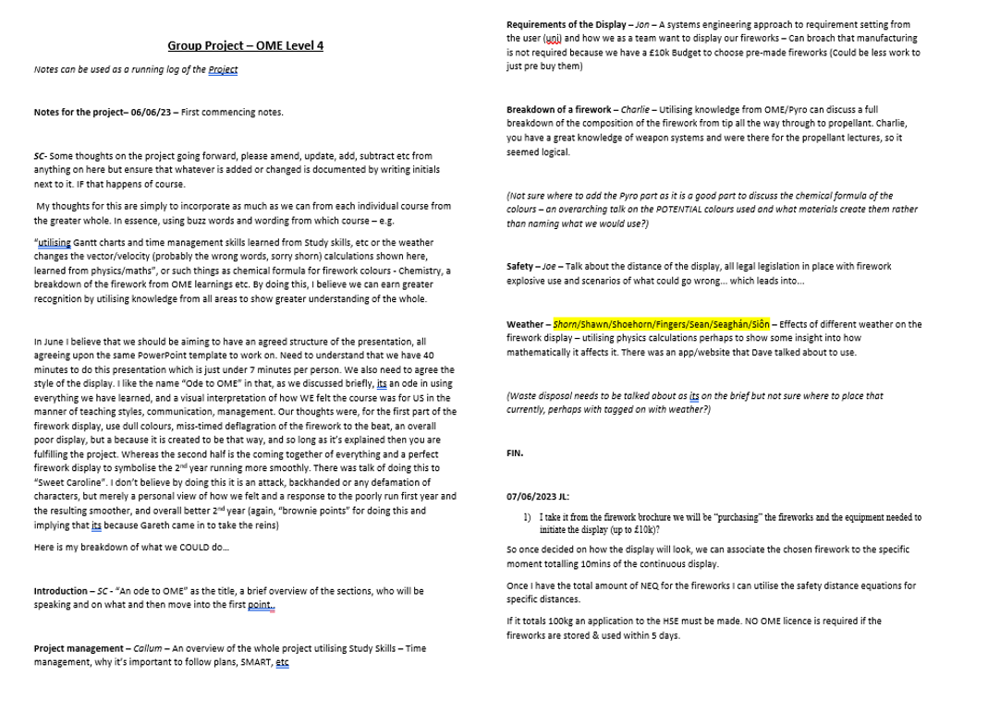

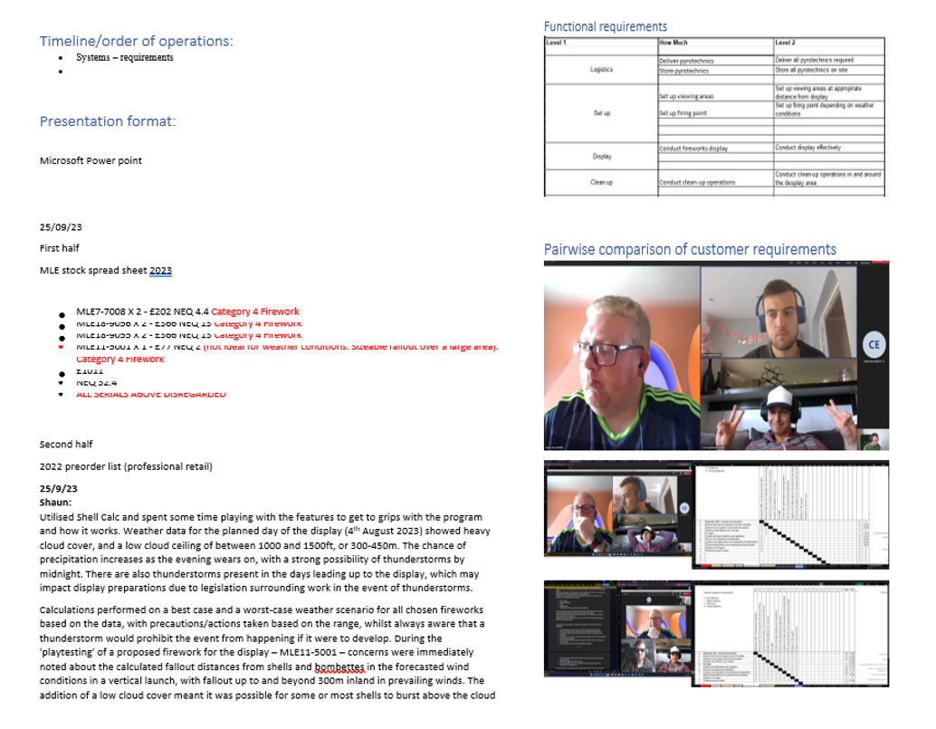

Annex B – ShellCalc use.
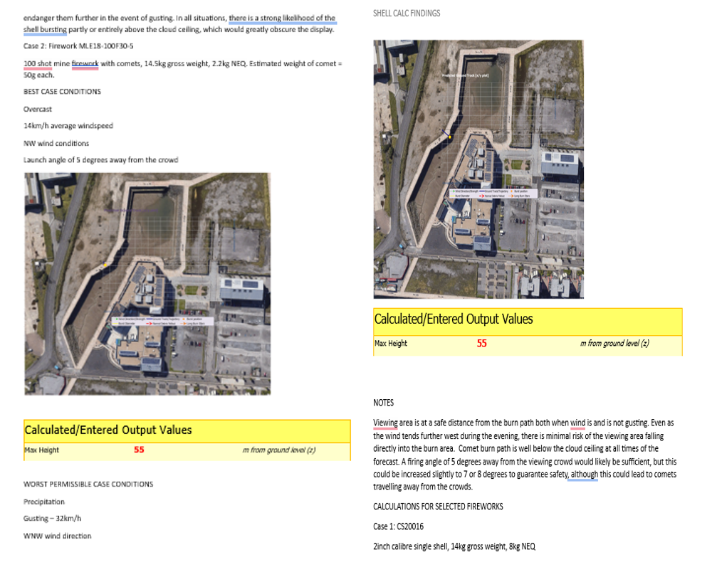

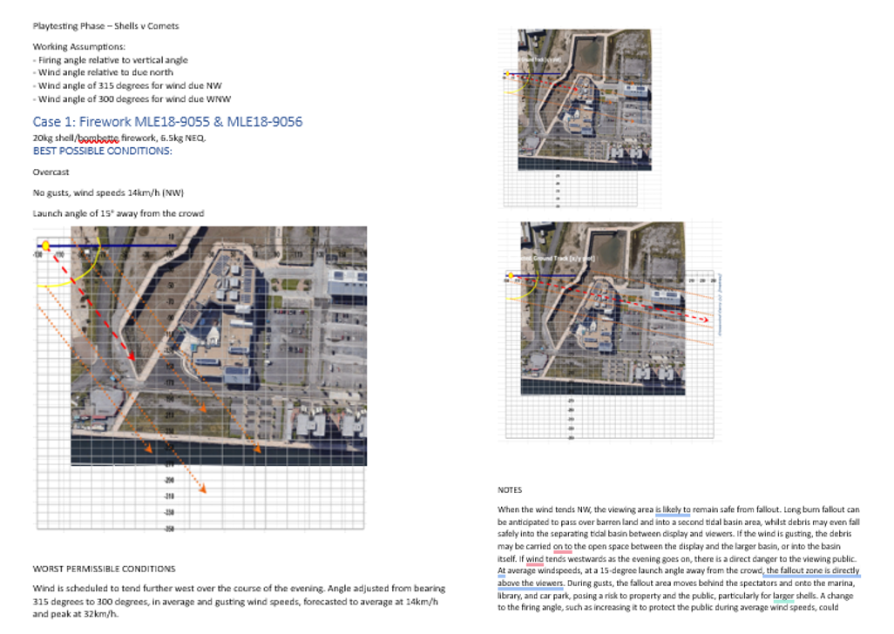

Annex C – Feedback Received
Final Viva
Project type: | Survey | Review | Experiment | Development
1. Response to Questioning | /30 | /30 | /30 | 25/30
2. Presentation of Design | /50 | /50 | /25 | 25/30
3. Demo | - | - | /25 | 18/20
4. Presentation Style | /10 | /10 | /10 | 8/10
5. Presentation Quality | /10 | /10 | /10 | 9/10
TOTAL | /100 | /100 | /100 | 85/100

Callum
Reqs Good brief.
Speak slower …..
Good slides……Planning well documented…..how do you communicate.
Stake holders logged ….good!
John
Origins of requirements mentioned …good traceability
Slides small type??
Used pairwise to compare requirements. Traceable.
Safety Highest priority
Performance requirements??
Heavy lines in QFD 1 (might need to decompose.)
Scale for PFMEA??
Scott
Good intro
I liked the themes.
FMEA for firing system?? Or store?? 1 level down.
Detailed breakdown of the shots. Good
Pros and cons of software …good points.
Sean Malone
Procurement
Good specification and problems with specification highlighted,
Emphasis on communication.
Back to weather.
Contingency plans good.
Use hazardous……rather than dangerous.
Table of mitigations. Good.
Cars in car park? Valued targets
Wind direction?? From!!!! Work not wasted though. Showed a good thought process.
Charlie Jones
Clear specification of environmental issues
Tests to measure environ impact ……performance?
Dry run testing on firing circuit.
Subcontracted display. How controlled? Competence?
Details of firing circuits good.
Management of sight …..How??
Diagram of site? Where does the debris fall?
Plan of site should be in the presentation a little earlier.
Links to CAA and Coastguard.
Joe Lyons
Legislation well covered
Limitations and assumptions made clear
Problems of storage described ……minefield
Plan of site now introduced….could have been introduced earlier.
Coms between team members again… bring this out.
Decision tree might be good

All the above is small beer. Very professional presentation. Well done.
Somewhere there was a mention of detonation?? I hope not with fireworks.

