Scenario 1
by
Stoyan Chalakov

Introduction.
In this topic I will cover the components for scenario 1 of my exam. We will be talking about the small/middle range full set desktop system. Let listing some basic information first before we move on with the build.
Components
(Fisher, 2020)
Case.
What is a computer case?
This is a box which one serves mainly to mount the physical components, which lately form the system itself.
(Hope, 2020)
Motherboard.
What is a motherboard ?
Motherboard in simple words is a circuit board and also the biggest board on your system. Allocates power and allow the communication between your physical components (hardware components) such as CPU, RAM, Etc.
(Martindale, 2020)
CPU
What is a CPU?
CPU or Central Processing Units is responsible to execute instructions. We can say that CPU is like the brain of the system. Through it all commands and processes being managed and navigated correctly with the help of the motherboard. The processor unit is build by microscopic transistors ,which allows to do all calculation ,in need to run the programs.
(Fisher, Computer Power Supply, 2020)
PSU
What is a PSU ?
PSU or Power Supply Unit is a one of your hardware parts ,which provide power for the most parts of your case(system). The main task of the PSU is to convert the alternating electricity to direct one. This is what your components required. There is a two main differences - AC and DC .When we pick any of them ,we have to look carefully what to choose.
RAM
(Hope, RAM, 2020)
RAM or Random access memory allows us to store the information retrieved on your system.
How it works ? When we boot our system, part of it and from the drivers are load information in the memory. That function helps to our CPU to rapidly process the instructions and the programs, which we open.
(Domingo, 2019)
SSD
Solid State Drive. This hardware has the same function as the hard drive, but it works on different magnificent way. This drive can retain data even when the system is off. It stores the data on interconnected flash memory chips. They are like USB thumb drives, but faster and more reliable. Therefore, the minus of this type of drive is that they have shorter life than the HDD.
(Rouse, 2017)
Windows
Windows is a Microsoft operating system for many types of devices. This system allows us to use many applications and browsing online. That system is easy to work and you can customize it depending on your needs.
These are the most common and important components which we need to make and run the system. There are other output devices, necessary to operate with the computer. They are keyboard, mouse and monitor. Different types and variations may apply. I have not given any source for these devices, because now days everyone knows, or they should at least know what they represent.
Build
(SilverStone SST-SG13B, 2020)
For a case I chose this Silver Stone Mini -ITX case. The main reason to chose it is that is very small, and it will not take lots of space. Also, it will be lighter than the ordinary tower pc case. Easily to move as well if the elder person decide to change its location.
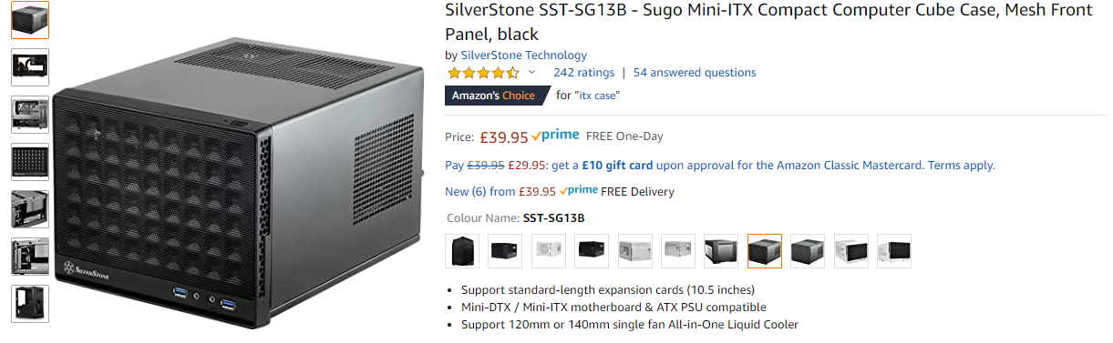
Product specification from manufacturer:
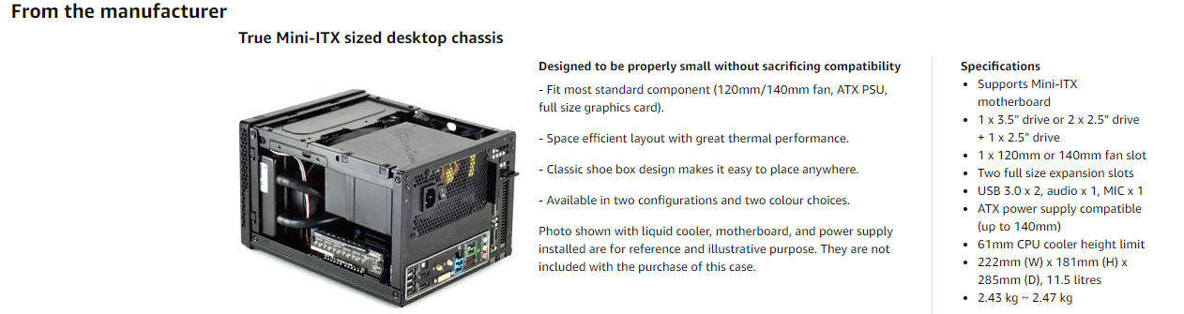

For this build I have chosen PSU AeroCool Integrator:
(AeroCool Integrator, 2020)
With a 400w power supply and 80 plus rang, it provides up to 85% efficiency on that entry level system.
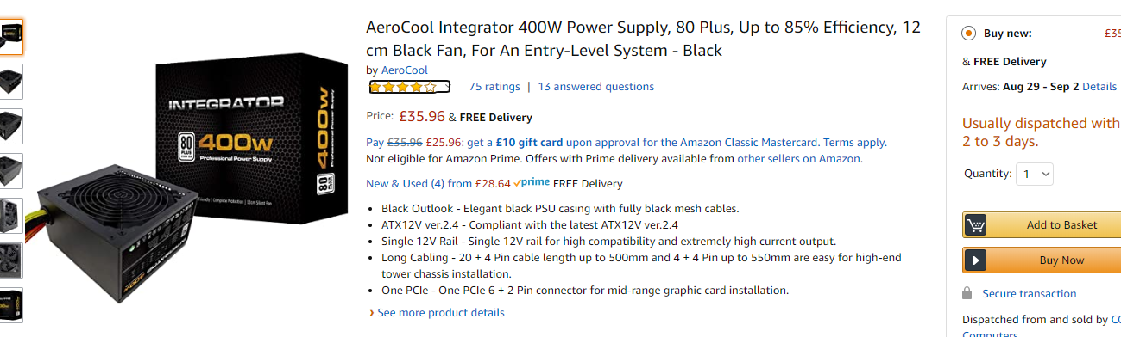
The specifications will be listed bellow:
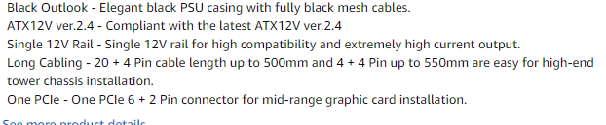

My next component is the motherboard.
(Gigabyte N110N, 2020)
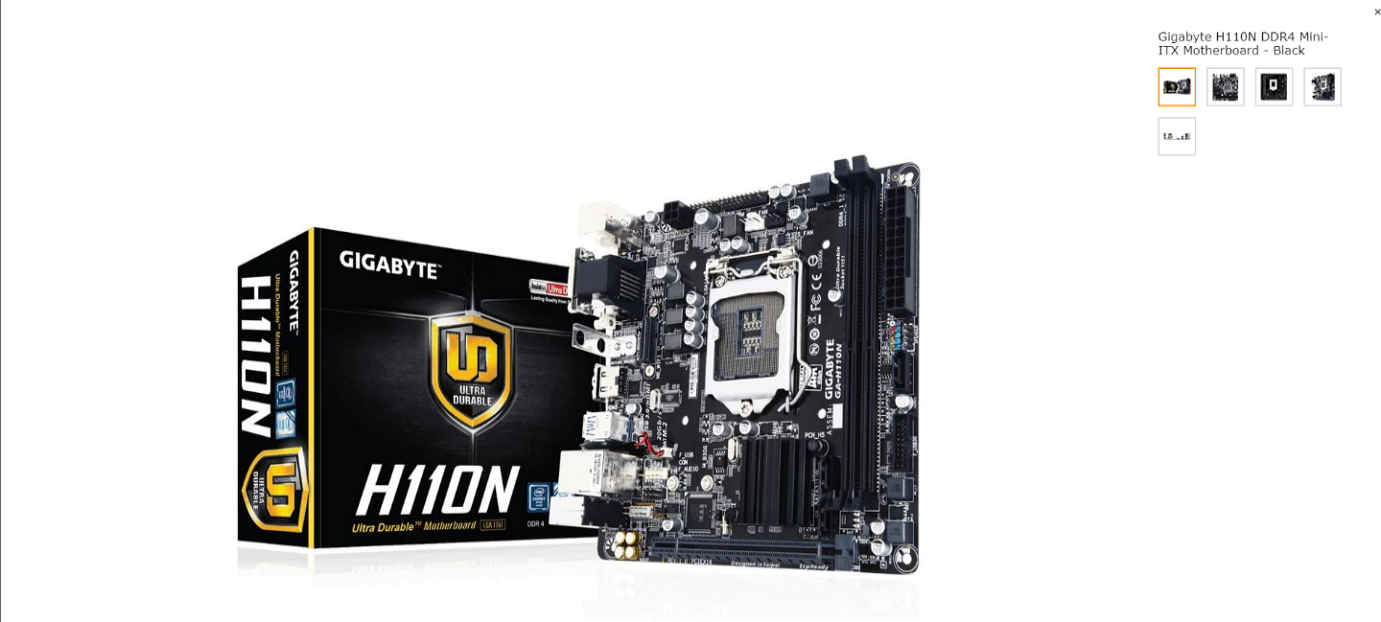
I have chosen Gigabyte H110N. This is standard DDR4 memory type support motherboard with a LGA 1151 socket for an Intel processor. This hardware is also Mini- ATX model which one will fit perfectly in my box. That motherboard also supports 6th and 7th generation Intel processors. List of the specification will be provided:
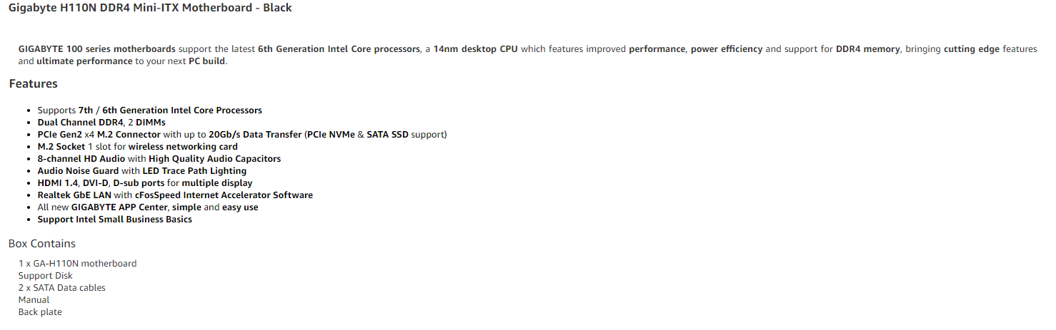
It is time now to put our CPU in to the motherboard socket. For that purpose, I decide to use the Intel Pentium Gold G5400. This processor is 1151 socket it has dual core – 4 Thread(4MB Cache) 3.7Ghz frequency .Very low on power consumption (54W)and the best option is that has an integrated UHD 610 Intel Graphics ,therefore we don’t have to spend an additional amount for graphic card.
(Intel Pentium Gold G5400, 2020)
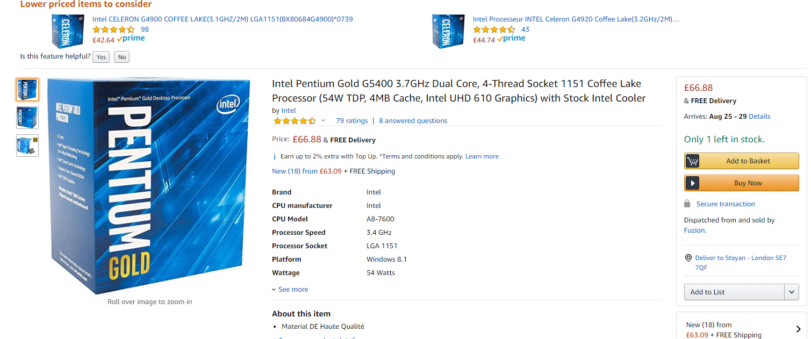
Another cool feature of this processor is that also coming with a stock cooler and we don’t have to spend money on that. Regarding the fact that the elder person will not using this pc for gaming, stock cooler is more than enough to keep it in decent temperature. The integrated GPU will run all videos on the web and the video calls with no problems.
It is time now to insert the RAM
My next choice is HyperX Fury model. This DIMM DDR4 memory
work on a bit higher than the default Frequency, which it makes it perfect for browsing and easy access to all applications on the system.
(HyperX Fury HX424C15FB3, 2020)
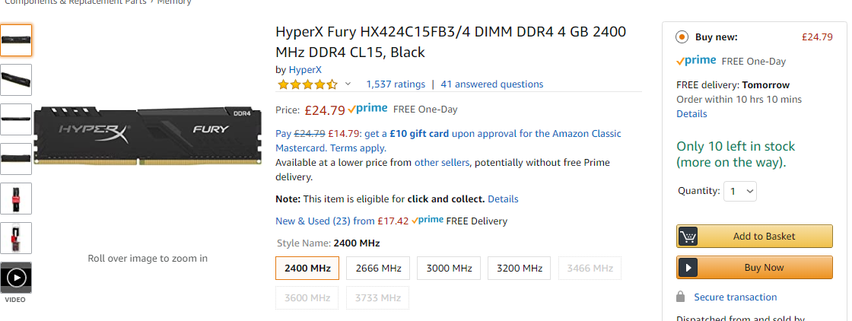
For the next components I have not done any research ,because they are attachment to the actual component or with another words extensions .
That will be Brackets for our SSD drive (2,5inch) and they are 3,5 inch so we can perfectly fit in the box and everything to be tidy.
(Inateck SSD Mounting Bracket, 2020)
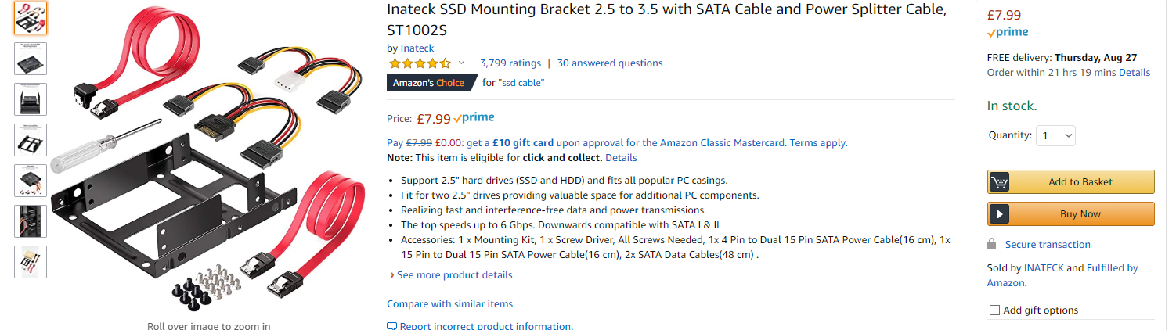
Detail are listed within the picture above.
The second component is the thermal paste which one it is used to our CPU and GPU processors to keep a normal temperature (cooling).
(ARCTIC MX-2, 2020)

Based on research and customer reviews I have chosen this model.
Next and very important component is our SSD. I choose 240 gb only .I think that will be enough for the system and elderly person to have some additional storage(pictures for example).The other reason is that SSD is in times faster that the HDD and with combination with our RAM stick should provide a good performance .
(SanDisk PLUS , 2020)
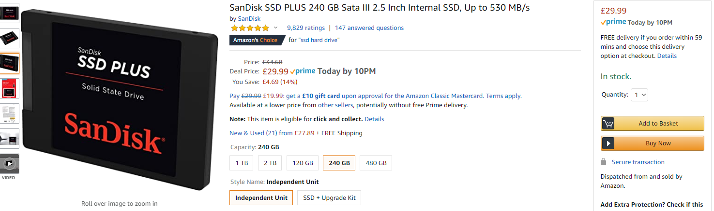
For an operating system I have chosen Windows Home 10 (32bit/64 bit version). It is very good price for the product, and they give an option if you like to choose between both. Also, Windows system is very easy to operate and customize by your desire.
(Windows 10 Home, 2020)
For the Monitor I have chosen BenQ GW240.This is a 24Inch (1080p) Full HD Eye Care IPS monitor. I chose this option for the elderly person because of the eye care system and anti-glare function. Also 24 inch should be perfect for that scenario.
(BenQ GW280, 2020)
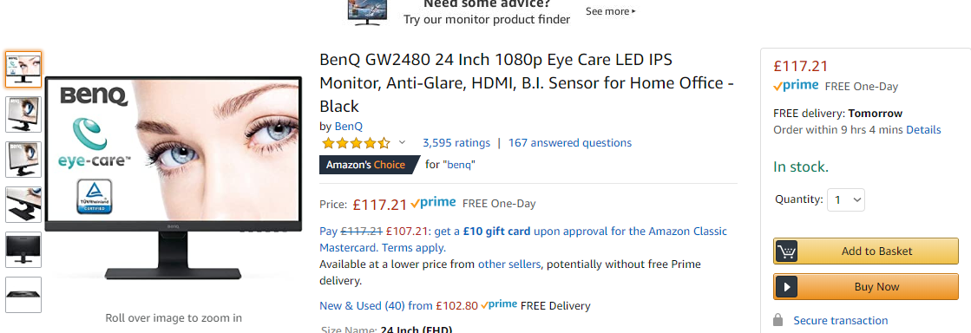
More detailed product specification will be listed bellow :
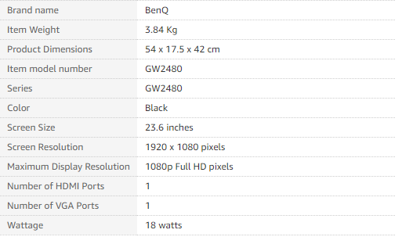
Keyboard and mouse I have chosen are Wired. Regarding the scenario for full size but slim keyboard that is my option.
(Wired Keyboard and Mouse, 2020)
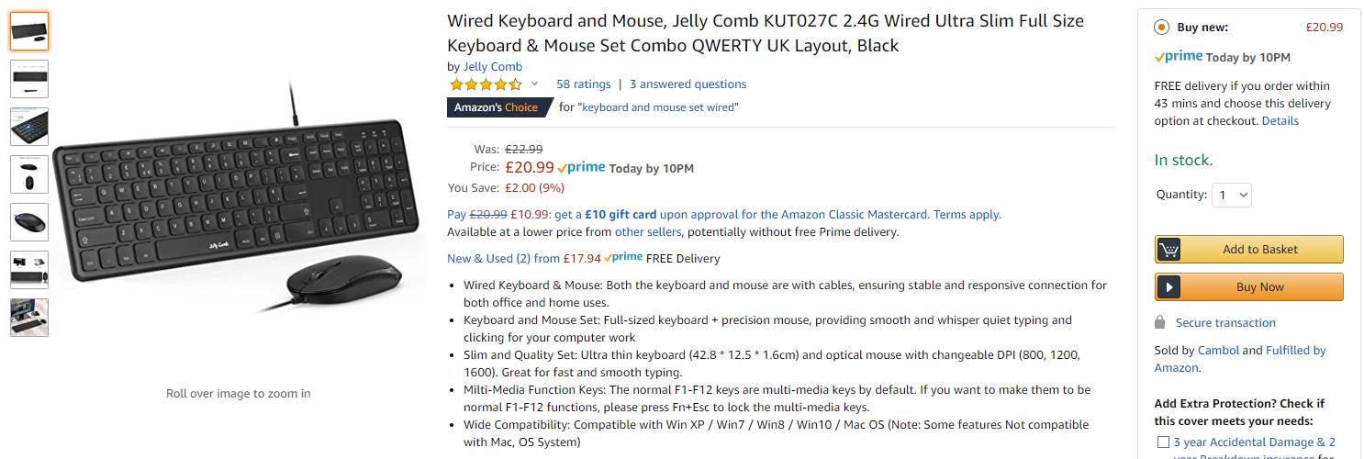
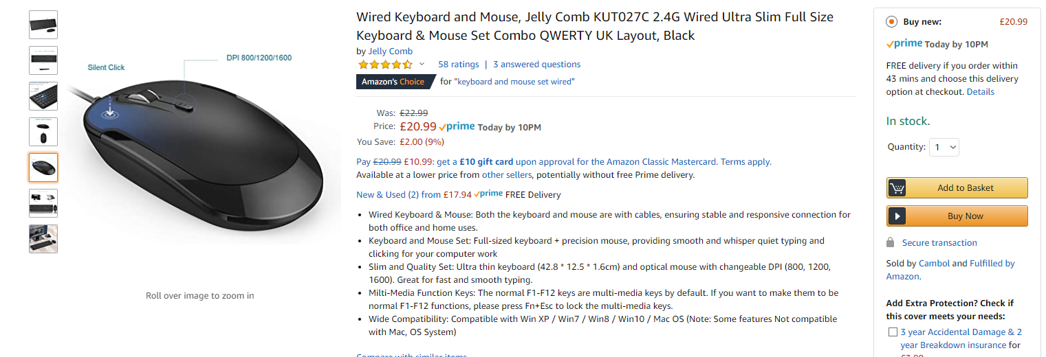
Also it is a decent amount of price for this set.
For skype and calls I chose this camera which has a build-in microphone.
(Dericam 1080P, 2020)
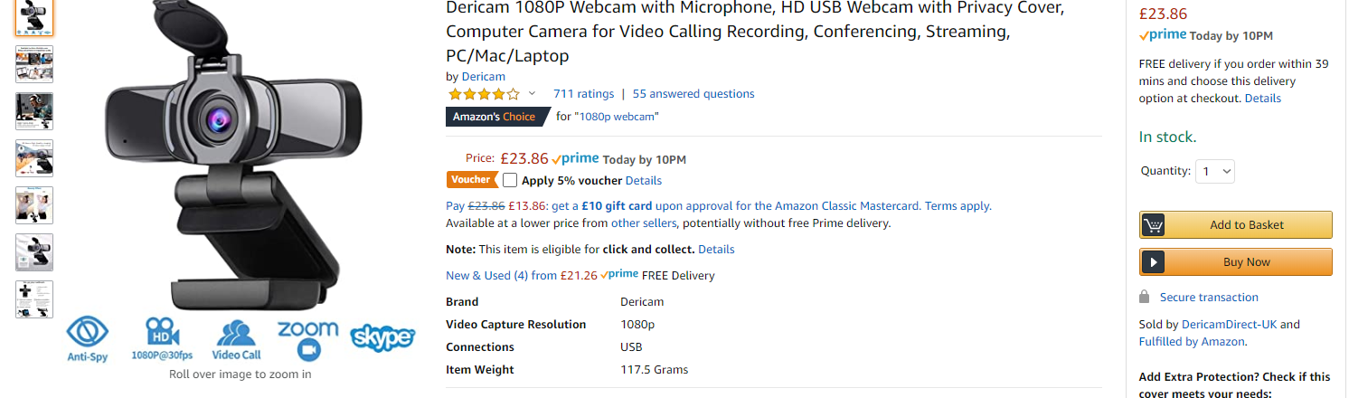
I will list the product specifications, but the main ones are it’s a FullHD(1080p)also there is a anti-spy cap and it is recommended for a skype calls as well.
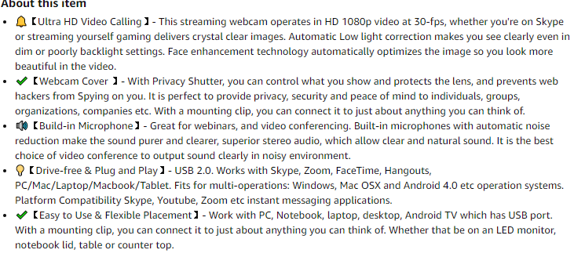
And finally ,regarding that our monitor does not have any build-in speakers I chose Trust Aris 2.0.There is a decent output power for fair price.
(Trust Arys 2.0, 2020)
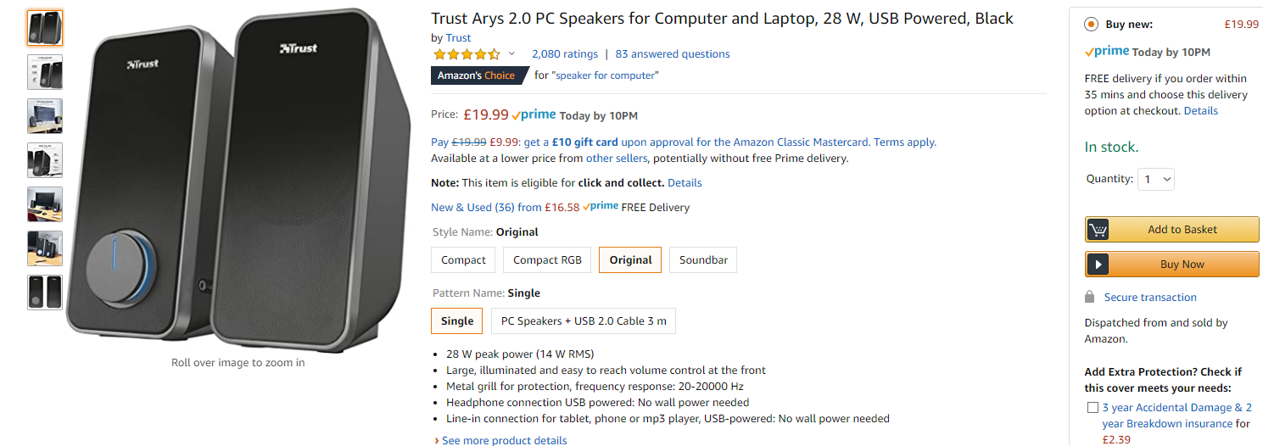

For conclusion that is a good system which will perform well and serve good to the elder person.
On the price side it is a total of 530.37 £. I know that it may bit overpriced, but for that price we are having a system with all brand-new components and warranties and in some cases with further option to upgrade.

