
BMHP 6006_Lon Mental Disorders and Psychopathology Assessment Component 2 Report Tunde Bodi 2114279
Lecturer: Bianca Sanfilippo


Contents

Introduction 2
General Anxiety Disorder (GAD) 2
Classification of GAD within ICD-10 2
People suffering from general anxiety disorder in the UK 2
Causes of anxiety (Aetiology) 2
Signs and Symptoms 3
When anxiety can be diagnosed 3
Current treatments 3
Recommendations for improvement of anxiety 3
Principles of care for people with generalised anxiety disorder 4
Schizophrenia 4
Classification of Schizophrenia within ICD-10 4
Causes of Schizophrenia (Aetiology) 4
Signs and Symptoms 5
Diagnosis of Schizophrenia 5
Current treatments 5
Measurements of rehabilitation 6
Guidance and principle of care and recommendations NICE 6
Autism 6
Classification of Autism within ICD-10 7
Data about people living with Autism worldwide and in the UK 7
Causes of Autism (Aetiology) 7
Signs and Symptoms 7
Diagnosis of Autism 8
Current treatments 8
Recommendations for Improvement of Autism 8
Guidance and principles of care NICE 9
Conclusion 9
References 10
Appendix 14

Introduction
This report will critically examine the classification, diagnosis, treatment and measurements of rehabilitation for the following three mental health disorders found in the ICD-10 manual (WHO, 2010). The three mental health disorders that will be examined in this report are General Anxiety Disorder (F40-F48), Schizophrenia (F20-F29) and Autism (F80-F89), as indicated by the numbers found in the ICD-10 manual (WHO, 2010).

General Anxiety Disorder (GAD)
General Anxiety Disorder is a long-term and very common condition when a person feels anxious for a longer period from different things and it could be variable with various feelings such as worry, stress, and depression (NHS, 2023). People suffering from this condition feel overwhelmed with the feeling of worry about different things in their lives such as health, and finances, and they have difficulties controlling their worries (Anxiety UK, 2023).

Classification of GAD within ICD-10
General Anxiety Disorder is classified within ‘F40-F48 Neurotic, stress-related and somatoform disorders’ and takes place under F41.1 (WHO, 2010). It says that disorders manifested in anxiety are major symptoms and there are more different types of anxiety existing in this category which are occurring secondary or primary with other mental health conditions such as phobias, depression and obsessive-compulsive disorders (WHO, 2010).

People suffering from general anxiety disorder in the UK
In the UK anxiety is the most common disorder and the numbers are continuously increasing every year due to the uncertainty of the future and the high amount of stress in modern life (Pindar, 2023). At this time around 8 million people are suffering from this condition in the UK which means that every 6 in 100 is diagnosed every week (Pindar, 2023). Around 800.000 people suffer from anxiety each year actively working and employee anxiety statistics showed that more than 60% of the workers experience symptoms but only 10% seek help from mental health professionals (Pindar, 2023).

Causes of anxiety (Aetiology)
The environment in this modern life is challenging emotionally, physically, mentally and socially and it is so fast paced it could generate anxiety disorders in people (Shri, 2010). Anxiety is a complex disorder, there are biological, psychological and social factors that could cause this disorder and one needs to examine each aspect to make the correct diagnosis and provide the best treatment for individuals (Shri, 2010). Furthermore, it could be a contributing factor to experiencing traumas, such as abuse, neglect, divorce and other negative effects also, it could be a learned behaviour which has been adapted from family or caregivers showing anxious behaviour and children usually copying them and shaping their personality (Meek, 2021). Lastly, caffeine, lifestyle habits and relationships could generate anxiety disorders too (Meek, 2021).

Signs and Symptoms
The most common sign of General Anxiety Disorder is feeling excessive and uncontrollable worry about different things and these overwhelming feelings could generate other symptoms too (NIH.GOV, 2022). Other symptoms are feeling lightheaded, feeling nervous or on the edge all the time, having difficulties with concentration, and experiencing unexplainable pain such as muscle pains, and headache. Feeling tired more often and having difficulties with relaxation (NIH.GOV, 2022).

When anxiety can be diagnosed
Unfortunately, many people suffering from this condition put off getting help for reasons such as not having enough time, or they think it is a normal feeling in the rushing everyday life, but the fact is, if the symptoms persist over 6 months need to speak with health care professional and ask their help to further examination to get the right diagnosis and treatment from them (NHS, 2023).

Current treatments
Firstly, the GP will refer the patient to a blood test to discover if any conditions could be contributing to the condition anxiety person this could be a deficiency of important vitamins such as iron and B-12 and checking the level of the thyroid gland which also could contribute this condition (NHS, 2023). When the right diagnosis then patients are usually referred to mental health professionals on Cognitive Behaviour Therapy which helps to approach negative thoughts from different perspectives teaching strategies can be helpful in cooperating with anxiety and they also use acceptance and commitment therapy which use different approaches, but these may be more useful with the patients because everybody has different needs (NIH.GOV, 2022). There is a tool called GAD-7 available in different languages and the 7 questions on this list help to identify the severity of the feeling of anxiety in the patient in the last two weeks, so it helps to measure the level and keep track of the person's anxiety level and with this information could give an idea what treatment needs to provide to the person (see appendix A) (CORC, 2023).

Recommendations for improvement of anxiety
Research from Temple et al. (2017) shows that overtaking caffeine could negatively stimulate the nervous system and it could generate negative side effects such as anxiety and nervousness, so it is very important to not drink more than the recommended amount of 400mg per day in adults, between 12-18 years old 100mg and under 12 years only 2.5mg/kg/day (Temple et al, 2017). There are also many kinds of complementary and alternative therapies recommended by Mind (2023) website which could be useful in reducing stress and supporting a well-balanced life (Mind, 2023). These therapies include yoga, aromatherapy, reflexology, acupuncture and massage therapies, mindfulness and therapies using herbal remedies (Mind, 2023).

Principles of care for people with generalised anxiety disorder
The health care professional always needs to provide understandable and clear information verbally and if it is possible in written format about their condition and available treatment options also, provide them information about available services which could be useful if they are in crisis and need immediate help (NICE, 2020). Health care professional needs to build up a relationship with the patient build up a non-judgemental environment explore the person's worries and understand this condition provide them information about the available treatment and help them to decide which would be the best option for them (NICE, 2020).

Schizophrenia
Schizophrenia is a long-term mental health condition which is influenced by genetic and environmental factors, but it is still not yet clear what are the exact causes (NHS, 2023). Is a type of psychosis and is considered a disability because it has affected the person's daily life in all parts and needs help to live with it and manage it during their lifetime (NHS, 2023). It affects about 24 million people around the world which means that every one person from 320 suffers from this condition (WHO, 2022). Research shows that schizophrenia is a major illness in the UK and at any one time, about 220,000 people getting treatment for it in the NHS (Livingwithschizophrenia, 2017).

Classification of Schizophrenia within ICD-10
Schizophrenia is classified within ‘F20-F29 Schizophrenia, schizotypal and delusional disorders’ and takes place under F20 (WHO, 2010). It says that the characteristic sign of schizophrenia is changing the way of thinking which is inappropriate and blunted and a person hearing or experiencing voices that are not realistic and having visions and uncontrollable thoughts (WHO, 2010). Also, the schizophrenic disorder could be continuous, or episodic with more relapsing and it could be controlled with the right medication treatment (WHO, 2010).

Causes of Schizophrenia (Aetiology)
There are both genetic and environmental risk factors playing an important role in the occurrence of schizophrenia, but genetic factors have smaller effects on the genes if somebody inherits then environmental risk factors, especially in early childhood could generate schizophrenia (Kelly and Murray, 2000). Also, research shows that people living with different mental health conditions have a high risk of developing this condition, and usually appears in young adults causing obstacles in emotion, thinking and behaviour (Zhang, 2020). Studies show that people living with schizophrenia have different brain structures and different amounts of neurotransmitters such as dopamine (NHS, 2023). Other triggers could be pregnancy, stress, and using different drugs, especially cannabis (NHS, 2023).

Signs and Symptoms
The condition of schizophrenia develops slowly and often appears first in young adulthood but identifying first signs could be very difficult (NHS, 2023). The symptoms are classified as negative and positive symptoms which means that the positives are the present symptoms, and the negatives are developing later and appear in reduced amounts (Edwards, 2023). The common early signs in childhood are delay in development then behavioural problems such as depression and isolation from others and lastly reduced personal hygiene, suicidal thoughts and decreased activity level at work with limited energy (Edwards, 2023). Schizophrenia causes a range of cognitive problems and the most common issues in thinking are hallucinations, disorganized speech and delusion which means false beliefs in not real things (Mayoclinic, 2020).

Diagnosis of Schizophrenia
If schizophrenia is suspected needs to see a GP practitioner who will further refer patients to the Community Mental Health Team, who will further examine the individual family history background and the symptoms that occurred and currently have (NHS, 2023). Sometimes it is not clear if the symptoms the individual experiences are from schizophrenia so mental health carers need to examine if there could be any other related mental health issues such as bipolar disorder or schizoaffective disorder (NHS, 2023). The doctors also could request CT or MRI scan examinations and screening for alcohol and drug usage because these substances could cause symptoms similar to schizophrenia (Mayoclinic, 2020).

Current treatments
Schizophrenia has different symptoms with each person therefore everybody needs a different treatment plan which could help them ease their symptoms, but schizophrenia will never disappear because this mental health condition at this time is uncurable (Mind, 2023). The main treatments are referring individuals to talking therapies such as cognitive behaviour therapy which teaches how to deal with and manage their feelings and symptoms in their daily life, and the other effective way is taking medications which help to reduce the symptoms (NHS, 2023). Also, there are opportunities to join arts, dance and drama therapies which could be helpful for people who cannot or could hardly talk about their problems these kinds of therapies could be beneficial in working on traumatic events and elevating the mood of the person with working out their negative feelings (Mind, 2023). Lastly, people suffering from more severe schizophrenia episode needs clinical treatments and they are referred to the hospital to get continuous treatment (NHS, 2023).

Measurements of rehabilitation
People have the right to get involved about their conditions and suggestions about their treatment plans so they can decide which options would be the best for them (NICE, 2020). People living with long-term mental health conditions need longer treatment from healthcare professionals sometimes in hospital settings and to make sure they are getting the right treatment and care must be measured time by time the quality-of-care healthcare provides their patients (Killaspy et. al, 2011). The quality indicator for rehabilitative care (QuIRC) tools helps find out if the care given by healthcare to the patient is appropriate and if it is providing the best care and treatment plan for them provided with dignity, and respect and always focusing on individual needs (Killaspy et. at, 2011). A detailed example list of what QuIRC-SA examining is in Appendix B (Dalton-Locke et. al, 2023).

Guidance and principle of care and recommendations NICE
Healthcare care needs to assess the patient carefully and provide them with a safe environment for them to protect themselves from self-harm, neglect or abuse and needs to focus on patient needs and appropriate help to get the best result and a safe place for them (NICE, 2022). Healthcare needs to promote patients about their recovery and possible future care by offering them interventions such as occupational health therapists, and social and psychological supports and provide them with the best available treatment care in a safe not stigmatizing non-judgmental environment (NICE, 2014). Lastly, need to build up a trustable and supportive relationship between healthcare providers and patients and provide them with an optimistic and hopeful atmosphere by offering continuous help and treatment for them while working in partnership (NICE, 2014).

Autism
It is called another name for autism spectrum disorder because every person is different living with this condition and it is not a sickness or illness, it means people living with this condition have their brains work differently (NHS, 2022). It is uncertain what causes autism, it could be a genetic contribution, but no medication, diet or other lifestyle factors could contribute to it (NHS, 2022). The characteristic of autism is having difficulties with communication and with interaction with others also, there are typical patterns in behaviour such as detailed focusing or unusual reactions to sensations (WHO, 2023).

Classification of Autism within ICD-10
Autism is classified within ‘F80-F89 Disorders of psychological development’ and takes place under the section of ‘F84 Pervasive developmental disorders (WHO, 2010). The category between ‘F80-F89’ includes all disorders which are common in childhood and delay the development of cognitive such as language skills and other important coordination skills which are further developing over time (WHO, 2010). Pervasive development disorder includes a group of disorders which are showing abnormalities in social interactions and the patterns of communication and activity skills (WHO, 2010).

Data about people living with Autism worldwide and in the UK
There are only estimations are available about how many people living with Autism because the understanding of this condition always changing and due to this many people are not aware of that may they be autistic too (National Autistic Society, 2023). Based on the Government survey in the UK estimated that one person from 100 is autistic and around 700,000 people living with this condition in the country currently (National Autistic Society, 2023). Autism Spectrum Disorder typically develops in early childhood and every child from 36 is autistic worldwide and is more common in boys than girls (CDC, 2023).

Causes of Autism (Aetiology)
Scientists still do not know exactly what the main causes of autism are, and they trying to understand the reason they discovered that there are contributing factors that may be affecting children's cognitive development in the womb (NIH, 2023). Contributing factors could be older parents, genetic factors, maternal obesity, diabetes and other illnesses during pregnancy also, be an indicator if persisting any birth difficulties which cause a lack of oxygen in the baby’s brain (NIH, 2023). An American researcher Bohorquez discovered also that there could be a gut-brain connection to autism because he discovered that autistic children usually have some gastrointestinal issues and unusual food-related behaviours (Collins, 2020).

Signs and Symptoms
The signs and symptoms are different with children and adults, and they could be different between boys and girls (NHS, 2023). Children are usually not talking too much, avoiding eye contact and not responding to their name also doing repetitive movements and getting easily irritable (NHS, 2023). It is harder to identify with girls because they can hide the condition and can cope better with social situations also showing fewer repetitive activities than boys {NHS, 2023). The common signs in adults' life are having difficulties making friendships, doing daily routines which gives them comfort, showing they are uninterested in different things, and they are getting anxious about different social situations (NHS, 2023).

Diagnosis of Autism
There are no specific diagnostic tests to identify autism because the signs could be different in each person so the best diagnosis could be made after observing the individual if shows any related symptoms then healthcare professionals further refer to a specialist psychiatrist, psychologist or neurologist specialist (Mayoclinic, 2018). Diagnosing autism in children usually asks the parents about their social behaviour, such as how they interact with others and how children's behaviour changes over time (NHS, 2022). Also, diagnosing autism in adults is more difficult because they already got the knowledge how to live with this condition and may show fewer signs but during their assessment with a specialist could reveal autism in terms of the answer given to a specific question connected to it (Klein, Jayne and Leonard, 2023).

Current treatments
The most important step in the treatment for autistic people is to take steps to improve their mental health condition and specific therapies such as cognitive behaviour therapy could help individuals learn how to make their life easier and get more confidence (Klein, Jayne and Leonard, 2023). Therapies could be offered individually and there are family therapies for children where family members are also involved in learning how to play and interact with the children to help them promote their behaviour and social life improvement (Mayoclinic, 2018). There are no specific medications for autism but medications such as antidepressants could help with anxiety and depression which are very common among autistic people (Klein, Jayne and Leonard, 2023).

Recommendations for Improvement of Autism
There are different kinds of therapies available to improve autistic people's skills and mental health this could cognitive behaviour therapy could be helpful for people dealing with anxiety or depression, and there are speech-language therapies for people struggling with communication and helping them to improve their verbal and non-verbal communication skills with exercises like describing their feelings and helping them to build up a better structure of their language skills (Reid, 2023). There are also available physical therapies which are helping to autistic individuals struggling with their physical actions such as handwriting (Reid, 2023).

Guidance and principles of care NICE
Healthcare professionals must ensure an environment for autistic people where they can provide the best and continuous support and treatment for everyone, and the specialist autism team should always support access to the available services like delivering special treatment and assessments for them and making their referral system accessible and simplified for them including the self-referral system (NICE, 2011). Good communication is vital between healthcare professionals and the patient and with the family if they get involved and apply a person-centred approach where the focus is always on the individual needs and always treating them with dignity and respect (NICE, 2011).

Conclusion
General Anxiety Disorder, Schizophrenia and Autism are common mental health conditions affecting millions of people around the world and healthcare professionals must treat them by focusing on their needs by approaching person-centred care and keeping the principles and regulations applicable to caring with people who are living with different mental health conditions. Equality Act 2010 legally protects people against discrimination, especially people living with long-term conditions therefore when healthcare provides treatment for their patients need it with respect and must communicate clearly to protect their dignity and keep their data confidential (GOV.UK, 2015).

References
Anxiety UK (2023) Generalised Anxiety Disorder [Online]. Available from: https://www.anxietyuk.org.uk/anxiety-type/generalised-anxiety-disorder/ (Accessed: 23 November 2023)
CDC (2023) Data & Statistics on Autism Spectrum Disorder [Online]. Available from: https://www.cdc.gov/ncbddd/autism/data.html (Accessed: 30 November 2023)
Collins, F (2020) Could A Gut-Brain Connection Help Explain Autism? [Online]. Available from: https://directorsblog.nih.gov/2020/01/23/could-a-gut-brain-connection-help-explain-autism/ (Accessed: 30 November 2023)
Dalton-Locke et. al (2023) Predictors of Quality of Care in Mental Health Supported Accommodation Services in England: a Multiple Regression Modelling Study [Online]. Available from: https://www.researchgate.net/publication/328411698_Predictors_of_Quality_of_Care_in_Mental_Health_Supported_Accommodation_Services_in_England_a_Multiple_Regression_Modelling_Study (Accessed: 28 November 2023)
Edwards, R. (2023) Early Signs and Symptoms of Schizophrenia [Online]. Available from: https://www.verywellhealth.com/early-signs-schizophrenia-5101519 (Accessed: 28 November 2023)
GOV.UK (2015) Equality Act 2010: guidance [Online]. Available from: https://www.gov.uk/guidance/equality-act-2010-guidance (Accessed: 01 December 2023)
Kelly, J. and Murray, R. (2000) What risk factors tell us about the causes of schizophrenia and related psychoses [Online]. Available from: https://link.springer.com/article/10.1007/s11920-000-0019-1 (Accessed: 28 November 2023)
Killaspy et. al (2011) The development of the Quality Indicator for Rehabilitative Care (QuIRC): a measure of best practice for facilities for people with longer-term mental health conditions [Online]. Available from: https://bmcpsychiatry.biomedcentral.com/articles/10.1186/1471-244X-11-35 (Accessed: 28 November 2023)
Klein A, Leonard, J. & Sharon, A. (2023) Everything you need to know about autism in adults [Online]. Available from: https://www.medicalnewstoday.com/articles/326841 (Accessed: 01 December 2023)
Livingwithschizophrenia (2017) Facts and Figures [Online]. Available from: https://livingwithschizophreniauk.org/facts-and-figures/ (Accessed: 25 November 2023)
Mayoclinic (2018) Autism spectrum disorder [Online]. Available from: https://www.mayoclinic.org/diseases-conditions/autism-spectrum-disorder/diagnosis-treatment/drc-20352934 (Accessed: 01 December 2023)
Mayoclinic (2020) Schizophrenia [Online]. Available from: https://www.mayoclinic.org/diseases-conditions/schizophrenia/symptoms-causes/syc-20354443 (Accessed: 28 November 2023)
Meek, W. (2021) Generalized Anxiety Disorder: Causes and Risk Factors [Online]. Available from: https://www.verywellmind.com/gad-causes-risk-factors-1392982 (Accessed: 23 November 2023)
Mind (2023) What treatments are there for schizophrenia? [Online]. Available from: https://www.mind.org.uk/information-support/types-of-mental-health-problems/schizophrenia/treatment/ (Accessed: 28 November 2023)
National Autistic Society (2023) What is autism? [Online]. Available from: https://www.autism.org.uk/advice-and-guidance/what-is-autism (Accessed: 30 November 2023)
NHS (2022) How to get an autism assessment [Online]. Available from: https://www.nhs.uk/conditions/autism/getting-diagnosed/how-to-get-diagnosed/ (Accessed: 01 December 2023)
NHS (2022) What is autism? [Online]. Available from: https://www.nhs.uk/conditions/autism/what-is-autism/ (Accessed: 30 November 2023)
NHS (2023) Causes – Schizophrenia [Online]. Available from: https://www.nhs.uk/mental-health/conditions/schizophrenia/causes/ (Accessed: 28 November 2023)
NHS (2023) Diagnosis – Schizophrenia [Online]. Available from: https://www.nhs.uk/mental-health/conditions/schizophrenia/diagnosis/ (Accessed: 28 November 2023)
NHS (2023) Overview – Generalised anxiety disorder in adults [Online]. Available from: https://www.nhs.uk/mental-health/conditions/generalised-anxiety-disorder/overview/ (Accessed: 23 November 2023)
NHS (2023) Overview – Schizophrenia [Online]. Available from: https://www.nhs.uk/mental-health/conditions/schizophrenia/overview/ (Accessed: 25 November 2023)
NHS (2023) Signs of autism in children [Online]. Available from: https://www.nhs.uk/conditions/autism/signs/children/ (Accessed: 30 November 2023)
NHS (2023) Symptoms – Schizophrenia [Online]. Available from: https://www.nhs.uk/mental-health/conditions/schizophrenia/symptoms/ (Accessed: 28 November 2023)
NHS (2023) Treatment – Schizophrenia [Online]. Available from: https://www.nhs.uk/mental-health/conditions/schizophrenia/treatment/ (Accessed: 28 November 2023)
NICE (2011) Autism: recognition, referral, diagnosis and management of adults on the autism spectrum [Online]. Available from: https://www.nice.org.uk/guidance/cg142/documents/autism-in-adults-nice-guideline2 (Accessed: 01 December 2023)
NICE (2014) Psychosis and Schizophrenia in adults: prevention and management [Online]. Available from: https://www.nice.org.uk/guidance/cg178/chapter/Recommendations#subsequent-acute-episodes-of-psychosis-or-schizophrenia-and-referral-in-crisis-2 (Accessed: 28 November 2023)
NICE (2020) Generalised anxiety disorder and panic disorder in adults: management [Online]. Available from: https://www.nice.org.uk/guidance/cg113/chapter/Recommendations#principles-of-care-for-people-with-generalised-anxiety-disorder-gad (Accessed: 24 November 2023)
NICE (2020) Rehabilitation for adults with complex psychosis [Online]. Available from: https://www.nice.org.uk/guidance/ng181/chapter/Recommendations (Accessed: 28 November 2023)
NICE (2022) Self-harm: assessment, management and preventing recurrence [Online]. Available from: https://www.nice.org.uk/guidance/ng225 (Accessed: 28 November 2023)
NIH (2023) Autism [Online]. Available from: https://www.niehs.nih.gov/health/topics/conditions/autism/index.cfm (Accessed: 30 November 2023)
NIH.GOV (2022) Generalized Anxiety Disorder: When Worry Gets Out of Control [Online]. Available from: https://www.nimh.nih.gov/health/publications/generalized-anxiety-disorder-gad (Accessed: 24 November 2023)
Pindar, J. (2023) Anxiety Statistics UK: 2023 [Online]. Available from: https://championhealth.co.uk/insights/anxiety-statistics/ (Accessed: 23 November 2023)
RC PSYCH (2023) Anxiety and generalised anxiety disorder (GAD) [Online]. Available from: https://www.rcpsych.ac.uk/mental-health/mental-illnesses-and-mental-health-problems/anxiety-and-generalised-anxiety-disorder-(gad) (Accessed: 23 November 2023)
Reid, S. (2023) Autism Treatments, Interventions, and Therapy Options [Online]. Available from: https://www.helpguide.org/articles/autism-learning-disabilities/autism-treatments-therapies-interventions.htm (Accessed: 01 December 2023)
Shri, R. (2010) Anxiety: Causes and Management [Online]. Available from: https://so06.tci-thaijo.org/index.php/IJBS/article/view/2205/1843 (Accessed: 23 November 2023)
Temple et al, (2017) The Safety of Ingested Caffeine: A Comprehensive Review [Online]. Available from: https://www.ncbi.nlm.nih.gov/pmc/articles/PMC5445139/ (Accessed: 24 November 2023)
WHO (2010) ICD-10 Version: 2010 [Online]. Available from: https://icd.who.int/browse10/2010/en (Accessed: 23 November 2023)
WHO (2022) Schizophrenia [Online]. Available from: https://www.who.int/news-room/fact-sheets/detail/schizophrenia (Accessed: 25 November 2023)
WHO (2023) Autism [Online]. Available from: https://www.who.int/news-room/fact-sheets/detail/autism-spectrum-disorders (Accessed: 20 November 2023)
Zhang, X. (2020) Four Possible Causes of Schizophrenia [Online]. Available from: https://ieeexplore.ieee.org/abstract/document/9361957 (Accessed: 28 November 2023)

Appendix
Appendix A: Generalized Anxiety Disorder Screener (GAD-7):
(SignNow,2023)
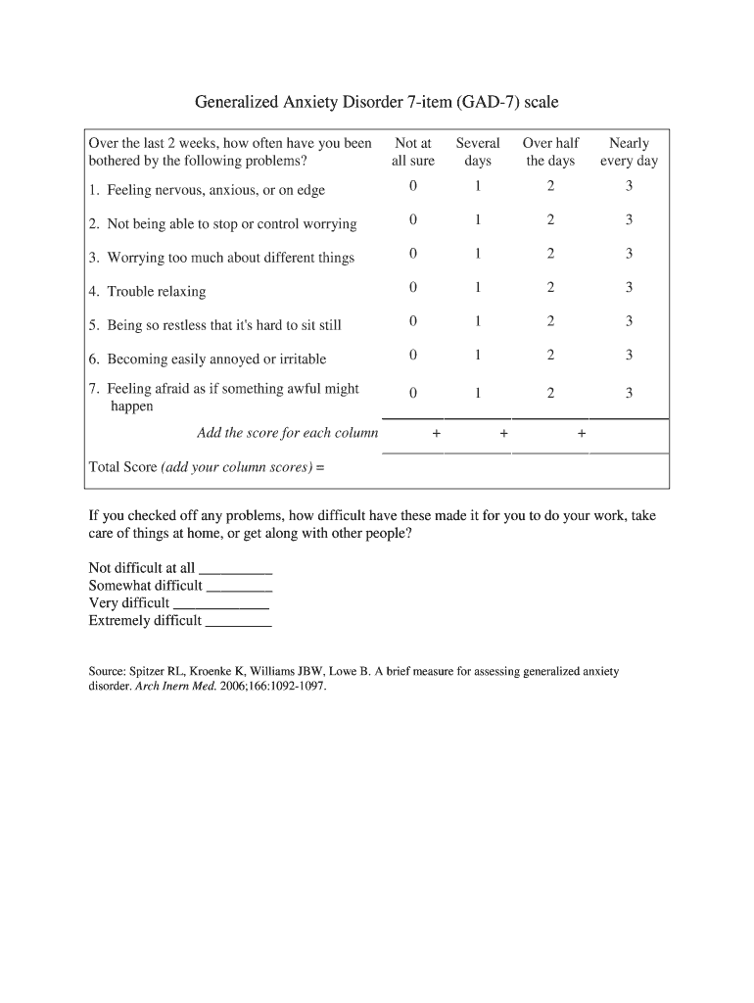

Appendix B: Indicators for The Quality Indicator for Rehabilitative care (QuIRC-SA) sample:
(Frontiers, 2019)
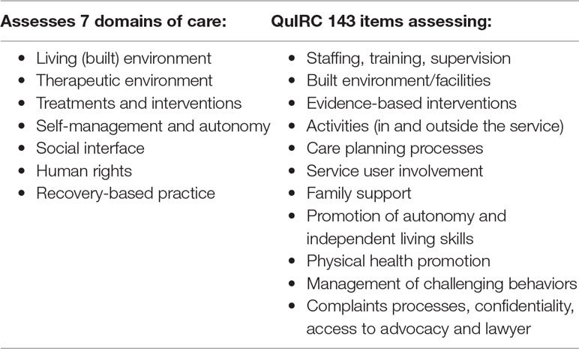19)

