Name: Antonio Mario Arsenio Fernandes
Student ID: 2440649
Lecturer Name: Muhammad Aliyu
Module Code: LCHS4003
Module Name: Introduction To Health and Social Car

Table of Contents
National Health Service (NHS) 3
Conclusion: 4
References: 4

Ambulance: 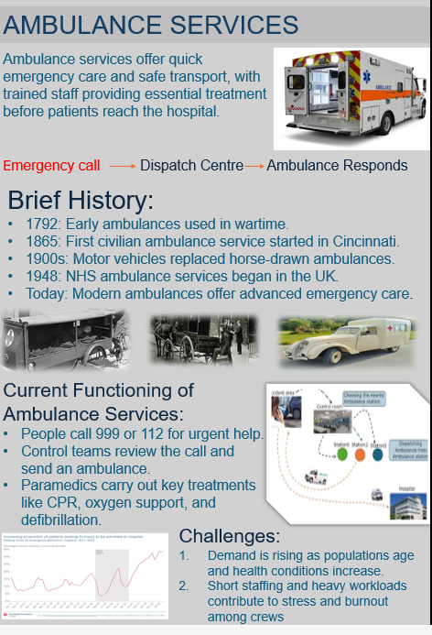

National Health Service (NHS)
The NHS is regarded as one of the most important elements of the United Kingdom’s public welfare system. Since it was founded in 1948, National Health Services has been intended to ensure that healthcare services are accessible to everyone, regardless of financial position or social background. Its creation was shaped by the historical, political and social developments that took place during and after the Second World War. Understanding how the NHS was established and how it functions today helps to clarify its role in providing healthcare throughout the UK.
Before the NHS was introduced, healthcare in Britain was not organized under one national structure. Medical treatment was offered through voluntary hospitals, private doctors, charitable groups and certain services delivered by local authorities. Access to healthcare often depends on a person’s ability to pay for treatment. Therefore, many individuals from low‑income households struggled to obtain suitable medical care, which led to obvious inequalities within the health system (Timmins, 2018).
The experience of the Second World War had a major influence on ideas surrounding a national health service. During the conflict, hospitals and medical resources were centrally organized by the government to deal with the large number of injured civilians and soldiers. This central management showed that a nationwide healthcare system could operate effectively and support the needs of the population (Greener, 2020).
Another important factor in the creation of the NHS was the Beveridge Report published in 1942. Prepared by the economist William Beveridge, the report proposed a broad welfare programmed aimed at tackling major social problems in Britain. Beveridge identified five main social challenges: Want, Disease, Ignorance, Squalor and Idleness (Beveridge, 1942).
The National Health Service (NHS) was formally established on 5 July 1948 by the Labour government under Prime Minister Clement Attlee. Aneurin Bevan, the Minister of Health, oversaw the implementation of the new healthcare system. Its aim was to provide medical care to everyone without direct charges at the point of treatment. The system was built on three key principles: healthcare should be available to all, treatment should be free when delivered, and care should be determined by clinical need rather than personal wealth (NHS England, 2023).
Over time, the organization of the NHS has been altered in response to changing healthcare demands, population shifts and government reforms. The NHS continues to be funded mainly through taxation and national insurance contributions, allowing services to be delivered without direct cost to patients. In England, the Department of Health and Social Care is responsible for setting healthcare policy and distributing funding. NHS England oversees the management and delivery of services nationwide (The King’s Fund, 2023).
Healthcare services within the NHS are commonly divided into three categories: primary, secondary and tertiary care. Primary care serves as the first point of contact and includes services provided by general practitioners, dentists, pharmacists and opticians. Secondary care refers to specialist treatment provided in hospitals following referral from primary care. Tertiary care involves highly specialized medical procedures, such as advanced surgery and complex treatments, delivered in major specialist centers (Greener, 2020).
Although the NHS is recognized as one of the most comprehensive universal healthcare systems in the world, it faces several ongoing challenges. Increasing demand for services, an ageing population and shortages of healthcare professionals have placed additional pressure on the system. Rising costs and extended waiting times have also contributed to continued debates about funding and long‑term sustainability (The King’s Fund, 2023).

Conclusion:
The NHS was created as part of wider post-war welfare reforms aimed at promoting social equality and improving public health. Influenced by the Beveridge Report and introduced by Aneurin Bevan, the NHS established a healthcare system based on fairness and universal access. Although its structure has evolved, the NHS continues to follow its original principles of providing care based on need rather than financial ability.

References:
Beveridge, W. (1942) Social Insurance and Allied Services. London: HMSO.
Greener, I. (2020) Healthcare in the UK: Understanding Continuity and Change. Bristol: Policy Press.
NHS England (2023) The NHS Constitution for England. Available at: https://www.england.nhs.uk
The King’s Fund (2023) How does the NHS work? Available at: https://www.kingsfund.org.uk
Timmins, N. (2018) The Five Giants: A Biography of the Welfare State. London: HarperCollins.

