Principles of Health and Social Care (BMHP5002) Assessment 1
case study report
Maryam Malik (1919971)
Diya Ganguly (Lecturer)

Contents page

Introduction ……………………………………………………………………………1
Discussion/Analysis …………………………………………………………………..2
Recommendations ……………………………………………………………………5
Conclusion …………………………………………………………………………….7
References …………………………………………………………………………….8
Appendix 1……………………………………………………………………………10
Appendix 2 ……………………………………………………………………………11
Appendix 3 ……………………………………………………………………………12

Introduction

Improvements in people's health and wellbeing has evidently produced a society of individuals living longer lives than the previous generations. Previous fatal diseases, nowadays are curable or manageable with treatments, enabling a person to add years or decades to their life spam (WHO, 2021). Nevertheless, this doesn't prevent the fact that often people are suffering with complex health conditions that require ongoing care and support for conditions such as diabetes, heart disease, cancer or dementia (WHO, 2021). The aim of the following report is to analyse and evaluate the support available in health and social care, for the specific needs of a vulnerable elderly couple, based on the information contained in the particulars of the case study. Based on the presenting needs and circumstances of Mr and Mrs T, the adequate organisation chosen, to be an integral part of their journey, is the Adult Social Services department within their Local Authority.
Achieving high quality support for service users, should include the individuals' carers and family and available support through other networks and services in the community, enabling everyone involved to understand the service users' situation and to access support when required. Those involved in their care and support would be aware of the person's capabilities and should maintain valuable principles when providing person-centred care. Maine principles are choice, dignity, independence, partnership, privacy, respect, rights, safety, equality, inclusion and confidentiality (NHS, 2017). These vital principles shall be discussed in depth further into the report and can be visualised in diagram that shows collective words relating to valuable principles (Appendix 1).

Discussion/Analysis
Mr and Mrs T will be faced with significant challenges on a daily basis whilst living independently at home. Mr T has a progressive dementia and Mrs T has had a hip operation and is frail due to a recent fall and aided by a mobility frame. Their care and support imply a wide range of needs that will require the coordination and cooperation from various services, such as health, social care, public health and community services in order to deliver a service focussed on their individual needs within their own home. In addition to chronic health conditions which have not been identified in the case study, but could include diabetes, heart condition, high blood pressure etc. Local authority adult social services have duties to undertake an assessment of vulnerable elderly persons, under the Care Act 2014, Section 19​, who find themselves in need of care and support. The assessment is aimed in identifying the specific needs of a person in order to provide the appropriate services to meet their level of care and support. This would be a critical intervention and should be a system of integrated care and support, where the individual's needs are supported by compassionate care resulting in better health and wellbeing (SCIE, 2021).
The Department of Adult Social Care within a Local Authority provide a range of services to support the elderly or individuals living with a physical or mental disability, to live independently, and do so alongside key national standards (GOV.UK, 2021).
​Care Quality Commission Fundamental Standard​s, where standards are implemented that give guidance and expectations of service that a service user should experience. The most fundamental principles included within practice are:
- Person-centred care: this requires personalised care or treatment, tailored specifically to meet the individual's needs and preferences.
- Dignity and respect: it's imperative that a person receiving treatment and care, that this is carried out respectfully and with dignity at all times.
- Consent: prior to any care or treatment, a person or anyone that legally acts on their behalf, must agree to the care or treatment.
- Safety: unsafe care or treatment that may put a person at risk of harm, must not be undertaken.
- Safeguarding from abuse: whilst receiving care an individual must not suffer the consequences of abuse or ill-treatment (CQC, 2017).
There is a protocol that social services follow when an individual is referred to them, or directly contacts the service for help and support (Appendix 2) provides visual diagram that simplifies the process carried out from an initial assessment to providing care and support (ECL, 2021). Firstly, in order to identify the individual's care and support needs, an approach is required, this is usually an appropriate and proportionate needs assessment which will establish the total extent of the person's needs. This will be person-centred, where discussions should effectively express the individual's wishes relating to the support and care desired in their day-to-day life. Ideally, the assessor would conduct the assessment in the person's home, where they can relate to the extent of their needs (Carers UK, 2021).
Although the local authority has its own assessment procedure, they adhere to a national criterion to make a decision whether an individual is eligible for care support which is followed by a means test, an eligibility assessment, that determines and calculates the amount the person needs to contribute towards their care and support in reference to The Care and Support (Eligibility Criteria) Regulations 2015. The financial assessment will clearly state and explain the overall charges. Following an eligibility determination, the local authority, by law, must provide a written record of the needs and eligibility assessment to the persons requesting support and care (Age UK, 2021). Throughout the process of collecting necessary information, there is a legal obligation to comply with data confidentiality under the ​Data Protection Act 2018. The local authority has a duty to ensure a person's data is only shared for the purpose that is required need to know or be seen basis and to make information accessible to those who require support and care and financial support, such as Disabled Facilities Grant, Attendance Allowance, Council Tax Support, Heating Benefits, TV Licence concessions, Disability Living Allowance, to acquire these services (GOV.UK, 2021)
​Mr and Mrs T are an elderly couple with different care and support needs. However, the key principles of practice would apply to both these individuals. As the couple live together in their own home and wish to continue living independently for as long as they can, a combined ‘Support Care Plan’ would incorporate both their mutual needs but also their individual needs, as their health and personal requirements must be tailored to them specifically. Both their ages suggest that as elderly people, their physical capabilities may be restricted due to lack of strength, energy and coordination to carry out day-to-day tasks.
At present, Mrs T is physically frail after a fall and hospitalisation for a hip operation and Mr T has progressive dementia and chronic health conditions. In order to meet both their personal care needs, domiciliary care should be included in their care plan. This type of care would assist the couple in a variety of ways, such as assistance with household chores, organising social events, grooming and personal care, mobility support and preparing meals (Helping Hands, 2021). The local authority can recommend and arrange home care from a paid carer and depending on the individual's financial means, will need to be accountable for the total cost of these payments or the local authority may contribute to the cost. Costs of care providers can be financially daunting for elderly people with respect to affordability but there is funding available that may cover the costs (Age UK, 2021).
Whilst domiciliary care will without a doubt benefit the elderly couple tremendously with daily chores and personal care, the amount of support and care to meet both their needs depends entirely on how often and the number of hours is provided by carers to specifically meet their needs. Social service may arrange to implement the service for support and care with the support plan, but they do not oversee the service provided by the carers.
As part of the need’s assessment, the local authority would include home adaptations to cover costs of up to £1,000 (Age UK, 2021). Home adaptations would scientifically make a tremendous impact on the wellbeing of Mr and Mrs T, helping them with any mobility needs and making their home safer preventing any potential risks of harm to them. Adaptations could include any or all of the following:
- Stairlifts - to prevent major falls and help with mobility to another area of the home.
- A bath lift or walk-in shower with grab rails to help get in and out of the facility.
- Widening doorways for easier access to other rooms and preventing the risk of walking into restricted space.
- Outdoor ramp or step rail gives much easier access.
- Security, outside lights and intercom systems
- Raised toilet seat and frame helps to get up and down.
- Reclining chairs is much easier option to get up then a regular chair.
- Bed grab rail would help to lift all body up.
- Kettle with holder helps to tilt the kettle.
- Cutlery with special handles and cups with two handles makes it easier to pick up and move things around.
- Slip mat for bath or shower can help prevents falls.
- Smoke alarms
Appendix 3 show image of few examples of home adaptations (Adapt Your Home For Life, 2020).
Apart from home adaptations a fundamental part of social care services is to provide Mr and Mrs T with a Telehealth equipment. Device detects if a person has a high blood pressure, diabetic or chronic obstructive pulmonary disease and sends alert to a call centre which organise the help. This service is vital to living at home independently for elderly people, providing peace of mind in the case of an emergency. Should a situation arise where either or both Mr and Mrs T experience an emergency, such as a fall or feel unwell or distress, they are able to access emergency response at the touch of a button on a bracelet that can be worn arm (Age UK, 2021).
The local authority also provides community services where Mr and Mrs T could attend social events and participate in hobbies or socialise with other elderly people in the community. Events such as tea parties, quizzes or lunches are beneficial to their wellbeing, giving them the opportunity to remain active (GOV.UK, 2021).

​Recommendations
Local Government has a crucial role in supporting and maintaining health and wellbeing of older people for as long as possible. Local authorities must ensure that older people’s interests, wishis and needs are met by the local community. Many older people are not aware of benefits they are entitle to. Therefore, council should advise elderly about available funds and facilities also provide and commission local services that manages finance, provide advice and advocacy to older people (Age UK, 2014).
Dementia is a condition that degenerates the brain and does so progressively over time. Whilst domiciliary care is fundamental to support the needs and care for Mr and Mrs T, this type of service is not tailored to the specific needs of Mr T. Home help visits to help carry out daily chores maybe an ideal support for Mrs T, but it would be recommendable to provide an additional professional carer,
exclusively for the tailored needs of Mr T. If an initial intermittently service was to be provided, this should be reviewed initially on a three months basis given that Mr T's condition could deteriorate rapidly and perhaps need to consider live-in care (Oxford University Press, 2021). There will come a point when Mr T will not be able to understand, remember or have the capacity to make certain choices. It is recommended that Mrs T take into the consideration the implications of having to make future decisions for Mr T with regards to his support and care needs and also financial decisions by obtain a lasting power of attorney. This would give Mrs T legal rights to make appropriate decisions for her husband as outlined in the Mental Capacity Act 2005. ‘The Act applies to everyone involved in the care, treatment and support of people aged 16 and over living in England and Wales who are unable to make all or some decisions for themselves’ (SCIE, 2020). Although a lasting​ power of attorney would give Mrs T legal rights to make decisions for her husband, she herself is an elderly person whose mental capacity due to aging, may need others involved with support and care needs to assist her with advice in making adequate decisions.
​Prior to a visit for an assessment, it would be recommended to list all needs and future implications to support and care so that all needs are identified (Carers UK, 2021). Additionally, occasions may arise where the support and care providers are not fulfilling their duties to the best of their abilities and concerns may be addressed. Perhaps, adaptations need to be reviewed to ensure that these are meeting the outcomes. Whilst there are protocols in place, that place a duty on social services to deal with complaints from the service user, these can take time and issues are not always resolved quick enough to prevent further distress to the individual experiencing the situation (CQC, 2017). An emergency response needs to be put in place to prolong resolutions to situations.

Conclusion

The report highlights that most of the needs of older vulnerable adults wishing to continue living independently are supported by their local authority through adult social care. The practice of health and social care policy are to identify and respond to the needs of elderly people in crisis, by acknowledging, assessing, intervening and providing support and care for those with complex physical and mental disabilities (NHS, 2017). Therefore, local authorities would ensure Mr and Mrs T quality of life and support them to live independently within their own home. The principles of Health and Social Care practice are undertaken by legislation assuring standards of care, access to services, ensuring funding and developing support and care which promote independence (CQC, 2017).
As elderly people become increasingly frail or develop mental or chronic health conditions, daily chores become extremely difficult to manage, but there are home adaptations that can be carried out to make these challenges easier and services that provide support and care to assist individuals to live independently in their own homes. These responses from social care ensure effective practice which will prevent further risks by safeguarding individuals.

References

Adapt Your Home For Life (2020) Adapt Your Home for Life. Available at: https://adaptyourhomeforlife.co.uk/ (Accessed: 22 August 2021).
Age UK (2014) Local Government’s Role in Responding to an Ageing Population. Available at: http://www.cpa.org.uk/cpa-lga-evidence/Age_UK/LGACallEvidenceLArole(Age%20UK).pdf (Accessed: 22 August 2021).
Age UK (2021) Benefits and Entitlements. Available at: https://www.ageuk.org.uk/information-advice/money-legal/benefits-entitlements/?gclid=CjwKCAjw1JeJBhB9EiwAV612y557GtR5V9BdCJ1-pDbcGmT-H9nRM_NNRHSO4Gu0iAUHuxdXYIeQwhoCfqgQAvD_BwE (Accessed: 22 August 2021).
Age UK (2021) Disabled Facilities Grants. Available at:
https://www.ageuk.org.uk/information-advice/care/housing-options/adapting-home/disabled-facilities-grants/ (Accessed: 20 August 2021).
Age UK (2021) Telecare and telehealth. Available at: https://www.ageuk.org.uk/information-advice/care/housing-options/adapting-home/telecare/ (Accessed: 25 August 2021).
Care Act 2014 Section 19. Available at: https://www.legislation.gov.uk/ukpga/2014/23/section/19/enacted (Accessed: 18 august 2021).
Carers UK (2021) Assessments. Available at: https://www.carersuk.org/images/Factsheets/2021-22_factsheets/Assessments_-_England_April_2021-22.pdf (Accessed: 24 August 2021).
CQC (2017) The Fundamental Standards. Available at: https://www.cqc.org.uk/what-we-do/how-we-do-our-job/fundamental-standards (Accessed: 20 August 2021).
Data Protection Act 2018. Available at: https://www.legislation.gov.uk/ukpga/2018/12/contents/enacted (Accessed: 24 August 2021).
ECL (2021) Social Care Simplified. Available at: https://www.ecl.org/about/social-care-simplified (Accessed: 21 August 2021).
Helping Hands (2021) Domiciliary Care. Available at: https://www.helpinghandshomecare.co.uk/home-care-services/domiciliary-care/ (Accessed: 20 August 2021).
GOV.UK (2021) Care and support statutory guidance. Available at: https://www.gov.uk/government/publications/care-act-statutory-guidance/care-and-support-statutory-guidance#contents (Accessed: 18 August 2021).
GOV.UK (2021) Data Protection. Available at: https://www.gov.uk/data-protection (Accessed: 24 August 2021).
GOV.UK (2021) Lasting power of attorney: acting as an attorney. Available at: https://www.gov.uk/lasting-power-attorney-duties (Accessed: 22 August 2021).
Mental Capacity Act 2005. Available at: https://www.legislation.gov.uk/ukpga/2005/9/section/3 (Accessed: 18 August 2021).
NHS (2017) Safeguarding Adults: a guide for health care staff. Available at: https://www.england.nhs.uk/wp-content/uploads/2017/02/adult-pocket-guide.pdf (Accessed: 20 August 2021).
Oxford University Press (2021) The Fundamentals of Person-Centred Care for Individuals with Dementia. Available at: https://academic.oup.com/gerontologist/article/58/suppl_1/S10/4816735 (Accessed: 20 August 2021).
SCIE (2020) Mental Capacity Act 2005 at a glance. Available at: https://www.scie.org.uk/mca/introduction/mental-capacity-act-2005-at-a-glance (Accessed: 18 August 2021).
SCIE (2021) Eligibility criteria under the Care Act 2014. Available at: https://www.scie.org.uk/care-act-2014/assessment-and-eligibility/eligibility/criteria (Accessed: 24 August 2021).
The Care and Support (Eligibility Criteria) Regulations 2015. Available at: https://www.legislation.gov.uk/uksi/2015/313/regulation/2/made (Accessed: 21 August 2021).
WHO (2021) Ageing and health. Available at:
https://www.who.int/news-room/fact-sheets/detail/ageing-and-health (Accessed: 25 August 2021).

Appendix 1

Shows an image of collective words relating to valuable principles (NHS, 2017)

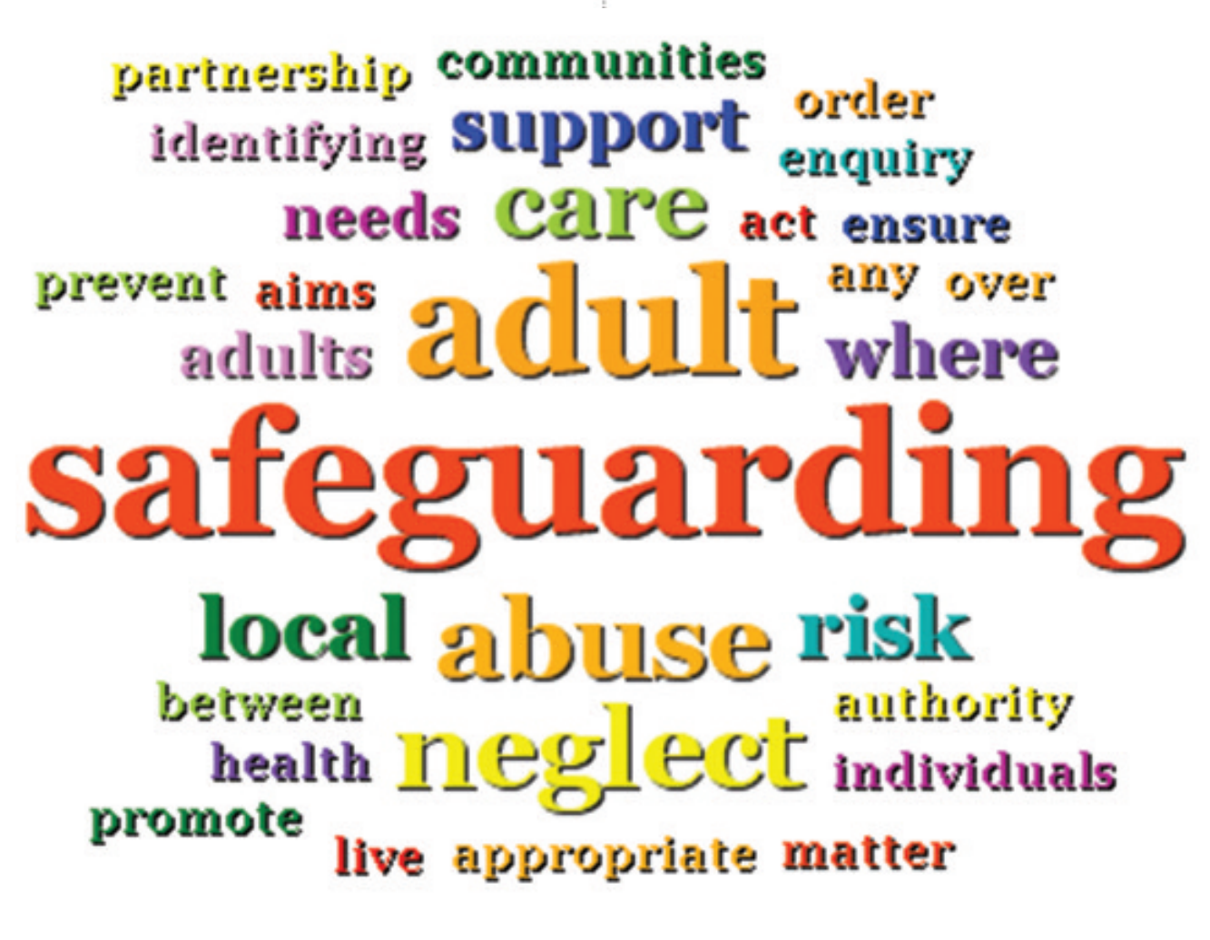

Appendix 2

Social Care Simplified (ECL, 2021)

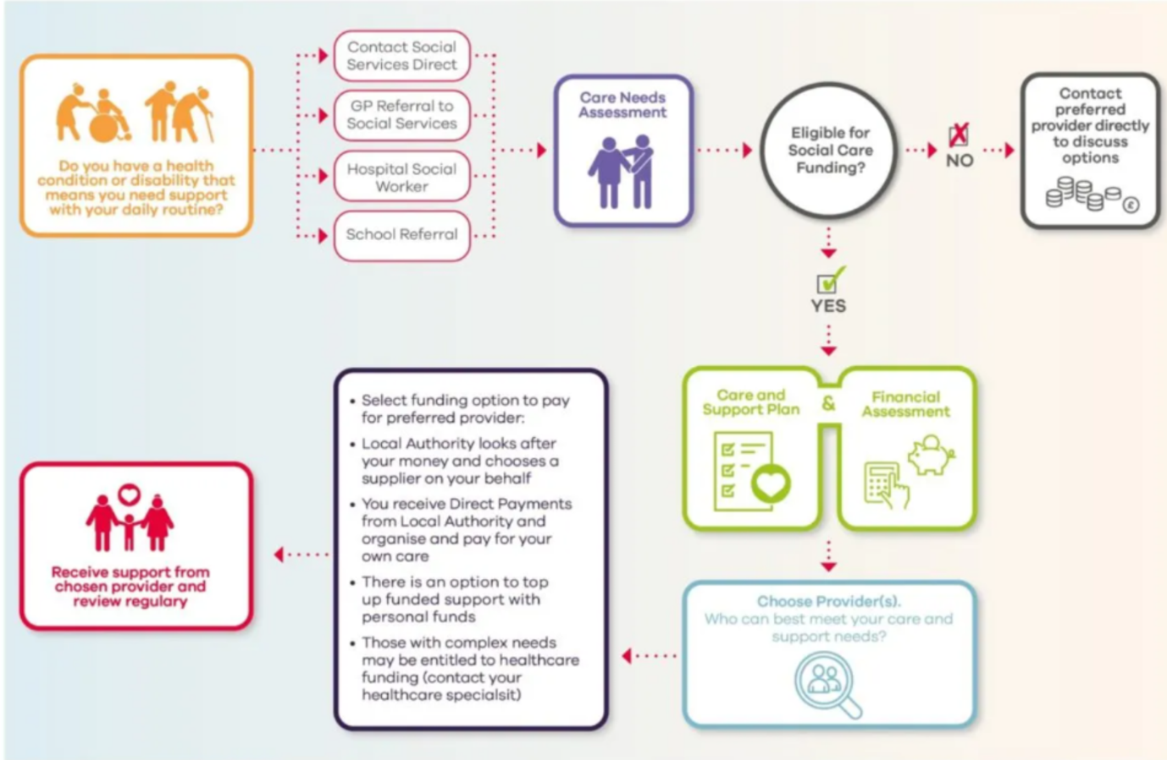

Appendix 3

Shows collective images of home adaptations (Adapt Your Home For Life, 2020)



