

Name: Shamaila Sakhawat
Student ID: 2309140
Lecturer: Dr Aishat Bakre
Module: Community Care and Management of Longer-term Conditions
Module Code: LCHS7003
Assignment Title: Component 1 Information Booklet of Longer-term Condition Management

Contents
LIVING WITH CHRONIC KIDNEY DISEASE 3
Definition and classification 4
Aim of the Booklet 4
Worldwide prevalence/burden 5
UK prevalence/burden 5
Risk factors/aetiology! 5
Physical, psychological, and social impacts 7
NHS treatments and clinical decisions 8
Models for improved long-term outcomes 9
UK model: House of Care 10
International model: Chronic Care Model 11
11
Policy, guidelines, and local implementation 12
Recommendations: whole-person care and self-management 13
End-of-Life and Conservative Kidney Care 13
Conclusion 14
References 15

LIVING WITH CHRONIC KIDNEY DISEASE
Physical, psychological, and social impacts | Evidence-based management | Person-center care
A critical information booklet for UK health and social care.
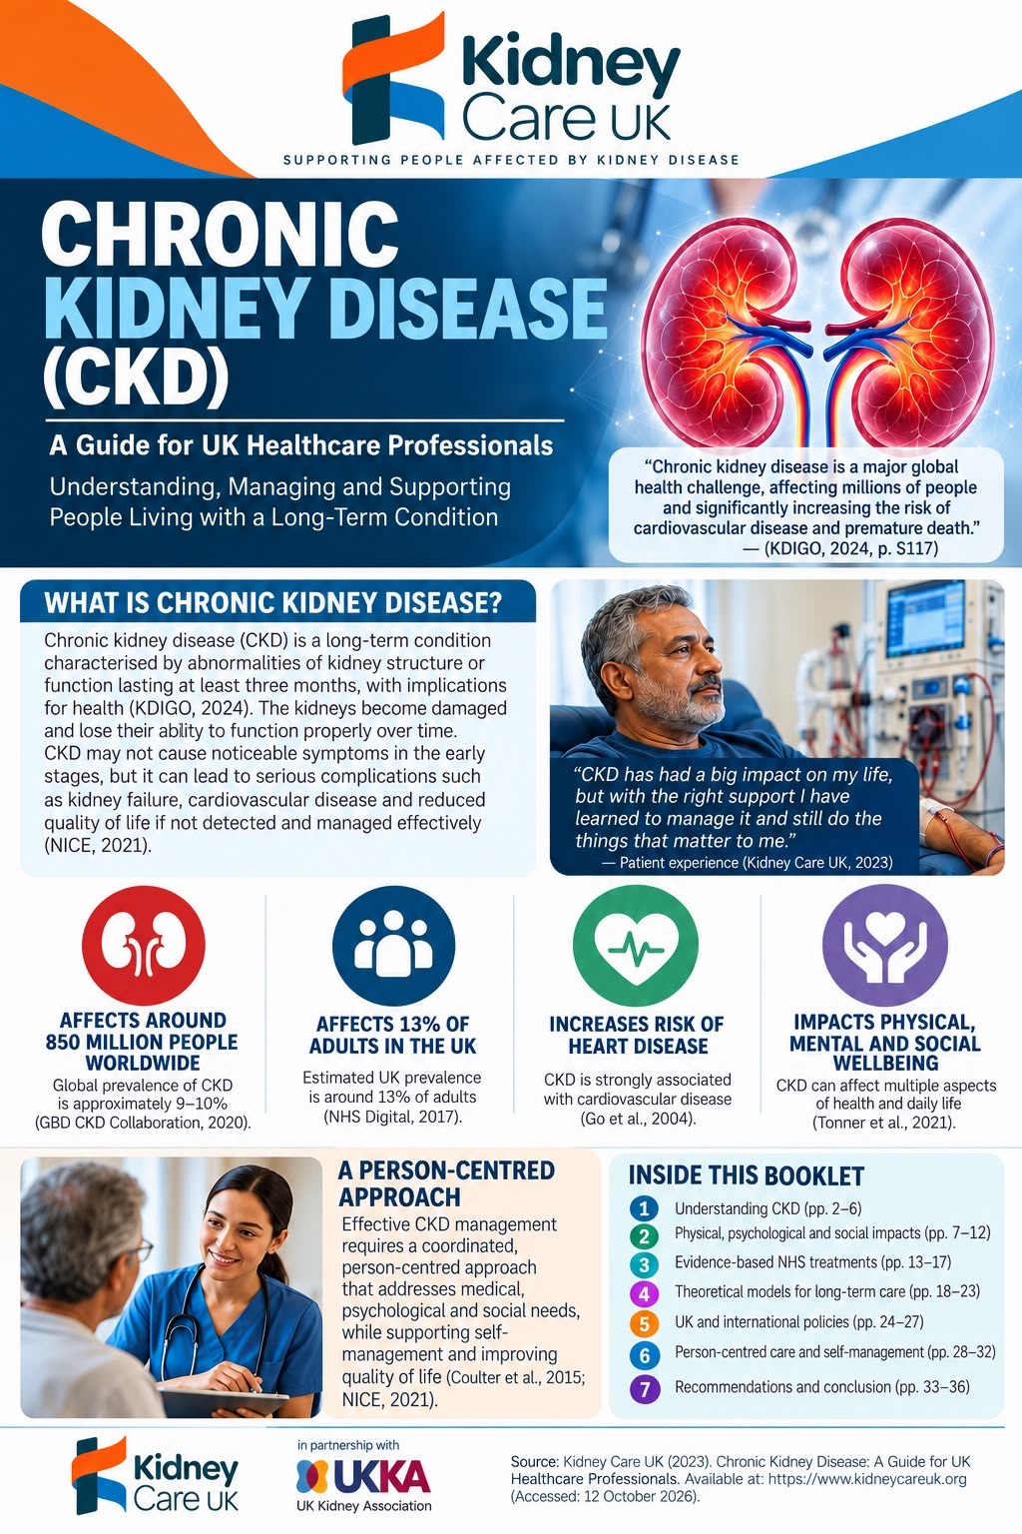
Figure 1: CKD overview infographic (user-supplied artwork).

Definition and classification
Chronic kidney disease (CKD) is an abnormality of kidney structure or function that persists for at least three months and has implications for health (KDIGO, 2024). It is a heterogeneous condition rather than a single disease. Prognosis varies according to the underlying cause, estimated glomerular filtration rate (eGFR), albuminuria, cardiovascular risk, and the patient’s wider circumstances (KDIGO, 2024; Webster et al., 2017).
CKD classification uses cause, GFR category and albuminuria category (CGA). G1 (eGFR at least 90) and G2 (60–89 mL/min/1.73 m²) require other evidence of kidney damage for a CKD diagnosis; G3a is 45–59, G3b 30–44, G4 15–29 and G5 below 15. Albuminuria categories A1, A2 and A3 add independent prognostic information. A single low eGFR does not establish chronicity: repeat testing and assessment for acute kidney injury are essential (KDIGO, 2024; NICE, 2021).
Beyond laboratory values, CKD poses a major global health burden associated with substantial cardiovascular mortality, hospitalisation risks, and health disparities (Bikbov et al., 2020; Chronic Kidney Disease Prognosis Consortium, 2010; Crews et al., 2019; Go et al., 2004). Progression significantly impacts physical and mental health, often leading to a high prevalence of depression and functional decline (Palmer et al., 2013). Consequently, comprehensive clinical care must extend beyond biochemical staging to encompass holistic, person-centred management, shared decision-making, and proactive care planning tailored to individual patient values and wider socioeconomic circumstances (Coulter et al., 2015; Elwyn et al., 2012; Morton et al., 2010).

Aim of the Booklet
This booklet aims to equip UK health and social care professionals with a critical, evidence-based guide for delivering holistic, integrated care to individuals living with chronic kidney disease. By synthesising clinical staging with the multi-dimensional physical, psychological, and social impacts of renal disease, it guides practitioners through evidence-based disease management and cardiorenal therapies (Heerspink et al., 2020; Verberne et al., 2016). Ultimately, it seeks to bridge health disparities, operationalise person-centred care through the House of Care framework, and support statutory assessments under the Care Act 2014 via meaningful shared decision-making (Barnes et al., 2017; Elwyn et al., 2012; NHS England, 2016). Furthermore, it promotes tailored end-of-life planning to optimise long-term outcomes and quality of life across diverse populations (NHS England and Improvement, 2022; Wagner et al., 2001).

Worldwide prevalence/burden
Globally, the Global Burden of Disease CKD Collaboration (2020) estimated 697.5 million people with CKD in 2017, or 9.1% of the population. This historical estimate is not a current 2026 count; population ageing and differing measurement methods complicate comparisons. These estimates establish population burden; however, prevalence cannot demonstrate diagnostic coverage, treatment access, or the effectiveness of healthcare provision (Global Burden of Disease Chronic Kidney Disease Collaboration, 2020).

UK prevalence/burden
In the UK, estimates depend on age, sampling and whether both eGFR and urine ACR are used. UK Kidney Association resources commonly describe CKD as affecting one in ten adults; this is an approximate public-health description, not a verified 2026 national count. England’s Health Survey provides historical population data, while GP registers reflect recognised cases and can underestimate undiagnosed disease (NHS Digital, 2017; NICE, 2021).The World Organisation WHO, 2025) adopted a landmark resolution making chronic kidney disease (CKD) affecting 850 million people globally and 7.2 million in the UK a global health priority.

Risk factors/aetiology!
Diabetes, hypertension, glomerular disorders, inherited conditions, and earlier kidney injury are major causes. Poverty, unequal access to tests, health literacy and environmental exposures can also shape disease risk and prompt care (Crews et al., 2019). Modifiable risk factors include poorly controlled diabetes and hypertension, smoking, excess weight, high sodium intake, and avoidable exposure to nephrotoxic drugs (Romagnani et al., 2017). These factors can be addressed through individualised medicines, prevention, and supported behavior change; however, opportunities to change depend on income, food access, and continuity of care (NICE, 2021; Crews et al., 2019).
Non-modifiable risk factors include older age, family history, inherited kidney conditions, and congenital structural abnormalities. Such factors inform targeted assessment rather than implying inevitable progression. Ethnicity may correlate with unequal disease burden but should not be treated as a biological explanation without examining social determinants and access to care (KDIGO, 2024; Crews et al., 2019). Clinical assessment should investigate medication exposure, family history, and previous acute kidney injury (KDIGO, 2024).

Addressing this growing epidemiological trajectory necessitates moving beyond passive epidemiological tracking toward proactive, system-wide health interventions (Tonelli et al., 2025). Translating clinical guidelines into population-level risk reduction requires structured chronic care models that integrate clinical management with community-level preventive initiatives (Wagner et al., 2001). Furthermore, addressing structural health inequalities demands inclusion-focused frameworks to ensure vulnerable and marginalised demographics receive prompt diagnostic screening, evidence-based cardiorenal therapies, and equitable social care evaluations (England, 2023; NHS England, 2019). Consequently, mitigating global and national CKD expansion requires aligning clinical risk factor modification with social care infrastructure to dismantle pervasive health disparities (Barnes et al., 2017; Bennett et al., 2018).

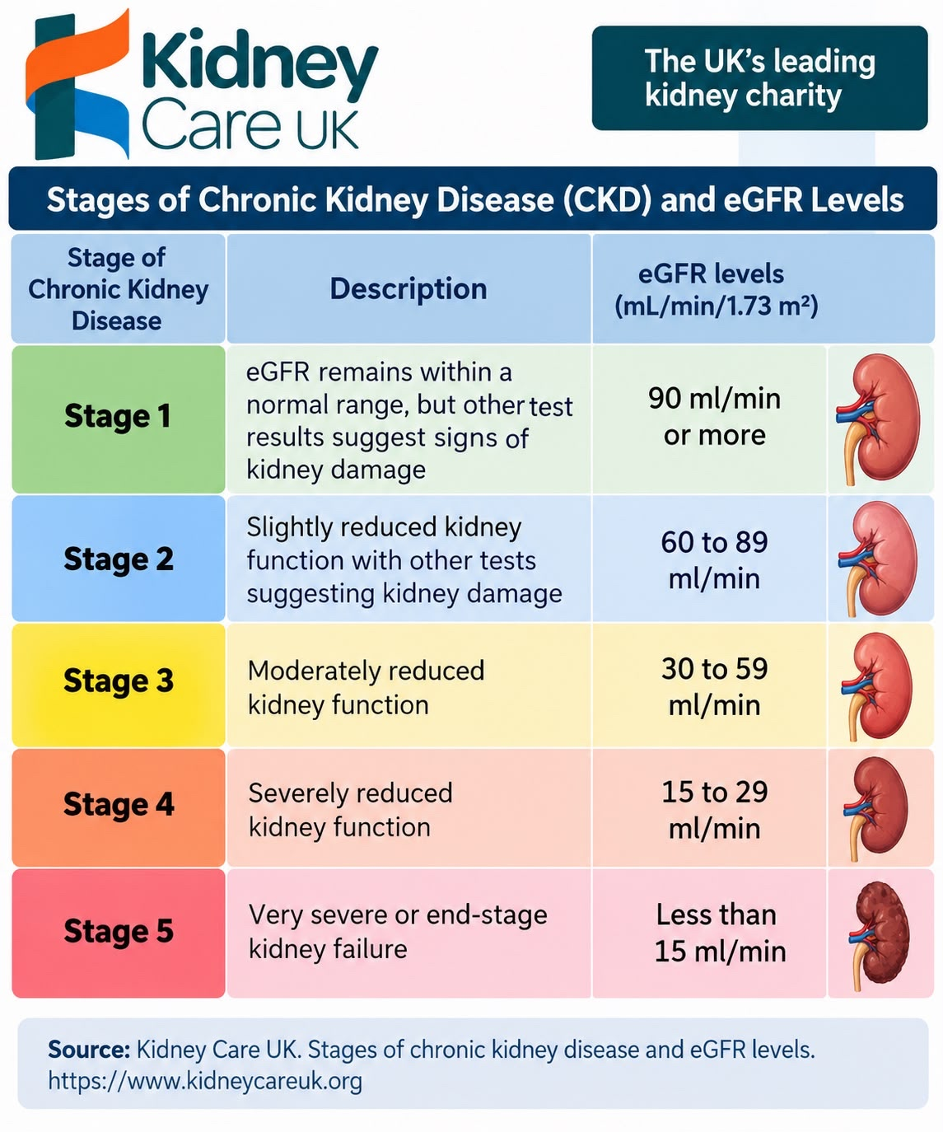

Figure 2: Stages of CKD and eGFR levels. Image supplied by user; branding and source shown in image.
Critical note: the image groups G3a and G3b together as “Stage 3”; KDIGO (2024) separates G3a (45–59) and G3b (30–44). G1 and G2 require other evidence of kidney damage.

Physical, psychological, and social impacts
CKD can cause fatigue, anaemia, fluid overload, pruritus, sleep disturbance, mineral-bone disorders, and cardiovascular complications (KDIGO, 2024). Albuminuria and reduced eGFR independently predict cardiovascular events and mortality (Go et al., 2004; Matsushita et al., 2010). Symptoms correlate imperfectly with laboratory indices, so patient-reported outcomes matter alongside clinical measurements.
Fatigue and anemia can restrict walking, work, and participation in ordinary family activities. Fluid restriction, multiple medicines, and dialysis schedules can reduce independence. However, severity cannot be inferred from the CKD stage alone: clinicians should ask patients what symptoms prevent them from doing, and weigh treatment benefits against disruption and adverse effects (Morton et al., 2010).
Psychological consequences include uncertainty, fear of progression and depression (Palmer et al., 2013). Anxiety may intensify around declining blood results, dialysis preparation, and transplant eligibility. Depression screening can identify unmet needs, but fatigue and sleep problems may also arise directly from kidney disease. A score should therefore prompt a clinical conversation rather than automatically establish a psychiatric diagnosis. Stigma and communication that presents kidney failure as inevitable can further undermine confidence.
Social consequences include lost income, travel costs, altered family roles and treatment-related disruption. Home dialysis may offer flexibility but transfers clinical work to households and may be impractical for people without sufficient space, training, or support (Morton et al., 2010). Family carers require assessment rather than being treated as an unlimited substitute for funded care. Critical implication: a reduction in albuminuria is incomplete as a measure of success if a patient cannot afford appointments or experiences untreated depression. Whole-person care combines kidney-risk indicators with symptoms, functioning, emotional wellbeing, and carer needs.
Family members may experience disrupted employment, emotional strain, and pressure to coordinate complex treatment. Conversely, reliable family support may improve continuity. A critical equity issue is that identical treatment choices are not equally possible for people in overcrowded housing or with insecure employment. Care planning should include accessible appointments, welfare advice, and carer support with patient consent (Crews et al., 2019; Morton et al., 2010).

NHS treatments and clinical decisions
According to NICE guideline NG203 (NICE, 2021; Martinez et al., 2021), evidence-based management of chronic kidney disease requires a structured clinical strategy centred on strict blood pressure optimisation, annual urine albumin-to-creatinine ratio (ACR) quantification, comprehensive medication reviews, and risk-based specialist nephrology referral guided by the Kidney Failure Risk Equation (KFRE). In accordance with national and international recommendations, renin-angiotensin-aldosterone system (RAAS) blockade using angiotensin-converting enzyme (ACE) inhibitors or angiotensin receptor blockers (ARBs) serves as a foundational disease-modifying therapy for patients with significant albuminuria, provided baseline eGFR and serum potassium levels are rigorously monitored to mitigate risks of acute kidney injury and hyperkalaemia (KDIGO, 2024; NICE, 2021). Furthermore, while landmark randomized controlled trials confirm that sodium-glucose cotransporter-2 (SGLT2) inhibitors significantly attenuate disease progression and cardiovascular mortality across eligible CKD cohorts (Fayed et al., 2025; Heerspink et al., 2020), translating these trial findings into individual clinical practice requires clinicians to critically weigh relative risk reductions against absolute individual benefits, potential adverse effects, patient preferences, and baseline risk profiles.
Comprehensive disease management begins with identifying underlying aetiologies, systematically tracking eGFR and ACR trajectories, mitigating overall cardiovascular risk, and critically reviewing nephrotoxic or renally excreted pharmacotherapies. Within the NHS framework, holistic clinical care encompasses glycemic control, statin therapy for cardiovascular primary or secondary prevention, renal dietetic support, and proactive management of secondary complications such as renal anomia and mineral-bone disorder (KDIGO, 2024; NICE, 2021). However, dietary restrictions must be critically individualised; non-evidence-based or overly rigid restrictions on potassium, fluid, or protein intake run the risk of compromising nutritional status, precipitating protein-energy wasting, and severely degrading overall quality of life (KDIGO, 2024; NICE, 2021).
When disease progresses to kidney failure, management transitions toward evaluating modality options: haemodialysis, peritoneal dialysis, kidney transplantation, and comprehensive conservative kidney management. Renal transplantation consistently demonstrates superior long-term survival and quality-of-life outcomes compared to chronic dialysis in eligible candidates; however, historical observational comparisons must be interpreted with caution, as they frequently reflect inherent selection bias and healthier baseline candidate profiles (Wolfe et al., 1999). Conversely, while maintenance dialysis extends survival, it imposes a profound treatment burden, high cardiovascular risk, and substantial lifestyle disruption; in contrast, comprehensive conservative management represents an active, highly structured symptom-focused care pathway rather than passive withdrawal or clinical abandonment (Davison et al., 2015; Verberne et al., 2016).

In operational terms, haemodialysis typically requires regular, high-frequency clinic visits for machine-based blood filtration, while peritoneal dialysis utilises the patient's peritoneal membrane as a biological filter, enabling home-based self-care following structured training (Bennett et al., 2018). Renal transplantation offers functional restoration but demands exhaustive candidate suitability assessments and lifelong adherence to complex immunosuppressive regimens. Conservative care priorities physical symptom alleviation, psychological well-being, and alignment with personal values without invasive renal replacement interventions (Davison et al., 2015; Verberne et al., 2016). Because each pathway presents distinct trade-offs regarding survival expectancy, infection risks, travel burden, and carer strain, clinical decision-making must avoid fixed universal hierarchies and instead embody dynamic, revisited shared decision-making (Coulter et al., 2015; Elwyn et al., 2012; Morton et al., 2010).

Models for improved long-term outcomes
The UK House of Care supports personalised planning and patient priorities but requires workforce continuity and genuine partnership address the complex physical, psychological, and socioeconomic burdens of long-term renal disease (Coulter et al., 2013, 2015; Morton et al., 2010; NHS England, 2016). Without structural alignment with chronic care principles and targeted health inclusion strategies, personalised care risks becoming a superficial administrative exercise rather than a driver of equitable, high-quality care (Crews et al., 2019; Wagner et al., 2001).

UK model: House of Care

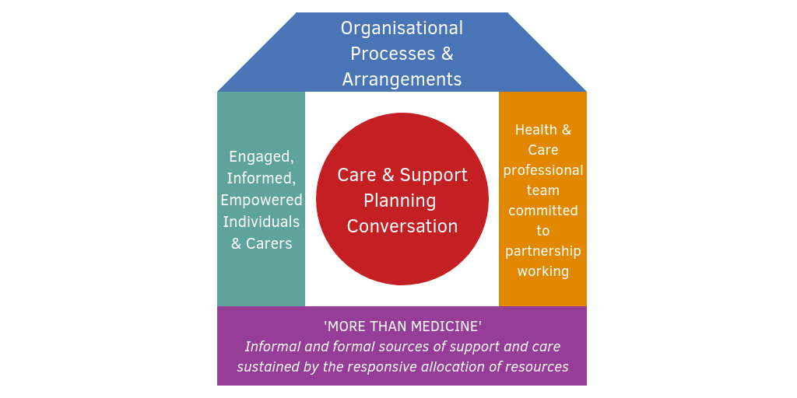
Figure 3: The House of Care model (Coulter et al., 2013, p.11).
The House of Care is a UK framework for collaborative, personalised care, and support planning designed to optimise long-term condition management through structural integration (Coulter et al., 2013; NHS England, 2016; Wagner et al., 2001). It brings together informed and engaged patients, healthcare professionals committed to partnership, organisational processes, and supportive commissioning/community resources (Coulter et al., 2013, 2015; NHS England, 2016). In CKD, a shared plan could prioritise managing fatigue, preserving social roles, and supporting employment alongside strictly clinical targets such as urine ACR and blood-pressure control (Coulter et al., 2015; KDIGO, 2024; Morton et al., 2010; NICE, 2021). Its strength is that goals are negotiated through shared decision-making rather than imposed paternalistically (Coulter et al., 2013; Elwyn et al., 2012). However, its primary weakness lies in operational implementation: short consultation times, fragmented health and social care records, unequal access to interpreting support, and systemic health disparities can reduce meaningful partnership to a superficial administrative checklist (Barnes et al., 2017; Bennett et al., 2018; Crews et al., 2019; NHS England, 2023). Furthermore, because evidence for personalised care planning demonstrates variable clinical and psychological outcomes across diverse patient demographics, implementation success must be evaluated using validated patient-defined outcomes and quality-of-life indicators rather than merely tracking the number of care plans filed (Coulter et al., 2015; NHS England, 2016; Palmer et al., 2013).
To achieve sustainable long-term care modifications for chronic kidney disease, practice must evolve beyond episodic clinical reviews to embed continuous, multi-professional disease management (Wagner et al., 2001). Long-term strategies require individualised pharmacological regimens such as disease-modifying SGLT2 inhibitors and RAAS blockade alongside proactive monitoring for systemic complications, including depression and cardiovascular risk (Go et al., 2004; Heerspink et al., 2020; Palmer et al., 2013). Also, long-term modifications must integrate statutory social care assessments under the Care Act 2014, community care packages, and home-based support options to alleviate treatment burden, preserve patient autonomy, and support informal carers throughout disease progression (Barnes et al., 2017; Bennett et al., 2018; Davison et al., 2015).

International model: Chronic Care Model
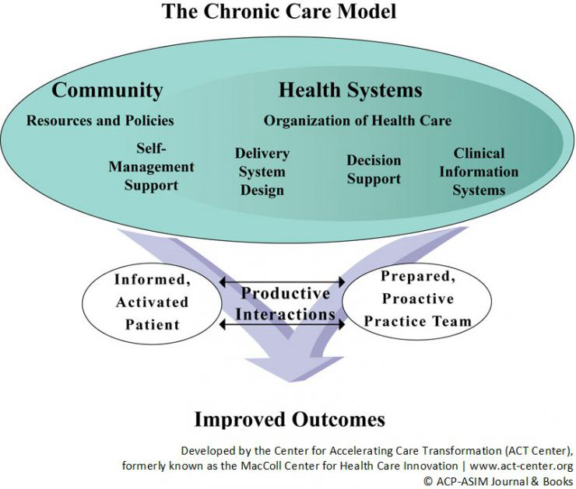
Figure 4: The Chronic Care Model (adapted from Wagner, 1998).

The Chronic Care Model coordinates initiative-taking teams, self-management support, decision support, information systems, and community resources (Wagner et al., 2001). For CKD, this might mean eGFR/ACR recall systems, pharmacist-led review, and specialist advice. However, implementation requires capacity and attention to equity. Together, the two models address personalised care relationships and service organisation and are complementary rather than interchangeable.
Wagner’s international model aims to create productive interactions between informed, activated patients and prepared practice teams. Delivery-system design distributed roles across GPs, renal nurses, and specialists; clinical decision support translates guidance into practice; information systems identify patients needing follow-up; and community links help with practical barriers. The model is stronger than individual education alone because it addresses coordination. Nevertheless, electronic reminders do not guarantee prompt appointments, and digital-first services may exclude people with language or technology barriers. Comparative evaluation should include uptake, continuity, wellbeing, and inequality alongside biochemical targets (Wagner et al., 2001).
Operationalising the Chronic Care Model within primary care systems requires alignment with national frameworks like the House of Care to bridge clinical management and community support (NHS England, 2016; Wagner et al., 2001). Crucially, structural health inequalities, social deprivation, and digital exclusion must be explicitly addressed to prevent exacerbating existing healthcare disparities (Crews et al., 2019; NHS England, 2023). Furthermore, integrated multidisciplinary pathways must incorporate formal social care assessments under the Care Act 2014 and community care provisions to support informal carers and holistic patient needs (Barnes et al., 2017; Bennett et al., 2018). Sustainable chronic kidney disease care depends on embedding shared decision-making across all system levels (Elwyn et al., 2012).

Policy, guidelines, and local implementation
NICE NG203 guides CKD assessment and management; NG107 addresses kidney replacement therapy and conservative management. KDIGO (2024) provides an international comparator but must be adapted to UK services. NHS England’s personalised care and integrated care agenda encourages coordination across primary care, hospitals, and community support (NHS England, 2019; NHS England, 2023).
A proposed West Midlands improvement project could audit prompt ACR testing, referrals, home-dialysis access, and interpreter provision. These are suggested priorities, not verified claims about current local performance. Measures should be stratified by deprivation and relevant protected characteristics, with follow-up on patient experience rather than process compliance alone.
Implementation should distinguish policy aspirations from measurable delivery. An integrated care system could establish baseline testing rates, pilot multilingual invitations, and evaluate whether improved testing leads to appropriate medication review or specialist referral. The Equality Act 2010 and Care Act 2014 provide relevant duties concerning access and carers. A rise in tests alone is an inadequate endpoint if patients remain unable to obtain treatment or understand results.
National policy creates an evidence-based standard, but delivery is shaped by local commissioning, workforce capacity, and social-care availability. The NHS Long Term Plan promotes integrated prevention, while inclusion-health priorities require action on access barriers (Barnes et al., 2017). The Care Act 2014 provides a framework for assessing eligible carers’ needs; audits should evaluate whether this entitlement translates into practical support rather than assuming policy publication equals implementation (NHS England, 2019; NHS England, 2023)

Recommendations: whole-person care and self-management
Offer initiative-taking, risk-stratified review, confirm abnormal results, and explain absolute risk without alarm. Embed shared decision-making at treatment transitions and support home blood-pressure monitoring, medicines reconciliation, tailored dietary advice and clear safety-netting where appropriate (NICE, 2021; Elwyn et al., 2012). Screen for distress and consider language, disability, digital access, finances, and transport barriers.
Assess carers’ needs with consent, coordinate multidisciplinary review, and identify a named contact for complex cases. Evaluate shared goals, symptoms, patient-reported experience, ACR testing, avoidable admissions, and unequal access. Introduce supportive and palliative care when appropriate in advanced disease; end-of-life planning should reflect individual wishes and not be presumed necessary for everyone with CKD (Davison et al., 2015).
A feasible improvement plan would first co-design accessible information with patients, then pilot structured shared-decision appointments for people approaching kidney failure. Review clinical and patient-reported outcomes at six and twelve months and examine whether benefits reach disadvantaged groups.

End-of-Life and Conservative Kidney Care
Care at the end of life must be fundamentally personalised, proactive, and aligned with individual values. NHS England promotes personalised palliative and end-of-life care to improve patient choice, control, and outcomes through earlier identification of disease trajectories, preference discussions, and integrated multidisciplinary services (NHS England and Improvement, 2022).
Central to this model is Advance Care Planning (ACP). ACP should be introduced as a voluntary, dynamic process initiated early in the disease trajectory revisited continuously as clinical needs or preferences change rather than treated as a fixed administrative decision or one synonymous with the withdrawal of active care (Davison et al., 2015; Elwyn et al., 2012).
In end-of-life kidney care, prompt ACP is essential because decisions regarding dialysis withdrawal, symptom control, and preferred place of death are deeply individual (Davison et al., 2015; Verberne et al., 2016). However, the operationalisation of ACP depends on sensitive communication and is frequently complicated by prognostic uncertainty, cognitive impairment, or family conflict (Davison et al., 2015; Morton et al., 2010). Operationalising this personalisation requires embedding structured shared decision-making models to address patient values alongside complex multi-morbidity (Elwyn et al., 2012; Morton et al., 2010). Furthermore, alignment with statutory social care assessments under the Care Act 2014 and community support packages ensures holistic, equitable care delivery across diverse patient populations (Barnes et al., 2017; Bennett et al., 2018).

Conclusion
Chronic kidney disease management cannot be judged solely by biochemical markers such as eGFR, albuminuria, or baseline dialysis survival metrics (Go et al., 2004; Palmer et al., 2013). Physical symptom burdens, psychological distress, financial hardship, and informal caring responsibilities interact directly with therapeutic efficacy and overall treatment adherence (Barnes et al., 2017; Bennett et al., 2018). Combining the UK House of Care and the international Chronic Care Model offers a robust foundation for delivering person-entered, coordinated, and multi-professional care across primary and secondary interfaces (Coulter et al., 2015; Wagner et al., 2001). However, clinical advancements such as early SGLT2 inhibitor deployment and RAAS blockade must be integrated alongside statutory social care assessments under the Care Act 2014 to address systemic health disparities and socioeconomic barriers (Crews et al., 2019; KDIGO, 2024; NICE, 2021). Future service evaluation must critically examine whether clinical improvements translate into enhanced daily functioning, equitable access, and preserved patient autonomy across historically underserved and disadvantaged populations (Elwyn et al., 2012; Morton et al., 2010; NHS England, 2023).

References
Barnes, D., Boland, B., Linhart, K. and Wilson, K. (2017) ‘Personalisation and social care
assessment–the Care Act 2014’, BJPsych Bulletin, 41(3), pp. 176–180.
Bennett, L., Honeyman, M. and Bottery, S. (2018) New models of home care. London: King's Fund.
Bikbov, B., Purcell, C.A., Levey, A.S., Smith, M., Abdoli, A., Abebe, M., Adebayo, O.M., Afarideh, M.,
Agarwal, S.K., Agudelo-Botero, M. and Ahmadian, E. (2020) ‘Global, regional, and national burden of
chronic kidney disease, 1990–2017: a systematic analysis for the Global Burden of Disease Study
2017’, The Lancet, 395(10225), pp. 709–733.
Chronic Kidney Disease Prognosis Consortium (2010) ‘Association of estimated glomerular filtration
rate and albuminuria with all-cause and cardiovascular mortality in general population cohorts: a
collaborative meta-analysis’, The Lancet, 375(9731), pp. 2073–2081.
Coulter, A., Entwistle, V.A., Eccles, A., Ryan, S., Shepperd, S. and Perera, R. (2015) ‘Personalised
care planning for adults with chronic or long‐term health conditions’, Cochrane Database of
Systematic Reviews, (3), art. no. CD010523.
Coulter, A., Roberts, S. and Dixon, A. (2013) Delivering better services for people with long-term
conditions: building the house of care. London: The King's Fund.
Crews, D.C., Bello, A.K., Saadi, G. and World Kidney Day Steering Committee (2019) ‘Burden,
access, and disparities in kidney disease’, Blood Purification, 48(1), pp. 32–39.
Davison, S.N., Levin, A., Moss, A.H., Jha, V., Brown, E.A., Brennan, F., Murtagh, F.E., Naicker, S.,
Germain, M.J., O'Donoghue, D.J. and Morton, R.L. (2015) ‘Executive summary of the KDIGO
Controversies Conference on Supportive Care in Chronic Kidney Disease: developing a roadmap to
improving quality care’, Kidney International, 88(3), pp. 447–459.
Elwyn, G., Frosch, D., Thomson, R., Joseph-Williams, N., Lloyd, A., Kinnersley, P., Cording, E.,
Tomson, D., Dodd, C., Rollnick, S. and Edwards, A. (2012) ‘Shared decision making: a model for
clinical practice’, Journal of General Internal Medicine, 27(10), pp. 1361–1367.
Fayed, A., Fathy, A., Rakha, N.K., Soliman, K.M. and Hammad, H. (2025) ‘The effect of Empagliflozin
on alleviating C4d over-activation in Diabetic kidney disease’, The American Journal of the Medical
Sciences, 369(5), pp. 568–573.
Global Burden of Disease Chronic Kidney Disease Collaboration (2020) ‘Global, regional, and
national burden of chronic kidney disease, 1990–2017’, The Lancet, 395(10225), pp. 709–733.
Go, A.S., Chertow, G.M., Fan, D., McCulloch, C.E. and Hsu, C.Y. (2004) ‘Chronic kidney disease and
the risks of death, cardiovascular events, and hospitalisation’, New England Journal of Medicine,
351(13), pp. 1296–1305.
Heerspink, H.J., Stefánsson, B.V., Correa-Rotter, R., Chertow, G.M., Greene, T., Hou, F.F., Mann,
J.F., McMurray, J.J., Lindberg, M., Rossing, P. and Sjöström, C.D. (2020) ‘Dapagliflozin in patients
with chronic kidney disease’, New England Journal of Medicine, 383(15), pp. 1436–1446.
Kidney Disease: Improving Global Outcomes (KDIGO) CKD Work Group (2024) ‘KDIGO 2024 clinical
practice guideline for the evaluation and management of chronic kidney disease’, Kidney
International, 105(4S), pp. S117–S314.
Martinez, Y.V., Benett, I., Lewington, A.J. and Wierzbicki, A.S. (2021) ‘chronic kidney disease:
summary of updated NICE guidance’, BMJ, 374, art. no. n1992.
Morton, R.L., Tong, A., Howard, K., Snelling, P. and Webster, A.C. (2010) ‘The views of patients and
carers in treatment decision making for chronic kidney disease: systematic review and thematic
synthesis of qualitative studies’, BMJ, 340, art. no. c112.
National Institute for Health and Care Excellence (NICE) (2021) chronic kidney disease: assessment
and management (NICE Guideline NG203). London: NICE.
NHS England (2016) The House of Care: a framework for long term condition care. London: NHS
England.
NHS England (2019) The NHS Long Term Plan. London: NHS England.
NHS England (2023) A national framework for NHS – action on inclusion health. London: NHS
England.
NHS England and NHS Improvement (2022) Personalised palliative and end-of-life care. London:
NHS England.
Palmer, S., Vecchio, M., Craig, J.C., Tonelli, M., Johnson, D.W., Nicolucci, A., Pellegrini, F.,
Saglimbene, V., Logroscino, G., Fishbane, S. and Strippoli, G.F. (2013) ‘Prevalence of depression in
chronic kidney disease: systematic review and meta-analysis of observational studies’, Kidney
International, 84(1), pp. 179–191.
Romagnani, P., Remuzzi, G., Glassock, R., Levin, A., Jager, K.J., Tonelli, M., Massy, Z., Wanner, C.
and Anders, H.J. (2017) ‘chronic kidney disease’, Nature Reviews Disease Primers, 3(1), art. no.
17088.
Scholes, S. (2017) Health survey for England 2016: Physical activity in adults. London: NHS Digital.
Tonelli, M., Meda, R.L., Abdijalil, G., Pichaiwong, W., Hafidz, M.I.A., Michalska, M. and Ulasi, I. (2025)
‘Implementing the commitments of the WHO kidney health resolution: initial steps in 3 diverse
settings’, Kidney International, 108(6), pp. 969–977.
Verberne, W.R., Geers, A.T., Jellema, W.T., Vincent, H.H., van Delden, J.J. and Bos, W.J.W. (2016)
‘Comparative survival among older adults with advanced kidney disease managed conservatively
versus with dialysis’, Clinical Journal of the American Society of Nephrology, 11(4), pp. 633–640.
Wagner, E.H., Austin, B.T., Davis, C., Hindmarsh, M., Schaefer, J. and Bonomi, A. (2001) ‘Improving
chronic illness care: translating evidence into action’, Health Affairs, 20(6), pp. 64–78.
Webster, A.C., Nagler, E.V., Morton, R.L. and Masson, P. (2017) ‘Chronic kidney disease’, The
Lancet, 389(10075), pp. 1238–1252.
Wolfe, R.A., Ashby, V.B., Milford, E.L., Ojo, A.O., Ettenger, R.E., Agodoa, L.Y., Held, P.J. and Port,
F.K. (1999) ‘Comparison of mortality in all patients on dialysis, patients on dialysis awaiting
transplantation, and recipients of a first cadaveric transplant’, New England Journal of Medicine,
341(23), pp. 1725–1730.

