

Institute of Inner-City Learning Birmingham Campus

BSc (Hons) Health and Social Care
DISSERTATION GUIDANCE AND TEMPLATE

Disclaimer
This document was correct at the time of publication. The Module Coordinator reserves the right to modify any statement if necessary, make variations to the content or methods of delivery of programmes of study, to discontinue programmes, or merge or combine programmes if such actions are reasonably considered to be necessary by UWTSD. Every effort will be made to keep disruption to a minimum, and to give as much notice as possible. An electronic copy of this handbook can be found on the Moodle page for the module.

DECLARATION
This work has not previously been accepted in substance for any degree and is not being concurrently submitted in candidature for any degree
Signed……………………………………………
Date………………………………………………
STATEMENT 1
This dissertation is being submitted in partial fulfilment of the requirements for the degree of BSc.
Signed…………………………………………….
Date………………………………………………
STATEMENT 2
This dissertation is the result of my own independent work/investigation, except where otherwise stated. Other sources are acknowledged by footnotes giving explicit references. A bibliography is appended.
Signed……………………………………………
Date………………………………………………
STATEMENT 3
I hereby give consent for my dissertation, if accepted, to be available for photocopying and for interlibrary loan, and for the title and summary to be made available to outside organisations.
Signed………………………………………………
Date…………………………………………………
STATEMENT 4
I hereby give consent for my dissertation, if accepted, to be available on the university’s IT system to those who have consent to use the system.
Signed………………………………………………
Date…………………………………………………

Put your title here – no more than 20 words maximum

Name: Mehwish Arshad
2312904

Dissertation submitted as part of the requirements for the award BSc (Hons) Health and Social Care

ACKNOWLEDGEMENTS (optional)
The acknowledgements section is a thank you paragraph which to everyone who has helped you whilst you have been researching and writing your dissertation.
This may be your supervisor or any other academic staff who have provided guidance and support; other students or colleagues that you have collaborated with; for example librarians; external bodies who have given you assistance.

ABSTRACT (1 page or 300 words – not included in the word count)

The abstract is a summary of the entire dissertation and is one of the final things you will complete, yet is one of the first parts of your dissertation a reader will see, therefore, be specific and explicit in your approach. An abstract should include:

a) The overall purpose, aim and objectives. An explanation as to why this research is important in the context of health and social care.
b) A summary of the methods used to complete your dissertation. Outline the research approach (thematic analysis) and indicate the focus on reviewing currently published literature.
c) A summary of the main findings. Highlight the most significant insights, themes and patterns and the conclusions drawn.
d) A brief mention of the limitations and barriers which you identified within your research and how this can be impactful in practice.
e) Summarise the recommendations that you have drawn from your findings. These should relate to future health and social care practice, policy, education and research.

Table of Contents

CHAPTER 1

  - Introduction
Autism Spectrum Disorder (ASD) is a lifelong neurodevelopmental condition characterised by persistent difficulties in social communication and interaction, alongside restricted and repetitive patterns of behaviour (National Institute for Health and Care Excellence, 2021). Over recent decades, the conceptualisation and diagnosis of ASD have evolved considerably, with broader diagnostic criteria and increased societal awareness contributing to a rise in reported prevalence (Green et al., 2022). In the United Kingdom, approximately one in 100 children is diagnosed with ASD, reflecting both improved identification and an increasing demand for health and social care services. However, this growing prevalence has also placed significant pressure on existing services, raising concerns regarding their capacity to deliver timely and effective support (National Institute for Health and Care Excellence, 2021).
Early childhood, particularly between the ages of 0 and 5 years, represents a critical period of neurological development during which intervention can have a lasting impact. Early intervention programmes aim to enhance key developmental areas such as language acquisition, social engagement, and adaptive functioning (Daniolou et al., 2022; Sandbank et al., 2023). Although research supports the benefits of early intervention, its overall effectiveness remains contested, with outcomes varying by intervention type, intensity, and delivery. This inconsistency highlights the need for further evaluation.
This dissertation aims to critically evaluate the effectiveness of early intervention programmes in improving social communication outcomes among children aged 0-5 years with ASD in the UK. The study seeks to contribute to existing knowledge by identifying both the strengths and limitations of current interventions and informing future policy and practice.

.

1.2 Definitions and Terminology
Defining key terminology is essential to ensure clarity and conceptual consistency throughout this dissertation. The following terms are central to the study
Autism Spectrum Disorder (ASD): A neurodevelopmental condition characterised by persistent deficits in social communication and interaction, alongside restricted and repetitive patterns of behaviour (Lord et al., 2020). ASD presents with varying levels of severity, reflecting its classification as a spectrum disorder.
Early Intervention: Refers to structured and targeted support delivered during early childhood (typically 0-5 years), aimed at improving developmental outcomes in areas such as communication, social interaction, and adaptive functioning (Ribeiro et al., 2022). While evidence suggests early intervention can promote developmental progress, outcomes may vary depending on intervention design and implementation.
Social Communication Skills: The ability to use verbal and non-verbal communication effectively within social contexts, including understanding social cues, engaging in reciprocal interaction, and forming relationships (World Health Organization, 2022).
Adaptive Functioning: The practical skills required for independent and socially appropriate functioning, including communication, socialisation, and self-care (Lord et al., 2020).
Acronyms and Abbreviations
- ASD: Autism Spectrum Disorder
- NHS: National Health Service
- NICE: National Institute for Health and Care Excellence
- UK: United Kingdom

1.3 Background and current context
Autism Spectrum Disorder (ASD) has historically been under-recognised within healthcare and educational settings, particularly during the late 20th century. During the 1990s, limited public awareness and significant stigma surrounding neurodevelopmental conditions contributed to delayed identification and restricted access to support services (Russell et al., 2021). As a result, many children did not receive intervention during critical developmental periods, potentially impacting long-term outcomes. A significant shift occurred in the early 2000s with policy developments such as Every Child Matters (HM Treasury, 2003), which promoted early identification and a more preventative approach to care. However, despite these advancements, service provision remained inconsistent, suggesting that policy change alone was insufficient to ensure equitable access.
In the current UK context, ASD services are primarily delivered through the NHS and guided by NICE recommendations. Despite this structured framework, a gap persists between policy and practice. Diagnostic delays remain a major concern, with families reporting long waiting times and delayed access to diagnosis (Crane et al., 2016). Additionally, increasing referral rates have placed significant pressure on services, which has not been matched by adequate resource expansion (Russell et al., 2021). Geographical and socioeconomic inequalities further restrict access, reinforcing disparities in outcomes and highlighting ongoing systemic limitations within early intervention provision.
1.4 Rationale for Research
This research is necessitated by the rising prevalence of Autism Spectrum Disorder (ASD) in the UK and the corresponding growth in demand for effective early intervention services (Issac et al., 2025; Russell et al., 2021).ASD is a neurodevelopmental condition that typically emerges in early childhood and significantly affects social communication and behaviour, reinforcing the importance of timely intervention (Lord et al., 2020). While the National Autism Strategy (2021-2026) and NICE guidelines advocate for timely support, a significant gap remains between these policy expectations and their actual implementation. Existing literature presents conflicting findings regarding the effectiveness of early intervention programmes, particularly concerning social communication outcomes (Sandbank et al., 2023). This lack of academic consensus, compounded by major practical issues such as long diagnostic waiting times and regional socioeconomic inequalities, creates uncertainty for practitioners and limits equitable access to services.
Consequently, this dissertation addresses these multifaceted gaps by critically evaluating the effectiveness of UK-based programmes to identify which methodological approaches yield the best developmental outcomes. By synthesising and critically appraising existing evidence, the study aims to contribute to a clearer understanding of how current service provision can be improved to ensure more consistent and effective support (Daniolou et al., 2022; Knapp et al., 2024). Furthermore, this research seeks to bridge the disconnect between theoretical policy and real-world clinical practice, providing a more robust evidence base for future service allocation (Cefalo, Rose and Jolly, 2023). A recognised limitation of this research is its reliance on secondary data, which, while providing a broad overview of trends, may not fully capture the diverse, individual lived experiences and qualitative perspectives of autistic children and their families.

1.5 Aim and Objectives
- Research Aim:
This study critically evaluates the effectiveness of early intervention programmes for children aged 0-5 years with autism spectrum disorder in the UK, focusing on factors influencing improvements in social interaction and communication across health and social care settings.

- Research Objectives:
- To critically define autism spectrum disorder and the significance of early intervention in children aged 0-5 years within the UK.
- To examine UK research evidence on how early intervention influences social and communication abilities in autistic children aged 0-5.
- To critically evaluate the effectiveness and limitations of current early intervention approaches used within UK health and social care services for this age group.
- To provide evidence-based recommendations for policymakers, practitioners, and caregivers to optimise early intervention access and impact.

1.6 Conclusion
In conclusion, this chapter has introduced Autism Spectrum Disorder (ASD) as a complex neurodevelopmental condition affecting communication, behaviour and social interaction (World Health Organization, 2025). The discussion has emphasised the critical importance of early intervention for children aged 0-5, with evidence demonstrating its effectiveness in improving developmental and social communication outcomes (Daniolou et al., 2022; Sandbank et al., 2023).
Within the UK context, key challenges were identified, including diagnostic delays, regional disparities and inconsistencies in service provision, highlighting a clear gap between policy frameworks and real-world practice (Russell et al., 2021; National Institute for Health and Care Excellence, 2021). These issues reinforce the need for further critical evaluation of existing early intervention approaches.
This dissertation will address these gaps by examining the effectiveness of early intervention programmes. The next chapter will critically review current literature to establish a strong theoretical foundation for the study.

CHAPTER 2 – Background Information and Analysis

2.1 Introduction
Autism Spectrum Disorder (ASD) is a lifelong neurodevelopmental condition characterised by persistent difficulties in social communication and interaction, alongside restricted and repetitive patterns of behaviour (National Institute for Health and Care Excellence, 2021). Over recent decades, the conceptualisation and diagnosis of ASD have evolved considerably, with broader diagnostic criteria and increased societal awareness contributing to a rise in reported prevalence (Green et al., 2022). In the United Kingdom, approximately one in 100 children is diagnosed with ASD, reflecting both improved identification and an increasing demand for health and social care services. However, this growing prevalence has also placed significant pressure on existing services, raising concerns regarding their capacity to deliver timely and effective support (National Institute for Health and Care Excellence, 2021).
Early childhood, particularly between the ages of 0 and 5 years, represents a critical period of neurological development during which intervention can have a lasting impact. Early intervention programmes aim to enhance key developmental areas such as language acquisition, social engagement, and adaptive functioning (Daniolou et al., 2022; Sandbank et al., 2023). Although research supports the benefits of early intervention, its overall effectiveness remains contested, with outcomes varying by intervention type, intensity, and delivery. This inconsistency highlights the need for further evaluation.
This dissertation aims to critically evaluate the effectiveness of early intervention programmes in improving social communication outcomes among children aged 0-5 years with ASD in the UK. The study seeks to contribute to existing knowledge by identifying both the strengths and limitations of current interventions and informing future policy and practice.

2.2 Historical Background
The understanding of Autism Spectrum Disorder (ASD) has evolved considerably over time, shaped by shifting medical paradigms, sociocultural influences, and advances in scientific research. Early conceptualisations of autism emerged in the mid-20th century through the work of Leo Kanner and Hans Asperger, who independently identified patterns of social and communication differences in children. These early accounts were instrumental in distinguishing autism from other psychiatric conditions, particularly childhood psychosis (Jackman and Zwaigenbaum, 2023; Vicedo, 2024). However, they were limited by the scientific understanding and societal attitudes of the time.
Throughout the latter half of the 20th century, understanding of ASD remained fragmented, with misconceptions influencing research and practice. One of the most prominent was the “refrigerator mother” hypothesis, which incorrectly attributed autism to emotionally distant parenting. This theory reflects the historical tendency to pathologise families in the absence of robust scientific evidence. Subsequent research shifted towards biological and neurological explanations, marking a major turning point in conceptualisations of autism (Lang, 2025). This transition highlights how scientific progress can both challenge and reshape societal assumptions.
The development of formal diagnostic frameworks, particularly the Diagnostic and Statistical Manual of Mental Disorders (DSM), played a key role in standardising classification. Revisions to diagnostic criteria broadened autism into a spectrum condition, recognising variability in presentation and support needs (Lang, 2025; Vicedo, 2024). While this improved identification and access to diagnosis, it also led to ongoing debate regarding diagnostic boundaries and concerns about overdiagnosis.
From the late 20th century onwards, there has been increasing emphasis on early identification and intervention, supported by evidence highlighting early childhood as a critical developmental period. Research demonstrates that early intervention can improve social communication and developmental outcomes (Towle et al., 2020; Fuller and Kaiser, 2020). McGlade et al. (2023) further report that very early interventions for infants at increased likelihood of autism may improve neurodevelopmental outcomes, although effects vary across domains and study quality. Consequently, behavioural interventions such as Applied Behaviour Analysis (ABA) became widely implemented, although they have also been critiqued for prioritising behavioural conformity over autonomy.
Despite these advancements, service provision has often remained reactive rather than preventative, with delays in diagnosis limiting timely access to intervention (Green et al., 2022). In response, UK policy frameworks, including those led by the National Health Service and the National Institute for Health and Care Excellence, have promoted more integrated and earlier intervention approaches (NHS England, 2022; NICE, 2021). In addition, workforce development initiatives such as the Oliver McGowan Mandatory Training have improved autism awareness and professional confidence in supporting autistic individuals (Bashir et al., 2026).
More recently, there has been a shift towards a neurodiversity-informed perspective, which challenges deficit-based models and recognises autism as a form of natural neurological variation. This approach emphasises strengths, individuality, and environmental adaptation rather than normalisation (Cherewick and Matergia, 2024). However, tensions remain between medical and social models, particularly in relation to diagnosis, intervention, and policy development.
Overall, the historical evolution of ASD reflects a progression from misunderstanding and stigma towards a more nuanced, evidence-based, and person-centred understanding, although challenges such as diagnostic delays and service inequalities remain ongoing (Lang, 2025; Green et al., 2022).

2.3 Theoretical Background
This research is underpinned by a range of theoretical perspectives that explain how early intervention may influence social communication outcomes in children with Autism Spectrum Disorder (ASD). These include developmental, behavioural, and social learning approaches, alongside the integration of person-centred care within contemporary healthcare practice.
A central framework is Developmental Theory, which emphasises early childhood (0-5 years) as a critical period for cognitive and social development due to heightened neural plasticity. This perspective is widely reflected in ASD research, where early intervention is prioritised to maximise developmental outcomes. For example, Sandbank et al. (2023) conducted a meta-analysis demonstrating that early interventions are associated with improvements in social communication, although outcomes vary significantly depending on intervention characteristics. Similarly, Daniolou et al. (2022) highlighted that earlier intervention is linked to more favourable developmental trajectories. Green et al. (2022) extend this argument by emphasising that current autism service pathways remain largely reactive and diagnosis-led, highlighting the need for earlier, integrated and proactive intervention systems aligned with developmental principles. However, while developmental theory effectively justifies the importance of early timing, it has been criticised for adopting a generalised view of development that may not fully account for the heterogeneity and individual variability seen in children with ASD.
In addition, Social Learning Theory provides a framework for understanding how children acquire social and communicative behaviours through observation, imitation, and interaction. This theory has been applied extensively in early intervention research, particularly in parent-mediated and naturalistic developmental behavioural interventions (NDBIs), where caregivers model and reinforce communication behaviours. Research suggests that such approaches can improve joint attention and social engagement in young children with ASD. Alkinja and Pereira (2022) further support this by demonstrating that structured interventions incorporating modelling and social stories can improve social communication skills in children with ASD, highlighting the practical effectiveness of social learning–based approaches. However, critics argue that social learning theory may have limitations in this context, as children with ASD may experience difficulties with attention, imitation, and social reciprocity, which can reduce the effectiveness of observational learning compared to typically developing peers.
Furthermore, Behaviourism underpins structured interventions such as Applied Behaviour Analysis (ABA), which utilises reinforcement to increase desired behaviours. More recently, Naturalistic Developmental Behavioural Interventions (NDBIs) have been proposed as a bridge between behavioural and developmental approaches, aligning structured intervention techniques with a neurodiversity-informed perspective that emphasises quality of life and individual strengths (Schuck et al., 2022). Behaviourist approaches have been widely implemented and evaluated within ASD research, with evidence indicating measurable improvements in communication and behavioural outcomes (Sandbank et al., 2023). Despite this, ABA and similar approaches have been subject to ongoing debate, with some researchers highlighting concerns regarding their repetitive nature and potential lack of individualisation. These criticisms suggest that while behaviourism provides a clear and measurable framework for intervention, it may not fully address the complex and diverse needs of children with ASD.

2.4 International Context
Global Perspective
Autism Spectrum Disorder (ASD) and early intervention for children aged 0-5 years are increasingly recognised as global public health priorities due to the critical importance of early childhood development in shaping long-term outcomes. This developmental period is marked by heightened neuroplasticity, meaning early intervention can significantly influence social communication, cognitive development, and adaptive functioning. The World Health Organization (2025) highlights autism as a key developmental condition requiring early identification and access to appropriate supportive services.
Evidence from systematic reviews and meta-analyses demonstrates that early intervention can improve developmental outcomes in young children with or at high likelihood of ASD, particularly when implemented during the preschool years (Franz et al., 2022; Daniolou, Pandis and Znoj, 2022). Furthermore, research suggests that earlier intervention is associated with greater reductions in autistic symptoms and improvements in language and communication development (Maksimović et al., 2023). Overall, global evidence supports the implementation of accessible, family-centred, and community-based early intervention models to enhance developmental trajectories for children with ASD (Franz et al., 2022; World Health Organization, 2025).

Comparative Analysis

Comparative analysis indicates that healthcare system structures significantly influence access to early intervention for children with ASD. In the United States, a mixed public–private model contributes to fragmented provision, with access strongly influenced by socioeconomic status. Although early intervention legislation exists, implementation is inconsistent, resulting in unequal access across regions and populations (Vilches et al., 2023).

In Canada, a publicly funded healthcare system aims to ensure universal access to early intervention services. However, disparities persist, particularly in rural and remote areas, alongside workforce shortages that limit consistent service delivery. Similarly, Australia’s National Disability Insurance Scheme (NDIS) adopts an individualised funding model intended to improve choice and person-centred care. While this has improved access for many families, evidence highlights challenges including system complexity, administrative burden, and variability in service quality (Jha and Jha, 2025).

Across these contexts, there is international agreement on the importance of early identification, multidisciplinary collaboration, and family-centred intervention. However, the effectiveness of these principles is shaped by structural factors such as funding models, workforce capacity, and policy implementation. Consequently, despite widespread recognition of early intervention as best practice, systemic inequalities continue to affect access and outcomes globally (Ranzato et al., 2026).

Case Studies

International case studies further illustrate both progress and ongoing challenges. In the United States, parent-mediated interventions for children aged 0–5 have shown improvements in social communication outcomes, with systematic reviews reporting consistent benefits (E Deniz et al., 2024). However, access remains unequal, with socioeconomic, racial, and geographic disparities affecting service uptake (J Shenouda et al., 2022).

In Australia, the National Disability Insurance Scheme (NDIS) has expanded access to early intervention through individualised funding. Despite this, families report ongoing difficulties with system navigation and inconsistent service delivery, highlighting implementation gaps (S Gavidia-Payne, 2020).

In lower-resource contexts such as India, community-based and parent-led interventions have emerged as culturally adaptable and cost-effective alternatives to specialist-led services. These models demonstrate feasibility in resource-limited settings, although their long-term sustainability depends on continued investment, training, and policy support (I Dey et al., 2024).

2.5 National/Local UK Context

Within the United Kingdom, Autism Spectrum Disorder (ASD) in children aged 0–5 years is increasingly recognised as a key area of early childhood development and public health priority (World Health Organization, 2025). There is strong emphasis on early identification and intervention during this critical developmental period, where neuroplasticity enables measurable improvements in social communication and adaptive functioning (Sandbank et al., 2023; Daniolou et al., 2022). The UK approach is grounded in a multidisciplinary, family-centred model involving coordinated input from healthcare, education, and social care services.

Early intervention is widely regarded as essential for improving long-term developmental outcomes and reducing inequalities. However, despite this policy emphasis, increasing demand for services has placed considerable pressure on diagnostic and intervention pathways, with evidence indicating delays in assessment and access to support (Russell G et al., 2021).

Policy and Regulation

ASD early intervention in the UK is underpinned by national policy frameworks and clinical guidelines provided by the National Institute for Health and Care Excellence (2021), which set out evidence-based recommendations for identification, diagnosis, and early developmental support. These frameworks increasingly promote needs-led and pre-diagnostic support, reflecting a shift towards earlier intervention.

The National Health Service is responsible for delivering services through multidisciplinary teams, typically including paediatricians, speech and language therapists, and psychologists, and provides structured pathways for autism diagnosis and referral (National Health Service, 2026). In addition, the Special Educational Needs and Disabilities framework ensures coordination between health and education systems to support children with developmental needs (Department for Education and Department of Health, 2015).

Despite this robust policy architecture, a significant gap remains between policy intention and practical implementation. Workforce shortages, funding constraints, and rising demand contribute to inconsistent service delivery, limiting equitable access to early intervention. This highlights a persistent tension between policy ambition and real-world capacity within the UK system.

Local Context

At the local level, early intervention provision for ASD varies considerably across the UK due to decentralised commissioning through local authorities and integrated care systems. This has resulted in persistent regional inequalities, often described as a postcode lottery, where access to timely diagnosis and intervention is influenced by geographical location rather than clinical need (Smith, 2023).

These variations are driven by differences in funding allocation, workforce capacity, and local service demand, with evidence indicating significant barriers to accessing autism-related healthcare services across NHS systems (Babalola et al., 2025). In some areas, structured early intervention pathways include parent training and home-based interventions, whereas other regions rely on more limited or delayed clinic-based services. Such inconsistencies directly affect the timeliness and effectiveness of support during the critical 0–5 developmental window.

Furthermore, devolved healthcare systems in Scotland, Wales, and Northern Ireland introduce additional variation in service organisation and policy implementation. While core principles of early intervention are shared, differences in commissioning structures and SEND-related support contribute to unequal experiences for families across the UK (Warnock, 2025).

2.6 Conclusion

In conclusion, this chapter has demonstrated that Autism Spectrum Disorder (ASD) in early childhood is a complex neurodevelopmental condition where early intervention plays a critical role in improving developmental outcomes. Evidence consistently shows that earlier intervention is associated with significant improvements in social communication, language development, and adaptive functioning (Fuller and Kaiser, 2020; McGlade et al., 2023). In addition, systematic reviews highlight that intervention during the preschool years is particularly effective due to heightened neuroplasticity, reinforcing the importance of timely support (Franz et al., 2022). Furthermore, the timing of diagnosis and intervention is crucial, as earlier identification has been linked to improved long-term developmental trajectories (Towle et al., 2020).

However, despite strong evidence supporting early intervention, challenges remain in both policy and practice. In the UK context, delays in diagnosis, service pressures, and fragmented pathways continue to limit access to timely support, reducing the effectiveness of early intervention strategies (Green et al., 2022; NHS, 2026). This highlights a persistent gap between policy ambition and service delivery.

More recently, there has also been a shift towards neurodiversity-informed approaches that emphasise strengths, individuality, and environmental adaptation rather than deficit-based models (Cherewick and Matergia, 2024). This evolving perspective further supports the need for more inclusive, person-centred intervention frameworks.

Overall, the evidence confirms that early intervention is essential, but its effectiveness depends on timely access, system capacity, and equitable service provision.

CHAPTER 3 – Methods and Search Strategy

3.1 – Introduction
This chapter outlines the systematic, desk-based secondary research methodology used to explore the effectiveness of early intervention programmes in improving social and communication skills for children aged 0-5 years with Autism Spectrum Disorder (ASD) in the UK. The study relies entirely on existing literature and does not involve primary data collection. It expands on the academic methodology poster, detailing the search strategy, inclusion and exclusion criteria, validation process, and thematic analysis. These methods were designed to ensure transparency, rigour, and replicability throughout the research process (Saunders and Lewis, 2017). The selected methodological approach is essential in identifying and critically analysing Literature that forms the foundation for the thematic findings presented in Chapter 4, directly addressing the study’s aims and objectives.

3.2 – Search Strategy
The search strategy was systematically developed from the research question, focusing on key concepts including Autism Spectrum Disorder (ASD), early intervention, and early childhood development (0-5 years).
• Developing Keywords:
Terms included autism spectrum disorder, early intervention, 0-5 years, preschool, UK, effectiveness, outcomes, health and social care. Synonyms covered early support, developmental intervention, language development, NHS services, and UK policy.
• Boolean Operators:
Boolean operators were used to refine the search strategy, as outlined by Aveyard (2014) and Cottrell (2017). AND was used to combine key concepts (e.g. autism AND early intervention AND UK), OR was used to include synonyms (e.g. autism OR ASD), and NOT was used to exclude irrelevant populations such as adults or non-ASD developmental conditions.
• Structured Search Plan:
This systematic planning approach is supported by Aveyard (2014, pp.143-156), who emphasises the importance of clearly defined search strategies in literature-based research. These methods form the foundation for the thematic findings presented in Chapter 4.

– Searching for Information
• Databases and Platforms:
Literature and evidence were retrieved from credible, authoritative platforms selected for their relevance to health, social care and child development research: Google Scholar, the UWTSD Library database, Social Care Online (national social care research database), and NICE Evidence / NHS Evidence (UK health guidelines and official research).
The CRAAP Test was used to evaluate the credibility of all sources. Searches focused on high‑quality peer‑reviewed journals including SAGE Journals, European Psychologist, Child and Adolescent Psychiatry and Mental Health, Journal of Intellectual Disabilities and Journal of Child Psychology and Psychiatry (Aveyard, 2014). These journals were selected for their reputation for publishing rigorous, peer‑reviewed, UK‑relevant research in health, psychology and child development, ensuring all sources were authoritative and academically recognised.
• Using Filters:
Search filters were applied to improve relevance and quality. These included publication dates between 2016 and 2026, peer-reviewed articles only, English-language publications, and studies focusing on children aged 0–5 years. Priority was given to UK-based research where available to ensure contextual relevance to the NHS and UK social care systems.
• Search Process:
Search terms were refined iteratively where initial results were too broad or irrelevant. Adjustments included adding additional synonyms and narrowing key terms to improve specificity. All search outcomes were recorded in a Source Tracking Table (Appendix 1), ensuring a clear audit trail of the selection process.

– Research Validation
• Skimming Techniques:
To quickly assess relevance, each article was first scanned by reviewing its title, abstract, introduction and conclusion; this allowed initial filtering to identify sources aligned with the research scope (Aveyard, 2014). For the remaining sources, the CRAAP Test was applied to evaluate quality (Chalkley, 2024)

• CRAAP Test Application:
Currency: prioritised recent publications (2016-2026), though key reviews from 2018 were retained where still widely cited in current guidance.
Relevance: checked direct link to early intervention for children with ASD aged 0-5 years.
Authority: confirmed authors were qualified researchers, and journals were peer-reviewed and recognised in the field.
Accuracy: assessed clarity of methods, data support and consistency with wider evidence.
Purpose: ensured research was objective, free from commercial bias or advocacy agendas.
The CRAAP test was applied to all selected sources to assess their Currency, Relevance, Authority, Accuracy, and Purpose. All articles achieved high scores, with particular attention given to Currency, Relevance, and Authority to ensure the literature was current, credible, and directly related to the research topic
• Decision-Making:
For example, Zhu et al. (2026) were included because they were recently published, focused on early intervention for children with ASD, and appeared in a peer-reviewed journal. The study met all CRAAP criteria and received a score of 5/5, demonstrating its reliability and suitability for inclusion. Similarly, the National Autistic Society (2026) provides authoritative background on the core characteristics of autism, supporting the relevance criterion of the CRAAP test for sources used throughout this study

- Inclusion and Exclusion Criteria
Clear inclusion and exclusion criteria were applied to ensure consistency and maintain the quality of selected literature.
• Inclusion Criteria:
Inclusion criteria consisted of peer-reviewed journal articles published between 2016 and 2026, written in English, and focused on Autism Spectrum Disorder, early intervention, and children aged 0–5 years. Studies relevant to UK healthcare or social care systems were prioritised to ensure contextual relevance.

• Exclusion Criteria:
Exclusion criteria included non-peer-reviewed sources such as blogs, opinion articles, and news media, as well as studies published before 2016, non-English publications, and research focusing on adults or older children. Studies not directly related to ASD or early intervention were also excluded.
• Justification:
These rules ensured only high-quality, current, relevant and reliable evidence was selected. By setting clear limits on date, age, location and source type, I avoided outdated, biased or irrelevant information, keeping the research focused and strengthening the trustworthiness of all findings.

– Analysing Research

• Thematic Coding Approach:
Thematic analysis was used to analyse the selected literature due to its flexibility in identifying, organising, and interpreting patterns within qualitative data. This method is widely used in health and social care research and follows the structured framework developed by Braun and Clarke (2006).
• Developing Themes:
Each study was read in detail to identify key concepts, repeated ideas, and significant findings. These were coded into initial themes such as early identification, parental involvement, intervention effectiveness, and barriers to service delivery.
Codes were then grouped into broader analytical themes aligned with the research question and objectives. These themes included the effectiveness of early intervention, barriers to access, and UK policy and service provision.

• Organisation:
To manage the analysis clearly, I used a Results Summary Table (see Appendix 2) and colour-coding to highlight and group shared keywords and concepts across all sources. Different colours represented specific topics such as core focus, intervention type, UK context and family support, making it easy to see patterns and links between studies. This visual organisation helped track coding and theme development, ensuring all evidence was structured and ready for discussion in Chapter 4.

– Ethical Considerations

• Secondary Research Ethics:
This study was based entirely on existing, publicly available, published research sources. No new data collection took place, and no contact with participants, service users or professionals was required, so there was no risk of harm, privacy breach or consent issues related to primary research.
Despite the absence of primary data collection, the research adhered to the principles of the General Data Protection Regulation (GDPR) and the Data Protection Act 2018. As all data used were publicly available, no personal or sensitive data were processed or stored (National Data Guardian, 2024)
• Academic Integrity:
All sources were accurately cited and referenced consistently using the Harvard referencing style, ensuring no plagiarism or misrepresentation of others' work.
• Transparency and Credibility:
Literature was selected, analysed and presented fairly, without bias, and limitations of each study (including the UK context) were clearly noted to ensure an objective review of evidence.

3.8 – Chapter Conclusion

• Summary:
This chapter has outlined the rigorous, systematic methods used to locate, evaluate and analyse research evidence. It detailed the search strategy, inclusion/exclusion rules, validation using the CRAAP test, and the thematic coding and colour‑coding process used to organise findings. Every step was documented to ensure transparency and replicability.
Thematic analysis provided a structured approach for identifying patterns across the selected literature, supported by established methodological frameworks (Braun and Clarke, 2006; Aveyard, 2014). Ethical considerations, including GDPR compliance, ensured responsible handling of all data sources.
• Link to Next Chapter:
The 5 selected articles form a strong, reliable evidence base, balancing UK‑specific data with the latest international findings. Chapter 4 will present the key findings organised into the identified themes, comparing and discussing results in relation to the study’s aims and research question.

CHAPTER 4 – Findings and Discussion (4,000 words approx.)

Below is a template and guidance on how to complete Chapter 4 – Findings and Discussion. Please read the whole document carefully and familiarise yourself with the BMHP6020 - Independent Project Moodle page, which also includes a step-by-step PowerPoint Guide.
This document is for guidance only and you do not have to follow it, you are free to present this Chapter however you wish.

4.1 – Introduction (100 word approx.)

This would be the introduction paragraph to this Chapter. Treat this heading like you would in any other assignment.
You will provide a brief overview of findings and discussion chapter is and what will be included (based on the headings on the pervious slide).
This is to inform the reader about the evaluation you plan to undertake and how this will be accomplished. Be straight to the point. Try not to ‘waffle’.

4.2 – Thematic Analysis (200 word approx.)

• Definition of Thematic Analysis:
- You will begin this section by providing a clear definition of thematic analysis in the context of secondary research. Use an appropriate academic source to support your definition and include a reference using Harvard style.
• Link to Coding/Results Table:
- Explain how you applied this method to your reviewed literature. Refer to your coding or results table (from Chapter 3 or the appendices) as evidence of your coding process.
- Briefly introduce the themes you identified, which will be explored in the following sections of this chapter.

4.3 – Theme 1 (insert theme heading here) (1,150 words approx.)

In this section you will explain to the reader about your first theme. Here are some examples of what to incorporate when discussing your theme: (you do not need to include all of them below , these are just examples, it is up to you to determine which is appropriate, if any).

Definition
- Definition:
  - Provide a clear and concise definition of the theme, if relevant to your discussion.
  - Explain any specific terminology related to the theme.

Background Information
- Historical/Contextual Background:
  - Offer a brief overview of the background information related to the theme.
  - Discuss any historical context or developments that are pertinent.

Impact on Research Question
- Relevance to Title/Research Question:
  - Explain how this theme impacts your research question or dissertation title.
  - Discuss the significance of the theme in relation to the overall topic.

Statistical Information
- Data and Statistics:
  - Include relevant statistical information that supports your theme.
  - Discuss any controversial or noteworthy statistics and their implications.

Theories, Policies, and Legislation
- Theoretical Framework:
  - Discuss relevant theories that relate to your theme.
  - Explain how these theories apply to your theme and research question.
- Policy and Legislation:
  - Describe any relevant policies or legislation that pertain to your theme.
  - Analyse the impact of these policies or laws on your theme and research area.

Implications
- Positive and Negative Implications:
  - Analyse the implications of the theme on your research question.
  - Discuss both positive and negative impacts, providing a balanced view.

Examples from Your Articles

- In this section, include examples from the articles you discussed in your ‘Results Summary Table’ from Chapter 3 that support the theme you’re writing about.
- Choose 2–3 articles that match your theme.
- Explain what the article says and how it connects to the theme.
- Say if the articles agree or show different points of view.
- Show how this helps answer your research question.

Connections to Other Themes
- Interconnections:
  - Mention any connections between this theme and other themes in your dissertation.
  - Highlight how themes may overlap or influence each other.

4.4 – Theme 2 (insert theme heading here) (1,150 words approx.)

In this section you will explain to the reader about your second theme.
Here are some examples of what to incorporate when discussing your theme: (you do not need to include all of them below , these are just examples, it is up to you to determine which is appropriate, if any).

Definition
- Definition:
  - Provide a clear and concise definition of the theme, if relevant to your discussion.
  - Explain any specific terminology related to the theme.

Background Information
- Historical/Contextual Background:
  - Offer a brief overview of the background information related to the theme.
  - Discuss any historical context or developments that are pertinent.

Impact on Research Question
- Relevance to Title/Research Question:
  - Explain how this theme impacts your research question or dissertation title.
  - Discuss the significance of the theme in relation to the overall topic.

Statistical Information
- Data and Statistics:
  - Include relevant statistical information that supports your theme.
  - Discuss any controversial or noteworthy statistics and their implications.

Theories, Policies, and Legislation
- Theoretical Framework:
  - Discuss relevant theories that relate to your theme.
  - Explain how these theories apply to your theme and research question.
- Policy and Legislation:
  - Describe any relevant policies or legislation that pertain to your theme.
  - Analyse the impact of these policies or laws on your theme and research area.

Implications
- Positive and Negative Implications:
  - Analyse the implications of the theme on your research question.
  - Discuss both positive and negative impacts, providing a balanced view.

Examples from Your Articles

- In this section, include examples from the articles you discussed in your ‘Results Summary Table’ from Chapter 3 that support the theme you’re writing about.
- Choose 2–3 articles that match your theme.
- Explain what the article says and how it connects to the theme.
- Say if the articles agree or show different points of view.
- Show how this helps answer your research question.

Connections to Other Themes
- Interconnections:
  - Mention any connections between this theme and other themes in your dissertation.
  - Highlight how themes may overlap or influence each other.

4.5 – Theme 3 (insert theme heading here) (1,150 words approx.)

Definition
- Definition:
  - Provide a clear and concise definition of the theme, if relevant to your discussion.
  - Explain any specific terminology related to the theme.

Background Information
- Historical/Contextual Background:
  - Offer a brief overview of the background information related to the theme.
  - Discuss any historical context or developments that are pertinent.

Impact on Research Question
- Relevance to Title/Research Question:
  - Explain how this theme impacts your research question or dissertation title.
  - Discuss the significance of the theme in relation to the overall topic.

Statistical Information
- Data and Statistics:
  - Include relevant statistical information that supports your theme.
  - Discuss any controversial or noteworthy statistics and their implications.

Theories, Policies, and Legislation
- Theoretical Framework:
  - Discuss relevant theories that relate to your theme.
  - Explain how these theories apply to your theme and research question.
- Policy and Legislation:
  - Describe any relevant policies or legislation that pertain to your theme.
  - Analyse the impact of these policies or laws on your theme and research area.

Implications
- Positive and Negative Implications:
  - Analyse the implications of the theme on your research question.
  - Discuss both positive and negative impacts, providing a balanced view.

Examples from Your Articles

- In this section, include examples from the articles you discussed in your ‘Results Summary Table’ from Chapter 3 that support the theme you’re writing about.
- Choose 2–3 articles that match your theme.
- Explain what the article says and how it connects to the theme.
- Say if the articles agree or show different points of view.
- Show how this helps answer your research question.

Connections to Other Themes
- Interconnections:
  - Mention any connections between this theme and other themes in your dissertation.
  - Highlight how themes may overlap or influence each other.

4.6 – Chapter Conclusion (200 words approx.)

This is where you will conclude the Chapter! Remember every chapter you write will have an introduction section and a conclusion section. You will provide a brief summary of what you have covered within Chapter 4 – Findings and Discussion. You will also signpost to Chapter 5 e.g. “the following chapter will evaluate current literature in relation to (insert topic)…”

CHAPTER 5 – Conclusion and Recommendations (1,000 words approx.)

Below is a template and guidance on how to complete Chapter 5 – Conclusion and Recommendation. Please read the whole document carefully and familiarise yourself with the BMHP6020 - Independent Project Moodle page which also includes a step-by-step PowerPoint Guide.
This document is for guidance only and you do not have to follow it, you are free to present this Chapter however you wish.

5.1 – Overall Conclusion (200 words approx.)

- Purpose of the Conclusion:
  - In this section, you will provide a clear and concise summary of your entire dissertation. This is your opportunity to reflect on what you have explored and achieved.
- Key Points to Include:
  - Summarise the main findings from each chapter, drawing together the most important ideas, insights, and outcomes of your work.
  - Revisit the research aim and objectives you stated in Chapter 1. Explain how each of these has been addressed through your research, and whether they have been fully or partially met.
- Important Reminders:
  - Do not introduce any new information, analysis, or references in this section.
  - Focus only on what has already been discussed and evidenced in your previous chapters.
  - You might go over the suggested word count, that is okay but don’t forget you also have the abstract!
  - Keep your language clear, confident, and conclusive. This is the final reflection of your work.

5.2 – Recommendations (800 words approx.)

Below you will provide at least 3 recommendations for future practice in relation to your topic area. Your recommendations need to be practical and achievable within theory and/or practice. You will also demonstrate the barriers and limitations to your recommendations and how this can be overcome.

5.2.1 – Recommendation 1

5.2.2 – Recommendation 2

5.2.3 – Recommendation 3

CHAPTER 6 – References and Appendices

6.1 – References

Alkinja, I. and Pereira, A. (2022) ‘The effects of an educational program based on modeling and social stories on improvements in the social skills of students with autism’, Heliyon, 8(5).Available at: https://doi.org/10.1016/j.heliyon.2022.e09289 (Accessed: 1 April 2026).
Aveyard, H. (2014) Doing a literature review in health and social care: a practical guide. Maidenhead: Open University Press, pp. 143–156.
Babalola, T.T., Dipper, L. and Botting, N. (2025) ‘Barriers and facilitators of healthcare access for autistic children in the UK: a survey of parents and healthcare professionals’, International Journal of Developmental Disabilities, pp. 1-11. Available at: https://doi.org/10.1080/20473869.2025.2554819 (Accessed: 2 April 2026).
Bashir, A., Rana, K.S., Murphy, J. and Drozd, M. (2026) Tier 1 evaluating the implementation of the Oliver McGowan Mandatory Training in learning disabilities and autism across interdisciplinary health-related courses at Aston University. Frontiers in Medicine, 13. Available at: https://doi.org/10.3389/fmed.2026.1672094 (Accessed: 02 April 2026).
Braun, V., and Clarke, V. (2006). Using thematic analysis in psychology. Qualitative Research in Psychology, 3(2), 77-101.
Chalkley, A. (2024) ‘Making the most of libraries, part 5: evaluating information using the CRAAP Test’, British Journal of Healthcare Assistants, 18(7), pp. 284–286. Available at: https://magonlinelibrary.com/ (Accessed: 9 June 2026).
Cefalo, R., Rose, M. and Jolly, A. (2023) Social Policy Review 35: Analysis and Debate in Social Policy, Bristol: Policy Press. Available at: https://doi.org/10.51952/9781447369219 (Accessed: 2 April 2026).
Cherewick, M. and Matergia, M. (2024) ‘Neurodiversity in practice: a conceptual model of autistic strengths and potential mechanisms of change to support positive mental health and wellbeing in autistic children and adolescents’, Advances in Neurodevelopmental Disorders, 8, pp. 408-422. Available at: https://link.springer.com/article/10.1007/s41252-023-00348-z(Accessed: 1 April 2026).
Cottrell, S. (2017) Critical thinking skills: effective analysis, argument and reflection. 3rd edn. London: Bloomsbury. Available at: https://ebookcentral.proquest.com/lib/trinity/detail.action?docID=6234915 (Accessed: 9 June 2026).
Crane, L., Chester, J.W., Goddard, L., Henry, L.A. and Hill, E. (2016) ‘Experiences of autism diagnosis: A survey of over 1000 parents in the United Kingdom’, Autism, 20(2), pp. 153-162. Available at: https://doi.org/10.1177/1362361315573636(Accessed: 26 March 2026).

Daniolou, S., Pandis, N. and Znoj, H. (2022) ‘The efficacy of early interventions for children with autism spectrum disorders: A systematic review and meta-analysis’, Journal of Clinical Medicine, 11(17), pp. 5100. Available at: https://doi.org/10.3390/jcm11175100(Accessed: 26 March 2026).
Data Protection Act 2018, c. 12. London: The Stationery Office. Available at: https://www.legislation.gov.uk/ukpga/2018/12/contents (Accessed: 9 June 2026).
Dawson‑Squibb, J.J., Davids, E.L. and de Vries, P.J. (2018) ‘Scoping the evidence for EarlyBird and EarlyBird Plus, two United Kingdom‑developed parent education training programmes for autism spectrum disorder’, Autism, 23(3), pp. 765–777. Available at:https://doi.org/10.1177/1362361318760295 (Accessed: 17 May 2026).
Deniz, E., Francis, G., Torgerson, C. and Toseeb, U. (2024) ‘Parent-mediated play-based interventions to improve social communication and language skills of preschool autistic children: a systematic review and meta-analysis’, Journal of Autism and Developmental Disorders. Available at: https://link.springer.com/article/10.1007/s40489-024-00463-0(Accessed: 2 April 2026).
Department for Education and Department of Health (2015) Special educational needs and disability code of practice: 0 to 25 years: statutory guidance for organisations which work with and support children and young people who have special educational needs or disabilities. Available at: https://assets.publishing.service.gov.uk/media/5a7dcb85ed915d2ac884d995/SEND_Code_of_Practice_January_2015.pdf (Accessed: 1 April 2026).
Dey, I., Chakrabarty, S. and Chakrabarti, B. (2023) ‘Autism community priorities in diverse low-resource settings: a country-wide scoping exercise in India’, Autism, 28(1), pp. 187-198. Available at: https://doi.org/10.1177/13623613231154067 (Accessed: 2 April 2026).
Franz, L., Goodwin, C.D., Rieder, A., Matheis, M. & Damiano, D.L. (2022) ‘Early intervention for very young children with or at high likelihood for autism spectrum disorder: An overview of reviews’, Developmental Medicine & Child Neurology, 64(9), pp.1063-1076. Available at :https://doi.org/10.1111/dmcn.15258 (Accessed: 01 April 2026).
French, L. and Kennedy, E.M.M. (2018) ‘Annual Research Review: Early intervention for infants and young children with, or at‑risk of, autism spectrum disorder: a systematic review’, The Journal of Child Psychology and Psychiatry, 59(4), pp. 444-456. Available at:https://doi.org/10.1111/jcpp.12828Digital Object Identifier (DOI) (Accessed: 17 May 2026).
Ferreira, H.A., Pacheco, P.M., Santos, T.H.F. and Molini‑Avejonas, D.R. (2025) ‘Early speech therapy intervention in children with Autism Spectrum Disorder’, Codas, 37(4), p. e20240245. Available at: https://doi.org/ 10.1590/2317-1782/e20240245en (Accessed: 17 May 2026).

Fuller, E.A. and Kaiser, A.P. (2020) ‘The effects of early intervention on social communication outcomes for children with autism spectrum disorder: a meta-analysis’, Journal of Autism and Developmental Disorders, 50, pp. 1683-1700. Available at: https://link.springer.com/article/10.1007/s10803-019-03927-z (Accessed: 1 April 2026).
Galliver, M., Gowling, E., Farr, W., Gain, A. and Male, I. (2017) ‘Cost of assessing a child for possible autism spectrum disorder? An observational study of current practice in child development centres in the UK’, BMJ Paediatrics Open, 1(1), p. e000052. Available at: https://doi.org/10.1136/bmjpo-2017-000052 (Accessed: 17 May 2026).

Gavidia-Payne, S. (2020) ‘Implementation of Australia’s National Disability Insurance Scheme: experiences of families of young children with disabilities’, Infants & Young Children, 33(3), pp. 184-194. Available at: https://doi.org/10.1097/IYC.0000000000000169 (Accessed: 2 April 2026).
Gellert, B.M., Osiadło, A., Religioni, U., Pinkas, J. and Ostrowski, J. (2025) ‘Autism spectrum disorders – a historical overview’, Wiedza Medyczna, 7(2), pp. 1-11. Available at:https://www.wiedzamedyczna.pl/index.php/wm/article/view/183 (Accessed: 2 April 2026).
Grant, A., Williams, G., Williams, K., and Woods, R. (2023) ‘12: Unmet need, epistemic injustice and early death: how social policy for Autistic adults in England and Wales fails to slay Beveridge’s Five Giants', In Social Policy Review 35. Bristol, UK: Policy Press. Available at:https://doi.org/10.51952/9781447369219.ch012 (Accessed: 26 March 2026).
Green, J., Leadbitter, K., Ainsworth, J. and Bucci, S. (2022) ‘An integrated early care pathway for autism’, The Lancet Child & Adolescent Health, 6(5), pp. 335-344. Available at:https://www.thelancet.com/journals/lanchi/article/PIIS2352-4642(22)00037-2/abstract (Accessed: 26 March 2026).
Green, J., Leadbitter, K., Ainsworth, J. and Bucci, S. (2022) ‘An integrated early care pathway for autism’, The Lancet Child & Adolescent Health, 6(5), pp. 335-344. Available at: https://doi.org/10.1016/S2352-4642(22)00037-2 (Accessed: 1 April 2026).
Grey, I., Brennan, D. and Cody, B. (2024) ‘Outcomes for children with autism spectrum disorder and their families after two years of school based early intensive behavioural intervention’, Journal of Intellectual Disabilities, 29(4), pp. 512–530. Available at: https://doi-org.uwtsd.idm.oclc.org/10.1177/17446295241231039
(Accessed: 17 May 2026).
Han, D.G., Lee, Y.J., Kim, H.S., Suh, H.W., Lee, J.G., Shin, S.H., Yang, M.B., Choi, H.M., Kim, T.H., Kang, J.G., Ko, E., Lee, J. and Park ,M. (2026) ‘Effectiveness and experiences of early intensive behavioral and naturalistic developmental behavior interventions for autism spectrum disorders: a mixed-methods systematic review and meta-analysis’, Child and Adolescent Psychiatry and Mental Health, 20(1), p. 14. Available at: https://doi.org/10.1186/s13034-025-00997-z
(Accessed: 16 May 2026).

HM Treasury (2003) Every Child Matters. London: The Stationery Office. Available at:https://www.gov.uk/government/publications/every-child-matters?(Accessed: 30 March 2026).
Hosozawa, M., Sacker, A., Mandy, W., Midouhas, E., Flouri, E. and Cable, N. (2020) ‘Determinants of an autism spectrum disorder diagnosis in childhood and adolescence: Evidence from the UK Millennium Cohort Study’, Autism, 24(6), pp. 1524-1536. Available at:https://doi.org/10.1177/1362361320913671 (Accessed: 17 May 2026).
Issac, A., Halemani, K., Shetty, A., Thimmappa, L., Vijay, V.R., Koni, K., Mishra, P. and Kapoor, V. (2025) ‘The global prevalence of autism spectrum disorder in children: a systematic review and meta-analysis’, Osong Public Health and Research Perspectives, 16(1), pp. 3-27. Available at: https://doi.org/10.24171/j.phrp.2024.0286 (Accessed: 26 March 2026).
Jackman, A. and Zwaigenbaum, L. (2023) ‘The history of autism spectrum disorder’, in Neurodevelopmental Pediatrics. Springer Nature, pp. 215-226. Available at: https://link.springer.com/chapter/10.1007/978-3-031-20792-1_12 (Accessed: 2 April 2026).
Jha, P. & Jha, A. (2025) ‘Global best practices in early childhood education: Comparative analysis of India and countries with advanced ECE systems’, Journal of Early Childhood Research, 24(1), pp.125-141.Available at: https://doi.org/10.1177/1476718X251363723 (Accessed: 01 April 2026).
Knapp, M., Cyhlarova, E., Salehi, N., Stubbs, E., Walbaum, M., Jadoolal, S. and Shah, M. M. (2024) The economic case for prioritising autism in policy and reform: Care Policy and Evaluation Centre (CPEC), London School of Economics and Political Science. Available at: https://doi.org/10.21953/lse.qmmctio4css8. (Accessed: 2 April 2026).
Lang, H.M. (2025) ‘History of the autism diagnosis– how the perspectives have changed’, Health Care Analysis, 33, pp. 337-348. Available at:https://link.springer.com/article/10.1007/s10728-025-00527-0#citeas(Accessed: 1 April 2026).
Lord, C., Brugha, T.S., Charman, T., Cusack, J., Dumas, G., Frazier, T., Jones, E.J.H., Jones, R.M., Pickles, A., State, M.W., Taylor, J.L. and Veenstra-VanderWeele, J. (2020) ‘Autism spectrum disorder’, Nature Reviews Disease Primers, 6, 5.Available at: https://doi.org/10.1038/s41572-019-0138-4 (Accessed: 26 March 2026).
Maksimović, S., Marisavljević, M., Stanojević, N., Ćirović, M., Punišić, S., Adamović, T., Đorđević, J., Krgović, I. and Subotić, M. (2023) ‘Importance of early intervention in reducing autistic symptoms and speech–language deficits in children with autism spectrum disorder’, Children, 10(1), 122. Available at: https://doi.org/10.3390/children10010122(Accessed: 01 April 2026).
McGlade, A., Whittingham, K., Barfoot, J., Taylor, L. and Boyd, R.N. (2023) ‘Efficacy of very early interventions on neurodevelopmental outcomes for infants and toddlers at increased likelihood of or diagnosed with autism: a systematic review and meta-analysis’, Autism Research, 16(6), 1145–1160. Available at: https://doi.org/10.1002/aur.2924 (Accessed: 1 April 2026).
National Autistic Society (2026) What is autism? Available at:https://www.autism.org.uk/advice-and-guidance/what-is-autism (Accessed: 18 June 2026).
National Data Guardian (2024) National Data Guardian 2023-2024 report. London: GOV.UK. Available at: National Data Guardian 2023-2024 report - GOV.UK (Accessed: 9 June 2026).
National Health Service (2026) How to get an autism diagnosis. Available at: https://www.nhs.uk/conditions/autism/getting-diagnosed/how-to-get-diagnosed/?utm (Accessed: 1 April 2026).
National Institute for Health and Care Excellence (2021) Autism spectrum disorder in under 19s: support and management. Available at: https://www.nice.org.uk/guidance/cg170 (Accessed: 30 March 2026).
Okoye, C., Obialo-Ibeawuchi, C.M., Obajeun, O.A., Sarwar, S., Tawfik, C., Waleed, M.S., Wasim, A.U., Mohamoud, I., Afolayan, A.Y. and Mbaezue, R.N. (2023) Early diagnosis of autism spectrum disorder: A review and analysis of the risks and benefits. 15(8), e43226.Available at: https://assets.cureus.com/uploads/review_article/pdf/169662/20240724-319105-o1fch0.pdf (Accessed: 30 March 2026).
Ranzato, E., Bianquin, N., de Diego-Lázaro, B., Esposito, R., Lüke, T., Muscat, L., Siddiqui, Z., Pecini, C., Polychroni, F., Sormunen, K., Steiner, T.M., Tabin, M. and Gómez-Merino, N. (2026) ‘From policy to practice: a comparative study on inclusive and special education for students with SEND across Europe’, European Journal of Special Needs Education. Available at :https://doi.org/10.1080/08856257.2026.2649544 (Accessed: 01 April 2026).
Ribeiro, M. F., Barreto, J. B. M., & Sousa-Gomes, V. (2022). Early intervention in autism spectrum disorder: An integrative literature review. European Psychologist, 27(4), 338-351.Available at: https://doi-org.uwtsd.idm.oclc.org/10.1027/1016-9040/a000475 (Accessed: 26 March 2026).
Russell, G., Stapley, S., Newlove-Delgado, T., Salmon, A., White, R., Warren, F., Pearson, A. and Ford, T. (2021) ‘Time trends in autism diagnosis over 20 years: a UK population-based cohort study’, Journal of Child Psychology and Psychiatry, 63(6), pp. 674-682. Available at: https://doi.org/10.1111/jcpp.13505 (Accessed: 26 March 2026).
Sandbank, M., Bottema-Beutel, K., Crowley LaPoint, S., Feldman, J. I., Barrett, D. J., Caldwell, N., Dunham, K., Crank, J., Albarran, S. and Woynaroski, T. (2023) ‘Autism intervention meta-analysis of early childhood studies (Project AIM): updated systematic review and secondary analysis’, the BMJ, 383, pp. e076733. Available at: https://doi.org/10.1136/bmj-2023-076733 (Accessed: 26 March 2026).
Saunders, M., and Lewis, P. (2017) Doing Research in Business and Management. (2nd ed.) Pearson.
Schuck, R.K., Tagavi, D.M., Baiden, K.M.P., Dwyer, P., Williams, Z.J., Osuna, A., Ferguson, E.F., Jimenez Muñoz, M., Poyser, S.K., Johnson, J.F. and Vernon, T.W. (2022) Neurodiversity and autism intervention: reconciling perspectives through a naturalistic developmental behavioural intervention framework. Journal of Autism and Developmental Disorders, 52, pp.4625-4645.Available at:https://link.springer.com/article/10.1007/s10803-021-05316-x(Accessed: 1 April 2026).
Shenouda, J., Barrett, E., Davidow, A.L. et al. (2022) ‘Disparities in early intervention program participation by children with autism spectrum disorder in a US metropolitan area, 2006 to 2016’, JAMA Pediatrics, 176(9), pp. 906-914. Available at: https://doi.org/10.1001/jamapediatrics.2022.2366 (Accessed: 2 April 2026).
Smith, D.L. (2023) A district level population-based study of structural inequalities in autism pathways. D.Clin.Psychol thesis, University of Leeds. Available at: https://etheses.whiterose.ac.uk/id/eprint/33763/ (Accessed: 2 April 2026).
Towle, P.O., Patrick, P.A., Ridgard, T., Pham, S. and Marrus, J. (2020) ‘Is earlier better? The relationship between age when starting early intervention and outcomes for children with autism spectrum disorder: a selective review’, Autism Research and Treatment. Available at: https://doi.org/10.1155/2020/7605876 (Accessed: 1 April 2026).
Vicedo, M. (2024) ‘Moving beyond the search for the first discoverer of autism’, Frontiers in Psychiatry, 15. Available at: https://doi.org/10.3389/fpsyt.2024.1266486 (Accessed: 1 April 2026).
Vilches, S. L., Pighini, M. J., Stewart, M. J., Rossa-Roccor, V., & McDaniel, B. (2023) ‘Preparing early childhood educators/interventionists: Scoping review insights into the characteristics of rural practice’, Rural Special Education Quarterly, 42(1), pp. 17-29. Available at: https://doi.org/10.1177/87568705221150514 (Accessed: 01 April 2026).
Warnock, R. (2023) ‘Relational legacies and relative experiences: austerity, inequality and access to special educational needs and disability (SEND) support in London, England’, The Geographical Journal, 189(4), e12536. Available at: https://doi.org/10.1111/geoj.12536 (Accessed: 2 April 2026).
World Health Organization (2025) Autism spectrum disorders. Available at: https://www.who.int/news-room/fact-sheets/detail/autism-spectrum-disorders (Accessed: 30 March 2026).
Whitehouse, A.J.O., Varcin, K.J., Alvares, G.A., Barbaro, J., Bent, L., Boutrus, M., Evans, E., Green, J., Hudry, K., Maybery, M.T., Pillar, S. and Dissanayake, C. (2019) ‘Pre‑emptive intervention versus treatment as usual for infants showing early behavioural risk signs of autism spectrum disorder: a single‑blind, randomised controlled trial’, The Lancet Child & Adolescent Health, 3(10), pp. 605-615. Available at: https://doi.org/10.1016/S2352-4642(19)30184-1
(Accessed: 17 May 2026).
Zhu, H., Ho, K.Y., Wu, V., Ye, J., Lin, X., Li, Y., Yu, Z., Wang, X. and Li, X. (2026) ‘Facilitators, barriers, and strategies in implementing early intervention for children with autism spectrum disorder aged 0–6 years: A multicenter qualitative study using the consolidated framework for implementation research’, Autism: The International Journal of Research and Practice, 30(4), pp. 1028-1046. Available at: https://doi-org.uwtsd.idm.oclc.org/10.1177/13623613261422944 (Accessed: 16 May 2026).

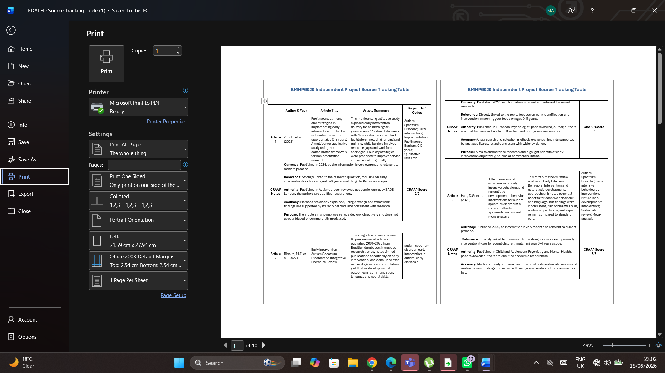
Appendix 1
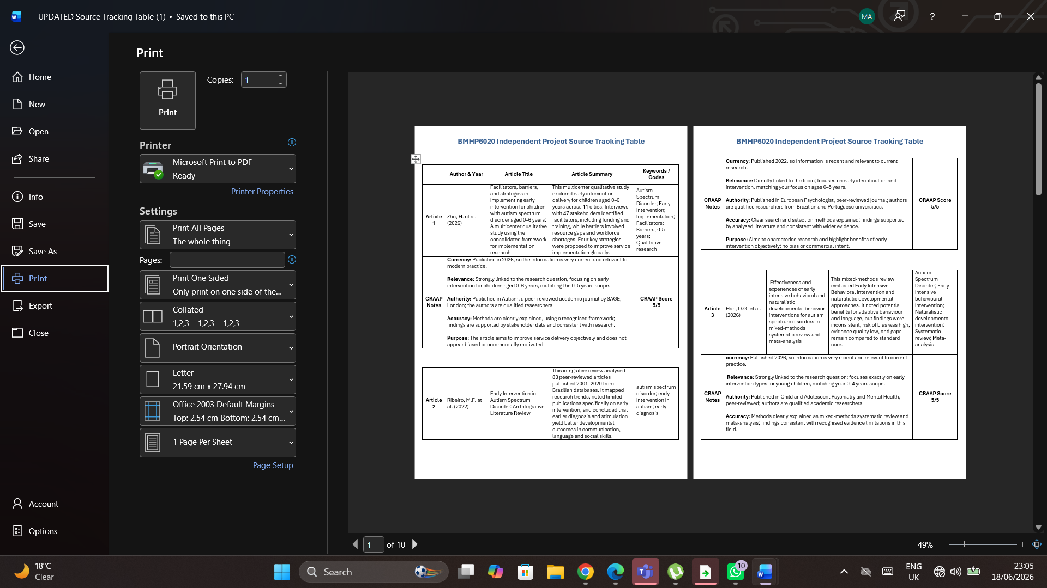
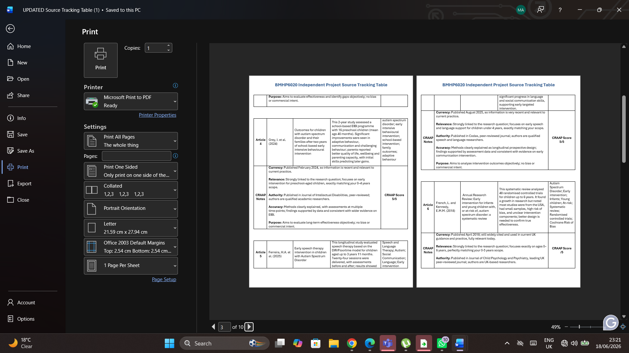
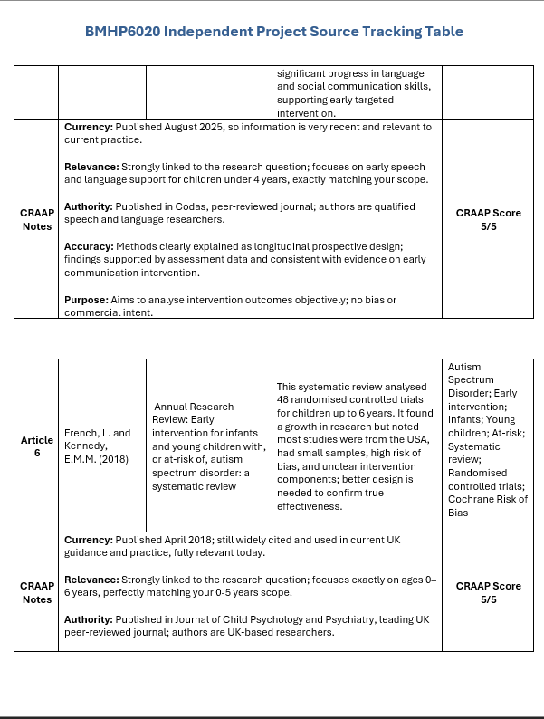

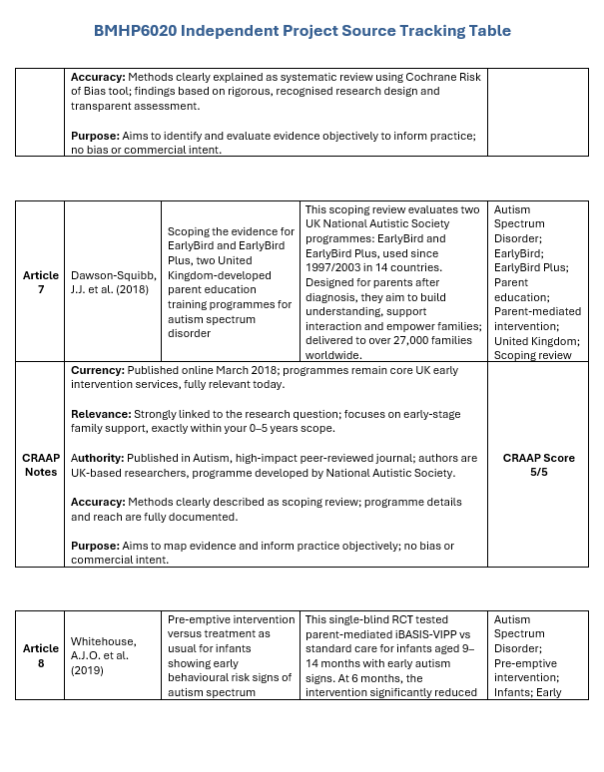
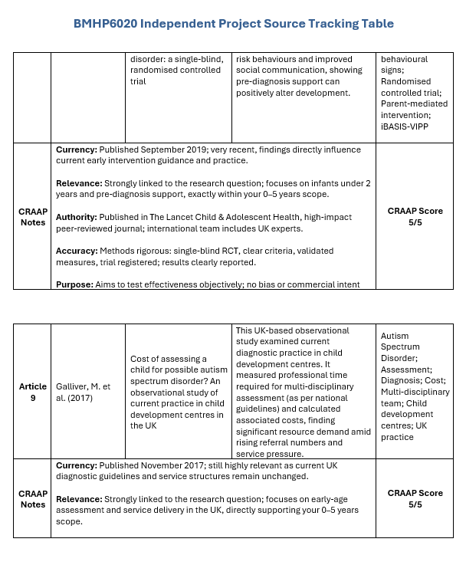

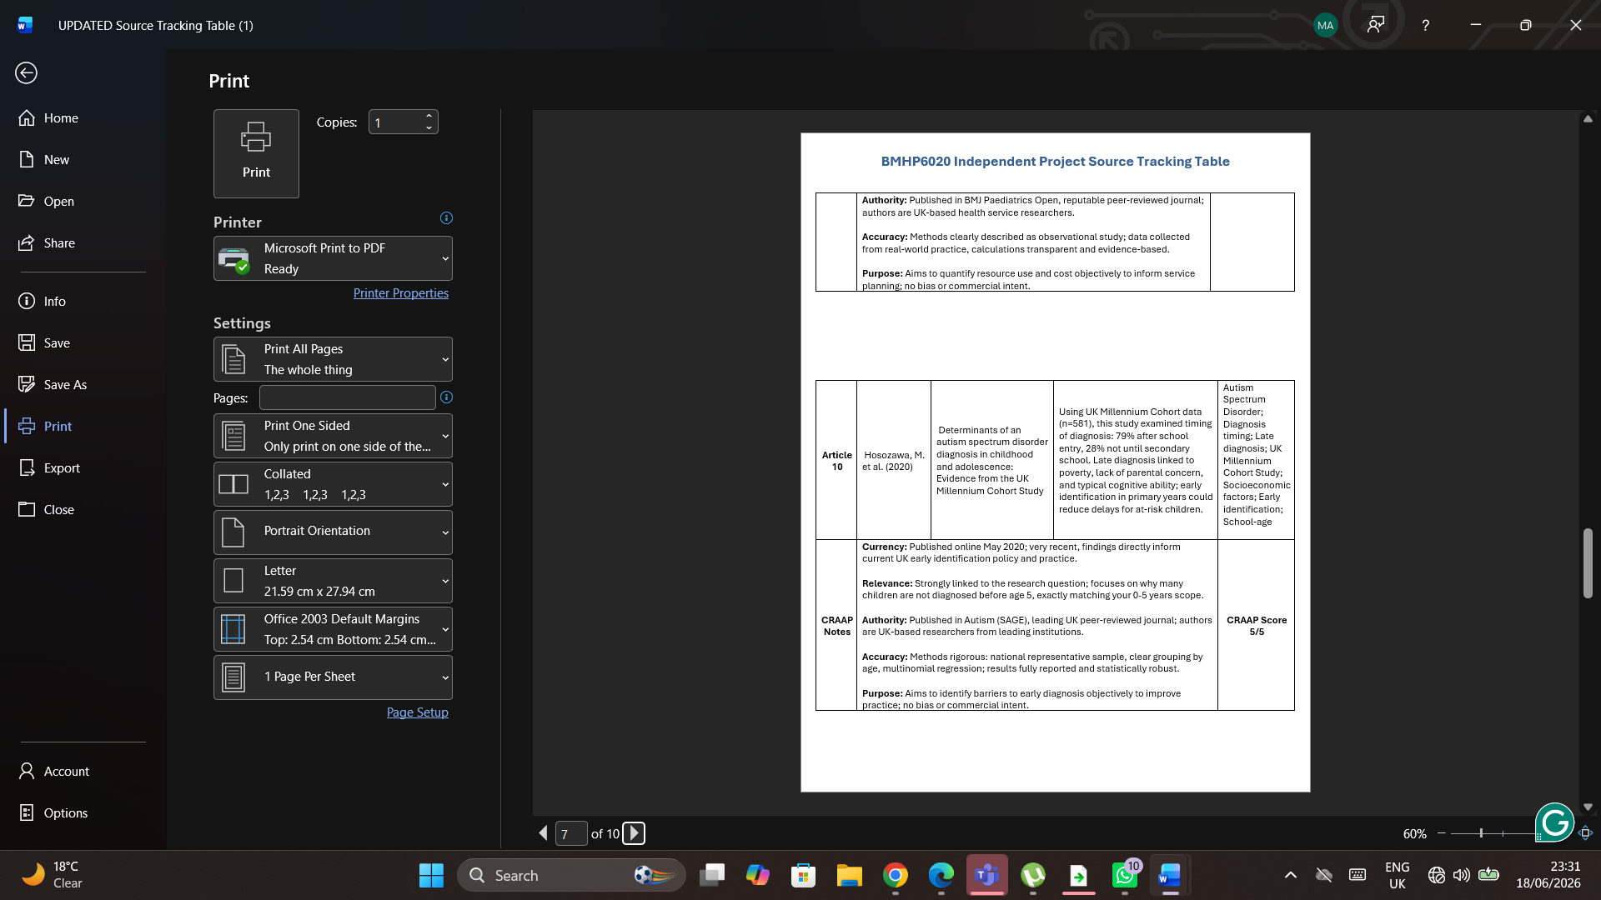

**Note – a reference list is an essential part of your dissertation and there at to be between 50-100 references needed within your reference list from credible and reliable sources of information. Ensure to include a variety of sources from books, journal articles, websites and statistical data bases. Your reference list should also be in the Harvard Referencing format, further information can be found below:
- UWTSD Harvard Referencing Handbook
- Cite them Right - Harvard Referencing

6.2 – Appendices

You can include any information within your appendices which you believe to be relevant and beneficial to your dissertation but could not add within the main body of your work. Examples of this can include: data and statistics, case studies or other documentation.


Appendix 2







Additional Information

- It is important to remember that the word limit is part of the task. You will lose marks if you go over or under 10% of your given word count for the dissertation.
- It is a requirement that you submit your work in a MS Word processed format.
- Pictures, diagrams and visuals are welcome within your work. Seek guidance for illustrative material.
- Black word-processed print to be used. The font chosen for the main body of the finished work is Arial, Calibri or Aptos, point 11.
- Text should be at least 1½ line spacing (usually double-spaced) and of justified alignment (straight edges both sides).
- Pages shall be numbered consecutively from the first page of the first chapter throughout the main text (including appendices) in Arabic numerals (i.e. 1, 2, 3, etc.).
- Page numbers should be located at the bottom of the page.
- Main text should be divided into chapters beginning with an introductory chapter which sets the scene. Each chapter should begin on a separate page.

