

BA (Hons) Leadership and Management Skills for the Workplace

Student Name: Senita Ghirrdra
Student Number: 2336206
Module: Strategic Management for Business (LCLM6001)
Lecturer Name: Dr Faizu Edu
Session: May 2026
Assignment:

Strategic Analysis and Recommendations for VodafoneThree

Contents
1. Executive Summary | 3
2. Introduction to Vodafone | 3
3. Evaluation of Current Market Situation | 4
3.1 PESTEL Analysis | 4
3.2 Porter’s Five Forces | 5
3.3 SWOT Analysis | 6
4. Strategic Growth Options and Proposed Strategy | 7
5. Strategy Evaluation | 9
6. Stakeholder Analysis | 10
7. Implementation and Monitoring | 11
8. Conclusion | 13
References | 14

1. Executive Summary
This report evaluates VodafoneThree’s strategic position following the 2025 merger of Vodafone UK and Three UK and considers how the organisation can convert its increased scale and £11 billion network investment commitment into sustainable growth. The analysis finds that the merger provides significant strengths, including approximately 27 million customers, expanded network capabilities and targeted annual cost synergies of £700 million. However, VodafoneThree continues to operate in a highly competitive and regulated market, where major rivals are also investing heavily in digital infrastructure.
PESTEL, Porter’s Five Forces and SWOT analysis indicate that increasing data consumption, 5G development and growing business reliance on digital connectivity create opportunities beyond traditional consumer mobile services. However, high competitive rivalry and customer bargaining power make growth based primarily on price or subscriber acquisition less attractive.
Using the Ansoff Matrix, four growth routes are considered: market penetration, market development, product development and diversification. Product development is recommended as the primary strategy, focused specifically on VodafoneThree’s business market by expanding its enterprise proposition through complementary managed digital services, including security, Internet of Things (IoT) and cloud connectivity. SFA analysis indicates that this provides the strongest balance between opportunity and manageable risk. A phased pilot-and-scale implementation approach is recommended, supported by stakeholder engagement and clear financial, customer and operational Key Performance Indicators (KPIs).
2. Introduction to Vodafone
Vodafone is a global telecommunications organisation providing mobile, fixed and digital connectivity services to consumers and businesses. Its UK operations are currently undergoing significant strategic transformation following the 2025 merger between Vodafone UK and Three UK. The £16.5 billion transaction created VodafoneThree, the UK’s largest mobile operator, serving approximately 27 million customers. The merger increases the scale and capabilities of the combined organisation and forms part of Vodafone Group’s wider strategic focus on restoring growth, improving customer experience, simplifying operations and strengthening its competitive position.
VodafoneThree states that its mission is to build the UK’s best network, supported by its wider purpose to “connect every community” (VodafoneThree, 2026). This purpose is reflected in four ambitions: becoming number one for customers, network, business and people. These priorities are also consistent with Vodafone Group’s broader commitment to enabling a digital, inclusive and sustainable society (Vodafone Group, 2026a). The organisation therefore seeks stronger financial performance, improved connectivity, customer outcomes and wider economic and social value.
Central to this transformation is an £11 billion ten-year network investment programme to expand coverage, improve performance and support applications including IoT and smart cities. The merger is also expected to generate approximately £700 million in annual cost synergies through network and operational integration. However, greater scale and investment do not automatically create competitive advantage; VodafoneThree must convert its expanded capabilities into sustainable commercial growth while managing post-merger integration. The following analysis therefore evaluates VodafoneThree’s current market position before identifying and assessing potential strategic growth options.
3. Evaluation of Current Market Situation
VodafoneThree operates within a market shaped by regulatory intervention, high infrastructure investment, intense competition and rapidly changing digital demand. PESTEL is used to assess how these external conditions affect VodafoneThree’s strategic position, while Porter’s Five Forces evaluates competitive pressures within the UK telecommunications market. SWOT then synthesises these findings to identify the organisation’s key strategic strengths, weaknesses, opportunities and threats.
3.1 PESTEL Analysis
Politically and legally, the Vodafone–Three merger has significantly changed the UK mobile market and attracted regulatory scrutiny. The Competition and Markets Authority approved the merger subject to legally binding commitments, including network investment and protections relating to selected consumer tariffs and wholesale access (CMA, 2024). VodafoneThree has therefore gained greater scale but must demonstrate that the merger delivers benefits to customers and competition. The £11 billion investment is consequently both a commercial opportunity and regulatory commitment.
Economically, telecommunications is highly capital intensive, while conventional mobile subscription growth is limited. Ofcom (2026) reported 90.6 million active mobile subscriptions in Q1 2026, representing annual growth of only 1.0%, compared with a 13.1% increase in mobile data usage to 3,042 petabytes. This suggests that consumer mobile connectivity is a mature market with limited growth from subscriber acquisition alone, while increasing data consumption creates opportunities to generate greater value from connectivity.
Competition for this growth remains strong. BT expects to invest more than £40 billion in UK digital infrastructure between 2020 and 2030, while Virgin Media O2 reports investment exceeding £2 billion annually (BT Group, 2026; Virgin Media O2, 2026). VodafoneThree’s £11 billion commitment therefore strengthens its position, but comparable investment by rivals means infrastructure expenditure alone is unlikely to provide sustained differentiation.
Social and technological developments strengthen the case for creating greater value from the network. Connectivity is increasingly important for employment, business and access to services, while VodafoneThree identifies digital inclusion and online safety as significant social issues (VodafoneThree, 2026). Meanwhile, 5G provides opportunities to move beyond traditional connectivity by enabling new revenue streams through IoT-based services, smart-city applications and managed digital platforms (Rangga et al., 2024). This is particularly relevant to VodafoneThree because its network investment could support higher-value business services rather than simply improving mobile connectivity.
Dynamic capabilities research supports this distinction. Competitive advantage depends upon an organisation's ability to “integrate, build, and reconfigure” competencies as conditions change (Cavusgil and Deligonul, 2025, p. 33). The merger therefore creates potential rather than advantage; its value depends upon VodafoneThree successfully integrating and commercialising its enlarged capabilities.
Environmental pressures provide a further consideration. Vodafone monitors energy use, emissions and network waste within its non-financial performance (Vodafone Group, 2026a). Network integration may enable duplicated infrastructure to be removed and efficiency improved, potentially aligning commercial and environmental objectives.
Overall, PESTEL reveals a strategic tension: VodafoneThree benefits from greater scale, increasing data demand and stronger network capabilities, but faces regulatory obligations, substantial investment commitments and well-funded competitors.
3.2 Porter’s Five Forces
Competitive rivalry is high, with VodafoneThree competing against BT/EE, Virgin Media O2 and lower-cost providers. Competitors are also strengthening their business propositions; Virgin Media O2, for example, has created O2 Daisy as a dedicated B2B challenger (Virgin Media O2, 2026).
Buyer power is high because consumers can compare providers relatively easily, while business customers can negotiate significant contracts. Sustained price competition is therefore unattractive. Supplier power is moderate because operators depend upon specialist technology and infrastructure suppliers, although VodafoneThree’s increased scale may strengthen its bargaining position. The threat of new nationwide network operators is low due to high capital and regulatory barriers, although mobile virtual network operators (MVNOs) and digital providers can compete for parts of the customer relationship. Substitution is moderate: customers still require connectivity but increasingly use internet-based alternatives for communication.
Five Forces therefore reinforces the PESTEL findings. In a market characterised by high rivalry and buyer power, competing primarily through price risks eroding the value created by the merger. VodafoneThree instead needs to differentiate how its expanded network creates customer value.
3.3 SWOT Analysis
The PESTEL and Five Forces findings can be consolidated through SWOT, distinguishing VodafoneThree’s internal capabilities from the opportunities and threats within its external environment.
Table 1: SWOT Analysis of VodafoneThree

Strengths | Weaknesses
Approx. 27 million customers following merger | Complexity of integrating two major organisations
Combined Vodafone and Three network capabilities | Significant integration commitments
£11bn network investment programme | Need to convert investment into commercial returns
Targeted £700m annual cost synergies | Merger benefits depend on successful integration
Existing Vodafone Business capabilities | Integration and growth may stretch capability
Opportunities | Threats
Rapidly increasing mobile data consumption | Intense rivalry from BT/EE and Virgin Media O2
Growth in enterprise digital connectivity | Major competitor infrastructure investment
5G-enabled IoT and connected services | High customer bargaining power
Security and cloud connectivity services | Regulatory scrutiny following merger
Expansion among SMEs and public-sector organisations | Network improvements may be replicated

The SWOT indicates that VodafoneThree’s strategic challenge is not a lack of resources but converting them into sustainable competitive advantage. This is particularly important because research shows that merger activity does not automatically improve performance; strategic alignment and successful assimilation of capabilities influence whether anticipated benefits are realised (López-Manuel et al., 2024).
The strongest opportunity therefore lies in commercialising the improved network through higher-value services for business customers. However, competitor investment and the potential replication of network improvements mean infrastructure alone is unlikely to provide lasting differentiation.
The analysis consequently raises the strategic question: how can VodafoneThree convert its greater scale, investment and capabilities into sustainable growth rather than simply becoming a larger mobile operator? Section 4 addresses this by evaluating the four growth options within the Ansoff Matrix.
4. Strategic Growth Options and Proposed Strategy
Ansoff’s (1957) Matrix provides a useful framework for assessing potential growth by distinguishing between existing and new products and markets. As illustrated in Figure 1, the framework identifies four potential growth routes for VodafoneThree: market penetration, market development, product development and diversification. Comparing all four options enables selection of the most appropriate strategic direction.
Figure 1: Ansoff Matrix Applied to VodafoneThree
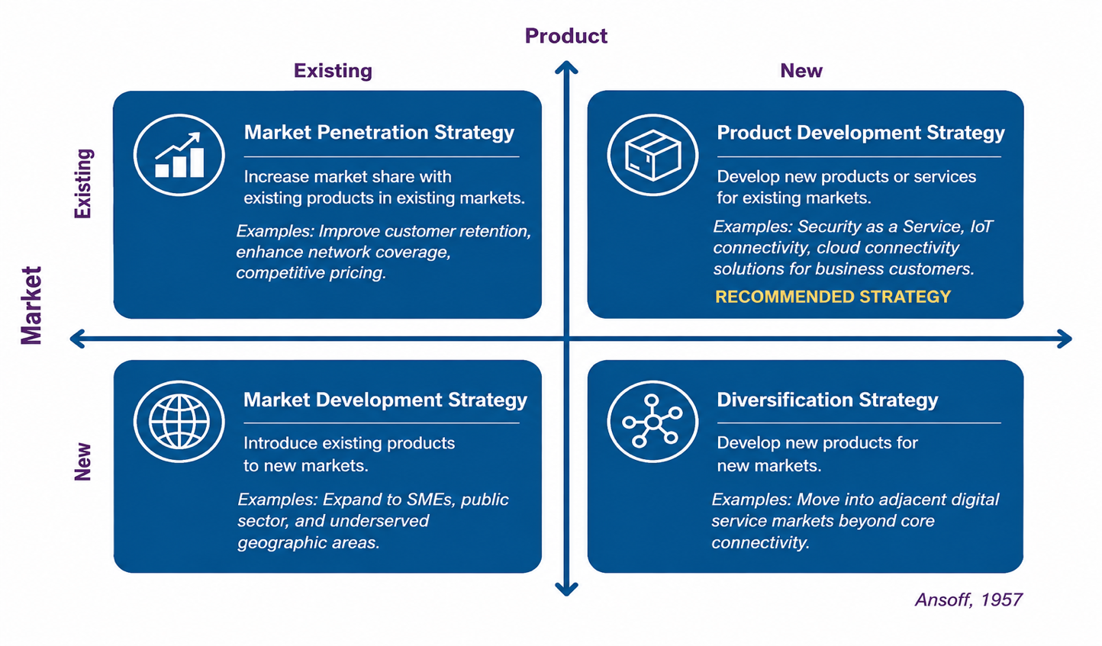
The first option is market penetration, involving greater sales of existing services within the UK market. Improved coverage, customer service and competitive propositions could help retain customers and attract users from competitors. However, the market analysis identified traditional mobile connectivity as a mature market, with only 1.0% annual subscription growth and strong competitive rivalry. Aggressive penetration through price reductions could therefore transfer customers between operators rather than create substantial market growth. Market penetration remains important for protecting VodafoneThree’s core position but is unlikely to provide sufficient long-term growth independently.
The second option, market development, would use existing services to reach new customer segments. Improved national coverage could enable VodafoneThree to serve businesses and communities previously affected by weaker connectivity, supporting its purpose to “connect every community”. The enlarged network could also support greater penetration among SMEs and public-sector organisations. This offers additional growth while remaining close to existing capabilities, although VodafoneThree would still depend heavily upon traditional connectivity revenues.
The third option is product development, providing new or enhanced services to markets VodafoneThree already understands. This offers an attractive balance between opportunity and risk because VodafoneThree can build upon existing customer relationships, network capabilities and Vodafone Business. Rather than viewing the £11 billion investment simply as infrastructure expenditure, the enhanced network can become a platform for higher-value business services.
The proposed Product Development strategy is therefore to deepen VodafoneThree’s existing enterprise proposition by integrating connectivity more closely with managed security, IoT and cloud connectivity services for its established business market. VodafoneThree would move beyond selling businesses mobile and data contracts towards becoming a broader connectivity partner supporting their employees, systems and devices. This directly supports its ambition to become #1 for business while generating greater commercial value from existing resources.
The final option is diversification, involving substantially new services and customer markets. Research on Telecom as a Service (TaaS) suggests that telecommunications organisations can extend beyond conventional connectivity into subscription-based managed security, IoT and cloud solutions (Hegde and Varughese, 2025). However, the research also identifies integration difficulties, security concerns and vendor dependency. Large-scale diversification would therefore be particularly risky while VodafoneThree is integrating a major merger.
Consequently, Product Development provides the strongest balance between growth potential and manageable risk. Market penetration should protect the core business, while market development can extend existing services into attractive customer segments. Related diversification can develop gradually once new capabilities have been demonstrated successfully. In competitive-strategy terms, this represents differentiation rather than cost leadership: VodafoneThree should create greater customer value through its combined network and services rather than becoming the lowest-cost provider.
The recommendation flows directly from the preceding analysis. PESTEL identified increasing digital demand and investment commitments; Five Forces demonstrated why price competition is unattractive; SWOT highlighted enlarged capabilities alongside integration risks; and Ansoff identifies Product Development as the strongest route for converting these capabilities into growth. The proposed strategy must now be tested through SFA to determine whether it is suitable, feasible and acceptable.
5. Strategy Evaluation
The Suitability, Feasibility and Acceptability (SFA) framework provides a structured basis for evaluating whether a strategy responds effectively to the external environment, can realistically be delivered and produces outcomes acceptable to the organisation’s stakeholders (Johnson et al., 2008).
From a suitability perspective, product development responds directly to the strategic conditions identified earlier. The UK consumer mobile market is highly competitive, conventional subscription growth is relatively modest and VodafoneThree has committed substantial resources to infrastructure. At the same time, data consumption and organisational dependence upon digital connectivity continue to increase. Expanding enterprise services therefore gives VodafoneThree an opportunity to generate additional value without relying primarily on consumer price competition. Research into digital transformation further suggests that digital change affects how businesses organise themselves and create value rather than simply involving adoption of individual technologies (Verhoef et al., 2021). This strengthens the rationale for VodafoneThree to support business customers through broader connectivity services.
The strategy is also potentially feasible because VodafoneThree possesses substantial resources, including approximately 27 million customers, an expanded network, Vodafone’s existing Business operation and the £11 billion investment programme. Nevertheless, feasibility cannot be judged purely by financial and technological resources. The organisation must simultaneously integrate Vodafone and Three while developing new propositions. Research into acquisitions indicates that strategic alignment and the ability to assimilate capabilities are important determinants of post-acquisition performance (López-Manuel et al., 2024). VodafoneThree should therefore introduce new enterprise propositions gradually rather than attempting an immediate large-scale transformation.
In terms of acceptability, the strategy offers potential benefits to shareholders, customers and employees, but also creates identifiable risks. Shareholders could benefit from additional revenue streams and more effective commercial use of infrastructure already being developed. Enterprise customers could gain access to more integrated services, while employees may benefit from opportunities to develop new skills. However, customer adoption cannot be guaranteed, additional services require investment and competitors including BT and O2 Daisy are pursuing similar business opportunities. The strategy therefore relies upon several assumptions: that business demand for digital connectivity continues to grow, that integration proceeds sufficiently to support new services, that customers perceive value in an integrated proposition and that additional investment produces acceptable returns.
These assumptions should be acknowledged rather than presented as certainties. VodafoneThree should test them through controlled customer pilots before committing substantial additional resources. Overall, SFA supports Product Development, but conditionally: suitability is strong, feasibility is credible and acceptability depends on disciplined investment, successful integration and demonstrable customer demand. This supports phased implementation rather than immediate full-scale expansion. These conditions make effective stakeholder management particularly important.
6. Stakeholder Analysis
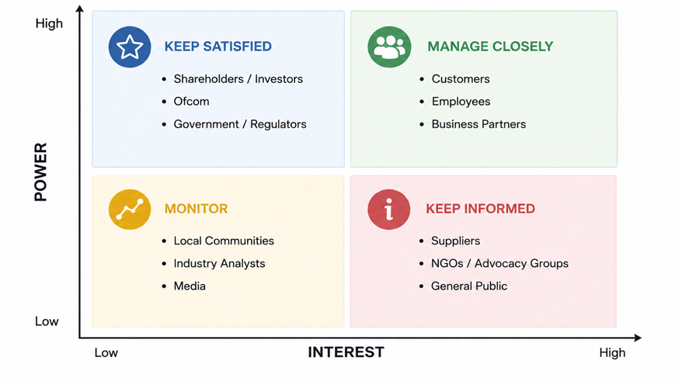
Mendelow’s stakeholder mapping framework categorises stakeholders according to their relative power and interest, allowing organisations to prioritise different approaches to engagement (Mendelow, 1981). Figure 2 applies this framework to the key stakeholders affected by VodafoneThree’s proposed Product Development strategy.

Figure 2: Mendelow Power–Interest Matrix for VodafoneThree
As illustrated in Figure 2, the VodafoneThree Board and senior leadership possess both high power and high interest because they determine strategic priorities, allocate resources and remain accountable for delivery of the merger’s promised benefits. They should therefore be managed closely through regular reporting on customer, financial, integration and strategic performance. CMA and Ofcom also possess high power and high interest because VodafoneThree must continue to demonstrate compliance with competition, consumer-protection and network-investment commitments. Engagement with regulators should therefore remain proactive and transparent rather than taking place only when problems arise.
Enterprise customers are central to the proposed growth strategy because their willingness to adopt additional services ultimately determines its commercial success. Selected customers should therefore be involved in the design and testing of new propositions, enabling VodafoneThree to develop services around real business needs rather than assumed demand. Shareholders and investors also require careful engagement because although product development could improve long-term returns, they may be concerned if additional investment increases financial exposure without evidence of commercial performance.
Employees have comparatively less formal power but high interest because both merger integration and the proposed strategy may change organisational structures, skills and responsibilities. Communication, consultation and reskilling should therefore form part of implementation. Technology partners, suppliers and communities also require appropriate engagement where they support service delivery or are affected by VodafoneThree’s network commitments. The stakeholder analysis consequently demonstrates that successful strategy implementation depends upon coordinated organisational support rather than financial investment alone, leading directly to the implementation and monitoring plan.
7. Implementation and Monitoring
The proposed strategy should be implemented through a phased pilot, evaluate and scale approach. This reduces the risk of committing substantial resources before VodafoneThree has demonstrated customer demand and operational capability. Holm et al.’s (2026) systematic review of 160 studies concludes that effective strategy implementation depends upon both managerial and organisational factors, including leadership, resource allocation, communication, organisational structures and continuous learning. Implementation should therefore be treated as a company-wide strategic initiative rather than simply a new product launch. Table 2 translates this strategy into a phased implementation and monitoring plan.

Table 2: VodafoneThree Product Development Implementation and Monitoring Plan
Objective | Action | Timing | Key Performance Indicators
Protect the core business | Continue integration while maintaining customer experience and network improvements | Year 1 onwards | Customer retention, churn, satisfaction, network performance
Identify enterprise opportunities | Research priority business segments and engage existing enterprise customers | Months 0–6 | Qualified opportunities, customer participation, pipeline value
Develop and test services | Pilot new enterprise propositions with selected customers | Months 6–18 | Pilot uptake, conversion to contracts, customer satisfaction, implementation cost
Scale successful propositions | Expand proven services across Vodafone Business customer base | Years 2–3 | Enterprise revenue growth, contract numbers, renewals, recurring revenue
Monitor strategic returns | Review financial, customer, operational and regulatory performance | Ongoing | Return on investment (ROI), profitability contribution, retention, regulatory milestones

As shown in Table 2, scaling occurs only after customer demand and operational capability have been tested. A cross-functional implementation team should bring together Vodafone Business, finance, customer experience, HR, technology and regulatory expertise. This ensures commercial objectives, customer requirements, employee capability and regulatory commitments remain aligned. Communication will be particularly important during the merger period. Holm et al. (2026) identify communication and operationalisation as important mechanisms for translating strategy into action, meaning employees need to understand both the purpose of the enterprise growth strategy and their individual responsibilities in delivering it.
Monitoring should combine financial and non-financial indicators, consistent with Vodafone’s existing use of both types of KPI (Vodafone Group, 2026b). Management should also establish clear decision points before pilots begin. Services demonstrating strong customer demand and acceptable returns should receive additional resources, whereas propositions that do not meet agreed thresholds should be revised or discontinued. This creates strategic discipline by preventing further investment in weak propositions simply because resources have already been committed.
The implementation approach therefore completes the strategic logic established throughout the report. The merger provides increased scale; environmental analysis identifies the external opportunity and constraints; competitive analysis demonstrates the need for differentiation; Ansoff identifies Product Development as the preferred growth route; SFA tests whether the strategy is viable; stakeholder analysis identifies the groups required to support delivery; and phased implementation provides a realistic mechanism for translating the recommendation into sustainable growth.
8. Conclusion
The Vodafone–Three merger has created a stronger organisation with greater scale, network capability and potential to compete in the UK telecommunications market. However, the analysis demonstrates that size and infrastructure investment alone will not create sustainable competitive advantage. VodafoneThree must convert these resources into services that generate additional customer value and commercial returns.
Of the four Ansoff growth options evaluated, Product Development provides the strongest strategic direction. Expanding the enterprise proposition into complementary security, IoT and cloud connectivity services builds upon existing capabilities while avoiding the greater risk associated with immediate large-scale diversification. Market penetration and development should continue to support the core business.
Successful delivery will depend upon merger integration, customer demand, stakeholder support and disciplined investment. A phased approach, using pilots and measurable KPIs before wider expansion, therefore provides VodafoneThree with a realistic route towards sustainable growth while supporting its ambition to become the UK’s leading network and business connectivity provider.

References
Ansoff, H.I. (1957) ‘Strategies for diversification’, Harvard Business Review, 35(5), pp. 113–124.
BT Group (2026) Annual Report 2026. Available at: https://www.bt.com/about/annual-reports/2026summary/#ceos-message (Accessed: 1 August 2026).
Cavusgil, S.T. and Deligonul, S.Z. (2025) ‘Dynamic capabilities framework and its transformative contributions’, Journal of International Business Studies, 56(1), pp. 33–42. Available at: https://doi.org/10.1057/s41267-024-00758-8.
Competition and Markets Authority (CMA) (2024) CMA clears Vodafone / Three merger, subject to legally binding commitments. Available at: https://www.gov.uk/government/news/cma-clears-vodafone-three-merger-subject-to-legally-binding-commitments (Accessed: 4 August 2026).
Hegde, P. and Varughese, R.J. (2025) ‘Telecom as a Service (TaaS): Subscription-Based Telecom Offerings for Managed Security, IoT Solutions, and Cloud Connectivity’, International Journal of Communication Networks and Information Security, 17(3), pp. 291–300. Available at: https://www.proquest.com/scholarly-journals/telecom-as-service-taas-subscription-based/docview/3232790620/se-2?accountid=130472 (Accessed: 3 August 2026).
Holm, C.G., Kringelum, L. and Anand, A. (2026) ‘Creating effective strategy implementation: a systematic review of managerial and organizational levers’, Review of Managerial Science, 20(2), pp. 673–705. Available at: https://doi.org/10.1007/s11846-025-00880-3.
Johnson, G., Scholes, K. and Whittington, R. (2008) Exploring Corporate Strategy: Text and Cases. 8th edn. Harlow: Pearson Education.
López-Manuel, L., Sartal, A. and Vázquez, X.H. (2024) ‘On the alignment of competitive strategies for successful acquisitions: a two-decade longitudinal analysis’, Competitiveness Review, 34(4), pp. 703–717. Available at: https://doi.org/10.1108/CR-10-2022-0156.
Mendelow, A.L. (1981) ‘Environmental scanning: the impact of the stakeholder concept’, in Proceedings of the Second International Conference on Information Systems, Cambridge, MA, pp. 407–418.
Ofcom (2026) Telecommunications Market Data Update. Last updated 23 July 2026. Available at: https://www.ofcom.org.uk/phones-and-broadband/telecoms-infrastructure/telecommunications-market-data-update (Accessed: 3 August 2026).
Rangga, Y.D.P., Rahayu, S. and Ganiyev, K. (2024) ‘5G Technology’s Impact on Efficiency and Innovation in Telecommunications’, Management Dynamics: International Journal of Management and Digital Sciences, 1(2), pp. 10–19. Available at: https://doi.org/10.70062/managementdynamics.v1i2.445.
Verhoef, P.C., Broekhuizen, T., Bart, Y., Bhattacharya, A., Dong, J.Q., Fabian, N. and Haenlein, M. (2021) ‘Digital transformation: A multidisciplinary reflection and research agenda’, Journal of Business Research, 122, pp. 889–901. Available at: https://doi.org/10.1016/j.jbusres.2019.09.022.
Virgin Media O2 (2025) VMED O2 UK Limited: Annual Report and Consolidated Financial Statements 2025. Available at: https://news.virginmediao2.co.uk/wp-content/uploads/2026/04/VMED-O2-UK-Limited-2025-Annual-Report-and-Consolidated-Financial-Statements.pdf (Accessed: 2 August 2026).
Vodafone Group Plc (2026a) Annual Report 2026. Available at: https://www.vodafone.com/investors/performance-and-reports/annual-reporting (Accessed: 2 August 2026).
Vodafone Group Plc (2026b) Key Performance Indicators. Available at: https://reports.investors.vodafone.com/view/500231330/8/ (Accessed: 1 August 2026).
VodafoneThree (2026) Sustainability and Social Impact Report. Available at: https://www.vodafonethree.com/impact-report/ (Accessed: 1 August 2026).

