LEVEL 4 ASSESSMENT SPECIFICATION

Student name: Serroukh serroukh
Student ID number: 2541168
Programme: CertHE Computing Skills for Workplace
Module: Learning in the Digital Era
Module code: ACCA4025 Contribution to
Overall Module
Assessment (%): 50%
Lecturer: Suneth Warnakulasooriya Internal Verifier: Sadhana Jha
Assignment Title: Component 1- E-Portfolio Word count (or equivalent):
Submission deadline:
13-11-2026 2 pm
Return date of provisional marks & written feedback: 11-12-2026

Introduction to Data Computing for the Workplace, with a focus on Business Platforms. This means learning how organisations use digital tools, spreadsheets, databases, cloud platforms, business intelligence and AI to manage information and make decisions.

Task 01 A
Introduction to data computing for the work place with foucus on buissness platforms this means learinging how to use digital
Essential skills required for academic studies and future employment

Essential skills required for academic studies (use at least 2 credible sources which talk about Essential skills required for academic studies (apply IEEE referencing) (150 words)

At university, academic writing is a skill students use each day. A must for all degrees is a strong grasp of the English language (international students or not). Being able to write to a good standard is key for coursework assignments such as dissertations and lab reports as well as during exams, answering longer written answers and essay questions.​ [1]​

You are expected to build on what you learnt at A-levels where instead of outlining a point, you have to be able to argue it using appropriate formal language matching the writing style of academic research. If spelling and grammar is an issue for you, it is time to put the work in before you start your degree as lecturers will not appreciate reading an essay that is full of grammatical errors and misspelt words.​ [1]​

- analyse 3-5 current popular AI assistants and briefly document the best use for each. use several screenshots of 3 – 5 AI assistants. ( 200 words)

Criteria | ChatGPT | Copilot | Gemini
Generating answers | Explains business and computing concepts. | Answers workplace questions and summarises information. | Explains concepts and assists with research.
creative work, code/diagram generation | Generates ideas, code and diagram descriptions. | Assists with coding and workplace content. | Helps brainstorm, write and develop code.
data analysis | Analyses spreadsheets and creates charts. | Analyses Excel data and suggests formulas. | Helps interpret information and organise data
problem-solving | Breaks tasks into manageable steps. | Supports Microsoft 365 workflows | Helps explore options and develop solutions.

- Identify a course available in LinkedIn which talks about AI assistance.

I recommend Career Essentials in Generative AI by Microsoft and LinkedIn. This learning path covers generative AI, practical workplace applications, Microsoft Copilot and the ethical use of AI. It is relevant to my studies in data computing and business platforms because it explains how AI can improve productivity and support business tasks.

LinkedIn Learning, formerly Lynda.com
+1
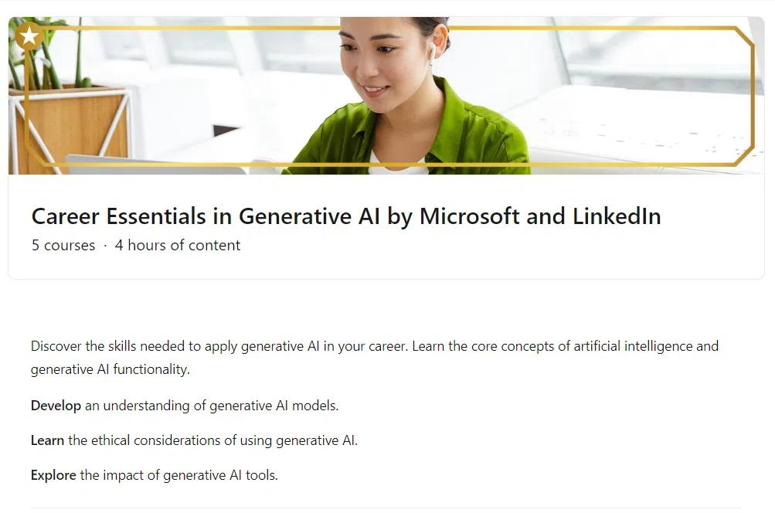
Course details
- Provider: Microsoft and LinkedIn Learning
- Topics: Generative AI, AI tools, workplace productivity and responsible AI
- Duration: Approximately 4 hours, depending on the current course requirements
- Relevance: Using AI assistants to support business data analysis and everyday workplace tasks.
Open the course on LinkedIn Learning
Evidence of engagement
- Open the course link and sign in to LinkedIn Learning.
- Start the course and complete a relevant module.
- Take a screenshot showing the course title and your learning progress.
- Add the screenshot to your assignment with a caption describing what you learned.
Example caption: Figure 4. Evidence of my engagement with the Career Essentials in Generative AI learning path on LinkedIn Learning.

- Submit this document to Turnitin and generate the similarity report and take a screenshot of your similarity report and paste it here. Please evaluate your similarity percentage. (200 words) – self evaluation

- 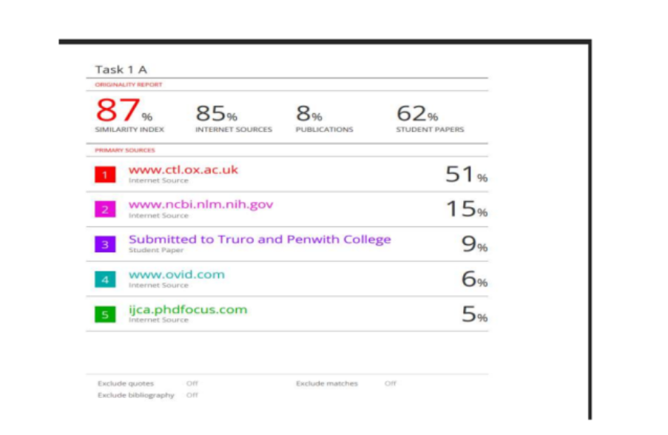
In this similarity report, it shows 87%

Reflection on Turnitin Similarity and Self-Assessment
After submitting my assignment to Turnitin, I received a similarity score of [insert your actual percentage]%. This helped me understand the importance of academic integrity and correct referencing. I learned that a similarity score identifies text matching other sources and does not automatically mean plagiarism [1]. Reviewing the similarity report can help me identify passages that need better paraphrasing, clearer citations or quotation marks.

In future assignments, I will improve my academic writing by researching information from several credible sources, explaining ideas in my own words and using the IEEE referencing style consistently. I will also check that every in-text citation corresponds to an entry in my reference list. Additionally, I will use AI tools responsibly to support my understanding and planning rather than relying on them to produce unverified information.

Using the Generic Assessment Criteria (GAC) as a guide, I would award myself [insert your mark]%. I believe this mark reflects my understanding of the topic, my effort in researching relevant information and my ability to connect digital skills with business platforms. However, I recognise that I need to improve my critical analysis, academic writing and referencing. By acting on these areas, I aim to produce more accurate, well-structured and independent academic work in future assignments.

Before submitting
Replace [insert your actual percentage] with your Turnitin score.

Replace [insert your mark] with a realistic mark based on your assignment's GAC.

Check your university's assessment criteria before finalising your self-assessment.

Reference

[1] Turnitin, “Understanding the similarity score for students.” [Online]. Available:
https://guides.turnitin.com/hc/en-us/articles/23713493434253-Understanding-the-similarity-score-for-students . [Accessed: Oct. 15, 2026].

Task 2

​​References
​​
​[1] | ​A. Sen, “uniadmissions,” 4th August 2025. [Online]. Available: https://www.uniadmissions.co.uk/application-guides/6-essential-skills-for-university-students/. [Accessed 8th October 2026].
​[2] | ​Lemon. T, Lampard. R, Stone. B, “National Library of Medicine,” 10th April 2013. [Online]. Available: https://pmc.ncbi.nlm.nih.gov/articles/PMC3722370/. [Accessed 8th October 2026].
​​​￼
​​​

