

Assessment 1 – Reading Task Template
PART 1: Upload your photo of your A3 in-class notes here:
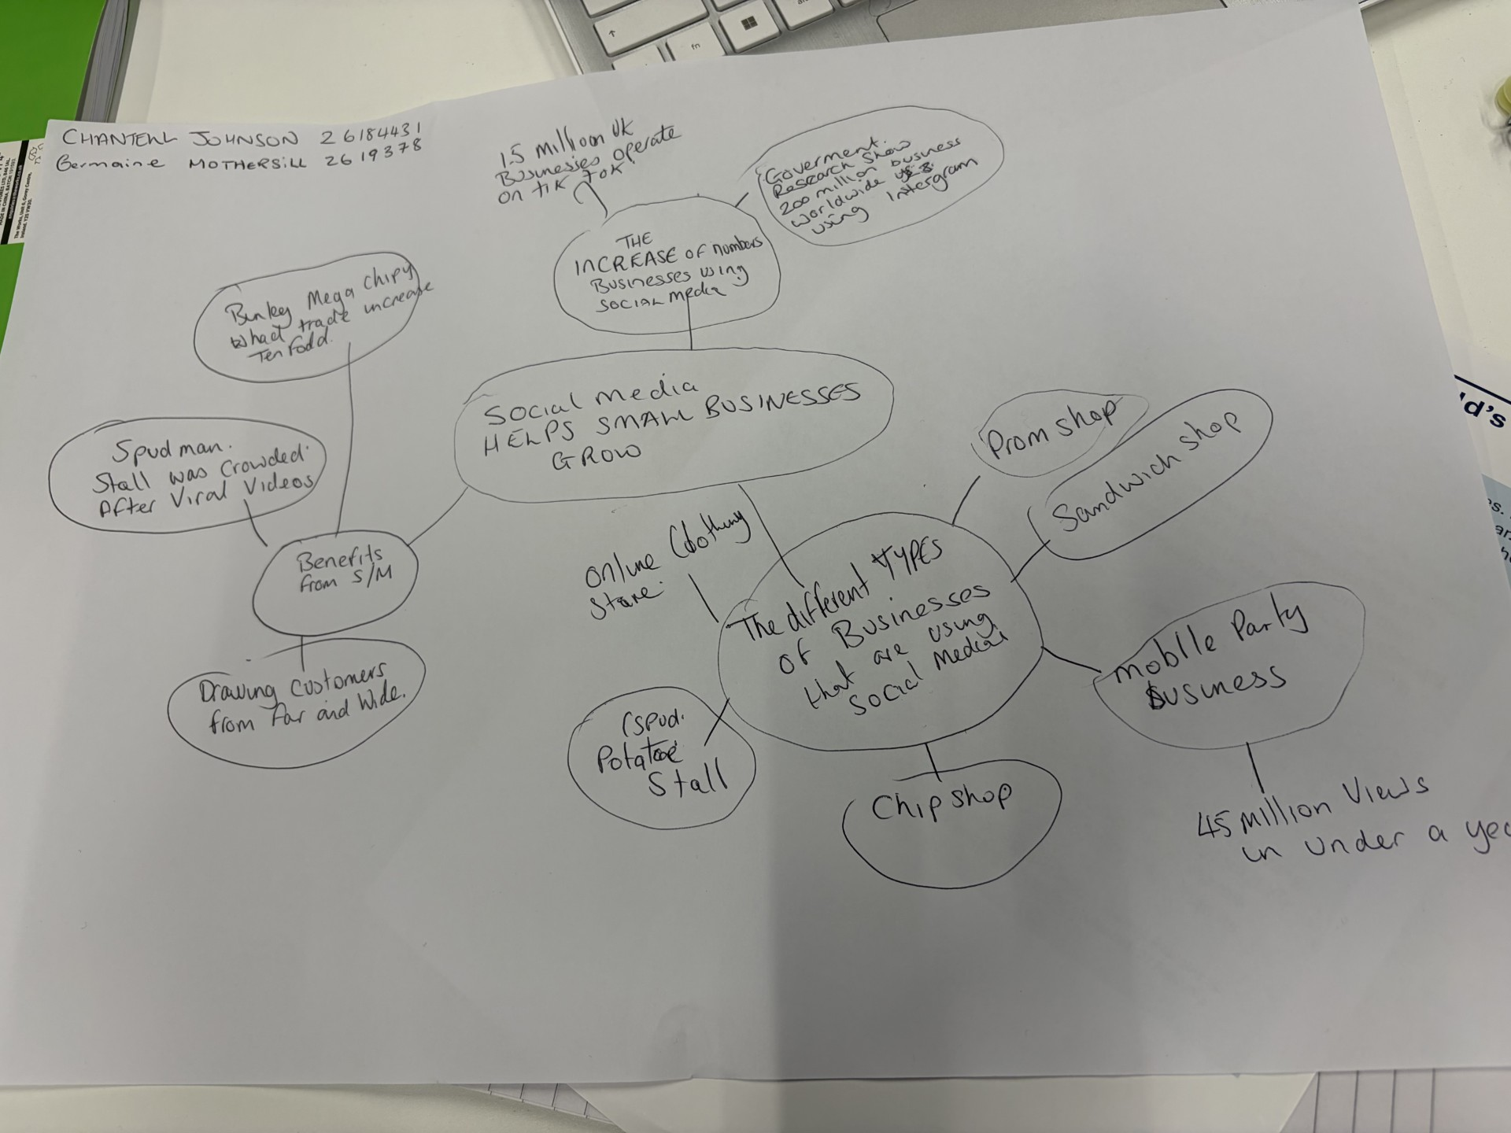

PART 2:
- Answer every question below in 1-3 full sentences.
- Use your own words. Do not use generative AI to answer these questions.
- Include a specific detail from the text when asked.
REMINDER
- The main idea is the overall message of the whole text.
- A key point helps to explain the main idea.
- A specific detail or example from the text shows that the key point is true.

- What is the main idea of the whole text?
ANSWER
The main idea of the BBC News article is how social media grows businesses. It refers to numerous types of businesses and how having a social media platform has helped their business grow. It also has accounts from different types of business owners explaining how it has helped them with facts and figures to prove these points

- What is one key point that supports the main idea, and which specific example from the text shows this?
ANSWER
A key point is that businesses have had profitable trade increase since posting on platforms like Instagram and TikTok. According to the government Business Academy more than 200 million business owners are using Instagram to gain the attention of costumers globally. Whereas shared Tic Tok shared 1.5 Million UK businesses use their platform. Binley Mega Chippy saw a ten-fold in trade increase due to posting videos. Another person was "Spudman " who runs a jacket potato stall sales also went up after his post went viral

- What is a different key point that supports the main idea, and which specific example from the text shows this?
ANSWER
Another key point is that all types of businesses that are using these platforms like Instagram, Facebook and TikTok to post videos and are gaining views globally are having an increase to customers that are travelling the distance for the product or service required. The Honywood Sandwich Shop a sandwich has customers coming from distances for their chicken burger which a customer had posted. The owner of "Krystalls Boutique" she has only been posting for18 months, and she has girls coming from Cyprus and others travelling 6-hour journeys, for her prom dresses.

- Which part of the text do you think is most important, and why?
ANSWER
I think the most important part of the text is different accounts from, the different business owners selling different services and products telling their story of how social media helped them. My reasoning being is these are true accounts of small businesses giving a real aspect to me.

Reflection:
- What did you find difficult in this task (including in-class components), and why was it difficult?
ANSWER
During this task the difficulties I came across initially was that note taking and comprehension remembering a written texts just read.is not a strong area for me. In terms of explaining my myself in short or answering questions without dragging. I also found that it was hard to answer the questions based on my mind map

- What helped you with this difficulty, and how did it help you?
ANSWER
Regarding the mind map In order help me with this i done a bit of research and found out I didn't have to use everything the same but as a guide. I beleve me even using the mind mapping idea has helped makes notes in term of doing this assignment in terms of time management and daily tasks

