ACBA5001 Project Planning for Construction
|
Student number 2014439
James FEENEY
2023
Contents
Introduction 2
Method Statement 3
Bibliography 13

Introduction

Quality assurance and quality control is the effort undertaken by manufacterers, or in this case construction companies, to ensure that products and services they provide are to a good standard and without defect. Quality control attempts to ensure defects are discovered and avoided before the completetion stage. Quality assurance is
‘focussed on providing confidence that quality will be fulfilled’. (ISO 9001, 2015)

To achieve high quality, a clear process should be detailed from the top of an organisation down to the worker on the ground. The vast majority of construction firms will now have some sort of SHEQ management system in place. SHEQ standing for Safety, Health, Environment and Quality. These are governed by international standards.
- Quality (ISO 9001, 2015)
- Environment (ISO 14001, 2015)
- Safety & Occupational Healt (ISO 45001, 2018)
In construction these standards are implemented and reinforced through many different way. One way in which we ensure a quality end product is delivered is through the use of method statetment. These statements provide a logical step by step guide to completeing task in a timely yet safe manner.
In construction these statements are commonly known as RAMs, standing for risk assements and method statements. Risk assements identify potential hazards in a project and suggest porssible actions, where as the method statement walks through the task it self and detailing the measures that need to be in place to complete a task safely.
Below we have been given a project where there needs to be a bungalow deolished, and the building of a new 2 storey 4 bedroom house. I have attempted to provide a method statement for the setting up of the site, and more specifically a method statement and risk assements associated with internal plastering and external rendering.

Method Statement

Contract Name: UWTSD New House Build and demolition of current bugalow

Address: UWTSD SA1 Waterfront Campus

Site Location:
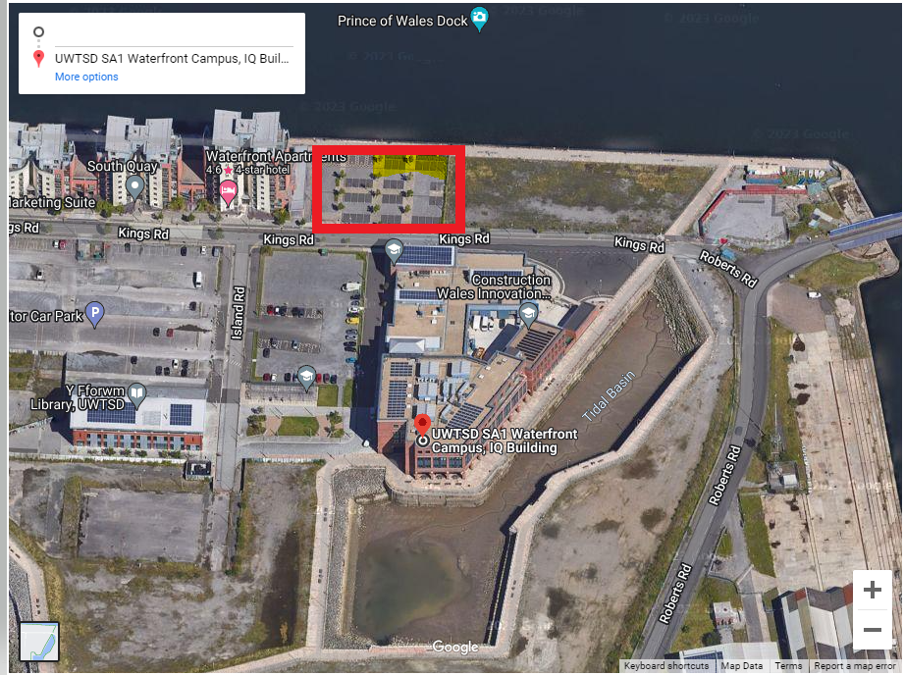
(SA1 Swansea Waterfront, n.d.)

Description of works:
- Site deliveries
- Site set up
- Fire procedures while works are being undertaken
- Site inductions
- Demolitions of single storey 3 bedroom dwelling
- Construction of foundations and walls to DPC level
- Installation of drainage / modification of existing drainage for rainwater collection
- Constructionof ground floor slab
- Brick laying
- External rendering
- Construction of a trussed roof for new 2 storey house
- Working at height / working on scaffold
- installation of plaster boards
- Internal plastering
- Electrical first fix
- Electrical Second fix
- Plumbing first fix
- Plunmbing second fix
- Decorating
- Installation of new doors and windows
- Paving and landscaping
- Installation of carpets and floor finishing
- What power tools can be used on site
- Working at height permits to work
- Permit to works for hot works

Start / End dates:
Expected start date for works: 01/09/2023
Expected end date for works : 15/01/2023

Assocaited Health, Safety and Environmental Assessments, Steps to Reduce Risks:
Task specific risk assements have been undertaken for the relevant activities listed below;
- RA01 site deliveries
- RA02 working on scaffolding
- RA03 Plasterboard installation
- RA04 Hand Power Tools
- RA05 Plastering
- RA06 Mixing Plaster
- RA07 using Hand Tools
(Extract of these provided under relevant task)
Task specific COSHH Assements
- Multi Finish Plaster
- Plaster board

Project Supervision and Training
Name: James Feeney
Role: Site Manager
Training / Qualifications:
Site Management Safety Training Scheme (SMSTS) | CITB five day training course  -Health and Safety and the legal system in the UK (Haswa 1974)  -COSHH Regulations (Noise at work regulations / manual handling Operations Regulations 1992 / Control of Vibration at Work 2005)  - Waste and Environmental Management (Environmental Protection Act 1990)  - Provision and use of work equipment regulations 1998  -Lifting Operations and Lifting equipment regulation 1998  - Asbestos and asbestos related diseases  -Ocupational Health / drugs and alcohol in the workplace and mental health awareness
First Aid and Fire Warden | 3 day training
HNC  (Higher National Certificate) | Civil Engineering

Site Labour
- 5 x general site operatives
- 2 x Site plumbers first fix
- 2 x site plumbers second fix
- 2 x site electricians first fix
- 2 x site elctricians second fix
- 3 x carpenters first fix
- 3 x carpenters second fix
- 4 x wet trades
- 3 x scaffolders
- 3 x ground workers
- 3 glazing operatives
- 3 x roofers
Plant, Tools and Equipment
- 10 KVA continuously rates singlw phase site 10kva transformer (input 240 volt / output 110 volt)
- 110v extension cables
- 110v splitter boxes
- 110v sds drill (MDU 8 hours)
- 110 v sds breaker (MDU 3 hours 33 minutes)
- 110v jig saw (MDU 3 hours 8 minuites)
- 110v makita skill saw ( MDU 8 hours)
- Waker concrete poker 57mm (MDU 8hours)
- PASMA scaffold towers
- Scaffold tube and fit
- 3.2 m ladders (ladders to be inspected and tagged)
- 5m ladder (ladder to be inspected and tagged)
- Site task lighting 110v
- Paddle mixers (MDU 4 hours)
*MDU refers to maximum daily usage for that particular tool. HAVs (Hand and Arm Vibration tools to be signed out and the hours spent with that tool to be recorded by the site manager).
Small tools
- 11” plastering trowel
- Speedskim semi-flex plastering rule 48”
- Taping and jointing knife 10”
- Aluminium plasters hawk 13”
- Edging trowel
- Internal corner towel 3 ¾” by 3 ½”
- Plasters float
- Mortar mixing board 70cm by 70cm
- Dust sheets
- Hoover
Personal Protective Equipment Required

- 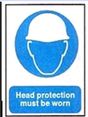 Hard hats must be worn at all times
-  Safety glasses to be worn at all times
- 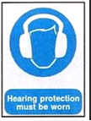 Hearing protection must be worn at all times
-  High visibilityclothing must be worn at all times
- Hand Protection must be worn at all times
- 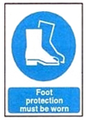 Appropriate safet boots/trainers/wellies to be worn at all times
- 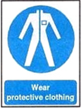 Protective clothing must be worn at all times. No shorts permitted, and long sleeves required
- 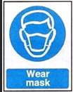 Dust masks should be worn for certain tasks. Face fitting may be required.

Welfare Facilities
- Toilets
- Shower room
- Drying room
- Drinking water points
- Canteen fitted with suitable seating, kettle / urn, microwave, toaster.

First Aid Facilities
- First aider on site – James Feeney (Site Manager)
- First aid kits to be stored in Site mangers office and clearly labelled 
- Nearest 24 hour A&E is Moriston Hospital, Post code SA6 6NL

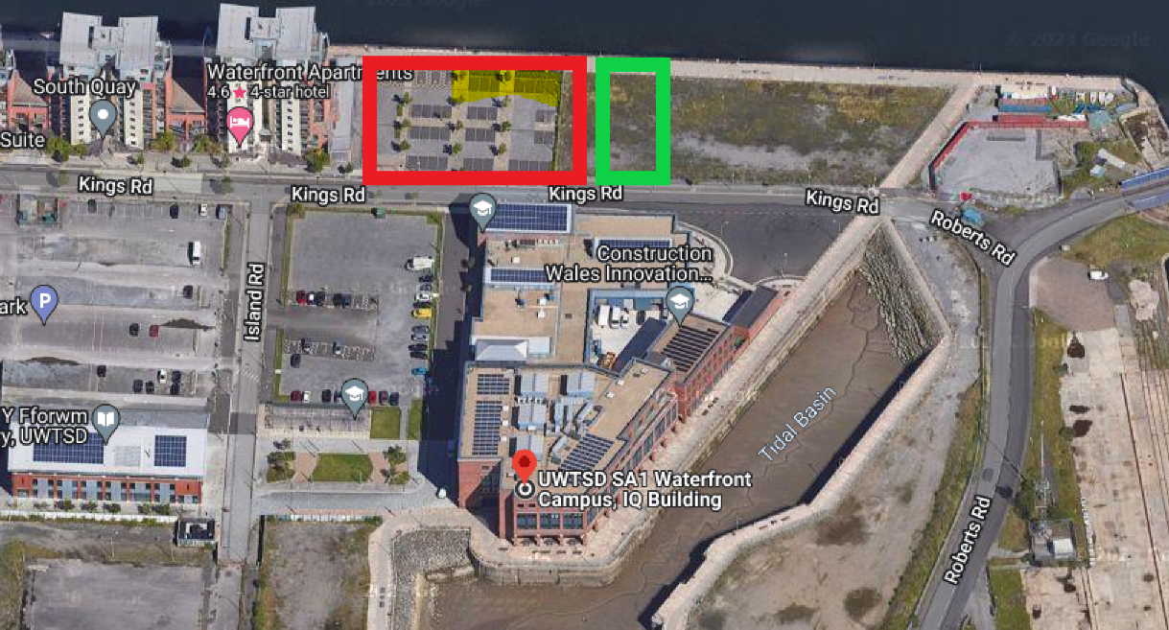
Figure 1Site in red, welfare and site office in green

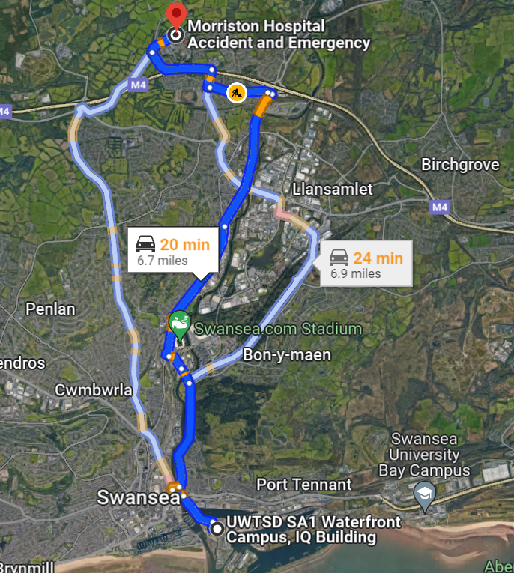
Figure 2 Morriston Hospital Accident and Emergency

Site Set Up
- Site Project Manager to make sure that the site manager has set up all the site folder system.
- Displayed all the insurances and F10 (notification of construction project) on on site at the main entrance.
- Site Manager has set up a welfare area with running water and toilet facilities and separate area for consuming food, away from the working site locations.
- The Site Project manager and site manager will then set out a Fire safety plan for when the works commence and display this at the entrance of the site works and also inform the staff when they have an site induction before starting any form of work.
- The Site manager will set up first aid and eye wash stations around the working areas.
- The site manager will apply for the scaffold street application with the scaffold contractor.
- The site manager will carry out the site inductions for all the contractors and site visitors. The site visitor must always be accompanied by the site manager whilst on site.

Unloading bricks/blocks bags of sand/cement/plaster and other materials from suppliers
All suppliers of materials to contact the site manager to book in all deliveries for site 24hrs in advance. On the day of the deliveries, they must contact the site manager 30mins before arriving on site, so that the site manager can isolate an area for the delivery vehicle to park safely and unload safely without effecting the public and business in the vicinity of the works being carried out.

Delivery vehicles to park in designated area and guided in by an appointed vehicle marshal, and pedestrian and other persons to be kept away from other moving vehicles.
Bricks/blocks/bags and other materials, to be unloaded by forklift onto hand carts or pallets and transported to the storage location inside the site that have been segregated to store the materials whilst the works are being carried out.

The Site manager must carry out a quality and quantity checks of all the delivers to make sure TVC Small works have received the correct materials and there is no visible damage to the delivery. Once this has been carried the site manager will sign the delivery documentation to say that he is happy with the delivery.

Hazard Description | How operative maybe affected? | Controls in place | Further controls/ actions
Manual Handling | Repeated lifting increases risk of muscular skeletal disorders. Back and neck strains and injury to other parts of the body. Damage to materials and plant. | Use of forklift and hand carts. Check the wight of materials. Generally, 25 kg should be the maximum one person should lift. | Manual handling training to be provided.
Slips trips and falls | Risk of slips and trips from materials being left lying around | Operatives to be told to keep delivery area clear. Person banking forklift to help supervise this. | Regular checks by site manager
Figure 3 Relevant risk assessments

Fixing Plasterboard or sheet timber materials
Materials to be carried to the working area by hand by one or two operatives and stacked on the floor.
Sheets to be cut to size using hand or power tools or craft knives.

Sheets for wall to be raised by hand and fixed using screws or nails at agreed spaces.
Sheets for ceilings to be raised by genie lift and fixed using screws or nails at agreed spaces, all internal cables and 1st fixed electrical outlets to be installed as the boarding is being carried out. All operatives who are always carrying out the installation of the sheet boarding process wear RPE.
Site operatives required Laborer’s/plasterers.
Specific Training needed –Manual handling training and Face fit testing.
Machine/tools training Trade training with relevant skills cards.

Relevant risk assessments as figure 3 as well as the following
Hazard Description | How operative maybe affected? | Controls in place | Further controls/ actions
Dust | Dust from cut/trimmed sheets can irritate eyes | Operatives to be aware of risk of dust especially from above. Eye protection and face mask to be worn | Tools could be fitted with dust extraction tools, or could cutting be undertake outside
Figure 4 relevant risks

Mixing plaster and other wet trades materials

Mixing area to be set up close to working area.
Area to cleared of trip hazards.
Plaster to be mixed using hand or power tools in buckets or mixing bath.
Mixed plaster to be transferred from bath via shovel or via buckets to spot board that will be a waist height to prevent over stretching and manual handling issues.

Plastering ceilings

Spot boards to be erected at working area.
All trip hazards to be removed from working area.
Suitable means of accessing ceiling i.e. scaffolding or mobile towers to be available and a trained operative to alter and move any form of PASMA equipment.

Plastering/rendering internal or external walls
Spot boards to be erected at working area.
All trip hazards to be removed from working area.
Suitable means of accessing higher levels to be available
Handrails to be raised on scaffold if required to prevent falling Via suitably fixed ladders to scaffold/suitable hop-ups, Edge protection – higher handrails etc. in place any works being carried out next to any public interface to have an exclusion zone in place with barriers to prevent the public being splashed of fall over any loose materials on the floor.

Hazard Description | How operative maybe affected? | Controls in place | Further controls/ actions
Splashing Materials | Contact with wet or dry gypsum-based materials can cause irritation to unprotected skin or burn eyes. Dust from dry materials can damage the lungs. | Site personnel to use barrier creams and or gloves. Ensure the area is well ventilated. | Site manager to make sure appropriate PPE is available.
Cuts | Use of Knives while cutting bags can cause lacerations to hands / fingers | Suitable gloves to be worn. | Toolbox talks on use and storage of knives.
Falls from mobile tower or scaffolding. | The potential to be hurt by hitting the tower on the way down and the level below. The potential to hit others by falling or dropping tools. | Only PASMA and trained scaffolder operators to construct towers. Towers to be inspected every 7 days or when moved to a different location. Tools to be tethered where possible. | Site manager to ensure all scaffolding is tagged, and to ensure relevant PPE and training is given.

Bibliography
ISO 14001. (2015). Enviromental Management for Business.
ISO 45001. (2018). Occupational health and safety management systems.
ISO 9001. (2015). Quality Management Systems.
SA1 Swansea Waterfront. (2023). Retrieved from https://www.uwtsd.ac.uk/sa1/

(SA1 Swansea Waterfront, n.d.)

