Different type of wood in whisky industry

Submitted by: Aista Phillips
Student Number: 2126964
Date: March 2024
Program: MSc International Innovation Management
Module: Masters Project
Module Code: ACFA 7003
Contents
Abstract: 4
Chapter 1: Introduction 5
1.1 Background 5
Significance of wood in shaping the character and quality of whiskies. 7
1.2 Objectives 8
The impact of different wood types on the aging process. 8
Type of oak often used in the whisky industry 8
Different types of wood are already in use in whisky industry 10
The diversity of flavour profiles resulting from various wood choices 11
The influence of environmental factors on wood maturation. 12
Chapter 2: The main types of Wood Used in Whisky Maturation 13
2.1 American Oak (Quercus alba) 13
2.2 European Oak (Quercus robur and Quercus petraea) 15
General Characteristics of European Oak (both species): 15
2.3 Other Oak and non-Oak Varieties 17
Chapter 3: Maturation Process and Flavour Development 19
3.1 Chemical Reactions during Maturation 19
3.2 Factors Affecting Maturation 24
Chapter 4: Regional and Climate Influences 24
Climate and environmental conditions 24
4.1 Whisky Regions 25
4.2 Global Perspectives 27
Wood choices in other whisky-producing regions. 27
Chapter 5: Challenges and Future Trends 28
5.1 Sustainability and Sourcing 28
Sustainable wood practices in the whisky industry. 28
5.2 Innovation and Experimentation 29
Trends in experimenting with new wood types. 29
Focusing on Ash wood, Pearwood, Caucasian Oak, Carpathian Oak. 33
Limited Use and Experiments: 36
Chapter 6: Conclusion 39
6.1 Summary of Findings 39
6.2 Implications for the Whisky Industry 39
References 42

Abstract:
Its rich history, craftsmanship and meticulous process of aging spirits characterize the whisky industry. Central to this process is the choice of wood for cask maturation. This dissertation delves into the various types of wood used, examining their distinct characteristics and influences on the maturation process and final flavour profiles of whiskies. The exploration encompasses traditional oak varieties, such as American and European oak as well as unconventional choices, different wine casks and wood types. It explores the intricate interplay between wood, climate, and regional nuances.
This dissertation aims to contribute to a comprehensive understanding of the intricate relationship between wood types and the whisky maturation process, offering valuable insights for distillers, researchers and enthusiasts in the ever-evolving world of whisky production.

Note: The term Whiskey usually refers to the Irish and American product. The general term, especially the Scotch variety is Whisky (without the “e”). For clarity, the term Whisky is used throughout this dissertation.

Chapter 1: Introduction

1.1 Background
The art of creating fine whisky is a harmonious blend of science, tradition and the environment in which it matures. One of the most influential factors in shaping the character and flavour profile of whisky is the type of wood used in the aging process. Distillers carefully select different types of wood, primarily oak, to impart distinct qualities to their spirits.
In Gaelic, whisky is considering as the “water of life” and refers to the water that flows through us. Whisky has been in the spirit industry for hundreds of years. Historically there are signs that early Christian Missionaries brought the art of distilling to the country and Scottish farmers thought to have distilled for hundreds of years. Mr J Marshall Robb explains in his book 'Scotch Whisky', that the earliest references to whisky are much later. In 1494, an entry found in the Scottish Exchequer Rolls, which mentions 'eight bolls of malt to Friar John Cor for the purpose of making aqua vitae'.
When King James IV was in Inverness during September 1506, his Treasurer’s Accounts record entries for the 15th and 17th of the month respectively: ‘For aquavite to the King. . .’ and ‘For ane flacat of aquavite to the King. . .’ lt is probable the aqua vitae in this case was spirit for drinking. In those days they drank, spirit unaged straight from the stills often adding flavours like honey or herbs to soften a rather harsh and aggressive drink.
Whisky production and maturation have a rich and diverse history, deeply intertwined with the cultural and economic development of various regions.
History tells that the wooden barrels used for whisky maturation occurred by a happy accident. Distilling more spirit that they could use straight away, it needed to be stored and this achieved using oak barrels. After sometime when finally ready to use the spirit came the realization that the spirit became softer, had more flavour and a far nicer character than the original drink. From then on, maturation as well as the use of oak barrels became a crucial part of the process.
In the old days it was enough just to fill barrels with spirit and leave it for a while but now whisky maturation is far more intricate. There are several different parameters differences in the maturation outcome: Maturation time, Oak (wood) type, freshness of the cask, cask history, size, whisky finishes and climate. All those factors can change whisky flavour and they are all important but the most important for maturation is the Oak (wood).
Since ancient times casks have been used to transport alcoholic beverages. Greeks and Romans during their many invasions, utilized casks held together by hoops to ship to store their wines. The Latin word ‘cupa’, which means vessel, believed to be the origin of the word cooper. The trade for which a person trained to construct and repair barrels.
Whisky was first stored in casks in the early 1800s when distillers realized the cask had a positive effect on the spirits’ maturation. Due to its ability to be rendered watertight oak makes a great vessel. Oak is a perfect container because expert coopers can make it waterproof. It is also porous, allowing the exchange of spirit and wood tannins, so enhancing and building flavour during the maturing period.
Regulations regarding the use of barrels in maturation were originally put into place in Scotland during the First World War. In 1915, under the stewardship of teetotaller David Lloyd George passed the Immature Spirits Act. This mandated that spirit must mature in casks for a minimum of three years before it can be termed whisky. This was to prevent harsh, strong New-Make Spirit entering the market and so restrict the supply of alcohol to the nation.
Lloyd George did not want alcohol interfering with military recruitment and vital munition production. As Minister of Munitions he wanted full prohibition famously stating, ‘Drink is doing more damage in the war than all of the German submarines put together.’ (Jeffreys, 2023)
He did not get his way but other strict controls introduced; Beer watered down and reduced licencing hours. However, by 1917 many distilleries closed due to lack of labour and restrictions on Barley consumption. It is ironic Lloyd George and the anti-alcohol lobby had the effect of regulating and improving quality. Whisky would become a premium product recognised around the world.
New US legislation in the 1930s encouraged Scotch whisky distillers to use American oak barrels. The Coopers' powerful labour union and in an effort to support the lumber industry in the United States after the Great Depression, a law was passed in 1935 that limited the maturation of bourbon to only virgin, brand-new oak casks. This opened the door to a barrel surplus because distilleries could now only utilize barrels once. To recuperate some of their expenses they started selling the barrels to Scotland, the world's largest whisky producer at the time, whose distilleries eagerly purchased the barrels at a substantial discount. (Plappert, 2020)
Whisky maturation in wood is a three-step process that is required to happen in three separate ways. These processes are Additive, Subtractive and Interactive, respectively. It is worthwhile to expand on them: The cask will give the spirit more flavour and personality as Additive. This includes the addition of wood sugars, oaky aromas, tannins and colour (the effect of the preceding filling cask
Subtractive: The cask removes certain volatiles and compounds from the spirit. Softening, mellowing and making it more accessible. Before used in the beverage business casks are often burnt; the charred wood serves as a natural filter to eliminate unfavourable substances like Sulphur.
Interactivity: This is the creative process. To produce fresh flavours and fragrances, certain chemical and molecular reactions take place between the wood, the spirit, leftovers from prior fills and most significantly with oxygen. The spirits oxidize, the casks breathe, and the oak and spirits change one another. Different oak species may yield varying outcomes in this interacting process. The varied properties of the wood, such as its density, permeability, hemicellulose, lignins, tannins, oils, lipids and other components all have a different effect on the spirit. Despite the fact that the contemporary Scotch Whisky business has existed for more than 250 years, experts and industry members like Dr. Bill Lumsden of Glenmorangie contend that the third interaction process is still only now beginning to be scientifically understood. (FINE + RARE, n.d.)
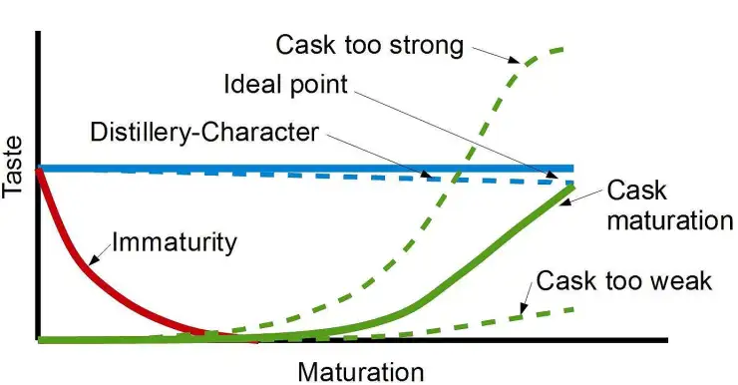
Fig 1 Optimal flavour profile of whisky (AUGUST 22, 2017 BY WHISKY WONDER)

Significance of wood in shaping the character and quality of whiskies.
Throughout its history, whisky production has evolved, adapting to changes in technology, regulation and consumer preferences while retaining its character as a complex and diverse spirit. Wood plays a crucial role in shaping the character and quality of whiskies during the maturation process. The interaction between the spirit and the wooden cask contributes to various aspects of the final product including flavour, aroma, colour and overall complexity. Here are some key points highlighting the significance of wood in whisky maturation, development and production:
- Flavour Development- Compounds such as vanillin, lignins, and tannins extracted from the wood during maturation influence the taste profile. These flavours can include notes of vanilla, caramel, spice, and various fruit or nut undertones.
- Colour Enhancement- Whisky’s natural colour is an interaction between the spirit and wood. As whisky ages, it takes on hues from pale gold to deep amber. The compounds leached from the wood, along with the charred layer inside the cask, contribute to the final colour.
- Aroma Complexity- A significant portion derived from the wood. Compounds from the cask, combined with the aging process, create a complex bouquet of scents. This can include woody notes, as well as hints of spices, toffee, and other aromatic elements.
- Maturation Process- The porous nature of wood allows the whisky to interact with air, promoting oxidation and the development of new compounds. This process contributes to a mellowing of the spirit, smoothing out harsh notes and enhancing the overall balance.
- Tannin Influence- Tannins from the wood contribute astringency, affecting its mouthfeel and texture. While excessive tannins can result in bitterness, a moderate amount can provide structure and complexity.
- Cask Size and Type- Can influence the final product. Smaller casks have a higher surface area relative to volume, leading to faster maturation and greater wood influence. Different types of wood, such as oak from various regions, also contribute distinct characteristics.
- Previous Contents of the Cask- Whisky casks are often reused having previously held other spirits like sherry, bourbon or wine. Residual flavours from the previous contents absorbed by the wood and transferred to the whisky during maturation, adding layers of complexity.
- Balance and Harmony- The art of whisky maturation achieves a harmonious balance between the spirit and the wood. Distillers carefully monitor the aging process ensuring the wood imparts desirable qualities without overwhelming the inherent character of the whisky.

1.2 Objectives
The choice of wood for whisky maturation plays a crucial role in shaping the final flavour, aroma and character of the whisky. Distillers often use a variety of wood types to achieve specific objectives.

The impact of different wood types on the aging process.
The choice of wood, size and type of cask and the duration of maturation all play critical roles in shaping the unique character and quality of whiskies. The interplay between the spirit and the wooden vessel is a delicate and intricate dance that distillers carefully orchestrate to create a final product that reflects both tradition and innovation.
The impact of different wood types on the aging process is a fascinating aspect of whisky production. Distillers carefully select the type of wood for cask construction and the choice can significantly influence the final flavour, aroma and overall profile of the whisky. The most commonly used wood for maturation is oak but the specific type of oak and any previous use of the cask play crucial roles. Here are some key factors to consider:

Type of oak often used in the whisky industry
Quercus Alba, often known as American White Oak. It has distinctive vanilla, coconut and sweet spice scents. The Bourbon industry exclusively uses this cask type. When it comes to ageing, American Oak is by far the most productive type of wood. The majority however, was first used to age Bourbon before being sold to outside parties to age everything from tequila to single malt Scotch Whisky to which it frequently imparts a vanilla and fresh fruit taste. The flavour profile of new American oak is subtly different but distinct. Sweet vanilla flavours predominate but balanced by spicy and woody notes. Any fruitiness runs the risk of blending with a specific vegetal bitterness.
Quercus Robur, European or Spanish Oak. The term "European Oak" typically refers to timber from France or Spain. Sherry casks are frequently used to age alcoholic beverages like Cognac and Armagnac but whisky consumers frequently experience the impact of these barrels. Although the taste is considerably different, European Oak has a grain that is often much more compact than American oak, making it less porous and requires a longer period to impart required flavours. European Oak is frequently credited with giving alcoholic beverages a "Darker," "Deeper" flavour profile by leaning away from vanilla and fresh fruit and more toward tannins, stewed citrus notes, a woody spicy character and milder dried fruit flavours.
With numerous types of European Oak appearing all over the continent, provenance is a deciding factor. Spanish Oak, for instance, has a bigger effect on the distillate since it is relatively porous. Oaks from colder environments, from Russia or Ukraine may have little to no porosity and no effect on flavour.
Flavours of tobacco, cedar, nuttiness, coffee and chocolate are among the popular descriptors of French Oak, mixing an unusual blend of both savoury and sweet flavours. Another underrated fact is that currently, more whisky, fully or partially, is completed in French Oak barrels and this is undoubtedly true in other nations that produce whisky. The wine industry prefers French Oak (quercus petraea) to American Oak because it imparts additional subdued flavours to the wine. French Oak is less thick than American oak (for the additive and interactive processes). Having said that, it gives the wine stronger tannins. French Oak former wine casks subsequently utilized in the whisky business, the presence of these tannins needs to be carefully assessed and kept in check.
If the tannins from the French Oak combine with any leftover tannin soak from a prior wine filling, it might produce a "double whammy" of tannins that overwhelm the whisky and upset the balance.
When it comes to the maturing of alcohol, Scotch Oak is particularly rare because the tree itself is rare due to years of slow deforestation. It is often wild rather than cultivated, making it difficult to work with and construct barrels. Scotch Oak is considered to impart a fiery and spicy flavour to the whisky. European oak offers a more comparable product than American oak.
Similar to Scotch Oak, Irish oak is infrequently used in the manufacture of barrels. Mostly because of the dearth of this wood type. However, recent Midleton Distillery research suggests that this specific type imparts sweet flavours of vanilla, caramel, and chocolate coupled with a fair dosage of woody spices, setting itself out significantly from its Scottish sibling. (Qureshi, 2018)
Particularly uncommon is Hungarian Oak, whose effect on the distillate strikes an unusual spice mix, with subdued wild berry flavours and a greater depth than the more conventional European oak.
Mizunara wood is indigenous to the Japanese islands and frequently mentioned in relation to the unique aroma of Japanese whisky. Mizunara Oak barrels are challenging to build and particularly rare because they are a protected and a slow growing tree. In the whisky community, their use is frequently the subject of much enthusiasm and discussion. A lot of the time though, such excitement is really just marketing hype. The tree is typically at least 200 years old and commercially difficult to work. The wood is porous with leaks and evaporative stability perpetual issues. Mizunara barrels of exceptional quality are particularly pricey due to their scarcity. The high cost of whiskies matured or finished with Mizunara wood is due to a few factors that most consumers are probably unaware. According to expert opinion, Japanese and Scotch whiskies need to age in Mizunara casks for at least 15 years before the genuine characteristics, flavours and properties of the wood become apparent. Younger whiskies or those that were only briefly finished do not benefit from or have the capacity to exhibit the specific qualities that Mizunara oak can add. (www.wineenthusiast.com, n.d.)
Amburana, a Brazilian rainforest native, is one of the less well-known woods used to age whisky. The Amberana, which is often used to age cachaça, a Brazilian alcohol made from sugarcane, lends whisky a potent tonka bean flavour, pronounced vanilla undertones with fragrant coconut and cinnamon overtones.
The whisky market is evolving. The global whisky boom is still going strong and distillers are experimenting more than ever. Without barriers from customs or laws, nations without a whisky-making tradition have entered the worldwide market. This provides opportunities for some distillers who are looking for uncommon, rare types of oak. Here are some examples:-
The Westland Distillery in Seattle, which won Washington State Distillery of the Year at the 2017 NY International Spirits Competition, utilized Garry Oak- a derived Garryana Native Oak collection. Garry Oak, a native of the Pacific Northwest is found between California and British Columbia. It has notes of roasted coffee, cocoa and a dark deep spice. The problem is that there is no reliable way to obtain the oak because it is so scarce and its usage in whisky maturation new. Despite this, the Westland team continue to search the West Coast for even a single stave of the oak. To avoid contributing to the extinction of the species, they take care to use only fallen trees.
By using materials sourced within a 75-mile radius of the distillery, Mackmyra has led the Swedish whisky movement as the country’s first distillery. Mackmyra use Swedish oak casks procured from the south of Sweden, taking the phrase "local" even further. Originally, this oak was used in ship construction.
Angel D'Orazio, the master distiller of Mackmyra states, "Swedish Oak (Quercus Robur) is very slowly cultivated here thus its taste derives from that gradual growth." (WhiskySpeller, 2014) In comparison to its American siblings, it gives a more peppery, spicy side and has less vanilla than Quercus Alba.

Different types of wood are already in use in whisky industry
The Cleveland Underground Select uses a variety of woods in an effort to bring out the many distinctive flavours that each type of wood can produce.
While Black Cherry Wood-aged whisky offers tart, sour notes and sweet spice. The hickory-aged bourbon adds notes of smoke and potent spice. There are expressions of maple, apple and honey locust wood in the portfolio.
Since 2014, research into whisky maturation in various wood types has tested knowledge and methodology, none more so than experiments with wild cherry casks, according to Kevin O'Gorman, Master of Maturation at Midleton Distillery. (Fri, Jul and 2021 - 09:15, 2021) The result is a world-first in Irish Whisky, with a nose of coconut fibre and ginger, a palate of fresh green herbs and black tea. Combined with unmistakable pot still spices and a long fresh finish with prickly spice and hazelnut. The rare, porous wood has been a real achievement creating a perfect balance of flavour.
Acacia wood purchased from France and usually matured between one and four years has tight grain and was initially aged in a combination of former bourbon and sherry casks. This gave the whisky a dark mahogany colour and slowly imparted rich nutty and chocolatey flavours.
Players in other nations have been aware of it for a time. Producers like Teeling and Midleton have long pushed the boat in Ireland, where the restrictions are less rigorous than in Scotland. When it comes to checking out new things, such as whiskies aged in casks that previously contained ginger beer, pineapple rum, and other wines, Campbell says that Teeling is really one of his go-to whiskies of interest. (Williams, 2021) His favourite is their Sommelier Selection Margaux Cask.
Midleton has experimented with finishes in French Chestnut. The whisky offers banana, slight cinnamon and sweet delicate fruit. A small batch finished in Mulberry is sed for its Method and Madness series.
Yoshino Sugi (Japanese Cedar). Kamiki is a blended whisky that is aged in Japan and finished in Japanese cedar. It contains both Japanese and imported whiskies. The Kamiki, the first of its kind, is blended and aged in Osaka. To make the whisky strong enough to be bottled and subsequently distributed in batches, Japanese spring water added. Japan's cedar, most frequently used for structures and temples, gives the final expression delicate hints of honey, sandalwood and ginger.
As consumers and distillers alike recognise there are a variety of flavours still to be discovered. Affected by the countless sorts of wood across the globe, progress is being made in the understanding the effects of maturation in distinctive woods. The aforementioned producers, the extra effort is paying off even if the casks themselves may be more difficult to assemble and leak more.
Cotswolds Distillery, founder Daniel Szor mostly uses oak casks, but plans to explore with other woods for the brand's experimental collection, including cherry, acacia and chestnut. Szor is quick to emphasize that the focus will remain on maintaining the DNA of the spirit that pours from the stills in the English countryside, even though he has a little bit more flexibility than his fellow Scottish colleagues. “I think it’s important to describe the effect of these ‘exotic’ casks on whisky as being exactly what it is – flavouring – as such they can be successful in drawing in new consumers who might be looking for sweeter or more novel flavours.”- says Mr. D. Szor. (spiritsbeacon.com, n.d.)
The diversity of flavour profiles resulting from various wood choices.
Commonly used in bourbon production, American white oak imparts flavours of vanilla, caramel and sometimes coconut. The wood often charred, contributes a sweetness and richness in the whisky. Additionally, the porous nature of American oak allows for greater interaction between spirit and wood.
European oak, often used in Scotch whisky production, imparts different characteristics compared to American oak. It can contribute more tannic and spicy notes, as well as flavours of dried fruits, nuts, and sometimes a hint of earthiness.
Mizunara oak unique to Japan contributes distinctive flavours such as sandalwood, coconut and a pronounced spiciness. The wood is porous, giving higher evaporation rates and flavour concentration.
Casks previously used for aging sherry contribute rich and sweet flavours. This can include notes of dried fruits (raisins, figs), nuts (almonds, walnuts) and a deep fortified wine sweetness.
Bourbon casks, typically made of new charred American white oak, impart sweet and robust flavours. This can include vanilla, caramel and sometimes a touch of charred oak.
Casks previously used for aging wine (such as red wine or port) can introduce fruity, tannic, and sometimes spicy notes to the whisky.
Some distillers use casks that have held multiple types of spirits or wines, creating a complex interplay of flavours. This approach can result in a multi-layered and nuanced whisky.
The diversity of flavour profiles in whisky is testament to the art and science of whisky maturation. The choice of wood significantly shapes the final product, allowing for a rich tapestry of aromas and tastes that cater to a wide range of preferences among whisky enthusiasts. Distillers continue to experiment with different wood types and cask treatments, contributing to the ever-evolving landscape of whisky flavours.

The influence of environmental factors on wood maturation.
Environmental factors play a significant role in the maturation of whisky, affecting the interaction between the spirit and the wooden cask. These factors can influence the rate of maturation, the extraction of flavours from the wood and the overall character of the final product. Here are some key environmental factors that affect wood maturation:
- The temperature of the maturation environment influences the rate at which the whisky interacts with the wood. In warmer climates such as Kentucky for bourbon or parts of Japan for whisky, the expansion and contraction of the wood occur more rapidly. This leads to increased interaction between the spirit and the wood, resulting in faster maturation compared to cooler climates.
- Humidity levels also play a role. In humid environments, casks may breathe more, allowing the whisky to penetrate deeper into the wood and extract flavours. Conversely, in drier climates, evaporation rates may be higher, concentrating flavours and potentially leading to greater wood influence.
The atmospheric pressure at different altitudes can affect the maturation process. Distilleries located at higher altitudes experience lower atmospheric pressure, which could affect the rate at which the spirit interacts with the wood. The reduced pressure might lead to slower maturation.
Seasonal temperature variations can influence the rate of expansion and contraction of the cask. During warmer seasons, wood expands allowing the spirit to penetrate deeper. In cooler seasons, wood contracts, releasing the absorbed compounds back into the whisky. Diurnal temperature variations where significant differences between daytime and nightime temperatures occur can contribute to the complexity of the maturation process. These swings promote more interaction between the whisky and the wood. Similar to wine the concept of terroir applies to whisky maturation. The specific geographic location including soil composition and local flora can influence the flavours imparted by the wood. For example, water sources with unique mineral content may affect the character of the whisky. The location of the maturation warehouse within a distillery can also be a factor. Warehouses on higher floors may experience different temperature and humidity conditions than those on lower floors, leading to variations in maturation.
Movement of the cask, whether intentional (e.g., turning or rotating casks) or due to environmental factors (e.g., seismic activity), can influence the extraction of flavours. Agitation promotes more contact between the whisky and the cask interior. Microorganisms present in the maturation environment (moulds and fungi) can interact with the wood affecting the maturation process. Although some microbial activity is undesirable, certain interactions contribute to whisky complexity
Understanding and managing environmental factors is a delicate art for distillers. Combinations of these elements contribute to the unique characteristics of whiskies from different regions and distilleries. As a result, environmental factors are an integral part of the terroir of whisky, influencing the final flavour, aroma and overall profile of the matured spirit.

Chapter 2: The main types of Wood Used in Whisky Maturation

2.1 American Oak (Quercus alba)
Most commonly used is American oak predominantly Quercus alba, but may include wood from 10 or more other species of American white oak (Singleton 1974). American oak is a species native to North America and commonly used in the production of whisky, particularly bourbon. It is the primary species used in the construction of barrels for aging whisky in the United States and is known for its relatively wide and porous grain. The wide grain allows for greater interaction between the whisky and the wood imparting distinct flavours during the maturation process. Some of the common flavour characteristics associated with American oak include:
Vanilla: A noticeable sweetness often derives from compounds like vanillin present in the wood.
Caramel: The charring process contribute caramelized sugars, adding a rich sweetness to the whisky.
Coconut: Some barrels can contribute coconut-like notes enhancing its complexity.
Spice: Introduction of spicy notes, including hints of cinnamon and nutmeg.
Tannins: American oak tends to have moderate levels of tannins contributing to the structure and mouthfeel of the whisky. Tannins can add a subtle astringency to the spirit.
American oak barrels are often charred or toasted. Charring involves briefly exposing the interior of the barrel to an open flame creating a layer of charcoal. Toasting is a gentler process that involves heating the wood to different temperatures. Both processes influence the flavours extracted from the wood and contribute to the colour of the whisky.
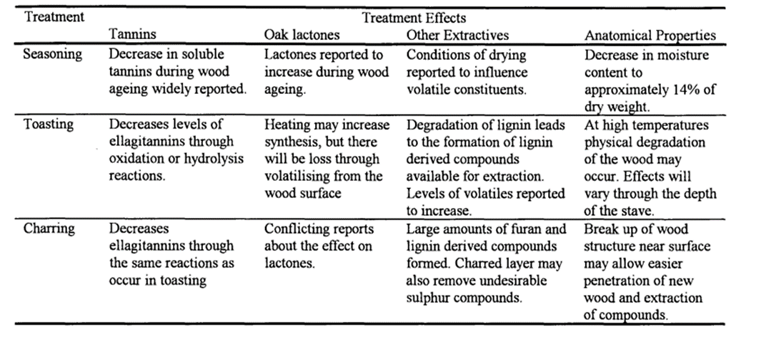
Table 1: Summary of effects of cooperage treatment on wood properties (Thesis & Mosedale, n.d.)
American oak contributes to the colour of the whisky, imparting compounds from the wood to the spirit. The barrels’ charred layer enhances a deep amber colour associated with matured whiskies.
American oak is widely available and is often less expensive than some other types of oak. This availability makes it a popular choice for American whisky production and is a legal requirement for aging bourbon in the United States. Bourbon must be aged in new charred oak barrels. (www.govinfo.gov, n.d.) The regulation contributing the distinctive flavour profile associated with bourbon. American oak is relatively porous, allowing for more interaction between the whisky and the wood. This porosity influences the rate of maturation, contributing to a faster aging process observed in warmer climates. American oak's influence on whisky production extends beyond bourbon. Other types of American whiskies even some Scotch whiskies utilizing this oak species. Its unique characteristics contribute to the diverse, recognizable flavour profiles of whiskies worldwide.
The legal use of new barrels distinguishes bourbon from other whiskies and contributes to the unique character of the spirit. (www.govinfo.gov, n.d.)
American oak contribute moderate levels of tannins, adding structure and a subtle astringency to the mouthfeel and overall balance of the spirit. Its porosity combined with warm climate in bourbon producing regions, facilitates a faster aging process.
Interaction between whisky and the wood accelerates, leading to a quicker maturation of flavours and a shorter aging period compared to some other types of oak. While bourbon must be aged in new charred oak barrels, the used barrels are not discarded. (www.govinfo.gov, n.d.) Many distilleries sell or exchange their used barrels to other spirit producers such as Scotch whisky or rum makers, contributing to the global influence of American oak in the world of spirits. Contributing to the consistency and recognizable character of bourbon as a distinct category of whisky.
American oak is a fundamental and defining element in bourbon production, imparting specific flavours that shape the identity of bourbon. The combination of wood influence, charring and the aging process in new barrels results in the rich, sweet and complex flavour profile that is synonymous with bourbon whisky.
The impact of American oak on the flavour profiles of whiskies is profound and distinctive. It is widely used in the production of various whiskies including bourbon, Tennessee whisky and whiskies from other countries.
American oak barrels after their initial use in producing bourbon, are repurposed for aging other types of whiskies, including Scotch. This global influence of American oak contributes to a diverse range of flavour profiles and allows for innovation in the whisky industry.
In summary, the use of American oak barrels significantly shapes the flavour profiles of whiskies, providing a unique combination of sweetness, spice and complexity. Whether in the context of bourbon, Tennessee whisky or other whiskies aged in American oak, it has become synonymous with certain flavour characteristics that whisky enthusiasts recognize and appreciate.

2.2 European Oak (Quercus robur and Quercus petraea)
European Oak refers to two closely related species of oak trees found in Europe: These two species commonly known as English Oak and Sessile Oak respectively. While they have many similarities, there are differences between the two.

General Characteristics of European Oak (both species):
European Oak is highly valued for its wood, which is strong, durable and has a distinctive grain pattern. It is widely used in construction, furniture making, flooring and wine barrel production. These oaks exist in a variety of habitats, ranging from lowland forests to upland woodlands. They are important components of many European ecosystems. European Oaks provide habitat and food for various wildlife species. Their acorns are a crucial food source for animals such as deer, squirrels and birds. Oak is renowned for longevity, living for several centuries with some specimens reaching ages of 500 years or more. Oak trees have cultural significance in many European societies. They are often associated with strength, durability and longevity. Additionally, oak trees have been symbolically important in various mythologies and folklore. As with many other tree species, European Oaks face threats, such as habitat loss and climate change. Conservation efforts are important to ensure the continued health and sustainability of oak populations. These trees play a vital role in European ecosystems and used by humans for various purposes for centuries. Their significance extends beyond their ecological contributions to include cultural, economic and aesthetic aspects.
European Oak and American Oak are distinct species with differences, particularly in their wood characteristics. There is more to the distinction between American oak and European oak than just the botanical species. Both are associated with distinct environments and used in very different ways by different cooperage sectors. Historically in Europe, oak is grown, silvicultured and been used for generations. The traditional approach to the silviculture has been to produce wood with regular narrow annual rings by maintaining high stand densities. Slow-growing oak is considered to produce better quality wood (Weaver and Spiecker 1994), but attitudes have changed as it is realised that faster-growing oak can produce the same high-quality wood.
It was believed, the flavour associated with oak depends on the forest where it is grown. However, there is considerable uncertainty as to what distinguishes the different geographic types of oak. (Schahinger 1991), Wood from the same location, even if it is the same species may have grown under different climatic conditions or silviculture regimes. (Kenk 1994)
 | European Oak: | American Oak:
General | Typically, has a more pronounced and varied grain pattern. The growth rings can be wider and more irregular, resulting in a distinctive and attractive appearance. The texture is often coarse. | Generally, has a finer and a more uniform grain pattern. The growth rings are usually tighter, and the wood has a smoother texture compared to European Oak.
Colour | The heartwood of European Oak can vary in colour from light tan to pale yellow-brown. It may have pink or brown tones, and the sapwood is usually lighter in colour. | American White Oak, one of the most common species used, tends to have a light to medium brown colour with a pinkish hue. The sapwood is typically paler than the heartwood.
Tannins | Generally, contains higher levels of tannins compared to American Oak. This can contribute to astringency and a more complex flavour in wine and spirits aged in European Oak barrels. | Contains tannins as well, but in different concentrations and chemical forms. American Oak barrels often impart a smoother and sweeter flavour profile to beverages
Density and Hardness | Generally denser and harder than American Oak. This characteristic contributes to the durability and strength of European Oak wood | While still durable, American Oak is slightly less dense and not as hard as European Oak. This can influence its workability and susceptibility to wear.
Common Uses | Traditionally used for furniture, cabinetry, flooring and wine barrels. Its high tannin content makes it particularly suitable for aging wines and spirits. | Widely used in the construction of furniture, flooring, and barrels for aging whisky and wine. American White Oak in particular, is popular for its use in the wine and spirits industry
Geographical Distribution | Found predominantly in Europe, with species like Quercus robur and Quercus petraea being native to the region. | Various species are found across North America, with American White Oak (Quercus alba) being one of the most commonly used species in woodworking and cooperage.
Table 2: Differences between American oak and European oak
Understanding these distinctions is important, especially in industries like winemaking and woodworking. Choice of oak significantly affects the final product. Each type brings its own unique qualities influencing the flavour, appearance and overall characteristics of the finished product.
European Oak, particularly English and Sessile Oak are commonly used in whisky maturation. The influence of European Oak is significant, imparting distinct characteristics to the final product.
European Oak tends to impart a different flavour profile to whisky than American Oak. It often contributes rich, complex and spicy notes, with hints of tannins, dried fruits and sometimes a touch of earthiness. The tannins from European Oak barrels can add astringency and structure to the whisky, influencing its mouthfeel and overall taste. Some whisky-producing regions, especially in Europe, have a long tradition of using European Oak casks for maturation. This is particularly true for Scotch whisky, where both English and Sessile oak utilized.
Other whisky-producing regions often use American Oak barrels. However, there is a growing trend among distillers worldwide to experiment with different types of oak, creating unique and diverse flavour profiles. European Oak sherry casks are highly sought after for whisky maturation. These casks, which previously held sherry, contribute additional flavours such as dried fruits, nuts, and sometimes a subtle sweetness to the whisky.
Whisky makers engage in a balancing act when selecting casks. The choice between American Oak and European Oak, as well as the history of the cask (whether it previously held sherry, wine, etc.), greatly influence the final flavour profile of the whisky. Many distilleries and master blenders experiment with different types of oak casks to create limited edition or experimental releases.
European Oak, especially in the form of sherry casks, plays a significant role in the maturation process of certain whiskies, particularly in regions like Scotland. The distinct flavours and characteristics it imparts contribute to the diversity and complexity of the global whisky market. English and Sessile Oak, contribute significantly to the flavour complexity of beverages, especially in the context of aging wines and spirits like whisky.
European Oak has higher tannin content than American Oak. Tannins are compounds found in wood that contribute astringency and structure to the beverage. They can impart a drying sensation and add complexity to the mouthfeel. European Oak often imparts rich and complex flavours to the beverage. This can include notes of dried fruits, dark chocolate, tobacco, and sometimes a hint of spiciness. These flavours contribute to the overall complexity and depth of the drink. The porous nature of oak allows the beverage to interact with the air during maturation. European Oak, with its distinctive grain and higher levels of compounds like lignin, can contribute aromatic compounds to the beverage, enhancing its bouquet.
European Oak casks facilitate the extraction of a wide range of compounds from the wood, including vanillin, lactones, and phenolic compounds. These compounds contribute to the flavour profile by adding sweet, creamy, and sometimes smoky or toasty notes. European Oak casks may be used for extended maturation periods, the wood imparting a gradual evolution of flavours, allowing for a complex interplay between the beverage and the cask. The porous nature of oak also allows for subtle microbial activity, which can contribute to the development of unique flavours. This is especially true in traditional cellaring environments.
In the context of whisky, for example, European Oak casks are highly prized for their ability to impart a broad spectrum of flavours that add depth and complexity to the spirit. The combination of tannins, aromatic compounds, and the influence of previous contents creates a harmonious and intricate flavour profile appreciated by enthusiasts and connoisseurs alike.

2.3 Other Oak and non-Oak Varieties
The use of non-traditional wood choices in whisky maturation has become a fascinating and innovative trend in the whisky industry. Distillers and blenders are experimenting with various types of wood to impart unique flavours and characteristics to their spirits.
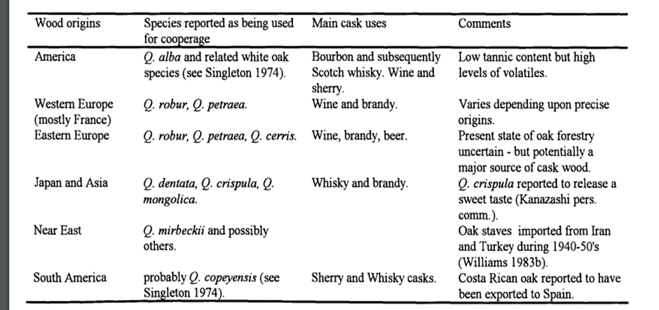
Table 3: Sources of oak wood reported as used for the maturation of alcoholic beverages (MOSEDALE, 1995)
Table 3 lists and describes some past and present sources of oak cask wood. Wood other than oaks occasionally used to store alcoholic beverages are normally coated on the inside by paraffin or silicone to prevent leakage and the release of unpleasant odours (Lamfalussy 1953; Molnar et al. 1985)
While oak from the Quercus alba species (American White Oak) is traditional in whisky maturation, some distillers are experimenting with French Oak (Quercus robur and others). French Oak can contribute different flavours, such as pronounced tannins, spice, and sometimes floral and fruity notes. Chestnut wood used in some experimental cask maturation, imparts a different set of flavours, these include notes of earthiness, nuttiness, and a distinct aromatic quality.
Acacia wood is lighter and more porous than oak, and it has been used in whisky maturation to impart delicate flavours. It can contribute floral, herbal, and sometimes fruity notes to the whisky. Mulberry wood often used experimentally in maturation is known for its sweet and fruity characteristics its use can result in whiskies with unique flavour profiles. Maple wood, associated with syrup production, used in cask maturation imparts sweet and sometimes spicy flavours to the whisky. Teak, a tropical hardwood, has been associated with experimental cask maturation. It can contribute complex flavours, including a certain richness and depth.
Some distillers experiment with hybrid casks combining staves of different wood types. These casks may include a combination of oak, chestnut or other woods, providing a complex flavour profile.
These non-traditional oak choices add an exciting dimension to the world of whisky, providing enthusiasts with a diverse range of flavour experiences. However, it is important to note that these experiments often lead to limited-edition releases, as the outcomes can be unpredictable and may not conform to traditional expectations. The exploration of non-traditional oak choices highlights the creativity and willingness of distillers to push boundaries and create new and intriguing expressions.
Mongolian Oak, rare and expensive, used in Japanese whisky production can give a fragrant aroma of incense, sandalwood, pineapple and coconut. Mizunara oak is a type of oak native to Japan. It imparts distinctive flavours of sandalwood, coconut, and a unique spiciness to whisky. The porous nature of Mizunara wood accelerates the maturation process, allowing for quicker interaction between the wood and the spirit. Japanese Cedar, a rare choice in whisky production but has been explored in the Japanese whisky industry to bring unique characteristics to the spirit. Japanese Cedar wood is known to introduce sweet and smoky flavours, reminiscent of Mezcal. It adds a distinctive aromatic profile, bringing a fresh somewhat floral note to the whiskies, offering a different dimension to the tasting experience. Cedarwood casks can contribute resinous and aromatic qualities to whisky. This non-traditional wood choice may impart flavours of cedar, pine, and sometimes a subtle smokiness. Juniper wood used experimentally for cask maturation can impart herbal and piney notes to the whisky, providing a unique and aromatic character. Cherrywood casks can contribute fruity and sweet notes to whisky. The wood may impart flavours reminiscent of cherries, adding a layer of complexity to the spirit. Plum wood can contribute fruity and sometimes floral characteristics, providing a unique flavour profile to the spirit. Peach wood, another experimental wood, can impart subtle fruity and sweet notes, contributing to a nuanced flavour profile.
Oregon oak, specifically Quercus garryana, is native to the Pacific Northwest in the United States. Used by some distillers to impart unique flavours such as nutmeg, cinnamon, and a distinct spiciness to the whisky. Experimental Redwood casks contribute flavours of cedar, pine, and sometimes a mild sweetness. Amburana Wood, primarily used in South America for aging cachaça and rum. Imparts unique flavours like cinnamon, nutmeg, and tropical fruit. John (2023).
It is important to note that the use of non-oak materials is often experimental and can result in limited-edition releases. The characteristics imparted by these non-traditional woods can vary and the outcomes sometimes unpredictable. Distillers may use a combination of different wood types or employ specific toasting and charring techniques to enhance or modify the flavour contributions. As the whisky industry continues to innovate, the exploration of non-oak materials adds an exciting dimension to the diversity of flavours available to whisky enthusiasts.

Chapter 3: Maturation Process and Flavour Development

3.1 Chemical Reactions during Maturation
Whisky is commonly produced from grain (wheat, barley, corn, rye.) in a plant performing varied processes (malting, milling, mashing, fermenting, distilling and maturation). However, it is acknowledged that maturation gives whisky its final character, recognizable all over the world. The compounds in the wooden barrel are responsible for the scent and colour in the final drink. Development in oak barrels also increases the antioxidant potential of whisky by growing the concentration of phenols, furans and removing unwanted compounds.
Traditional Pot Stills (Double Distillation) produce a consistent distillate that may alter little from still to still. The variety of flavours in the final product imparted by maturation. Modern Stills are capable of producing varied high quality distillate so increasing the range of flavours and characteristics of the whisky. Indeed, at Penderyn Distillery, two Faraday Single Distillation stills produce product alongside a traditional Pot still. Distillate from a mixture of the two provide an additional range of flavours.
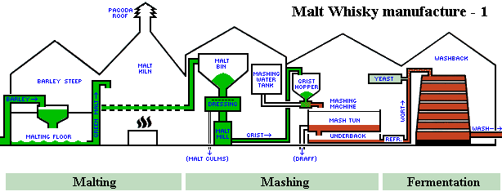
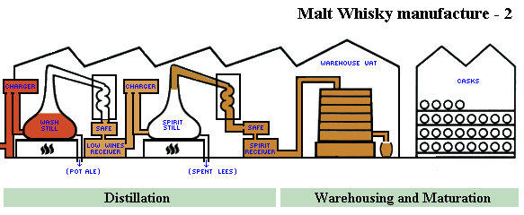
Fig 2 Whisky making process (Butler, n.d.)
However, it is without doubt, that the maturation process in wood barrels transforms the clear colour of the distillate and sometimes a sharp rough scent to a delicate, charming and brilliant colour.
The effect of maturation on whisky is quite distinct, with the unmatured spirit generally having few of the desirable properties sought in whisky taste and aroma. Therefore, the importance of the maturation process should not be underestimated. The following points are known about the maturation of whisky (Nishimura and Matsuyama, 1989):
1. Satisfactory maturation times may vary from 3 to more than 10 years.
2. There is normally a significant flavour difference between matured and unmatured spirits.
3. Volume and strength are lost due to the evaporation of water and alcohol through the porous wood of the casks.
4. Maturation time and the quality of the matured spirit may vary according to the type of whisky, the size, wood type and prior treatment of the cask and the environment in which the whisky is matured.
Maturation of whisky in wooden casks involves complex chemical reactions between the wood and the various constituents present in the whisky. These interactions play a crucial role in shaping the flavour, aroma, and colour of the final product.
Some of the main chemical reactions that occur during whisky maturation are as follows:
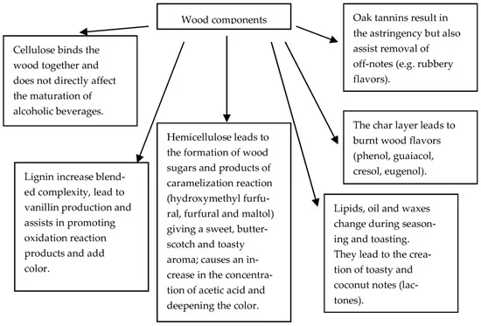
Table 4: Major wood constituents and basic chemistry (Tarko, Krankowski and Duda-Chodak, 2023)
Lignins in the wood contribute to the colour of the whisky as they break down during maturation. They release phenolic compounds, adding depth and complexity to the flavour. This wood component breaks down and releases sugars and other compounds that contribute sweetness and body to the whisky. While cellulose itself is not directly soluble in alcohol, it can influence the overall texture and mouthfeel of the whisky as it interacts with other compounds. Lignins and tannins from the wood contribute to the astringency of the whisky. Over time, these compounds leach into the spirit, imparting structure and complexity to the flavour. The whisky extracts colour compounds, including tannins and polyphenols, from the wood. Tannins in particular, contribute to the development of a deeper colour.
Oxygen enters the cask through the porous wood, leading to oxidative reactions. This contributes to the mellowing of flavours and the development of subtle, aged characteristics. Oxidation can also influence the formation of esters and aldehydes contributing to fruity and nutty notes in the whisky. Oxygen entering the cask during maturation can also lead to oxidative reactions that influence the colour of the whisky. While some oxidation may lighten the colour, it can also contribute to the development of complex hues.
Esters formed through the interaction of alcohol with acids present in the wood, contribute fruity and floral aromas to the whisky.
Lactones, such as cis- and trans-oak lactones formed during maturation contribute coconut and woody notes to the whisky, enhancing its aromatic complexity. These esters provide complexity and nuance to the nose.
Phenols in the wood, including guaiacol and syringol, contribute smoky and spicy notes to the whisky. The breakdown of lignins releases these compounds into the spirit.

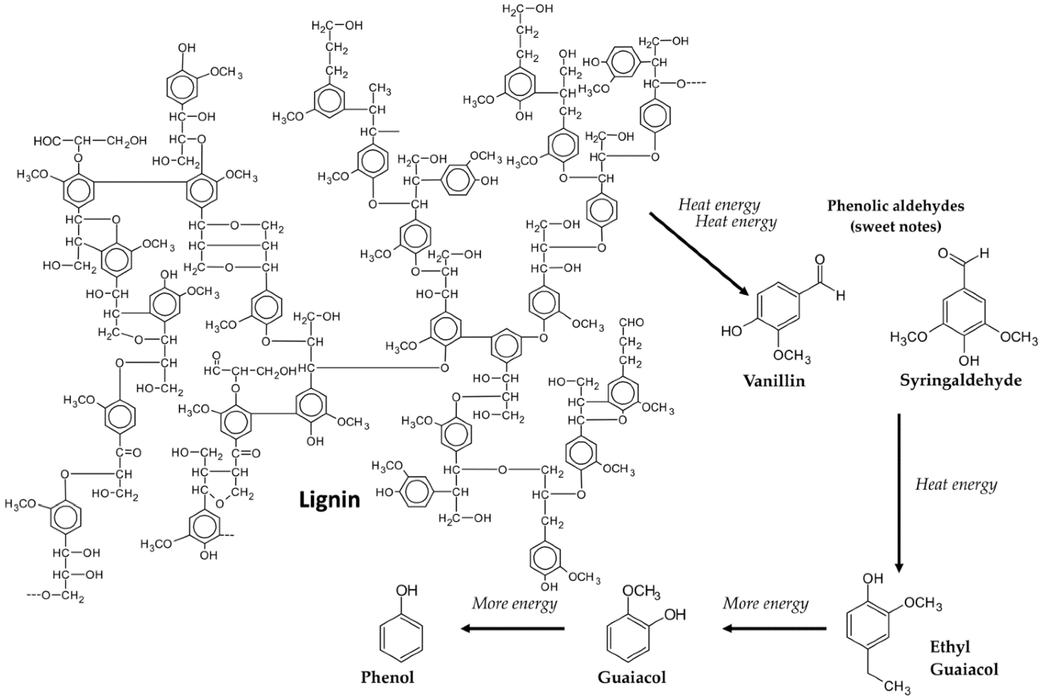
Fig 3 Thermal degradation of lignin (Tarko, Krankowski and Duda-Chodak, 2023)
The Maillard Reaction occurs between amino acids and reducing sugars, leading to the formation of complex flavour compounds. This reaction contributes to the development of rich, caramelized, and toasty flavours in the whisky.
Harsh and undesirable compounds such as acetaldehyde and fusel oils, may undergo chemical transformations during maturation, resulting in a smoother and more refined whisky.
If the cask previously held wine, sherry or another spirit, the residual compounds from the previous contents can interact with the whisky, introducing additional flavours and complexities.
The pH value of the wood and the whisky can influence the extraction of different compounds. Acidic conditions may enhance the extraction of certain flavour compounds.
It is essential to note that chemical reactions during maturation are highly dynamic and interrelated. The temperature, humidity, and environmental conditions of the maturation warehouse plays a role in influencing these reactions. The cumulative effect of these interactions over time results in the unique character and complexity of each whisky. The art of whisky maturation lies in understanding and managing these chemical processes to produce a well-balanced and flavourful final product.
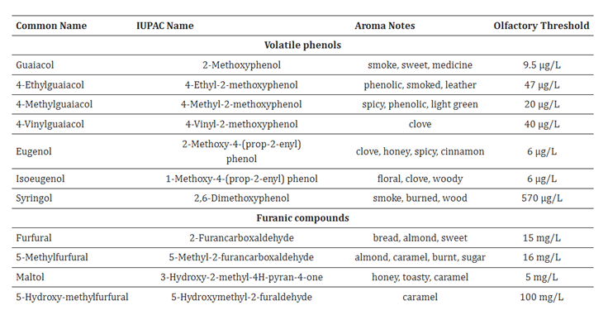
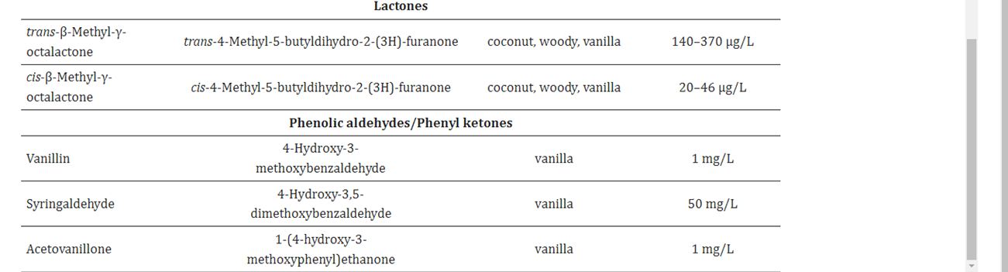
Table 5: Main aroma compounds derived from wood (Tarko, Krankowski and Duda-Chodak, 2023)
New distillates matured for long periods in oak alter from a sharp and crude state, to mellow and wonderful notes. Clear distillates take on a golden tone demonstrating numerous changes within the whisky and the advancement of flavour components and pigments. Maturing is a key figure giving distillates a proper quality and sensory profile. It fortifies the physical-chemical interaction between the wood and fluid resulting in an alteration of colour and volume of the ethyl liquor.
Nevertheless, the ultimate taste of the drink depends primarily on the first composition of the distillate. The interaction of the whisky with the wood and its compounds during maturation helps balance the different flavour elements, including sweet, bitter and savoury notes. Microbial activity in the cask may contribute to the development of certain flavours and influence the overall taste profile of the whisky. The chemical reactions during maturation are dynamic and multifaceted, contributing to the complexity and uniqueness of each whisky. Interplay between the whisky and cask shapes its colour, aroma and taste. Resulting in a well-rounded and harmonious final product.

3.2 Factors Affecting Maturation
The duration of maturation or the length of time whisky spends aging is a crucial factor that significantly influences its final characteristics. In the early stages of maturation, the whisky interacts more actively with the wood. This can lead to rapid extraction of compounds from the cask, including colour, flavour, and aroma compounds. Overtime the interaction with the wood continues at a slower rate. Extended maturation allows for more nuanced and subtle interactions, contributing to the development of complex flavours and aromas.
Whiskies matured for shorter durations may exhibit a lighter colour, with less time for the extraction of pigments and compounds from the wood. Longer maturation periods contribute to deeper and more intense colours as the whisky absorbs a greater amount of compounds, including tannins and lignins. Early in maturation, the whisky may display more prominent and youthful characteristics. This can include raw grain flavours and a stronger influence of wood-derived compounds. In the early stages, the aroma profile influenced by the rapid extraction of volatile compounds from the wood. It can exhibit raw and primary aromas.
With time the whisky undergoes a more balanced and gradual development of flavours. Complex interactions between the whisky and the wood lead to the emergence of nuanced and layered taste profiles. Longer aging allows for development of a sophisticated and multi-layered aromatic profile. Subtle and complex aromas may emerge, contributing to the overall whisky bouquet. Younger whiskies may have a more spirited aggressive mouthfeel, the alcohol presence more pronounced.
Over time, the texture becomes smoother and more refined. Tannins and other compounds from the wood contribute to a well-rounded and velvety mouthfeel. Evaporation loss, known as ‘angel's share’, is less significant during shorter maturation periods. With longer maturation the angel's share becomes higher, a greater portion of the whisky evaporates over time. This can result in a concentration of flavours and an change in alcohol content. Whiskies with shorter maturation periods are typically ready for market sooner, reducing production costs and allowing for a quicker return on investment. Longer maturation requires greater investment in storage space and resources. The cost of aging inventory for extended period may be higher, but can lead to premium and well-aged products.
The duration of maturation is a critical variable that distillers carefully manage to achieve the desired balance of flavours, aromas and overall character in their whiskies. Both short and extended maturation periods have their merits. The choice depends on the distiller's vision and the desired style of the final product.

Chapter 4: Regional and Climate Influences

Climate and environmental conditions
Climate and environmental conditions play a crucial role in the maturation of whisky. The interaction between the whisky and the atmosphere within the maturation warehouse can significantly influence the final characteristics of the spirit.
Temperature variations between seasons and day-night cycles cause the whisky to expand into the wood during warmer periods and contract during cooler periods. This promotes the extraction of flavours from the cask. In warmer climates, such as Kentucky in the United States or certain regions in Australia, higher temperatures can accelerate the maturation process.
The whisky may interact more rapidly with the wood, leading to faster extraction of compounds and potentially more intense flavours. In cooler climates, such as Scotland, the maturation process is generally slower. The whisky has less interaction with the wood, allowing for a more gradual and nuanced development of flavours.
Higher humidity levels can prevent excessive evaporation (angles’ share). This is important in regions with high temperatures to minimize losses during maturation. Lower humidity levels may contribute to higher evaporation rates. While this can lead to a higher angel's share, it may also concentrate the flavours in the remaining liquid, intensifying the overall character of the whisky.
Changes in barometric pressure can influence the movement of air into and out of the cask, affecting the rate of maturation. However, the impact of barometric pressure thought less significant than temperature and humidity. Coastal maturation warehouses may experience more moderate temperature fluctuations due to the influence of the sea, potentially resulting in a different maturation profile compared to inland warehouses. Maturation at higher altitudes may result in lower atmospheric pressure so affecting the maturation process and even resulting in unique environmental conditions.
The environmental conditions within the warehouse can influence microbial activity. Microorganisms present in the air and wood may contribute to the development of certain flavours and characteristics in the whisky. The construction and insulation of the maturation warehouse can affect the internal environment. Well-ventilated warehouses with good insulation help maintain a stable environment and minimize temperature fluctuations. As we have seen wood type, quality and previous use influence how the whisky and wood interact. The environmental conditions can affect the permeability of the wood and the extraction of compounds. Some whisky-producing regions have regulations that specify certain environmental conditions for maturation. For example, Scotch whisky must mature in Scotland, the climate having a distinct impact on the maturation process.
In conclusion, the interplay between temperature, humidity, and other environmental factors contributes to the unique characteristics of whiskies from different regions. Distillers carefully consider these conditions when selecting maturation sites and managing their aging inventory to achieve the desired flavour profiles in their final products.

4.1 Whisky Regions
Whisky region refers to specific geographic areas known for producing whiskies with distinct characteristics influenced by factors such as climate, water source, local traditions and regulations. Different regions around the world have developed unique styles of whisky, each reflecting the local environment and production methods. Here are some prominent whisky regions:
Scottish Highlands: Known for a diverse range of whiskies. Highland malts can vary widely in flavour; some may be peaty and robust, while others are sweet and fruity.
Speyside: Recognized for its high concentration of distilleries, Speyside produces whiskies often characterized by their sweetness, maltiness, and complexity.
Islay: Famous for its heavily peated and maritime-influenced whiskies. Islay malt is favoured for their bold, smoky, and medicinal flavours.
Lowlands: Generally producing lighter and more approachable whiskies, Lowland malts often exhibit floral and grassy notes.
Irish Whisky: Known for its smooth and triple-distilled character, Irish whisky may display flavours ranging from light, floral, to rich, and complex. Key regions include Cork, Dublin, and Midleton.
Welsh whisky has gained recognition and popularity in recent years, and several distilleries in Wales are producing high-quality spirits. While the characteristics of Welsh whisky can vary depending on the specific distillery and production methods. Welsh whiskies often described as crisp and clean with a smooth and an approachable character, can be attributed to the use of fresh and clear Welsh water in the production process. Many Welsh whiskies exhibit fruity notes, including orchard fruits like apples and pears. These fruity characteristics influenced by the choice of yeast strains during fermentation, as well as the distillation and maturation processes. Welsh distillers’ experiment with a variety of cask types for maturation, including ex-bourbon barrels, sherry casks, and even wine casks. Diversity in maturation contributes to a broad spectrum of flavours and aromas. As the Welsh whisky industry continues to evolve, individual distilleries may develop their own distinct characteristics, contributing to the diversity and richness of the global whisky landscape
American (Kentucky): Bourbon is an American whisky and Kentucky is particularly renowned for its production. Bourbon characterized by its sweet, corn-based mash bill and often features flavours of caramel, vanilla, and oak.
Tennessee (Jack Daniels): Similar to bourbon but distinguished by additional charcoal filtering known as the Lincoln County Process. Jack Daniels is a renowned Tennessee whisky.
Canadian Whisky: Often a blend of various grains, Canadian whisky tends to be smooth and light. Rye whisky from Canada may or may not contain a high percentage of rye grain.
Japanese Whisky: Inspired by Scotch whisky production methods, Japanese whisky has gained international acclaim for its quality and craftsmanship. Japanese distilleries produce a variety of styles from peated to delicate and floral.
Indian Whisky: India has a growing whisky industry with warm climates leading to faster maturation. Indian whiskies exhibit a range of flavours, often influenced by the use of local grains and cask types.
Australian Whisky: The Australian whisky industry has been gaining recognition for its diverse and innovative expressions. Climate conditions influence the maturation process, resulting in unique flavour profiles.
New Zealand Whisky: Similar to Australia, New Zealand's whisky industry is relatively young producing whiskies with distinctive characteristics influenced by local climates and production methods.
Taiwanese Whisky: Kavalan, a prominent Taiwanese distillery has gained international acclaim. The warm climate in Taiwan accelerates maturation, resulting in whiskies with rich and complex flavours.
Each whisky region has its own history, traditions and production methods. Contributing to the diversity of whiskies available globally. The unique characteristics of whiskies from different regions make exploring the world of whisky an exciting and rewarding journey for enthusiasts.

4.2 Global Perspectives

Wood choices in other whisky-producing regions.
While oak remains the predominant wood choice for whisky maturation globally, some whisky producing regions experiment with different types of wood or use unique cask treatments to impart distinct flavours to their spirits. Here are examples of regional wood choices or treatments:-
Native to Japan, Mizunara oak is valued for its distinctive flavours of sandalwood, coconut, and a unique spiciness. Some Japanese whiskies for example Suntory and Nikka, use Mizunara casks to impart these unique characteristics.
Some Australian distillers’ experiment with native woods such as Tasmanian oak, eucalyptus and other local species to create unique flavour profiles. Native woods contribute to the diversity of Australian whiskies.
Indian distillers experiment with local wood varieties, including indigenous oak and other hardwoods. The warm climate in India accelerates maturation, influencing how the whisky interacts with different types of wood.
Taiwan: While American oak is commonly used, Taiwanese distillers like Kavalan also experiment with other wood types. These include ex-wine, sherry and port casks. This variety contributes to the unique flavour profiles of Taiwanese whiskies.
Swedish distillers, such as Mackmyra, primarily use oak casks for maturation. Additionally, they have experimented with other barrels, including ex-wine and small-sized casks to influence the flavour development of their whiskies.
In France, particularly in the Cognac region, Limousin oak traditionally used for maturing Cognac. Some French distillers use this oak for whisky maturation, contributing spicy and woody notes.
South African distillers often use French oak barrels for whisky maturation. These barrels may be ex-wine or brandy barrels, adding a layer of complexity to the final product.
New Zealand distillers experiment with native woods, such as rimu and totara, alongside traditional oak. The use of native woods adds a unique and local touch to New Zealand whiskies.
English distillers may use English oak alongside traditional American oak. Additionally, some distillers experiment with casks that previously held wine, contributing to diverse flavour profiles.
Some German distillers use German oak for maturation, and the choice of wood may vary between distilleries. German oak can impart different flavours compared to other oak varieties.
While oak remains the primary choice, the specific characteristics of the wood whether sourced locally or internationally and the previous use of the cask (e.g. wine, sherry or port) contribute the diverse flavour profiles of whiskies from different regions. Distillers' experimentation with wood types and treatments is a key factor creating unique and innovative expressions of world whisky.

Chapter 5: Challenges and Future Trends

5.1 Sustainability and Sourcing

Sustainable wood practices in the whisky industry.
As environmental awareness increases, sustainable industry wood practices have become increasingly important. Distilleries recognize the need to manage wood resources responsibly.
Distilleries are increasingly focusing on sourcing wood from sustainably managed forests. This involves practices such as replanting trees to replace those harvested for cask production and ensuring the long-term health of the forests. Some distilleries seek wood from forests certified by organizations such as the Forest Stewardship Council (FSC). This certification ensures that wood sourced from responsibly managed forests meet environmental and social standards.
Distilleries may use reclaimed or repurposed wood for cask construction. Utilizing wood from old casks, furniture or other sources so reducing the demand for new timber and minimizing waste. Distilleries explore ways to recycle or repurpose casks that have reached the end of their useful maturation life. Some distilleries opt for local wood species that are abundant and considered sustainable. Additionally, the use of invasive species for cask construction can contribute to ecological management by reducing the invasive impact on local ecosystems.
Smaller cask sizes have become popular for maturation. While this practice, often driven by the desire to accelerate the aging process, also reduces the amount of wood required for each cask making the process more resource-efficient. Experimentation with alternative wood types such as acacia or chestnut that are abundant and fast growing can contribute to sustainability.
Distilleries work to optimize the use of wood during the barrel construction process, minimizing waste and maximizing the yield from each log. This includes the use of advanced technology and craftsmanship. The carbon footprint associated with the production and transportation of casks considered, with some distilleries sourcing wood locally to reduce the environmental impact of transportation. Ongoing research and innovation in cask construction techniques and alternative materials aim to develop more sustainable practices in the whisky industry. This includes exploring ways to extend the lifespan of casks and reduce environmental impact.
By adopting sustainable wood practices, the industry aims to balance the tradition of using wooden casks for maturation with a commitment to environmental stewardship. As consumer awareness of sustainability increases, distilleries continue to explore and implement practices that contribute to the long-term health of forests and ecosystems. The whisky industry faces several challenges related to wood sourcing for maturation. These challenges affect the availability, quality, and sustainability of wood. The global demand for whisky and other spirits is increasing, leading to a higher demand for wooden casks. This increased demand can put pressure on the supply chain, leading to challenges in securing a consistent and high-quality source of wood. Climate change can affect the growth and quality of trees. Temperature changes, precipitation patterns and extreme weather events may affect the growth rates and characteristics of wood, potentially affecting the flavour profiles of whiskies.
Ensuring the sustainability of wood sourcing is a priority for the whisky industry. However, verifying and maintaining sustainable practices in forestry can be challenging, especially when dealing with complex supply chains and multiple suppliers. While certification programs like the FSC exist to promote sustainable forestry practices, verifying the certification of wood sources and ensuring compliance with sustainability standards throughout the supply chain can be logistically challenging.
Distilleries must adhere to various regulations and standards related to wood sourcing, such as restrictions on the use of certain types of wood or requirements for cask construction. Ensuring compliance with these regulations can be a complex task, particularly when sourcing wood internationally. Maintaining consistent wood quality is crucial for ensuring the desired flavour and maturation characteristics of whisky. Variability in wood quality, such as differences in grain tightness and chemical composition, can pose challenges for distilleries seeking consistency in their products.
Additionally wood used for cask production competes with other industries, such as construction and furniture. High-quality wood suitable for whisky casks may become scarcer or more expensive due to increased demand from various sectors. Whisky maturation often requires several years sometimes decades. This long maturation time poses a challenge in forecasting future wood needs and ensuring a stable supply over extended periods, especially when demand for aged whiskies is high. The transportation of large and heavy wooden casks can be logistically challenging. Distilleries may face difficulties in transporting casks from the forest to the cooperage and then to the maturation warehouse, especially if located in remote or inaccessible areas. The spread of invasive species or diseases that affect trees impact the availability of suitable wood. Diseases like Dutch elm disease or invasive pests can devastate forests, affecting the quality and quantity of available wood.
Addressing challenges require collaboration between distilleries, cooperages and forestry organizations. Sustainable and responsible wood sourcing practices, along with ongoing research and innovation are essential to ensuring the long-term viability of the whisky industry and the availability of high-quality wood for maturation.

5.2 Innovation and Experimentation

Trends in experimenting with new wood types.
Innovation and experimentation with new wood types have become prominent trends in the whisky industry as distillers seek to create unique flavour profiles and differentiate their products. Distilleries around the world are exploring a variety of wood types, including non-traditional options, to influence the maturation process and impart distinctive characteristics to their whiskies.
The raw distillate, and in particular the maturation conditions, play a significant role in the final flavour of the whisky. However, the type of wooden cask used for maturation appears to be the most important factor in determining the final flavour of a whisky. The type of wood used for maturation can affect the taste, colour, and aroma of the whisky. The effect of maturation depends on the nature of the whisky. In some cases, the wood contributes significantly to the flavour. In other cases, the whisky may have an already identifiable taste and the effect of maturation is less. The time needed to reach a satisfactory state of maturation is a financial and practical concern to the manufacturer and varies depending on the type of wood used. (MOSEDALE, 1995)
Acacia wood, has been experimented with for maturation. It is lighter and more porous than oak and has been used for sweet and white wines in France, Italy and Spain for many years. American winemakers have probably championed it the most, especially in white wines like pinot and sauvignon blanc. Some wineries also experiment with Riesling and Chardonnay. Apparently, Acacia emphasizes fruit and floral compositions without too much oak vanilla and tannins. Whiskies aged in acacia casks may display floral, herbal and sometimes fruity notes. Bushmills released a Distillery exclusive whisky matured in Acacia wood.
Some distilleries have experimented with chestnut casks for maturation. Chestnut wood imparts earthy, nutty and aromatic qualities to the whisky, offering a distinct flavour profile. Released as part of the Defilement series, the 8-year-old whisky is finished in a new, charred chestnut octave cask.
Cherry wood, known for imparting a subtle sweetness to the whisky can manifest as fruity and sometimes floral notes in the final product. It also contributes spicy and complex flavours.
These nuances can add depth and character to the overall flavour profile. Cherry wood may not have as much impact on the colour of the whisky as oak but can contribute to a rich and slightly reddish hue. More recently, distilleries such as Teeling and Mackmyra have a tendency to experiment with Cherry Wood. Teeling used it to make a 15-year-old Irish Single Malt, which was aged first in bourbon casks and then in virgin Cherry Wood casks.
Ash wood is less common and generally considered to impart lighter flavours compared to oak. The wood may contribute more subtle and delicate notes to the whisky, making it an interesting choice for those seeking a different flavour experience. Ash wood has the potential to introduce herbal and nutty characteristics. These flavours can add complexity and a unique dimension to the overall taste. It allows a faster maturation process compared to oak and the porosity of the wood and interaction with the spirit can accelerate the extraction of flavours. While not as influential as oak in terms of colour, it can contribute to the whisky's appearance. The spirit may take on a lighter hue and interaction with ash result in a different visual aspect compared to traditional oak-aged whiskies.
Pear wood is uncommon in the whisky industry, primarily because it lacks certain characteristics that are desirable for aging and maturing whisky. The choice of wood for whisky casks is crucial, as it significantly influences the flavour, aroma, and overall quality of the final product. Pear wood, is less porous limiting the ability to impart desirable characteristics to the spirit. Working together with the cooperage it came to the light that Pear wood barrels were not holding liquid the same way as other barrels. The experiment stopped and the conclusion was although the wood had very pleasant aroma it is not suitable for the whisky industry.
Innovative Toasting and Charring Techniques:
Table 6: Summary of the effects of cooperage treatment on wood properties. (Thesis and Mosedale, n.d.)
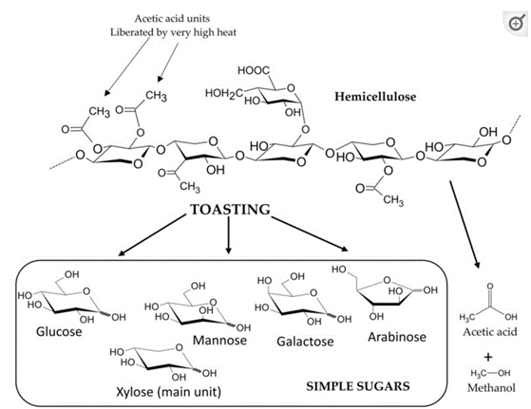
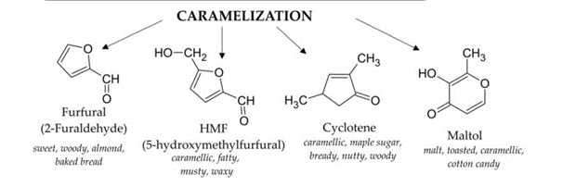
Fig3 Structure of a hemicellulose molecule and the products liberated during toasting and caramelizsation processes (Tarko, Krankowski and Duda-Chodak, 2023)
Whisky derives primarily from barley in a process that includes mashing, fermentation, distillation and aging. It gets its final character from the compounds transferred from the wood into the spirit. Aging in oak barrels increases the antioxidant potential of whisky by increasing the concentration of phenols, furans and acid compounds.
Distillers are exploring different toasting and charring techniques to enhance the influence of wood on the whisky. Variations in the intensity and duration of toasting and charring achieve specific flavour outcomes.
Some distilleries are experimenting with hybrid casks, combining different wood types or using casks made from staves of various woods. This approach allows for a multi-dimensional flavour profile resulting from the interaction of different wood influences. For example, Cherry wood staves and American Oak tops; this combination can create a whisky with a complex interplay of sweet, fruity, spicy, and vanilla notes.
The exploration of new wood types and maturation techniques are driven by the desire to create whiskies with diverse and unexpected flavour profiles. As consumers increasingly seek unique and distinctive expressions, distillers continue to push the boundaries of wood experimentation so contributing to the ongoing evolution of the whisky industry.
Collaborations between distillers and wood specialists have become a notable trend in the whisky industry. These partnerships aim to explore innovative maturation techniques and experiments with unique wood types, so creating distinctive flavour profiles.
The late Dr. Jim Swan, a respected whisky consultant, collaborated with Penderyn on various projects, including experiments with wood and maturation techniques. These contributing to the development of innovative expressions.
Collaborations between distillers and wood specialists continue to push the boundaries of what is possible in whisky maturation, resulting in a diverse array of unique and memorable expressions for consumers to explore. The STR cask is a style especially designed and optimised for maturation by the late Dr. Jim Swan. At the time, it was born from the need to re-use more wood from the abundance of old wine casks in Europe and America to produce single malt whisky. Originally used for the ageing of red wine (in our case, Spanish Rioja) and was coopered with American oak. After first application, our STRs are refurbished by J.Dias cooperage in Porto, Portugal (4th generation family business, now run by Sandra Dias).
Wood specialists bring expertise in forestry, cooperage, and wood science. Their knowledge of different wood species, toasting and charring techniques and the impact of wood on whisky. They can advise distillers on sustainable wood practices, helping ensure responsible and environmentally friendly sourcing of wood for cask production. This may involve considerations such as replanting, forest management, and certification programs. The collaboration can innovate maturation techniques, including variations in temperature, humidity and airflow within maturation warehouses. These experiments aim to optimize the interaction between whisky and wood for unique flavour development.
Distillers benefit from the educational aspects of collaborations, gaining insights into wood science and maturation processes. The knowledge shared between distillers and wood specialists contribute to ongoing advancement of the industry. The Macallan collaborated with French cask maker Jean-Marc Paquet to create bespoke oak casks from the Vosges region in France so contributing to the distillery's Edition series. The craft of the cooper in opening up the wood is a vital component in accessing all of this valuable material.
It would be an interesting experiment to work closely with coopers to accumulate data to produce a comprehensive background of the capabilities of different wood types. At Penderyn, we are experimenting with wood types and their finishes. This is a fascinating creative process allowing distillers to explore unique flavour profiles and create distinctive expressions.

Focusing on Ash wood, Pearwood, Caucasian Oak, Carpathian Oak.
Ash trees grow all over Europe. Barrels for production use certified wood that comes from sustainable producers. It is characterized by light colours ranging from yellowish to white-reddish. With strong, sweet flavours reminiscent of honey and minimal tannins making up a unique flavour character.
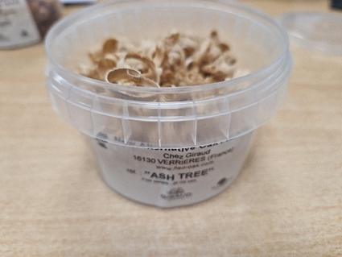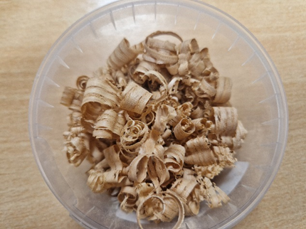
Fig 4 Ash Wood shavings
No unique volatile compounds were detected in the ash, because all the compounds in the ash were detected in at least one other tree, be it acacia, chestnut, cherry or oak. However, the quantitative differences can clearly be used to identify roasted ash, of which tyrosol is the most interesting because, although it is present in this wood and oak spicewood, after roasting it was found only in ash - 24.6 and 26.4 μg/g for oak species. In addition, this wood is quantitatively different and contains more certain volatile compounds than all reference woods (acacia, cherry, acacia), especially after roasting, including: catechol, 3-methylcatechol, homovanillyl alcohol, coniferaldehyde, 2-phenoxyethanol, 1 -hydroxyl. -2-butanone, 1-acetyloxy-2-butanone, γ-butyrolactone, solerone, 3,5-dimethylcyclotene, 4,5-dimethyl-2-cyclohexen-1-one, 2-furanmethanol, 3-ethylcyclotene, α-methylcrotonolactone , solerone and 3 -hydroxybenzaldehyde. Focusing on the volatile compounds desired by consumers, it was found that guaiacol, isoeugenol, syringol, and maltol, as well as vanillin, cystaldehyde, and acetovanillin were also abundant in ash wood at medium roast. Therefore, it is a wood with more volatile phenols after light and medium roasting (Fig. 5c, d) and more phenolaldehydes/phenylketones after medium roasting (Fig. 1d). However, furfural is quite low in wood and the concentration of furanic compounds is very low after all forest treatments (Figure 5 b-d). There are compounds that are not detected in ash wood but are present in traditional wood, such as trans- and cis-lactones, which are of great interest. Roasted ash seems more aromatic. (Martínez-Gil et al., 2022)
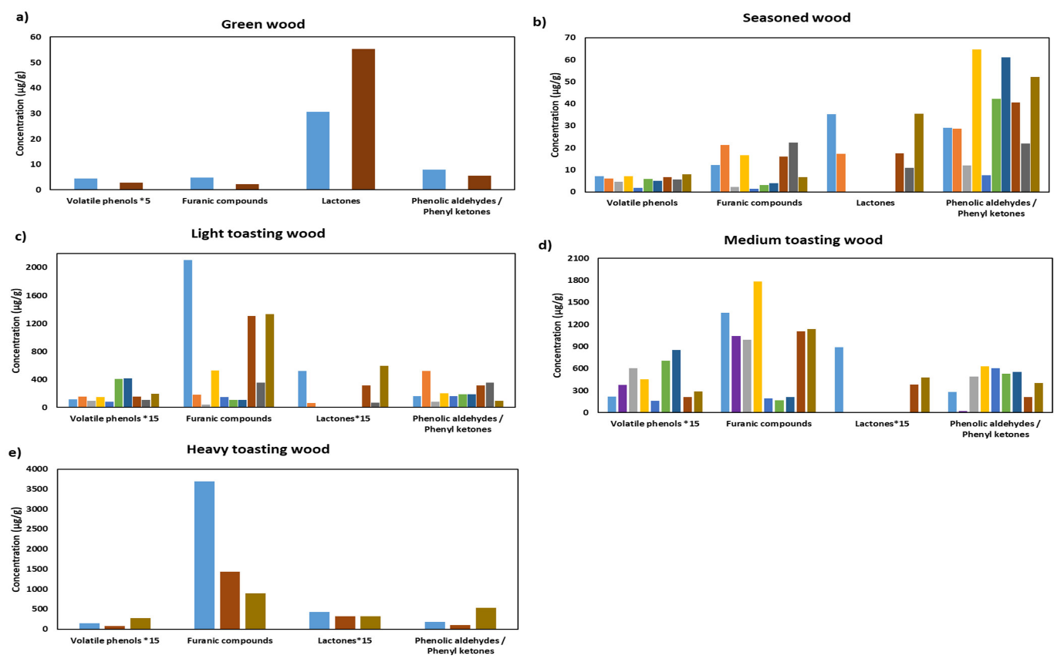
Fig 5 Graphical representation of the averages of the sum of the compounds in wood volatile phenols, furanic compounds, lactones and phenolic aldehydes/phenyl ketones by wood species, after the different cooperage treatments: (a) green, without treatment; (b) seasoned (carried out in oven and in open air); (c) light-toasted (light toasting, 190 °C for 10 min, 160–170 °C for 20 min and for 35 min); (d) medium-toasted (medium toasting, 180 °C for 45 min, 200 °C for 15 min and 35 min, 210 °C for 20 min and 45 min, and medium plus toasting); (e) heavy-toasted (heavy toasting and 250–260 °C for 27 min). (Martínez-Gil et al., 2022)
Ash wood in the industry is generally limited and often experimental specific releases or limited-edition expressions to explore the unique characteristics imparted by this wood type. It presents challenges, including potential brittleness and less flexibility compared to oak. These factors affect cask construction and the ability to shape it into traditional barrel forms.
"Caucasian oak" typically refers to oak wood sourced from the Caucasus region, which includes countries such as Georgia, Armenia, Azerbaijan, and parts of Russia and Turkey. Oak from this region has gained attention in various industries, including the wine and spirits industry, for its distinct characteristics The wood from Caucasian oak may have a unique pore structure, and the size and distribution of pores can impact its suitability for different applications, such as barrel making. Caucasian oak has been used in the aging of wines and spirits, including brandies. The wood is valued for its potential to impart specific flavours and aromas to the beverages. Caucasian Mountain oaks provide first-rate wood for barrels with distinctive flavour profiles. Before the production process begins, a lengthy drying procedure assures the greatest quality. Unlike other wood, it has soft tannins; mineral, fruity and fresh flavours make these outstanding barrels shine. The unique climate and soil conditions in the Caucasus region can influence the characteristics of the oak grown there. Factors such as terroir, similar to those influencing wine grapes, may play a role in the final profile of the wood.

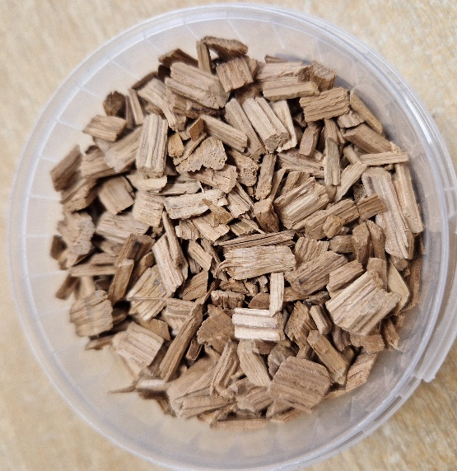
Fig 6 Caucasian oak woodchips
The Carpathian Mountains span several countries in Central and Eastern Europe, including parts of the Czech Republic, Slovakia, Poland, Hungary, Ukraine, and Romania. The region is known for its diverse ecosystems and rich biodiversity. Historically, oak wood from the Carpathian region has been used in carpentry, construction, and furniture making. The region has a tradition of forestry, and oak is one of the hardwood species that grows in the area. Some distillers and producers may explore the use of oak from the Carpathian region for aging beverages. The unique terroir and climate of the region contribute distinctive characteristics to the wood. The foothills of the Carpathian Mountains, oak trees provide a special kind of barrel-making wood. Local experts meticulously select the wood for the casks. Aging in this wood improves the aromatic profile of all types of spirits and distillates.

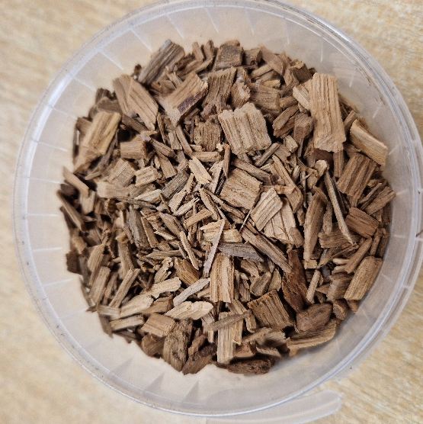
Fig 7 Carpathian oak woodchips
Despite producing wonderful aromas and flavours, Apple and Pear wood are infrequently utilized because they lose their seal over time. Pearwood offers a light fruitwood smoke flavour that is round, acidic, and somewhat peppery. Although, flavours would contribute for the whisky, from the knowledge from the coopers about the lose their seal over time I decided not to include in the next step of the flavour experiment.
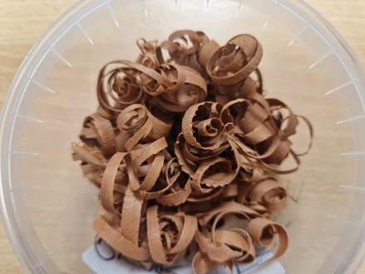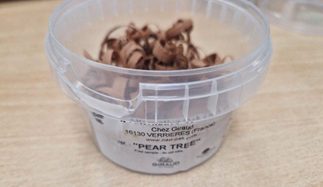
Fig 8 Pear wood shavings

Limited Use and Experiments:
As the whisky industry continues to embrace innovation and experimentation, some distillers may explore ash wood to create whiskies with distinct and unconventional profiles. These experiments contribute to the diversity of offerings in the market. Ash wood may contribute to a sense of terroir, especially if the wood locally sourced. Distillers interested in highlighting the unique characteristics of a specific region explore the use of native wood types.
Whisky enthusiasts seeking novel and unconventional flavours are intrigued by unique and experimental releases. It is essential to note that in the industry, the use of ash wood is not as widespread or traditional as oak. Oak highly favoured for its structural qualities and appealing flavours has an established historical use in maturation. However, as the industry continues to evolve and experiment it is possible that the use of alternative woods, including ash and others, may gain further exploration in the future.
Steps of experiment:
1. Obtain Wood Chips: Prepare Wood Chips: Ensure the chips are clean and free from any contaminants. Place Wood shavings in a dryer for 3 days evenly distributing moisture down to about 4% dry weight
2. Select Containers: Choose separate glass containers for each wood type, to ensure the flavours from different woods remain distinct.
3. Measure Wood Chips: A consistent amount of wood chips for each container. The amount depending on personal preference. A few grams per 100ml of base spirit is a reasonable ratio. In the container the wood communicates with the spirit, absorbing it and then releasing it. Be conservative and do not add too many shavings at once; less is more.
4. Add Base Spirit: In each container completely cover wood chips with New Make Spirit.
5. Tightly seal containers to prevent evaporation and contamination. One of the main disadvantages of using wood chips in containers is the lack of oxidation. This natural occurrence in aging spirits adds complexity and intensity to flavours and is largely responsible for the fruit, mint and spice notes. The whisky can breathe inside the leak proof but porous cask, allowing oxygen to enter through its ‘pipes’. Clearly the same cannot be said for any sealable glassware.
6. Allow Infusion: Place the containers in a cool, dark place and allow the wood chips to infuse the spirit. Shake containers gently every few days to enhance contact between the wood and spirit.
7. Taste Testing: After the desired infusion period, conduct taste tests to evaluate the flavours imparted by each wood type. Take notes on colour, aroma and taste characteristics.
Ash Wood results:
Aroma: Pure, light yellow fruits, slightly sour, lemon, mango, powdered cream cookies, concentrated aromatic essential oils and fragrant lily. Just a little oily but smells nice and clean. There are small changes and layers without twists. High openness giving a high sense of pleasure.
Palate: Interesting, something different from the usual whisky. Sweet and juicy fruit jelly, some honey and cream embellishment. Displays a bigger body but is not heavy. However it has an oily feel, slight herbal lemon grass with light spices.
Finish: The finish is medium; flavours focused on honey, herbal spice, nut and vanilla spice. Medium to slightly dry without noticeable astringency or bitterness.
Colour:
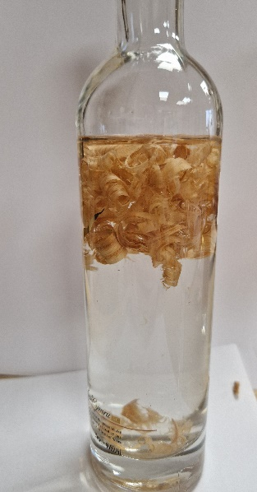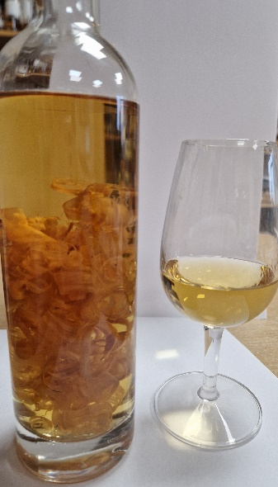
Fig 9 At the start of experiment, clear New Make Spirit and at the end a lovely yellow amber colour.
Carpathian Mountains oak results:
Aroma; A distinctly light and Penderyn-like nose with aromas of toffee and cake. Marzipan and almond flavour and a vanilla and creamy sugar undertone that totally reminds of Almond cakes.
Palate; All of these dessert-like flavours carry flavour. When it hits the lips, an extra bit of lemon-peal freshness but then the real treat comes at the end of the bite. A crazy liquorice meets cinnamon and almost cayenne spices and takes over all those appetizers. Generally sweet tastes.
Finish: These spicy notes also take over the finish complemented by a rich spicy touch. Not in a dominant or overwhelming sense. Simply bringing a fuller flavour profile to the table.
Colour:
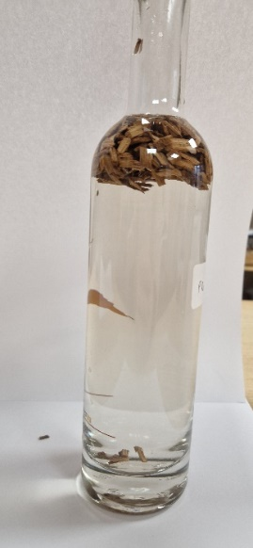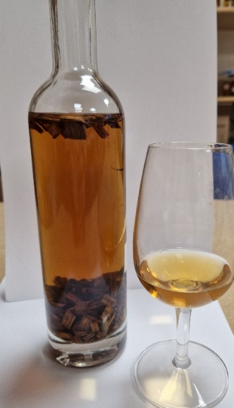
Fig 10 At the start of experiment, clear New Make Spirit at the end a lovely deep copper colour.
Caucasian Mountains oak results;
Aroma: Wonderful sweet and fruity aroma, plum jam, banana bread, dark chocolate covered cherries, creamy coconut and refreshing mango cinnamon ice cream.
Palate: Meringue with mango coulis and fresh raspberries. The initial start replaced with matcha powder giving this dessert flavour a slightly spicy Asian touch.
Finish: Candied orange sticks and candied clementine with Moroccan spices.
Colour:
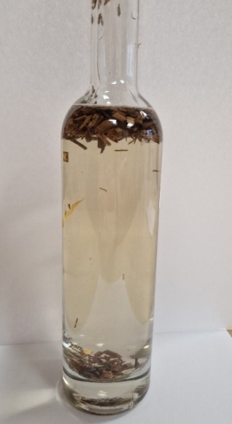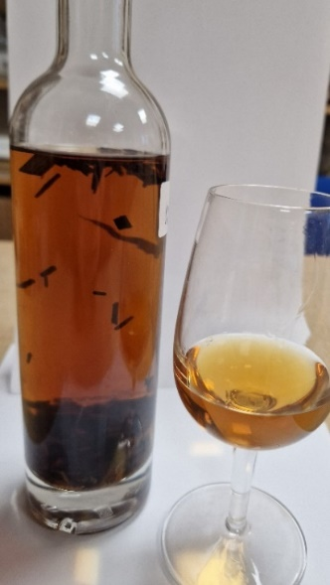
Fig 11 A clear New Make Spirit finishes as a pleasant burnished hue

Chapter 6: Conclusion

6.1 Summary of Findings
The use of different wood types in the whisky industry is a testament to the craftsmanship and innovation of the distilling community. From the vanilla sweetness of American oak to the intricate flavours of sherry casks, each wood type contributes to the symphony of tastes that make every whisky unique. As distillers continue to experiment and push boundaries, the influence of wood remains a cornerstone in the ever-evolving world of whisky production.
Today, whisky production has become a global industry with countries such as the United States, Canada, Japan, Wales, Israel and others producing high-quality whiskies. Craft distilleries have also emerged contributing to a diverse and dynamic whisky market.
Experimenting with different types of wood in whisky production can yield a wide range of flavours and characteristics, ultimately contributing to the diverse and evolving landscape of the whisky industry.
The choice of wood significantly influences the flavour profile of whisky. Different wood types, such as oak, cherry, chestnut, ash wood and others, impart unique characteristics, ranging from sweetness and spiciness to nuttiness and fruitiness. While oak remains the traditional and predominant wood for whisky maturation, distillers and cooperages are increasingly experimenting with unconventional woods. These experiments aim to push boundaries, create distinct flavour profiles and offer consumers novel and exciting whisky experiences.
Oak is favoured for its versatility and ability to contribute a wide array of flavours. The toasting and charring processes applied to oak barrels play a crucial role in shaping the final taste and colour of the whisky. Processes like STR (Shaved, Toasted, and Re-charred) display how innovations in barrel construction techniques can influence maturation. These methods aim to rejuvenate barrels and extract unique flavours from the wood. Distilleries may release unique expressions or limited editions that highlight the impact of different wood types. These releases provide enthusiasts with an opportunity to explore and appreciate the nuances brought about by experimental wood choices.
Some wood types, such as chestnut have different porosity and tannin levels, potentially leading to accelerated maturation. This characteristic affects the aging process resulting in whiskies with distinct profiles in a shorter period. Distillers engaging in wood experiments meticulously document their processes, wood choices and the aging duration. This information serves as a valuable resource for learning and refining techniques in subsequent experiments. The use of different wood types in whisky production represents a dynamic and creative aspect of the industry. As distillers continue to innovate, whisky enthusiasts can anticipate a continued expansion of flavour possibilities and an evolving appreciation for the art and science of wood influence in whisky maturation.

6.2 Implications for the Whisky Industry
The exploration of different wood types in whisky maturation has several practical implications for distillers, providing opportunities for innovation, differentiation, and meeting the evolving preferences of consumers. Distillers can use the knowledge gained from experimentation to innovate and create unique expressions of whisky. This innovation can help distilleries stand out in a competitive market attracting consumers seeking novel flavour experiences. Distillers leverage the use of different wood types to create limited edition or specialty releases. These expressions become collectors' items and generate excitement among enthusiasts.
Understanding the impact of different woods allows distillers to tailor flavour profiles of their whiskies. Specific wood types chosen to enhance certain characteristics, whether it is emphasizing sweetness, add spiciness or introduce unique fruity notes. Experimentation that accelerates maturation can be practical for distillers looking to produce high-quality whiskies in a shorter period. This is particularly useful for meeting demand or releasing products sooner. Knowledge of wood interaction enables distillers to optimize their barrel management processes and informed decisions made on barrel reuse, maturation times or implementing toasting and charring techniques. Distillers use experiments as a tool for consumer education. Sharing the details of wood choices, maturation processes and the resulting flavour profiles can engage consumers and deepen their understanding and appreciation of whisky.
Keeping an eye on market trends and consumer preferences is crucial. Experimenting with different wood allows distillers to respond to changing consumer tastes and preferences thus staying relevant in a dynamic market. Distillers can explore the use of alternative and sustainable wood sources for barrel construction so aligning with the industry's focus on environmentally friendly practices.
Collaboration with cooperages, researchers and other industry experts further refines their understanding of wood influences. Partnerships can lead to shared knowledge and the development of new and exciting wood-related innovations. Rigorous documentation of wood experiments allows distillers to maintain process consistency. Understanding how different woods behave enables better control over the final product ensuring a reliable and high-quality product.
In summary, the practical applications of experimenting with different wood types in the whisky industry extend beyond just flavour creation. Distillers can use this knowledge strategically to innovate, differentiate their products, meet consumer demands and contribute to the overall growth and dynamism of the whisky market.
As the whisky industry continues to evolve, there are several considerations for future research into the influence of wood on whisky maturation and flavour development.
- Regional variations in wood characteristics and their influence on flavour profiles. Considering factors such as climate, soil composition and tree growth conditions.
- The role of microorganisms, including yeast and bacteria, in the interaction between wood and whisky during maturation. Understanding microbial dynamics may provide insights into the development of unique flavour compounds.
- Genetic variations in oak and other wood species and their influence on the compounds extracted during maturation. This could lead to the development of wood types specifically bred or selected for whisky maturation.
- The effects of wood treatment techniques, such as varying levels of toasting, charring or innovative use of ultrasound or pressure treatment. Determine how these processes influence the extraction of compounds and change the resulting flavour profile.
- Methods for accelerating maturation while maintaining quality. This includes exploring the use of smaller cask sizes, increased wood surface area and other techniques to achieve desirable flavour development in a shorter time.
- Sustainable practices for wood sourcing. This includes alternative wood types, barrel reuse and assessing the environmental footprint of different wood-related practices.
- Conduct studies on consumer preferences related to wood influences in whisky. Use sensory analysis to identify key attributes that appeal to consumers and guide distillers in creating products that align with evolving market tastes.
- In-depth chemical analyses of the compounds extracted from different wood types during maturation. This can provide a comprehensive and chemical understanding of the specific compounds contributing to flavour, aroma and colour in whisky.
- The interaction of different wood types in various distillation processes (pot, column and hybrid stills). How wood influences integrate during fermentation and distillation.
- Long-term effect of various woods over extended maturation periods to understand how certain profile characteristics develop and mature with time.
- Collaboration between distillers, cooperages, researchers and other stakeholders to share insights and knowledge. A collaborative approach can accelerate research efforts and lead to innovations in wood-related practices.
Continued research in these areas deepen our understanding of the complex interactions between wood and whisky, allowing further innovation and refinement of high quality and diverse whiskies.

References
‌
2022. [online] Available at: <https://onlinelibrary.wiley.com/doi/full/10.1002/jib.660> [Accessed 4 October 2022].
‌2022. [online] Available at: <https://www.researchgate.net/figure/Diagram-of-maturation-harvest-and-breeding-for-one-age-class-of-fish-harvested-either_fig2_47677527> [Accessed 4 October 2022].
2022. [online] Available at: <https://www.researchgate.net/publication/342479437_Sensory_profile_of_hemicellulose-rich_wood_extracts_in_yogurt_models> [Accessed 4 October 2022].
Alcohol Professor. 2022. Around the World With Whisky Wood | Alcohol Professor. [online] Available at: <https://www.alcoholprofessor.com/blog-posts/blog/2018/04/19/around-the-world-with-whisky-wood> [Accessed 4 October 2022].
AOAC 1980 Official Methods of Analysis (9.098-9.100). Association of Official Analytical Chemists, Washington DC. USA.
Barecki, J., 2022. From Barrel To Bottle: How Wood Aging Impacts Whiskey. [online] Drinkhacker: The Insider's Guide to Good Drinking. Available at: <https://www.drinkhacker.com/2017/02/01/from-barrel-to-bottle-how-wood-aging-impacts-whiskey/> [Accessed 4 October 2022].
Butler, J. (n.d.). Edinburgh malt whisky tour. [online] www.dcs.ed.ac.uk. Available at: https://www.dcs.ed.ac.uk/home/jhb/whisky/glossary.html [Accessed 14 Feb. 2024].
Cask, S., 2022. The Mighty Oak - King of Casks. [online] Stillincask.com. Available at: <https://stillincask.com/blog/the-mighty-oak-king-of-casks> [Accessed 4 October 2022].
Casteele K V. Geiger H.van Sumere C F 1983 Separation of phenolics and coumarins by reversed-phase high- performance liquid chromatography. J Chromatogr
Citeseerx.ist.psu.edu. 2022. [online] Available at: <https://citeseerx.ist.psu.edu/viewdoc/download?doi=10.1.1.852.5277&rep=rep1&type=pdf> [Accessed 4 October 2022].
Cover, D., 2022. Experiments in Oak: a DIY Maturation Experiment. [online] Daveswhiskyreviews.com. Available at: <http://www.daveswhiskyreviews.com/2017/03/experiments-in-oak-diy-maturation.html> [Accessed 4 October 2022].
Crawford D L. Barder M J. Pometto A L, Crawford R L 1982 Chemistry of softwood lignin degradation by Streptomyces viridosporus. Arch Micobiol .
‌De Rosso, M.; Panighel, A.; Vedova, A.D.; Stella, L.; Flamini, R. Changes in chemical composition of a red wine aged in acacia, cherry, chestnut, mulberry, and oak wood barrels. J. Agric. Food Chem. 2009, 57, 1915–1920. [Google Scholar] [CrossRef]
Discover Magazine. 2022. What Gives Your Favorite Whiskey Its Unique Flavor?. [online] Available at: <https://www.discovermagazine.com/the-sciences/what-gives-your-favorite-whiskey-its-unique-flavor> [Accessed 4 October 2022].
Discovery, W., 2022. In-bottle Maturation Experiment. [online] Whisky-discovery.blogspot.com. Available at: <https://whisky-discovery.blogspot.com/2014/03/in-bottle-maturation-experiment.html> [Accessed 4 October 2022].
Distiller - The Liquor Expert. 2022. Aging Spirits: The Magic of Oak | Distiller. [online] Available at: <https://distiller.com/articles/aging-spirits> [Accessed 5 October 2022].
Diva-portal.org. 2022. [online] Available at: <https://www.diva-portal.org/smash/get/diva2:1275732/FULLTEXT01.pdf> [Accessed 4 October 2022].
Fernández de Simón, B.; Martínez, J.; Sanz, M.; Cadahía, E.; Esteruelas, E.; Muñoz, A.M.M. Volatile compounds and sensorial characterisation of red wine aged in cherry, chestnut, false acacia, ash and oak wood barrels. Food Chem. 2014, 147, 346–356
FINE + RARE. (n.d.). FINE+RARE: Dr Bill Lumsden talks about whisky innovation. [online] Available at: https://www.frw.co.uk/editorial/dr-bill-lumsden-the-eternal-inventor [Accessed 9 Feb. 2024].
Forest Stewardship Council. (n.d.). What is FSC? [online] Available at: https://uk.fsc.org/what-is-fsc#:~:text=FSC%20forest%20management%20certification%20confirms.
Fri, Jul, 02 and 2021 - 09:15 (2021). Master distiller: ‘I have the best job in the world’. [online] Irish Examiner. Available at: https://www.irishexaminer.com/business/companies/arid-40327589.html [Accessed 9 Feb. 2024].
Gollihue, J., Pook, V.G. and DeBolt, S. (2021). Sources of variation in bourbon whisky barrels: a review. Journal of the Institute of Brewing. doi:https://doi.org/10.1002/jib.660.
Gollihue, J., Richmond, M., Wheatley, H., Pook, V.G., Nair, M., Kagan, I.A. and DeBolt, S. (2018). Liberation of recalcitrant cell wall sugars from oak barrels into bourbon whisky during aging. Scientific Reports, [online] 8(1), pp.1–12. doi:https://doi.org/10.1038/s41598-018-34204-1.
Higuchi T 1985 Biosynthesis of lignin. In: Biosynthesis and Biodegradation of Wood components' ed Higuchi T. Academic Press. London. UK.
Irish Distillers. 2022. Two New And Experimental Irish Whiskeys Welcomed To The Method and Madness Range | Irish Distillers. [online] Available at: <https://www.irishdistillers.ie/two-new-and-experimental-irish-whiskeys-welcomed-to-the-method-and-madness-range/> [Accessed 4 October 2022].
Jeffreys, H. (2023). Tour of duty. [online] Drinking Culture. Available at: https://henryjeffreys.substack.com/p/tour-of-duty#:~:text=The%20worry%20was%20that%20alcohol [Accessed 9 Feb. 2024].
John (2023). Amburana Wood: a rising star or another whisky fad | Whiskipedia. [online] whiskipedia.com. Available at: https://whiskipedia.com/fundamentals/amburana/ [Accessed 9 Feb. 2024].
John (2023). The types of wood used in the whisky industry | Whiskipedia. [online] whiskipedia.com. Available at: https://whiskipedia.com/fundamentals/wood-types/ [Accessed 23 Jan. 2024].
Lundquist K. Kirk T K 1971 Acid degradation of lignin. IV. Analysis of lignin acidolysis products by gas chromatography, using trimethylsilyl derivatives.
Martínez-Gil, A., del Alamo-Sanza, M., Sánchez-Gómez, R. and Nevares, I. (2018). Different Woods in Cooperage for Oenology: A Review. Beverages, 4(4), p.94. doi:https://doi.org/10.3390/beverages4040094.
Martínez-Gil, A.M., del Alamo-Sanza, M., del Barrio-Galán, R. and Nevares, I. (2022). Alternative Woods in Oenology: Volatile Compounds Characterisation of Woods with Respect to Traditional Oak and Effect on Aroma in Wine, a Review. Applied Sciences, 12(4), p.2101. doi:https://doi.org/10.3390/app12042101.
MOSEDALE, J.R. (1995). Effects of oak wood on the maturation of alcoholic beverages with particular reference to whisky. Forestry, 68(3), pp.203–230. doi:https://doi.org/10.1093/forestry/68.3.203.
Nimz H 1974 Beech lignin - Proposal of a constitutional scheme.
Nishimura K. Matsuyama R 1989 Maturation and maturation chemistry. In: The Science and Technologl, of Whiskies. ed Piggott J R. Sharp R. Duncan R E B. Longman, Harlow. Essex. UK.
Nishimura K. Ohnishi M. Masuda M, Koga K, Matsuyama R 1983 Reactions of wood components during maturation. In: Flut our of Distilled Beverages. Origin and Development. ed Piggott J R. Ellis Horwood. Chichester, UK.
Obst J R. Kirk T K 1988 Isolation of lignin. In: Methods in Enzymology vol 161 Biomass Part B Lignin, Pectin and Chitin. ed Wood W A. Kellogg S T. Academic Press. London. UK.
Philp J 1989 Cask quality and warehouse conditions. In: The Science and Technology of Whiskies, ed Piggott J R, Sharp R. Duncan R E B. Longman. Harlow, Essex. UK.
Pitmagazine.uk. 2022. The science of smoke – Pit. [online] Available at: <https://pitmagazine.uk/features/the-science-of-smoke/> [Accessed 4 October 2022].
Puech J-L, Moutounet M 1990 Oakwood chemistry and extractable substances. In: Proceedings of the Third Aviemore Conference on Malting Brewing and Distilling ed Campbell 1. Institute of Brewing. London. UK
Qureshi, W. (2018). Case study | Distilling the story behind Midleton Distillery’s Very Rare limited edition. [online] Packaging News. Available at: https://www.packagingnews.co.uk/design/case-study/case-study-distilling-story-behind-midleton-distillerys-rare-limited-edition-10-04-2018 [Accessed 9 Feb. 2024].
Reazin G H 1983 Chemical analysis of whisky maturation. In:Flavour of Distilled Bevereges. Origin and Derelopment. ed Piggott J R. Ellis Horwood. Chichester. UK.
spirits.eu. (n.d.). spiritsEUROPE - A Spirit of Tradition - Distillation process. [online] Available at: https://spirits.eu/a-spirit-of-tradition/distillation-process.
spiritsbeacon.com. (n.d.). Cotswolds Distillery; does bigger mean better? [online] Available at: https://spiritsbeacon.com/features/insight/cotswolds-distillery-does-bigger-mean-better.
Tanahashi M, Higuchi T 1988 Chemical degradation methods for characterisation of lignins. In: Methods in Enzymlogy vol 161 Biomass Part B Lignin. Pectin and Chitin. ed Wood W A. Kellogg S T. Academic Press. London. UK.
Tarko, T., Krankowski, F. and Duda-Chodak, A. (2023). The Impact of Compounds Extracted from Wood on the Quality of Alcoholic Beverages. Molecules, 28(2), p.620. doi:https://doi.org/10.3390/molecules28020620.
The Best Beer Website | For Beers Lovers. 2022. Like the various types of wood, they influence whisky. [online] Available at: <https://www.forbeerslovers.com/en/like-the-various-types-of-wood-they-influence-whiskey> [Accessed 4 October 2022].
Thesis, D. and Mosedale, J. (n.d.). VARIATION OF OAK WOOD PROPERTIES INFLUENCING THE MATURATION OF WHISKY. [online] Available at: https://ora.ox.ac.uk/objects/uuid:b0383556-7c95-48d7-902b-ef4a9f0732dc/download_file?file_format=application%2Fpdf&safe_filename=603833614_Redacted.pdf&type_of_work=Thesis [Accessed 23 Jan. 2024].
Whisky Wonder. 2022. How Casks Affect the Flavour of Whisky. [online] Available at: <https://whiskywonderr.wordpress.com/2017/08/22/how-casks-affect-the-flavour-of-whisky/> [Accessed 4 October 2022].
Whisky.com. 2022. Maturation in Casks - Whisky.com. [online] Available at: <https://www.whisky.com/information/knowledge/production/details/maturation-in-casks.html> [Accessed 4 October 2022].
Whiskyinvestdirect.com. 2022. Perspectives on world whisky: The rise & fall of Royal Welsh Whisky, 1889-1900 | WhiskyInvestDirect. [online] Available at: <https://www.whiskyinvestdirect.com/whisky-news/world-whisky-royal-welsh-frongoch> [Accessed 4 October 2022].
WhiskySpeller (2014). Discovering the Swedish spirits from the Mackmyra Distillery. [online] WhiskySpeller. Available at: https://speller.nl/2014/04/13/discovering-the-swedish-spirits-from-the-mackmyra-distillery/ [Accessed 9 Feb. 2024].
Williams, A. (2021). Behind the wood used in cask maturation. [online] VCL Vintners. Available at: https://vclvintners.london/whisky-journal/the-blog/behind-the-wood-used-in-cask-maturation/ [Accessed 9 Feb. 2024].
www.govinfo.gov. (n.d.). The standards of identity. [online] Available at: https://www.govinfo.gov/content/pkg/CFR-2016-title27-vol1/xml/CFR-2016-title27-vol1-sec5-22.xml#:~:text=produced%20in%20the%20United%20States [Accessed 20 Nov. 2023].
www.wineenthusiast.com. (n.d.). What is Japanese Mizunara Oak and is it Worth It? | Wine Enthusiast. [online] Available at: https://www.wineenthusiast.com/culture/spirits/what-is-japanese-mizunara-oak-worth-it/ [Accessed 9 Feb. 2024].
MOSEDALE, J.R. (1995). Effects of oak wood on the maturation of alcoholic beverages with particular reference to whisky. Forestry, 68(3), pp.203–230. doi:https://doi.org/10.1093/forestry/68.3.203.

‌

