
Program of study : BA Business Management
Module Name : Entrepreneurship
Module code : LCBB5001
Module Leader : Vasilios Tavlaridis
Assignment title : Assessment Component 1: Written Report/ Business Plan
Student Name : Asen Asenov
Student ID : 2028526

Table of Contents
Introduction 3
Overview of the business idea and its product/service 3
Ownership and Legal format of the startup 4
Management of the company 4
Evaluation of the business idea by using the SWOT analysis mode 4
Assessment of the current external environment by using the PESTEL analysis model 5
Identification of the key marketing factors by using the 4Ps of marketing mix model 7
Explanation of the target market and the marketing strategies the company will adopt to reach their customers 7
A cash flow forecast for the first 12 months- startup costs cannot exceed £50,000 9
Reference 10

Introduction 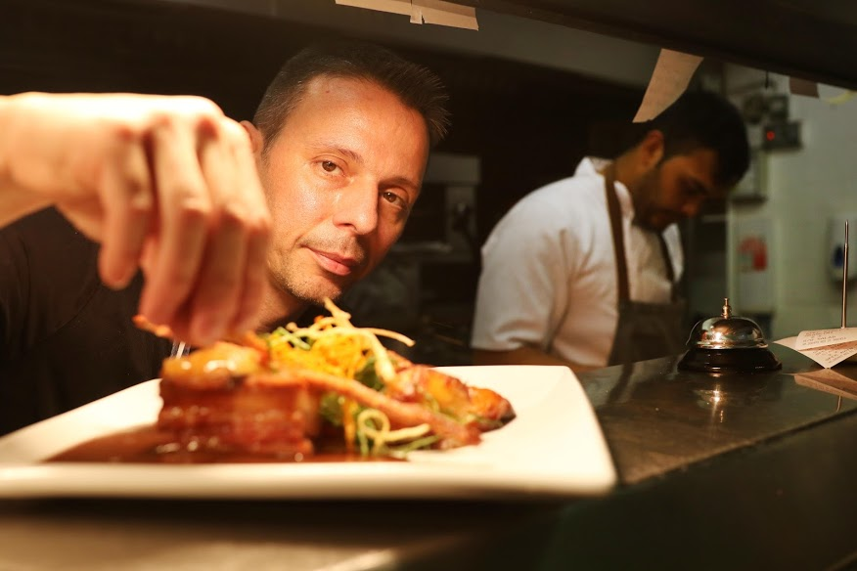
The present age is the age of business progress. In this era, new businesses are being formed all over the world, including the United Kingdom. Similarly, a YouTube channel called Cooking Lessons is opening in Wales, UK. This report will cover all the issues required to open a business (Frederick et al. 2018). This report will cover everything from new business registration to product marketing.

Overview of the business idea and its product/service
The goal is to launch a YouTube channel devoted to cooking courses. The internet has made it easier than ever to find recipes for every conceivable food. However, not every encountered video is with identical quality. Some of the recipes are terrible, the camera work is poor and the people in the videos ramble incessantly about them, giving the channel a diary-like ton. This channel will be devoted to diverse cuisines, allowing viewers to “travel” the globe and learn how to prepare their own dishes. It will be full of surprises for different guests and hosted by experienced, creative and open-minded individual. The channel will feature a variety of cuisines, including Italian, Bulgarian, Mexican and Chinese. It will be in English, but Mandarin subtitles will also be included. In addition, a What’s up- app will have a chat where consumers will be able to voice their opinions, suggest new ideas and win prizes. (Provencher, 2020), (Hazelgren, 2005, p.21)
Consumer interest in home cooking, cooking from scratch, recipes, cooking ideas and improving cooking abilities in the United Kingdom is increasing, according to statistical data. It also shows that 73% of home cooks wish they knew how to prepare a larger variety of dishes, and that 44% are interested in developing their cooking skills. (Caines,2022)
Generation Y and Z utilise social media into their cooking and eating practice. More than half European 13 to 39 years old made meals that were popular on social media, according to a 2022 poll conducted in many European countries. In addition, over a third of respondents sought for recipes on social media. (Gelder, 2022)
YouTube is the finest platform for creating a profitable and popular channel, because after Google, it is the second most popular search engine. It really receives more monthly quarries than Microsoft Bing, Yahoo and Ask.com combined. Each month more than 2 billion users, log in. YouTube users watch more than one billion hours of videos per day and are responsible for billions upon billions of views (YouTube,2021). The platform prominence allows it to access a large audience. (Mohsin,2022)

Ownership and Legal format of the Company
YouTube is one of the most popular social media platforms in the world. Anyone with a Google Account can start their own YouTube channel on the YouTube platform. There are many companies that use YouTube as a marketing tool to expand their business. Cooking Lessons seeks to expand its business through YouTube marketing (Ruiz-Viñals et al. 2018). However, in this case, the company has to fulfill some legal requirements. In order for a company to be recognized, the company must first register in accordance with UK government policy. As a registered company, the company can then start a business through a business YouTube account. One thing to keep in mind, however, is that a business account requires a YouTube channel logo and trademark registration, which allows a company to start trading after obtaining permission by registering in accordance with customary law.

Management of the company
Since the Cooking Lessons Company is a small business, it is primarily registered as a sole proprietorship. The sole proprietorship business is the simplest type of business where all types of management of the company are managed and controlled by the owner himself. Even in a cooking company, the owner takes care of everything himself. In fact, the company does not have any employees at the moment, but the company will provide manpower in line with the expansion of the business. The owner does all the work himself, including preparing all the cooking utensils and making cooking videos and uploading them to the channel. However, from time to time the owner hires people to do the video and also the owner does video editing from outside to increase the quality of his company's video which includes external professional services. The owner has to work on such a decision as it is the starting stage of the company. As the scope of business grows or the number of daily videos increases, it will be necessary to hire technical and video men for editing and also for video marketing.



Evaluation of the business idea by using the SWOT analysis mode
The full form of SWOT is strength, weakness, opportunity and threat. Therefore SWOT analysis is a strategy to evaluate these four aspects of business (Sutrisno et al. 2017). SWOT analysis is a tool that helps analyze what the business is doing now and formulates a successful strategy for the future. SWOT exposes areas of the business that hinder business development. This part of the report will provide a brief SWOT analysis of the Cooking Lessons YouTube channel.

Strengths | Weaknesses
- Easy marketing activities.  - Promoting cooking lesson videos.  - Creating lots of viewers and fans.  - Develop a cooking business.  - Creating new cooking items.  - Running low cost campaigns.  - Making low cost video.  - Increase personal capacity. | - The tendency to do everything alone  - Lack of funding  - Lack of marketing and business plan  - Necessary manpower crisis.  - Ignorance about YouTube marketing  - Extra cost.  - Video editing person not always available
Opportunities | Threats
- Uploading new attachment item videos.  - Effective business development.  - Increase channel viewers, like comments and shares.  - Creating a business YouTube channel.  - Gaining reputation by uploading cooking lesson lessons. | - Viewers are unable to upload satisfactory videos.  - Giving bad feedback to viewers.  - Less viewers for low quality video uploads.  - Showcase from YouTube for breaking the rules.  - Loss of business standards.

Assessment of the current external environment by using the PESTEL

analysis model
PESTEL Analysis is a tool for verifying the business potential of an organization where the political, economic, social, technological, environmental and legal business potential of a particular country or region is verified (Ortega et al. 2019). This part of the report will analyze UK PESTEL for cooking lessons.
Political analysis: The rule of law, less corruption, regulated and proper functioning of government laws determine the stability of a country. The United Kingdom is one of the world's top politically stable countries, according to a World Bank ranking (Campos et al. 2019). The United Kingdom is one of the most powerful countries in the world, with a system of constitutional monarchies and parliamentary democracy. It forms a stable politics across the country by four paying parties, the Scottish National Party, Labor, the Label Democrats and the Conservatives, which is very conducive to building business.
Economic ‍analysis: The United Kingdom is a country with a diverse economy. Its market is so diverse that it provides equal opportunities for all kinds of businesses. As a result, the business grows very fast. Moreover, the UK government has announced a reduction in taxes for businesses here, which indicates a positive direction for business formation. Moreover, the amount of inflation in the UK is very low which helps to build business.
Social analysis: The United Kingdom is a civilized country with a population of about 74 million. The people living here are very health conscious. The education system in the UK is quite good and the education system is updated over time. The unemployment rate of the people here is also very low. So it can be said that the citizens here are quite aware which will serve as useful for business expansion.
Technological analysis: The United Kingdom is one of the most powerful technological countries in the world. It is home to some of the world's leading research and development centers for technological advancement (Ahmed et al. 2021). It seeks to break down any technical barriers that provide great opportunities for entrepreneurs. Moreover, the use of various modern technologies makes entrepreneurs interested in building a business.
Environmental analysis: Every business has to face environmental problems to grow there. This includes pollution and other environmental problems (Hooftman et al. 2016). The United Kingdom faces environmental problems such as bad weather in winter. However, the steps taken by the government play an important role in solving these problems. In summer it is quite suitable for business.
Legal ‍analysis: There is no legal complication for business formation and expansion in the UK (Prassl et al. 2015). It is very easy to conduct business by registering in accordance with the law to form a company and by following the recruitment law of 1997. Moreover, there are some laws like Bexit that are mandatory to follow.
So it can be said that cooking lessons can shape his business by following the data analyzed above.

Identifying of the key marketing factors by using the 4Ps of marketing mix model
Marketing 4PS is a strategy to market new products or services using the elements of marketing mix such as product, price, promotion and place (Salman et al. 2017). Below are the highlights of the Cooking Lessons on YouTube Channel marketing marked 4PS
Products: Products are a component of the marketing mix. Success is easily achieved by creating a market with quality products and services. Cooking lessons can improve the quality of service by uploading high quality modern videos.
Price: Price is a single amount of money that the customer is willing to pay for the service. Cooking Lessons YouTube Channel can accomplish this by providing good quality cooking courses at reasonable prices.
Promotion: Promotion is an act of conveying information about a product or service to the customer from which the customer is interested in purchasing the product. Cooking Lessons can promote its services through social media.
Place: Place is an important part of the marketing mix. It builds trust in the minds of customers. An online verification channel or page is a suitable place for cooking lessons.

Explaining of the target market and the marketing strategies the company will adopt to reach their customers
A target market is a set of potential customers of a company. Cooking Lessons the target market of the YouTube channel will be cooking women aged 18-35. Because women are more interested in cooking. Boys can also be its target if he is a lover of cooking (Heroux et al. 2017). Although the main target is 18-35 year old, it will be applicable for all adults. Cooking Lessons YouTube channel can use social media as a marketing strategy to market its services. Because, nowadays every human being is connected with social media. The company may also promote its services in the form of content posts, video posts, advertisements or events. In addition, the cost of social media promotion is low, which makes all other businesses interested in using it. The company can also reach the customer with service information very quickly and easily through social media. This will have a positive effect on the sales of the company's services.

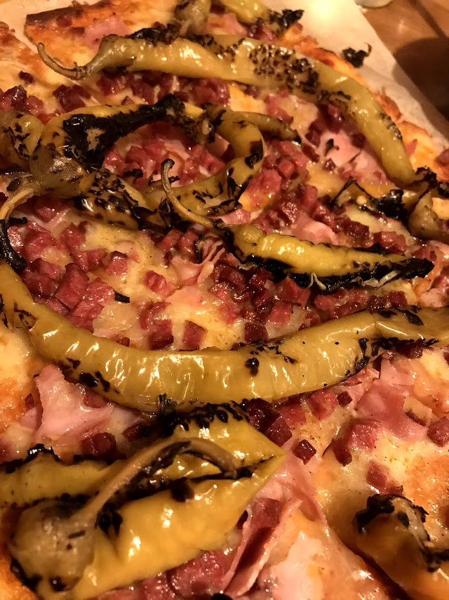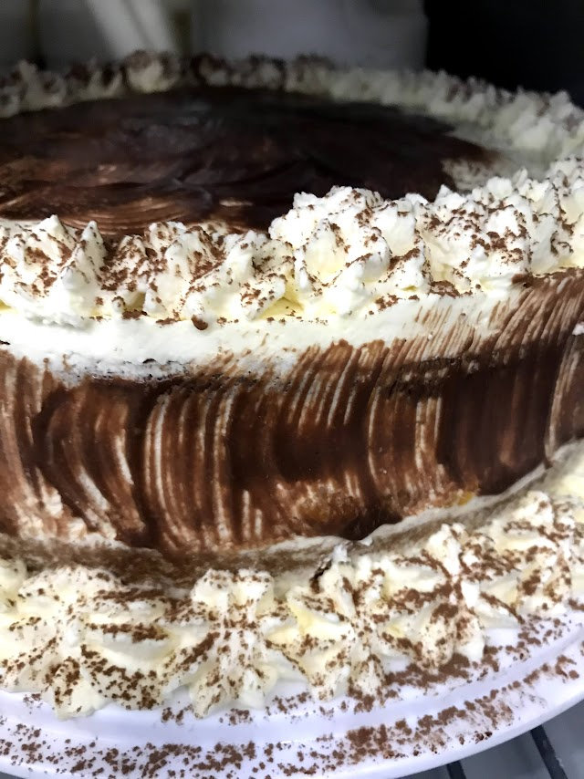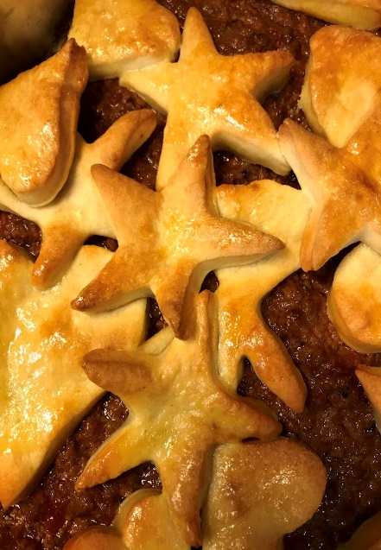


 | Jan | Feb | Mar | Apr | May | Jun | Jul | Aug | Sep | Oct | Nov | Dec
1. Operating cash-Beginning | £50000 | £35300 | £26600 | £17900 | £7200 | -£2500 | £20800 | £23700 | £18600 | £16500 | £17400 | £17700
2. Sources of New Cash
Cash Sales | £5000 | £6000 | £6000 | £4000 | £4000 | £4000 | £5000 | £7000 | £8000 | £9000 | £9000 | £6000
AR collection |  | £5000 | £6000 | £6000 | £7000 | £7000 | £5000 | £6000 | £8000 | £8000 | £6000 | £8000
Customer Deposit | £2000 | £2000 | £1000 | £1000 | £1000 | £2000 | £3000 | £3000 | £4000 | £7000 | £7000 | £4000
Bank Financing | - | - | - | - | - | £20000 | - | - | - | - | - | -
Other | - | - | - | - | - | £10000 | £10000 | - | - | - | - | -
3. Total Source Of Cash | £57000 | £48300 | £39600 | 28900 | £19200 | £40500 | £43800 | £39700 | £38600 | £40500 | £39400 | £35700
4.Use Of Cash
Payroll | £10000 | £10000 | £10000 | £10000 | £10000 | £10000 | £10000 | £10000 | £10000 | £10000 | £10000 | £10000
Rent | £3500 | £3500 | £3500 | £3500 | £3500 | £3500 | £3500 | £3500 | £3500 | £3500 | £3500 | £3500
Utilities | £1500 | £1500 | £1500 | £1500 | £1500 | £1500 | £1500 | £1500 | £1500 | £1500 | £1500 | £1500
Taxes | £1200 | £1200 | £1200 | £1200 | £1200 | £1200 | £1200 | £1200 | £1200 | £1200 | £1200 | £1200
Inventory Purchases | £5000 | £5000 | £5000 | £5000 | £5000 | £3000 | £3000 | £4000 | £5000 | £6000 | £5000 | £6000
Loan Payment | - | - | - | - | - | - | £400 | £400 | £400 | £400 | - | -
Other | £500 | £500 | £500 | £500 | £500 | £500 | £500 | £500 | £500 | £500 | £500 | £500
5. Total Uses of Cash | £21700 | £21700 | £21700 | £21700 | £21700 | £19700 | £20100 | £20100 | £22100 | £23100 | £21700 | £22700
6. Cash Flow | £35300 | £26600 | £17900 | £7200 | -£2500 | £20800 | £23700 | £18600 | £16500 | £17400 | £17700 | £13000
A cash flow forecast for the first 12 months- startup costs cannot exceed £50,000

Reference
Ahmed, S.A., Mohsin, M. and Ali, S.M.Z., (2021). Survey and technological analysis of laser and its defense applications. Defence Technology, 17(2), pp.583-592.
Asenov A.,(2011), Asen in Leo`s Cooking Show
Asenov A.,(2019),Asen as Head Chef of Flynn`s Restaurant
Caines R., Attitudes Towards Cooking in the Home -UK-2021, Available at: https://www.thrillist.com/entertainment/nation/best-youtube-cooking-channels ( Accessed: 22/06/2022)
Campos, P.A. and Reich, M.R., (2019). Political analysis for health policy implementation. Health Systems & Reform, 5(3), pp.224-235.
Frederick, H., O'Connor, A. and Kuratko, D.F., (2018). Entrepreneurship. Cengage AU.
Gelder K. , Popular social media food activities of Millennials and Generation Z in Europe in 2022, 1 January, Available: https://www.statista.com/statistics/1309605/cooking-behavior-young-consumers-europe/ (Accessed:22/06/2022)
Hazelgren, & Hazelgren, B. J. (2005). Your First Business Plan a Simple Question and Answer Format Designed to Help You Write Your Own Plan (5th ed.). Sourcebooks, Inc.
Heroux, Lise. "Comparative marketing strategies of fitness clubs in the United States and Canada." Economics World 5, no. 6 (2017): 529-538.
Hooftman, N., Oliveira, L., Messagie, M., Coosemans, T. and Van Mierlo, J., (2016). Environmental analysis of petrol, diesel and electric passenger cars in a Belgian urban setting. Energies, 9(2), p.84.
Mohsin M., 10 YouTube stats every marketer should know in 2022(infographic), 17 May, Available at: https://www.oberlo.co.uk/blog/youtube-statistics (Accessed:22/06/2022)
Ortega, R.G., Rodríguez, M.D.O., Vázquez, M.L., Ricardo, J.E., Figueiredo, J.A.S. and Smarandache, F., (2019). Pestel analysis based on neutrosophic cognitive maps and neutrosophic numbers for the sinos river basin management. Infinite Study.
Prassl, J. and Risak, M., (2015). Uber, taskrabbit, and co.: Platforms as employers-rethinking the legal analysis of crowdwork. Comp. Lab. L. & Pol'y J., 37, p.619.
Provencher L. (2005), The Best Cooking Channels on You Tube, 11 September, Available at: https://www.thrillist.com/entertainment/nation/best-youtube-cooking-channels (Accessed: 22/06/2022)
Ruiz-Viñals, C. and Álvarez-Gómez, F., (2018). Ownership and the desire for continuity over time, the principal “drivers” of the family business culture. Journal of China-USA business review, 17(8), pp.419-437.
Management Company or Managing Agent? Available at: https://iinsure365.co.uk/management-company-or-managing-agent/, (Accessed:18/07/2022)

