DECLARATION

This work has not previously been accepted in substance for any degree and is not being concurrently submitted in candidature for any degree

Signed……………………………………………

Date……05/05/21…………………………………………

STATEMENT 1

This dissertation is being submitted in partial fulfilment of the requirements for the degree of BA.

Signed…………………………………………….

Date………05/05/21……………………

STATEMENT 2

This dissertation is the result of my own independent work/investigation, except where otherwise stated.

Other sources are acknowledged by footnotes giving explicit references. A bibliography is appended.

Signed……………………………………………

Date………05/05/21………………………………………

STATEMENT 3

I hereby give consent for my dissertation, if accepted, to be available for photocopying and for interlibrary loan, and for the title and summary to be made available to outside organisations.

Signed………………………………………………

Date…………05/05/21………………………………………

STATEMENT 4

I hereby give consent for my dissertation, if accepted, to be available on the university’s IT system to those who have consent to use the system.

Signed………………………………………………

Date……………05/05/21

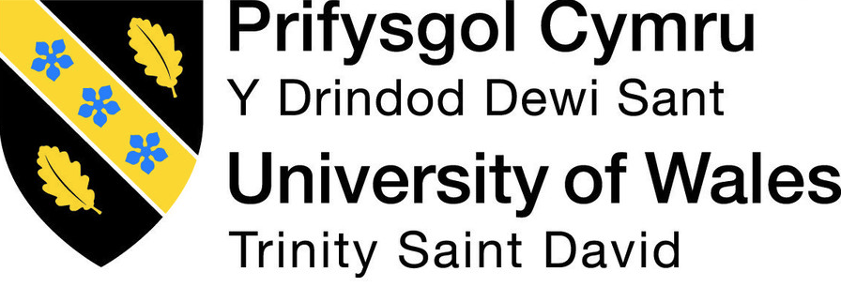

An Investigation into how unethical behaviour affects the brand image of an organisation.

Name: Georgia Passmore
Student ID: 1802108
School: UWTSD
Degree: BA (Hons) Business Management (Marketing)

Covid-19 Statement
The University of Wales Trinity Saint David recognises that the COVID-19 pandemic, and consequent closures of our campus (18th March 2020) and national and international lockdowns, has directly or indirectly impacted the work of many of our undergraduate researchers. Although the campus had periods of re-opening in 2020 and 2021, some research will have been disrupted and some personal circumstances difficult to manage. Teaching was arranged via suitable meeting software and documents shared electronically. All research data collection was designed to utilise digital data collection. The Covid-19 pandemic really strived to put extra stress and challenges on students, as a key worker I was expected to take on a lot more shifts which led to having to lose a lot of sleep to write and analyse, I do think about how much more improved the dissertation could be without the presence of the Covid-19 pandemic.

Acknowledgements
Firstly, I would like to say thank you to my all of my family and my partner for always encouraging me to keep going and do the best I can in all of my university endeavours. Not only have they provided a huge amount of support to me throughout my dissertation process but have done throughout my three years at UWTSD. This dissertation is dedicated to my Great-grandmother, Shirley Passmore, who has been my biggest supporter all of my life and especially through my time at university.
Lastly, I'd like to thank Caroline Jawad, my dissertation mentor. She has provided immense support throughout the dissertation and was always available for any queries I had. This dissertation would not have been completed had she not been so understanding and guiding.

Abstract
The position of ethics within the business industry are often discussed amongst researchers, even the effects of unethical behaviour have on an organisation's brand image in some depth. But what the researcher noticed missing was what opinions the public had on unethical behaviour within an organisation. This study's aim was to find out what the public really thought about ethics in business and whether or not this influenced their behaviour in terms of buying and customer loyalty. The study then discovered the associations and differences between gender, age and the questions provided. An online questionnaire was given out via social media channels and forums where 168 participants responded and tests like Chi-square analysis were conducted to discover any likenesses. Future research should aim to gain a more representative sample population and use additional qualitative research methods to gain a more in-depth understanding of the general public’s views relating to the topic. It is hoped that this and future research will contribute to raising awareness and prominence for the unethical problems in the business sector.

Chapter One: Introduction

This chapter aims to provide extensive background information and knowledge on the topics of ethics in business, unethical behaviour within organisations and brand image. It will also be explaining the aims and objectives of the research overall and how they will be positioned throughout the research. This research aims to discover and discuss the publics views on organisations conducting unethical behaviour and how that affects their brand image, also connected with brand loyalty and customer loyalty.

The previous research is made up of a lot of information regarding ethics in business overall and obviously the different sections of a brand's image and how they showcase themselves to the public. This research is more specifically looking out how a business taking part in things like tax evasion, child labour, sweatshop type business' and not considering environment factors or trying to be a solid sustainable business. The models of business ethics identify that ethics and behaviour differ cross-culturally and how culture has an impact on the ethical reasoning process behind ethical activities (Thorne and Saunders, 2002). Overall, this research is aiming to be an addition to the knowledge of the question background and not necessarily find a certain answer.

Background and Rationale

Unethical behaviour has been said to harm a business' brand and cause its customers to no longer want to buy from them (Leonidou et al. 2013). Ethics can be defined as a social concept of morals and unwritten rules in some sense, unethical behaviour is doing what is beyond wrong and socially unacceptable for an individual or business to act upon (White, 2001). Within the workplace there is typically a large set of rules, regulations and processes that have to be carried out in order for a business to run efficiently and successfully. These sets of rules are otherwise known as the 'code of conduct' and every employee has to agree and sign this document when first starting their employment with an organisation (Rozuel, 2016).

When discussing ethics in business it is hard for one to identify the difference between what is legal or illegal, although there are laws set in place for some circumstances, a lot of the time business' who are unethical find their way around these laws so they technically aren't breaking the law they are just going against the social norms and values of an organisation, which in itself is frowned upon by employees and outsider individuals (Selby, 1936). The UK government's sector of Department for Business Innovation and Skills has set guidelines that business owners are required to follow and if they do not co-operate there are often strict consequences to follow (gov.co.uk, 2021). This document draws on findings from behavioural psychology behind why public regulators should be seeking to affect the market behaviour of traders. A few examples of what rules and guidelines a business must meet for them to be successful; always put your customer first, no matter what the situation or how damaging it may be, there will always be a scenario where the customer must be prioritised about everything else (Battor, 2010). Honesty, this is key for a business to continue building relationships with their customers and be able to have the trust between different parties involved in business transactions, meetings and encounters. Keeping promises links in with having to be honest, to show the public and outsiders what the business truly values and stands for has to start with fulfilling any promise the company has made. Being fair and caring, now these characteristics do not only apply to customers but to employees, investors, suppliers and other parties involved. Being a business who looks out for the needs and wants of all involved suggests that a business has a good ethical standpoint (Nonis and Swift, 2001).

Nowadays, the current consumers are very involved with their purchasing and how the finished product has become available. From the starting point of design, manufacturing, labelling and then put online or on shelves, the consumer wants to know every small detail (Sangroya and Nayak, 2017). This is believed to be due to the rise in the amount of individuals from the millennial generation encouraging sustainable brands who show their values and mission statements to be beneficial to the world and its environment, brands have had to adapt and become more aware of how transparent their brand must be for these types of consumers to choose them (Arbouw, Ballantine and Ozanne, 2019).

Aims and Objectives
Aim:

To discover and discuss the general public's views on how brand image is connected to unethical behaviour conducted by organisations.

Objectives

1. To analyse suitable academic literature of examples of unethical behaviour in organisations and the damage it can cause to a brand image.

2. To understand and analyse the information and data in which I am writing about and understanding how the arguments I make are relevant to answering the question.

3. To explore and find the best suited research approach for the investigation into why Ethics can create positive and negative outcomes for an organisation.

4. To understand how the data analysed is associated with previous research and how it is linked to the title.

5. To produce recommendations and possible pathways for future research, and to outline any limitations to the study.

Research Structure

In order to meet each objective and complete the aim of the research, the research itself will be sectioned into five chapters. Chapter one is the introduction, chapter two the literature review, chapter three the methods and methodology, chapter four the data collection and data analysis and chapter five the conclusion and recommendations.

Chapter one; the introduction has introduced the background to the topic to give the reader a more clear and in-depth understanding of the research topic. It has displayed the layout of the research, the reason for conducting research and the aim and objectives of the research.

Chapter two; the literature review has gathered all aspects of information and knowledge found on the niche topic, ranging from journals, previous thesis or dissertations and websites. This chapter will help the reader understand the topic, the problem and issues encountered on the topic and what gaps there are in the previous research.

Chapter three; the methods and methodology will identify the techniques and research methods being used throughout the research. This will lead the way for the next chapter which will be analysing the data collected from previous research and questionnaires.

Chapter four; data collection and analysis will sort through the data that has been collected and decide what is best to use to provide for the research question and how the findings will have supported previous research but also created a gap for future investigators.

Chapter five; conclusions and recommendations will discuss and complete the aims and objectives of the research and provide avenues of recommendations for future research. There will be discussion of limitations and the main findings of the research.

Conclusion

Chapter one has outlined the layout of the dissertation and also identifying the aims and objectives. The next chapter will be the literature review and will aim to complete the first objective.

Chapter 2 - Literature Review

2.1 - Introduction

The purpose of this chapter is to review relevant academic literature involving examples of an organisation conducting unethical behaviour and the affects it has on a brands image and reputation long term. This chapter will complete the first objective of the dissertation.

"To analyse suitable academic literature of examples of unethical behaviour in organisations and the damage it can cause to a brand image".

The literature review to follow is composed of information and materials from Google Scholar, the University of Wales Trinity Saint David's Online Library (UWTSD) and Taylor & Francis Online. The majority of sources used are from academic journals and primary research found on the topic area. Search terms included; unethical behaviour, business, negative, brand image.

2.2 - Unethical behaviour

The many dimensions of unethical behaviour are often the cause of the failure of a business. Moral reasoning theorists focusing on Constructivist tradition have assumed that a breakdown occurs in the link between a person's moral judgement within a particular situation and his ultimate behaviour in that situation (Bersoff, 2010). Due to the large number of organisations damaging their reputation and brand, academic interest in unethical employee behaviour (UEB) has increased massively (Tenbrunsel and Smith-Crowe, 2008). Unethical employee behaviour can take many forms within an organisation, ranging from disclosed information regarding the business and its sales to money theft. Research suggests that Unethicality is based on patterns of coming from two different sides: self interest and intentionality. The former shows whether the unethical behaviour is on par with self-interest and the latter categorises the behaviour itself conforming to dual-process theories (Veetikazhi et al., 2021). Simply speaking, unethical behaviour is an action that is considered morally wrong for a person or an organisation, in the case of this research, we are relating to the matter of an organisation. Examples of unethical behaviour in an organisation include; clothing retail employing individuals at a ridiculously low wage and providing them with tiresome working hours and unsafe working conditions, otherwise known as 'sweatshops' or in terms of consumers, a company may use marketing bait as a ploy to bring in consumers to buy their products through false advertising and non-existent sales or offers (Arnold and Bowie, 2003). Construal level theory predicts that individuals will judge immoral events more specifically when they are presented in a way that suggests a higher construal level compared to a lower construal level. There has been a vast amount of research into the behavioural sciences searching for possible factors that affect human moral behaviour, the rationale of the construal theory is that when a higher level occurs, people consider the reason why behind a situation whereas a lower level would question how something has occurred. Similarly, Agerström, Björklund, and Carlsson (2013) showed that a third-person perspective led to a more abstract construal of a situation, and as a result, to harsher judgments of moral actions relative to a first-person perspective (Gamliel, Kreiner and McElroy, 2017).

2.3 - The role of unethical behaviour in business
To briefly define unethical behaviour in business, it is when an action carried out by an employee of a company or the company decide as a whole to conduct actions that fall below the line of minimum standards and codes of conduct within business. Whether businesses benefit from the decisions they make is an ongoing argument amongst the public. These actions can typically fall into four categories; unethical practice towards customers, towards employees, unfair competition and unfair but legal practices (Holton, 2021). Exploiting workers is a common issue within companies and clearly puts them in the category of businesses using unethical practices. Exploitation can include paying workers an illegally low wage and forcing them to work hours that are deemed unsafe for individuals or opening manufacturing warehouses in countries where there are no labour laws, so companies are technically able to employ workers from the age of five years old. Tax Evasion is another common factor in conducting unethical practices, companies can avoid paying tax through various loopholes and therefore end up taking home billions in profits if they are a larger scale company (Lashley, 2016). There are five main theories in relation to business ethics, the first being Utilitarianism, this theory is a prominent perspective on business ethics and determines right from wrong.

2.4 - Utilitarianism
Utilitarianism believes that the most ethical choice is the one that will produce the best outcome (greatest good) for the most amount of people (greatest number), it is the most common approach for ethics in business because of the way it accounts for costs and benefits (Begue, 2016). Jeremy Benthen is said to be the founder of Utilitarianism, Benthen believed that the best way to come to an agreement of the best policies for a society would be to compare the good and bad points of each of them (Warke, 2010).

2.5 - Deontology
In contrast to the Utilitarianism approach, there is a theory named Deontology. Produced by Immanuel Kant, the explanation for Deontology is as follows; ethical action appears from someone's duties which are defined by rational thought. Under this form of ethics, it would be unacceptable to justify a situation by showing it produced good consequences, this is often referred to as 'non-consequentialism'. When comparing the different basis of ethics, it is clear to see that Consequentialists start by deciding what is good and actions that produce the maximum amount of good (White, 2009).

2.6 - Social Justice Theory and Social Contract Theory
Another branch of the five theories that support business ethics are social justice theory and social contract theory. Social contract theory suggests that in society people live in line with a mutual understanding that established rules and social norms must be followed. The social justice theory suggests that justice must be distributed evenly. Marxists say that people should be given goods according to their needs (Kimmel, Smith and Klein, 2011).

2.7 - Virtue Theory
The Virtue theory emphasises the value of virtuous qualities rather than formal rules. One of the first individuals to focus on this particular theory was Aristotle, he advocated the ethical values of certain qualities and virtues in a person's character (Zyl, 2013).

2.8 - Josephson's Core Values Analysis
Finally, Josephson's core values analysis and decision process are believed to include a set of core values that have been identified and can be applied to real life situations in the corporate workplace. The core values include; trustworthiness, respect, responsibility, fairness, caring and citizenship. When organisations and more specifically individuals are faced with ethical problems, the core values model allows them make decisions, overall it shows that a step by step guide is needed within organisations to face ethical dilemmas (Gross-Schaefer, 2008). The majority of theorists that focus their work on ethics have their own individual standpoints from researching other topics. All though all theories ultimately have the same outcome of bringing the greatest good to any situation, it is interesting to see that Josephson's theory suggests humans make decisions based only on their core values and the characteristics they have as an individual. Whereas, the social justice and social contract theory suggest that individuals make decisions based on what their surrounding society has mirrored onto them through social norms and laws.

2.8 - Brand Image of a Business

To put it simply, brand image is the view the customers or any outside party have of the business and what they can interpret about the company through these views. It ultimately states what the business stands for, a brand image is not something always visual about the business, it can be a connection between the consumer and the business (Ghosh, Ahmed, Annavarjula and Min Lie, 2008). There are many strategies businesses will use to gain competitive advantage over their competitors typically within the same trade or product selling., but there are four strategies that are used specifically to create a successful and positive brand image. Product line extension is the process of introducing a new product, usually within the same category or product line that the business already operates from within. This is a very common approach in business as it allows a company to release new products under their established name, in relation to brand image, this approach allows a business to portray a view that they are keeping up to trends, staying fresh with new ideas and presenting new things to customers so they stay interested in the business (Ishihara and Zhang, 2017). The Multi Brand approach is similar to the product line extension, this simply means one brand group together different named products of the same product line and put them together as the top competitors. The consumers will still view the competition between the products, but they will all still have the same corporate ownership. This will support the goal of improving brand image because it leaves little room for new competitors to enter the market, meaning the current products will become household names (Preece and Kerrigan, 2015). Brand Extension is when a business enters a completely new niche market or category to attempt to broaden their business and capabilities, they are typically carefully thought and planned very accurately. More often the business will extend themselves into a new niche market, but it will already have some relation to the business' products or their morals. For example, Tesla is an electric car company but have recently extended into home renewable energy products which is part of their mission statement (Shokri and Alavi, 2019). Finally, the last strategy to retaining a positive brand image is the introduction of a new brand. It may stem from a new product line extension or branching into other markets but a company could rebrand themselves to change their style, their values or if they believe it is beneficial to them, they could potentially re start their business and its model from scratch (Cheng and Paliwoda, 2008).

2.9 - Brand Marketing
Brand Marketing is the technique of promoting a business' products or services in a particular way to highlight the brand overall. The main purpose of brand marketing is to showcase the brands main values and mission, the true identity and style of the business and creating a look for the brand that customers will recognise (Calder, Malthouse and Maslowska, 2016). This links in with brand equity, which is really beneficial to a business' brand, as all other approaches have focused on, it mirrors what the brand stands for and how they plan on rewarding their customers. A brand has to be trustworthy and recognisable for customers to be aware of their brand to continue shopping and staying loyal to the business. Brand marketing has completely evolved over time and the introduction of social media use in business is huge and plays the biggest role in the success of a brand (Oliveira-Castro et al., 2008).

3.0 - Consumer Loyalty
Consumer loyalty is a relationship between the customer and company that is formed on the basis of trust and allows the customer to make repeat purchases with the brand. It is a way of prioritising customer relationships and showing the customer that they mean something to the business and their custom is appreciated. People are a loyal to a brand because of positive experiences, whether it be their own experiences or others have recommended through word of mouth (Servera-Francés and Piqueras-Tomás, 2019). Brand loyalty is slightly different to consumer loyalty in the sense if a customer is loyal to the brand, they are more likely to buy different products from the same brand (Kim, Lee and Lee, 2007).

3.1 - Customer Buying Behaviour
There are four types of customer buying behaviour, a buyer's decision making obviously depends on what kind of product their looking to buy. The complex buying behaviour is when consumers are buying a more expensive product, consumers take time to think about investing in an expensive product, so this means they are highly involved in their purchase decision (Xiao and Nicholson, 2011). Dissonance-reducing buying behaviour (DR), the consumer involvement in these purchases are very high, due to the price and availability. There is a low availability choice of the product needed and not many differences between brands, the consumer ultimately will buy the product that is the most accessible to buy (Yap and Gaur, 2014). Habitual buying behaviour occurs when a customer has the least amount of involvement in the purchase process, these are typically products and services for everyday use and not something consumer has to necessarily think about deeply. Habitual buying is usually influenced by media sources (Lester, Forman and Loyd, 2005). Variety seeking buying behaviour, consumer involvement is low. These types of customers like to switch between different brands just to try out new things because of boredom or trends, they seek new products and brands simply for variety not due to satisfaction (Banerjee, Divakar and Karuppur, 1998). Consumers have to consider certain things when buying a product or service, sometimes without even realising. Consumers consider things like price of the product, the availability of the product and depending on their personal characteristics like income and age will determine how and what they buy from a business. In relation to the branding, the way a business will showcase themselves overall will show a customer how they operate and treat loyal customers, down to the logo and colour choices of the business' marketing campaigns.

3.2 - Conclusion
This chapter achieved the first objective:

"To analyse suitable academic literature of examples of unethical behaviour in organisations and the damage it can cause to a brand image".

The literature review revealed that there are a lot of in-depth theories and models in relation to brand image and the way customers purchase their products and services. Unethical behaviour in a business can cause detrimental effects to the progression and success of a company, the many examples given previously regarding unethical acts such as sweatshops. Theorists such as Kant and Josephson revealed a lot of information with regards to why individuals and organisations make decisions and how it affects them. There was a lot of information and literature available on brand image and its connection to unethical behaviour within a business, almost too much to analyse every bit but the information provided gave a clear indication that a business really needs a successful branding image to create relationships with their customers.

Chapter Three: Methods and Methodology

Introduction

The previous chapter, the Literature Review, succeeded in its objective to:

"To analyse suitable academic literature of examples of unethical behaviour in organisations and the damage it can cause to a brand image".

This chapter aims to complete the second objective:

"To explore and find the best suited research approach for the investigation into why ethics can create positive and negative outcomes for an organisation".

To achieve this objective, the use of the Research Onion developed by Saunders et al. (2007), will be used as a guide to outline the decision-making process. Reliability, validity and
ethical issues will also be considered throughout the writing process.

Research Onion

Saunders' Research Onion simply explains the various steps to take when developing research methodology. The onion works from working from the outside inwards. The research onion will be used as a guide to use appropriate research methods and processes. The research onion is made up of six layers: philosophy, approach, strategy, choice of methods, time horizons, data collection and analysis (Saunders et al. 2007).

Figure 3.1 - Research Onion available from (Saunders et al. 2016.)
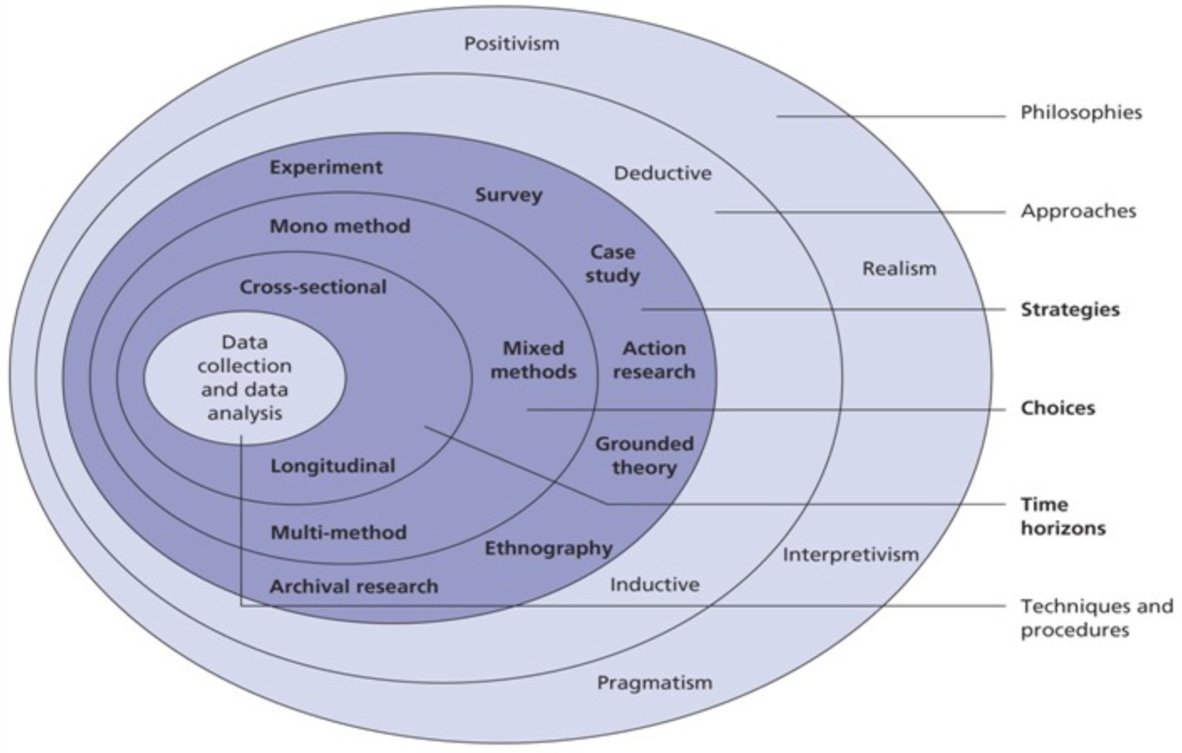
Figure 3.1 - The figure is highlighted to include the Researchers choices in terms of each layer of the Research Onion.

The approach chosen to take when investigating will be an Exploratory approach, Exploratory approach can be defined as a particular method of research that investigates an issue or problem that is not clearly defined and therefore lacks research. It has a clear understanding of the problem but is not concluding a set solution for it (Stebbins, 2001). In relation to the research, how does unethical behaviour affect an organisation's brand image, this approach is the most suitable so the information gathered in this report can contribute to the understanding rather than find a set end solution.

3.2 Philosophy

The first layer of the Research Onion is the Research Philosophy, more simply it is the set of beliefs in which the research is based on. In this investigation, the researcher will be taking the perspective of Pragmatism, due to the fact that thus belief focuses on using the best tools available for the research, and to research from a practical point of view. This is appropriate for the research in question because the research itself will not deliver a set solution or answer, it will create more knowledge for others to question and work on. It uses both ends of the philosophy spectrum so the research it is not constricted to one approach. Both qualitative and quantitative data will be used if needed throughout the research.

3.3 Approach

In this research, an inductive approach will be used to observe the data as it entails generating different theories through the research and building on those theories. Inductive approach is linked to qualitative and quantitative data theories, it is believed as a common theory that qualitative data works best within an inductive approach but if applicable the use of quantitative data. This is the best option for this particular research as there is a lot of research available on the wider topic but the question in particular needs to be progressed and worked on (Saunders et al. 2009).

3.4 Strategy

This Research in particular would benefit from using surveys, more specifically questionnaires to gain views and opinions on the matter from the public. Retrieving feedback from the public will help investigate why the general consumer buys certain products/services from organisations or according to the research question, what is it about organisations performing unethical behaviour that causes damage to their brand image and equity. The advantages of questionnaires are that large amounts of information can be obtained in a short period of time and it is more compatible when using qualitative data as the main source of research in this case (Lambert, 2019). The surveys used in this research are in the form of questionnaires and were first made in drafts on survey monkey then finalised through Google Forms. The questionnaire was posted on social media such as Facebook and Instagram via a link, sent out to contact members through Whatsapp and posted on public forums where it could reach a wider range of participants. Background questions were asked and included stating that all responses would remain anonymous. Contact details of the Researcher and the University were provided to the participants if they wanted to discuss the questionnaire further.

3.5 Choice

The section of choices is simply based on how many methods of data the researcher uses (Sahay, 2016). Mixed Methods simply is the choice of using either qualitative or quantitative data sources and works best for the research due to the open choice of using qualitative or quantatative data (Hassard and Pym, 1990). The benefit of using this choice is that as previously mentioned, the research can take any pathway it wishes. The literature available was huge and as there will be no final answer or solution to the research, the researcher feels this is the best suited option.

3.6 Time Horizon

In this Research it will use Cross Sectional Research, which is the best option for the options chosen. A Time Horizon is simply explained as a period of time in which the data will be collected (Armstrong, 2001). Cross Sectional Research is quicker than other types.

Techniques for Data Collection, Processes and Analysis

Data Collection

In this Research there will be various types of data used, Primary research will benefit the investigation as content from already written text by other researchers will be used hugely and also the researcher will be conducting the questionnaire created and using the results and findings from it to provide other views and opinions to further the knowledge. Primary data is one found firstly by a researcher and secondary data is one already by another researcher and available for others to use (Hox and Boeije, 2005).

Questionnaire Design

The questionnaire is built up of five demographics questions to build up an idea of the participants' background, the rest of the questions are mixed between closed questions and open questions. The closed questions are simply to get a straightforward answer to use statistically while the open questions so the participant can elaborate if they wish. All questions have been marked as required on the questionnaire due to the fact each question is important in obtaining views and opinions from the participants, so the researcher is able to conjure up more knowledge and understanding of the topic. Also, by asking these particular questions will obviously create fresh ideas from average working-class people who only see the outside of the organisation's they purchase from. This will benefit the research because the required answers will provide large amounts of opinions to include and the non-required questions will help even more for the research to provide an in-depth knowledge of participants opinions.

Questionnaire and Literature Review Matrix

Questions | Literature Review Reference
1. Do you give your consent for the anonymous responses to be used in a research dissertation? | Questions 1-5 are based on background information of the participants, to enable the researcher to retrieve more information about the type of individuals that are participating.
2. What age category do you belong to?

3. What do you identify as?

4. What is the highest level of education you have undertaken?
5. What is your occupation?

6. Do you consider yourself to be an ethical person? | This question was included to see how the participants thoughts on being an 'ethical' person fitted in with age and occupation.
7. I would buy a product/service from an organisation who tests on animals? | This question was included to have the participants understand what sort of unethical cases the researcher would be referring to. The use of multiple choice makes the questionnaire seem less of a chore to complete.
8. I would buy a product/service from an organisation that uses child labour? | Above applies.
9. If an organisation you had previously bought from conducted unethical behaviour, would you still continue to buy from them? | This question uses the closed question format to truly understand the thoughts behind buying from unethical companies.
10. Please give a brief explanation for your answer to the above | For this type of question, there is a small box provided for the participant to elaborate their answer for more understanding.
11. If an organisation you were interested in did not take part in a political/social/cultural campaign (such as Black Lives Matter and using the hashtag 'Blackout') would you buy from them? | This question uses an emotive topic to really allow to participants to think accurately and answer truthfully about this sensitive topic.
12. How would you define good ethical behaviour? | Retrieving what the participant believes to be ethical in their own terms.
13. Do you think that organisations should contribute to the local area/community that they operate from within? | Again, another question that will trigger truthful answers from the participant due to the personal nature of the question.
14. Do you think that ethics are important to the success of an organisation? | Ultimately the most important set of questions, answering the research question bluntly.
15. Do you think a business' ethical standpoint affects their brand image overall? | Above applies
16. All an organisation has to do to be ethical is follow the law?

17. Business marketing is the only way of creating a good brand image?

18. Do you think a customer buys a product for any other reason than simply needing it?

19. Would you buy a product if you didn't necessarily need it?

20. Are you aware of what this logo means? | Here the researcher uses visual images to keep the participant interested and encouraging them to answer consistently.
21. Do you recognise this printing and symbols?

22. What does this logo represent?

Analysis

The data will be analysed using a Statistical Package for the Social Sciences (SPSS). Demographic information will be analysed, followed by further statistical. Before entering the data into the software system, the researcher will be analysing beforehand to discover the most relevant and best findings to use.

Reliability and Validity

Reliability of data is seen when results are consistently obtained, whereas validity of data is seen when data is collected accurately (Saunders et al., 2009). Reliability and validity are essential in research as without this data findings would be non-existent.

Limitations

The limitations of the data findings are that the participants taking part range in job, age, level of education so it is uncertain to know if the responses will be accurate and honest regarding the topic. The researcher sent out the questionnaire to various social media channels and family members, so again it will be interesting to see what type of answers will be provided. Whether they'll be serious or quite humorous answers due to the age group expected to answer.

Ethical issue

This research is conducted in line with the ethical standards of the UWTSD, with approval from the research supervisor and co-ordinator obtained via an ethics approval form (see appendix 3). Ethical considerations were met through anonymity, confidentiality, and security of data. The questions were answered voluntary and all participants were over the age of 18. The data was collected and stored with password protection on one device, eliminating misuse. The researcher foresaw no potential psychological harm to participants. Being quite a sensitive topic and some questions based on emotive situations, the researcher made sure to explain the purpose of the dissertation and provided answer boxes to particular questions, so participants were able to express their true opinions and feelings.

Conclusion

This chapter accomplished the second objective:

"To explore and find the best suited research approach for the investigation into why ethics can create positive and negative outcomes for an organisation".

This chapter has shown what types of research methods will be used and how the data will be analysed. The following chapter will be analysing the data found and will be discussed further.

Chapter Four: Data Collection and Data Analysis

Introduction

The previous chapter completed its objective successfully. This chapter aims to achieve the third objective:

"To understand and analyse the information and data in which I am writing about and understanding how the arguments I make are relevant to answering the question".

This chapter will be analysing the collected data and presenting the data in an understandable form. As mentioned in the previous chapter, a questionnaire was sent out on many different forums for the public to voluntarily participate in if they wished to do so. One hundred and sixty-eight participants took part in the questionnaire, the purpose of the responses was to gain a clear insight into what the general public thought about businesses conducting unethical behaviour, more specifically focusing on how these actions affect a business' brand image and reputation.

Data Analysis

The process of data analysis is to use certain statistical or logical methods to describe and present large quantities of data (Flick, 2009). There are different ways to analyse data and come to an evaluation depending on the topic and the aim of the analysis itself. The various methods chosen are usually based on whether there has been use of qualitative or quantitative methods, knowing the difference between the two and then applying it to the data analysis will create a clear pathway for a better final report (Brandt, 2014). This data in particular was analysed using the IBM SPSS Statistics software package. The types of statistics that were provided was descriptive and this was done via the cross-tabulations process. Then finally the use of the Chi-square analysis method was used to establish the associations between variables.

Methods

The participants of this questionnaire were split into different categories to establish their background information and its connection to the responses given. The participants who were aged 60 or older were removed from the final statistics due to the number of participants of that age group being so low it was not valid to analyse (Messick, 1987). Similarly, participants who opted for the 'prefer to self-describe', 'non-binary' and 'other' were removed from the data to allow a clearer and less complicated end result (Levin et al., 2020).

Demographic and Descriptive Statistics

The number of participants this questionnaire reached was one hundred and sixty-eight, these participants were discovered via social media and large group connections on open forums (Costa UK staff page). A large quantity of the participants therefore worked for Costa meaning that a high number would include 'Barista', 'Barista Maestro' or 'Manager'. Although not intentional, it actually worked out really well for the research that the majority of participants were a part of a large corporate organisation and can use their knowledge of organisations to answer truthfully and accurately (Costa, 2021). Out of the total number of participants, 30 of them were between the ages of 18 and 20, 86 of them were between 21 and 29, 34 of them were between 30 and 40, 17 of them were between 40 and 59 and there was only one participant over the age of 60. The frequency charts from SPSS show that the majority of participants (40%) had undertaken a degree, followed by A Levels (22%) then GCSE's (18%).

Chi-Square Analysis
Seven of the Chi-square analyses were conducted to determine if there was any association between the gender of the participants and the seven questions they answered. Due to the way Chi-square analysis works, only questions containing nominal data could be used (Kirkpatrick and Feeney, 2015). Chi-square analysis was used for questions 6, 11, 13, 15, 16, and 17.

The figure below shows the association between the genders of male and female against the question "Do you consider yourself to be an ethical person?"

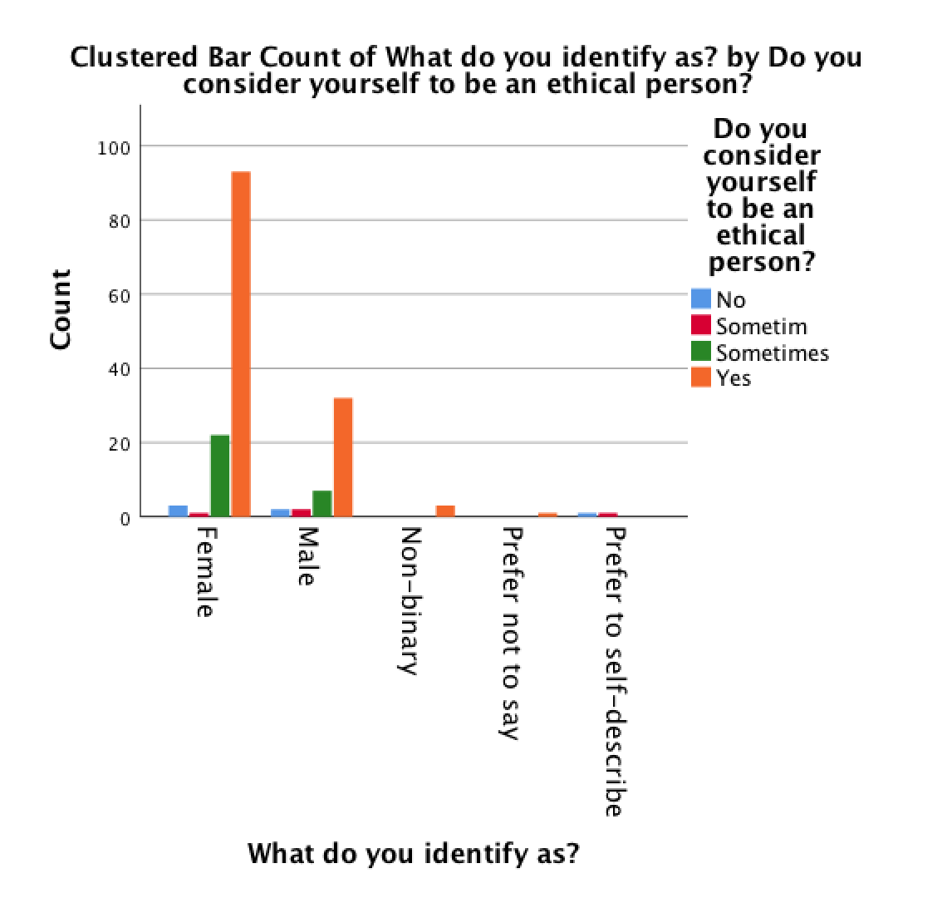

The above graph shows the connection between the gender of participants (only including male and female) and the participants response of "yes", "no" or "sometimes" to the question of "Do you consider yourself to be an ethical person?".

The figure below shows non-significant associations between the two variables

Questions | Significance (P Value)
Question 9.  If an organisation you had previously bought from conducted unethical behaviour, would you still continue to buy from them? | .174
Question 11.  If an organisation you were interested in did not take part in a political/social/cultural campaign (such as Black Lives Matter and using the hashtag 'Blackout') would you buy from them? | .663
Question 14.  Do you think that organisations should contribute to the local area/community that they operate from within? | .332
Question 15.  Do you think that ethics are important to the success of an organisation? | .115
Question 16.  Do you think a business' ethical standpoint affects their brand image overall? | .138
Question 17.  All an organisation has to do to be ethical is follow the law? | .149

This suggests that the gender of the participants has a clear correlation between whether they consider themselves to be ethical or not, with females having the highest amount of the answer "yes" it back up the theory that females are more likely to participate in questionnaires and be the most emotive with their answers (Smith, 2009).

Chi-Square Analysis and Age Association

Another six analyses of Chi-square were conducted to see if there were any connections between the age of the participants, as previously mentioned excluding over 60 years old, and the answers they provided to the questionnaire. As per the last analyses, this was conducted for questions 6,9,11,14,15,16 and 17. These were questions that provided nominal data, so it was easier to analyse. These results are shown in the figures below - outlining the significance between the age of participants and whether they would continue to buy from an organisation that has conducted unethical behaviour.

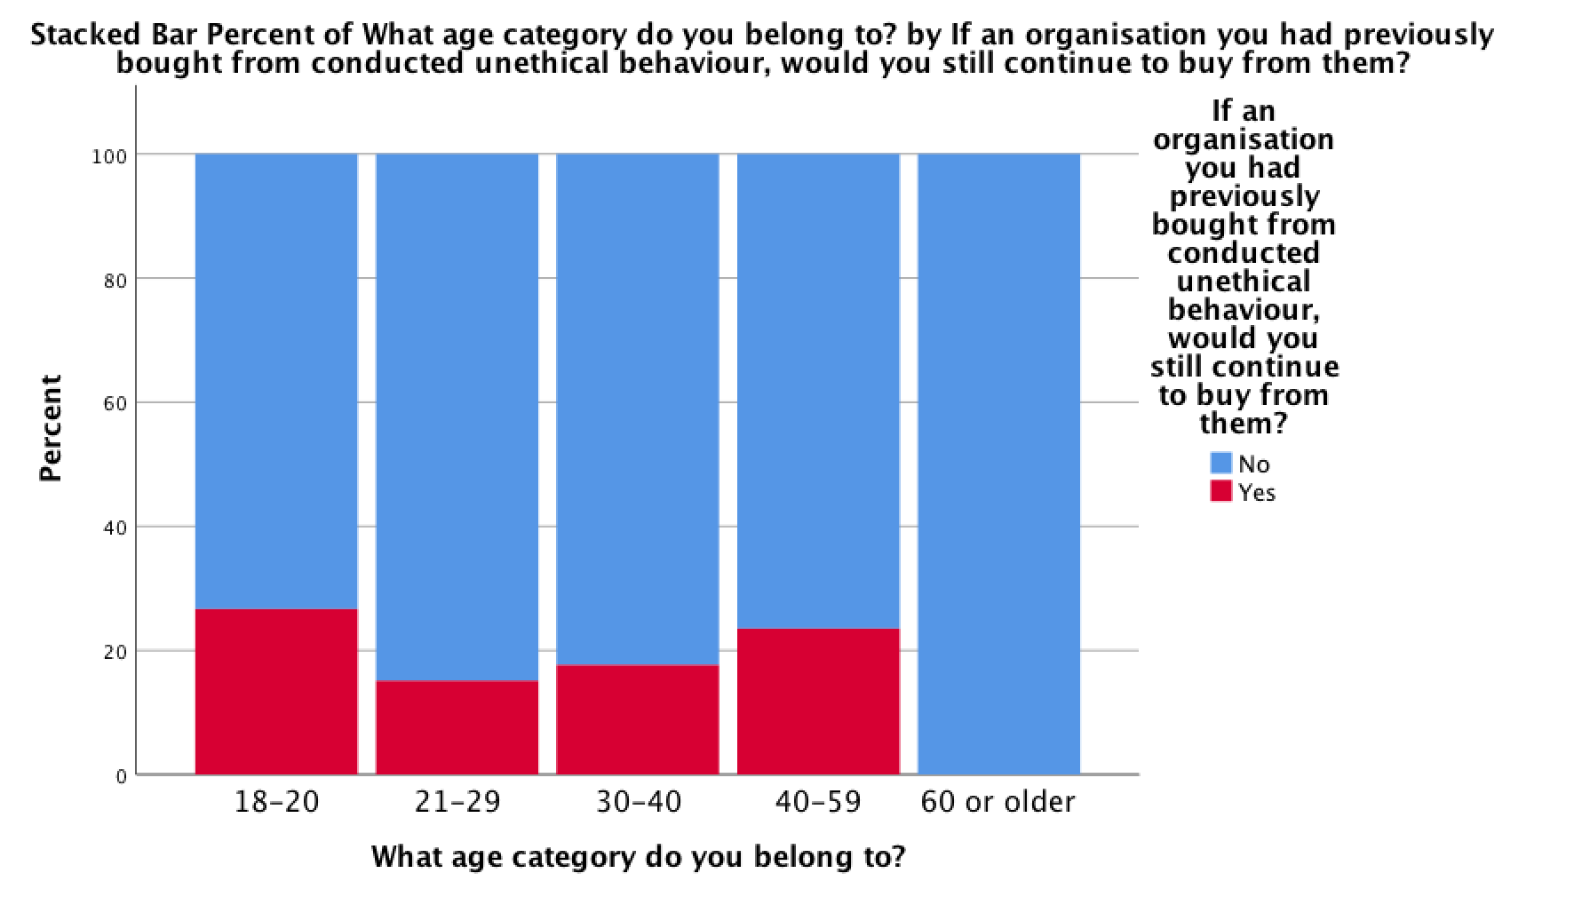

The figure below shows the significant association between the age of the participants and whether or not they believe that a business' ethical standpoint affects their brand image overall.

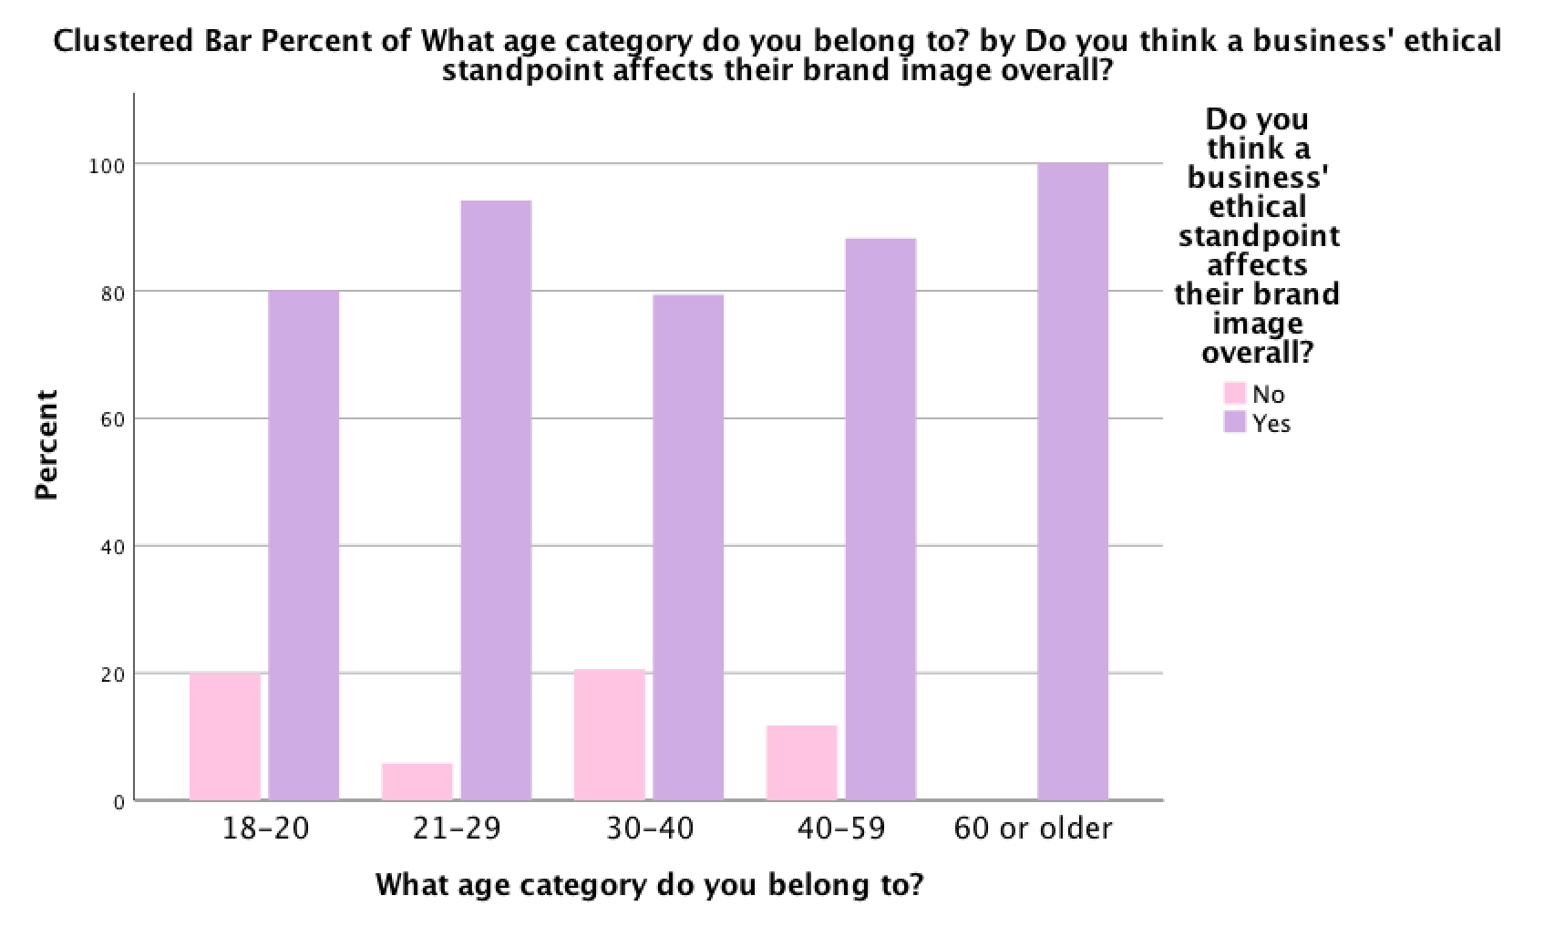

The table below shows the non-significant associations between age and the remaining questions.

Questions | Significance (P Value)
Question 6.  Do you consider yourself to be an ethical person? | .129
Question 11.  If an organisation you were interested in did not take part in a political/social/cultural campaign (such as Black Lives Matter and using the hashtag 'Blackout') would you buy from them? | .244
Question 14.  Do you think that organisations should contribute to the local area/community that they operate from within? | .278
Question 15.  Do you think that ethics are important to the success of an organisation? | .687
Question 17.  All an organisation has to do to be ethical is follow the law? | .292

Discussion
From what the analyses has discovered, females are more likely than males to answer a questionnaire or survey as a form of emotive behaviour or as what can be considered as helping someone out (Smith, 2009). Females are more likely to answer truthfully but can be known to answer what they think is the best option, where as a male may choose an option that sounds like the correct answer or what is deemed as appropriate (Curtin et al 2000; Moore & Tarnai, 2002; Singer et al 2000). Even though there are no correct answers in this questionnaire, it is simply in search of opinions and honest views. A female is more likely to express herself emotionally throughout a survey compared to a man, suggesting the female participants of this questionnaire are more likely to disagree with a business conducting unethical behaviour (Moos, 1969). This supports the perception and expected result that females respond with an ethically polite manner, the research suggests that gender has a large influence on behaviour; females are more inclined to act in a socially responsible and ethical manner when responding to questionnaires (Arlow, 1991; Driessen, 2019; Godwyn, 2013; Haski-Leventhal et al., 2017; Landry et al., 2016; Peake & Eddleston, 2017; Zou et al., 2018). Out of the twenty-four questions, seven were chosen to conduct Chi-square analysis due to the nature of the nominal data. It became apparent that females answered yes to "Do you consider yourself to be an ethical person?" more than males (excluding the other options). This supports the research that suggests that women were more likely to answer what they think is socially responsible and ethically appropriate. When conducting Chi-square analysis and discussing age association it became apparent that the majority of participants belonged to the age category of 21 to 29 years old, suggesting that younger people are more open to taking part in questionnaires overall, as previous research has suggested, younger participants felt more obliged to answer questions with a focus on social responsibility and doing the right thing ethically speaking (e.g. Duarte, 2010; McGlone et al., 2011). The majority of younger participants answered yes to the question "Do you think a business' ethical standpoint affects their brand image overall?". To clarify, not all data was chosen to be analysed due to the type of measure the variable is, only nominal data could be used for Chi-square tests. The questions that were chosen included nominal data and enabled the researcher to find associations and differences via test and analyses through SPSS. A lot of the data from other questions proved to have no significance and no association between the specified variables suggesting that those questions (6,11,14,15 and 17) are not related to the age or gender of the participants. The results of this chapter have shown a great insight into public views and opinions and have made it clear how a select sample of individuals feel towards organisation's brand image and ethical standpoint, although we could never truly know everyone's opinion it was very beneficial that the majority of participants all are employed by the same large corporate company and belong to different levels of hierarchy (Lawler and Suttle, 1972).

Limitations
The limitations of this analysis have stemmed from the limitations of chapter three when the researcher began discussing the types of research methods that would be used, how data would be analysed and the way in which the researcher would actively collect opinions and views from the public to meet the research objectives. To start, it was difficult to choose via the research onion which philosophies would be considered, as there would be a mixture of both qualitative data and quantitative data available. The limitations of the data collection include the exclusion of the options "non-binary", "prefer to self-describe" and "other", although this was simpler and more convenient to analyse through SPSS, it could be considered that not all responses were valid due to the numbers included in the non-significant results table did in fact include the responses of all participants. A draft was sent out to a select few people as a mistake and when corrected the draft responses still appeared as an option, although the researcher did not include any of the draft numbers within the data, visually the option "sometim" is still apparent in the data and some graphs/charts.
Conclusion
This chapter achieved the third objective:
"To understand and analyse the information and data in which I am writing about and understanding how the arguments I make are relevant to answering the question".
In conclusion, the current study has shown that there are very few associations between the variables and this particular set of participants have simply answered the questions to personal preference or opinion. There are some connections between the gender of the participants and the particular questions the researcher conducted Chi-square analysis on, meaning it suggests that previous research carried out stating females are more likely to take part in a questionnaire and answer honestly because they feel socially responsible to do so (Smith, 2008). Overall, the result shown is that the female participants contributed to the research question by providing an opinion that was honest and potentially emotion based. This chapter successfully managed to complete the objective by analysing the data and information discovered and relating it back to the research question to provide further knowledge on the topic. Ultimately the purpose of this chapter was to gather and evaluate public views and opinions and it's met that objective perfectly.

Chapter Five: Conclusions and Recommendations

The previous chapter analysed the data and evaluated the main findings from the information gathered. This chapter will successfully complete the two final aims objectives:

"To understand how the data analysed is associated with previous research and how it is linked to the title".

"To produce recommendations and possible pathways for future research, and to outline any limitations to the study".

Main Findings

The data analysed showed that the majority of participants in the questionnaire were either females, between the ages of 21 to 29 years old or worked at Costa. The specific occupation was not intentional to the research, due to sharing the questionnaire for the public to answer voluntarily via social media platforms and topic specific groups, it meant a lot of Costa Coffee staff answered. This meant that analysing the job occupation of the participants compared to the answers to the rest of the questions would be invalid to the research and was therefore removed. Female participants believed that they are 'ethical' people compared to the majority of males who answered the most to the option 'sometimes'. There was no notable association between age and the questions, although the older aged participants responded to "If an organisation you were interested in did not take part in a political/social/cultural campaign (such as Black Lives Matter and using the hashtag 'Blackout') would you buy from them?" with the answer yes. Particularly as this question is related to using social media, it led the researcher to believe that the older aged participants answered simply because that's what they believe to be the best option available.

Implications

The study has shown that females tend to consider themselves ethical people, whereas males answered 'sometimes' suggesting that they either simply conduct unethical behaviour sometimes or they didn't understand the ultimate meaning of 'ethical' in the question. Generally speaking, this has a real-life implication, although a stereotypical accusation to make it is a negative impact for further investigations into this topic that males are more likely to choose options that they personally feel is the best option, not actually what they truly feel or believe. It is clear to see from the information gathered from the questionnaire that the public do believe that unethical behaviour does have an affect on brand image, a lot answered questions that involved no longer buying from an organisation who conduct unethical behaviour or even people not liking an organisation due to no participation in social/political campaigns. The researcher believes that the question "how does unethical behaviour affect a brand image" can never truly be answered completely, the use of previous research and the questionnaire carried out has simply help towards building more knowledge and create another platform for a future researcher to further investigate. There is overall a lot of evidence to suggest that the sample of people that responded to the questionnaire would always have opinions that suggest that unethical behaviour definitely affects brand image.

Recommendations

Firstly, this recommendation is for future researchers and investigators of this topic. After discovering some literature that was specifically for this avenue, it was clear to see there is a lack of information concerning the public's opinions on businesses' brand image and therefore required a lot of time-consuming digging for the research to retrieve material on the subject. A recommendation the researcher has for the future investigators is to potentially use interviews instead of a questionnaire to gain more insight to what people truly believe. A lot of the questions in this particular research questionnaire were the closed type and didn't require participants to expand unless they wished to do so. Although this provided a fair amount of data for the research, it would be beneficial to consider for future research. Another recommendation is now for the businesses' that do in fact conduct unethical behaviour, act accordingly and if there is a way to prevent conducting unethical behaviour, always choose that pathway. From the research gathered it is obvious that the persona these organisations have shown has nothing but negative impact for their business and profits but for anyone or any other business/product linked to the name. This study has shown that the public are more likely to not shop with a company if they show unethical behaviour, even if the consumers had previously bought from the company, nearly all the participants said they would not continue to make purchases. There is definitely a gap for future research as the time period for this particular research was during the Covid-19 pandemic, where plans for gathering research may have included going out into the public and discussing the topic and their responses in more depth with the participants, it made more sense for this research to be collected via online questionnaire.

Conclusion

This study has met all its aims and objectives throughout the dissertation meaning the research question could be answered. Yes, it is clear to see that unethical behaviour within an organisation definitely does affect their brand image and reputation. Although only a small sample was used for this research, the researcher feels it is common sense or common knowledge that bad behaviour will always bring negative connotations to a brand's image or reputation. This also leaves a gap for future research by similar individuals to be able to add more knowledge to the topic, just as this dissertation has. This study has helped the researcher grow her knowledge on the topic massively and she could confidently say it has provided the skills and knowledge to progress into her chosen career path.

Self-Reflection

The researcher set out to gain more knowledge in this topic and ha certainly completed that goal through the research and data analysis. It has been interesting to discover a whole new set of skills and conquer the challenges set before the researcher, through using SPSS. The process of researching and discussing the dissertation was proven very difficult at times, especially due to Covid-19 pandemic where it was sometimes impossible to go down avenues that the researcher wished was an alternative option such as face to face interviews or observations. Although the dissertation tested the researcher's ability and positive outlook at some points, it was a very enjoyable and rewarding experience, gaining a lot of topic specific knowledge and a skill set preparing the researcher for the industry she wishes to enter.

Final Summary

The research has contributed to the understanding of how unethical behaviour and the understanding of ethics in general affects a brand's image and reputation. It has provided a gap in research for other individuals to add their research and knowledge potentially.

References

