Author: Adam Davies
P147908
Abstract
This report outlines the design of microcontroller bicycle computer. Overviewed is the deign procedure taken in which all components and sensors are selected using research analysis. Circuit schematic design, PCB layout and software designs are all produced within the report. Overall the system is regarded a success providing ease of use to the user and additional safety functionality.
(M3X8529) EMBEDDED MICROCONTROLLERS
Computer Engineering & Microprocessors Assignment
Word Count: 10,071
Lecturer: Gareth Jones
Table of Contents

1. Introduction 7
2. Background Information 7
2.1. Existing Products 8
2.1.1. Pedal Pro Wireless Multifunction Computer 8
2.1.2. Sigma BC 16.16 9
2.1.3. Cateye Strada wireless 8 function RD300W 9
2.1.4. Garmin Edge 25 10
2.1.5. Polar V650 10
2.1.6. Xplova X5 11
2.2. Product Comparison 12
2.3. Research Analysis 13
3. Design Specification 15
4. Design Procedure 16
4.1. Speed and Distance 16
4.1.1. Sensor Requirements 17
4.1.2. Technology Selection 18
4.1.3. Sensor Selection 19
4.1.4. Signal Conditioning 20
4.2. Cadence 20
4.2.1. Sensor Requirements 21
4.2.2. Technology Selection 22
4.2.3. Sensor Selection 23
4.2.4. Signal Conditioning 23
4.3. Altitude/Elevation 24
4.3.1. Sensor Requirements 24
4.3.2. Technology Selection 25
4.3.3. Sensor Selection 26
4.3.4. Signal Conditioning 27
4.4. Temperature 27
4.4.1. Sensor Requirements 28
4.4.2. Technology Selection 28
4.4.3. Sensor Selection 29
4.4.4. Signal Conditioning 30
4.5. Real Time Clock and Date 31
4.5.1. Method Selection 31
4.5.2. Component Requirements 32
4.5.3. Component Selection 32
4.5.4. Signal Conditioning 33
4.6. User Input 34
4.6.1. User Input Requirements 35
4.6.2. Technology Selection 35
4.6.3. Component Selection 36
4.6.4. Signal Conditioning 37
4.7. Indicators 38
4.7.1. Component Requirements 38
4.7.2. Component Selection 39
4.7.3. Indicator Control 39
4.7.4. Signal Conditioning 41
4.8. Vehicle Detection 42
4.8.1. Sensor Requirements 42
4.8.2. Technology Selection 43
4.8.3. Sensor Selection 44
4.8.4. Design Consideration 44
4.8.5. Signal Conditioning 46
4.9. Display 46
4.9.1. Component Requirements 47
4.9.2. Technology Selection 48
4.9.3. Component Selection 49
4.9.4. Signal Conditioning 50
4.10. Low Power Indicator 50
4.11. Elapsed Time and Calories Burned 51
4.12. Microcontroller 52
4.12.1. Number of Pins 52
4.12.2. Program Memory and RAM 53
4.12.3. Clock Frequency 54
4.12.4. Analogue to Digital Convertor Resolution 57
4.12.5. Microcontroller Selection 59
4.12.6. Microcontroller Information 60
4.13. Battery 61
4.13. Battery Selection 63
4.14. USB 64
4.15. SD Card 66
5. Final Design 67
5.1. Initial Block Diagram 67
5.2. Circuit Schematic 68
5.3. PCB Design 77
5.3. Software Design 83
5.4. Costing 87
5.5. User Manual 88
6. Recommendations and Conclusion 91
6.1. Conclusion 92
7. References 93
8. Bibliography 100
9. Appendix 101
9.1. Appendix A 101
9.2. Appendix B 101

Table of Figures

Figure 1: Bicycle Industry Forecast (2016 to 2021) [3] 7
Figure 2: Pedal Pro Wireless Multifunction Computer [4] 8
Figure 3: Sigma BC 16.16 [5] 9
Figure 4: Cateye Strada RD300W [6] 9
Figure 5: Garmin Edge 25 [7] 10
Figure 6: Polar V650 [8] 10
Figure 7: Xplova X5 [9] 11
Figure 8: Hall-Effect Sensor Fitting Location [10] 13
Figure 9: LM35 full temperature range configuration [39] 30
Figure 10: Microchip 'MCP7940M-I/P' pin layout [45] 33
Figure 11: Pull up Resistor Switch not Pressed 37
Figure 12: Pull up Resistor Switch Pressed 37
Figure 13: Proximity Indicator Control 40
Figure 14: Transistor Switch Circuit 41
Figure 15: Current Sensing Circuit without Load 45
Figure 16: Current Sensing Circuit with Load 45
Figure 17: Garmin LiDAR Sensor I²C Connection Layout [65] 46
Figure 18: Low Voltage Indicator 50
Figure 19: Lithium Ion Controller [79] 64
Figure 20: DC/DC Step Up Convertor [80] 65
Figure 21: System Block Diagram 67
Figure 22: Battery Charger Circuit 68
Figure 23: Voltage Regulator 69
Figure 24: Voltage Clamp 69
Figure 25: I2C Sensors 70
Figure 26: Temperature Sensor 71
Figure 27: GPS module 71
Figure 28: Cadence Sensor 72
Figure 29: User Inputs 72
Figure 30: LDR Configuration 73
Figure 31: USB and SD Card 73
Figure 32: Indicators 74
Figure 33: Display 75
Figure 34: Low Battery Indicator 76
Figure 35: Microcontroller 76
Figure 36: Composite PCB View 77
Figure 37: Top Veiw 78
Figure 38: Bottom View 79
Figure 39: Top 3D View 80
Figure 40: Side 3D View 81
Figure 41: Bottom 3D View 82
Figure 42: User Input Flowchart 84
Figure 43: Main Routine Flowchart 86

Table of Tables

Table 1: Existing Product Comparison 11
Table 2: Technology Comparison for Speed and Distance 17
Table 3: Sensor Comparison for Speed and Distance 18
Table 4: Technology Comparison for Measuring Cadence 21
Table 5: Hall-Effect Sensor Comparison for Cadence 22
Table 6: Technology Comparison for Altitude/Elevation 24
Table 7: Sensor Selection for Altitude/Elevation 25
Table 8: Technology Comparison for Temperature Measurement 27
Table 9: Sensor Selection for Temperature 28
Table 10: Component Selection of RTC IC 31
Table 11: Technology Comparison for User Input 34
Table 12: Component Selection for User Input 35
Table 13: LED Comparison for Indicators 38
Table 14: Technology Selection for Vehicle Detection 42
Table 15: Vehicle Detection Sensor Selection 43
Table 16: Technology Selection for System Display 47
Table 17: Graphical LCD Display Comparison 48
Table 18: MET Units [74] 50
Table 19: Pins Required 51
Table 20: Program Memory Approximation 52
Table 21: PIC 18F45K50 Specification Overview 58
Table 22: Total Current Consumption 60
Table 23: Battery Comparison 62
Table 24: Final Cost of the System 86

1. Introduction

This report outlines the design of a microcontroller based bicycle computer. Presented are sections overviewing the background research, design procedure and final design. Findings along with future recommendations are concluded at the end of the report.

2. Background Information

Bicycle computers were first introduced by Curtis Veeder in 1985 when he invented the ‘Cyclometer’ [1]. This was a mechanical device which counted rotations of a bicycles wheel by using an analogue odometer. Existing systems are extensively sophisticated in comparison with the majority using microcontrollers.
Local councils in the UK are now encouraging people to cycle, this especially the case in city areas to reduce congestion and for environmental issues. A government report in the UK presents planning to fund £385 million on cycling schemes and £85 million on local cycle roads [2]. A report by ‘Lucintel’ [3] predict that the global bicycle industry by 2021 could be as large as $59.9 billion (figure 1). This market increase is possibly due to encouragement factors from councils with this increase potentially leading to a demand in bicycle computers.

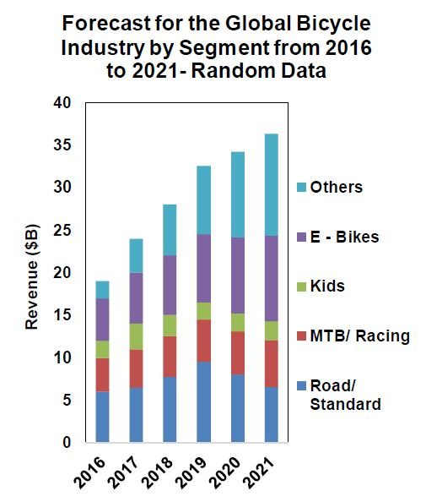
Figure 1: Bicycle Industry Forecast (2016 to 2021) [3]

2.1. Existing Products
The following overviews the features and functions of six bicycle computers on the market. To ensure a full comparison products ranging from budget to premium are analysed.

2.1.1. Pedal Pro Wireless Multifunction Computer
The ‘Pedal Pro’ wireless bike computer is a budget product (figure 2). It features waterproof casing, touch screen display and input buttons. The system uses a wireless ‘Hall Effect’ sensor attached to a bicycles wheel which detects data from wheel movement. It measures speed, cadence, distance, temperature and more.

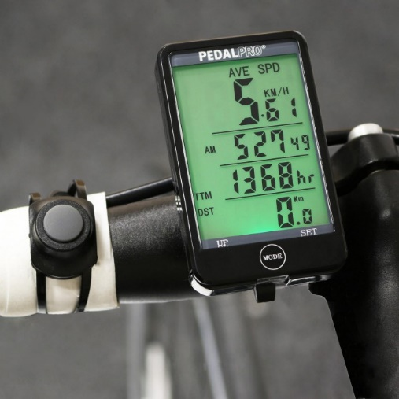
Figure 2: Pedal Pro Wireless Multifunction Computer [4]

2.1.2. Sigma BC 16.16
The ‘Sigma BC 16.16’ is a compact budget computer (figure 3). It features LCD display, user input, water tight enclosure and is compatible with sigma sport wireless sensors. Although not included as standard wireless ‘Hall-Effect’ cadence sensors can be purchased separately. It can also be connected through a dedicated app where estimated arrival time (ETA) and distance to destination can be displayed. The system with included sensors measures speed, distance, fuel savings, temperature and more.

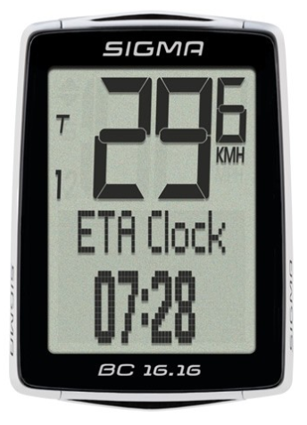
Figure 3: Sigma BC 16.16 [5]

2.1.3. Cateye Strada wireless 8 function RD300W
The ‘Cateye Strada RD300W’ is a mid-range bicycle computer (figure 4). It features LCD display, long battery life of up to 1 year through low power modes, wireless ‘Hall-Effect’ sensor and real time clock. It measures speed, distance, elapsed time and temperature.

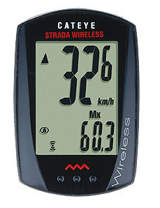
Figure 4: Cateye Strada RD300W [6]

2.1.4. Garmin Edge 25
The ‘Garmin Edge 25’ is a mid-range compact system (figure 5). It features LCD display, rechargeable lithium-ion battery, internal GPS and memory to store up to 10 rides. It also features Bluetooth which can be paired to a mobile device through a dedicated mobile application. It measures distance, speed, time and temperature.

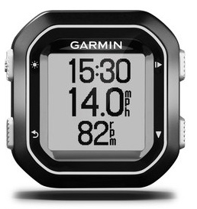
Figure 5: Garmin Edge 25 [7]

2.1.5. Polar V650
The ‘Polar V650’ is a premium cycle computer (figure 6). It features HD touch screen, water resistant casing, rechargeable battery with up to 10 hours training time and internal memory to store 10,000 hours ride time. It also boasts connectivity through USB and Bluetooth which can be paired with a dedicated application. It measurers speed, distance and displays map information through GPS.

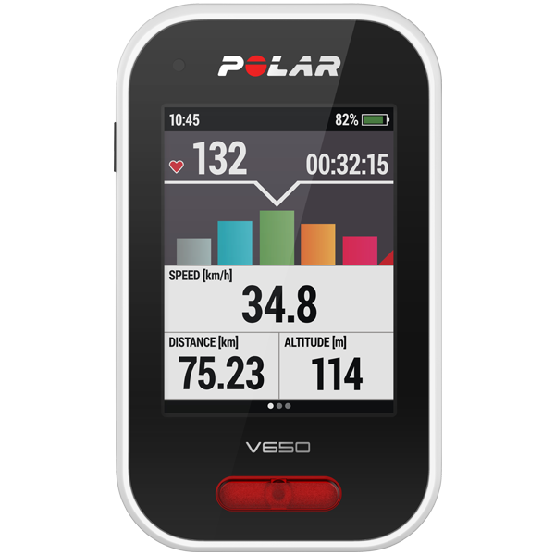
Figure 6: Polar V650 [8]

2.1.6. Xplova X5
The ‘Xplova X5’ is a premium bicycle computer (figure 7). It features capacitive touch screen, Bluetooth and USB connectivity, mobile application pairing, 8 GB of RAM, Wi-Fi compatibility and internal memory. The device also features a HD 720 by 30 FPS video camera to store rides which can be viewed from a video application. It measures speed, distance and displays map information through internal GPS. Temperature and light sensors are also internal to the device, however cadence and other measurement sensors are sold separately.

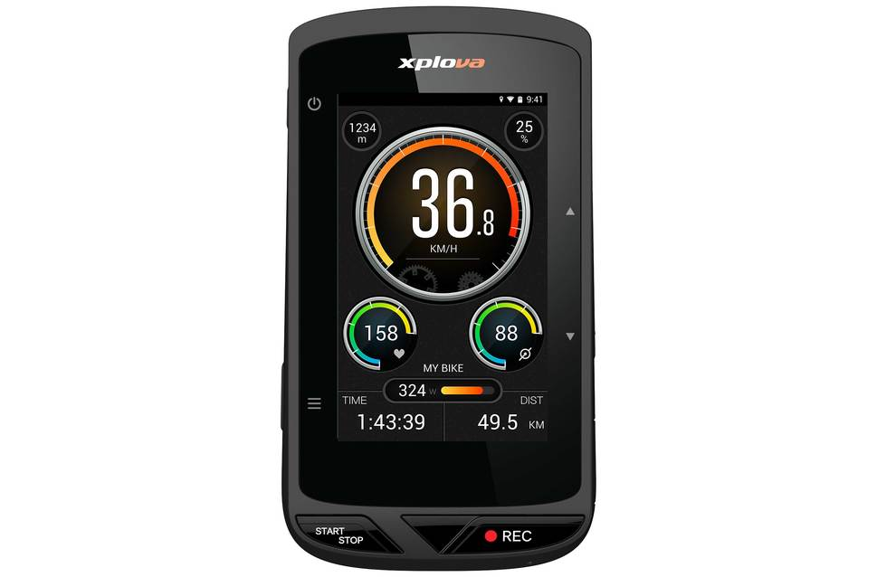
Figure 7: Xplova X5 [9]

2.2. Product Comparison
Below is a comparison of previously discussed products specifications (table 1).
Table 1: Existing Product Comparison
 | Pedal Pro [4] | Sigma BC 16.16 [5] | Cateye RD300W [6] | Garmin Edge 25 [7] | Polar V650 [8] | Xplova X5 [9]
Image | 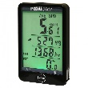 |  | 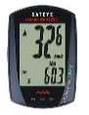 |  | 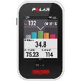 | 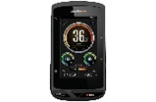
Power
Battery | Lithium-Ion | Lithium-Ion | Lithium-Ion CR2032 | Rechargeable Lithium-Ion | Rechargeable Lithium-Ion | Rechargeable Lithium-Ion
Battery Life | 25 hours | 20 hours | 1 year (1 hour per day) | 10 hours | 10 hours | 12 hours
Display
Type | LCD Touch Screen | LCD Screen | LCD Screen | LCD Screen | Colour Touch Screen | Colour Touch Screen
Resolution | Low | Low | Low | 128 x 160 | 320 x 240 | 240 x 400
Sensors
Internal | X | Accelerometer | X | GPS, GLONASS | GPS, GLONASS | GPS, GLONASS, Accelerometer
External | Wireless Hall-Effect, Wired Remote Switch | Wireless Hall-Effect | Wireless Hall-Effect | X | X | X
Measurements
Speed | Yes | Yes | Yes | Yes | Yes | Yes
Cadence | Yes | Yes (Separate Sensor) | Yes (Separate Sensor) | Yes (Separate Sensor) | Yes (Separate Sensor) | Yes (Separate Sensor)
Distance | Yes | Yes | Yes | Yes | Yes | Yes
Time | Yes | Yes | Yes | Yes | Yes | Yes
Temperature | Yes | Yes | X | Yes | Yes | Yes
Clock | Yes | Yes | Yes | Yes | Yes | Yes
Other Features
Connectivity | X | NFC | X | Bluetooth, USB | Bluetooth, USB | Bluetooth, USB, Wi-Fi
Memory | X | X | X | 10 rides | 10,000 hours | 1 GB
Camera | X | X | X | X | X | Yes (HD 720p @ 30fps)
Extra Features | - Sleep Mode  - User Input  - Waterproof | - Sleep Mode  - User Input  - Waterproof  - Mobile App Pairing | - Sleep Mode  - User Input  - Waterproof | - Sleep Mode  - User Input  -Waterproof  - Mobile App Pairing  - PC Charging | - Sleep Mode  - User Input  - Waterproof  - Mobile App Pairing  - PC Charging  - Map Display  - Custom Profiles | - Sleep Mode  - User Input  - Waterproof  - Mobile App Pairing  PC Charging  - Map Display  - Custom Profiles
Price | £11.95 | £26.79 | £38.98 | £87.00 | £189.50 | £389.96

2.3. Research Analysis
The majority of existing systems compared all measure similar parameters irrespective of price. All products measure speed, distance, average speed, trip time and display a real time clock as standard. As well as these standard parameters all systems record cadence either with an included or separately sold sensor.
The sensors the products adopt are dependent on price. Generally premium products use GPS/GLONASS technologies to measure speed and distance. These premium computers such as the ‘Xplova X5’ also display maps from the internal GPS and application information. Budget and mid-range systems use a wireless or wired ‘Hall-Effect’ sensor which is attached within proximity of the wheel where a paired magnet is placed on the spokes (figure 8).

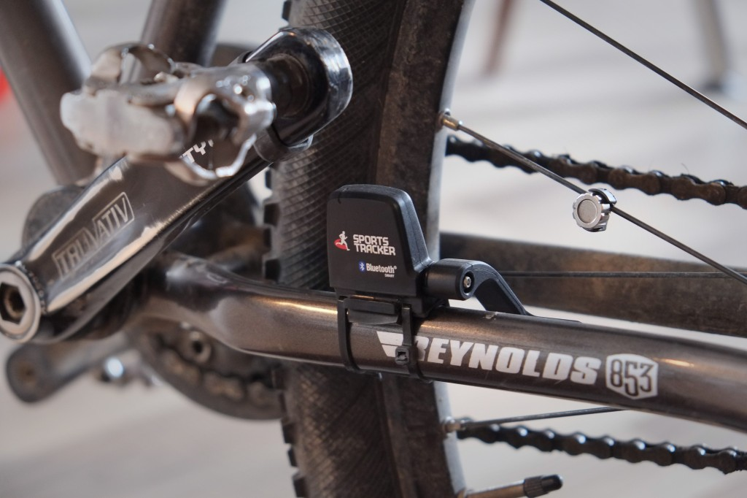
Figure 8: Hall-Effect Sensor Fitting Location [10]

Another comparable difference between premium and budget products is the display quality. Many premium products use colour screens which have a higher resolution. Lower end products use standard non colour LCD screens with lower resolution.
Connectivity functionality is also dependant on price with higher end models generally featuring Bluetooth as standard, this therefore giving the ability to be paired with dedicated mobile applications. Higher end models also include USB and even Wi-Fi connectivity which lower end systems lack. Lower end models also lack the ability to store any data due to the lack of internal memory and external memory compatibility.
All compared systems implement low power modes to reduce the power consumption from the respective batteries. Lower end systems compared generally have a better battery life, this possibly due to the lower functionality, lack of internal sensors and lower quality display. However they mostly use standard batteries which are not rechargeable via PC, whereas higher end models are.
Although extra features such as app pairing and enhanced connectivity are beneficial it is believed it can make the system over complicated. E. Burke [11] believes that more sophisticated systems are overcomplicated and future systems may lead to be impossible for the average person to operate. This is regarded as an important factor to consider when designing the computer as the system should be made as easy as possible for the cyclist to use whilst riding.
From the research collected it is believed that a system which can provide ease of use to the user whilst maintaining standard functionality to be a key factor. It is also believed that safety features would be beneficial to the system as which surprisingly the majority of systems lack.
All products on the market provide functionality which can be used by all types of cyclists. Producing a system which can provide functionality from a hobbyist, to a mountain biker, to a professional tour de France rider would be beneficial as it would not limit the product to a sole target audience. The design specification for the system is discussed in the following section.

3. Design Specification

Presented below is the design specification of the system.
The system must:
- Measure and display speed, distance, cadence, altitude, elapsed time, calories burned, real time and date.
- Have directional indicators which can be controlled through the computer.
- Have USB connectivity.
- Have an internal battery which can be recharged through USB lasting for 7 days (average ride time 3 hours a day).
- Have user input to allow the user to enter height, age and weight.
- Have SD Card compatibility for ride statistics to be stored.
- Have vehicle detection which will alert the user of a vehicle within the rear vicinity.
- Incorporate a low battery indicator.
- Adopt power saving methods to reduce power consumption.
- Use a PIC based microcontroller.

4. Design Procedure

The design strategy adopted was to use component analysis. This allowed for a variety of components, methods and design principles to be analysed for each of the requirements allowing optimal selection.

4.1. Speed and Distance
All types of cyclists will require to be made aware of speed and distance. Keeping track of targeted distances and speeds can be beneficial for training and for every day purposes. The speed of an average cyclist on a flat surface is around 10.5mph [12]. However, professional cyclist have been recorded at speeds of 60mph downhill [12]. Due to the system being designed for all cyclists it must register over a speed of 60mph. Both speed and distance can be measured together through one sensor. Outlined below are the technologies considered for speed and distance.

- IR (Reflective): Works by pulsing an infra-red beam in which if a reflective property is present it will reflect and the sensor will receive the beam [13]. To achieve a speed and distance measurement an IR sensor may be placed near the front wheel. A reflective strip could be fitted on one of the spokes. Every time the beam is reflected the sensor would count the RPM. Calculations could be made from the RPM to determine both speed and distance.

- Hall-Effect Sensor: A sensor in which the output voltage is affected by the presence of a magnetic field [14]. This sensor could measure both distance and speed through obtaining the RPM. It could be placed in proximity of the wheel with a magnet fitted to the spokes with each rotation activating the sensor.

- GPS: A system consisting of satellites in space which functions by sending and receiving radio signals. To determine positioning GPS uses the time taken for the signal to reach the intended receiver and use extensive coding to achieve this [15]. By determining positioning GPS can calculate distance and speed.

- Switch: A switch maybe used by fitting it to the wheel with a latch. The latch would hit the switch after each rotation in which speed and distance can be calculated.

4.1.1. Sensor Requirements
Outlined below are the requirements of the sensor and technology to measure speed and distance.
Must:
- Be capable of measuring up to or above 60mph.
- Have low power consumption.
- Be low cost.
- Be reliable.

4.1.2. Technology Selection
Below is a comparison of technologies considered (table 2).
Table 2: Technology Comparison for Speed and Distance
 | IR Reflective | Hall Effect | GPS | Switch
Accuracy | Medium (absorbed in water) | High | High | Medium (bounce issues)
Response | High | High | High | Medium
Robustness | High | Medium (Mechanical) | High | Low
Reliability | Medium (absorbed in water) | Medium (sceptical to wear and tear) | High | Low ( wear and tear major concern)
Size | Medium | Small | Small | Small
Cost | Fairly expensive | Inexpensive | Medium | Inexpensive
Score | 13 | 16 | 17 | 12
= 3 = 2 = 1

Regarded as most suitable for measuring speed and distance is GPS. GPS provides high accuracy, high response time and due to it not being mechanical it is reliable. The other advantage of GPS compared to other technologies is it can be fitted internally to the computer, so no external wiring or external fittings are required.
Although ‘Hall-Effect’ sensors and switches are less expensive their mechanical nature means they are prone to wear and tear. IR was disregarded as it can be absorbed in water therefore suffers from accuracy and reliability issues.

4.1.3. Sensor Selection
Below is a comparison of selected GPS modules (table 3).
Table 3: Sensor Comparison for Speed and Distance
 | Parallex PAM-7Q [16] | U-Blox Neo 6M Module [17] | U-BLOX NEO-7 M Mini GPS Module [18] | GMouse Mini GPS PS2 [19]
Image | 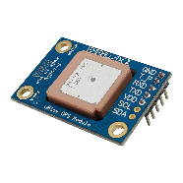 | 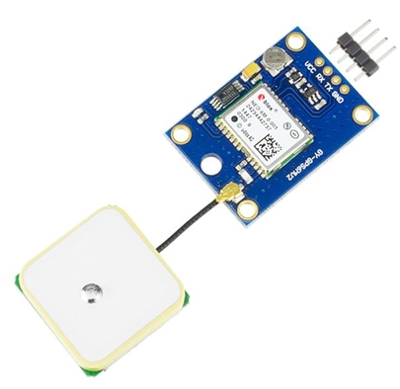 | 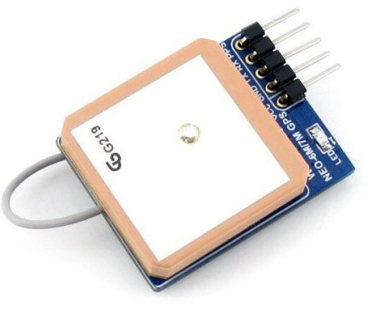 | 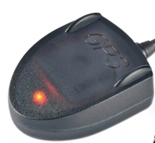
Supply Voltage (V) | 5 | 3.3 - 6 | 2.7 – 5.5 | 5
Power Consumption (mA) | 35 | 50 | 35 | 60
Number of Channels | 56 | 50 | 56 | 66
Horizontal Accuracy (m) | < 2 | 2 | < 2.5 | 3
Speed Accuracy (m/s) | 0.1 | 0.1 | 0.1 | 0.2
Max Speed (mph) | 1,000 | 1,118 | 1,000 | 980
Max Update Rate (Hz) | 10 | 5 | 10 | 10
Interface | UART (TTL) | UART (TTL) | RS232 (TTL) | RS232 (TTL)
Cost | £32.18 | £22.69 | £21.45 | £32.67
Score | 24 | 23 | 26 | 21
= 3 = 2 = 1

The GPS sensor selected for measuring speed and distance is the ‘U-BLOX NEO-7 M Mini’. This GPS is a 56 channel module with built in antenna which has high speed and distance accuracy, low power consumption and has a UART (RS232 TTL) output. The majority of other GPS sensors compared similarly in terms of accuracy, however they were mostly more expensive or featured higher power consumption.

4.1.4. Signal Conditioning
The GPS module requires no signal conditioning due to the interface being UART (RS232 TTL). It can be directly connected to configured UART TX and RX pins on the microcontroller.

4.2. Cadence
Cadence is the measurement of the number of completed pedals per minute. It is an important measurement for all cyclists. Keeping track of cadence information can improve a cyclist’s efficiency and present intensity information to the rider. On average a typical cyclist will have a cadence of around 60-80 rpm [20]. Professional cyclists generally pedal at a higher rate with an average maximum of 165 rpm. Technologies for measuring cadence are discussed below.

- Accelerometer: A sensor which measures the acceleration applied to an object due to external force [21]. An accelerometer could be used to measure cadence by being attached to the cyclist’s upper body. Due to the movement made when pedalling cyclists exert movement up and down around the shoulder area. This is considered as proportional to the pedal rate.

- Hall-Effect: It can be used to measure cadence by being placed on the crank shaft of the bicycle with the magnet connected to the pedal. With every rotation the magnet would pass activating the sensor.

- Coil: A device which when a voltage is applied creates its own magnetic field. A coil may be used to open and close a switch after each revolution.

- IR: It could be placed near the crank shaft to detect a beam break every time the pedal passes, thus counting the pedal rate.

4.2.1. Sensor Requirements
The technology and sensor requirements for cadence are below.
Must:
- Have a response time able to measure up to 165rpm.
- Have low power consumption.
- Be cost effective.
- Be adequately sized.

The minimum response time should be calculated approximately. Taking 165rpm as the maximum:
$$Revs per second= \frac{RPM}{1 second}$$
$$Revs per second= \frac{165}{60}=2.75 revs per second$$

So if approximated to three revolutions per second:
$$1 Reveloution \sim 333 ms$$

This is the minimum response time required from the sensor.

4.2.2. Technology Selection
Below outlines a comparison of technologies (table 4).
Table 4: Technology Comparison for Measuring Cadence
 | Accelerometer | Hall-Effect | Coil | IR
Accuracy | Medium | High | Medium | Medium (affected by water)
Reliability | Medium (Could potentially be affected by bumps) | Medium (Mechanical) | Medium | Medium (affected by water)
Response | High | High | Medium | High
Size | Small | Small | Can be Bulky | Small
Cost | Medium | Inexpensive | Medium | Expensive
Score | 12 | 14 | 9 | 11
= 3 = 2 = 1

The technology best suited for measuring cadence is a ‘Hall-Effect’ switch. This technology provides high accuracy, high response time and are fairly inexpensive. All other technologies suffer accuracy issues. Although an accelerometer would provide high response times it is regarded as inaccurate as it may be affected by any large bumps or ride jerks.
‘Hall-Effect’ sensors can be wireless or wired. For this system a wired sensor is regarded as more suitable. This is due to wireless sensors being more expensive and require wireless modules for connectivity. It is believed that the cost to implement this would outweigh the benefits. Another disadvantage for wireless sensors is a separate power source is required.

4.2.3. Sensor Selection
Below is a comparison of considered ‘Hall-Effect’ sensors (table 5).
Table 5: Hall-Effect Sensor Comparison for Cadence
 | Hamlin 55100-3M-02-A [22] | Comus PGN-SP-003 [23] | Honeywell 103SR13A-1 [24] | Honeywell SR 16/SR 17 [25]
Image | 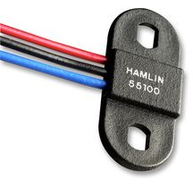 | 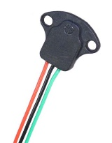 | 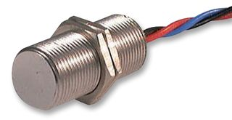 | 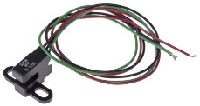
Supply Voltage (V) | 3.8 - 24 | 4.5 - 24 | 4.5 - 24 | 3.8 - 30
Current Consumption (mA) | 10 | 5.2 | 10 | 10
Switching Speed (µs) | 100 | 80 | 1.5 | 1.5
Output Type | Digital (0-5V) | Digital (0-5V) | Digital (0-5V) | Digital (0-5V)
Cost | £12.10 | £6.29 | £20.72 | £11.24
Score | 12 | 14 | 12 | 13
= 3 = 2 = 1

The sensor regarded as most suited is the ‘PGN-SP-003’ by Comus. This sensor provides a response time of 100µs which is below the required 330ms. It also features low current consumption, is inexpensive and is compact. Although it does not feature switching speeds as high as both Honeywell sensors it has a lower current consumption and is less expensive.

4.2.4. Signal Conditioning
Due to the sensor being an open collector output it requires a pull up resistor to connect the output to the power supply. This will pull the sensors output to 5V which can be connected to a digital input on the microcontroller.

4.3. Altitude/Elevation
Altitude/elevation would be useful information for mountain bikers and professional athletes. Altitude/Elevation is the height of a point relative to sea or ground level. In terms of suitable measurement range +/- 20 kPa which equates to around 2,000 meters above sea level. The types of technology which are considered for measuring altitude are outlined below.

- GPS: Can use positioning information to calculate relative altitude.

- Barometric Pressure Sensor: Uses a pressure switch or other displacement technologies in which the output is relative to the force applied [26]. Due to pressure differing at specific altitudes the sensor can calculate the altitude.

4.3.1. Sensor Requirements
Outlined below are the requirements for an altitude/elevation sensor.
Must:
- Measure around 2,000 meters above sea level or equivalent
- Measure with a fairly high degree of accuracy.
- Have low power consumption.
- Be cost effective.
- Be able to measure reliably.

4.3.2. Technology Selection
Below outlines a comparison of the technology selection (table 6).
Table 6: Technology Comparison for Altitude/Elevation
 | GPS | Barometric Pressure Sensor
Accuracy | Medium (signal attenuation may occur) | High
Reliability | Medium | High
Size | Small | Small
Cost | Medium | Inexpensive
Score | 10 | 12
= 3 = 2 = 1

The technology selected is a barometric pressure sensor. Barometric sensors generally feature higher accuracy compared with GPS sensors. This due to GPS signals being delayed and attenuated from buildings, trees and other objects [27]. Due to this feature generally aimed at mountain bikers, who are likely to be in either a forestry or rocky environments it may lead to inaccuracies and less reliability. Pressure sensors are also less expensive.

4.3.3. Sensor Selection
Below is a comparison of considered barometric pressure sensors (table 7).
Table 7: Sensor Selection for Altitude/Elevation
 | SparkFun - MPL3115A2 [28] | Parallax Inc. - Module 29124 [29] | MPXV7002 Pressure Sensor [30] | GY-68 BMP180 [31]
Image | 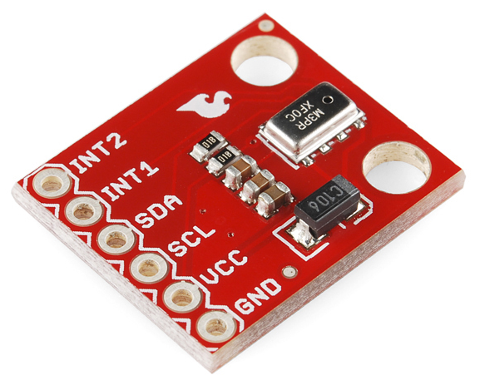 | 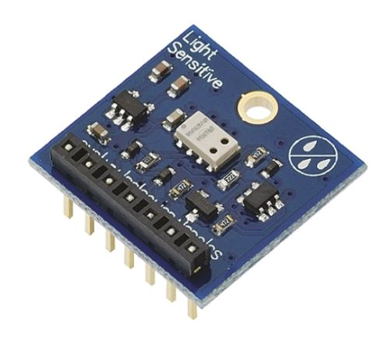 | 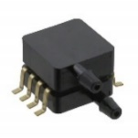 | 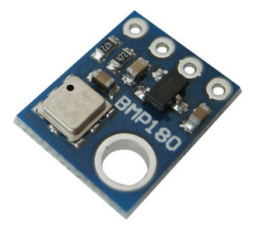
Pressure Range (kPa) | 20 - 110 | 1-120 | +/- 2 | -30 to +110
Supply Voltage (V) | 1.95 – 3.6 | 3.3 – 6.5 | 4.75 – 5.25 | 1.8 – 3.6
Current Consumption (mA) | 2 | 1.74 | 10 | 1
Accuracy | +/- 30 cm | +/- 20 cm | +/- 5% | 17 cm
Output Type | I²C (20 bit) | I²C (24 bit) | Analogue (0.5V – 4.5V) | I²C
Structure | Evaluation Module | Evaluation Module | SMD | Evaluation Module
Price | £13.46 | £26.98 | £9.67 | £5.16
Score | 16 | 17 | 17 | 20
= 3 = 2 = 1

The pressure sensor regarded as most suitable is the ‘GY-68 BMP180’ evaluation module. The sensor has low current consumption (the lowest of compared sensors), a more than optimal range of -30 to 110 kPa (equating to -500 to 9000m), and is the most inexpensive of compared sensors. The majority of other sensors were disregarded mainly due to higher current consumption and costing. Although the ‘BMP180’ does have a non-ideal voltage of 1.8V to 3.6V, a voltage regulator can be used to drop the voltage from an assumed 5V supply.

4.3.4. Signal Conditioning
Due to the selected pressure sensor having an I²C interface there is very little signal conditioning required. However due to the sensor having an open drain terminal it requires an external pull-up resistor. A 10k resistor will be used on both data pins and clock pins of the I²C bus.

4.4. Temperature
External air temperature is a useful parameter for all types of cyclists to be made aware of. It can be used as an indicator for when extreme conditions may be apparent. For example if the conditions are below freezing it can give an indication that the cyclist should be aware of ice. Outlined below are the technologies which may be used to measure temperature.

- Thermocouple: Measures air temperature by using two dissimilar metal alloy wires joined at one end. A difference in temperature can create a proportional voltage difference [32].

- Thermistor: A sensor whose resistive value or current value changes with temperature [33]. Thermistors are made up of semi conductive material whose resistance is sensitive to temperature.

- Resistance Temperature Detector (RTD): Work off the same principle as thermistors with resistance changing with temperature. The main difference is that the materials in RTD are pure metals.

- Infrared (IR): Detects the thermal radiation given off by an object or surrounding. This radiation given off is mostly IR radiation which IR sensors can detect. The sensor can calculate the temperature by the distribution of these frequencies, thus allowing the device to provide a non-contact measurement [34].

- Temperature IC: These are integrated circuits which consist of extensive signal processing, semiconductor technology and ‘Proportional To Absolute Temperature’ (PTAT).

4.4.1. Sensor Requirements
The temperature sensor requirements are outlined below.
Must:
- Measure a temperature range of around -20 to 50˚C (suitable outdoor temperature range).
- Be compact in size.
- Have low power consumption.
- Be cost effective.

4.4.2. Technology Selection
Below compares the considered technologies (table 8).
Table 8: Technology Comparison for Temperature Measurement
 | Thermocouple | Thermistor | RTD | IR | IC
Range | Wide Range (-200 to 1750˚C) | Large Range (-50 to 150˚C) | Large Range (-200 to 600˚C) | Large Range (-50 to 2000˚C) | Good Range (-70 to 150˚C)
Accuracy | Low (0.5 to 5˚C) | High (0.05 to 1.5˚C) | High (0.1 to 1˚C) | High | Medium (0.5 to 3˚C)
Stability | Fairly Stable | Medium | Medium | Fairly Stable | Stable
Size | Fairly Bulky | Small | Medium | Medium | Small
Cost | Medium | Medium (Linearization circuitry required) | Expensive | Expensive | Inexpensive
Score | 11 | 13 | 11 | 12 | 14
= 3 = 2 = 1

The technology which is best suited for the design is a temperature IC. An IC has been selected as they are reasonably inexpensive, provide a good measurement range and are compact. Technologies such as RTD’s and IR are disregarded for generally being expensive and being bulky. This may lead to either the sensor having to be fitted externally to the computer or increasing the size of the computer. Thermistors provide better accuracy over a temperature IC, however they do require linearization circuitry to linearize the output. This additional circuitry can increase the overall cost of the system, therefore was disregarded.

4.4.3. Sensor Selection
Below compares selected temperature IC’s (table 9).
Table 9: Sensor Selection for Temperature
 | LM35 [35] | AD590JH [36] | MCP9701A [37] | Maxim DS18S20 [38]
Image | 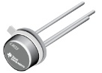 | 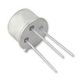 | 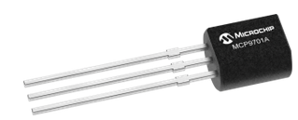 | 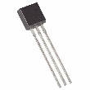
Operating Voltage (V) | 4 to 30 | 4 to 30 | 3 to 5.5 | 3 to 5
Current Consumption (mA) | 0.060 | 0.2 | 0.012 | 4
Range (˚C) | -55 to 150 | -55 to 150 | -40 to 120 | -55 to 125
Accuracy (˚C) | +/- 0.5 | +/- 0.5 | +/- 2 | +/- 0.5
Output | Analogue | Analogue (Current) | Analogue | Digital
Cost | £1.68 | £12.98 | £0.26 | £4.12
Score | 17 | 14 | 17 | 15
= 3 = 2 = 1

The sensor which is regarded as most suited for the design is the LM35 IC. It provides optimal measurement range, low current consumption and good accuracy. The ‘AD590JH-ND’ was disregarded due to it being expensive and having a current output which would require current to voltage circuitry to interface to the microcontroller. The ‘DS18S20’ was also disregarded due to price but also due to its higher power consumption. Microchips ‘MCP9701A’ compares similarly with the selected LM35, however although it is a considerably cheaper it has +/- 2˚C of accuracy which is deemed unsuitable. Although accuracy is not essential for the temperature of the system it is considered too much of an error.

4.4.4. Signal Conditioning
The LM35 sensor with the basic configuration measures from 2 to 150˚C. This reading is not enough as it needs to measure down to -20˚C. To achieve this some signal conditioning circuitry will be required to use the sensor in its full measurement range. As from the manufacturers data sheet of suggested circuits two diodes and a resistor are used (figure 9). This works by using the two diodes to offset/lift the ground pin of the LM35 to around 1.4V. By connecting the positive output through an 18k resistor allows the device to measure the negative temperature range.

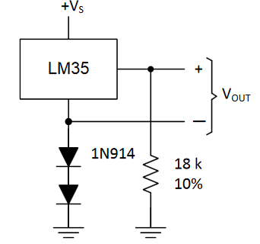
Figure 9: LM35 full temperature range configuration [39]

To interface to the microcontroller an analogue to digital convertor is required. Both negative readings and positive must be taken to separate pins and converted. The temperature can be calculated by subtracting the positive from the negative (pin 2 output – pin 3 output respectively).

$$Temperature= poitive reading pin-negative reading pin$$

4.5. Real Time Clock and Date
It is important for any type of cyclist to keep track of time for varying reasons. A professional cyclist may need to track time for training, whereas a daily commuting cyclist may want to track time for journey purposes. The methods which may be used to achieve a real time clock and calendar are outlined below.

- Software Algorithms: A clock can be achieved through timer and counter software routines. A timer can be used to time each instruction and then after a specified limit add it to a counter to calculate the time. This method requires fairly extensive software and there can be inaccuracies as the timers set are dependent on the selected crystal [40].

- Built-in RTC: Some microcontrollers have internal RTC arrangements. These can be activated through software. They can use external oscillators, internal oscillators or power line frequencies to achieve a clock.

- External RTC IC: A real time clock IC is a device which outputs real clock time and date information. They are available in a variety of data interfaces including I²C and SPI.

4.5.1. Method Selection
All the discussed methods have advantages and disadvantages. Regarded as the most suited method for a real time clock would be to use an external RTC IC. These chips are inexpensive and are accurate in providing date and time information.
Although using software algorithms would be cheaper and use fewer components it can be made inaccurate due to potential overflows needing to be considered. Also, implementing this method would mean that the microcontroller will be continuously counting and will not be free to do anything else. Using an internal RTC has also been disregarded as it is believed to be beneficial to leave microcontroller selection as open as possible so the optimal microcontroller can be selected.

4.5.2. Component Requirements
Outlined below are the requirements for the RTC) IC.
Must:
- Have a low power consumption.
- Use compatible interface output for a pic microcontroller.
- Be low cost.
- Measure both time and date.

4.5.3. Component Selection
Below compares RTC ICs considered (table 10).
Table 10: Component Selection of RTC IC
 | MCP7940M-I/P [41] | Epson Q42730111000200 [42] | Maxim DS1307+ [43] | Intersil CDP68HC68T1EZ [44]
Image | 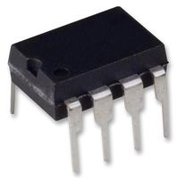 | 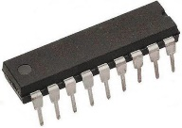 | 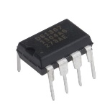 | 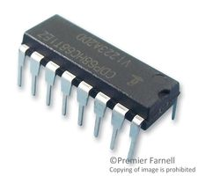
Operating voltage (V) | 1.8 to 5.5 | 2.4 to 5.5 | 4.5 to 5.5 | 3 to 6
Current Consumption (mA) | 0.3 | 6 | 1.5 | 0.08
Stand by Current (µA) | 1.2 | 15 | 200 | 20
Output Type | I2C | Parallel (16 bit) | I2C | SPI
Price | £0.71 | £3.49 | £4.13 | £8.74
Score | 15 | 11 | 11 | 12
= 3 = 2 = 1

The RTC IC best suited for the design is regarded as the ‘MCP7940M-I/P’ by microchip. This IC was selected as it is a low cost option with low power consumption. Other ICs such as the Espon ‘Q42730111000200’ and Maxim ‘DS1307+’ were disregarded due to both having high current consumption in both stand by and operation modes. Although the Intersil ‘CDP68HC68T1EZ’ has fairly low current consumption which compares similarly to the selected IC it is substantially more expensive so was also disregarded.

4.5.4. Signal Conditioning
The ‘MCP7940M-I/P’ has an I²C interface so it requires an external pullup resistor due to it being an open drain terminal. A 10k resistor will be used to pull both clock and data pins to the power rail of the system.

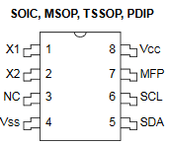
Figure 10: Microchip 'MCP7940M-I/P' pin layout [45]

The IC also requires an external clock to X1 and X2 pins (see figure 10). A 32 kHz crystal will be used as recommended by the manufacturer with two external load capacitors connected to ground [45]. Also featured on the IC is a multifunction pin which can be used as an output pin for an alarm or square wave output functions. This pin will be not be required for the design.

4.6. User Input
User input in any system improves the user interaction and interface. The system will require user input for entering the cyclist’s weight, height and age. This information will be used to calculate the calories burned by the user. The user may also be required to switch information on the display. Below are the considered user input methods.

- Capacitive Touch Screen: This type of screen uses a charge which is held by specific layers under the screen. As a pressure or an object closes the reference charge is changed [46]. This change is picked up via sensors which can determine the x and y coordinates.

- Resistive Touch Screen: Is made up of several layers where two conductive layers are separated by a gap [47]. The bottom layer is usually connected to a voltage supply in which as pressure is applied to the top layer, the second layer makes contact to the voltage source. This voltage is then read and can be used to locate a point of contact.

- Push Button: A push button is one of the simpler forms of user inputs and can be used within this system.

- Capacitive Touch Sensors: As a capacitive switch is touched it changes the capacitance of the switch. This is due to the electrical charge carried disturbs the sensors own charge causing the switch to operate.

4.6.1. User Input Requirements
Below are the requirements for selecting a technology for user input.
Must:
- Be cost effective.
- Be suitable for outdoor conditions.
- Be responsive and reliable so the cyclist does not have to be pre occupied ensuring an input is made.

4.6.2. Technology Selection
Below compares the technologies considered (table 11).
Table 11: Technology Comparison for User Input
 | Capacitive Touch Screen | Resistive Touch Screen | Push Button | Capacitive Switch
Responsiveness | Medium (can be affected by water) | Medium | High | Medium (can be affected if rider is wearing gloves)
Reliability | Medium | Medium (poor visibility in outdoor conditions) | Medium (Mechanical considerations) | Medium
Durability | High | High | Medium | High
Cost | Expensive | Medium | Inexpensive | Medium
Score | 8 | 9 | 10 | 9
= 3 = 2 = 1

The technology regarded as best suited for user input are push button switches. Although they are mechanical and do not possess the best reliability they are a cost effect option which provide high response. A high response is extremely important as the cyclist will not want to be pre occupied pressing inputs, as this may affect the cyclists ride experience. Other user input technologies were disregarded mainly as they are affected by outdoor conditions. For example capacitive touch screens and touch sensors are less responsive to materials. Capacitive technologies are generally more expensive.

4.6.3. Component Selection
Below compares the considered push buttons (table 12).
Table 12: Component Selection for User Input
 | EOZ FL Series [48] | Vandal Resistant [49] | Schneider ZB4BA4 [50] | PB Series Pushbutton [51]
Image | 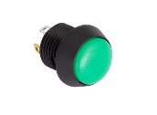 | 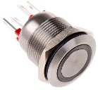 | 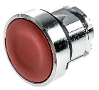 | 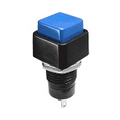
Voltage Rating (V) | 5 | 24 | 5 | 24
Button Size (mm) | 12 | 28 | 22 | 20
IP Rating | 67 | 66 | 67 | 65
Cost | £2.23 | £12.10 | £5.11 | £4.60
Score | 12 | 9 | 11 | 10
= 3 = 2 = 1

The push buttons regarded as most suited for the final design are the ‘FL Series’ by EOZ. They provide an IP67 rating meaning they are readily suitable for outdoor use, have optimal voltage rating and are inexpensive. Other push buttons were disregarded mainly due to being more expensive. Although all other compared push buttons have a larger diameter they would increase the overall size of the computer. The ‘PB’ pushbutton compares similarly however they have a lower IP rating with no built in rubber seals, therefore have a lower protection against outdoor conditions.

4.6.4. Signal Conditioning
The only required conditioning for the buttons is for a pull up resistor or pull down resistor. For this system a pull up resistor configuration will be used. This means that initially the pin on the microcontroller will be high due to the high impedance state of the pin (figure 11).

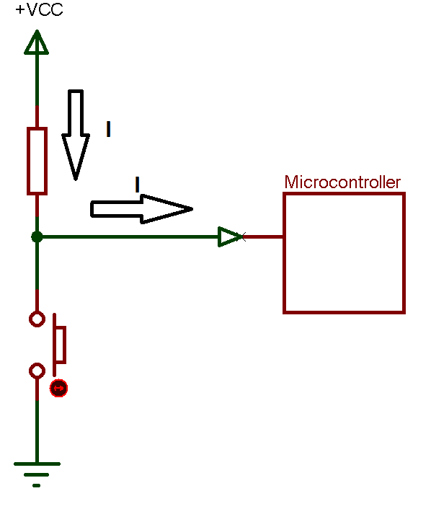
Figure 11: Pull up Resistor Switch not Pressed

Once the switch is pushed then the current flows through the resistor and then to ground. This is due to the switch effectively looking like a short circuit (figure 12). However it is not considered a short as the resistor will limit the current to ground.

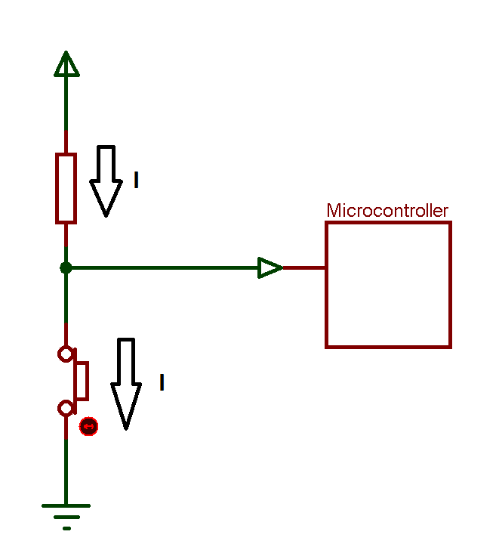
Figure 12: Pull up Resistor Switch Pressed

4.7. Indicators
Indicators are regarded as a beneficial safety feature for the system. Many accidents involving cyclists are caused by vehicles. A report by the Royal Society for the Prevention of Accidents [52] states that 57% of cyclist collisions with vehicles are caused by the driver/rider failing to look properly, with also 17% of accidents due to poor turn or manoeuvre. It is believed that indicators would alert and make drivers more aware of cyclist’s intentions, thus effectively improving the communication between each other.
LEDs will be used for the indicators. The reason LEDs are the chosen light source as they provide a good bright source which is inexpensive and energy efficient. The indicators will require waterproof casing to allow the LEDs to function in outdoor conditions.

4.7.1. Component Requirements
Overviewed below are the requirements for the indicator LEDs.
Must:
- Have low power consumption.
- Provide an overall brightness over 20 lumens.
- Be cost effective.

4.7.2. Component Selection
Below is a comparison of considered LEDs (table 13).
Table 13: LED Comparison for Indicators
 | Dialight 679-2222-332F [53] | VCC PML50 [54] | RS Pro 763-7918 [55] | Waytek Amber LED Indicator [56]
Image | 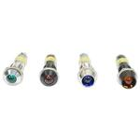 | 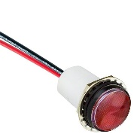 | 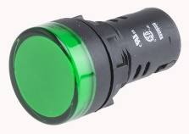 | 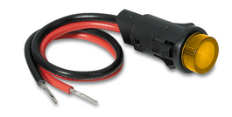
Brightness (Lumens) | 5.3 | 5.8 | 12 | 5
Operating Voltage (V) | 6 | 5 - 28 | 5 - 24 | 12
Power Consumption (mA) | 20 | 20 | 20 | 20
Cost | £9.35 | £8.79 | £2.86 | £6.48
Score | 8 | 9 | 12 | 9
= 3 = 2 = 1

Regarded as the most suited LEDs for the indicators are ‘RS Pro 763-7918’. These provide the most brightness out of all compared LEDs and feature low power consumption at a very low price. Although the selected LEDs do not provide the required brightness, two will be connected in series to compensate for this. Other LEDs were disregarded due to lower brightness and for being more expensive.

4.7.3. Indicator Control
It is believed that the user input for the computer and indicators remain separate. The reason being it would be awkward for the user to reach over to the computer. Having inputs on the handle bar grips is believed to be a valuable feature.
Capacitive touch sensors would be a viable option as they have a high response time and could be fitted to the side of the handle bars. However, these are fairly unreliable when gloves are worn which would be a concern. Another possible method is to use proximity sensors. They could be fitted in an array so when the cyclist waves or swipes over each sensor it could switch the corresponding indicator on (figure 13). When the three sensors output in a set order it would light the corresponding indicator.

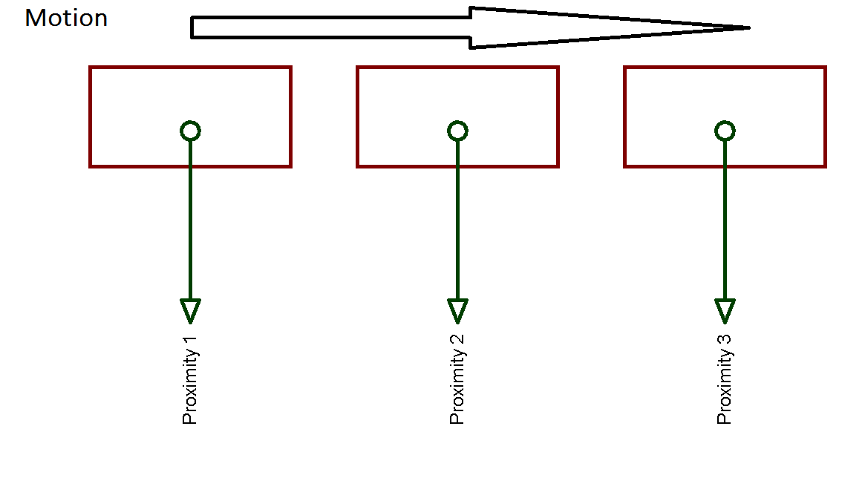
Figure 13: Proximity Indicator Control

This method however may also be unreliable, if the user accidentally waves his hand across whilst riding they could unintentionally turn the indicator on. Regarded as the most suitable option would be to use the standard push button switches selected in the user input section. Adjustable clamps will be used so the user can place them wherever suited.

4.7.4. Signal Conditioning
The LEDs may require external hardware as they may draw to much current for the selected microcontroller. The average microcontroller can output around 25mA on an I/O pin. The current draw for the LEDs will be 40mA therefore a transistor will be used to control the LEDs (figure 14). In this case as the microcontroller outputs high the transistor will conduct allowing current to flow through the LEDs.

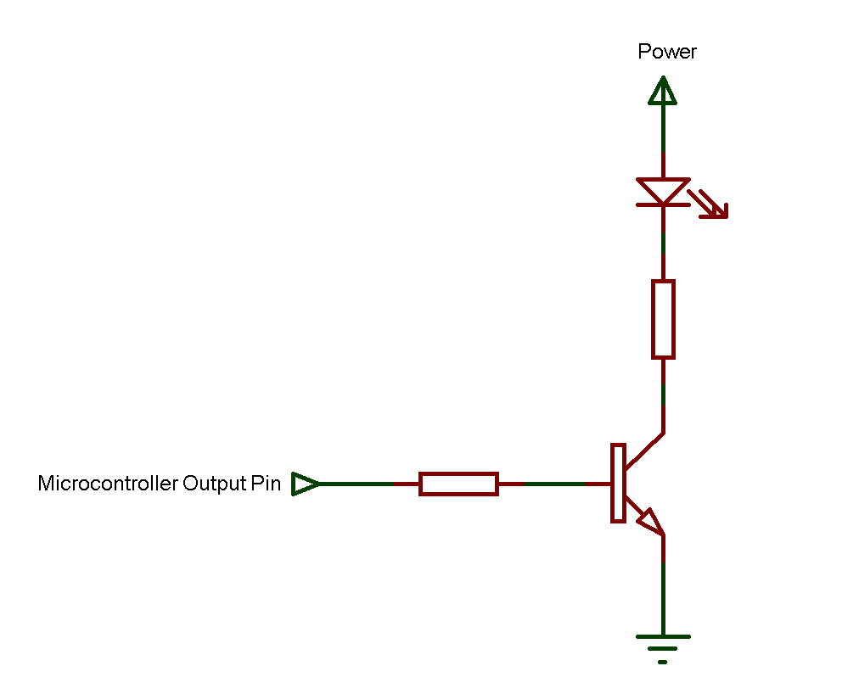
Figure 14: Transistor Switch Circuit

This will be however dependant on whether the microcontroller selected will feature high current drive output pins. If this is the case this circuitry will not be required.

4.8. Vehicle Detection
This feature of the bike computer will alert the user of any vehicles which may be in the rear vicinity. This can be a major safety feature as it can make a road cyclist more aware of surroundings. The types of sensors on the market are generally sold separately and do not interface directly to a bike computer. To implement this feature distance measuring and detection technologies will be considered. Outlined below are types of technologies which may potentially be used.

- Ultrasonic: Uses a transmitter which transmits an ultrasound signal generally over 40kHz. If there is an object in the near vicinity it will reflect the sound back and will be picked up by a receiver. The distance can then be calculated using time of flight principle [57].

- RADR: Produces radio waves and transmits them using a magnetron. If the waves detect an object they will reflect back where a receiver then picks up the signal. The time taken for the return signal can be used to calculate the distance.

- LiDAR (Light Detection And Ranging): This transmits and generates a pulsed laser light. Any reflective pulses are picked up by a receiver in the sensor in which time of flight is calculated to give the distance [58].

- Camera: Can be used for object detection by using various software algorithms. Once the camera sensor is set up the information it gathers can be used in various ways.

4.8.1. Sensor Requirements
Below are the requirements for vehicle detection sensor.
Must:
- Measure a distance of over 15m.
- Have low power consumption.
- Have a quick response time.
Although cost will be considered due to most technologies being fairly expensive it is not a necessity. The price for the sensor should be under £100 as a budget.

4.8.2. Technology Selection
Below overviews a comparison of the types of technologies considered (table 14).
Table 14: Technology Selection for Vehicle Detection
 | Ultrasonic | RADAR | LiDAR | Camera
Range | Short to medium (0-10m) | Short to Long range | Short to Long range | Short to Long
Accuracy | Accurate | Accurate | Accurate | Medium
Response | Low to Medium | Medium | High | High
Reliability | Medium (Directivity issues) | Reliable | Reliable | Not Reliable (affected by dust and fog)
Cost | Inexpensive | Medium to Expensive | Medium to Expensive | Expensive
Score | 12 | 13 | 14 | 10
= 3 = 2 = 1

The technology which is regarded as best suited for vehicle detection is LiDAR. LiDAR works over a range of distances and provides a reliable measurement. Camera systems are primarily disregarded due to them being unreliable as they are affected by fog and other conditions [59]. RADAR is comparatively similar to LiDAR, however due to it having a generally lower response time it is also disregarded.
Finally ultrasonic was disregarded as although it is cheap and accurate it has directivity issues. If an object is angled in a specified direction to the sensor only some of the reflective signal is received [60].

4.8.3. Sensor Selection
Below presents a comparison of selected LiDAR sensors (table 15).
Table 15: Vehicle Detection Sensor Selection
 | Garmin LIDAR Lite v3 [61] | Benewake ToF LiDAR [62] | SF02 Laser Rangefinder [63] | Benewake TF02 LIDAR [64]
Image | 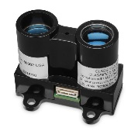 | 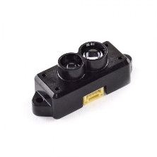 | 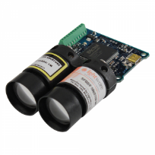 | 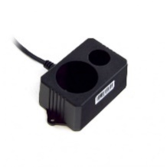
Range (m) | 0.05 to 40 | 0.3 to 12 | 0 to 50 | 0 to 22
Operating Voltage (V) | 4.75 - 5 | 4.5 - 6 | 4.5 – 5.5 | 5
Power Consumption (mA) | 130 | 120 | 150 | 200
Accuracy (cm) | +/- 2.5 | +/- 1 | +/- 2 | +/- 2
Response Time (ms) | 2 | 5 | 2 | 5
Interface | I2C | UART | UART | UART
Cost | £93.18 | £33.46 | £279.67 | £132.45
Score | 19 | 18 | 18 | 16
= 3 = 2 = 1

The sensor selected for vehicle detection is the Garmin ‘LiDAR Lite V3’. This sensor provides excellent range, low power consumption and high response time. Although not the least expensive other sensors such as the Benewake ‘mini’ and Benewake ‘TF02’ suffered in range and power consumption respectively. The Parallex ‘SF02’ is comparatively similar to the selected sensor, however it is almost three times the price meaning it is an unviable choice.

4.8.4. Design Consideration
Due to the high price of the LiDAR sensor it would increase the overall cost of the bicycle computer. If the product was going to be released onto market it would be viable to sell this as an optional extra. This would allow customers to buy the basic bike computer and allow them to buy this extra sensor. This will require detection circuitry so when the sensor is plugged into the corresponding socket the program may read the sensor.
To achieve this a resistor can be connected on the power connection for the sensor (figure 15). The voltage across the resistor can be monitored through analogue pins on the microcontroller. With no load connected there will be no voltage drop across the resistor.

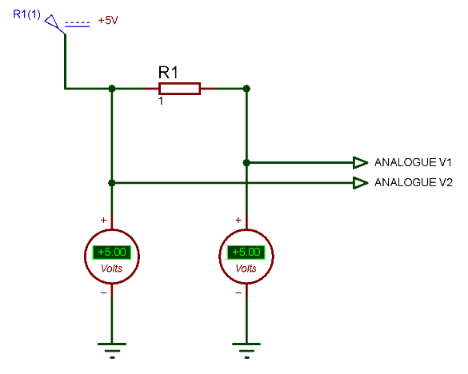
Figure 15: Current Sensing Circuit without Load

With a load connected there will be current flowing through R1 and through the load causing a voltage drop across R1 (figure 16). This voltage drop can be monitored to detect whether the sensor is connected. This can then enable the software to read the sensor for the vehicle detection function.

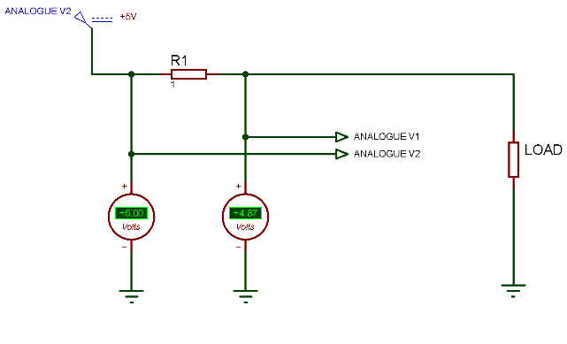
Figure 16: Current Sensing Circuit with Load

4.8.5. Signal Conditioning
As the LiDAR sensor has an I²C interface there is very little signal conditioning required. The device will be connected to the already discussed I²C bus which will use a 10k pull up resistor on both data and clock pins. As referred to the manufactures data sheet a recommended 680µF capacitor should be connected between ground and power (figure 17) [65]. This capacitor is used for decoupling purposes.

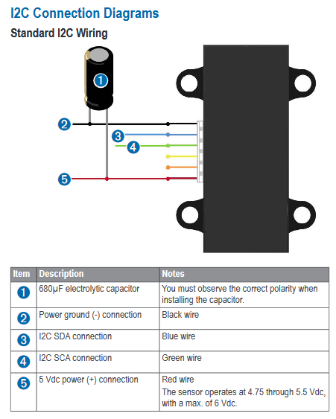
Figure 17: Garmin LiDAR Sensor I²C Connection Layout [65]

4.9. Display
The display for the system is a vital part as it will be displaying information continuously to the user. Information displayed will be distance, speed, time elapsed, calories burned, user information, date, time, temperature and elevation. Due to user input already determined as push buttons touch screen systems are not considered. The types of display which may be used are discussed below.

- LED Display: Uses Light Emitting Diodes (LED) at different arrangements [66]. Usually are available in three configurations being edge lit, full array and direct lit.

- LCD Display: Uses liquid crystals to rotate and polarise light to turn on and off pixels [67]. Generally LCD are good for low power battery systems.

- Seven Segment Display: Uses LEDs to light up pre-arranged pixels. They are usually very limited to the amount of letters and numbers displayed.

- Graphical LCD Display: Works off the same principle as standard LCD displays. However they use graphical drivers meaning that they can display graphic files and can display text at specified sizes and positions.

4.9.1. Component Requirements
Below are the requirements for selecting the display.
Must:
- Be low power.
- Be able to display characters, numbers and special characters.
- Be suitable for outdoor viewing.
- Be low cost.

4.9.2. Technology Selection
Below compares each selected technology (table 16).
Table 16: Technology Selection for System Display
 | LED | LCD | Seven Segment | Graphical LCD
Character Limit | Characters, numbers, special | Characters, numbers, special | Limited | Characters, numbers, special and graphics
Refresh Rate | High | Medium | High | Medium
Power Consumption | Low | Low | Low | Low
Reliability | Excellent (operate at low temperatures) | Medium (can freeze) | Excellent (operate at low temperatures) | Medium (can freeze)
Outdoor Viewing | Medium (dependant on brightness of LED) | Excellent | Medium (dependant on brightness of LED) | Excellent
Cost | Expensive | Medium | Inexpensive | Medium
Score | 15 | 15 | 15 | 15
= 3 = 2 = 1

The display best suited for the system is a graphical LCD. A graphical LCD fits the requirements due to low power consumption, low cost and excellent outdoor viewing. It was selected over a normal LCD as characters can be resized and positioned freely. A seven segment display was disregarded due to the limited display options. A LED type screen was also not considered mainly as they are a more expensive option over LCD displays.

4.9.3. Component Selection
Below compares selected graphical LCDs (table 17).
Table 17: Graphical LCD Display Comparison
 | Winstar WDG0151-TMI [68] | JHD521Y/JG [69] | RX160160B-FHW [70] | Vishay LCD-128G064E [71] | LGM12864B [72]
Image | 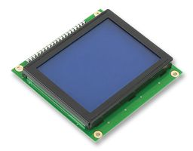 | 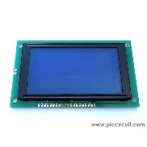 | 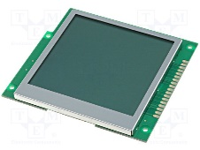 | 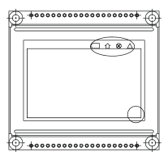 | 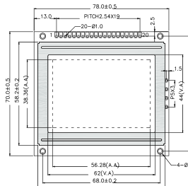
Operating Voltage (V) | 7.6 – 9.26 | 4.5 - 5 | 3 – 3.6 | 2.8 – 5.5 | 4.5 – 5.5
Current Draw (mA) | 100 | 50 | 80 | 330 | 240
Resolution | 128 x 64 | 128 x 64 | 160 x 160 | 128 x 64 | 128 x 64
Refresh Rate (ms) | 250 | 250 | 250 | 250 | 250
Interface | Parallel | Parallel | Parallel | Parallel | Parallel
Cost | £13.27 | £13.68 | £14.53 | £11.34 | £15.98
Score | 16 | 17 | 15 | 16 | 15
= 3 = 2 = 1

The LCD regarded as most suitable for the final design is the ‘JHD521Y/JG’. This LCD has primarily been selected due to its low power consumption which is lower than all compared displays. It also uses a built in graphic driver and provides a suitable refresh rate. Other LCDs were mainly disregarded due to higher power consumption. The Winstar ‘WDG0151-TMI’ compared similarly to the selected module. However was disregarded due to having a higher power consumption and a non-optimal operating voltage. This would require more discrete hardware potentially increasing the cost.
The selected LCD features a parallel interface which requires many pins. Although using an I²C interface would require less pins it would have a slower response time. This mainly due to it being serial data which would directly impact refresh times.

4.9.4. Signal Conditioning
The graphical LCD display selected has a built in graphical driver IC, therefore there are no requirements for the microcontroller to have its own built in driver. The display will require all data, register select, read write, chip select, enable and reset pins to be connected to digital output pins on the microcontroller. These require no signal conditioning and can be directly connected.
To reduce the current consumption of the display the backlight can be dimmed. This can be automatically achieved by using a Light Dependant Resistor (LDR). The LDR can be connected to an analogue pin on the microcontroller. By reading the LDR the backlight could then be controlled through a PWM signal through a transistor.

4.10. Low Power Indicator
A low power indicator will provide the user with an indication of when the battery is low. Although this could be achieved by reading the batteries voltage through the microcontroller a hardware implementation will be adopted to reduce the number of pins.
One way of achieving this is to use a low drop out voltage regulator which would be fed into a comparator. The reference voltage can then be set through a variable resistor. When the battery level drops to the threshold voltage, the comparator would output and turn on an LED. Although this method would work it is believed that a better way would be to use a precision reference voltage Zener. This method would be cheaper and uses less components (figure 18).

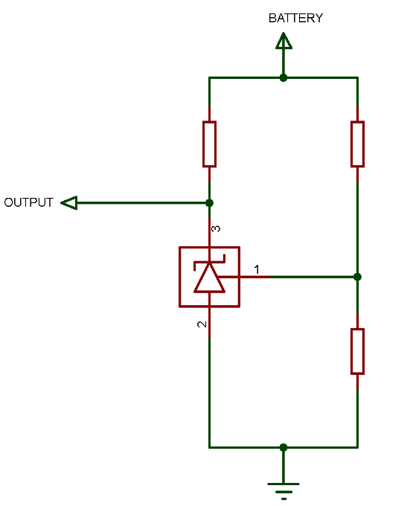
Figure 18: Low Voltage Indicator
The reference voltage for the device is set by the potential divider between R2 and R3. As the voltage drop across R3 reaches 2.5V the diode will conduct through terminal three, thus effectively shorting the LEDs out. Two LEDs must be used as the device has a minimum ‘on’ voltage of 2V which is not enough to light one LED [73].

4.11. Elapsed Time and Calories Burned
Both elapsed time and calories burned can be achieved through software routines on the microcontroller. Built in timer modules can be used to work out the elapsed ride time. The timer could start once a reading is read from the cadence sensor. If the rider stops pedalling the timer could stop halting the total elapsed ride time.
Calories burned can be achieved through software calculations. It can use an energy activity value called a MET rating which can be used to calculate calories burned. The MET rating is variable with intensity. Three variables could be used to store a light, medium and high intensity comparing this with speed readings (table 18).
Table 18: MET Units [74]
Light Cycling under 10mph | 4.0 MET
Cycling 10-16mph | 6.0 MET
Cycling 16+mph | 8.0 MET

Within the calculation the user’s weight and elapsed ride time can be used.
$$MET ×Weight kg=calories burned/hour$$

4.12. Microcontroller
The system will use an 8 bit microcontroller. Before a microcontroller can be selected the following parameters must be acquired.
- Number of pins required.
- Size of RAM and program memory.
- Clock frequency.
- Analogue to digital convertor resolution.

4.12.1. Number of Pins
Below are number of pins required (table 19).
Table 19: Pins Required
Pin | Number Required
Analogue Inputs | 5
Digital Inputs | 5
Digital Outputs | 3
Serial Peripheral Interface | 4
USB | 2
RS232 | 2
I²C | 2
Display | 12
Power | 4
Total | 39

The microcontroller will require 39 pins, although it is good practice to have five spare pins the system would require a larger microcontroller. Microcontrollers over 40 pins generally have very high specifications which maybe overkill and costly for the application. An internal clock will be used to save pins and potentially decrease PCB land costs.

4.12.2. Program Memory and RAM
An approximation of both the required program memory and RAM are below. The program memory is required to perform four analogue to digital conversions, I²C, RS232 and SPI interfacing and additional calculations.
An average complied program language is around 1 Byte per 1 character. On average one line is 25 characters long.
$$1kB\sim 40 lines$$
Below shows approximated number of lines required (table 20).
Table 20: Program Memory Approximation
Code | Number of Lines
Configurations | 30 lines
Analogue to Digital Conversion | 8 lines x 4
Timers | 6 lines x 2
Loops | 30 lines
Calculations | 10 to 20 lines
Data Storage | 40 lines
LCD Interfacing | 50 lines
I²C Interfacing | 100 lines
RS232 Interfacing | 80 lines
USB Interfacing | 50 lines
SPI Interfacing | 50 lines
Other code | 100 lines
Header Files | 600 lines
Total | 1,144 lines

Over approximations have been made to allow for any errors.
$$Program Memory \sim \frac{1,144}{40}=28.6kB$$
The RAM for the system is approximated using the program memory information.
$$RAM \sim 400 Bytes$$

4.12.3. Clock Frequency
To calculate the required clock frequency an approximation of instruction cycles are required.
A/D conversions required for current sensing, temperature and LDR. Below is an overview of the instructions required for an A/D conversion.
$$Select Channel=4 instructions$$
$$Wait=30 us$$
$$Convert=1 instruction$$
$$Wait=6 us$$
$$Read Conversion=12 instructions$$
$$Total instructions=17+36 us=53 us$$

The current sensing circuit will be read once every 10 seconds.
$$Cycles per second=53 ×4=212 cycles$$
$$Cycles per 10 seconds= \frac{212}{10}=21.2 cycles$$
$21.2 ×2=42.4 cycles$ per second

The LDR will be read every 10 second.
$$Cycles per 10 secinds=21.2 cycles$$

Temperature will be read once every 10 seconds. The difference is it will be stored on the SD card.
$$Store Data=100 instructions \\ 53+100=153 instructions$$
$$Cycles per second=153 ×4=612$$
$$Cycles per 10 seconds= \frac{612}{10}=61.2 cycles per second$$

For cadence a digital input is required. This input will need to be read for the maximum specified RPM which is around 165.
$$Cadence readings required= \frac{60}{165}=0.363 seconds$$
This means that the reading will need to be taken at every 200ms. Outlined below are the instructions required for a digital input.
$$Interrupt routine=4 instructions$$
$$Read Output=4 instructions$$
$$Calculations=8 instructions$$
$$Store Data=100 instructions$$
$$Total instructions=116 instructions$$
For cadence:
$$Cycles per second=116 ×4=464 cycles$$
$$Cycles per second=464 ×5 readings every second=2,320 cycles$$

Three sensors use I²C interface which all have to be initialised and read. I²C requires for the microcontroller to have a built in Master Synchronous Serial Port (MSSP) module. The relevant registers must be set to configure the module as I²C. I²C uses a master and a slave in which communication between the two devices is essential. In this case the microcontroller is the master and the sensor is the slave.
$$Initialise Registers Master=8 instructions$$
$$Write data to slave=15 instructions$$
$$Transimit=20 instructions$$
$$Wait while transmition is in progress=50 us$$
$$Read Data from Slave=15 instructions$$
$$Store Data=100 instructions$$
$$Total Instructions=158+50=208 instructions$$

The elevation sensor is I²C and will be read every 1 second.
$$Cycles per second= 208 ×4=832 cycles$$
$$Cycles every second= \frac{832}{1}=832 cycles$$

The real time clock is I²C and will be read every 0.1ms
$$Cycles per second=208 ×4=832 cycles$$
$$Cycles every second=832 ×10 readings every second=8,320$$

The vehicle detection sensor is I²C and will be read once every 25ms. This data however will not be stored so the storage instructions are not accounted for.
$$Cycles per second=108 ×4=432 cycles$$
$$Cycles per second=432 ×40= 17,280 cycles$$

The other readings which will be taken are from the speed and distance GPS module. This uses RS232 interface. To use this the USART module of the microcontroller must be accessed. To allow this the relevant USART registers must be set.
$$Ready UART for reciving=20 instructions$$
$$Read Data=15 instructions$$
$$Store Data=100 instructions$$
$$Total=135+50us \left(for delays\right)=185 instructions$$

For speed and distance calculations are also required to convert the coordinates into speed and distance.
$$Calculations \sim 20 instructions$$
The GPS will be read every second.
$$Cycles per second=205 ×4=816 cycles$$
$$Cycles per second= \frac{816}{1}=816 cycles$$
For the display and other instructions not accounted for, 5,000 cycles will be allocated to the total.
$$Total=254.4+122.4+2,320+8,320+17,280+816+5,000=34,112.8 cycles$$
For the system a 34 kHz clock is optimal. However due to approximation errors and microcontrollers running at high frequencies the total will be multiplied by 50.
$$Total= 34,000 ×50=1,700,000 cycles$$
The system running at 2 to 4 MHz is optimal.

4.12.4. Analogue to Digital Convertor Resolution
The system requires five A/D conversions. These are from the current sensing circuit, temperature sensor and LDR. Outlined below are calculations for the minimum required A/D conversion resolution.
The sensing circuit is supplied off 5V. With a 1Ω resistor used the voltage drop across the resistor is as follows:
$$Equalvialnt Resistance of Sensor=38Ω$$
$$Vdrop=\frac{Current Sensing Resistor}{Current Sensing Resitor+Load Resistance} ×Supply Voltage$$
$$Vdrop=\frac{1}{1+38} ×5$$
$$Vdrop=0.128V$$
$$V=5-0.128=4.87V$$
So an A/D resolution is required to detect a 0.128V drop.
An 8 bit resolution is as follows at 5V:
$$8 bit Resoloution= \frac{5}{256}=0.01953 V$$
This is more than enough to register the voltage drop

For the temperature sensor it provides a positive temperature output and negative temperature output.
When a positive temperature is read it has a maximum reading of 150˚C with a voltage output of 2.40V. At 0˚C it has a voltage output 0.19V.
$$2.4 V-0.19 V=2.21 V$$
$$\frac{2.21}{150}=0.0147 V$$

This means an 8 bit resolution would not satisfy this. A 10 bit resolution is as follows:
$$10 bit Resoloution= \frac{5}{1024}=0.0043 V$$
This is enough to satisfy the positive temperature reading.
For the negative reading it outputs at -55˚C with a voltage of 1.13V and at 0˚C measures 0.19V.
$$1.13 V-0.19V=0.94 V$$
$$\frac{0.94}{55}=0.0171 V$$
The 10 bit resolution is more than enough to satisfy this.
So the microcontroller requires to have at least a 10 bit A/D convertor resolution.
The LDR is not considered as accuracy is not essential.

4.12.5. Microcontroller Selection
The required microcontroller will have a minimum of the following specifications.
- Pin Count: 39
- Program Memory: 28.5kB
- RAM: 400 Bytes
- Clock Frequency: 2 to 4 MHz
- A/D Resolution: 10 bit
The following parameters were entered on microchips parametric search in which only one suitable microcontroller was matched. The microcontroller found was ‘PIC 18F45K50’ (table 21). (See Appendix A for search screenshot).
Table 21: PIC 18F45K50 Specification Overview
Name | PIC 18F45K50 [75]
Image | 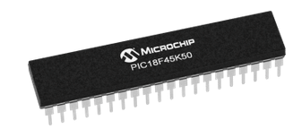
Program Memory | 32kB
RAM | 2048 Bytes
Internal Oscillator | 16MHz
A/D Channels | 25
A/D Resolution | 10 bit
Pin Count | 40
Price (per 5k) | £1.41

Although there are no other microcontrollers to compare it against. The selected microcontroller provides optimal program memory, number of pins and A/D resolution at a low cost. Although RAM and the internal clock are regarded as overkill it will not effect the performance of the system.

4.12.6. Microcontroller Information
Presented below is information of the internal modules included on the ‘PIC18F45K50’.

4.12.6.1. Enhanced Capture/Compare/PWM (ECCP)
This module is used to control time based pulses. The capture part of this module can write the value of an internal timer when a rising or falling edge of a pulse is detected. The compare module can set an interrupt or change the state of an output pin when the value of the timer reaches a set threshold. Finally the PWM part can output a programmable set square wave at a specified frequency were the duty cycle can be reconfigured.
An enhanced CCP module includes all three of these elements and more. The other features include selectable polarity for PWM signals, auto detection for shutdown, restart of the module timers and pulse steering control. For this system the CCP module will be used as a PWM signal which will control both LED indicators.

4.12.6.2. MSSP
The Master Synchronous Serial Port (MSSP) is a module which allows for a range of serial interfacing. The microcontroller supports I²C master and slave modes as well as SPI. For this system SPI will be used for the SD card with I²C configured on other pins.

4.12.6.3. High/Low Voltage Detect
This module can be used to detect a set voltage point in terms of high or low power. As a set point is tripped this can generate an interrupt which can perform a sub routine.

4.12.6.4. CTMU
Charge Time Measurement Unit (CTMU) is a module which is used with other analogue modules to provide differential time measurements between pulse sources [75]. The unit can measure changes in capacitance, time and actual capacitance. It can be used in conjunction with capacitive touch screens were measurements can be made from the change in capacitance given from these devices.

4.12.6.5. USART
The built in USART module can be used to interface and communicate with devices using RS-485, RS-232 and LIN/J2602. It features an auto wake up when a start bit is addressed and auto baud detection. This module will be used in the system for interfacing the GPS module.

4.12.6.6. Watch Dog Timer
The watch dog timer module in the PIC microcontroller is a module which can be configured to generate a system reset if the software faults or crashes. This can be used through software or through hardware ICs. This may be done in this system with the watchdog timer configured after each loop.

4.13. Battery
The battery required for the system will need to be 5V as the majority of sensors run off a 5V supply. A 3.3V regulator can be used to drop the voltage for the elevation sensor and the SD card. Below is the total current draw from the system (table 22).
Table 22: Total Current Consumption
Component | Maximum Current Draw (mA)
U-BLOX NEO-7M Mini GPS | 35
Comus PGN-SP-003 | 5.2
GY-68 BMP180 | 1
LM35 | 0.060
MCP7940M-I/P | 0.0012
RS Pro 763-7918 (four required) | 80
Garmin LIDAR Lite v3 | 130
JHD521Y/JG | 50
Microcontroller | 20 max.
Total | 321.26 mA

This is the total current consumption for the system on at all times. By controlling the backlight of the LCD through the LDR the backlight potentially could be off for the majority of the time. So if approximately there is a 50% reduction in power consumption from the LCD it would make the current draw 25mA.
Another consideration is that the indicators are not likely to be constantly on. They will be switched on and off for short intervals. They are likely to be off for around 80% of the time so this current can be approximated to 16mA.
Refined total current draw:
$$Current Draw \sim 257.56mA$$
For the system to last the specified 7 days with 3 hours cycle time a day:
$$Hours on=3 ×7=21 hours$$
$$Battery Rating=257.56 ×21=5408.76mA \sim 5.5 Ah$$

4.13. Battery Selection
The battery must be rechargeable to satisfy the design specification. The battery type regraded as most suitable for this system is a lithium ion battery. Although lithium ion batteries are more expensive than Nickel–metal hydride batteries (NiHM) and other types they have many advantages.
Lithium ion batteries provide high energy density meaning that they generally have a larger power capacity whilst remaining compact in size. Although they can lose some of their capacity over time they can handle 1000s of recharge and discharge cycles. Lithium ion batteries also possess quick recharge times which would make them a suitable choice for the system.
A 7.3V battery with at least 5,500mAh is required. Below compares selected batteries (table 23).
Table 23: Battery Comparison
 | Ansmann Rechargeable [76] | Tenergy 7.4V Lion [77] | Samsung 7.4 Volt Lithium Ion Battery [78]
Image | 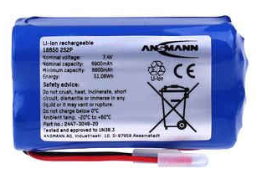 | 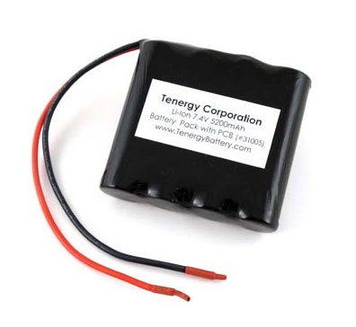 | 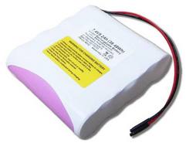
Voltage (V) | 7.4 | 7.4 | 7.4
Capacity (mAh) | 6900 | 5200 | 5200
Size (mm) | 70 x 37.5 x 37.5 | 72 x 70 x 20 | 76.2 x 69 x 18
Weight (g) | 196 | 190 | 199
Price | £23.95 | £35.89 | £42.69
Score | 14 | 13 | 11

The battery regarded as most suitable for the system is the ‘Ansmann’ rechargeable battery. This battery provides the most capacity out of the compared batteries and is considerably less expensive. The cost of the other compared batteries is the main reasoning for disregarding them.

4.14. USB
The USB in the system will interface to a PC for data transfer and to recharge the battery. USB 2.0 will be used due to the microcontroller supporting USB 2.0 modules. Due to the selected microcontroller featuring a built in USB module it means that the D+ and D- data pins can connect to the related pins.
Complexity is with the USB charging. USB 2.0 produces a 5V output with a maximum current of 500mA. However if there is a source trying to draw more than 500mA say at 1amp for example. This would not be good and would end up shutting down the USB. To achieve a limited current draw from the battery a lithium ion charger controller IC is required. Although this could be done in discrete hardware, ICs are cheap and reduce the development and design time. The selected IC is the LM3622 by Texas Instruments. This IC can be used for 8.2V batteries. It was selected due to it being inexpensive and available as standard at many retailers meaning that bulk ordering could be achieved. The circuit functions using a transistor to control the current through the battery. This is fed through a sensing pin were a diode is connected. A current sensing resisitor is connected through ground to provide feedback. Below is the typical application which will be used in the final design (figure 19).

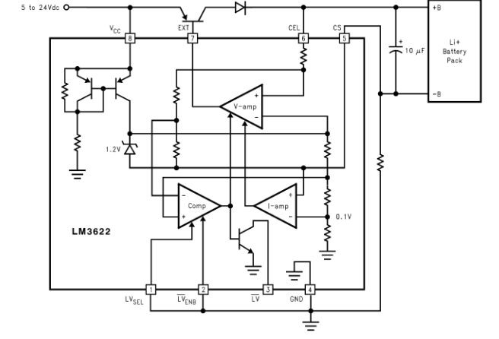
Figure 19: Lithium Ion Controller [79]

Due to the selected battery being at 7.4V (8.4V maximum charge) and the maximum output from the USB being 5V a step up in voltage is required. To achieve this a DC to DC step up convertor IC will be used. The selected IC to be used is the MC34063. This IC provides up to 1amp output and functions from an input range of 3V to 40V. This IC will be used before the control circuitry. The recommended circuit by the manufacturer for a non-inverting step up convertor will be used (figure 20).

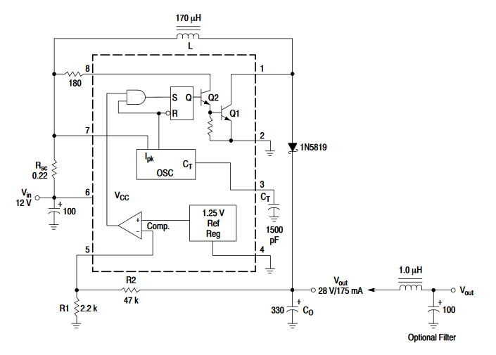
Figure 20: DC/DC Step Up Convertor [80]

The circuit functions by acting as a high speed switch. The diode prevents the voltage discharging through the internal circuitry. As the internal circuitry on pin one closes current will flow through the coil and through pin one. This effectively shorts out the coil but only for a short time for the coil to build up energy. As the coil increases in energy the voltage increases. The required output voltage is around 9V considering the voltage drop across the control transistor and diode. The output given from the manufactures data sheet is given by:
$$Vout=1.25 (1+ \frac{R2}{R1} )$$
Therefore to achieve a 9V output if R1 = 1k then R2 will = 6.2k.

4.15. SD Card
The system requires external memory to log parameters such as calories burned, distance, speed, date and user entered information. A SD card would provide a suitable means of storage. SD cards are cheap and are easily implemented due to the built in MSSP module on the PIC. A micro SD card is regarded as more suitable to ensure the casing for the system is as small as possible. To implement this in the final design a female micro SD card connector is required.

5. Final Design

All final circuit designs including a circuit schematic, a PCB layout and software diagrams are presented in the following.

5.1. Initial Block Diagram
Below is a block diagram of the system (figure 21).

Figure 21: System Block Diagram

5.2. Circuit Schematic
All components used are described in more detail in the previous related design procedure sections. Please refer to ‘Appendix B’ for a full schematic.
Figure 22: Battery Charger Circuit

Battery Charger Circuit (figure 22):
- The MC30463 steps up the 5V from the USB bus to around 9.2V with the gain given via R19 and R20.
- C4, C5 and C6 provide power de coupling.
- The LM3622 is used as a charger controller.
- Please refer to ‘USB’ section for detailed workings of the circuit.

Figure 23: Voltage Regulator

Voltage regulators (figure 23):
- The 7805 is used to provide 5V from the battery input.
- The 7803 provides 3V from the battery input.
- C8 to C11 are used as decoupling capacitors.
Figure 24: Voltage Clamp

Voltage Clamp (figure 24):
- A voltage clamp is used to prevent the voltage exceeding 5V.
- It is connected before the output of a sensor is connected to the microcontroller.
Figure 25: I2C Sensors

I²C Sensors (figure 25):
- The I²C bus is a serial bus which allows multiple slave devices to be connected to a sole master device unlike SPI and other asynchronous serial interfaces.
- Although I²C allows multiple devices to be connected it can be slower as for every 8 bits of data transmitted acknowledge bits must be sent. This can make it slower than other serial transmissions.
- However due to the system using only three devices it is satisfactory.
- The vehicle detection sensor uses a 1Ω resistor in which the voltage can be monitored.

Figure 26: Temperature Sensor
Temperature Sensor (figure 26).
- The LM35 is connected to 5V.
- It has a two analogue outputs due to the configuration used.
- The two outputs are fed into analogue channels on the microcontroller.
- A voltage clamp is used on each output pin (shown in figure 24).

Figure 27: GPS module

Speed and Distance GPS (figure 27)
- The GPS is powered from 5V.
- Due to it being UART interface it is connected to the relevant TX and RX pins on the microcontroller.
- A voltage clamp is used to prevent the voltage exceeding 5V on both RX and TX pins (shown in figure 24).
Figure 28: Cadence Sensor

Cadence Sensor (figure 28)
- The sensor is connected to 5V.
- Digital output which uses a 10k resistor to pull the output high.
- A voltage clamp is used on the output (shown in figure 24).

Figure 29: User Inputs
User Input (Figure 29):
- Uses 10k pullup resistors to connect the button to positive.
- Four buttons are used select, back, indicator right and left.
- These are all connected to digital pins on the microcontroller.

Figure 30: LDR Configuration
LDR (figure 30):
- The LDR is connected to 5V with a 10k resistor acting as a potential divider.
- The output is fed into an analogue pin of the microcontroller.

Figure 31: USB and SD Card
USB and SD Card (figure 31)
- The SD card is connected to relevant SPI pins configured in the MSSP module of the microcontroller.
- The CS pin is connected to a digital output pin.
- The USB is connected to the relevant configured pins.
- The USB bus pin is connected to the battery charging circuit.
Figure 32: Indicators

Indicators (Figure 32):
- The Indicator LEDs are connected through a transistor.
- The input to the transistor is connected through CCP module pins were a PWM output can be used to control the LEDs.

Figure 33: Display

LCD (Figure 33):
- The LCD is powered through 5V.
- The contrast pin is connected to a variable resistor.
- All data pins, enable, RS and CS pins are connected to digital output pins.
- The backlight is controlled by the transistor in which when the LDR is over a particular threshold the backlight will activate.
- This transistor is connected to a digital output pin.

Figure 34: Low Battery Indicator

Low Power Indicator (Figure 34)
- The TL431 is used a low power indicator
- The input reference is from the potential divider with the output in the form of an LED.

Figure 35: Microcontroller
Microcontroller (Figure 35)
- Shows all inputs and outputs from sensors and modules from the microcontroller.

5.3. PCB Design
Below is the PCB layout design for the final system (figure 36 to 41).

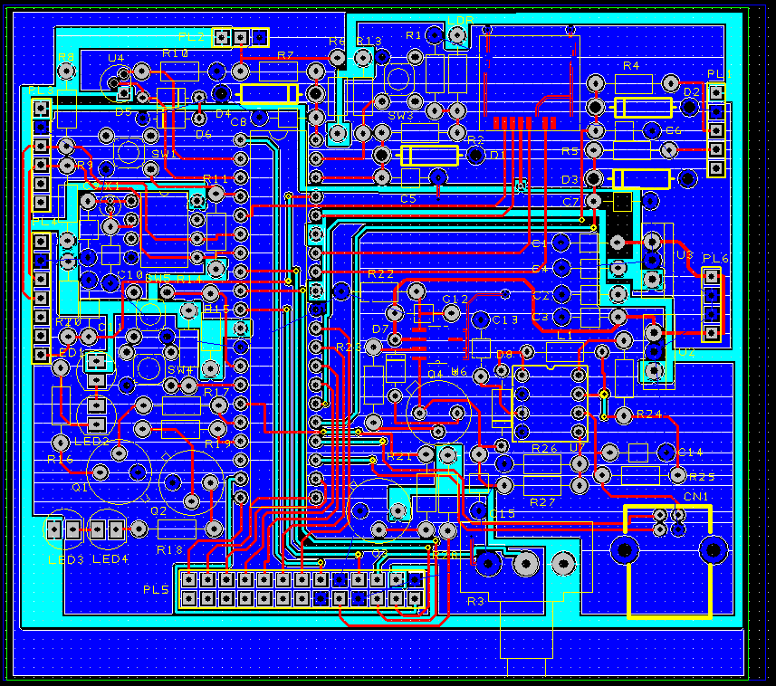
Figure 36: Composite PCB View

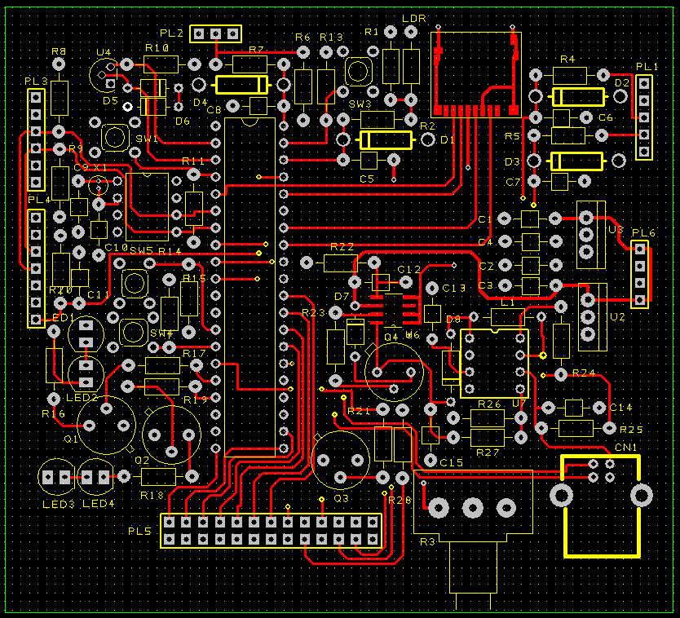
Figure 37: Top Veiw

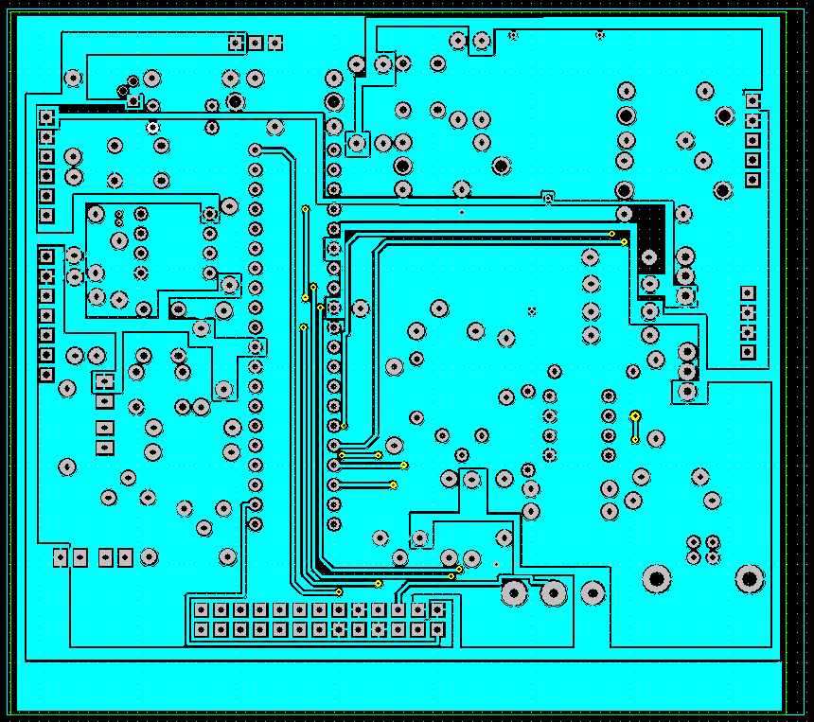
Figure 38: Bottom View

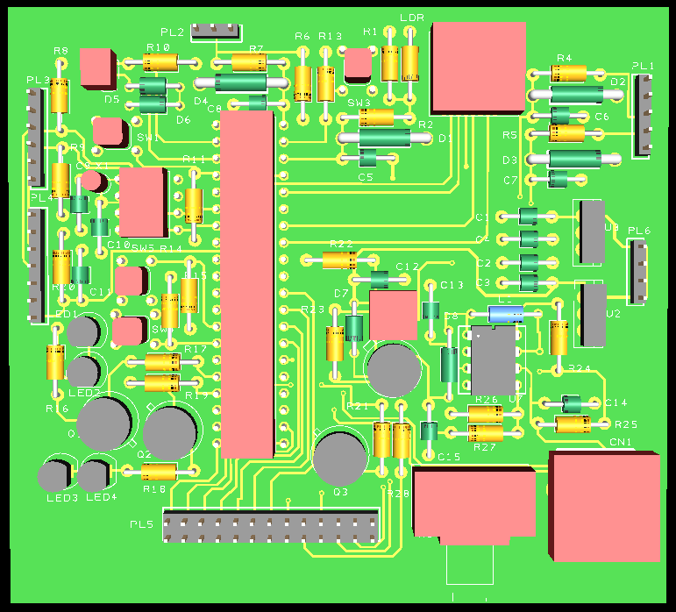
Figure 39: Top 3D View

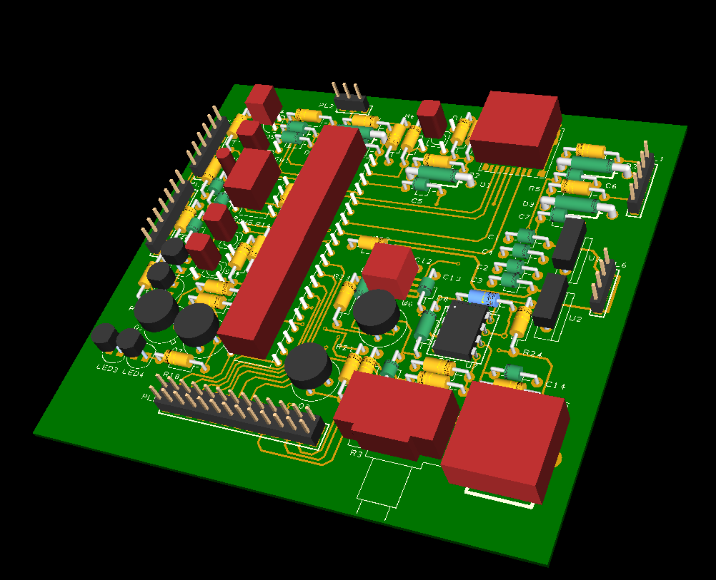
Figure 40: Side 3D View

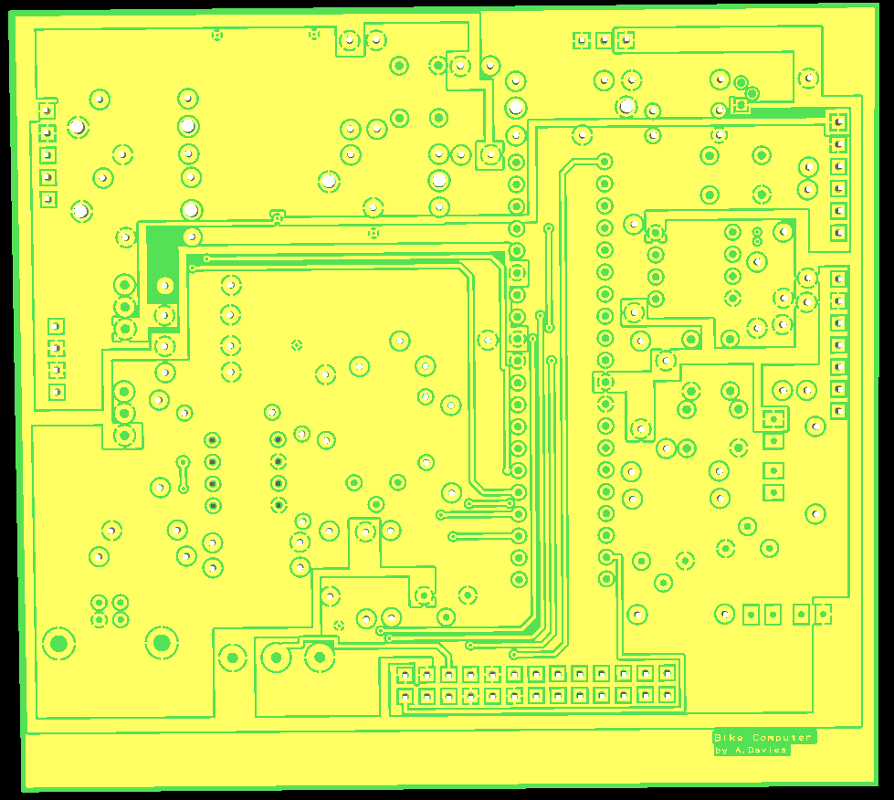
Figure 41: Bottom 3D View

The PCB is designed so all connectors are situated on the outside of the board as good practice. All signals are connected via copper tracks on the top and bottom layers. For the power rails a copper pour is made for 0V, 3.3V and 5V. This was done to reduce the number of tracks on the board.

5.3. Software Design
Presented in the following section is the software design for the system. It includes the pseudo code and flowcharts for the start-up, user input and main readings.
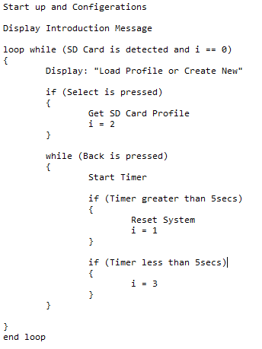
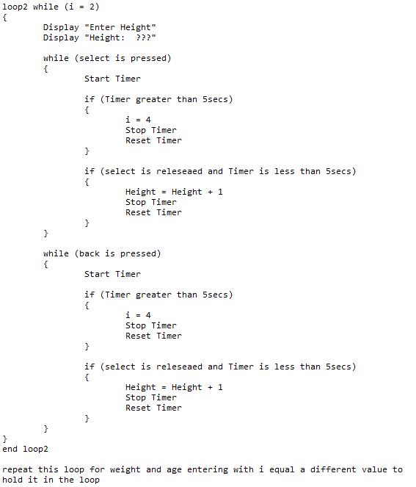
Figure 42: User Input Flowchart

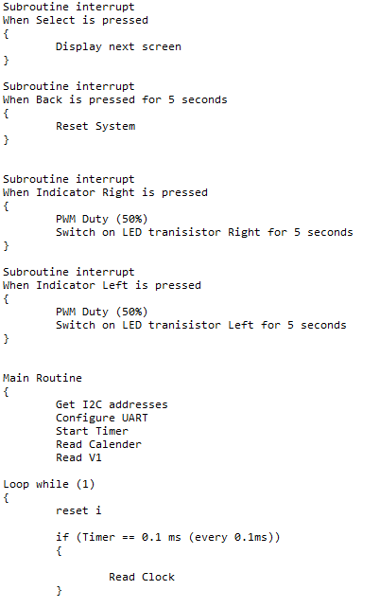
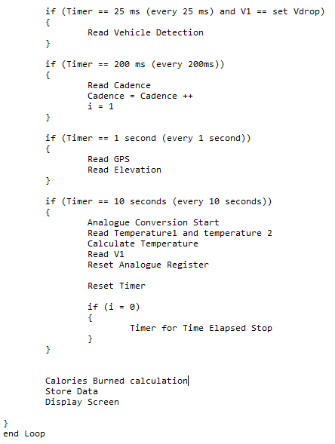
Figure 43: Main Routine Flowchart

5.4. Costing
Below is the overall cost (table 24).
Table 24: Final Cost of the System
Component | Manufacturer/Product Code | Source | Quantity | Price
Distance and Speed GPS | U-BLOX NEO-7 M Mini GPS Module | Cheap Drones UK | 1 | £21.45
Cadence Sensor | Comus PGN-SP-003 | Comus | 1 | £6.29
Elevation Sensor | GY-68 BMP180 | banggood.com | 1 | £5.16
Temperature Sensor | LM35 | Texas Instruments | 1 | £1.68
RTCC | MCP7940M-I/P | Microchip | 1 | £0.71
User Input | EOZ FL Series (Push Buttons) | EOZ | 6 | £13.38
Indicators | RS Pro 763-7918 | RS Components | 4 | £11.44
LCD Display | JHD521Y/JG | Piccircuit.com | 1 | £13.68
DC/DC Step Up | MC34063 | Texas Instruments | 1 | £0.99
Lithium Charger Controller | LM3622 | Texas Instruments | 1 | £1.43
Microcontroller | PIC18F45K50 | Microchip | 1 | £1.41
Battery | Ansmann Rechargeable | RS Components | 1 | £23.98
USB Module | USB Module | Mouser | 1 | £2.22
SD Card Module | SD Card Module | Mouser | 1 | £2.19
Voltage Regulator | 7805 | RS | 1 | £0.38
Voltage Regulator | 7803 | RS | 1 | £0.35
Switch | C & K Slide Switch | Farnell | 1 | £0.89
Resistor | 0.25Ω | Farnell | 1 | £0.186
Resistor | 1Ω | Farnell | 1 | £0.15
Resistor | 330Ω | reichelt.com | 2 | £0.28
Resistor | 180Ω | reichelt.com | 1 | £0.08
Resistor | 1kΩ | Farnell | 5 | £0.70
Resistor | 6.2kΩ | reichelt.com | 1 | £0.09
Resistor | 10kΩ | Maplin | 11 | £0.33
Resistor | 18kΩ | reichelt.com | 1 | £0.14
Capacitor | 210pF | Mouser | 1 | £0.54
Capacitor | 22nF | Farnell | 2 | £0.80
Capacitor | 0.1µF | Farnell | 2 | £0.22
Capacitor | 0.33µF | Farnell | 3 | £0.29
Capacitor | 10µF | Farnell | 1 | £0.08
Capacitor | 100µF | Farnell | 1 | £0.11
Capacitor | 680µF | Farnell | 1 | £0.52
Coil | 17µH | Mouser | 1 | £1.83
Diode | 1N914 | Mouser | 1 | £0.78
Diode | Generic Diode | Mouser | 1 | £0.43
Schottky Diode | 1N5819 | Farnell | 1 | £0.30
Crystal | 32kHz | The Pi Hut | 1 | £0.90
Transistor | 2N1711 (NPN) | Farnell | 3 | £2.97
Transistor | 2SA1493 (PNP) | Farnell | 1 | £0.89
Potentiometer | 10kΩ | Farnell | 1 | £1.39
LDR | Generic LDR | Hobby Tronics | 1 | £0.60
Total |  |  |  | £122.32

This is the total cost of the system without including the vehicle detection sensor. Although this price seems high due to the features of the product it compares relatively well with existing systems in its price range. With the vehicle detection sensor the systems cost would be around £222.32.

5.5. User Manual

Getting Started
- Insert a micro SD card into the card slot (located at the top of the computer).
- Ensure the battery is fitted correctly by sliding the back panel off the computer.

Fitting the Computer
- Fix the supplied adjustable bracket onto the handle bars fixing at the desired location.
- Place the computer into the bracket by sliding the computer until a click is heard.
- Ensure the computer is locked into place before use.

Fitting the ‘Hall-Effect’ Sensor
- Place the main sensor within the near proximity of the pedal shaft.
- Fix using the supplied adjustable bracket.
- Fix the paired magnet on the pedal directly opposite the sensor.
- Using the supplied cable ties fix the cabling along the bicycles body at the most feasible route.
- Cable tie any overhanging cable insuring it is not in direct contact with moving parts.
- Insert the connector into the socket at the base of the computer.

Fitting the Indicator Lights
- Firstly insure the seating is correctly adjusted to desired level.
- Fix the indicator with the supplied adjustable bracket at the back of the bicycle on the seat pole.
- Using supplied cable ties fix the cabling along the bicycles body to the computer at the most desired route.
- Cable tie any overhanging cables insuring they are not in direct contact with moving parts.
- Insert the connector into the marked connector labelled (IND).
- Fix the two control switches to the handle bars.
- Cable tie any overhanging wire to the computer.
- Connect to respective slots labelled (RIGHT) and (LEFT).
Note: Always test indicators before rides, never assume they are functioning.

Fitting the Vehicle Detection Sensor
Note this feature is optional and not supplied with the main product.
- Firstly insure the seat is correctly adjusted to desired level.
- Fix the sensor using the supplied bracket (note if indicators are fitted use the multipoint bracket provided).
- Using the supplied cable ties fix the cabling along the bicycles body to the computer at the most desired route.
- Cable tie any overhanging cables insuring they are not in direct contact with moving parts.
- Insert connector into slot marked (VDS).

Turning on my Bicycle Computer
- Slide the power switch to the left (facing screen).
- Check the display for introductory message.
- If Low power light is lit then the battery requires charging (see charging my computer section).
- If the display is functioning the system is on and ready to use.

Start up
- When starting a new profile you will be prompted with “Enter your Height”.
- Press the button labelled ‘Select’ to increase height.
- Press the button labelled ‘Back’ to decrease height.
- To reset the system from this menu hold the ‘Back’ button for a minimum of 5 seconds.
- Once you’ve selected a height press the ‘Select’ button to for 5 seconds to enter it (this will be stored on the SD card).
- After entering height you will be prompted to enter weight and age. To enter these parameters use the inputs described above.
- Once entered height, weight and age the bike computer is ready to use.

Main Function
- Once set up you will be prompted with the initial screen shown (image below).
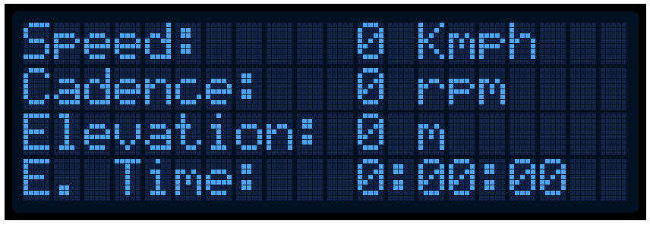
- All information will be automatically logged by the computer.
- To switch to display other parameters press the ‘Select’ button.
- This will display other parameters such as temperature and time.
- To switch back press the ‘Select’ button again.
- To reset the whole system press and hold the ‘Back’ button for 5 seconds.

Charging the Battery
- Plug the USB into a PC with USB 2.0 compliance.
- Once the system is charged enough the low battery indicator will go out.

Switching off my Bicycle Computer
- Slide the power switch fully to the right (facing display).
- Check the display to ensure computer is off.

6. Recommendations and Conclusion

Although it is believed the system has beneficial features there can be improvements made. Firstly the implemented low power system only will light the LED after a particular voltage drop. This means the user cannot track when the system is fully charged. To improve this the battery supply could be connected to an analogue pin on the microcontroller. This would allow for the batteries voltage to be monitored through all levels and could be displayed on the LCD.
Although the system has both PC connectivity and external storage it could add Bluetooth connectivity as provided by many existing systems. To implement this a Bluetooth module will be required to provide connectivity to other devices. This requires complex software algorithms to achieve this.
One of the main system improvements can come from featuring error detection. Using a watchdog timer can reset the system if any faults or crashes are detected. This can be done through software using the built in modules of the microcontroller.
More functionality may be added to the system which may include sensors such as UV levels. This would be beneficial as it would allow for cyclists to monitor safe UV levels and can indicate whether they require protection. This can be achieved by using a UV sensor module which can be either I²C interface, digital or analogue. Another feature which may be added is to add a bike light which can be controlled through the computer. This can be achieved in a similar way to the indicators already in the system. A transistor can be used to amplify the current and control the LEDs of the bike light. PWM can then be used for brightness and even flash control. This can be inputted by the user to select different lightning modes. To achieve some of these features a larger microcontroller with more pins is required. Using a larger microcontroller would allow for more external features to be added.

6.1. Conclusion
Although there are many features and improvements which may be added to the system the core design provides excellent functionality. It is believed the system is easy to use for the user and provides valuable safety features which are beneficial to all types of cyclists. If the recommended improvements were made it would enhance the product even more. Although these additional improvements would be valuable cost should be considered.
The only drawback to the system is the cost. The cost was much higher than anticipated and although initially targeted at a mid-range price it ended as a premium price. However it does provide additional functionality which many products lack currently on the market. If the system was to be re designed however more consideration would be taken in terms of costing. Overall however the system is regarded a success due to the functionally featured.

7. References

[1] | C. Suze, A History of Cycling in 100 Objects, illustrated ed., London: Bloomsbury Publishing, 2017, p. 88.
[2] | UK Government, “Government publishes £1.2 billion plan to increase cycling and walking,” gov.uk, 21 April 2017. [Online]. Available: https://www.gov.uk/government/news/government-publishes-12-billion-plan-to-increase-cycling-and-walking. [Accessed 5 January 2018].
[3] | Lucintel, “Growth Opportunities in the Global Bicycle Industry 2016-2021: Trends, Forecast, and Opportunity Analysis,” Lucintel, 2016.
[4] | Pedal Pro, “PedalPro Wireless Multifunction Bike Computer,” Pedal Pro, [Online]. Available: https://www.pedalpro.com/pedalpro-wireless-multifunction-bike-computer.html?gclid=EAIaIQobChMI2p-Q4LjL2AIVTrHtCh1I1QsjEAQYAiABEgJTrPD_BwE. [Accessed 9 January 2017].
[5] | Sigma Sport, “Sigma BC16.16,” Sigma Sport, [Online]. Available: https://www.sigmasport.com/en/produkte/fahrrad-computer#. [Accessed 9 January 2018].
[6] | Cateye, “CC-RD300W Strada Wireless,” Cateye, [Online]. Available: http://www.cateye.com/intl/products/detail/CC-RD300W/. [Accessed 20 January 2018].
[7] | Garmin, “Garmin Edge 25 Cycle Computer,” Garmin, [Online]. Available: https://buy.garmin.com/en-GB/GB/p/508489. [Accessed 9 January 2018].
[8] | Polar, “Polar V650 GPS Bike Computer,” Polar, [Online]. Available: https://www.polar.com/uk-en/products/pro/V650#gallery. [Accessed 17 Jaunary 2018].
[9] | Xplova, “Xplova X5,” Xplova Inc, [Online]. Available: https://www.xplova.com/gb/product/X5E?gclid=EAIaIQobChMI56nXq_2d2QIVqrXtCh1YEQiuEAAYASAAEgJY0PD_BwE. [Accessed 17 January 2018].
[10] | sports-tracker.com, “Learn to ride like a pro! Sports Tracker Speed & Cadence Sensor available now,” Sports Tracking Technologies Ltd., 29 April 2014. [Online]. Available: http://www.sports-tracker.com/blog/2014/04/29/sports-tracker-speed-cadence-sensor-available-now/. [Accessed 29 January 2018].
[11] | B. Ed, High-tech Cycling, illustrated ed., B. Ed, Ed., Human Kinetics, 2003, p. 45.
[12] | B. Jennifer and J. Marilyn, Cycling Futures, 1st ed., University of Adelaide Press, 2015.
[13] | K. B. Ashwini and C. M. Vinod, “Infrared Reflective Inorganic Pigments,” Recent Patents on Chemical Engineering, vol. 1, no. 1, pp. 67-79, 2008.
[14] | R. Edward, Hall-Effect Sensors: Theory and Application, 2nd ed., Newnes, 2011, p. 272.
[15] | B. Rashmi, L. R. Samantha and P. A. Dharma, “GPS: Location-Tracking Technology,” IEEE Computer, vol. 35, no. 4, pp. 92-94, 2002.
[16] | Parallex, “PAM-7Q GPS Module,” Parallax Inc., [Online]. Available: https://www.parallax.com/product/28509. [Accessed 18 January 2018].
[17] | Addicore, “NEO-6M GPS Module with EEPROM,” addicore.com, [Online]. Available: https://www.addicore.com/NEO-6M-GPS-p/231.htm. [Accessed 18 January 2018].
[18] | alexnld.com, “U-BLOX NEO-7 MMini GPS Module With Serial TTL RS232,” U-Blox, [Online]. Available: https://alexnld.com/product/u-blox-neo-7-mmini-gps-module-with-serial-ttl-rs232/. [Accessed 12 February 2018].
[19] | sumeetinstruments.com, “GMouse Mini GPS PS2 RS232 Receiver,” GMouse, [Online]. Available: http://shop.sumeetinstruments.com/index.php?route=product/product&product_id=1113. [Accessed 12 February 2018].
[20] | B. Tori, The Bicycling Big Book of Cycling for Beginners, illustrated ed., Rodale, 2014.
[21] | S. d. B. A. Paulo and V. Humberto, Accelerometers: Principles, Structure and Applications, Nova Science Publishers, Incorporated, 2013, p. 11.
[22] | Farnell, “55100-3M-02-A - Hall Effect Proximity Sensor, Flange Mount, 55100 Series, 3 Wire, 130 G, 3.8 to 24 Vdc,” Hamlin, [Online]. Available: http://uk.farnell.com/hamlin/55100-3m-02-a/sensor-hall-effect-mini-flange/dp/5052580?mckv=5PX5U2Kj_dc|pcrid|78108370389|&gross_price=true&CATCI=aud-294759717834:pla-67754050111&CAAGID=20220716709&CMP=KNC-GUK-GEN-SHOPPING-HAMLIN&CAGPSPN=pla&gclid=EAIaIQobC. [Accessed 25 January 2018].
[23] | RS, “Hall Effect Proximity Sensor, 3-Wire Open Collector, IPX5,” Comus, [Online]. Available: https://uk.rs-online.com/web/p/products/8662621/?grossPrice=Y&cm_mmc=UK-PLA-DS3A-_-google-_-PLA_UK_EN_Automation_And_Control_Gear-_-Sensors_And_Transducers%7CInfrared_Sensors-_-PRODUCT+GROUP&matchtype=&gclid=EAIaIQobChMIi9i-vPP42QIVpbftCh0R1A7hEAQYEiABEgL. [Accessed 24 January 2018].
[24] | Farnell, “103SR13A-1 - Hall Effect Sensor, Position, 103SR Series, Sink Output, 400 mV out, Cylindrical, 4.5 to 24 Vdc,” Honeywell, [Online]. Available: http://uk.farnell.com/honeywell/103sr13a-1/sensor-hall-effect-0-01a-npn-leads/dp/1796909?mckv=YO18ZYDl_dc|pcrid|78108376509|&gross_price=true&CATCI=aud-157604796549:pla-41477300408&CAAGID=14406255429&CMP=KNC-GUK-GEN-SHOPPING&CAGPSPN=pla&gclid=EAIaIQobChMI. [Accessed 24 January 2018].
[25] | RS, “Honeywell Digital Hall Effect Sensor switching current 20 mA supply voltage 3.8 → 30 V dc,” Honeywell, [Online]. Available: https://uk.rs-online.com/web/p/products/4077666/?grossPrice=Y&cm_mmc=UK-PLA-DS3A-_-google-_-PLA_UK_EN_Automation_And_Control_Gear-_-Sensors_And_Transducers%7CHall_Effect_Sensors-_-PRODUCT+GROUP&matchtype=&gclid=EAIaIQobChMIupjKoPf42QIVRjgbCh1SUQQOEAkYDiAB. [Accessed 27 January 2018].
[26] | R. Pavel and T. Alois, Modern Sensors Handbook, John Wiley & Sons, 2013.
[27] | G. Lammel, J. Gutmann, L. Marti and M. Dobler, “Indoor Navigation with MEMS sensors,” in Proceedings of the Eurosensors XXIII conference, 2009.
[28] | SparkFun, “SparkFun Altitude/Pressure Sensor Breakout - MPL3115A2,” sparkfun.com, [Online]. Available: https://www.sparkfun.com/products/11084. [Accessed 6 February 2018].
[29] | Parallax Inc, “Altimeter Module MS5607,” [Online]. Available: https://www.parallax.com/product/29124. [Accessed 6 February 2018].
[30] | NXP Semiconductors, “MPXV7002 Integrated Silicon Pressure Sensor,” NXP Semiconductors, 2017.
[31] | BangGood.com, “GY-68 BMP180 Digital Barometric Pressure Sensor Board Module,” [Online]. Available: https://www.banggood.com/GY-68-BMP180-Digital-Barometric-Pressure-Sensor-Board-Module-p-1059025.html?gmcCountry=GB&currency=GBP&createTmp=1&utm_source=googleshopping&utm_medium=cpc_ods&utm_content=heath&utm_campaign=pla-highprofit-gb&cur_warehouse=CN. [Accessed 7 February 2018].
[32] | J. Leigh, Temperature Measurement and Control, illustrated, reprint ed., IET, 1988, p. 193.
[33] | A. Răzvan-Daniel, “DESIGN AND IMPLEMENTATION OF A THERMOMETER WITH ARDUINO AND THERMISTOR,” Unconventional Technology Magazine, vol. 20, no. 4, pp. 37-41, December 2016.
[34] | P. R. N. Childs, J. R. Greenwood and C. A. Long, “Review of temperature measurement,” REVIEW OF SCIENTIFIC INSTRUMENTS, vol. 71, no. 8, pp. 2959-2977, Augest 2000.
[35] | Texas Instruments, “LM35,” [Online]. Available: http://www.ti.com/product/LM35. [Accessed 23 February 2018].
[36] | Farnell, “AD590JH - Temperature Sensor IC, Current, ± 5°C, -55 °C, +150 °C, TO-52, 3 Pins,” Analog Devices, [Online]. Available: http://uk.farnell.com/analog-devices/ad590jh/ic-temperature-transducer-to52/dp/409157?CMP=GRHB-OCTOPART. [Accessed 24 February 2018].
[37] | Microchip, “MCP9701A,” Microchip, [Online]. Available: http://www.microchip.com/wwwproducts/en/MCP9701A. [Accessed 24 February 2018].
[38] | Maxim, “DS18S20,” [Online]. Available: https://www.maximintegrated.com/en/products/analog/sensors-and-sensor-interface/DS18S20.html/tb_tab4. [Accessed 24 February 2018].
[39] | Texas Instruments, “LM35 Precision Centigrade Temperature Sensor,” Texas Instruments, Revised 2017.
[40] | 8052.com, “What is a Real Time Clock? (RTC),” [Online]. Available: http://www.8052.com/tutrtc. [Accessed 27 February 2018].
[41] | Farnell, “MCP7940M-I/P - RTC IC, Date Time Format (Date/Month/Year hh:mm:ss), I2C, 1.8 V to 5.5 V, DIP-8,” Microchip, [Online]. Available: http://uk.farnell.com/microchip/mcp7940m-i-p/rtc-i2c-64bytes-sram-8pdip/dp/2098894?mckv=5JqcDtNx_dc|pcrid|78108376749|&gross_price=true&CATCI=aud-294759717834:pla-131222015829&CAAGID=14983511589&CMP=KNC-GUK-GEN-SHOPPING-MICROCHIP&CAGPSPN=pla&gclid=EAIaIQo. [Accessed 26 February 2018].
[42] | RS, “Epson Q42730111000200, Real Time Clock (RTC) Parallel, 18-Pin PDIP,” Espon, [Online]. Available: https://uk.rs-online.com/web/p/products/6676240/?grossPrice=Y&cm_mmc=UK-PLA-DS3A-_-google-_-PLA_UK_EN_Semiconductors-_-Clocks_And_Timing_And_Frequency_Control_Circuits%7CReal_Time_Clocks-_-PRODUCT+GROUP&matchtype=&gclid=EAIaIQobChMI2e-v6dnf2QIVx53tCh1u1QF. [Accessed 28 February 2018].
[43] | RS, “Maxim DS1307+, Real Time Clock (RTC), 56B RAM Serial-I2C, 8-Pin PDIP,” Maxim, [Online]. Available: https://uk.rs-online.com/web/p/products/5402726/?grossPrice=Y&cm_mmc=UK-PLA-DS3A-_-google-_-PLA_UK_EN_Semiconductors-_-Clocks_And_Timing_And_Frequency_Control_Circuits%7CReal_Time_Clocks-_-PRODUCT+GROUP&matchtype=&gclid=EAIaIQobChMI2e-v6dnf2QIVx53tCh1u1QF. [Accessed 28 February 2018].
[44] | Farnell, “CDP68HC68T1EZ - RTC IC, Date Time Format (Day/Date/Month/Year hh:mm:ss), SPI, 3 V to 6 V, DIP-16,” Intersil, [Online]. Available: http://uk.farnell.com/intersil/cdp68hc68t1ez/ic-rtc-68hc68-dip16/dp/1018167?mckv=sQoxJgJZ_dc|pcrid|78108358149|&gross_price=true&CATCI=aud-294759717834:pla-67754054911&CAAGID=20220690429&CMP=KNC-GUK-GEN-SHOPPING-INTERSIL&CAGPSPN=pla&gclid=EAIaIQobChMIuLPZ. [Accessed 27 February 2018].
[45] | Microchip, “MCP7940M - Technical Datasheet,” Microchip, 2012.
[46] | Z. Marvin, Advances in Computers, Volume 77, Academic Press, 2009.
[47] | I. Dogan, Using LEDs, LCDs and GLCDs in Microcontroller Projects, John Wiley & Sons, 2012.
[48] | EOZ, “EOZ brings you the FL.series range, the first small-sized push button in the world with a Full Lighted cap,” EOZ, 2014. [Online]. Available: https://docs-emea.rs-online.com/webdocs/148e/0900766b8148e38d.pdf. [Accessed 28 February 2018].
[49] | Bulgin, “Stainless Steel Low Profile Vandal Resistant,” Bulgin, [Online]. Available: https://docs-emea.rs-online.com/webdocs/152c/0900766b8152c04d.pdf. [Accessed 1 March 2018].
[50] | Schneider Electric, “ZB4BA4,” Schneider Electric, [Online]. Available: https://docs-emea.rs-online.com/webdocs/1591/0900766b8159145e.pdf. [Accessed 1 March 2018].
[51] | switronic.com, “PB Series Push Buttons,” switronic, [Online]. Available: http://www.switronic.com/gallery/detail/425. [Accessed 1 March 2018].
[52] | The Royal Society for the Prevention of Accidents, “Road Safety Factsheet,” Birmingham, 2017.
[53] | Dialight, “Watertight Panel Mount Indicators,” [Online]. Available: https://www.mouser.co.uk/ds/2/109/Dialight_09142016_679_Watertight_Series_MDEL679CR_-1163618.pdf. [Accessed 21 February 2018].
[54] | VCC, “PML50 Series,” VCC, [Online]. Available: https://www.mouser.co.uk/ds/2/423/PML50-1100399.pdf. [Accessed 21 February 2018].
[55] | RS, “RS Pro Green LED Pilot Light, 22mm Cutout, IP65, 24 V ac/dc,” [Online]. Available: https://uk.rs-online.com/web/p/pilot-light-complete-units/7637918/. [Accessed 21 Febraury 2018].
[56] | Waytek, “Amber LED Indicator Light 1/2" Mounting Hole 12 Volt,” [Online]. Available: https://www.waytekwire.com/item/47654/Amber-LED-Indicator-Light/. [Accessed 21 February 2018].
[57] | M. Daniele, N. Claudio, O. Carlo, P. Dario, S. Emilio and T. Andrea, “Digital Time-of-Flight Measurement for Ultrasonic Sensors,” IEEE Transactions on Instrumentation and Measurment, vol. 41, no. 1, pp. 93-97, February 1992.
[58] | A. Markus-Christian, M. B. Thierry, L. Marc, A. M. Risto and R. Marc, “Laser ranging: a critical review of unusual techniques for distance measurement,” Optical Engineering, vol. 40, no. 1, 1 January 2001.
[59] | S. Zehang, G. Bebis and R. Miller, “On-road vehicle detection: a review,” IEEE Transactions on Pattern Analysis and Machine Intelligence, vol. 28, no. 5, pp. 694-711, 20 March 2006.
[60] | B. Johann and K. Yoram, “Obstacle Avoidance with Ultrasonic Sensors,” IEEE Journal of Robotics and Automation, vol. 4, no. 2, pp. 213-218, April 1988.
[61] | Garmin, “LIDAR-Lite v3,” Garmin Ltd., [Online]. Available: https://buy.garmin.com/en-US/US/p/557294#accessories. [Accessed 16 February 2018].
[62] | Robot Shop, “Benewake TFMINI Micro LIDAR Module (12 m),” Benewake, [Online]. Available: https://www.robotshop.com/en/benewake-tfmini-micro-lidar-module-12-m.html. [Accessed 16 February 2018].
[63] | Parallex, “SF02 Laser Rangefinder – 50 m,” Parallax Inc., [Online]. Available: https://www.parallax.com/product/28043. [Accessed 16 February 2018].
[64] | Robot Shop, “Benewake TF02 LIDAR LED Rangefinder IP65 (22 m),” Benewake, [Online]. Available: https://www.robotshop.com/uk/benewake-tf02-lidar-led-rangefinder-ip65-22-m.html?gclid=EAIaIQobChMI_r7h8_Xw2QIVQecbCh26Agj3EAYYBCABEgIuT_D_BwE. [Accessed 16 Febraury 2018].
[65] | Garmin, “Lidar Lite v3 Operation Manual and Tehnical Specification Data Sheet,” [Online]. Available: http://static.garmin.com/pumac/LIDAR_Lite_v3_Operation_Manual_and_Technical_Specifications.pdf. [Accessed 16 February 2018].
[66] | M. B. Uwe and H. S. Johann, Computer-Supported Cooperative Work: Introduction to Distributed Applications, Springer Science & Business Media, 2000, p. illustrated.
[67] | W. Chris, “LCDs (liquid crystal displays),” Explain that stuff, 1 November 2017. [Online]. Available: http://www.explainthatstuff.com/lcdtv.html. [Accessed 18 February 2018].
[68] | Farnell, “MIKROE-4 - Graphic LCD, 128 x 64, White on Blue, 5V, Parallel, No Font, Transmissive,” Winsatr, [Online]. Available: http://uk.farnell.com/mikroelektronika/mikroe-4/graphic-lcd-module-128-x-64/dp/2361575?mckv=_dc|pcrid|78108423189|&gross_price=true&CATCI=aud-294759717834:pla-142000774149&CAAGID=20220758949&CMP=KNC-GUK-GEN-SHOPPING-MIKROELEKTRONIKA&CAGPSPN=pla&gclid=EAIa. [Accessed 19 February 2018].
[69] | piccircuit.com, “128x64 Graphic LCD Display (Blue Backlight),” JHD, [Online]. Available: http://www.piccircuit.com/shop/display/66-128x64-graphic-lcd-display.html?gclid=EAIaIQobChMIwsqN-fjk2QIVD_EbCh2kNQfREAkYESABEgJew_D_BwE. [Accessed 18 February 2019].
[70] | Transfer Multisort Elektronik, “RAYSTAR OPTRONICS RX160160B-FHW,” [Online]. Available: https://www.tme.eu/en/details/rx160160b-fhw/lcd-graphic-displays/raystar-optronics/. [Accessed 19 February 2018].
[71] | Visahy, “LCD-128G064E,” [Online]. Available: https://www.vishay.com/docs/37237/128g064e.pdf. [Accessed 19 February 2018].
[72] | svet-el.si, “LGM12864B-NSW-BBW,” [Online]. Available: https://svet-el.si/download/Graficni_LGM12864B.pdf. [Accessed 19 February 2018].
[73] | A. Bruce, “Low Voltage Warning Devices,” [Online]. Available: http://homepages.paradise.net.nz/bhabbott/lvw.html. [Accessed 3 March 2018].
[74] | Havard Health, “MET-hour equivalents of various physical activities,” harvard.edu, December 2009. [Online]. Available: https://www.health.harvard.edu/staying-healthy/met-hour-equivalents-of-various-physical-activities. [Accessed 18 March 2018].
[75] | Microchip, “PIC18F45K50,” [Online]. Available: http://ww1.microchip.com/downloads/en/DeviceDoc/30000684B.pdf. [Accessed 22 March 2018].
[76] | Farnell, “2447-3049-20 - Rechargeable Battery, 7.4 V, Lithium Ion, 6.9 Ah, Wire Leads,” Ansmann, [Online]. Available: http://uk.farnell.com/ansmann/2447-3049-20/li-ion-battery-7-4v-6-9ah/dp/2777016. [Accessed 22 March 2018].
[77] | batteryjunction.com, “Tenergy 7.4V 5200mAh Side By Side Li-Ion Battery Pack with PCB and 20AWG Bare Leads (31005),” Tenergy, [Online]. Available: https://www.batteryjunction.com/tenergy-74-5200-li-ion-pack-31005.html. [Accessed 22 March 2018].
[78] | megabatteries.com, “7.4 Volt Lithium Ion Battery Pack (5200 mAh) with Protection IC,” Samsung, [Online]. Available: https://www.megabatteries.com/item_details2.asp?id=15786&cat_id=206&uid=1396. [Accessed 28 March 2018].
[79] | Texas Instruments, “LM3622,” [Online]. Available: http://www.mouser.com/ds/2/282/snvs043a-76214.pdf. [Accessed 23 March 2018].
[80] | Texas Instruments, “MC3x063A,” [Online]. Available: http://www.ti.com/lit/ds/symlink/mc33063a.pdf. [Accessed 23 March 2018].

8. Bibliography

[1] UWE Electronic, "Infrared Temperature sensors," [Online]. Available: https://www.uweelectronic.de/en/temperaturmanagement-2/thermosensoren/infrarot-temperaturfuehler.html. [Accessed 22 October 2017].
[2] J. Bird, Electrical Circuit Theory and Technology, 5th ed., J. Bird, Ed., Oxon: Routledge, 2015, p. 215.
[3] S. D. Joseph, Electronics: project management and design, 2nd, illustrated ed., Pearson Prentice Hall, 2004.
[4] M. Eric, Power Electronic Converters: PWM Strategies and Current Control Techniques, John Wiley & Sons, 2013.
[5] C. W. Jerry, The Electronics Handbook, illustrated ed., CRC Press, 1996.
[6] D. C. Kulshreshtha, Basic Electrical Engineering, Tata McGraw-Hill Education, 2009, p. 372.
[7] J. Cong, "Design of Electric Bicycle Controller," Computer and Information Science, vol. 2, no. 2, 2009.
[8] H. Vincent, Mastering the I2C Bus, Elektor International, 2011.
[9] P. Michael, PICmicro microcontroller pocket reference, New York: McGraw-Hill, 2001.

9. Appendix

9.1. Appendix A
Parametric search made on ‘Microchips’ website.

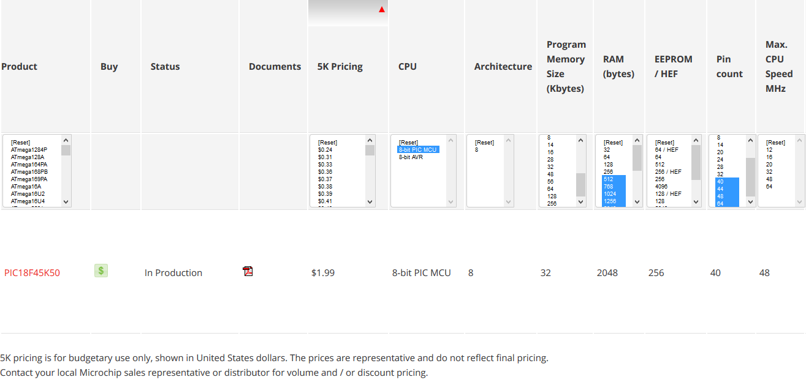

9.2. Appendix B
Full circuit schematic below.

