Brindusa Elena Nechita
1905284
University of Wales Trinity Saint David
Developing relationships and workplace achievement
Lecturer Brynach Heffernan

Introduction

Maintaining a high level of employee productivity is one of the important factors that help any business to remain profitable and competitive. The happier and less stressed employees are at work, the more they will be able to do a good job.
Main benefits of employee development:
- Increased job satisfaction
- Lower turnover rate
- Increased operational efficiency
- Improved productivity
- Enhancements in innovative thinking
- Proactive, not reactive, problem solving
But productivity does not necessarily mean more workload, but a smart way of working, by offering clear benefits in this regard.
This essay will look at the key elements and their benefits for both the organisation and the individual. There are four major developing vehicles that organisations are able to use in their benefit and the benefit of the individual: motivation, performance management, employee engagement and training. But using these techniques is not as easy as it is written in books and theories, as the willingness of the staff is the most important aspect that leads to the success of the organisation. Nevertheless, a company’s vision and mission that is shared with the individuals will contribute to both the employee’s performance and the organisation’s value, creating a win-win situation.
Motivation
Motivation is the process of selecting, guiding, and maintaining human behaviour. Motivation is the process in which people choose different forms of behaviour to achieve personal goals.
There are many theories, classical and modern, that are used in motivating employees (or people you work with). From the classic ones, Theory X and Theory Y are very interesting. In fact, X and Y are more like concepts that form a somewhat more complex theory than two different theories, as might emerge from the names given to them.
Theory X goes on the idea that people dislike work and, because of this, will only work effectively in a controlled work environment, where leaders make decisions and others take orders. It is considered that people would do anything to avoid work and that managers should do nothing but control them, manipulate them if you want, so that they can achieve their goals. According to this "theory", people generally avoid responsibilities as much as they can and have reduced ambitions.
The Y theory is the exact opposite of Theory X. It assumes that people do not instinctively reject work but accept that this is an important part of their lives and work to achieve some goals. In addition, most people gladly accept the responsibility and have a very high potential that must be identified and valued by managers.
"Most leaders act in accordance with Theory X but consider that Theory Y is more appropriate and effective and an effective guide to managerial action." McGregor (1960)
A manager can't ask his employees to be motivated, but he can create a climate in the company that motivates. Although the organizational climate is difficult to measure, the observation of his symptoms (staff fluctuation, presence at work, working relationships) indicates the appearance of problems that are also signs of a reduced motivation of the staff.
An employee's motivation to perform in his work and morale are closely related. If morale is high, there are premises for the person to be motivated in what he/she is doing, and low morale makes the motivation not long-lasting.
For short periods, employees can be motivated by different material or moral incentives, but only a good organizational climate (which translates into a special morale of employees) can support their long-term motivation.
The real motivation of the staff comes, in fact, from its self-motivation, the result of the manager's efforts to create an appropriate climate in the organization. These efforts consist of action on three factors that determine the motivation of employees: the ability to work, the desire to work and the rewards received.
‘Motivation is the art of getting people to do what you want them to do because they want to do it.’ (Dwight D. Eisenhower)
The idea that satisfaction and dissatisfaction are separate and distinct dimensions led Herzberg to the theory of motivation-hygiene ('The Motivation to Work', 1960).
The factors Herzberg has found most often associated are achievements, recognition, responsibility, the possibility of advancement, self-development and work itself. These factors are generally referred to as motivational factors because in their presence increases motivation. However, their absence does not necessarily lead to the appearance of a feeling of dissatisfaction. When motivational factors are present, they act as a source of satisfaction.
Factors cited as causes of dissatisfaction are supervision, working conditions, interpersonal relations, salary, job security and administration and policy of the organization. These factors, called hygiene factors, when they are at acceptable levels reduce dissatisfaction. However, they do not necessarily lead to high levels of motivation. When hygiene factors are missing, they act, precisely by their absence, as a source of dissatisfaction.
Denny’s American Dinner is a franchise restaurant part of the Magic Brands Corporation in UK. There are two operational managers (one front of house and one back of house), and three shift managers. We can see in this restaurant/organisation that Theory X dominates amongst staff and motivation is absent. The only motivation employees have is their wages and the vast majority of them avoid responsibilities and lack initiative/implication and would only be efficient if the shift manager specifically tells them what to do. This results in a lot of calls in sick as there is no implication or responsibility from their part and there are no consequences/punishment for their actions. Emphasizing furthermore, a shift manager would then work harder than the team they have, along with their specific duties they need to perform each day (customer service, shift reports, stock count, orders and deliveries, personnel absence, etc.). Some of Herzberg’s hygiene factors are being met such as the work conditions, relationship with the supervisor and subordinates, the salary but as stated before they do not lead to a high level of motivation. Security of the job is debatable because all staff is employed on a zero hours contract and the verbal agreements can change at any given time, depending on the necessity of the company.
Performance management
Performance Management is one of the most important HR processes in terms of the implications it has in terms of most of the dimensions of organizational life: the company's ability to activate its talents, create a correct scale of values, distribute benefits on merit by achieving internal equity, recognize and encourage performances, motivate employees.
The purpose of a Performance Management System, however, is NOT (only) individual performance but the company-wide performance of employees, considering that the whole represents more than the sum of the parts.
Performance management is a whole work system that starts with developing clear job descriptions, recruiting the best potential employees, integrating the new employees to the organisation’s culture, provide on-going training and feedback and provide career development opportunities and rewards.
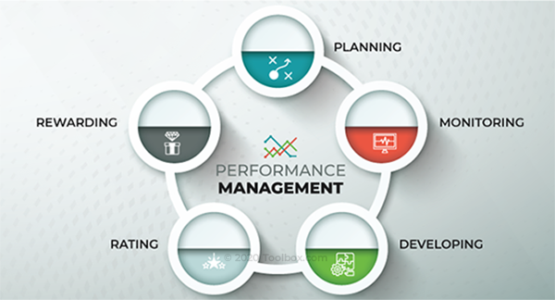
https://images.toolbox.demandshore.com/05/1e/345a3a5b47bb82a796babfee2861/what-is-performance-management.png
FOH (front of house) operational manager in Denny’s is responsible of recruiting personnel and after a 5 minute online interview, the potential employee is asked to give a two hours trial shift in the restaurant to see if they have the basics for the job and then the answer is given regarding the result. As a shift manager, there is no clear job description given, no organisational culture information and principles and training non-existent except for the day to day situations encountered each shift (customer complaints and how to address them, customer refunds, technology/till problems, etc.) that one must telephone or text message the other shift managers (with more experience) because the operational manager would be working from home sometimes and would not be answering their calls/messages.

Training
The training activity aims at accumulating a set of knowledge, skills, and competences, as a result of a process of transmitting information of a practical or theoretical nature in close connection with the assimilation of specific competencies of the accumulated information. The term training has its roots in what was once called apprenticeship; today, most often it is associated with the expression of personal development.
Training/development in the workplace is a field perceived to be carried out in an organized setting, using specific tools and equipment so that, through learning, it can achieve high performance, quantifiable from the point of view of productivity in the workplace. There is also the possibility of learning outside the workplace, but this method does not approach individually from the point of view of productivity. The second method has visible advantages because it makes the individual feel stimulated by the accumulation of information that can prove useful outside the workplace, which favours the assimilation of information.
With any staff replacement shaves there are costs beyond what we can capture at a glance. Losses involve both time and money. Searching for an employee means money given to recruitment agencies, time for interviews without being sure that the next employee will be better. For a new employee to give maximum work efficiency, he/she needs training and a probation period, trainings, mentors (experienced people who in turn waste time to prepare a new employee). This period can last from a few weeks to a few months, depending on the position occupied. By giving up an employee, the employer gives up everything he has invested in him.
To avoid these costs and to motivate talented individuals not to leave, a company can make up a retention plan, in which, among other things, it aims to improve certain aspects of organizational culture.
At the same time, it is a big mistake on the part of the employees to consider themselves irreplaceable. The employer may assume all these wastes of time and money and look for someone new. It is known that the departure of important specialists from a company produces important disturbances in the activity, which eventually turn into confusion, additional costs and expenses, but this is only true for valuable people.
In Denny’s, training/knowledge is given on the spot by shift managers in the beginning when you start your job and that is all. Staff meeting should happen once a week but because the company doesn’t want to pay extra hours for those not working that day, the meetings don’t take place. Operational managers have been told to keep a low labour percentage therefore shift managers are required to send people home before the actual end of their shift.
Employee engagement
The notion of commitment – or the involvement of employees motivated to make additional discretionary efforts for the company – is a relatively new topic in human resources management which, however, becomes one of the most important differentiators of our day, companies are in a continuous competition for high-performing employees.
Engagement is considered the main underlying the constant overshoot of the proposed targets and spectacular productivity increases, in close and direct correlation with innovation and creation, with performance above expectations and exceptional results.
Commitment and involvement are in fact the employee's adherence to a set of company values and objectives, to an organizational environment and culture and, not infrequently, to the manager and the team to which he belongs.
When these behaviours are rooted and strengthened by the passage of time, it has been observed that the beneficial effects extend to other teammates in the company, to clients and even to people outside the company, who perceive a very favourable image because of the passion and gift with which these employees talk about their job.
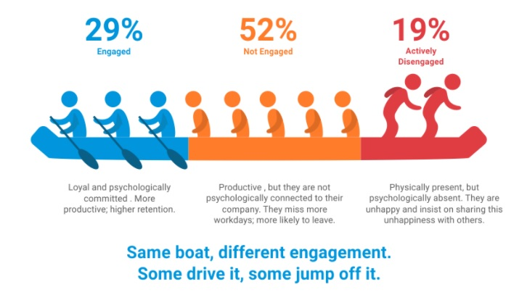
https://www.questionpro.com/blog/wp-content/uploads/2018/04/Employee-engagement-example.jpg
Employee engagement in this organisation reflects more in the attitude of the shift managers that are the most committed but not necessarily motivated by salary package. They know they have to do more than the job description states and get involved more as there is no actual and tangible support from the operational managers or the team members they coordinate. There are no incentives in a higher that predicted sale forecast or in a well managed customer problem. There is no passion in employees and they only perform at their minimum potential, getting the job done and going home.
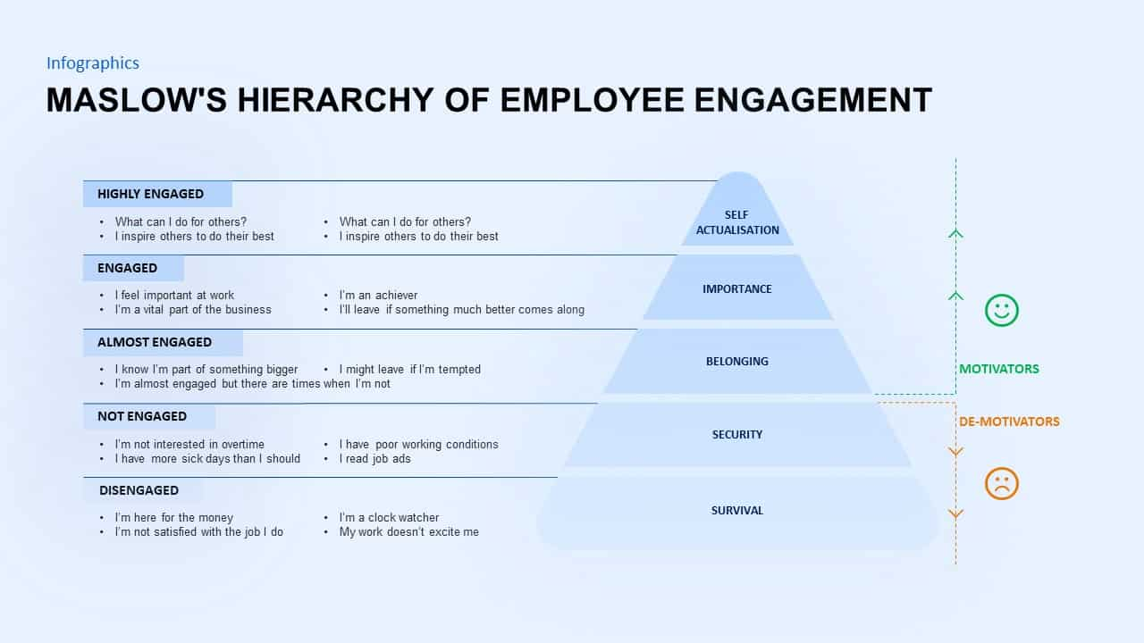
https://cdn.slidebazaar.com/wp-content/uploads/2020/02/Maslow%E2%80%99s-hierarchy-of-employee-engagement-PowerPoint-template.jpg

Conclusion

We can see in Denny’s American Dinner that all the developing elements set to develop relationships and workplace achievement are only being met in favour of the organisation. Starting with the zero hour contract which allows the company to give employees working hours only if it needs them and only in busy times (like the weekends) and then cutting back on hours and sending employees home if the restaurant is quiet to reduce back on labour is the biggest demotivator in motivation and engagement.
Improvements could be done in training as well as in performance management if the higher level managers would be more involved in setting and implementing a good and healthy company culture that they believe in, setting an example for all employees. If incentives cannot be offered because of the struggling financial times the organisation is going thru, feedback, whether appreciative or not, should be given on a regular basis, this way employees would have a feeling of belonginess and that their efforts are appreciated.

PDP in Denny’s American Dinner
Regarding initial training and organisational culture, this is a must for the organisation and the employees because it lays the base for engagement and motivation, customer service and restaurant standards. From this, targets would be much easier to achieve, the customer experience would improve, and they would return more often and give good reviews and attract even more customers.
If incentives (bonuses) cannot be given because of the current financial situation worldwide, feedback is another important strategy that can be used in the interest of both the company and the staff. Feeling that you are part of the bigger picture, feeling motivated to be better at your job than your colleagues, providing a good customer experience or being able to become a shift manager one day, is a feeling that no employee can ignore and can be a motivator factor for many.
The shift managers could provide extra training for specific situations to each individual as long as they have enough staff on a shift so that they can have the time and give full attention to this training (specific product making/presentation of meals/drinks, cleaning/disinfecting tables/toilets, customer check backs, operating till/changes/refunds/complaints).
A responsive and engaged FOH manager at all times and in all situations would make a difference in how employees respond and how their attitude can be positive and don’t feel frustrated. Tasks should be clearly set for all staff and consequences should be known. A FOH manager’s job is not a 9 am – 5pm job as the responsibility extends throughout the restaurant opening hours (9am – 8 pm) and availability to answer any issue would be very much appreciated by everyone.
The conclusion is that all aspects have much room for improvement as long as the change starts and is seen from the top, resulting in both happy employees and customers.

References

- UKEssays (2018), Leading Managing and Developing People in the Workplace Available at: https://www.ukessays.com/essays/business/leading-managing-and-developing-people-in-the-workplace-business-essay.php Accessed: 18th Nov 2020
- Heathfield, S. M. (2020), Performance Management Available at: https://www.thebalancecareers.com/performance-management-1918226 Accessed: 17th Nov 2020
- Lalwani, P. (2020), What Is Performance Management? Definition, Process, Cycle, and Best Practices for Planning Available at: https://www.toolbox.com/hr/performance-management/articles/what-is-performance-management/ Accessed: 22th Nov 2020
- What is work force development (2019) Available at: https://myworkchoice.com/blog/workforce-development/ Accessed: 20th Nov 2020
- Performance management (2020) Available at: https://www.valamis.com/hub/performance-management Accessed: 19th Nov 2020
- https://cdn.slidebazaar.com/wp-content/uploads/2020/02/Maslow%E2%80%99s-hierarchy-of-employee-engagement-PowerPoint-template.jpg
- https://www.questionpro.com/blog/wp-content/uploads/2018/04/Employee-engagement-example.jpg
- How Does Company Culture Actually Lead to Success? (Dec, 2015) Available at: https://www.entrepreneur.com/article/254049 Accessed: 3rd December 2020
- Reddy, C. (Nov, 2020) Scientific Management Theory: Advantages and Disadvantages Available at: https://content.wisestep.com/advantage-disadvantage-scientific-management-theory/ Accessed: 3rd Dec 2020
- Doyle, A. (Oct, 2019) Top Organizational Skills Employers Value with Examples Available at: https://www.thebalancecareers.com/organizational-skills-list-2063762 Accessed: 3rd Dec 2020
- Heathfield, S. M. (May, 2020) Performance Management Available at: https://www.thebalancecareers.com/performance-management-1918226 Accessed: 20th Nov 2020
- Juneja, P. Herzberg’s Two-Factor Theory of Motivation Available at: https://www.managementstudyguide.com/herzbergs-theory-motivation.htm Accessed: 25th Nov 2020
- Juneja, P. Theory X and Theory Y Available at: https://www.managementstudyguide.com/herzbergs-theory-motivation.htm Accessed: 25th Nov 2020

