End user computing

Business information technology

Planning End User Computing systems

Rutendo Gore

Beverly Holland

Introduction

A local cosmetic dentist “your teeth our smile “specialises in the treatment of tooth alignment and repair, Hollywood veneers and denture creation or replacement plus general cosmetic and repair.
The dental hospital has ten dental surgeries and one operating theatre. Each surgery is identified by its room number. All patients are admitted to the hospital are assigned to a room, however during the treatment which may last up 12 hours they may be transferred to different rooms. The hospital calls all the patients back for a check-up one month after they have been finished their treatment.
Patients are referred to the hospital from their NHS /private dentist. A diagnosis is made, and arrangements are made for future admission. Patients are sent notification of scheduled admissions one week in advance.
They realise it is time to computerise, they currently booking appointments using a hand written and over full diary. They would like to use a system that automatically updates a schedule for each room and the operating theatre and print out customer invoices and then record relevant information in a simplistic invoice list database.

Main menu
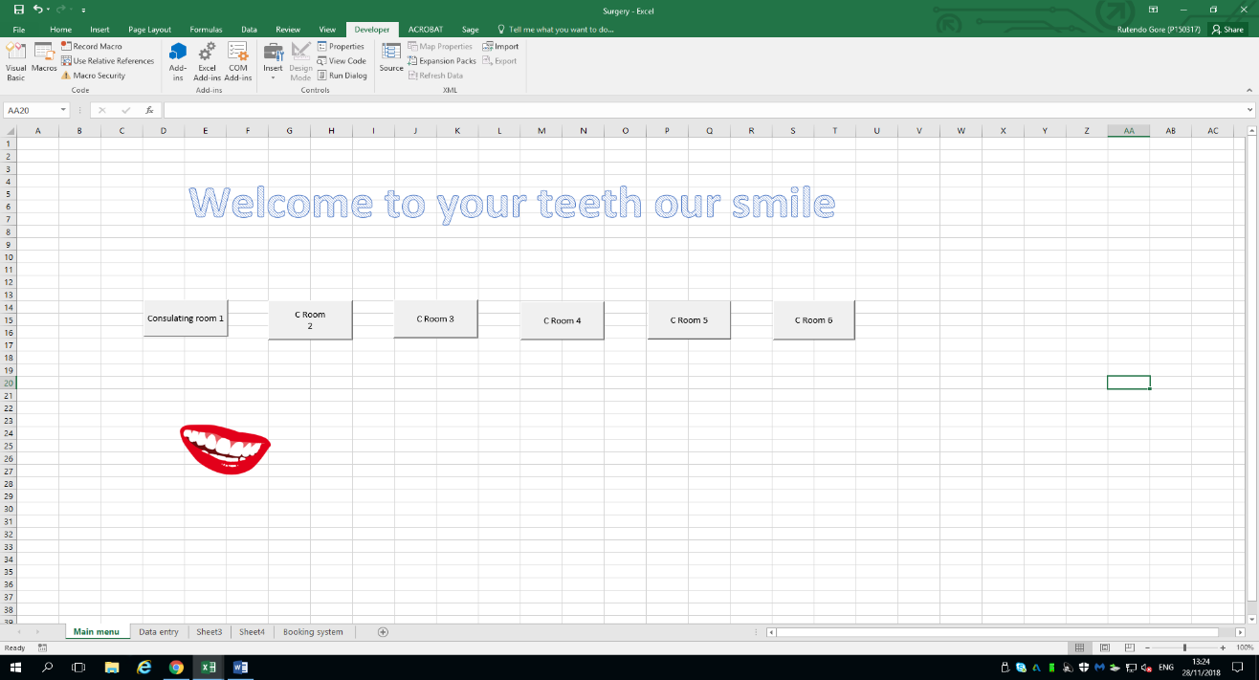
The screenshot shown above shows the main menu for the dental surgery , from the image there are six buttons which go to different consulting rooms , these are linked with macros. On each consultation room there Weill be a home button which will bring the user back to the main menu.

Define names in excel
Defining names in excel is very important. By defining names within excel you can make formula’s much easier to understand. Defining names is done by defining a name for cell ranges, once a name has been defined it can be altered anytime it needs to be amended. [1]
The image below shows how names have been defined in excel
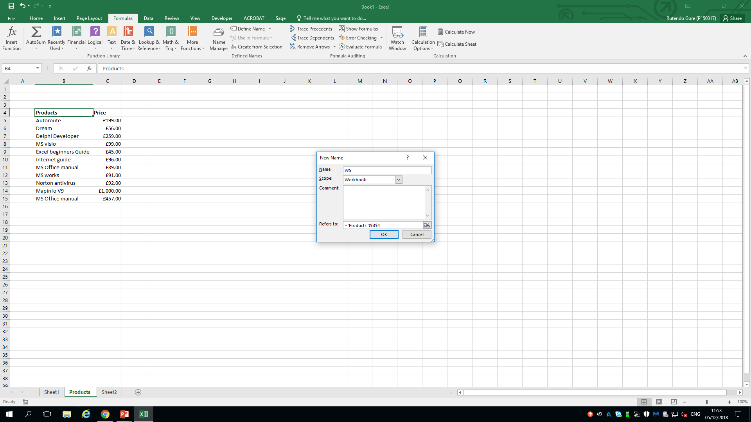
VBA input
Input within Visual Basic is very important, the code that I entered within visual basic is used to enhance the spreadsheet so it can do more. The input box function in Excel is used to prompt the user to enter a value. [2]
Planning in excel
Below shows a series of different screenshots in the planning phase for the dental surgery. The first screenshot shows the first consultation room over one month. The image below shows the name of treatment which is simple x-ray's and it show the standard charge for that particular treatment , the image also shows the number of treatments sold and the total sales.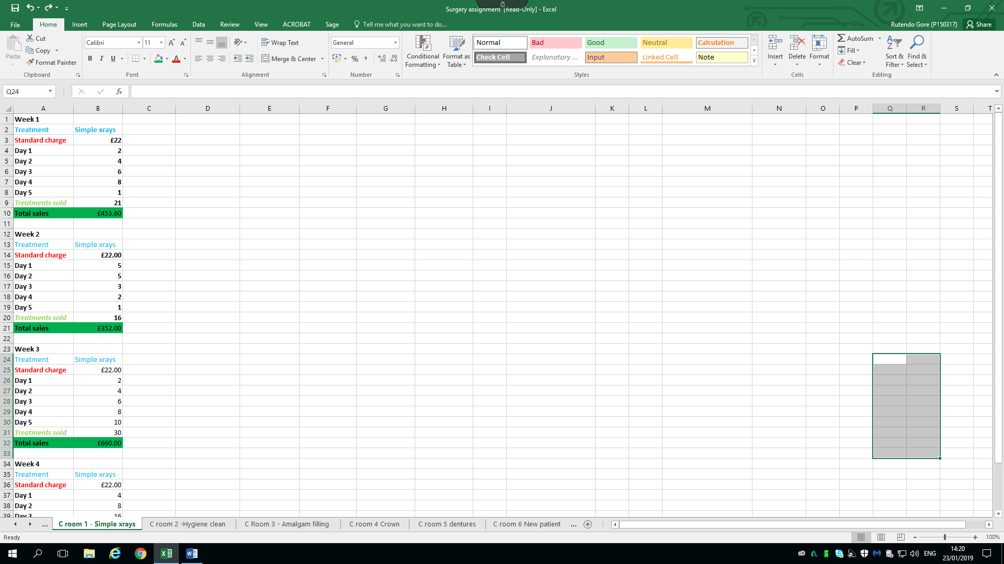This screenshot shows formulas being calculated for the treatments sold. The individual cells are highlighted as part of a formula being calculated.
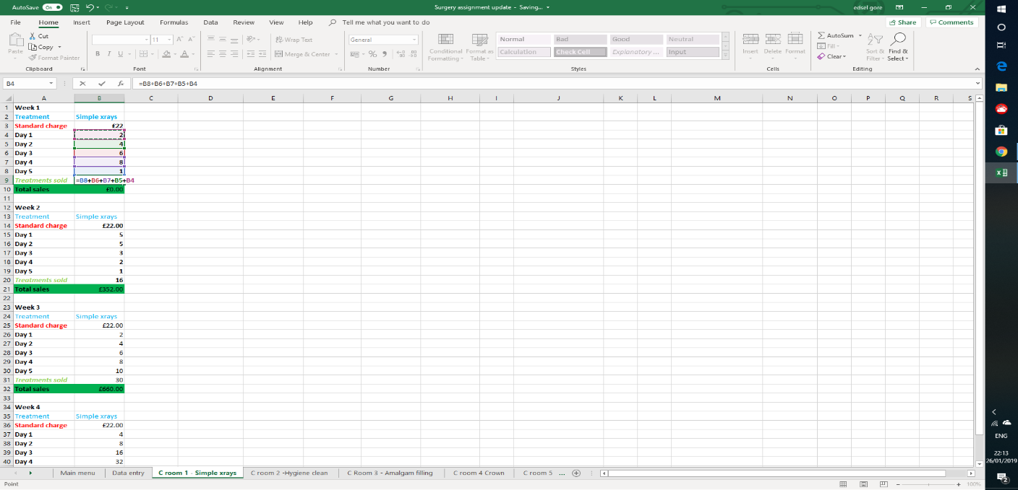
This screenshot shows the calculation for the total sales, this calculated by the standard charge price times the treatments sold.

The screenshot shows the x-ray treatments for each individual week.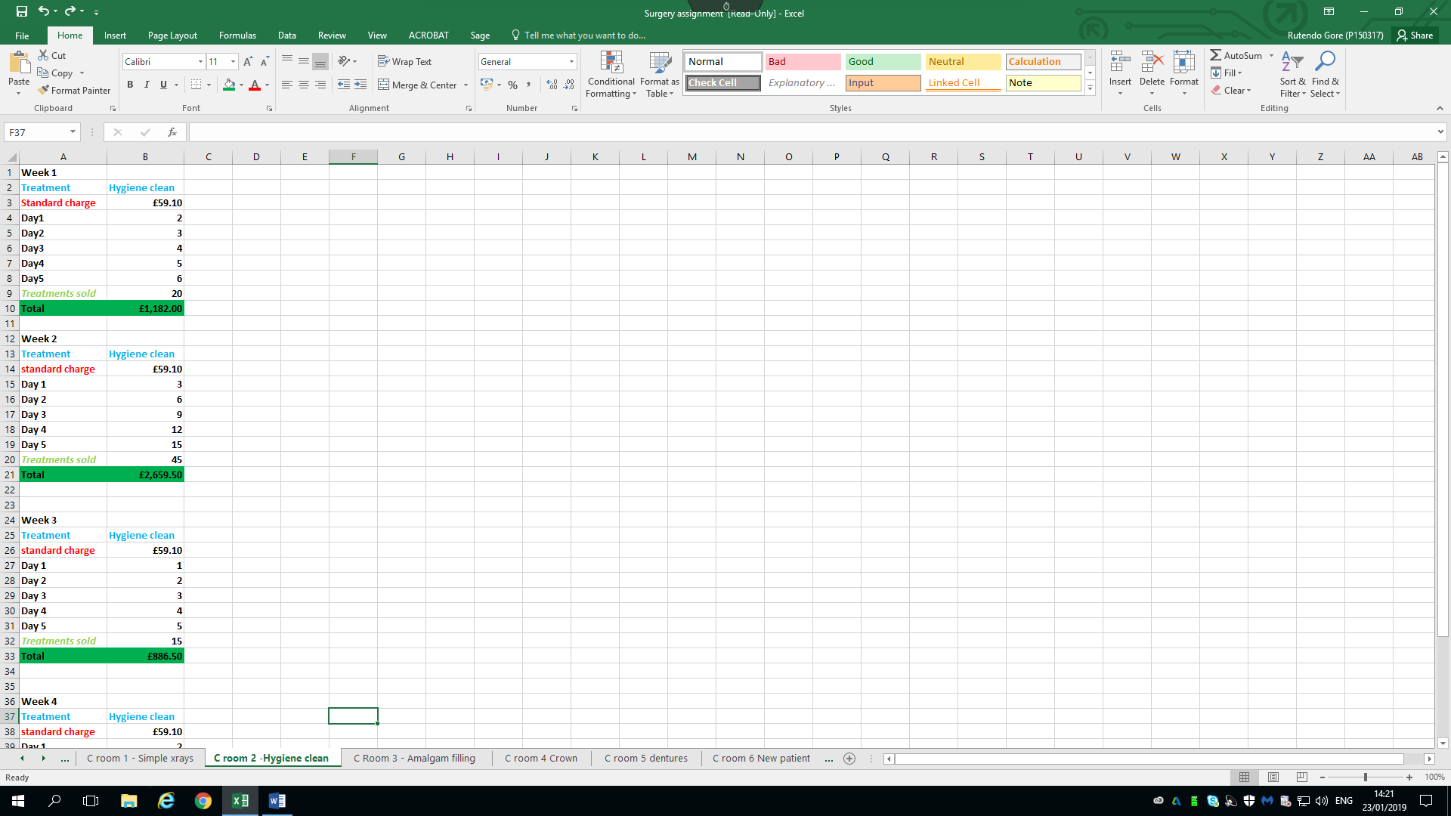
The image below shows the monthly breakdown for sales made for the hygiene clean treatment. The second week made a lot of sales especially for that treatment.
Hygiene clean
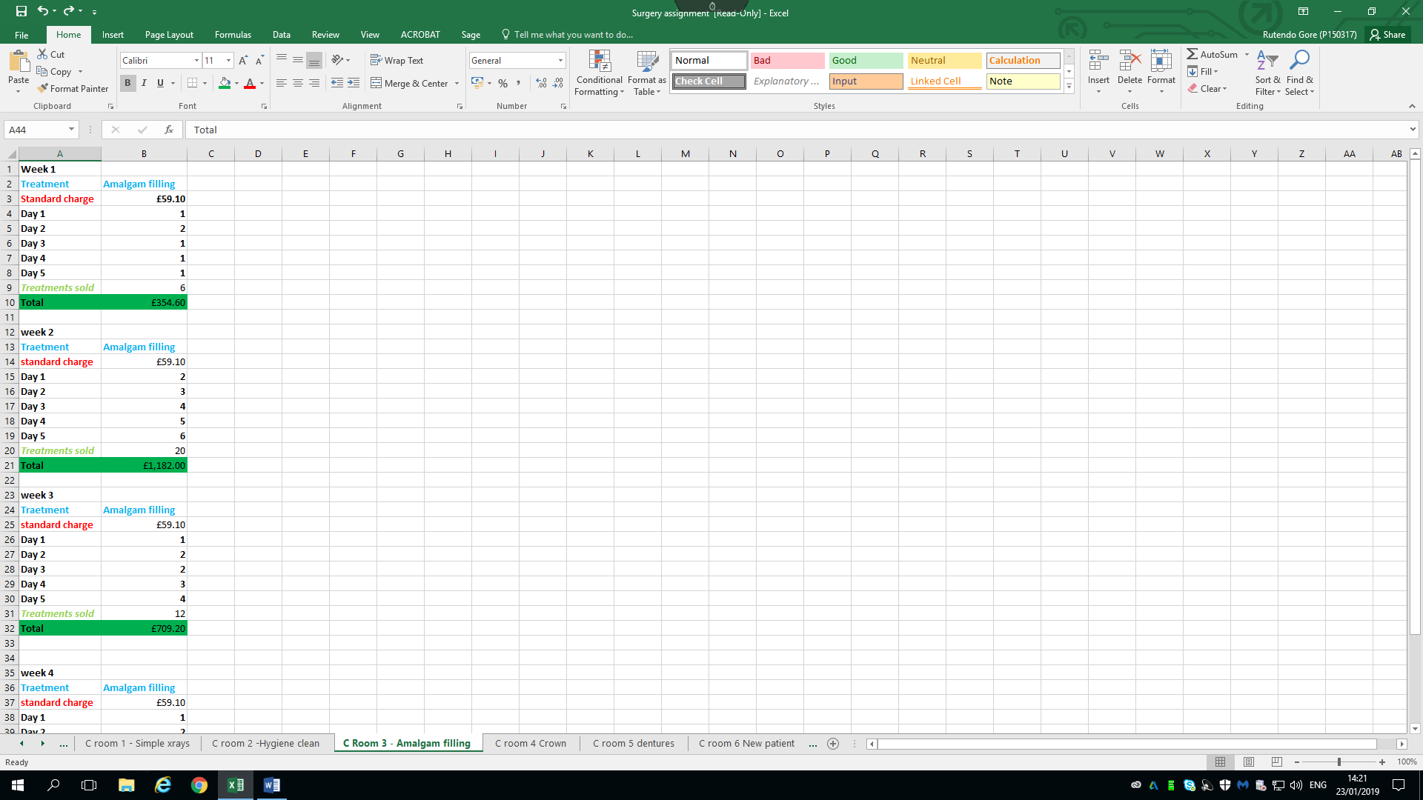
Amaglam cleaning
The screenshot shows the treatment for the amalgam filing for the whole month , the image also shows number of treatments sold and the total sales.
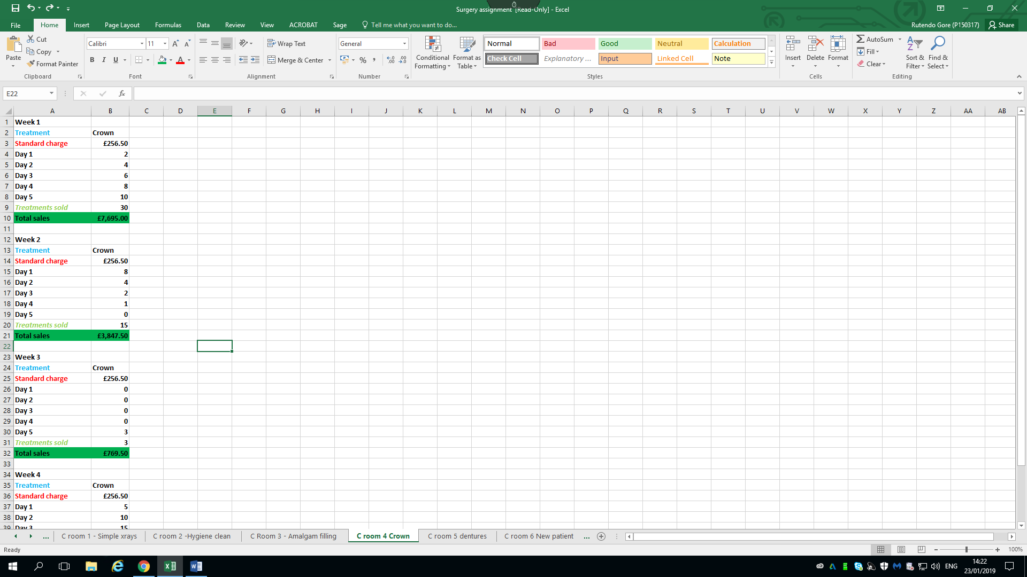
The image shows the crown treatment , the image shows the name of the treatment, the standard charge for the crown treatment soles are shown in the green line and it also shows the total sales for that particular treatment.

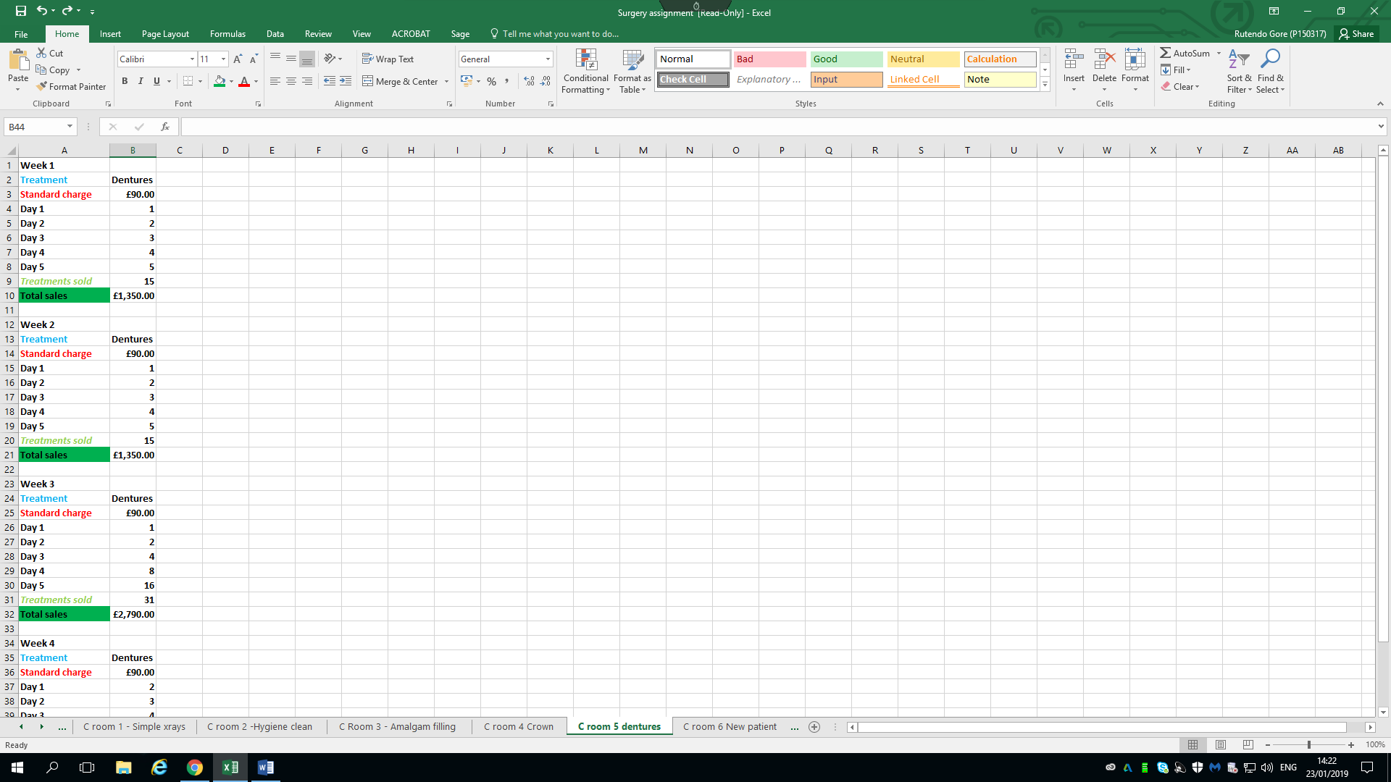
Dentures
This screenshot shows the treatment for the dentures , the image showed the number of treatments sold which is calculated by adding up the figures in the right hand column and the total sales is then calculated by standard charge and the total of treatments sold.

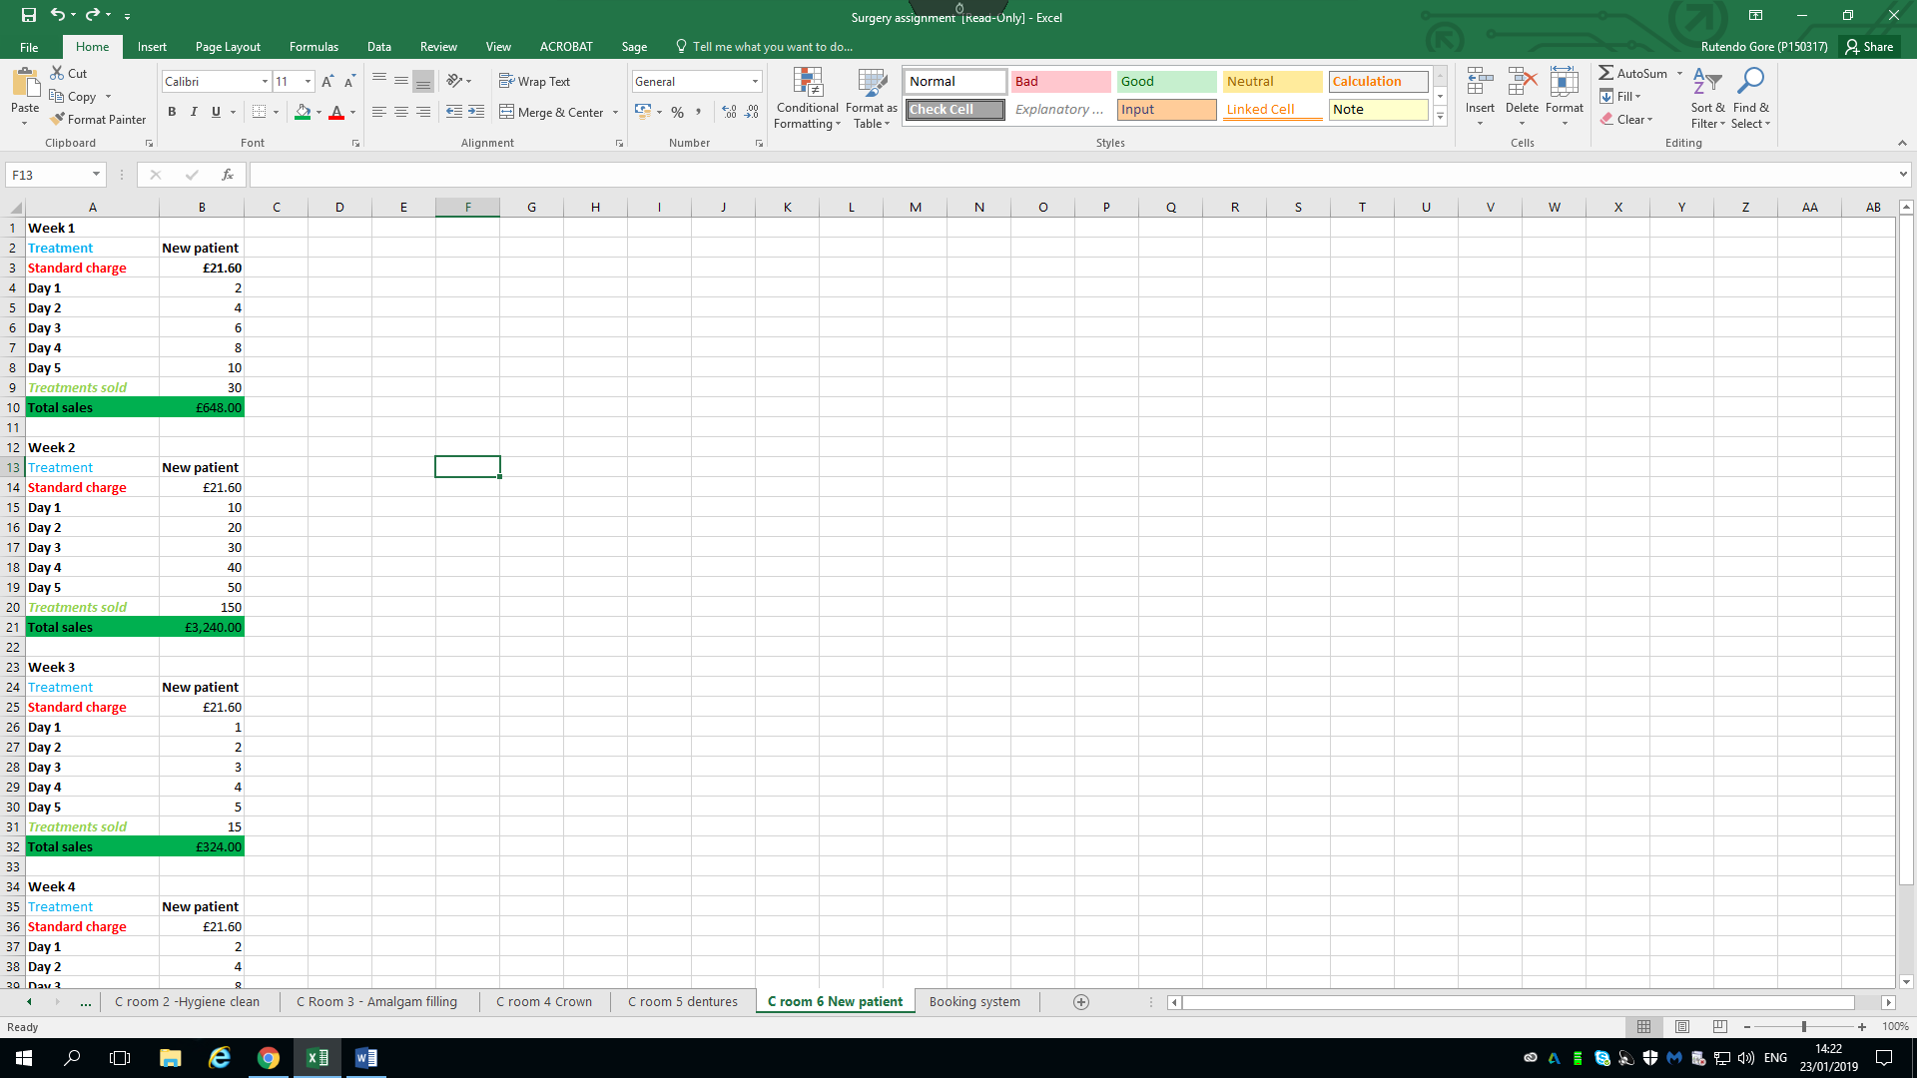
New patient
The image above shows the screenshot for the new patients at the dental surgery.

Variable data
The variable data within the dental surgery scenario is the treatments sold and total sales. This information is variable which means it can change , it can change from week to week , some weeks may have higher sales and some weeks the sales are less.
Constant data
The constant data within the dental surgery are the treatment charges and the name of the treatments. This data has to stay the same as more information will be added within the excel spreadsheet.

Booking system
The booking system that has been proposed for the dental surgery using different features in excel. The booking system will use a drop down menu to select an appointment , picking a date and confirmation of the booking will be sent to their email address.
The booking system will be a simple system that can be easily used by every one who needs to use it.
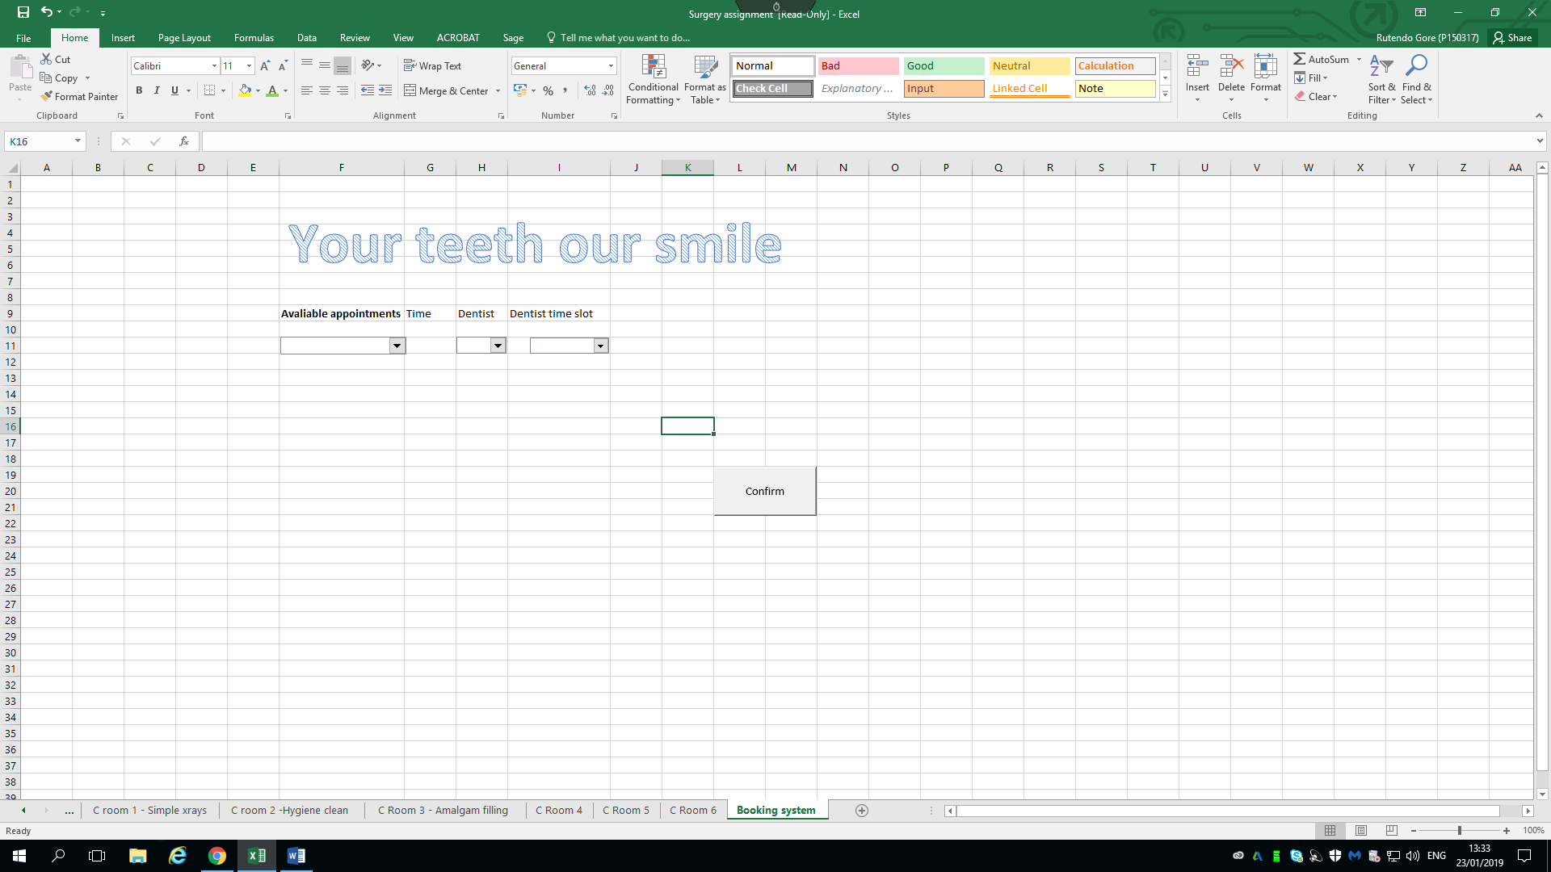
The booking system will also use V look up to see which appointments are available and picking the dentist and the time slot.
The image above shows the proposed booking system for the dental surgery, the booking system has now been computerised as the dental surgery was taking appointments using an old style method which was to write the appointments in the diary. This system will be available to everyone who is a patient at the dental surgery. The above image shows three columns which are available appointments ,dentist field, dental time slot to choose a slot that will suit you. Other tools that may be used in excel are the active x controls to enhance the performance of a spreadsheet.

https://www.which.co.uk/reviews/dentists/article/private-and-nhs-dental-charges accessed 28 /11\2018

