

Postgraduate/Distance Learning
Assignment coversheet & feedback form

THIS SHEET MUST BE THE FIRST PAGE OF THE ASSIGNMENT YOU ARE
SUBMITTING (DO NOT SEND AS A SEPARATE FILE)

For completion by the student:
Student Name: Christina Giles

Student University Email: 1805673@student.uwtsd.ac.uk
Module code: HPCA 7003  Module title: History of Astrology | Student ID number:  1805673 |  |  | Educational support needs:  Yes/No
Assignment title: Critical review of THREE primary source documents

Assignment due date: March 2, 2020
This assignment is for the 1st 2nd 3rd 4th 5th 6th module of the degree
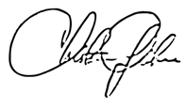
I confirm that this is my original work and that I have adhered to the University policy on plagiarism.
Signed ……………………………………………………………
Email submission:if you are submitting this form via email, please tick this box □
(as a substitute for your signature) to confirm that you agree to the above declaration.
Assignment Mark
1st Marker’s Provisional mark
2nd Marker’s/Moderator’s provisional mark
External Examiner’s mark (if relevant)
Final Mark

NB. All marks are provisional until confirmed by the Final Examination Board.

For completion by Marker 1 :
Comments:

Marker’s signature: |  |  | Date:
For completion by Marker 2/Moderator:

Comments:

Marker’s Signature: |  | Date:
External Examiner’s comments (if relevant)

External Examiner’s Signature: |  | Date:

  - A Critical Comparison of Venus in Three Primary Source Documents
  - Word Count: 2076/2000

Introduction
This essay will compare and contrast the treatment of the astrological use of Venus in the following sources: Claudius Ptolemy, Tetrabiblos, trans. by F. E. Robbins (Cambridge: Harvard University Press, 1940), Alan Leo, Esoteric Astrology (Rochester, Virginia: Destiny Books, 1989 [1913]), and Dane Rudhyar, New Mansions for New Men (CyberWorld Khaldea, 2008 [1938]).
According to Komoroska, Tetrabiblos (middle second century CE), is a Greek classical work that aimed to ‘establish astrology as a science in its own right,’ while Esoteric Astrology and New Mansions for New Men, according to Campion, emerged in the milieu of theosophy and mysticism of the nineteenth and early twentieth centuries. This essay will consider Ptolemy, Leo and Rudhyar’s handling of Venus via two themes: ’The Cosmological Treatment of Venus’ and ‘Venus, Transformation and the Soul’.

Theme One: The Cosmological Treatment of Venus
This theme examines the cosmological notions of Plato and Aristotle, and whether these classical cosmologies are reflected in handling of Venus within the aforementioned texts by Ptolemy, Leo and Rudhyar. It aims to uncover differences and similarities between the astrologers’ works as it pertains to Venus’s cosmology. Lastly, this theme sets a cosmological foundation for exploring Theme Two.

Platonic Venus
Central themes of Plato’s cosmology involve the concept of harmony radiating from a central intelligible force throughout the heavens. In Republic, Plato emphasizes the study of geometry, stating it is the ‘knowledge of the eternally real’ and the ‘splendor of the heavens,’ and the model of harmony. In Tetrabiblos, Ptolemy emphasizes Venus’s harmony through its nature in the angle of the sextile. He states that Venus, through the rulership of Libra and Taurus, preserves the ‘harmony of the sextile aspect’ with the signs of the luminaries, Cancer and Leo, and maintains its ‘proper face’ when sextile to the sun and moon.

Similarly, Alan Leo discusses Venus’s ‘harmonious and rhythmic nature’ through the aspect of the trine, which he asserts represents the ‘nature of Venus’. He illustrates this claim by stating that if Venus forms a trine between Saturn and Mars, it modifies the planets to ‘act more after the nature of Venus’ than of themselves. Additionally, evidence of platonic influence in Venus’s handling in Esoteric Astrology is found throughout the concept of Star Maps; One example is the ‘influence of Venus’ in the developed personality in Diagram XX, of which Venus is described as enabling ‘tact… taste, and diplomacy’.
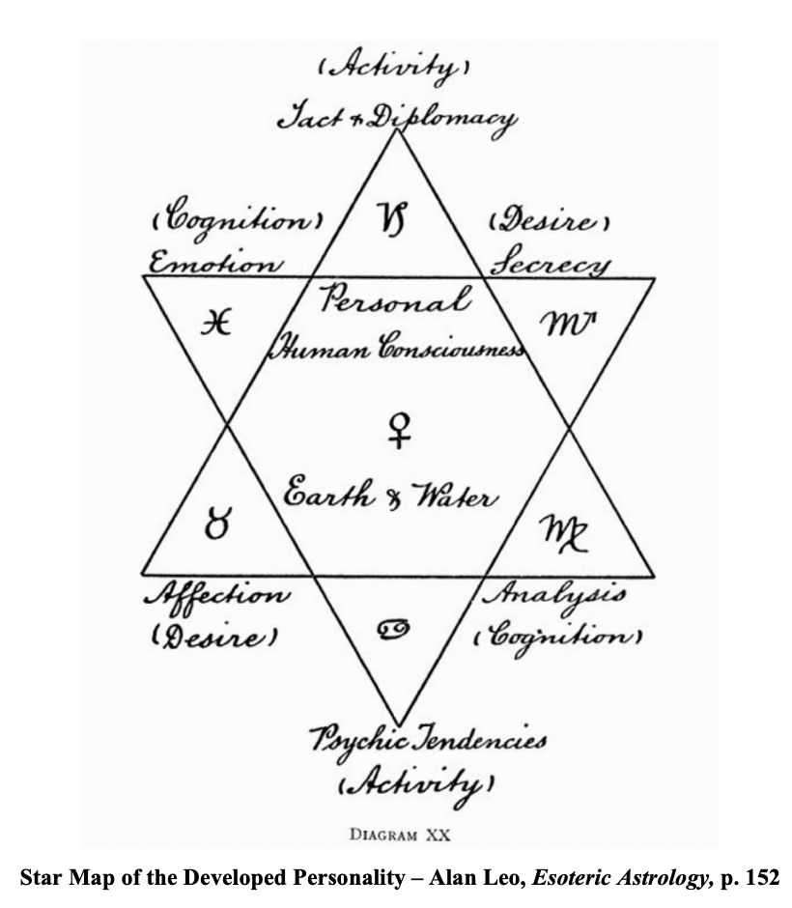

Evaluation of the Platonic Treatment of Venus
Both Tetrabiblos and Esoteric Astrology engage Venus’s geometric and harmonious qualities. It appears that Leo may have developed the Platonic influence further than Ptolemy in extensive star maps located throughout his text, as, according to Campion, the ‘notion of geometrical shapes’ was an example of the platonic influence within the theosophical movement. Although Rudhyar’s astrology may carry forward platonic notions, his handling of Venus in New Mansions for New Men, might be best categorized outside of the Platonic model.

Aristotelian Venus
Two important characteristics of the Aristotelian cosmology are naturalistic and teleological notions. The former examines what is ‘immediately cognizable’ in nature and the latter explores the ideal end goal for that which is of nature. In Tetrabiblos, one of Ptolemy’s first descriptions of Venus is being warm and humid. This example, with qualities of naturalism, is both stable and simplistic in its description of the planet; Further, Barton’s description of the Aristotelian view of the planets and stars as ‘unchanging’ (for they exist in ether) may provide a lens in which to view Ptolemy’s description of the planet.

In contrast, Rudhyar’s handling of Venus are not based on what can be grasped externally but are focused on the internal understanding of ‘sensations’. In New Mansions for New Men he explains that the sensation is the ‘first mode of operation’ for Venus, resulting in a synthesis of ‘the person’s memory’, influencing the way one exists in the world. Instead of a naturalistic explanation of Venus, Rudhyar, through the topic of ‘sensation’, develops Venus’s notions of transformation (explored in Theme Two) as the ultimate aim of the individual through the planet’s power. Similarly, Leo in the above example of the Star Map of the Developed Individual illustrates a teleological aim of the individual with the aid of Venus to expand their ‘personal human consciousness’.

Evaluation of the Aristotelian Treatment of Venus
All three texts share an Aristotelian influence, but with variations. It could be that since Ptolemy’s aim was to create a scientific approach to astrology, he emphasized the Aristotelian notions of naturalism as it pertains to Venus, while for Leo and Rudhyar, emerging out of theosophical and mystical milieu, emphasized teleological concepts within Aristotle’s cosmology.

Theme One Summary
This theme examined the cosmological notions of Plato and Aristotle, and whether these classical cosmologies are reflected in treatment of Venus by Ptolemy, Leo and Rudhyar. It discovered that both Tetrabiblos and Esoteric Astrology engaged Venus’s geometric and harmonious qualities which were Platonic in nature. There is evidence that Leo may have developed the Platonic influence further than Ptolemy in his star maps located throughout Esoteric Astrology. This theme found that all three texts shared an Aristotelian influence, but with variations. In describing Venus, Tetrabiblos adhered closely to a model of naturalism, while New Mansions for New Men engaged a teological ‘ultimate aim’ for the individual through the power of Venus. Similarly, this theme found that Esoteric Astrology also supported teleological aim of the individual in Venus’s ability to expand their ‘personal human consciousness’.

Theme Two: Venus, Transformation and The Soul
This theme explores the concepts of transformation and the soul in the handling of Venus. Further, it seeks to evaluate similarities or differences in each texts’ approach to engaging or avoidance of these notions of transformation and soul for the individual. Lastly, it builds upon Theme One’s cosmological concepts in an attempt to understand links between the astrologers’ handling of the planet and interpretations of Venus within the evolution of astrology.

Soul in Ptolemy’s Handling of Venus
Venus’s mystical notions of transformation are avoided in Tetrabiblos. Instead, the subject of transformation may be viewed through the soul. In discussing the quality of the soul in Book III, Ptolomey states that the position of Venus at the ‘mid-heaven beneath the earth… produce souls noble and wise’, with an interest in the mysteries. Further, Ptolemy claims that if Venus dominates, its subjects are ‘pleasant, good… eager for beauty, haters of evil, [and] lovers of the arts’. This approach of Venus and the soul engages notions of naturalism discussed in Theme One.

Although Ptolemy may not directly claim a transformative quality of Venus, we can see that Venus manifested within the individual may produce results in varying degrees in the development of the individual and in one’s relationships. In the fourth book, Ptolemy examines Venus and youth, where the powers of Venus begin to inspire the third stage of development of the individual where they may awaken to the ‘impulse toward the embrace of love’. This impulse may inspire marriage, and in such a union, the moon applied to Venus can allow men to find ‘cheerful, beautiful, and charming’ wives, whereas the sun and Venus can aid women in finding husbands with the qualities of being ‘neat and handsome’.

Soul and Transformation in Leo’s Handling of Venus
In contrast to Ptolemy, Alan Leo does not avoid the mystical notions of Venus’s transformative qualities. In the outset of Esoteric Astrology Leo defines Venus as the ‘spiritual self or individuality, risen above matter.’ In relationship to the human soul, Leo claims that Venus is the ‘planet of equilibrium’ balancing perceptions of the physical and ‘inner planes of being,’ thus ‘[representing] the human soul’.

Leo links the soul and transformation in his examples of Venus in Esoteric Astrology. He states that the ‘highest and most subtle states of consciousness… find expression through the Individuality, or permanent soul of man,’ of which Venus, the love aspect of the soul, permeates. On the other hand, Leo uses an example of a star map, the Star of the Personality, where Venus as ruler of Taurus, represented on the left hand base of the star, could influence the ‘acquisition of possessions’ in a manner of bondage to the material world and negative expressions of the personality. Here, we see traits of Venus that may limit the individual’s ability to transform the soul into the highest states of consciousness. Still, Leo emphasizes that once the individual has stilled his lower aspects, Venus can shine through as the ‘pure mind’ allowing transformation of the ‘Auric Egg’, which the ‘preserver of [the] Karmic record’ or the ‘storehouse’ of all that is good or evil in the individual.
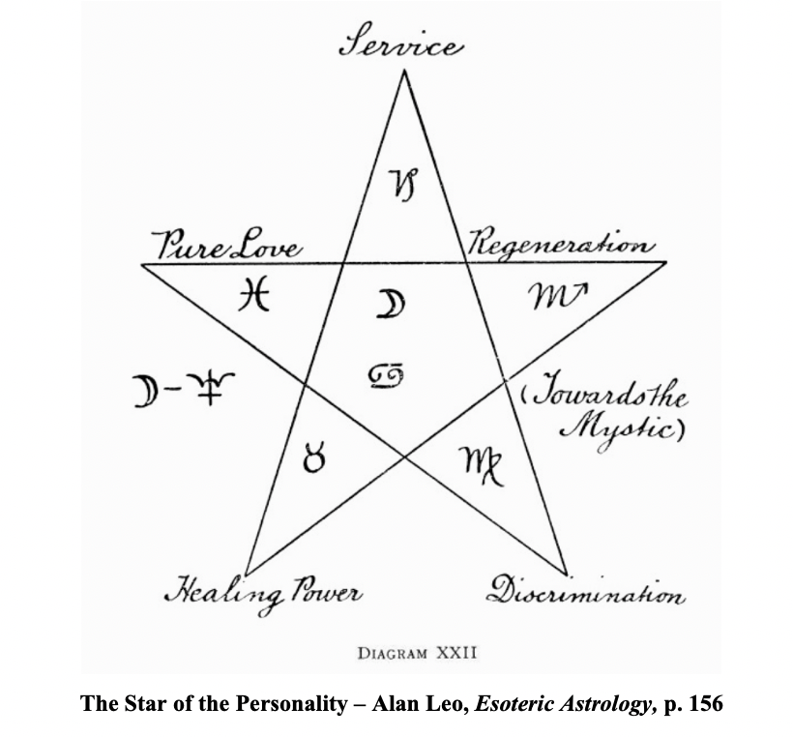

Transformation in Rudhyar’s Handling of Venus
Transformative qualities of Venus are explored in New Mansions for New Men with Rudhyar’s positioning of Venus as the symbol of the alchemist. He states that Venus is the ‘symbols of… [the] process of refinement and abstraction… the gate to the transcendental mind-realms: the Alchemist and the Initiator’. Rudyhar relies on archetypal characteristics within the symbols he associates with Venus’s transformation; He states that ‘one of the most common symbols of [Venus]’ is the pearl ‘born of irritation and pain’ and illustrates this in the example of Venus-Aphrodite emerging from the waters ‘with pearls around her neck’.

Another example of the alchemical and transformative qualities of Venus is that of the bee, which Rudhyar relates to the ‘quintessence’, the ‘life-processes symbolized by Venus’. According to Thorp, the ‘quintessence’ is an ‘addition to the traditional four elements of Greek science– earth, water, fire and air’, and it represents a fifth element of which Rudhyar defines as emerging from the alchemy of the four elements– the symbolic gold. Rudhyar states that the ‘quintessence’ is universally symbolized by the ‘honey-making bees’ where the bee distills the flower’s nectar, in a process of ‘earthly alchemy’. Further, he states that our task as ‘humans born of the Earth,’ is to ‘produce as flowers the nectar that shall draw us to the “celestial Bees”’ solidifying Venus’s symbol as the alchemist in one’s transformation to the universal.

Evaluation of Venus, Transformation and The Soul
It appears that concepts of transformation and the soul in the handling of Venus are varied in the approaches of these three texts. Ptolemy delivers descriptions of Venus and soul imbued with naturalism. Unlike Ptolemy, Rudhyar engages less with concepts of soul in New Mansions for New Men, but does explore the theme of transformation of which the individual’s soul is refined. Alan Leo’s Esoteric Astrology uncovers the workings of both concepts of soul and transformation, likely because of his direct theosophical influences.

Undoubtedly, the areas where concepts of soul and transformation in Venus arise in Ptolemy, Leo and Rudhyar’s works are firmly established in Aristotelian cosmology. Curry states that ‘the arrangement with Aristotelian naturalism engineered by Ptolemy’ may have ‘arguably enabled astrology to survive’ through the refinement of Aristotelian naturalism in Astrology’s history. Thus, we can relate Curry’s remarks to Venus’s handling; Venus remained entrenched in concepts of naturalism for Ptolemy but Aristotle’s notions of teleology were cultivated in the works of Leo and Rudhyar.

Theme Two Summary

This theme explored the concepts of transformation and the soul in the handling of Venus. It found that Venus’s mystical notions of transformation were avoided in Tetrabiblos but explored in Esoteric Astrology and New Mansions for New Men. Ptolemy focused on Venus’s qualities on the soul, particularly in its manifestation in relationships and the impulse toward the embrace of love. Rudhyar engaged less with concepts of soul but explored Venus’s role in transformation of the individual. Leo explored both concepts of soul and transformation in Venus, likely because of his direct theosophical influences.

Conclusion
This essay examined Ptolemy, Leo and Rudhyar’s handling of Venus via the two themes: ’The Cosmological Treatment of Venus’ and ‘Venus, Transformation and The Soul’. It found that Tetrabiblos and Esoteric Astrology engaged Venus’s geometric and harmonious qualities in Platonic in manner although Leo took Plato’s influence further in the development of Venus in the star maps. All three texts shared an Aristotelian influence in their description of Venus, but Tetrabiblos adhered closely to a model of naturalism, while Esoteric Astrology and New Mansions for New Men engaged a teleological approach. Lastly, this essay found that each of the three works explored concepts of soul or transformation in Venus through an Aristotelian lens, with Tetrabiblos predominantly engaging the former concept, New Mansions for New Men engaging the latter, and Esoteric Astrology balancing both.

Bibliography
Primary Sources
Aristotle, Physics, Volume I: Books 1-4, trans. by P. H. Wicksteed and F. M. Cornford (Cambridge, MA: Harvard University Press)
Leo, Alan, Esoteric Astrology (Rochester: Destiny Books, 1989 [1913])
Plato, Timaeus, trans. by R. G. Bury (Harvard University Press, 1929)
Plato, Republic, trans. by Christopher Emlyn-Jones and William Preddy (Cambridge, MA: Harvard University Press, 2013)
Ptolemy, Claudius, Tetrabiblos, trans. By F. E. Robbins (Cambridge, MA: Harvard University Press, 1940)

Rudhyar, Dane, New Mansions for New Men (CyberWorld Khaldea, 2008) <http://khaldea.com/rudhyar/nmnm/index.php> [accessed February 10, 2020]
Secondary Sources
Barton, Tamsyn, Ancient Astrology (London: Routledge, 1994)
Campion, Nicholas, A History of Western Astrology, Volume I1: The Medieval and Modern Worlds (New York and London: Bloomsbury Academic, 2013)
Curry, Patrick, 'Grounding the Stars', Journal for the Study of Religion, Nature, and Culture 1:2 (2007), pp. 210-219
Komorowska, Joanna, ‘Philosophy among Astrologers’, Culture and Cosmos, Vol. 11, no. 1 and 2 (2007), pp. 69-86

Thorp, John, 'The Luminousness of the Quintessence', Phoenix, Vol. 36, No. 2 (1982), pp.104-123

Claudius Ptolemy, Tetrabiblos, trans. By F. E. Robbins (Cambridge, MA: Harvard University Press, 1940), Alan Leo, Esoteric Astrology (Rochester: Destiny Books, 1989 [1913]), and Dane Rudhyar, New Mansions for New Men (CyberWorld Khaldea, 2008 [1938]), <http://khaldea.com/rudhyar/nmnm/index.php> [accessed February 10, 2020]
Joanna Komorowska, ‘Philosophy among Astrologers’, Culture and Cosmos, Vol. 11, no. 1 and 2 (2007), p. 73 and Nicholas Campion, A History of Western Astrology, Volume I1: The Medieval and Modern Worlds (New York and London: Bloomsbury Academic, 2013), pp. 231, 240-241
Plato, Timaeus, trans. by R. G. Bury (Harvard University Press, 1929), 29e, 36e-37a
Plato, Republic, trans. by Christopher Emlyn-Jones and William Preddy (Cambridge, MA: Harvard University Press, 2013), VII.527b-c, VII.530a-b
Ptolemy, Tetrabiblos, III.5
Ptolemy, Tetrabiblos, I.17, I.23
Leo, Esoteric Astrology, p. 79
Leo, Esoteric Astrology, p. 79
Leo, Esoteric Astrology, p. 173
Campion, A History of Western Astrology, p.243
Aristotle, Physics, trans. by P. H. Wicksteed and F. M. Cornford (Cambridge, MA: Harvard University Press), I.1.184a10-25 and II.1.194a28-29
Ptolemy, Tetrabiblos, I.4
Tamsyn Barton, Ancient Astrology (London: Routledge, 1994), pp. 60-61
Rudhyar, New Mansions, Venus: Queen of the Celestial Bees
Rudhyar, New Mansions, Venus: Queen of the Celestial Bees
Leo, Esoteric Astrology, pp. 152, 173
Leo, Esoteric Astrology, p. 173
Ptolemy, Tetrabiblos, I.4 and Rudhyar, New Mansions, Venus: Queen of the Celestial Bees
Leo, Esoteric Astrology, pp. 152, 173
Ptolemy, Tetrabiblos, III.13, IV.5, IV.10
Ptolemy, Tetrabiblos, III.13
Ptolemy, Tetrabiblos, III.13
Ptolemy, Tetrabiblos, IV.5, IV.10
Ptolemy, Tetrabiblos, IV.10
Ptolemy, Tetrabiblos, IV.5
Leo, Esoteric Astrology, p. 5
Leo, Esoteric Astrology, p. 25
Leo, Esoteric Astrology, p. 100
Leo, Esoteric Astrology, pp. 156-157
Leo, Esoteric Astrology, pp. 95-96
Rudhyar, New Mansions, Venus: Queen of the Celestial Bees
Rudhyar, New Mansions, Venus: Queen of the Celestial Bees
Rudhyar, New Mansions, Venus: Queen of the Celestial Bees
John Thorp, 'The Luminousness of the Quintessence', Phoenix, Vol. 36, No. 2 (1982), p. 105, Rudhyar, New Mansions, Venus: Queen of the Celestial Bees
Rudhyar, New Mansions, Venus: Queen of the Celestial Bees
Rudhyar, New Mansions, Venus: Queen of the Celestial Bees
Rudhyar, New Mansions, Venus: Queen of the Celestial Bees
Leo, Esoteric Astrology, pp. 5, 25, 100, 95-96, 156-157
Patrick Curry, 'Grounding the Stars', Journal for the Study of Religion, Nature, and Culture 1:2 (2007), pp. 210-219, see p. 3 in online copy of text <http://www.patrickcurry.co.uk/papers/GroundingtheStars.pdf>
Ptolemy, Tetrabiblos, III.13, IV.5, IV.10
Rudhyar, New Mansions, Venus: Queen of the Celestial Bees
Leo, Esoteric Astrology, pp. 5, 25, 100, 95-96, 156-157
Leo, Esoteric Astrology, p. 173
Ptolemy, Tetrabiblos, I.4 and Rudhyar, New Mansions, Venus: Queen of the Celestial Bees

