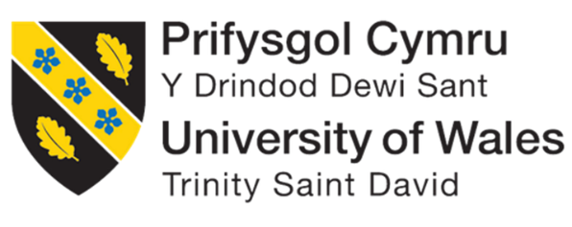
Programme: Master of Business Administration
Module: Human Capital Management
Module code: LCMB7023
Lecturer: Eno Maycock (Birmingham)
Assignment Title: Assessment component 1: Individual report
Student Name: MD NASIR JOHAN ANIK
Student ID: 2527013
Word Count: 2,625

Table of Contents
Introduction 3
TASK A: Socialisation, Identity & Business Activism 4
1. Critical Evaluation of Traditional vs. Strategic Socialisation 4
2. Framework for Structured Socialisation (Helios) 5
3. How to foster identification and business activism 7
TASK B: Job Design 9
1. Innovative Job Design Strategy 9
Job Characteristics Model (JCM). 9
Job Crafting Theory (Wrzesniewski & Dutton, 2001) 10
Skills-Based Architecture and Internal Talent Marketplaces 11
2. Promote Intrinsic Motivation and Innovation 11
TASK C : Reflective Report 13
1. AI as a Decision-Support Tool 13
2. Personal Capability Development Plan: 14
References 16

Introduction
This report critically addresses the role of strategic human resource management in supporting organisation renewal at Helios in three inter-related ways: organisation socialisation, job design and future oriented capability development. The report builds on existing theories including Organisational Socialisation Theory, Social Identity Theory, the Job Characteristics Model, Skills Based Workforce Architecture and Self-Determination Theory to suggest evidence-based interventions that can help to reinforce employee integration, organisational identification and innovation. Moreover, the report delves into the evolving potential of AI as a decision support tool in HR practice, along with the skills necessary to prepare for the future of HR.

TASK A: Socialisation, Identity & Business Activism

1. Critical Evaluation of Traditional vs. Strategic Socialisation
Helios Urban Mobility is in a pivotal moment of its organisational life. Given the 54% employee engagement score and the eight-month time-to-competency, there are systemic gaps in their employee human capital architecture, specifically for high-potential graduates, who need to be gradually integrated into technologically advanced, AI-powered work environments. Bauer et al. (2024) have also found that the first 12 months is the worst time to lose a new employee, as half of those that leave are doing so voluntarily – and if they do so within the first six months, the onboarding process is responsible.
The traditional onboarding is more transactional, a short-term administrative process with compliance orientation and transfer of procedural knowledge (Bauer, 2010). This is the ‘individualised’ tactics suggested by Van Maanen and Schein (1979), which involved ‘informal, random, variable, disjunctive processes' leaving newcomers to deal with organisational culture on their own. The effects have been shown to be evident; it results in higher role ambiguity, slower time-to-competency, and lower levels of psychological contract formation (Frögéli et al., 2023). These consequences are especially harmful in environments like Helios, where the graduates are expected to learn quickly the operating of AI-powered transport systems and smart infrastructure.
Van Maanen and Schein (1979) outline tactics that are structured, repetitive, and institutional, and that diminish uncertainty and quicken a feeling of belonging, including collective, formal, sequential, fixed, and serial. These methods are supported by contemporary evidence as a systematic review of Frögéli et al. (2023) showed that formal onboarding programmes were found to have a significant impact on socialisation outcomes for new professionals, with a focus on those lasting beyond the initial 90-day period.
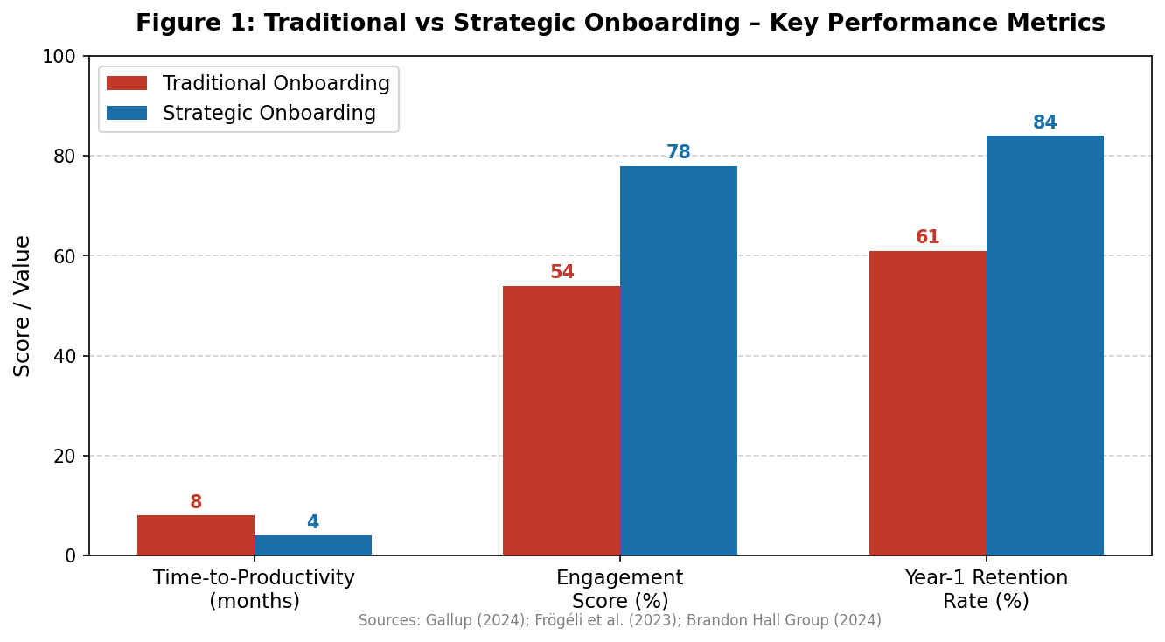
The theory of psychological contract also sheds light on the importance of strategic onboarding. The theory of psychological contract, another theory (Rousseau, 1989) also helps to explain the importance of strategic onboarding. Risk for attrition is significantly decreased when a relational contract is in place, founded on trust, socio-emotional investment, and developmental commitment. If there is a psychological contract that has been broken, then high potential graduates attending Helios will always exhibit increased intentions to leave (Woodrow and Guest, 2020). Finally, from a Social Identity Theory (SIT) perspective (Tajfel and Turner, 1979), strategic socialisation fosters a ‘citizenship of the organisation' identity, which allows newcomers to internalise the core of Helios' mission, namely the revolution in smart transport, as a part of their professional identity.

Figure 1: Traditional vs Strategic Onboarding – Key Performance Metrics (Sources: Gallup, 2024; Brandon Hall Group, 2024)

2. Framework for Structured Socialisation (Helios)
Whether it has been eight months or longer, Helios needs a socialisation architecture that is staged, immersive and evidence based in order to tackle the eight-month competency gap and accelerate the integration between its hubs in Europe and Asia. The proposed three-phase framework builds on Van Maanen and Schein (1979) institutionalised tactics, on socialisation milestone model (Bauer et al., 2024) and on the recent research on onboarding (Frögéli et al., 2023; Peltokorpi et al., 2022).
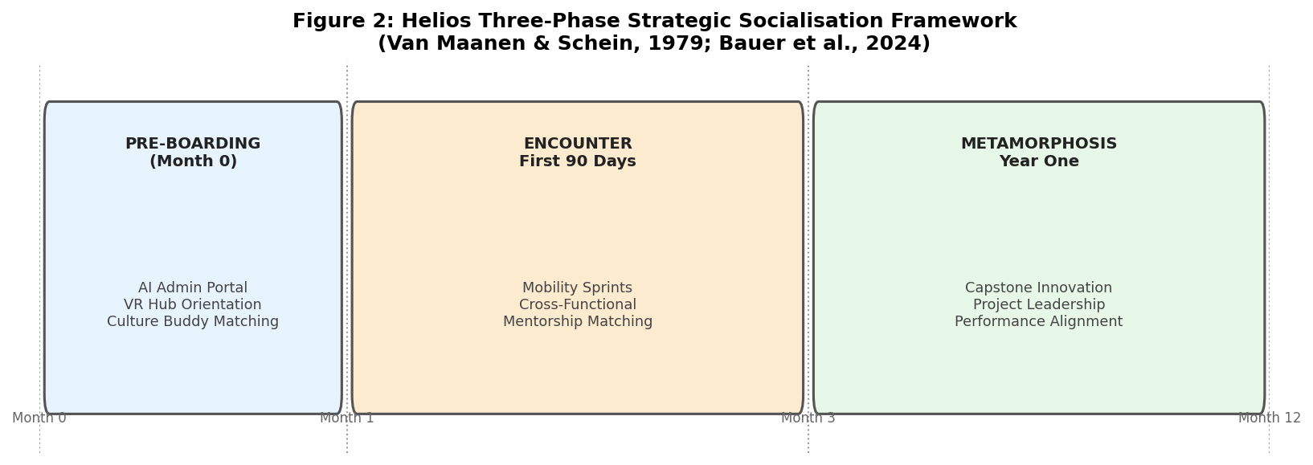
Figure 2: Helios Three-Phase Strategic Socialisation Framework (Van Maanen & Schein, 1979; Bauer et al., 2024)
Pre-boarding (The Anticipatory Stage): Socialisation should start from the moment of acceptance of an offer of employment. Helios will be scaling up the deployment of an AI driven pre-boarding portal to automate all administrative compliance tasks, providing a role ready Day One experience (Peltokorpi et al., 2022). New staff will have virtual reality (VR) visits of London, Berlin and Singapore hubs to help them be spatially and culturally oriented before they arrive on site. From the first step, a designated ‘Culture Buddy' from a regional office which is matched, is established as a peer from the other region, ensuring a cross-cultural link from the beginning and creating network building from the start.
The First 90 Days (The Encounter Stage): The new perspective of the encounter stage is transitioning from the administrative orientation to the rapid development of capability and embedding in the relational. The first four weeks are spent in ‘Mobility Sprints' working in cross-functional immersion placements across the engineering, analytics and urban policy teams. Formal and sequential approach (Van Maanen and Schein, 1979) allows for a holistic understanding of the entire value chain comprising the smart infrastructure of Helios. The health of the psychological contract is regularly assessed through survey questionnaires and using people analytics tools (Edwards et al., 2024), and expectation mismatches are resolved as they arise.
Year One (The Metamorphosis Stage): Six months, focus shifts to impact and mastery. Students work on a cross-border ‘Capstone Innovation Project' in which inter-regional teams are given ‘real-life city-government challenges. This is an ‘investiture' strategy (Van Maanen and Schein, 1979) that is a way of validating and utilising the distinct competencies that each graduate possesses when entering the organisation. A combination of comprehensive feedback loops, performance alignment processes, and AI-powered analytics platforms (Murugesan et al., 2023) will seek to achieve a reduction in ramp-up from eight to four months by the end of Year One.

3. How to foster identification and business activism
Three interrelated mechanisms are recommended, namely organisational identity, ethical professionalism and the mindset of a business activist, to counteract Helios' engagement decline and create a resilient workforce aligned with the purpose.
Organisational Identification: Helios can do this by implementing ‘Purpose-Driven Storytelling’ measures: leadership actively shares measurable urban impact of Helios' electric mobility solutions, such as carbon emissions reductions and air quality improvements in Berlin and London. To help graduates link their everyday technical efforts to a social mission, town halls focus on end-user impact stories in addition to financial reporting. This is in line with the current trend of purpose-driven employee engagement (SHRM, 2024) and stakeholder value creation (Eccles and Klimenko, 2020).
Ethical Professionalism: To establish an 'Ethics in AI Taskforce', with a graduate representative, Helios should establish. This effort inserts principled moral conversation into the day-to-day process of decision-making, helping employees build a solid moral compass that will stay in sync with new regulations and norms, such as the EU AI Act (European Commission, 2021) and international data governance frameworks. Giermindl et al. (2022) study on AI Governance in HR highlights the importance of transparency and accountability in AI-driven people management processes.
The ‘Business Activist’ Mindset: Ulrich’s (1997) HR Business Partner model has transformed over time, and a modern variant of the role has come to focus on the employee as ‘strategic architect', and as a ‘business activist’ who can catalyse systemic change in the organisation (Ulrich et al., 2023). This can be developed through the exposure that Helios offers its graduates to external stakeholders, such as city planning agencies, environmental NGOs and citizens, in the context of urban mobility, based on the concept of stakeholder capitalism proposed by Freeman (1984). The ‘Activism Leave' policy, which offers paid leave to undertake local sustainability projects, fills the gap between personal agency and business responsibility, and allows graduates to operate as engaged participants in the transformation to smart cities.

TASK B: Job Design

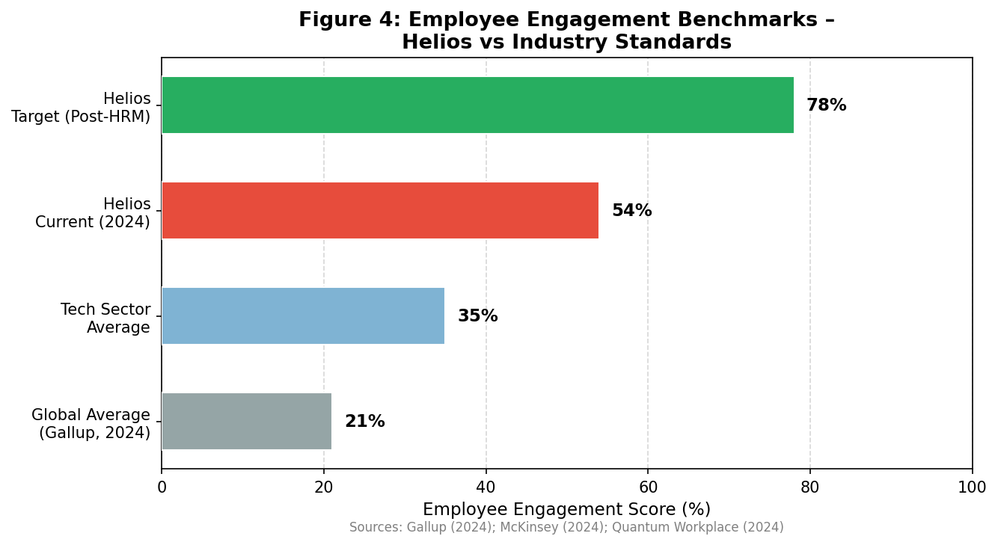
Figure 3: Employee Engagement Benchmarks – Helios vs Industry Standards (Sources: Gallup, 2024; McKinsey, 2024; Quantum Workplace, 2024)

1. Innovative Job Design Strategy
A 54% engagement score and higher employee attrition rates are signs of job architectures that have fundamental flaws and are not aligned with the dynamic and AI-powered nature of work at Helios. The classical job descriptions, which are based on defined roles and defined lists of tasks, are structurally ill-equipped for a smart-transport organisation, because the definition of work is constantly changing because of technological innovation (Klöpper and Köhne, 2023). The Job Design Strategy combines three complementary models: Job Characteristics Model (Hackman and Oldham, 1976), Job Crafting Theory (Wrzesniewski and Dutton, 2001) and a Skills Based Workforce Architecture (Boudreau and Jesuthasan, 2011).

Job Characteristics Model (JCM).
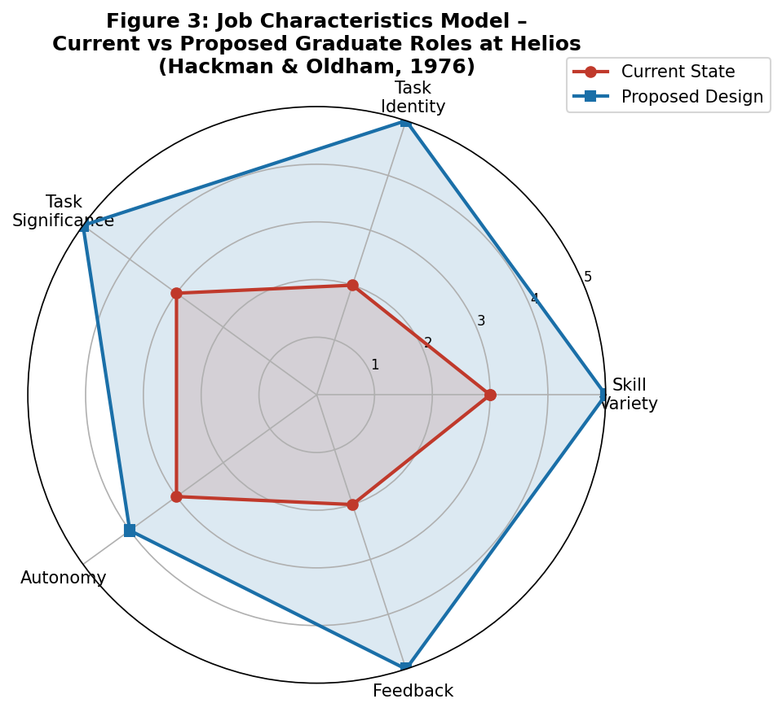
One of the most empirically well-established models for the diagnosis and redesign of work to maximize intrinsic motivation is the JCM developed by Hackman and Oldham (1976). The five core job dimensions—the skill variety, task identity, task significance, autonomy, and feedback—are important psychological states that lead to high performance and engagement. Helios' current deficit situation and proposed future redesigned state of Helios is shown below in Figure 3 across each dimension.
Figure 4: Job Characteristics Model – Current vs Proposed Graduate Roles at Helios (Hackman & Oldham, 1976; adapted from Holman et al., 2023)
The rotational of graduates between functions of algorithm design, urban policy analysis, and systems architecture fosters improved skill variety, in particular. Task Identity is enhanced by giving engineers ownership from initial design through deployment of respective infrastructure modules. Task Significance is enhanced by making the link between individual tasks and measurable urban emissions reductions explicit, and through the use of real-time environmental impact dashboards. Autonomy is implemented by using agile sprint methodologies that assign the backlog management to the self-organised project teams. Overall, skill variety and autonomy are shown to be important skill-based moderators of the cognitive job crafting behaviours (Wang, et al., 2024), further supporting this job redesign approach.

Job Crafting Theory (Wrzesniewski & Dutton, 2001)
Job crafting, or the reconfiguration of the boundaries of a task, relational, and cognitive job by the employee, is a significant ‘bottom-up’ complement to the ‘top-down’ JCM redesign (Wrzesniewski and Dutton, 2001; Annual Reviews, 2025). This meta-analysis by Holman et al. (2023) supports the findings of the authors that the impacts of job crafting on employees' well-being, engagement, and performance are mediated, with the primary indirect mechanisms being the improvement of work resources and work engagement. Helios should make it a point of design to establish a culture of job crafting by giving three types of job crafting 10% of each graduate's working week – explicit authority and encouragement.
- Task Crafting: involvement in other AI modelling or urban data projects outside of the formal remit of the task
- Relationship Building: direct business connections established between UK, German and Singapore teams in an proactive way.
- Cognitive Crafting: deliberate reworking of the professional identity with a focus from ‘software developer’ to ‘urban mobility pioneer’ Based on their research,

Skills-Based Architecture and Internal Talent Marketplaces
Roczniewska et al. (2023) proved that, when considered as a process of strategic alignment of personal and professional preferences, job crafting significantly enhances job satisfaction and organisational commitment in a technological environment. The concept of Skills Based Architecture and Internal Talent Marketplaces. The idea of Skills Based Architecture and Internal Talent Marketplaces. Helios needs to change the traditional hierarchical job concept into a skills-based jobs concept to be able to become agile enough for the urban mobility sector. An AI-based Internal Talent Marketplace aligns the skills profile and developmental interests of graduates to short-term, cross-functional projects across the three Helios hubs. A Berlin-based graduate wanting to build skills in predictive analytics could have an algorithmic match with a smart-grid project in London, so they are always challenged, cross-cultured and diversified.

2. Promote Intrinsic Motivation and Innovation
The proposed job design strategy is grounded in Self-Determination Theory (Deci and Ryan, 2000) which states that there are three central psychological needs: autonomy, competence, and relatedness, which are the bases of intrinsic motivation and continued innovative behaviour. Recent studies by Zhang et al. (2023) provide evidence for a sustained, positive relationship between job crafting and professional passion over time, while satisfaction of basic psychological needs set forth in SDT serves to support and drive professional passion. An intrinsically motivated employee demonstrates explorative and risk-taking behaviours that are essential preconditions for innovation (Amabile, 1997).

TASK C : Reflective Report

1. AI as a Decision-Support Tool
I've interacted with quantitative corporate systems as well as new HR tools that incorporate AI, so I know that AI in HR is not a future topic, but a current approach. The research from Fenwick et al. (2024) in Frontiers in Artificial Intelligence highlights the fundamental shift in HRM tasks towards being more cross-functional and data-driven, emphasising the need for HR professionals to demonstrate a high degree of AI literacy as a fundamental skill.
Murugesan et al.’s (2023) study of AI impacts on HR digitalisation in Industry 4.0 contexts support the importance of predictive and prescriptive AI capabilities in enhancing the quality and timeliness of HR decision making processes in hiring, monitoring engagement and HR retention interventions. With first-hand knowledge of how AI tools perform in complex contexts, however, an important insight has emerged: AI can show you what is happening (a 54% drop in engagement scores, for instance), but by itself it cannot explain why.
Therefore, I'm pledging to use AI as a decision support tool and not as a decision-maker. The study by Edwards et al. (2024) on HR analytics highlights how people analytics tools are becoming increasingly popular but also how the growing concerns around data governance, algorithmic bias, and employee privacy can't be ignored, as they demand human oversight.

2. Personal Capability Development Plan:
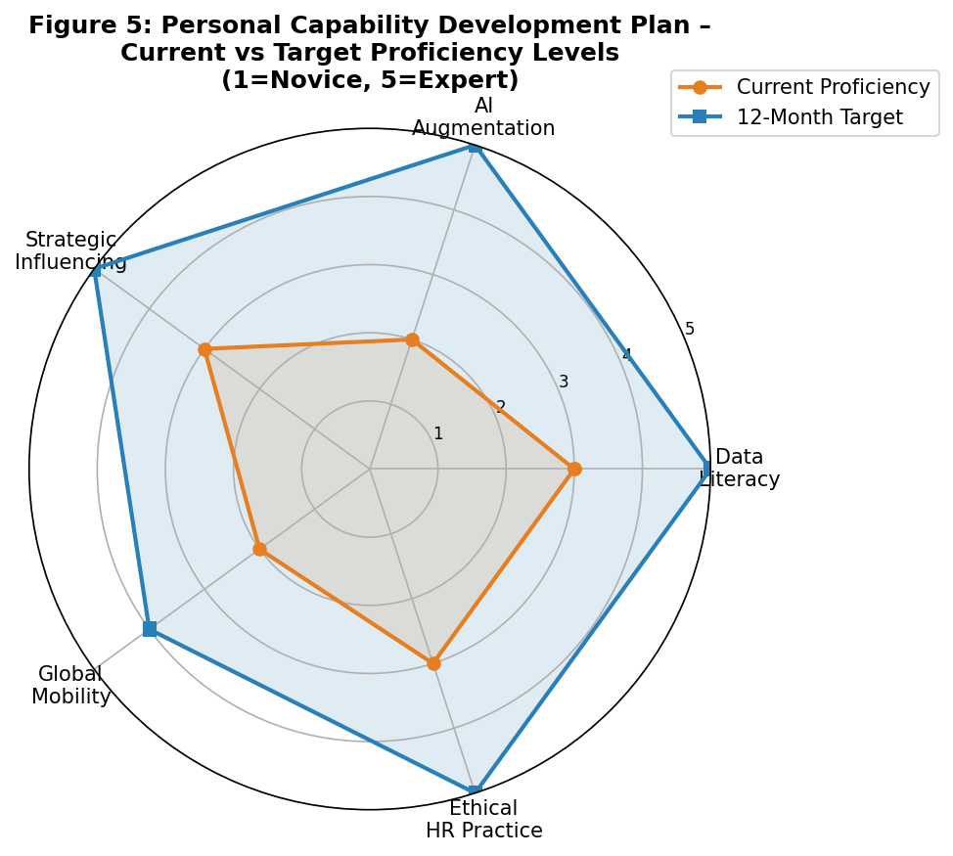
My approach to personal development focuses on four key strategic competency areas, all of which are directly connected with the changing needs of sophisticated HR leadership in technology-based, multi-location businesses.
Figure 5: Personal Capability Development Plan – Current vs Target Proficiency Levels (1=Novice, 5=Expert; aligned to SHRM Competency Framework, 2024)
Data Literacy & People Analytics: Learning from my finance and corporate administration academic background, I plan to further my qualifications in statistical modelling and HR people analytics. The aim is to be a fluent analyst of multi-dimensional workforce data and be able to convey that data in a commercially engaging and strategic manner to senior stakeholders. Edwards et al. (2024) found HR analytics to be a new research domain that is ‘finding its place in the world’, and beginners' expertise in this domain is a key distinguishing factor.
AI Augmentation & Workflow Automation: I will build on my technical experience with generative AI and spreadsheet integrations to gain experience with prompt engineering architecture and AI-powered workforce planning workflows. The study by Murugesan et al. (2023) shows the best advantage of using AI in HR digitalisation for HR practitioners who comprehend and are aware of the technical capabilities and ethical concerns of these tools.
Advanced HR roles in the region with a multinational context: Strategic Influencing & Stakeholder Management: Strategic influencing in the region are more advanced HR roles that depend on a level of stakeholder influence that goes beyond formal organisational authority in order to progress towards these roles. In modern times, the HR Business Partner must be a ‘credible activist’, who is both professionally knowledgeable and credible in interpersonal relationships to influence the C-suite in decision making, argues Ulrich et al.
Global Mobility Awareness & Cross-Cultural Competency: Cross-border HR leadership requires multifaceted understanding in complex HR value systems, international talent supply chains and multicultural value systems. This pillar is directly related to my goal of cultivating an operational mindset that is cosmopolitan, meaning it is able to develop and implement human capital strategies that are both locally relevant and globally sustainable.

References
Amabile, T.M. (1997) ‘Motivating creativity in organizations: On doing what you love and loving what you do’, California Management Review, 40(1), pp. 39–58.
Bauer, T.N. (2010) Onboarding New Employees: Maximizing Success. Alexandria, VA: SHRM Foundation.
Bauer, T.N., Perrot, S., Lehmann-Willenbrock, N. and Erdogan, B. (2024) ‘Organizational socialization and newcomer adjustment: An integrative review’, Annual Review of Organizational Psychology and Organizational Behavior, 11, pp. 17–61.
Boudreau, J.W. and Jesuthasan, R. (2011) Transformative HR: How Great Companies Use Evidence-Based Change for Sustainable Advantage. San Francisco, CA: Jossey-Bass.
Cappelli, P., Tambe, P. and Yakubovich, V. (2020) ‘Artificial intelligence in human resources management: Challenges and a path forward’, California Management Review, 62(4), pp. 15–42.
Deci, E.L. and Ryan, R.M. (2000) ‘The “what” and “why” of goal pursuits: Human needs and the self-determination of behavior’, Psychological Inquiry, 11(4), pp. 227–268.
Eccles, R.G. and Klimenko, S. (2020) ‘The investor revolution’, in Mayer, C. and Roche, B. (eds.) Putting Purpose into Practice: The Economics of Mutuality. Oxford: Oxford University Press, pp. 17–34.
Edwards, M.R., Charlwood, A., Guenole, N. and Marler, J. (2024) ‘HR analytics: An emerging field finding its place in the world alongside simmering ethical challenges’, Human Resource Management Journal, 34(2), pp. 326–336.
European Commission (2021) Proposal for a Regulation of the European Parliament and of the Council Laying Down Harmonised Rules on Artificial Intelligence (Artificial Intelligence Act). Brussels: European Commission.
Fenwick, A., Molnar, G. and Frangos, C. (2024) ‘Revisiting the role of HR in the age of AI: Bringing humans and machines closer together in the workplace’, Frontiers in Artificial Intelligence, 6, p. 1272823.
Freeman, R.E. (1984) Strategic Management: A Stakeholder Approach. Boston, MA: Pitman.
Frögéli, E., Jenner, B. and Gustavsson, P. (2023) ‘Effectiveness of formal onboarding for facilitating organizational socialization: A systematic review’, PLOS ONE, 18(2), p. e0281823.
Gallup (2024) State of the Global Workplace: 2024 Report. Washington, DC: Gallup Inc.
Giermindl, L.M., Strich, F., Christ, O., Leicht-Deobald, U. and Redzepi, A. (2022) ‘The dark sides of people analytics: Reviewing the perils for organisations and employees’, European Journal of Information Systems, 31(3), pp. 410–435.
Hackman, J.R. and Oldham, G.R. (1976) ‘Motivation through the design of work: Test of a theory’, Organizational Behavior and Human Performance, 16(2), pp. 250–279.
Holman, D., Axtell, C. and Totterdell, P. (2023) ‘A meta-analysis of the effects of job crafting on job outcomes: A resource-based perspective’, Work & Stress, 37(1), pp. 45–70.
Klöpper, M. and Köhne, S. (2023) ‘Shifting structures: A systematic literature review on people analytics and the future of work’, Proceedings of the European Conference on Information Systems (ECIS 2023), pp. 1–19.
Murugesan, U., Subramanian, P., Srivastava, S. and Dwivedi, A. (2023) ‘A study of artificial intelligence impacts on human resource digitalization in Industry 4.0’, Decision Analytics Journal, 7, p. 100249.
Peltokorpi, V., Allen, D.G. and Froese, F. (2022) ‘Organizational embeddedness, turnover intentions, and voluntary turnover: The moderating effects of employee demographic characteristics and values’, Journal of Organizational Behavior, 43(5), pp. 893–907.
Roczniewska, M., Rogala, A. and Retowski, S. (2023) ‘Job crafting as a strategic self-regulation approach: Aligning personal and professional inclinations’, Journal of Occupational and Organizational Psychology, 96(2), pp. 312–334.
Rousseau, D.M. (1989) ‘Psychological and implied contracts in organizations’, Employee Responsibilities and Rights Journal, 2(2), pp. 121–139.
SHRM (2024) 2024 Talent Trends Report: The State of HR and the Workforce. Alexandria, VA: Society for Human Resource Management.
Tajfel, H. and Turner, J.C. (1979) ‘An integrative theory of intergroup conflict’, in Austin, W.G. and Worchel, S. (eds.) The Social Psychology of Intergroup Relations. Monterey, CA: Brooks/Cole, pp. 33–47.
Ulrich, D. (1997) Human Resource Champions. Boston, MA: Harvard Business School Press.
Ulrich, D., Kryscynski, D., Ulrich, M. and Brockbank, W. (2023) Expanding the Value of HR: The RBL HR Competency Framework. Minneapolis, MN: RBL Group.
Van Maanen, J. and Schein, E.H. (1979) ‘Toward a theory of organizational socialization’, Research in Organizational Behavior, 1, pp. 209–264.
Wang, Z., Wang, Y., Jex, S.M., Liu, L. and Cao, J. (2024) ‘When does cognitive crafting matter more in enhancing employee thriving at work? The moderating role of skill variety and job autonomy’, Stress and Health, 40(3), p. e3323.
Woodrow, C. and Guest, D.E. (2020) ‘Pathways through organizational socialization: A longitudinal qualitative study based on the psychological contract’, Journal of Occupational and Organizational Psychology, 93(1), pp. 110–133.
Wrzesniewski, A. and Dutton, J.E. (2001) ‘Crafting a job: Revisioning employees as active crafters of their work’, Academy of Management Review, 26(2), pp. 179–201.
Zhang, W., Li, G. and Li, Y. (2023) ‘Job crafting and professional passion: A self-determination theory perspective’, Journal of Vocational Behavior, 142, p. 103872.

